EXP-25
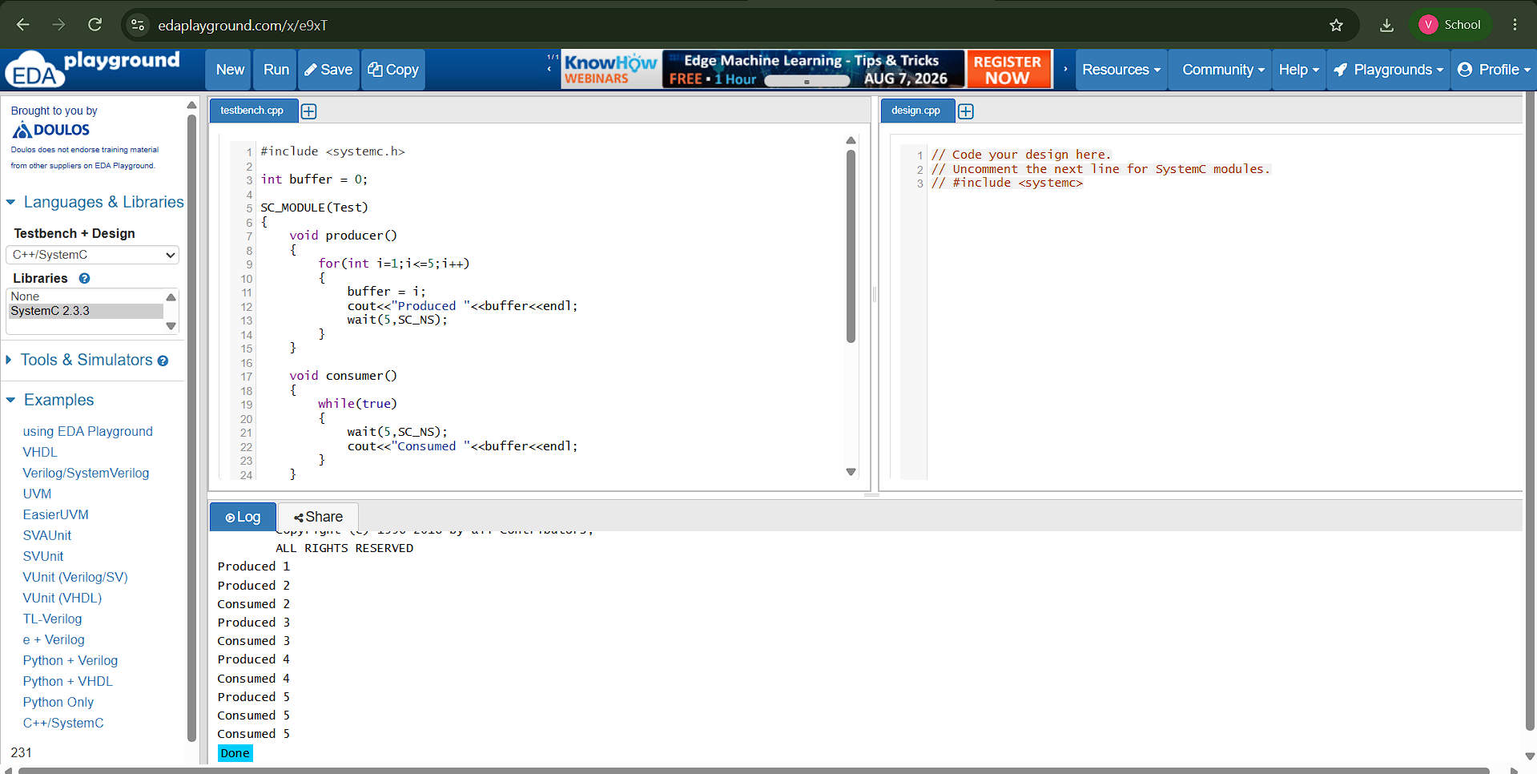

#include <systemc.h>

int buffer = 0;

SC_MODULE(Test)
{
void producer()
{
for(int i=1;i<=5;i++)
{
buffer = i;
cout<<"Produced "<<buffer<<endl;
wait(5,SC_NS);
}
}

void consumer()
{
while(true)
{
wait(5,SC_NS);
cout<<"Consumed "<<buffer<<endl;
}
}

SC_CTOR(Test)
{
SC_THREAD(producer);
SC_THREAD(consumer);
}
};

int sc_main(int argc,char* argv[])
{
Test t("t");
sc_start(30,SC_NS);
}

