EXP-26
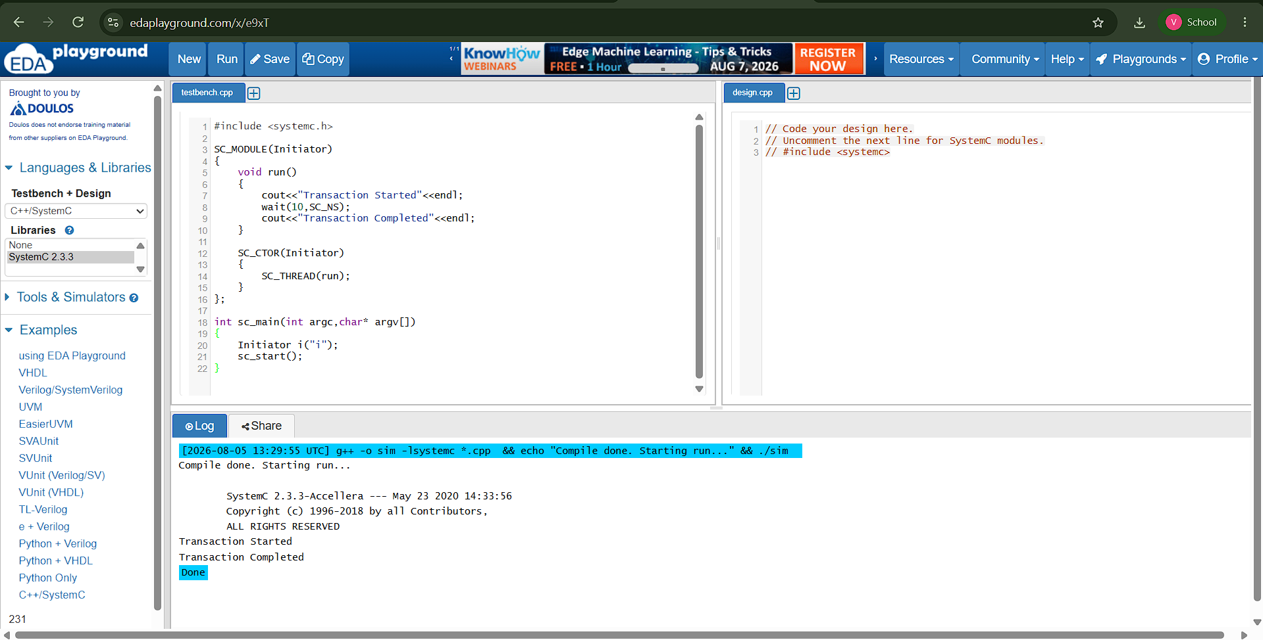

#include <systemc.h>

SC_MODULE(Initiator)
{
void run()
{
cout<<"Transaction Started"<<endl;
wait(10,SC_NS);
cout<<"Transaction Completed"<<endl;
}

SC_CTOR(Initiator)
{
SC_THREAD(run);
}
};

int sc_main(int argc,char* argv[])
{
Initiator i("i");
sc_start();
}

