EXP-27
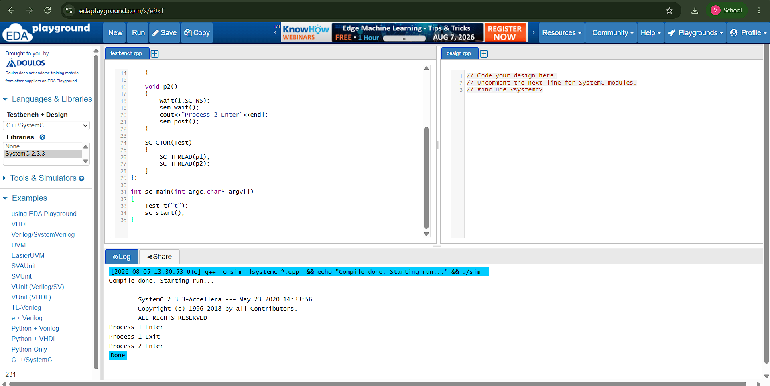

#include <systemc.h>

sc_semaphore sem(1);

SC_MODULE(Test)
{
void p1()
{
sem.wait();
cout<<"Process 1 Enter"<<endl;
wait(5,SC_NS);
cout<<"Process 1 Exit"<<endl;
sem.post();
}

void p2()
{
wait(1,SC_NS);
sem.wait();
cout<<"Process 2 Enter"<<endl;
sem.post();
}

SC_CTOR(Test)
{
SC_THREAD(p1);
SC_THREAD(p2);
}
};

int sc_main(int argc,char* argv[])
{
Test t("t");
sc_start();
}

