Homework 3 Student Name: Vasanth Seethapathi
AuE 8930: Computing and Simulation for Autonomy
Instructor: Prof. Bing Li, Clemson University, Department of Automotive Engineering

* Refer to Syllabus for homework (late) submission, grading and plagiarism policies;
* Submission due Mon. 10/10/2022 11:59 pm via Canvas, include:
- This document (with answers), and with your program results/visualization;
- A .zip file of (modified) source code and data if any, which the TA might run.
* All time complexity should in the big O notation.
* Control your code versions in Github or Bitbucket git repositories.
* Code template is in this Github repo, which can be used as a baseline for your homework.
* If you complete this homework using C++, your final grade will be with a bonus scale 105%.
In this case, for the question templates, you’ll also need to transfer it into C++.
* Development/coding environment for your programming:
  - IDE like PyCharm for Python with Anaconda as Python installations, or
  - CLion for C++ if use C++, or any other tools you prefer.
* The extra questions are optional. You max score is capped as 100.
* This homework includes two parts, and you are supposed to complete both A and B parts.

Part-A

All the solution is updated in the below GIT link –
GIT link - https://github.com/Vasanth2796/HPC_HW3

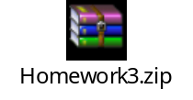

Kindly refer “Homework3” zip folder present in the GIT for solutions.
The solutions for Questions 1-8 are placed both in zip folder and the repository individually. The time complexity of the code is mentioned in the end of program for the necessary questions. I have use “messi5.jpg” file as an input for Question 6 and the output of that problem is “bilateral.jpg” file.

I have attached screenshots and comparison report for the Part-B activity in this report. Kindly check page 5 for the solution updates. The updated codes are available in the above-mentioned zip folder:
Paths –
- Homework3\map-path-search\Question_1
- Homework3\map-path-search\Question_2

Question 1 (10’)
Given an array of integers, find two numbers in it such that they can add up to a specific number.
You may assume there are exactly one solution, you can’t use the same element twice. (Only time-complexity optimized solution gets full grade)

Example:
Given [2, 7, 11, 4], Target = 13.
The answer is 2 and 11.

Modify the “solution” function in the question1.py.
(Analyze your time complexity)

Question 2 (10’)
Given a binary tree, find the max depth of it. Modify the “solution” function in the question2.py (Analyze your time complexity, and only time-complexity optimized solution gets full grade)

Question 3 (5’)
You are given two non-empty linked lists representing two non-negative integers. The digits are stored in reverse order and each of their nodes contain a single digit. Add the two numbers and return it as a linked list.
You may assume the two numbers do not contain any leading zero, except the number 0 itself.
Example:
Input: (2 -> 4 -> 3) + (5 -> 6 -> 4)
Output: 7 -> 0 -> 8
Explanation: 342 + 465 = 807.

Modify the “solution” class in question3.py, you may design your input to test it.

Question 4 (5’)
Given a string s, find the length of the longest substring without repeating characters. You can expect the string length is less than 100, and only contains English letters.
Example 1:
Input: s = "abcabcbb"
Output: 3
Explanation: The answer is "abc", with the length of 3.

Modify the “solution” class in question4.py, you may design your input to test it.

Question 5 (5’)
Given a string s containing just the characters '(', ')', '{', '}', '[' and ']', determine if the input string is valid.
An input string is valid if:
Open brackets must be closed by the same type of brackets.
Open brackets must be closed in the correct order.
Every close bracket has a corresponding open bracket of the same type.
Modify the “solution” function in the question5.py. (Analyze your time complexity)

Question 6 (5’)
Use OpenCV to do a bilateral filter to an image, modify from question6.py, you may use your favorite image, visualize the images before and after the filtering using matplotlib.

Question 7 (10’)
Given a binary tree and a sum, determine if the tree has a root-to-leaf path such that adding up all the values along the path equals the given sum. (Note: A leaf is a node with no children.)
Example:

Given the below binary tree and sum = 22,
5
/ \
4 8
/ / \
11 13 4
/ \ \
7 2 1
return true, as there exist a root-to-leaf path 5->4->11->2 which sum is 22.

Modify the “solution” class in question7.py, test the above example and design your test case.

Question 8 (10’)

Given two strings s and t, return true if t is an anagram of s, and false otherwise.
An Anagram is a word or phrase formed by rearranging the letters of a different word or phrase, typically using all the original letters exactly once.
Example 1:
Input: s = "anagram", t = "nagaram"
Output: true
Example 2:
Input: s = "rat", t = "car"
Output: false
Constraints:
1 <= s.length, t.length <= 5 * 104
s and t consist of lowercase English letters.

Modify the “solution” function in the question8.py. (Analyze your time complexity)

Extra Question 1 (2’) (Extra: means it is optional for you to do)
Given an integer array nums, find the contiguous subarray (containing at least one number) which has the largest sum and return its sum.
Example:
Input: nums = [-2,1,-3,4,-1,2,1,-5,4]
Output: 6
Explanation: [4,-1,2,1] has the largest sum = 6.

You may design your input to test it.

Extra Question 2 (2’)
You are given an array of k linked-lists lists, each linked-list is sorted in ascending order.
Merge all the linked-lists into one sorted linked-list and return it.
Example:
Input: lists = [[1,4,5],[1,3,4],[2,6]]
Output: [1,1,2,3,4,4,5,6]
Modify the “solution” class in extra_question2.py, you may design your input to test it.

Extra Question 3 (2’)
Write a NumPy program to get the values and indices of the elements that are bigger than 10 in a given array. - Modify the extra_question3.py

Extra Question 4 (2’)
Use template matching with OpenCV to find Messi’s face in an image, try all 6 methods and plot the result. - Modify the extra_question4/code.py

Extra Question 5 (2’)
Write a NumPy program to add, subtract, multiply, divide two arrays element-wise.
After you import numpy
The first step is to use NumPy to create two arrays: a, b
a and b should be the same dimensioned.
You initialize the values for a and b when you use numpy.array to create them.
Then a and b can apply the + - * / , like in the ways that two integers can do.
numpy will do the corresponding element-wise math operations implicitly.
Please do it for both a and b for two cases: they are 1D arrays and 2D arrays, such as a and b both are 4x1, and both are 4x4.

Extra Question 6 (2’)
Use SciPy for an application of Discrete Fourier Transform (DFT), modify the extra_question6.py, and apply DFT to the array “a” and visualize both original and result signals.

Part-B
Demo existing and revise search algorithms (40’)
- Reference code repo:
https://github.com/fengziyue/CU-Computing-Autonomy/tree/master/Homework3/map-path-search
- The TA will run and test your algorithms results using the GUI;

[a] For this question, you have the existing reference:
Occupancy gridmap class library:
Homework3/map-path-search/gridmap.py
Occupancy gridmap-based A* (A-start path searching algorithm) implementation:
Homework3/map-path-search/a_star_occupancy.py
As the default, you can use the 8 connectivity for this whole question.

1) Demo existing reference and get to know the behaviour of its path search. (2’)
The demo run file is: examples/occupancy_map_8n.py

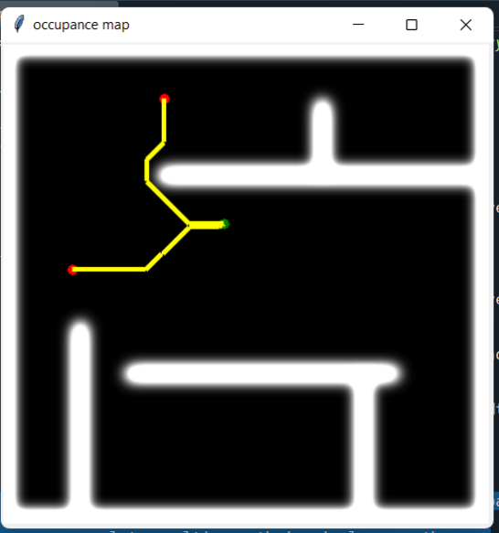
The diagram illustrates how the A* method is used to navigate the network from start to finish node. The A* algorithm employs a heuristic function to guess where the terminal node is located.

2) Implement occupancy gridmap-based Dijkstra for same functionality as (1a) (18’)
If you prefer, you can use this as the template to revise:
Homework3/map-path-search/a_star_occupancy.py’

“dijkstra_occupancy.py” is created based on the A star algorithm as reference. The code diff is as shown in the object attached below –


The modified code is updated in the GitHub as “Question_1” folder.

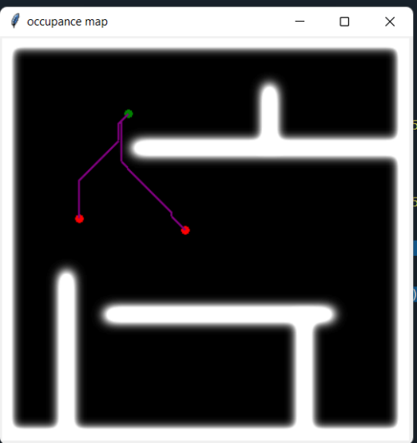

The main distinction between the Dijkstra algorithm and the A* algorithm is that the Dijkstra method lacks the distance heuristic function, whereas the A* algorithm has. Usually, Dijkstra method takes longer than the A* algorithm to locate the goal node for this reason.

[b] For this question, you have the existing reference:
Quadtree-map class library:
Homework3/map-path-search/quadtreemap.py
Quadtree map-based Dijkstra path searching algorithm implementation:
Homework3/map-path-search/dijkstra_quadtree.py
3) Demo existing reference and get to know the behaviour of its path search. (2’)
The demo run file is: examples/quadtree_map_8n.py

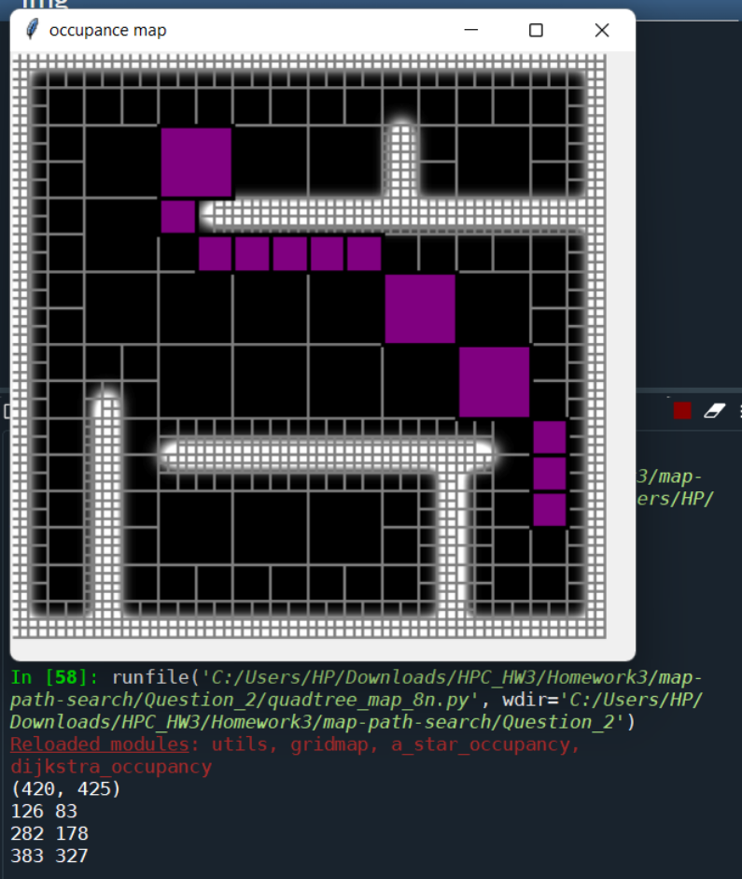

4) Implement Quadtree map-based A* for same functionality as (2a) (18’)
If you prefer, you can use this as the template to revise:
Homework3/map-path-search/dijkstra_quadtree.py

“a_star_quadtree.py” is created based on the dijkstra algorithm as reference. The code diff is as shown in the object attached below –

The modified code is updated in the GitHub as “Question_2” folder.

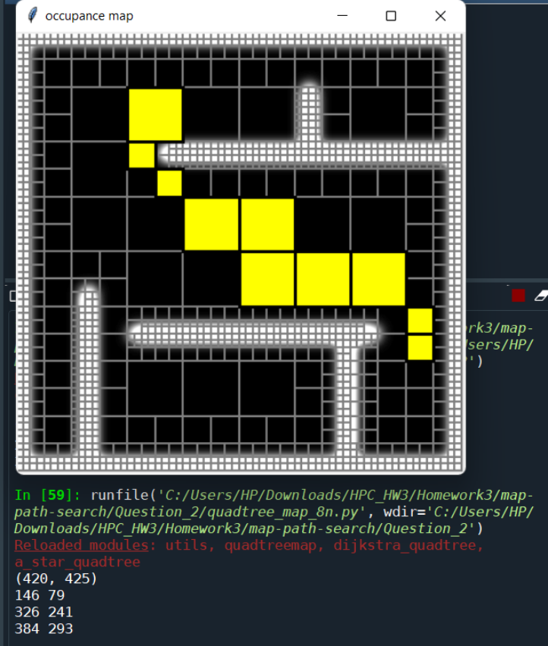

[c] Extra credits (optional to complete):
- 5) Try a few of different granularity, and describe the potential affect (2’);
- 6) Show both Dijkstra and A* algorithms into the GUI for the same mouse events (2’);

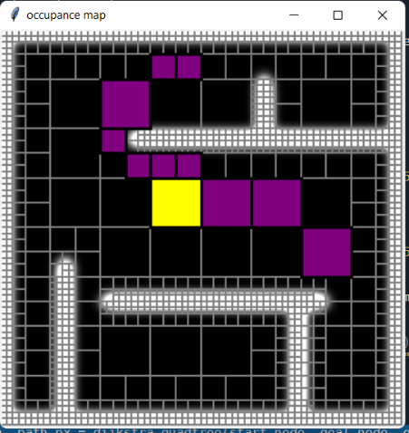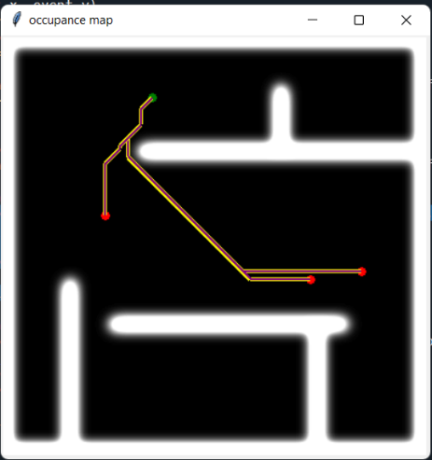

- 7) Analyze your time complexity of each algorithm (2’);

The time complexity of A* depends on the heuristic. In the worst case of an unbounded search space, the number of nodes expanded is exponential in the depth of the solution (the shortest path) d: O(bd), where b is the branching factor (the average number of successors per state).

Time Complexity of Dijkstra's Algorithm is O (V^2) but with min-priority queue it drops down to O (V + E l o g V)

