Main.py

import pandas as pd

import numpy as np

from sklearn.metrics import accuracy_score

from sklearn.model_selection import train_test_split

from sklearn.feature_selection import SelectKBest

from sklearn.feature_selection import chi2

from sklearn.preprocessing import MinMaxScaler

import pickle

import warnings

warnings.filterwarnings('ignore')

a=pd.read_csv("Gait_Data.csv")

print(a)

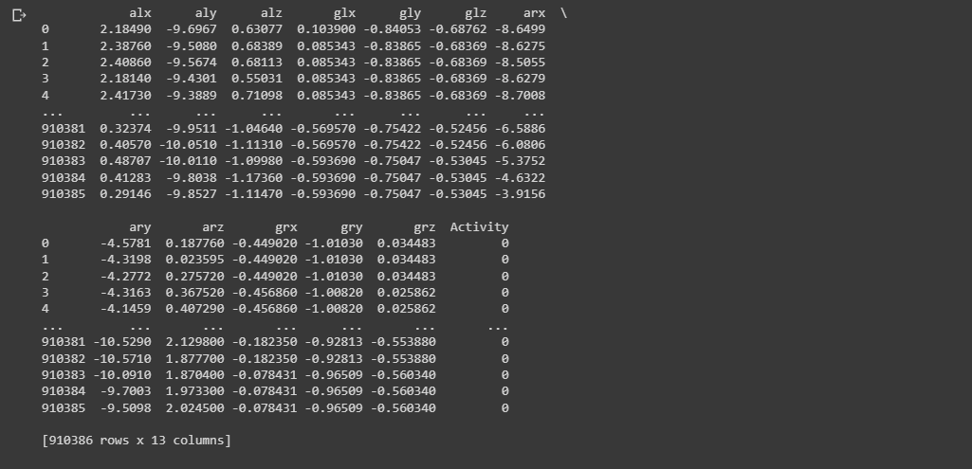

############################ features ####################################

X=a.drop(['Activity'],axis=1)

print(X)

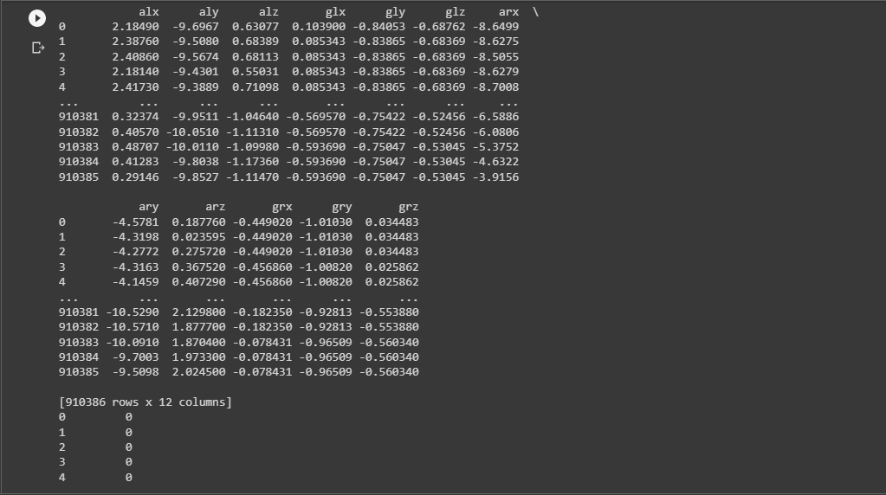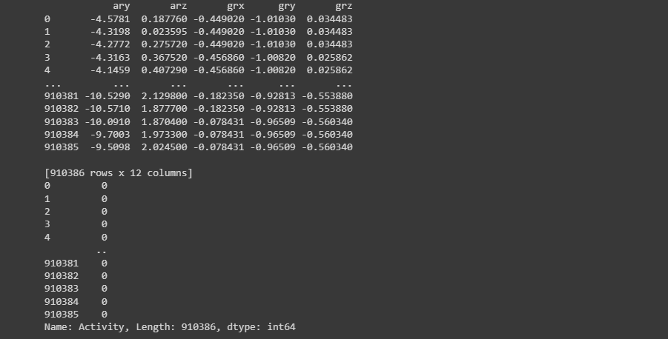

############################ labels ######################################

Y=a['Activity']

print(Y)

############################# traing and testing part #######################

x_train,x_test,y_train,y_test = train_test_split(X,Y,shuffle=True,test_size=0.25, random_state=0)

############################# Algorithm Implementation #######################

############################# Gaussian Naive Bayes #######################

from sklearn.naive_bayes import GaussianNB

NB = GaussianNB()

NB.fit(x_train, y_train) #train the data

y_pred=NB.predict(x_test)

##print(y_pred)

##print(y_test)

print('Naive Bayes ACCURACY is', accuracy_score(y_test,y_pred))



############################# RandomForestClassifier #######################

from sklearn.ensemble import RandomForestClassifier

clf = RandomForestClassifier(max_depth=2, random_state=0)

clf.fit(x_train, y_train) #train the data

y_pred_rf=clf.predict(x_test)

##print(y_pred)

##print(y_test)

print('Random Forest ACCURACY is', accuracy_score(y_test,y_pred_rf))



############################### KNN ############################################

from sklearn.neighbors import KNeighborsClassifier

# Create KNN classifier with k=3

knn = KNeighborsClassifier(n_neighbors=3)

# Train the classifier

knn.fit(X_train, y_train)

# Make predictions on the test set

y_pred = knn.predict(X_test)

# Calculate accuracy

accuracy = accuracy_score(y_test, y_pred)

print("Accuracy: ", accuracy)



##############################3#### SVM ####################################

from sklearn import svm

# Create a SVM classifier with a linear kernel

clf = svm.SVC(kernel='linear', C=1)

# Train the classifier on the training data

clf.fit(x_train, y_train)

# Make predictions on the testing data

y_pred = clf.predict(x_test)

# Evaluate the accuracy of the classifier

accuracy = accuracy_score(y_test, y_pred)

print('SVM Accuracy:', accuracy)

############################# DecisionTreeClassifier #######################

from sklearn.tree import DecisionTreeClassifier

DT = DecisionTreeClassifier(random_state=0)

DT.fit(x_train, y_train) #train the data

y_pred_DT=DT.predict(x_test)

##print(y_pred)

##print(y_test)

print('DecisionTree ACCURACY is', accuracy_score(y_test,y_pred_DT))



from keras.models import Sequential

from keras.layers import LSTM, Dense

model_LSTM = Sequential()

model_LSTM.add(LSTM(32, input_shape=(12,1)))

model_LSTM.add(Dense(16, activation='relu'))

model_LSTM.add(Dense(1, activation='sigmoid'))

# Compile the model

model_LSTM.compile(loss='binary_crossentropy', optimizer='adam', metrics=['accuracy'])

# Train the model

history = model_LSTM.fit(x_train, y_train, epochs=1, batch_size=32, validation_data=(x_test, y_test))

# Evaluate the model

test_loss, test_acc = model_LSTM.evaluate(x_train, Y_test)

##print("Test Loss:", test_loss)

print("Test Accuracy:", test_acc)



filename = 'model.pkl'

#pickle.dump(DT, open(filename, 'wb'))