

**Title:** **Impact of Additive Manufacturing on Design of Product in Spare Parts of Supply Chain**

Par/ by :

**Vasanth MURUGAN**

Mastère Spécialisé® / Master of Science

Program(s): MSc Supply Chain Management and Purchasing

Tuteur / Supervisor:

**Dr. Hussein NASERALDIN**

"J'atteste que ce travail est personnel, qu'il cite systématiquement toutes les sources utilisées entre guillemets et qu'il ne comporte pas de plagiat".

"I certify that this work is personal and exempt from plagiarism, and that all quotations from sources used are enclosed in quotations marks".

Signature

# **Abstract**

The traditional approach of a supply chain includes multiple suppliers and distribution steps, before the part reach to the consumer in an industrial workflow. Supply chain network is anticipated to be restructured with additive manufacturing methods and will gain applications across design and development, prototyping, production and distribution process. In this expected widespread adoption of 3D printing among supply chains, this thesis aims to analyze the impact of additive manufacturing technology on the supply chain network. With the widespread and economical uses of 3D printing, the industries in developing and developed countries are considering restructuring their supply chain network for various advantages including quick components production, reduction in suppliers, customized and in-house production and reduced inventory costs. The literature survey of important concepts and theories provided the platform for data collection, research, methodology development and analysis of components which impacts supply chain network due to advent of additive manufacturing. The present study concludes that induction of 3D printing technology at various stages of development and production provides innovative approaches to create products and augment manufacturing operations. Although, it requires restructuring and there are limitations with the technology, there is a huge impact of this on supply chain process in comparison to traditional approaches.

# **Acknowledgement**

We want to thank all the people who encouraged and supported us in starting the program of this Master of Science at SKEMA Business School, who helped us in developing our knowledge, competences and talents.

We are very grateful to Professor Hussein NASERALDIN for this thesis project at SKEMA business school, who was following us during the whole process and was giving us the important guidelines and advises to write this thesis. We are also very grateful to professor Xavier BRUSSET, head of the program Master of Science in Supply Chain Management and Purchasing.

We are grateful to Uni-via Technology Inc and SL Automobiles which enriched real experience during this Master program and open the doors for the bright career future, for the information which it shared with me, without which my thesis would not be so profound and interesting for the sustainable procurement systems. We would also like to thank for their patience and attentive attitude, for time granted, for the questions answered, for advises and experience shared.

All in all, we want to thank everyone who participated, followed, listened, gave advices and supported on this way. We are grateful to my family, friends and colleagues who were encouraging me in all complicated situations and shared their happy moments.

Table of Contents

Abstract 3

Acknowledgement 4

List of tables 6

List of figures 7

Executive summary 8

I. Introduction 10

I.1     Background 10

I.2     Objectives of the study 12

I.3     Significance and Approach 13

II. Literature Review 15

II.1     Additive Manufacturing 15

II.2     Traditional vs 3DP Supply Chain 19

II.3     Supply Chain with Additive Manufacturing 22

II.4     Present Scenario and Limitations 30

III. Methodology 32

III.1     Selected Organization for Case Study 32

III.2     Research Framework 32

III.2     Framework of case study 33

IV. Research 36

IV.1     Selected Organizations and 3D Printing Process 36

IV.2     Design of Spare Parts for 3D Printing 38

IV.2     3D Printing Supply Chain Network 40

IV.3     Spare Parts Designing and 3DP Supply Chain 43

V. Discussion and Limitations 50

V.1     Discussion 50

V.1     Limitations and Suggestions 54

VI. Conclusions 55

References 56

Appendix 1 59

Appendix 2 61

# **List of tables**

**Table 4.1:** Impacts of 3DP supply chain on design process of spare parts 44

# **List of figures**

**Fig. 1.1** 3D printing in the Gartner Hype Cycle 11

**Fig. 1.2** Workflow followed during the completion of this project. 13

**Fig. 2.1** A Brief Overview Additive Manufacturing 16

**Fig. 2.2** Subtractive vs Additive Manufacturing 17

**Fig. 2.3** Five key benefits of AM over traditional manufacturing 20

**Fig. 2.4** Production savings in cost and speed for AM: Facts and forecast 21

**Fig. 2.5** Breakeven analysis comparing conventional and AM process 23

**Fig. 2.6** The idea of 'Complexity for Free’ in Additive Manufacturing 25

**Fig. 2.7** Tradeoff curve for traditional manufacturing versus AM for a single product 27

**Fig. 3.1** Steps to be followed in our research study 33

**Fig. 3.2** Framework of case study 35

**Fig. 4.1** Additive Manufacturing (3DP) process in Powder bed fusion Technology 37

**Fig. 4.2** Detailed design process for the spare part for 3D printing 39

**Fig. 4.3** The 3DP supply chain network in the selected organizations 41

**Fig. 4.4** Impacts of 3D printing on supply chain of spare parts 43

# **Executive summary**

**Objectives:**

The following objectives were defined for this research:

a) To understand the process of 3D Printing and its role in product life cycle.

b) To understand the difference between conventional and 3DP Supply chain.

c) To find out the key factors of 3DP which affects design of product.

d) To study the existing 3DP end-to-end spare parts on-demand solutions in industry

e) To analyse and assess the impact of 3DP on spare part design and its supply chain.

f) To find out the limitations in this sector and provide suggestions for improvement.

**Introduction:**

The advents of Additive Manufacturing (AM) and Three-Dimensional Printing (3DP) are transforming the process flow of design, prototyping, manufacturing and distribution of products in almost all field of activity and it can make the supply chain process more innovative, efficient, faster, smarter and more economical. The business model with AM and 3DP are getting successful and, in comparison with conventional manufacturing approaches, provides customized approaches and various other economic advantages. When we deal with complex designs, it is difficult to design a feasible model which can be easily produced with the conventional manufacturing tools available. This acts as a barrier in creativity and innovation. The potentials of 3DP solves this issue and provide us flexibility to design and protype the models with not only customization, but with variation in materials and arrangement of layers. The present research report deals with the title of ‘Impact of Additive Manufacturing on Design of Product in Spare Parts of Supply Chain’. This project will focus on investigating the critical factor of relevance of 3DP in spare part design and supply while considering the company’s operating environment, manufacturing capability, customer needs and product portfolio.

**Methodology:**

To perform the research, we selected to perform the research and interview of a supply chain of Metal 3D printing in which, a metal printing company Uni-Via Technology is the provider of 3D printed metal spare part, and the end users are the companies who need spare parts in the field of biomedical equipment, aerospace components, industrial mold and creative designs. The end users provide design to the printing organization Uni-Via Technology Inc. located at Tucheng District of New Taipei City, Taiwan. Our research work is based on the study of a supply chain network which involve 3D printing. We are proposing research framework which will be developed for collection of information and details to study how additive manufacturing impacts the design of product in spare parts of supply chain. We will study these aspects through interview and then analyze the impact of 3D printing supply chain in the network. The selected organizations will be used for the interview and data collections. We had access to take interview from the employees of the metal 3D printing company Uni-Via Technology, which is the provider of 3D printed metal spare part, and the end user was from the field of automotive company, SL Automobiles.

**Results and analysis:**

To perform the study, as discussed earlier, we interviewed the responsible employees in the supply chain of a 3D metal printing company and its customer with demand of spare part printing. We had access to take interview from the employee of the metal 3D printing company Uni-Via Technology, which is the provider of 3D printed metal spare part, and the end user was from the field of automotive company, Koyo Automobiles. Based on interview Forms (Appendix 1 and Appendix 2), we collected the information for our research. The company works with Powder bed fusion (PBF) technology, which is a subset of additive manufacturing (AM). The end user, SL Automobiles, uses the facility for metal component fabrication, such as: near-waterway molds, heat exchange components, motorcycle components and automobile lightweight components. The 3D items are produced by a dedicated printer that prints in a constant fashion consecutive layers of material from the bottom upwards. Each layer is essentially a cross-section of the completed item. The supply chain network is dependent on the design process of the spare parts, and on key design considerations. In other words, it can be said that the design process in conventional manufacturing process is different from 3DP process. The spare part supplier and the 3D printing facility are integrated in a different manner in this supply chain. For the spare part demand, the supplier needs to get the items printed from the facility. To find out why the selected organizations are working with 3D supply chain, we questioned them in our interview about it. According to them, there are various benefits of working with 3D supply chain. We can see that there are various aspects of design which are interrelated to supply chain process when an industry use 3DP process for manufacturing. We observed that starting from the conceptualization of design to production planning, the distinct phases of design process gets changed when the supply chain is using additive manufacturing and 3D printing approaches.

**Discussion and Conclusion:**

There are various advantages of 3DP over conventional manufacturing process. The process of additive manufacturing and 3DP is used to make strong three-dimensional items without the need for a mold or cutting tool in layers from a digital file. There are various other important design considerations which should be kept in mind for a 3DP supply chain. The way each item is produced separately implies it is perfect for methods of mass customization. As we have observed in our research, additive manufacturing methods changes this traditional supply chain, providing geographical flexibility and simplifying the supply and production process of spare parts. It helps to optimize the supply chain, as, without any fragmented manufacturing, it is a one-step process. Further, in design process, we get wide choice of material selection and even designing of parts with more than one material, which, in supply chain process, help is attaining higher material and resources efficiency and incorporating sustainability in process. The 3DP supply chain allows for digital manufacturing approach where manufacturing is digitalized with 3DP method as manual process reduces and requirement are transmitted as design files.

# **Introduction**

The advents of Additive Manufacturing (AM) and Three-Dimensional Printing (3DP) are transforming the process flow of design, prototyping, manufacturing and distribution of products in almost all field of activity and it can make the supply chain process more innovative, efficient, faster, smarter and more economical (Chua and Leong, 2014). The process of AM and 3DP are layer by layer addition of material to develop a part or product in manufacturing systems and it brings the supply chain operation from global or external perspective to local in-house operations(Rogers, Baricz and Pawar, 2016). This process affects the overall product life cycle, including its design and prototyping process. For our master’s thesis project, we have selected the topic ‘Impact of Additive Manufacturing on Design of Product in Spare Parts of Supply Chain?’.

**I.1     Background**

The process of AM is attracting attentions of everyone from entrepreneur to multinational companies, as it provides various advantages over conventional methods. With new innovations in technology of 3DP, even the possibility of printing live biological parts is getting feasible and demonstrable, and various other types of materials, like bio-compatible materials, soft materials, metals, alloys, and smart materials, cell-based inks etc. can be printed and made into parts. This comes as a revolution in manufacturing industry and provides inspiring applications across a range of industries like aviation, automobile, space, food and many more.

Over the past few years, it can be noticed that 3DP is growing from a new entrant to focus in manufacturing, and it shows a huge impact on productivity with expectation and higher acceptability. The business model with AM and 3DP are getting successful and, in comparison with conventional manufacturing approaches, provides customized approaches and various other economic advantages(Ngo *et al.*, 2018). The 3DP approach provides various key advantages which helps the industry in multiple dimensions. Some of these advantages are as follows:

1. Reduction in production steps in design and prototyping
2. Customization of designed part and reduced dependence on conventional tools,
3. Reduced logistics and manufacturing cost, reduced supply chain.
4. Sustainable and green way of production

Gartner’s annual hype cycle of emerging technologies from Gartner Inc. (Michael Shanler, 2018), an information technology advisory company, shows an accelerated growth and expectation of 3DP technology.

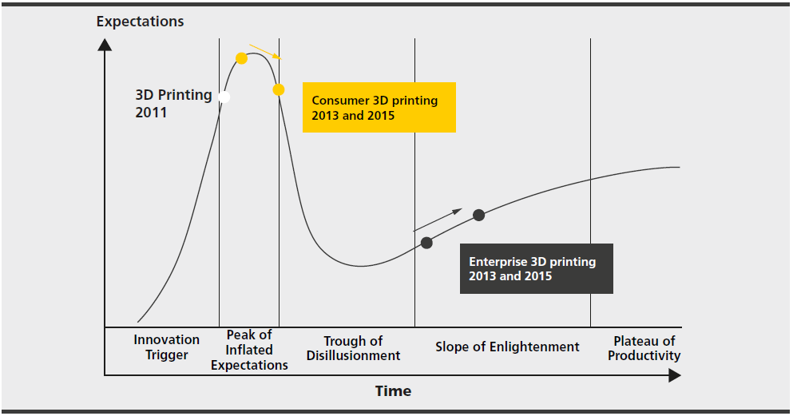

*Fig. 1.1 3D printing in the Gartner Hype Cycle (Michael Shanler, 2018)*

In an industry, the conceptual design process initiates the product development cycle. The next step, 3D design process itself considers what type of manufacturing process will be involved during the production. This causes the reduction in production steps for the product.

When we deal with complex designs, it is difficult to design a feasible model which can be easily produced with the conventional manufacturing tools available. This acts as a barrier in creativity and innovation. The potentials of 3DP solves this issue and provide us flexibility to design and protype the models with not only customization, but with variation in materials and arrangement of layers(Lu, Li and Tian, 2015).

Beside this, when we deal with a production process in a chain, which deals with various stakeholders, the process become highly interdependent and time consuming. The 3DP process can solve this as it reduces the chain length and allows faster delivery time through on-demand and decentralized production strategies. The 3D printing is beneficial due to its ability of producing variety of products by using a single 3D printer, thus it reduces the number of steps in the production chain, essentially enabling companies to leverage on-demand and decentralized production concepts. Further, as the process get reduced in logistics operation also due to elimination of shipping, export, import, tools and other costs due to localization of production facility, this assists the organization in strategically making the product life cycle more efficient, sustainable, green, cheaper and controlled. In terms of supply chain network, the traditional approaches include sourcing and shipping of materials from several locations to a central workshop where the product is developed and assembled. Further, the final product, after passing through various supply chain process gets delivered to the end users.

The concept of sustainability also gets included in the product development cycle with the use of AM and 3DP approaches. As we discussed, this process impacts every stage of product life cycle, starting from design process. In addition, the companies get additional saving in the form of reduction in material use and wastage due to design optimization and the way of manufacturing the parts. The designs need to be generally optimized for 3D printing as the process flow of manufacturing differs with conventional methods. There is an increasing need to reform this conventional process with innovative use of AM, and organizations are taking step in this field.

**I.2     Objectives of the study**

Considering the advantages of 3DP and AM in product life cycle, it will be beneficial to study the impact of these technology on supply chain network in an organization. The process of design of product is indirectly associated with the supply chain and is a preliminary step of prototyping and manufacturing. Our research study aims to study these impacts of 3DP with the following objective: These are the objective of our research study:

1. To understand the process of 3D Printing and its role in product life cycle.
2. To understand the difference between conventional and 3DP Supply chain.
3. To find out the key factors of 3DP which affects design of product.
4. To study the existing 3DP end-to-end spare parts on-demand solutions in industry
5. To analyze and assess the impact of 3DP on spare part design and its supply chain.
6. To find out the limitations in this sector and provide suggestions for improvement.

## I.3     Significance and Approach

To collect the information through Internet research and interview, we need to define our approach and understand the significance of this research and its practical implications. It is important to understand the significance of assessing the impact of 3D printing and additive manufacturing technology on the design of product, and more specifically on spare part design, production and its supply chain. Several international organizations and companies are developing research models to study the impact of 3DP and AM on manufacturing process and supply chain.

The study of key factors of various process through which companies can leverage 3D printing in the supply chain for increasing the operational outcome to improve the end user experience will be a significant contribution in assessment of this technology and its implication. The outcomes from our research study will provide an assessment of the key factors of 3DP which affects the design selection, process and approaches, together with the supply chain network. It will provide us an outlook of the industrial arrangement and will guide the upcoming industries to develop strategies in intelligent selection of 3DP technologies.

The present research report deals with the title of ‘*Impact of Additive Manufacturing on Design of Product in Spare Parts of Supply Chain’.* This project will focus on investigating the critical factor of relevance of 3DP in spare part design and supply while considering the company’s operating environment, manufacturing capability, customer needs and product portfolio. The assessment will deal with the adaptation of 3DP in these field and study the integration with supply chain network. The workflow as mentioned in Figure 1 is followed during the completion of this project.

*Fig. 1.2 Workflow followed during the completion of this project.*

In the following sections of this report, that follows, we will review various literature related additive manufacturing, product life cycle, supply chain in spare part production, key factors associated with design in 3DP process, impact of 3DP on design selection and on supply chain network, and will attain the knowledge of theoretical concepts and practical studies that are implicated for opportunities for greater customization and new business models. During the process of research, the literature survey of important concepts and theories will be performed which will give a base for the further surveys, research and methodology development with theoretical concepts.

A framework is developed for data collection related to the topic and the collected data are presented and discussed. The detailed analysis through research outputs of assessment of these data is suggested with discussions and limitations. The present study indicates and concludes that additive manufacturing technologies are likely to complement the traditional manufacturing techniques in spare part production process and it impacts the product life cycle from design process. The conclusion and limitations in approaches together with future scope will help the upcoming industries to do a feasibility study of their 3DP process and supply chain for efficient, improved and smart process flow.

# **Literature Review**

This section presents the literature and market review of concepts and the theoretical framework used for this research project by collecting the relevant sources and literatures on Additive Manufacturing and Three-Dimensional Printing based supply chain. The literature survey is performed to study the necessary concepts and approaches of AM and 3DP to develop a part or product in manufacturing systems and bringing the supply chain operation from global or external perspective to local in-house operations. It provided the platform for data collection, research, methodology development and analysis of components which affects supply chain network.

Innovative and efficient supply chain network helps in reduction of costs and the optimization of performance in industrial setup (Gunasekaran, Lai and Cheng, 2008). This network can be used as a strategic, process‐oriented, multi‐functional, and value‐creating and helpful in achieving superior financial outcomes. Corporate management aims at rapid growth in line with their corporate values and financial goals. Together with this, there is an urgent need to embed the advanced and efficient technologies in every possible process in an industry. By embedding alternate manufacturing process, and having an integrated framework of supply, the industry can manage their growth together with efficient and green operation.

In this chapter, we will review various literature related to the additive manufacturing process and 3DP and will attain the knowledge of theoretical concepts that are applied on collected information. We will investigate details of traditional supply chain and compare it with Supply chain with 3D printing, its application, present scenario and limitations. Also, we will understand the role of 3DP in product design and its life cycle, identify the key factors of 3DP which affects design of product and spare parts on-demand solutions in industry.

## II.1     Additive Manufacturing

Additive manufacturing is also known as rapid manufacturing, digital manufacturing, direct manufacturing and generative manufacturing. Here products are built layer-by-layer based on a digital image of the object from a three-dimensional computer aided design (CAD) file (Gibson, Rosen and Stucker, 2014). Contrary to conventional manufacturing technique like CNC machining, sheet metal forming, blanking, embossing, lathe work etc. that manufacture end products by reducing material from initial form of raw material, 3-dimensional printing makes the end product by adding material layer by layer that is how it is called ‘additive’. By using technology, AM is gaining and picking up the momentum in different industry as it can use the raw material with greater efficiency and produce the final required object with lower waste and with greater precision and tolerance. Plan as a CAD drawing from PC frameworks can be straightforwardly changed to the last item makes it incomparable in dealing with and creating a structure. The accessibility of such an adaptable procedure as far as materials, geometry, and configuration opens conceivable outcomes of creating new items and incorporating robotization and structure. Since the last shape is formed to by structure layers from powdered crude material the non-used or leftover crude material can be reused and recycled.

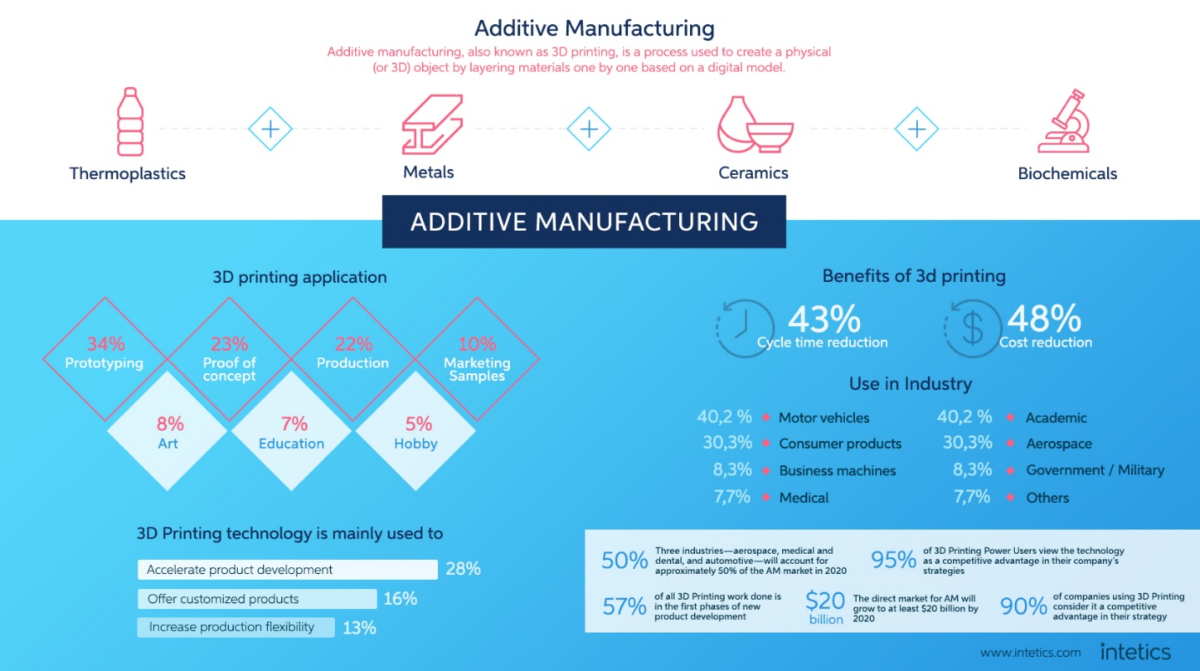

*Fig. 2.1 A Brief Overview Additive Manufacturing* (Intetics, 2019)

Traditional assembling forms are incredibly resourced driven. For instance, during the process of machining, a great deal of crude material is just discarded from the first form (Lu, Li and Tian, 2015). Additionally, a lot of coolant are required to keep the work at the best possible working condition as friction truly influences the surface completion of the item. Likewise, on account of casting, the material is first condensed and after that set again to solid form this prompts a critical wastage of material. Also, a ton of material is rendered useless in the structure to encourage uniform fluid metal dissemination and form occupation. So also, when parts are fabricated utilizing other regular assembling techniques like blanking, punching, pressing and cutting a great deal of sheet metal is squandered which at that point requires expensive remolding.

Conventional assembling forms like machining are designed in such a form that a tool with a function driven tooltip will encounter a quickly pivoting activity. Inevitably, the tooltip wears out and is either solidified and reshaped or disposed of, in the way of wastage of expensive and hardened tool. 3DP, then again, does not require tooling, is free from the utilization of coolants and is amazingly conservative in its utilization of material (Bak, 2003).

Every one of these constraints of traditional assembling forms result in some substantial resources losses as far as exorbitant fuel or dearth of material. These variables and the ongoing stringent environmental standards and weight on the businesses to make strides toward environmental friendliness and lessen their carbon impression make 3DP fabricating a powerful contender to supplant traditional procedures.

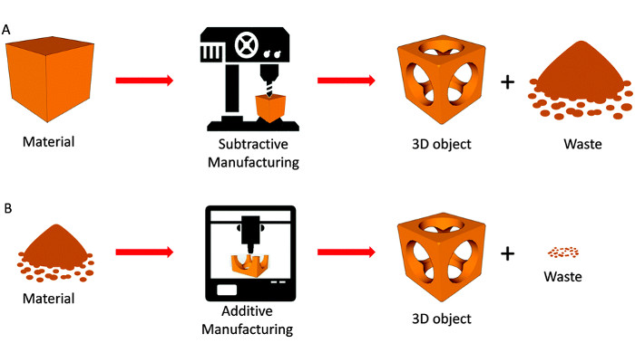

*Fig. 2.2 Subtractive vs Additive Manufacturing.* (D., 2018)

Additive manufacturing deploys the technology of additive layer manufacturing processes. Since the last 20 years additive manufacturing is being used to manufacture casting patterns and prototypes. Late advances in AM currently permit the quick assembling of end-use parts for a mixture of creative applications in materials, for example, metals, polymers, and ceramic production (Huang *et al.*, 2015).

The 3-Dimensional Printing operations is advanced in three fundamental steps. Initially a three-dimensional image of object that needs to be produced in scanned into the additive manufacturing machine with stores in it for further processing. Image data for this process can be obtained from mixture of sources, including computer aided systems, internet or from another outsourced systems. computed tomography (CT) and magnetic resonance imaging (MRI) medical scans and computer game programs are some data sources (Dawood *et al.*, 2015)(Ventola, 2014). The picture is then digitally fragmented into various two-dimensional layers. These layers speak to a profile of the part to be made. The layers are revamped and constructed inside the AM machine each one in turn, from the base up, until the part is finished. This ends the process of building part through AM. AM forms assemble and combine layers in various ways.

Generally, systems employed in Additive manufacturing utilize thermal energy from laser or electron pillars, which is guided through optics to melt or cut the material on which work is done. Different frameworks use different ink-stream type printing heads to precisely shower dissolvable or absorbable materials onto powdered clay or polymer. There are numerous systems and materials accessible to build a product through AM however the final product is the equivalent to other process. A substantial advantage of the CAD model is product fabricated without the impediments of customary assembling like the utilization of holdings, installations, machining, and humans. Listed below are some of AM operations (Wohlers and Gornet, 2014)-

1. Stereolithography`1987
2. Fused Deposition Modelling (FDM)1991
3. Solid Ground Curing (SGC)1991
4. Laminated Object Manufacturing (LOM) 1991
5. Selective Laser Sintering (SLS) 1992
6. Direct Shell Production casting 1993

Conventional process of operations requires a successive step of work carried out on the part like drilling, cutting which needs to extra effort however without the any need of more machines/operations, AM can build complex structure. AM machines can assemble complex parts without the guide of different machines. AM machines can likewise create parts that have enhanced strength to weight attributes which will surely affect the aviation and automotive manufacturing in a positive manner (Attaran, 2017).

Additive manufacturing is not subjected to the cutting or machining forces like in conventional manufacturing techniques. Since the job is stationary and there is no tool in contact with the job, a very good surface finish is achieved in the parts manufactured using AM machines. Also surface smoothness in AM is a function of layer thickness (Sachs *et al.*, 1997). A very fine surface finish can be achieved by having small layer thickness. Although this takes more time to build the part, yet an optimum scenario of smooth finish and reasonable manufacturing time can be achieved using AM techniques. Conventional manufacturing processes need jigs and fixtures to hold the job securely so that it can withstand the cutting forces exerted by the tool without vibrating. A lot of time must be dedicated to installing, aligning and removing the jigs from the machines. Additive manufacturing does not require jigs and fixtures but only support structures which are in built in the design of part and easily removable. Thus, a lot of time and effort can be saved without the use of jigs and fixtures.

## II.2     Traditional vs 3DP Supply Chain

Prototyping has always been an effective way of finding flaws and making improvements in the design before manufacturing it on a large scale. Additive manufacturing is essentially an extension of rapid prototyping and hence it obviously helps in saving time required for redesigning and rectification (Liu *et al.*, 2014). Using AM have already reported time savings of 60% to 90%. Additive Manufacturing can thus be used to reduce the lead time of the spare parts and thus improve their availability.

Additive manufacturing can produce parts in batch sizes of one which provides flexibility to the manufacturer to start and stop production according to the instantaneous demand from the market. Even small investors can develop their manufacturing facilities. Although presently AM machines are little costly but as these machines become cheaper, the small investors will be able to manufacture their products without much initial investment and compete with bigger corporations. Parts built using traditional manufacturing techniques are built according to ‘Design for Manufacture principle (O’Driscoll, 2002). This way parts are designed to manufacture and many times their important features are sacrificed to facilitate the ease of manufacturing. AM processes do not need to work according to this principle and hence original design can be retained and, in many ways, enhanced using additive manufacturing. Additive layer manufacturing can be used to augment the functional properties of the parts as they are built. Parts can be produced having mechanical properties varying over the entire body. This way part can be made more flexible at some point and stiffer at another, heavier at one point and lighter at another, thus improving their functionality.

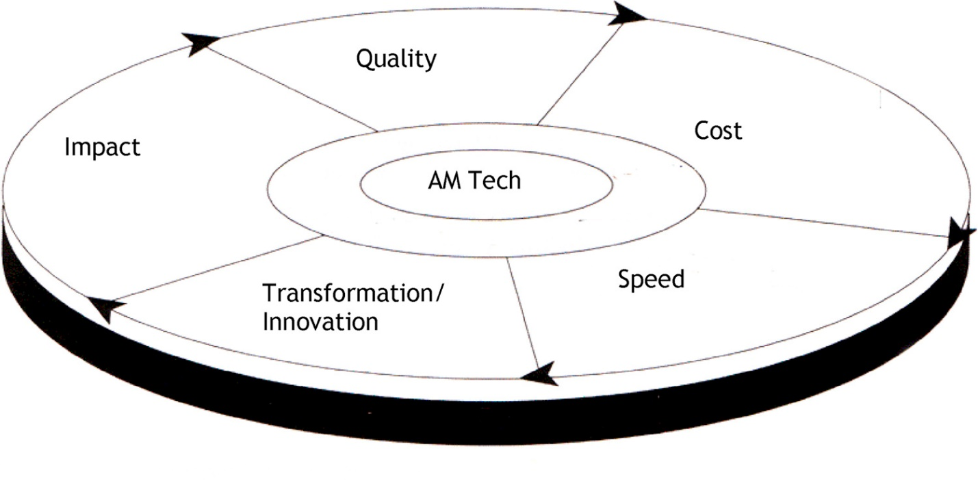

*Fig. 2.3 Five key benefits of AM over traditional manufacturing* (Attaran, 2017)

Another disadvantage of traditional manufacturing assembly line is formation of bottlenecks at certain points where the production from a machine or unit is unable to keep up with other machines. The capacity of the bigger machines is thus wasted, and rate of production is simply dependent on the rate at the bottleneck. Such scenario can also occur due to failure or maintenance of one unit on the assembly line. AM processes on the other hand do not require big assembly lines. A single machine can produce complex parts and hence they are not affected by such bottlenecks.

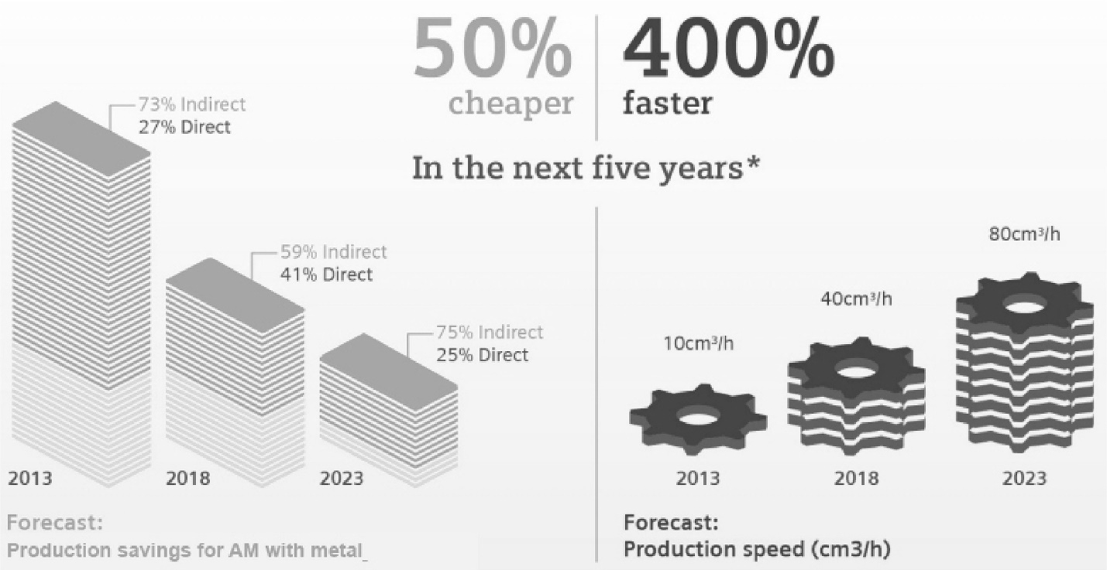

*Fig. 2.4 Production savings in cost and speed for AM: Facts and forecast* (Attaran, 2017)

The quality of production many times depends on the skills of workers especially in the machining and assembly sector. Labor fatigue and unskilled labors are the two biggest threats to achieve zero-defect products. AM processes usually require only initial input from the workers and eventually the process itself takes care of the rest (Attaran, 2017). This way the design of the product is materialized flawlessly without much interference from the operator.

Additive production increases the tool productivity as well as the quality of the product. Break even cost assessment in injection molding shows DMLS ' economic advantages over standard production. In many sectors, one of the costliest elements of manufacturing procedures is the production of specialist instruments. Using standard procedures is usually costly, time-consuming and very technically demanding. AM has the alternative: AM, based on additive manufacturing, allows fast, cost-effective and flexible production of single components or individualized serial goods–even in tiny batch sizes.

For additive manufacturing, even extremely complicated shapes and designs with embedded cooling or tempering channels are no issue. Here, conventional manufacturing procedures reach the limit of their capacities: they restrict design and building liberty because, for instance, often the only alternative for cooling is merely to drill the channels needed. Also, as a tool becomes more complicated, it increases enormously the expenses connected with it.

Additive Manufacturing's design advantages improve both the tool productivity and the quality of the plastic product. Scrap rate and decrease in price per portion. (Klahn, Leutenecker and Meboldt, 2015). Furthermore, producers benefit from reduced cycle time and longer tool service life. They can also market their products faster. For instance, by using Additive Manufacturing, many businesses have been able to decrease the time-to-market compared to standard tool manufacturing as part of a tool optimization project.

## II.3     Supply Chain with Additive Manufacturing

Additive manufacturing got its name from the production process; that is, material is added or layered to produce a product. For example, “printing” devices use digital designs to layer plastic, metal, or other materials until a part, component, or ﬁnal product is formed. Traditional manufacturing, in contradistinction, relies on milling (taking material away) a block of material to a desired shape. On complex designs, 3D printing can reduce the total number of components that must be assembled to create a ﬁnished product.

Kostidi and Nikitakos in “Disrupting the spare parts supply chain” states thatit is to study the disruption in the supply chain of the spare parts of the ships with the introduction of additive manufacturing (Kostidi and Nikitakos, 2016). There are many active investments by various industries for utilization of AM parts to capitalize on the value-added properties provided by AM which highlights some industrial examples for AM parts. The AM technology is getting involved in various industries like automotive, spare parts for capital goods, aircraft spare parts, aerospace, aeronautics, aircraft companies and operators and defense industries. Authors studied the impact of AM in the aircraft spare parts industry, with an emphasis on the use of distributed manufacturing strategy to reduce inventory cost. They concluded that on-demand and centralized production of spare parts is most likely to succeed.

In conventional manufacturing, with the total number of manufactured objects, the cost for each incremental unit of production decreases, while the cost per unit increases as complexity increases. Contrary to this, the price of 3D printing for each unit manufacturing continues largely uniform, with little effect due to the complete amount and complexity. Current 3D printing therefore demonstrates superiority in manufacturing of low to medium size and relative complicated structures. However, improvements in the adoption rate and 3D printing performance will continue in the years to come, the cost of manufacturing 3D printing will gradually decrease.

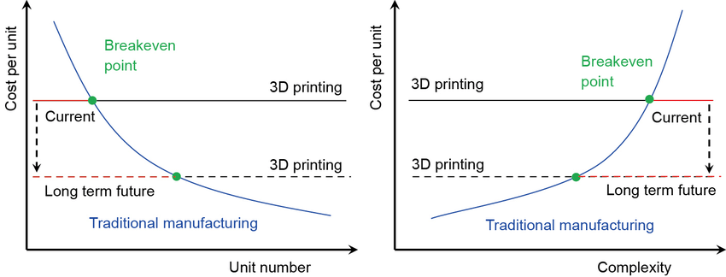

*Fig. 2.5 Breakeven analysis comparing conventional and AM process.*(Ma, Wang and Ju, 2018)

The manufacture of metal additives becomes an economically feasible option for the production of complicated serial components in small batch sizes. Increasing numbers of businesses use additive manufacturing (AM) to create high-end products with a competitive advantage over standard procedures (machining, forging and even casting). For some years now, the benefits of additive manufacturing for sectors with high-value / low-volume parts such as aerospace and defense or medical implants have been openly and enthusiastically praised. Typically, the unparalleled design liberty in AM is leveraged by:

1. Weight reduction
2. Part consolidation
3. Superior aesthetics
4. Design-driven manufacturing
5. Functional integration / customization
6. Manufacturing footprint reduction
7. Maximum freedom of design
8. Reduction in wage costs thanks to standalone processes
9. Highly productive tools, faster amortisation
10. Flexible manufacturing processes
11. Function integration

There are various questions related to supply chain based on AM. How the required files will be distributed? Where in the supply chain is optimum to have the AM of the parts? How will the personnel be trained in the new technology? The inventory costs for low turnover spare parts can be lowered and at the same time increase in customer service (Cohen, Zheng and Agrawal, 1997). AM could be beneficial for low demand, single item situations. The centralized production of spare parts is most likely to succeed. As far as the cost is concerned, as the market advances, patents expire, and demand grows, the machine cost as well as the production cost will fall.

A promising capacity provided by AM is to combine design liberty with optimization techniques (Wegener, 2010). Design liberty pushes complexity to fresh boundaries:

1. The complexity of the form: AM allows nearly any shape. In tailored and complicated geometries, the advantages of shape optimization can be utilized.
2. Hierarchical complexity: It is possible to design and build multi-scale structures from the microstructure through the mesostructure (scale sizes in the millimeter range) to the macrostructure scale of a part.
3. Material complexity: at one stage or layer at a moment, material can be processed specifically. It allows the development of components with complicated and variable compositions of materials and therefore gradients of material properties.
4. Functional complexity: it is possible to manufacture fully functional assemblies and processes immediately.

AM's potential radically changes product design and the normal process of growth. The chance of incorporating extra characteristics to enhance product efficiency at the same price challenges the traditional manufacturing paradigm that struggles to reconcile geometric complexity with low unit cost performance.

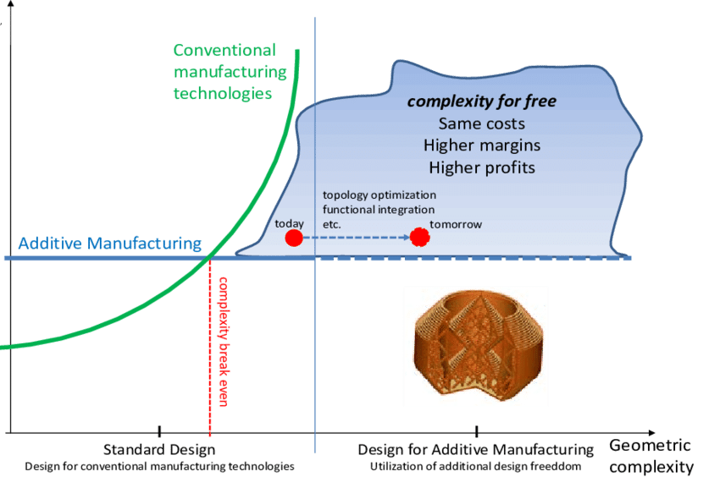

*Fig. 2.6 The idea of 'Complexity for Free’ in Additive Manufacturing* (Wegener, 2010)

***Direct Digital Manufacturing***

Amir and John in their article “The 3D printing order: variability, supercentres and supply chain reconfigurations” states that it is to introduce an alternative where DDM (direct digital manufacturing) supports and enhance traditional mass production (Sasson and Johnson, 2016). This also reshape the understanding of who generally adopts DDM, the products which have been built by DDM, and DDM’s future-term supply chain implications. It uses a qualitative approach by assessing supply chain reconfigurations and by exploring a DDM rollout scenario, i.e. cost/unit and time to delivery comparison scenarios. DDM’s capacity to segregate manufacturing variability ascribed to low volume parts. This proposes a different DDM rollout, different cultivates, and a different supply chain configuration. The paper had identified mass manufacturing variability depletion as the mechanism through which DDM may be adopted. This adoption trajectory will finally enable a supply chain passage in which spare parts inventories wanders from finished goods at proprietary facilities to raw materials at conception DDM supercenters.

The findings identify that current manufacturers with complex bills-of-material be able to develop DDM potential to segregate ingenious, low-volume production rate from ascendible mass production (Mueller, 2012). Progressing DDM competence and raw material scale advantages, the potential manufacturers have brought a locus of change in a manufacturing landscape steadily characterized by multi-product DDM supercenters.

Potential manufacturers of diverse products are in a distinctive position to progress DDM abilities and capabilities as a sub product of investment in increasing the efficiency of their conventional manufacturing operations. Early speculation in DDM might allow certain manufacturers to enhance into regional supercenters. By introducing DDM, one can mitigate production variability for manufacturers with complex products and diverse bill-of-materials, thereby enhancing mass production rate and improving DDM-based service manufacturing businesses (Gibson, Rosen and Stucker, 2015). In order to realize the power of DDM for mass producers whose customers will demand fast delivery of custom/special or spare parts, they need to digitize and spread out searchable or printable elemental files. The availability of those files will assure element compatibility, quality with other components and safety of the product. The best replacement is to let the 3D company produce replicas from 3D scanned or 3rd party replacement designs which results in diverse levels of safety, quality and compatibility.

***Supply Chain Strategies and 3D Printing***

Nyman and Sarlin in their article “From bits to atoms: 3D printing in the context of supply chain strategies” claims that an era of finely new kind of manufacturing technology arise in the state of 3D printing is definitely going to alter some of the underlying assumptions for various supply chain set-ups (Nyman and Sarlin, 2014). This article investigates opportunities and obstacles of 3D printing technology, especially in a supply chain context. The authors have proposed a combination of principles that will act to bridge current research on various supply chain strategies and 3D printing. With the combination of such principles, researchers and practitioners might better understand about the opportunities and constraints of 3D printing in a supply chain management context. This includes certain KPI’s like the production timings, properties of products, and the inventory position in the supply chain. They also analysed a summary of supply chain strategies such as the lean supply chain, Agile SC, as well as league supply chain to reach a balance between cost efficiency and responsiveness.

By the aid of the proposed model, they were able to figure out opportunities in as well as constraints of 3D printing. The Energy efficiency constraint was then brought up as one of the factors perhaps developing a cost disadvantage for 3D printing. While there are still limitations in field-testing of the outlined principles in this article, it contributes as an initial point for further assessment. There was a lot of optimism regarding opportunities to indulge consumers as a core part of the design process.

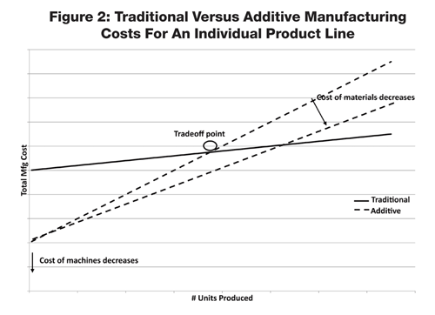

*Fig. 2.7 Tradeoff curve for traditional manufacturing versus AM for a single product* (Scott, 2013)

The fitness of additive manufacturing in the supply chain right now relies on the layout of the product, material expenses and the probability that rivals will get there first. Traditional manufacturing will almost always trump AM for large volume, mass-produced products. Traditional techniques tend to have high fixed costs for plant installation, tooling, etc. (y-intercept in Figure above). However, owing to the manufacturing efficiencies and the reduced price of products, the variable cost will be smaller. As the amount of units sold rises, traditional production will take over as the choice technique.

The characteristics for easy and fast circulation of design files, copyrights problems coupled to 3D printing may arise. There are several aspects of Supply chain strategies that go beyond operative controls to more strategic areas i.e. power, trust and control in the supply chain. However, it is unlikely and irrelevant that AM process will completely put back conventional manufacturing, and it may even complement it.

Peng liu et al. in their article “The impact of additive manufacturing in the aircraft spare parts supply chain: supply chain operation reference (SCOR) model based analysis” evaluates the impact of AM in the aircraft spare parts supply chain based on the well-known SCOR model (Liu *et al.*, 2014). A quantitative approach using three supply chain scenarios are investigated - namely, conventional supply chain, centralized AM supply chain and distributed AM supply chain. Conﬁgurations and SCOR representations of aircraft spare parts supply chain conﬁgure the ‘as-is’ thread-diagram or the ‘to-be’ thread diagram of a supply chain for a reference. A use on safety inventory comparison had also been studied. The result shows that when demand standard deviation increases, the required supply chain safety inventory increases for all three scenarios. However, the rate of increase is different for different parts under different scenarios. It is clearly demonstrated that AM has the potential to change the conventional conﬁguration of the aircraft spare parts supply chain to achieve safety inventory reduction; thus, cutting inventory holding cost across the entire supply chain. The analysis clearly demonstrates the potential of AM technology to make the aircraft spare parts supply chain more efﬁcient.

The centralized AM supply chain is more suitable for parts with low average demand, relatively high demand ﬂuctuation and longer manufacturing lead time. The distributed AM supply chain is suitable for parts with high average demand. The disadvantage is that the produced parts need to be shipped to the service locations, which results in the increase of response time. The ﬁrst approach is to use centralized AM capacity to replace inventory holding. The second approach is the distributed AM deployed at each service location. The advantage is the elimination of inventory holding and transportation costs and a faster response time.

Partanen et al. in their article “Additive manufacturing in the spare parts supply chain” states thatit is to evaluate the potential impact of additive manufacturing improvements on the configuration of spare parts supply chain (Khajavi, Partanen and Holmström, 2014). In short, the purpose is to identify the favorable supply chain configuration in different conditions. A case study on F-18 super hornet fighter jets has been selected since it was providing necessary data to model alternative spare parts scenarios. it has been accomplished thorough the scenario modelling of real-life spare parts supply chain in the aeronautics industry. Additive manufacturing technology enabled the engineering team to integrate different ducts into a single part in order to reduce the overall number of parts since those hornet super jets carry complex air-cooling ducts inside them. A Supply chain configuration model using four possible scenarios in (current/future) state by comparing them with centralized vs distributed production configuration. Stating where the AM technology to be installed to meet the spare parts demand. They wanted to know under which circumstances the distribution production becomes more cost effective.

They investigated the provision of spare parts for the super hornet jet. Analysis of the supply chain configuration model had led them to consider what the requirements on a future AM machine for distributed deployment in future spare parts supply chains. By only changing the specifications of AM machine the total cost is seemed to be lower than that of centralized distribution process. Finally, personnel costs are an important cost component that depends on the automation level of AM machines and the supply chain configuration.

Lower overall operation costs, lower down time, higher potential for customer satisfaction, centralized vs distributed production in the current and future AM process, lower capacity utilization, higher robustness to supply chain disruptions, reduced need for inventory management and logistics information systems, spare parts used in the air jets.

Mathew et al. in their article “How Invention and Entrepreneurship Will Disrupt Supply Chain Design” states that a correlated trend, the maker movement, is also emerging quickly, potentially engendering rapid supply chain evolution (Waller and Fawcett, 2014). They also claim that 3D printing will result in radical redesign of global supply chains or merely led to incremental changes? For instance, 3D printing may make long talked about mass customization in a reality. It may also provide results in manufacturing being located nearer to markets, including an increase in near shoring that is, the return of offshore manufacturing to the United States. As theory-laden academics, it is our responsibility to bring an understanding of the phenomenon of 3D printing to supply chain management, providing both the academy and the practitioner community with: A clearer documentation of what 3D printing really means to supply chain practice, an explanation of the dynamics of 3D printing i.e. how 3D printing is changing relationships, infrastructure, and decision making. Although we have only identiﬁed a short list of issues that should be investigated, the topics on the list demonstrate that 3D Printing’s inﬂuence on logistics and supply chain management is likely to be transformational.

## II.4     Present Scenario and Limitations

Current limitations of AM technologies include the restricted choice of materials and surface finishes compared to traditional mass manufacturing technologies (Attaran, 2017). Michael Schmidt, a professor for photonic technologies at the University of Erlangen-Nuremberg, said: “in order to open up the whole potential of additive manufacturing, it is vital to broaden the so far limited choice of materials” (Tofail *et al.*, 2018).

Experts do not expect AM to replace standard production procedures, however. The manufacturing sector will not be revolutionized, making traditional factories obsolete. We should instead see it as a complement and take advantage of its distinctive capacities. The technology will establish itself with minimal variations in niche industries involving comparable components. The technology opens up fresh manufacturing and worldwide supply chain possibilities. It improves current products and enables companies to produce completely new ones that were earlier impossible to create. In sectors such as automotive, aviation, and medical, almost every sector of the industry is on the AM chance to bring innovations to reality. While AM began primarily as a means of creating prototypes, latest advances in technology and AM technology applications indicate that the technology has the ability to revolutionize many facets of everyday life.

According to Terry Wohlers, president and principal consultant at Wohlers Associates, “there is significant demand for the ability to use more different types of materials in AM, but so far, the leading companies have not really pushed the envelope in terms of really going after a wide range of new materials yet” (Oettmeier and Hofmann, 2016). Large-scale production of standardized products with AM also still involves higher costs and a lower speed than with other mass manufacturing technologies. However, AM machine vendors are actively addressing these issues. With ongoing technological advances, these limitations may therefore become less relevant in the future. There are currently two primary roadblocks for industry-wide use of AM: capabilities and expenses. Capacity relates to the spectrum of finished goods that can be produced for use. This is presently quite restricted owing to the capacity to produce products with just one or two components, the restricted number of components that can be used (e.g., powders), and the process inaccuracies and absence of reproducibility. All this is being investigated around the globe, however, so we can expect these capacities to enhance quickly over the next decade.

Additive manufacturing could obsolete our complex worldwide supply chain within the next decade, replacing it with a new economy based on a high-tech scheme of local, linked providers. These efficiencies run the supply chain gamut, from production costs to installation and transportation, all the way to the component itself, while decreasing scrap, maximizing customization and enhancing installation cycle times. This eliminates both the need for high-volume manufacturing equipment and low-level assembly employees at once, thereby cutting off at least half of the supply chain in a single blow. From there, the efficiencies of that traditional model stop making sense— it's no longer financially effective to send zipping goods around the world to get to the client when production can take place at the same price almost anywhere. Digital files and the machines that make them wired and linked are the raw materials today, quicker and more effective than ever before.

The review of various articles and content from literature was an attempt to enhance the understanding of the impact of 3DP and AM in supply chain. the upcoming chapters will define the methodology for performing the research study and analyze various factors which impact the design of product in spare parts of supply chain through additive manufacturing.

# **Methodology**

Logistics is known to deal with detailed organization and implementation of a complex operations, especially the flow of items. The continuous flow of operations needs a strong supply chain. The on-demand manufacturing with innovative technologies like 3D printing are solving various issues of supply chain and logistics. This chapter deals with our methodology for performing our research study, including information about research design, selected organization, participants, methods of collecting data, analyzing the evidence, research steps, and limitations.

## III.1     Selected Organization for Study

To perform the research, we selected to perform the research and interview of a supply chain of Metal 3D printing in which, a metal printing company Uni-Via Technology is the provider of 3D printed metal spare part, and the end users are the companies who need spare parts in the field of biomedical equipment, aerospace components, industrial mold and creative designs. The end users provide design to the printing organization Uni-Via Technology Inc. located at Tucheng District of New Taipei City, Taiwan.

Uni-Via Technology Inc. began to provide 3D metal printing foundry services in 2018. The laser laminate manufacturing technology is an innovative manufacturing thinking. The mechanism of action is to firstly add three-dimensional layers of the object to be added, and the layer is powdered and then laser-fired to form the layer, and the layer is layered and formed, which is easy to construct complex shapes and interiors. Special flow channels and structures create industrial value products. The applicable materials for the 3D printing facility in Uni-Via Technology Inc. are stainless steel, die steel, cobalt chrome, titanium alloy and aluminum alloy.

## III.2     Research Framework

Our research work is based on study of a supply chain network which involve 3D printing. We are proposing research framework which will be developed for collection of information and details to study how additive manufacturing impacts the design of product in spare parts of supply chain. We will study these aspects through interview and then analyze the impact of 3D printing supply chain in the network. The selected organizations will be used for the interview and data collections.

We will follow the methodology in this research which will include the following steps as mentioned in the below flow chart for collection of details, its study and assessment.

*Fig. 3.1. Steps to be followed in our research study*

## III.2     Framework of study

The advents of Additive Manufacturing and Three-Dimensional Printing are transforming the process flow of design, prototyping, manufacturing and distribution of products and it can make the supply chain process more innovative, efficient, faster, smarter and more economical. We are looking for, in our research, the key factors that enables additive manufacturing process to impact the product life cycle of the spare parts, its design and supply chain network. To perform our research which is based on case study of a supply chain network, we need to design the study with research questions as per our methodology, for the selected organizations.

Case study is an appropriate research methodology for projects based on technology and research as it studies modern phenomena in its natural context. When using case studies for explanatory purposes, two basic types of models are feasible. The first is the design of a single case. Such models can be used to test theory, particularly in a disconfirming position, and the second design sort is a multi-case design in which conclusions are drawn from a group of instances. The Case study-based research methodology is generally exploratory in nature, with qualitative primary data and flexible design. In our research model, as we are studying the case from a single organization and related supply chain of spare parts. Various research questions are needed to be defined to collect information and perform a study, based on our objectives and methodology of this thesis. The following research questions and steps were defined to work further:

1. What is the process of 3D Printing and what they enable for the SCM?
2. What is the difference between conventional and 3DP Supply chain in terms of complexity of the value chain, number of the partners, performance on key aspects?
3. What are the key features that are present in an environment of 3DP supply chain only in respect to the conventional supply chain?
4. What are the existing 3DP end-to-end spare parts on-demand solutions in industry?
5. What are the impacts of 3DP on spare part design and its supply chain?
6. What are the limitations in this sector and provide suggestions for improvement?

Robert K Yin in his book mention that evidence may come from six sources: documents, archival records, interviews, direct observation, participant-observation, and physical artifacts. Also, there are three principles of data collection - use multiple sources of evidence; create a case study database; and, maintain a chain of evidence. In single case study, analysis is the most critical part and the construction and testing of an explanation is the primary objective.

The methodology and design is based on stepwise approach to research for a single case, considering the six sources of evidence and three principles of data collection as discussed earlier. To make it reliable and test its validity, data triangulation method will be used. As we are exploring the details from the organization, internal validity is not a concern in this case. External validity and reliability will be considered during the case study. The theoretical research together with empirical research will be supported by concepts and cases from literature review.

*Fig. 3.2. Framework of case study*

# **Research**

We found in literature that additive manufacturing facilitates to develop a part or product in manufacturing systems and bringing the supply chain operation from global or external perspective to local in-house operations. As per our methodology, we need to investigate details associated with it as a study of supply chain network and collect on-site information in these aspects. According to the framework developed for our research, we prepared an interview form (Appendix 1 and Appendix 2) to collect information for the selected organizations, and the research will be done based on interview and for collection of details related to the defined research questions in this chapter. We are aiming for a research which will be supported by interview. Considering the advantages of 3DP and AM in product life cycle, it will be beneficial to study the impact of these technology on supply chain network in an organization. The process of design of product is indirectly associated with the supply chain and is a preliminary step of prototyping and manufacturing.

In this chapter, based on interview and research, we will present the results. First, to understand the process of additive manufacturing and its role in supply chain, we will introduce the selected organizations, and describe their functioning in 3D printing. Then, we will describe the supply chain network consisting of the 3D printing organization (Uni-Via Technology Inc.) and their various end users who provide the designs for printing of spare parts and use it in their production and assembly line. After this, we will describe the requirements for design of spare parts and its process in the selected organization and will study how 3DP supply chain differs with conventional supply chain in terms of process of design requirements. The results will focus on the impacts of 3DP on spare part design and its supply chain.

## IV.1     Selected Organizations and 3D Printing Process

To perform the study, as discussed earlier, we interviewed the employees in the supply chain of a 3D metal printing company and its customer with demand of spare part printing. We had access to take interview from the employee of the metal 3D printing company Uni-Via Technology, which is the provider of 3D printed metal spare part, and the end user was from the field of automotive company, SL Automobiles. Based on interview Forms (Appendix 1 and Appendix 2), we collected the information for our research.

We found that Xu Wei, a section of Uni-Via Technology Inc. started providing 3D metal printing foundry services in 2018 to various end users and prints spare parts for them. They use laser laminate manufacturing technology, in which, the mechanism of action is to first add three-dimensional layers of the object to be added, and the layer is powdered and then laser-fired to form the layer, and the layer is layered and formed, which is easy to construct complex shapes and interiors. This special flow channels and structures are used to create industrial value products, especially for automobile applications. Customers’ demands various spare parts printing with applicable materials like stainless steel, die steel, cobalt chrome, titanium alloy and aluminum alloy. The company works with Powder bed fusion (PBF) technology, which is a subset of additive manufacturing (AM) whereby a heat source (laser, thermal print head etc.) is used to consolidate material in powder form to form three-dimensional (3D) objects. The heat source is applied to particles contained within a powder bed, which gradually indexes down as each layer is completed and new powder is spread over the build area.

*Fig. 4.1. Additive manufacturing (3DP) process in Powder bed fusion Technology*

The company uses multilayer manufacturing platform module technology (Model Number AM100/AM250/AM500, from ITRI Taiwan) with multi-laser synchronous processing technology for multi-layer manufacturing of spare parts. This is advantageous with different production area requirements and controlled simultaneous processing or divisional processing in the same area and expand the production of powder bed type laminate. The method of establishing large-scale pattern splicing, continuous scanning and elastic distribution of energy, effectively improve the production capacity of laminated production, and expand industrial applications. The end user, SL Automobiles, uses the facility for metal component fabrication, such as: near-waterway molds, heat exchange components, motorcycle components and automobile lightweight components.

## IV.2     Design of Spare Parts for 3D Printing

In our research, after collecting the information about the selected organization and 3D Printing technology and process being used, our next step was to know the process of designing the spare parts according to the requirements of 3D printing process. For this, according to our methodology, we approached the end user, SL Automobiles, to understand the process of design and associated requirements (according to interview form Appendix 2).

***Why 3DP over conventional manufacturing process***

The end user mentioned that traditional reductive manufacturing methods (where materials are removed) can take longer time and are much more costly. The process of additive manufacturing and 3DP is used to make strong three-dimensional items without the need for a mold or cutting tool in layers from a digital file. The 3D items are produced by a dedicated printer that prints in a constant fashion consecutive layers of material from the bottom upwards. Each layer is essentially a cross-section of the completed item.

***Spare parts requirement and its designing process***

The end user demands include spare parts and mold for cooling channel, direct parts and fuel nozzles for the automotive applications. The spare parts requirement at the company needs more flexibility in design specifications and demand complexity. Further, it is more on demand production and need to be delivered as quickly as possible. Beside this, company needs the product to be manufactured at a nearby location, with minimum operational process, thus reducing the process time and logistics. The supply chain network is dependent on the design process of the spare parts, and on key design considerations. In other words, it can be said that the design process in conventional manufacturing process is different from 3DP process, and thus, the supply chain differs in both cases. The detailed design process for the spare part in the end user company is shown in flowchart below.

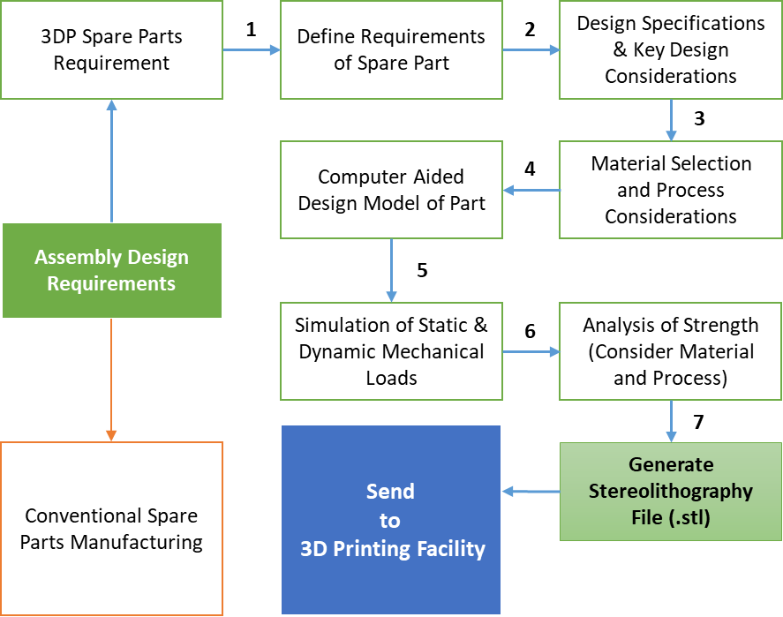

*Fig. 4.2. Detailed design process for the spare part for 3D printing*

We can see in the above flow chart that the end users have their assembly design requirements, which have two types of spare parts. Some parts are needed to be designed for conventional manufacturing process as they have specific requirements (forging method, metal cut etc.), and other parts are best suited with additive manufacturing methods. These parts are segregated by design from the assembly of product and 3DP spare parts requirements are defined. The design specifications for these parts are listed and accordingly, the key design considerations are assessed according to the function of the part. Different methods of 3D printing have varying capacities and distinct limitations on design. Here, these limitations are kept in mind while designing of the parts.

Next, the material selection is performed according to the need and function, specially the mechanical strength and compatibility. The material selection is interrelated with the process of manufacturing and in that also, which process is followed for 3DP and AM. Considering these, the CAD model of the spare part is modified / prepared in ‘Solid Works’ software. To analyses the strength with the key design considerations, the CAD model is tested by computer assisted simulation, in static and dynamic mode, by applying the constraints and loads, to simulate the real functional environment. Once the required strength is confirmed through the analysis, the part is ready for the manufacturing, so, for that, the design is processed to generate Stereolithographic file format (.stl), which is the required format for 3D printers.

## IV.2     3D Printing Supply Chain Network

In our research model, we studied the supply chain network of spare parts to be printed by additive manufacturing methods. Because it can be quite expensive for suppliers to keep an inventory of spare components, many turns to alternatives for additive manufacturing. This is because keeping digital designs instead of physical components is much easier and cheaper. This process is on demand, and the supplier gets in contact with their AM partner immediately afterwards to have the part printed by 3D printer.

Many vendors have lately turned to additive manufacturing to fix the issue of keeping spare parts inventories. Spare part with 3D printing provides digital warehousing service instead of maintaining an inventory of physical objects, which basically implies that there are no physical objects, only blueprints. When the application for some spare components appears, the 3D printing supplier takes the blueprint and produces the part needed.

The emergence of 3D printing is about to alter the conventional supply chain. This additive production technology, which has long been used in the prototyping of new goods, will allow vendors to produce and deliver on-demand parts— and do so locally, near where the components are required. Alternatively, businesses can choose to print their own components, completely bypassing suppliers. After knowing the basic details why, the selected organizations chose 3DP supply chain, we collected information about the process flow and important components in the 3D supply chain network, which includes the supplier and end user. The illustration below shows the 3DP supply chain in the selected organization.

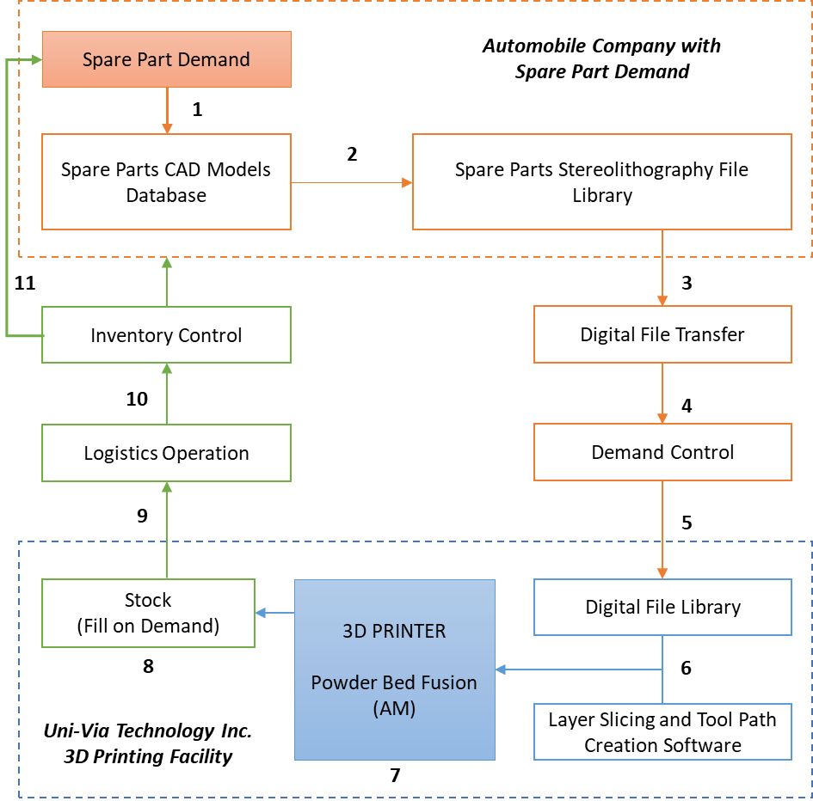

*Fig. 4.3. The 3DP supply chain network in the selected organizations*

As shown in above flow chart, the 3DP supply chain differs from conventional supply chain in various aspects. The spare part supplier and the 3D printing facility are integrated in a different manner in this supply chain. For the spare part demand, the supplier needs to get the items printed from the facility. The supplier keeps a spare parts CAD models database from which, they generate a .stl file library, which serves as a library of files to be sent to the printing facility.

The digital file is transferred through safe file transfer protocol and the demand for number of parts is controlled according to the requirement and stock. In this case, the inventory is small as the production can be done on demand with a short lead time. In Uni-Via Technology, where the 3D printing facility is located, there is a digital library for the files from different suppliers. The file for the supplier is selected and a software perform the layer slicing and tool path creation.

Further, this data is sent to the 3D printer where material and design information is loaded to print the spare parts. At the printing workshop, a small stock is maintained to store the printed spare parts, according to the demand. From the above printed stock of spare parts, logistic operations are performed to transfer the file to the supplier’s required workshop, through inventory control methods. This completes the supply chain of 3D printed spare parts.

***Impacts of 3D printing on supply chain of spare parts***

To find out why the selected organizations are working with 3D supply chain, we questioned the employee in our interview about it. According to them, there are various benefits of working with 3D supply chain. The integration of 3D printing into the supply chain allows them to compete better in the market. The 3D printing helps them to produce and get the supply on demand, allowing them to be more agile in producing customized and localized spare parts. It also reduces the entire supply chain by embracing 3D printing, removing much of the need for delivery and warehousing, thereby simplifying supply chain management and logistics.

We collected the information about these benefits and listed it as shown in the figure below. We can see that the organizations employee mentioned various benefits related to inducing 3D printing-based supply chain. The spare parts can be delivered on demand on there is no need to maintain a costly inventory and stock, which needs space also. It simplifies the supply chain and decrease the market time as the number of processes of manufacturing decrease, and so is the complexity of the process. Further, it allows for complex designs to be printed in a customized manner, with variety of material. The logistic operations are also simplified, with just transfer of files and collection of parts. The biggest advantage is the reduction in inventory cost, as it is on demand process for spare part production, with reduced lead time.

*Fig. 4.4. Impacts of 3D printing on supply chain of spare parts*

## IV.3     Spare Parts Designing and 3DP Supply Chain

According to our research questions, we interviewed to investigate the impacts of 3DP supply chain on spare part design. For this, we interviewed the supplier of spare part and the 3D printing facility also. Our questions for details collection were oriented to understand how the process of design of spare parts gets impacted when we select a 3DP supply chain, instead of a conventional supply chain. As we learned in literature that 3DP supply chain affects the whole product life cycle, so the design process is also one of them. In section IV.2 of this research, we learned the detailed design process for the spare part for 3D printing in the selected organization. In this section, we will understand in detail from the interview response, how the design process gets affected due to this.

We will discuss the collected information of design process and its correlation with the supply chain process in the table below.

*Table. 4.1. Impacts of 3DP supply chain on design process of spare parts*

|  |  |  |  |
| --- | --- | --- | --- |
| **SN.** | **Design Process** | **Impact on Design Process** | **Aspects of Supply Chain** |
| **1** | **Ideate and Conceptual Design Phase** | **-Geometric Freedom**  Can imagine complex geometric models of spare parts as unlike traditional supply chain, the complexity and optimization in 3DP is better than traditional SC.  **-Detailed Concepts**  Layer by layer manufacturing process allows to go for detailed conceptualization. | -Offer customized products to customer  -Edge in competition  - Increase in customer base |
| **2** | **Design Specification** | **-Design Features**  Wide range of design features possible to accommodate customer need  **-Codes and standards**  Intricate and complex codes can be followed as 3DP provides accuracy and precision.  **-Multiscale structure design**  Multiscale complexities can be realized with design freedom.  **-Tolerance Accuracy**  Smaller parts possible with accurate tolerance, helps in accurate assembly, size and structure, and less error. | -Wide field coverage of supply chain  -Standard and OEM part supply |
| **3** | **Material Selections** | **-Wide Choice / Multi-material design**  Accommodating needs of end user with wide range of material selection, multi-material or complex material distribution.  **-Lighter in Weight**  Additive process of manufacturing planned in design, reduces material use, wastage and thus cost. | -Higher material and resources efficiency  -Incorporating sustainability in process |
| **4** | **Computer Aided Modelling of Parts** | **-Simpler Design Parts**  Easy designing of spare parts with greater flexibility and accuracy.  **-Mass Customization**  Customized / alteration in design according to end user needs, as no fixed mold / process chain for manufacturing.  **-Geometry, tolerance and precision**  Intricate geometric modelling allowed with complex features and high tolerance, less constraints.  **-Optimized Geometries**  Flexibility in manufacturing allows optimization of design to a greater extent than conventional method. | -Reducing of complexity in supply chain  -Customized supply chain  -Reduction in cost and leading time of producing customized products  -Reduce obsolescence of parts |
| **5** | **Assembly Design and Dynamic Feasibility Study** | **-Parts consolidation**  Many parts in the design can be consolidated into one complex part and printed using 3DP.  **-Simplified Assemblies**  Greater accuracy and design flexibility offer accurate and easy assembly.  Part consolidation with more geometric freedom for complex geometries. | -Reducing steps of assembly  -Decrease time to market  -Rationalization of stock and logistics  -Reducing stock keeping unit |
| **6** | **Mechanical Simulations of Parts** | **-Higher durability**  Flexible material selection and detailed design specification  **- Design Failure Mode & Effects Analysis**  More control over design process and customized need demands DFMEA to be robust, which 3DP process allows. | -Improved physical performance of product  -Improved cost performance of product |
| **7** | **Manufacturing Plan** | **-Digital Manufacturing**  Manufacturing is digitalized with 3DP method as manual process reduces. Advanced digital DFM rules followed.  **-No Mold Making**  3DP allows printing of complex shapes without the process of mold design and other tedious manufacturing process.  **-Topology optimization**  Greater control over surface topology with layer by layer process. Optimize material layout within a given design space. Reduced post processing.  **-Minimal Tooling or Setup**  Design plans excludes the complex tooling plans.  Metal 3D printers can create parts without extra manufacturing work or machine setup.  **-Bill of Material**  An optimized bill of material with reduced sub-parts and processes. | -Reduced logistics and material transfer  -Cheap tooling cost  -Decentralized manufacturing  -Reduced capital requirements  -Collaborative way of manufacturing  -Quick response time |
| **8** | **Digital Library** | **-Digital inventory and Legacy Parts**  Printing replacement parts onsite and on demand helps to reduce the large inventory space into design library data.  **-Easy data transfer**  Shared / on-cloud digital library easy to share and communicate. | -Mass customization of spare parts  -Design customization and new design possibility  -Digital inventory of spare parts |
| **9** | **Prototype Testing** | **-In house and quick testing**  Quick and easy testing of prototype for design validation.  **-No specialized process for testing**  No need to get specialized manufacturing line just for testing. | -Easy design validation ensures robust supply chain.  -Allows Non-destructive quality control |
| **10** | **Production Planning** | **-Small batch production**  Design plan for on-demand small batch production instead of bulk.  **-Local & Multiple spot production**  De-centralized production planning with multiple facility of 3DP and local production without need to use specialized facility located far away.  **-Full Automation**  Require minimal designated operator time, less skilled operation, automatic and extended hour production. | -Reduced number of suppliers    -Production in proximity of end users  -On-demand and On-site production  -Local delivery instead of multi-step delivery process.  -Low labour cost  -Low warehouse and inventory cost  -Supply base reduction |

From the above table, we can see that there are various aspects of design which are interrelated to supply chain process when an industry use 3DP process for manufacturing. We observed that starting from the conceptualization of design to production planning, the distinct phases of design process gets changed when the supply chain is using additive manufacturing and 3D printing approaches.

Based on our interview questions, we tried to find out the risks and limitations also which the organization is facing due to incorporating 3DP supply chain. It was noted that there is a missing economy of scale in this approach. Further, the production speed is slower in comparison to mass production of spare parts through conventional methods. Besides, there are some limitations of materials which can be printed, especially some alloys. We also noted that sometime the supplier faces issue with quality of spare parts being printed. Also, the 3DP facility mentioned that the requirement of CAD model for 3D Printer is very specific and sometimes they face issue due to the variations and complexity, which the printer cannot handle. Also, there are instances when the printed spare parts need to be post processed to provide required topology and finish.

Based on our research questions, we collected the information from the selected organization for our research, and the data obtained as mentioned in this chapter will be discussed in next chapter. We will also discuss the limitations observed in this research and in approaches followed by the selected organizations.

# **Discussion and Limitations**

In our research work, reported in previous chapter, we performed study and interview in Taiwan to collect information to study the impact of 3DP supply chain on design of spare parts. We collected qualitative information at different stages of supply chain including the 3D printing facility and the supplier who needs the spare parts. We collected various information for our research through interview (Appendix 1 and Appendix 2).

## V.1     Discussion

We first studied about the organization and its 3D printing facility which helped us to understand the technical and supply chain background to the parts to be printed, and its material. The printing facility was using additive manufacturing process with Powder bed fusion technology for printing the metallic spare parts for various applications. We also studied about the organization which had the demand of spare parts to be printed for automobile assembly. We noticed that 3DP technology is significant in production of metal parts and it emerges to be well-suited for tackling the manufacturing and supply chain difficulties.

Further, in detail, we studied the design process of spare parts for 3DP supply chain requirements and found that the end users have their assembly design requirements, which have two types of spare parts. Some parts are needed to be designed for conventional manufacturing process as they have specific requirements (forging method, metal cut etc.), and other parts are best suited with additive manufacturing methods.

There are various advantages of 3DP over conventional manufacturing process. The process of additive manufacturing and 3DP is used to make strong three-dimensional items without the need for a mold or cutting tool in layers from a digital file. We studied the requirement of spare parts and its designing process, including key design considerations, material selection process, CAD modelling and further, generation of stereolithography file library which is used by 3D printer to print the spare part.

Different 3D printing processes have different capabilities and different design restrictions, and accordingly, the design for spare parts is made. In addition, there are various other important design considerations which should be kept in mind for a 3DP supply chain. The way each item is produced separately implies it is perfect for methods of mass customization. The end users will be able to have a much higher say in the final format of the item they purchase, and have it produced in accordance with their requirements.

The organization who supply spare parts to various industry are highly dependent on the supply chain of the parts, and production is the most important part of it. Traditional mode of supply chain includes conventional manufacturing methods, which consists of various phases of transport as well as significant warehousing. With transport expenses steadily rising after volatile oil prices, the centralized model is increasingly being challenged. However, shortening the distance between manufacturing and delivery does not shorten the supply chain drastically: the number of phases does not necessarily reduce.

The entire supply chain should not be confused with logistics, which relates only to the product's motion through the supply chain. Supply chain also results in elevated inventory and warehousing charges that should be reduced or even avoided. Therefore, the supply chain's primary challenge is its simplification as a heavy supply chain undermines attempts to construct a low-cost production system.

As we have observed in our research, additive manufacturing methods changes this traditional supply chain, providing geographical flexibility and simplifying the supply and production process of spare parts. It helps to optimize the supply chain, as, without any fragmented manufacturing, it is a one-step process. In addition, through digitalization, additive manufacturing phases out the physical inventory. Also, 3D printing enables on-demand production at a local scale, and the spare part is delivered to the supplier with the shortest delay and thus, allows for the omission of retailing and distribution stages.

The 3D printing machine can be laid anywhere with little investment, and the manufacturing can be pushed nearer to the end consumer. Moreover, additive manufacturing is now being used massively, and finding a 3D printing outsourcer in various fields is simple. Thus, leveraging current production capabilities is easy, without investing in any new infrastructure. Local-scale manufacturing cuts transport charges, and the manufacturing process's simplicity (one-step, without tooling) makes it fast. Beside this, we observed that a digital inventory reduces the cost of supply chain management. We observed these advantages for the 3DP supply chain network in the selected organizations in our research. Further, we studied through interview research questions about the impacts of 3D printing on supply chain of spare parts and noted various key aspects of it through the response. The key advantages of 3DP supply chain in spare parts which we observed in our research are delivery on demand, simplified supply chain, lower labor units and local production, no complex manufacturing processes, wide material options & customized design, simplified logistic operation, decrease time to market and reduce inventory and stock cost.

Design for additive manufacturing is a process in which the parts are designed for printing with a 3D printing facility. When integrated with a supply chain network as in a case of spare parts production and supply, the design process is customized according to the need as we saw in our research. After learning the detailed design process for the spare part for 3D printing in the selected organization, we understood in detail from the interview response, how the design process gets affected due to 3DP supply chain.

We noted that for spare part design, due to 3DP supply chain, there is an impact throughout the design process starting from the conceptual design phase. As the designer get more geometric freedom and detailed conceptualization is possible due to layer by layer material addition during manufacturing, this offers customized products to customer, edge in competition and increase in customer base in the supply chain. In a supply chain assisted with 3DP, wide field coverage of supply and standard and OEM part supply is possible as in design process, we get wide range of design features, intricate and complex codes can be followed as 3DP provides accuracy and precision and multiscale complexities can be realized with accuracy and tolerance.

Further, in design process, we get wide choice of material selection and even designing of parts with more than one material, which, in supply chain process, help is attaining higher material and resources efficiency and incorporating sustainability in process. Further, the product can be designed for additive process of manufacturing, which reduces material use, wastage and thus saves cost. Further, the easy designing of spare parts with greater flexibility and accuracy is a key feature which is possible with 3DP together with mass customization. It allows for designing to be customized or altered according to end user needs, as no fixed mold and process chain for manufacturing is followed. This helps in reduction in cost and lead time of producing customized products and reducing of complexity in supply chain.

The optimized geometries help in flexibility in manufacturing, which further allows optimization of design to a greater extent than conventional method. The 3DP approach also helps in assembly design and dynamic feasibility study, through Parts consolidation, where, many parts in the design can be consolidated into one complex part and printed using 3DP. This approach helps in reducing steps of assembly, decrease time to market, rationalize stock and logistics and helps in reducing stock keeping unit. Beside this, the pre-simulation of design helps in improved physical performance of product and improved cost performance of product in the supply chain of spare parts.

The 3DP supply chain allows for digital manufacturing approach where manufacturing is digitalized with 3DP method as manual process reduces and requirement are transmitted as design files. Advanced digital DFM rules followed. Also, the process helps in minimal tooling and additional setup, thus, the design plans excludes the complex tooling plans and the metal 3D printers can create parts without extra manufacturing work or machine setup. Beside this, we get an optimized bill of material with reduced sub-parts and processes. In the supply chain, these processes assist for reduced logistics and material transfer, cheap tooling cost, decentralized manufacturing, reduced capital requirements and allows for collaborative way of manufacturing and quick response time.

Further, the inventory process in 3DP supply chain is reduced to a digital library. Printing replacement parts onsite and on demand helps to reduce the large inventory space into design library data. These files can be shared and is easy to communicate. This helps the supply chain by mass customization of spare parts, design customization and new design possibility and making the digital inventory of spare parts. Also, the easy and quick protype testing assist for easy design validation, which ensures robust supply chain and allows non-destructive quality control. Further, the de-centralized production planning with multiple facility of 3DP and local production without need to use specialized facility located far away is a key benefit. It allows to make design plan for on-demand small batch production instead of bulk production. The 3DP printing require minimal designated operator time with automatic and extended hour production. This altogether helps the supply chain plan with reduced number of suppliers, production in proximity of end users, on-demand and on-site production, local delivery instead of multi-step delivery process, low labor cost, low warehouse and inventory cost and supply base reduction.

## V.1     Limitations and Suggestions

Through our research, we found that there are various limitations with 3DP supply chain for spare parts. As discussed in research section, it was noted that there is a missing economy of scale in this approach. Further, the production speed is slower, there are some limitations of materials, and quality of spare parts being printed. Other than the technical limitations of spare part production, we noticed that there are some key issues in the supply chain process of the selected organization. The key concept of sustainability, other than additive manufacturing concepts, were not incorporated.

Further, it seems that demand of various spare part production cannot be fulfilled due to the limitations in materials being printed. Also, even after proper design process, the printed spare parts sometime needed to be post-processed to give finish touch and topology. Beside this, there were sometime issues with integration of 3DP supply chain as still, the conventional supply chain was functional for those spare parts which cannot be printed with additive manufacturing.

Further, in our research, we interviewed with a limited set of staffs to understand the overall process from one 3D printing facility, and one spare part supplier. To get a detailed understanding and more robust results, in future, there is a need to interview multiple organizations. Also, the research performed is qualitative in nature with detail collection through interview. It is suggested, in future, to perform the research with quantitative analysis also with data collected and analyzed for 3DP supply chain.

# **Conclusions**

Additive manufacturing and 3D printing process reforms the supply chain and reduces the physical inventory to a digital library. In our research, we successfully studied the impact of 3DP supply chain on design process of spare parts. To perform the research, we first introduced our topic with background concepts and then defined our objectives to study the supply chain and impact on design process. We defined the significance and approach of our research and followed it for collection of data and completion of this report.

To understand the background concepts and gain knowledge about 3DP and associated supply chain of spare parts, we performed our literature survey by collecting information from internet and previously performed researches. From this survey, we gained knowledge about additive manufacturing, comparison between traditional and 3DP supply chain, supply chain with additive manufacturing and about the present scenario and limitations. Also, we understood the role of 3DP in product design and its life cycle, identified the key factors of 3DP which affects design of product and spare parts on-demand solutions in industry.

We successfully performed the survey and interview of a supply chain of Metal 3D printing in which, a metal printing company Uni-Via Technology is the provider of 3D printed metal spare part, and the end user was the company who was supplier of spare parts for automobile industry. From our research, we successfully studied the 3DP process and associated technology in the organization, followed by study of design of spare parts for 3D printing. We successfully studied detailed design process for the spare part for 3D printing. Further, we studied in detail the 3DP supply chain network in the selected organizations and analyzed the impacts of 3D printing on supply chain of spare parts, and its various benefits. Further, based on interview response, we discussed the collected information of design process and its correlation with the supply chain process. This helped us to successfully study the impacts of 3DP supply chain on design process of spare parts. Based on our interview questions, we also found the risks and limitations which the organization is facing due to incorporating 3DP supply chain. Thus, it can be concluded that starting from the conceptualization of design to production planning, the distinct phases of design process gets changed when the supply chain is using additive manufacturing and 3D printing approaches, and 3DP supply chain is advantageous in comparison to traditional approaches.

# **References**

Attaran, M. (2017) ‘The rise of 3-D printing: The advantages of additive manufacturing over traditional manufacturing’, *Business Horizons*. Elsevier, 60(5), pp. 677–688.

Bak, D. (2003) ‘Rapid prototyping or rapid production? 3D printing processes move industry towards the latter’, *Assembly Automation*. MCB UP Ltd, 23(4), pp. 340–345.

Chua, C. K. and Leong, K. F. (2014) *3D Printing and Additive Manufacturing: Principles and Applications (with Companion Media Pack) of Rapid Prototyping Fourth Edition*. World Scientific Publishing Company.

Cohen, M. A., Zheng, Y.-S. and Agrawal, V. (1997) ‘Service parts logistics: a benchmark analysis’, *IIE transactions*. Taylor & Francis, 29(8), pp. 627–639.

D., J. (2018) *3D Printing vs CNC Machining: Which is best for prototyping?*, *3Dnatives*. Available at: https://www.3dnatives.com/en/3d-printing-vs-cnc-160320184/.

Dawood, A. *et al.* (2015) ‘3D printing in dentistry’, *British dental journal*. Nature Publishing Group, 219(11), p. 521.

Gibson, I., Rosen, D. and Stucker, B. (2015) ‘Direct digital manufacturing’, in *Additive manufacturing technologies*. Springer, pp. 375–397.

Gibson, I., Rosen, D. W. and Stucker, B. (2014) *Additive manufacturing technologies*. Springer.

Gunasekaran, A., Lai, K. and Cheng, T. C. E. (2008) ‘Responsive supply chain: A competitive strategy in a networked economy’, *Omega*. Elsevier, 36(4), pp. 549–564.

Huang, Y. *et al.* (2015) ‘Additive manufacturing: current state, future potential, gaps and needs, and recommendations’, *Journal of Manufacturing Science and Engineering*. American Society of Mechanical Engineers, 137(1), p. 14001.

Intetics (2019) *Infographic: A Brief Overview Additive Manufacturing*. Available at: https://intetics.com/blog/infographic-a-brief-overview-additive-manufacturing.

Khajavi, S. H., Partanen, J. and Holmström, J. (2014) ‘Additive manufacturing in the spare parts supply chain’, *Computers in industry*. Elsevier, 65(1), pp. 50–63.

Klahn, C., Leutenecker, B. and Meboldt, M. (2015) ‘Design strategies for the process of additive manufacturing’, *Procedia CIRP*. Elsevier, 36, pp. 230–235.

Kostidi, E. and Nikitakos, N. (2016) *Disrupting the spare parts supply chain in the shipping industry with the introduction of 3D printing*.

Liu, P. *et al.* (2014) ‘The impact of additive manufacturing in the aircraft spare parts supply chain: supply chain operation reference (scor) model based analysis’, *Production Planning & Control*. Taylor & Francis, 25(13–14), pp. 1169–1181.

Lu, B., Li, D. and Tian, X. (2015) ‘Development trends in additive manufacturing and 3D printing’, *Engineering*, 1(1), pp. 85–89.

Ma, G., Wang, L. and Ju, Y. (2018) ‘State-of-the-art of 3D printing technology of cementitious material—An emerging technique for construction’, *Science China Technological Sciences*. Springer, 61(4), pp. 475–495.

Michael Shanler, P. B. (2018) *Hype Cycle for 3D Printing, 2018*.

Mueller, B. (2012) ‘Additive manufacturing technologies–Rapid prototyping to direct digital manufacturing’, *Assembly Automation*. Emerald Group Publishing Limited, 32(2).

Ngo, T. D. *et al.* (2018) ‘Additive manufacturing (3D printing): A review of materials, methods, applications and challenges’, *Composites Part B: Engineering*. Elsevier, 143, pp. 172–196.

Nyman, H. J. and Sarlin, P. (2014) ‘From bits to atoms: 3D printing in the context of supply chain strategies’, in *2014 47th Hawaii International Conference on System Sciences*. IEEE, pp. 4190–4199.

O’Driscoll, M. (2002) ‘Design for manufacture’, *Journal of materials processing technology*. Elsevier, 122(2–3), pp. 318–321.

Oettmeier, K. and Hofmann, E. (2016) ‘Impact of additive manufacturing technology adoption on supply chain management processes and components’, *Journal of Manufacturing Technology Management*. Emerald Group Publishing Limited, 27(7), pp. 944–968.

Rogers, H., Baricz, N. and Pawar, K. S. (2016) ‘3D printing services: classification, supply chain implications and research agenda’, *International Journal of Physical Distribution & Logistics Management*. Emerald Group Publishing Limited, 46(10), pp. 886–907.

Sachs, E. *et al.* (1997) ‘Progress on tooling by 3D printing; conformal cooling, dimensional control, surface finish and hardness’, in *1997 International Solid Freeform Fabrication Symposium*.

Sasson, A. and Johnson, J. C. (2016) ‘The 3D printing order: variability, supercenters and supply chain reconfigurations’, *International Journal of Physical Distribution & Logistics Management*. Emerald Group Publishing Limited, 46(1), pp. 82–94.

Scott, A. (2013) *Is Additive Manufacturing a Plus For You?*, *MH&L*. Available at: https://www.mhlnews.com/technology-amp-automation/additive-manufacturing-plus-you.

Tofail, S. A. M. *et al.* (2018) ‘Additive manufacturing: scientific and technological challenges, market uptake and opportunities’, *Materials Today*, 21(1), pp. 22–37. doi: https://doi.org/10.1016/j.mattod.2017.07.001.

Ventola, C. L. (2014) ‘Medical applications for 3D printing: current and projected uses’, *Pharmacy and Therapeutics*. MediMedia, USA, 39(10), p. 704.

Waller, M. A. and Fawcett, S. E. (2014) ‘Click here to print a maker movement supply chain: How invention and entrepreneurship will disrupt supply chain design’, *Journal of Business Logistics*. Wiley Online Library, 35(2), pp. 99–102.

Wegener, K. (2010) ‘Vorwort’Additive Fertigung’’, in *SWISS RaPiD Forum, St. Gallen*.

Wohlers, T. and Gornet, T. (2014) ‘History of additive manufacturing’, *Wohlers report*, 24(2014), p. 118.

# **Appendix 1**

**FORM FOR INTERVIEW**

**(3DP SUPPLY CHAIN OF SPARE PARTS)**

**FOR 3D PRINTING FACILITY STAFF**

**Name and Role:__________________________________ Date:__________________________**

**Section 1:** Kindly provide details about your organization and 3DP facility available.

_________________________________________________________________________________________ ____________________________________________________________________________________________________________________________________________________________________________________________________________________________________________________________________________________________________________________________________________________________________

**Section 2:** What is the process of 3D Printing which is used for spare parts?

_________________________________________________________________________________________ ____________________________________________________________________________________________________________________________________________________________________________________________________________________________________________________________________________________________________________________________________________________________________

__________________________________________________________________________________________________________________________________________________________________________________

**Section 3:** What are the key considerations in Design of Spare Parts for 3D Printing?

_________________________________________________________________________________________ ______________________________________________________________________________________________________________________________________________________________________________________________________________________________________________________________________________________________________________________________________________________________________________________________________________________________________________________________________________________________________________________________________________________

**Section 4:** What is the difference between conventional manufacturing methods and 3D Printing and what they enable for the SCM?

_________________________________________________________________________________________ ______________________________________________________________________________________________________________________________________________________________________________________________________________________________________________________________________________________________________________________________________________________________________________________________________________________________________________________________________________________________________________________________________________________

__________________________________________________________________________________________________________________________________________________________________________________

**Section 5:** Explain and draw the workflow of the 3DP supply chain network for spare part in your organization.

_________________________________________________________________________________________ ___________________________________________________________________________________________________________________________________________________________________________________________________________________________________________________________________________

**Section 6:** Mention and explain the impacts of 3D printing on supply chain of spare parts.

|  |  |  |  |  |
| --- | --- | --- | --- | --- |
|  |  |  |  |  |
|  |  |  |  |  |
|  |  |  |  |  |

**Section 7:** Mention and describe the impact of 3DP supply chain on Spare part design process.

|  |  |  |
| --- | --- | --- |
|  |  |  |
|  |  |  |
|  |  |  |

**Section 9:** Describe Limitations with 3DP supply chain and spare part printing with it.

_________________________________________________________________________________________ _____________________________________________________________________________________________________________________________________________________________________________________________________________________________________________________________________________________________________________________________________________________________________________________________________________________________________________________________

# **Appendix 2**

**FORM FOR INTERVIEW**

**(3DP SUPPLY CHAIN OF SPARE PARTS)**

**FOR SPARE PART DESIGN SUPPLIER**

**Name and Role:__________________________________ Date:__________________________**

**Section 1:** Kindly provide details about your organization and your spare parts requirements.

_________________________________________________________________________________________ ____________________________________________________________________________________________________________________________________________________________________________________________________________________________________________________________________________________________________________________________________________________________________

**Section 2:** What is the process of 3D Printing which you prefer for spare part printing?

_________________________________________________________________________________________ ____________________________________________________________________________________________________________________________________________________________________________________________________________________________________________________________________________________________________________________________________________________________________

__________________________________________________________________________________________________________________________________________________________________________________

**Section 3:** Why you prefer 3DP over conventional manufacturing methods and 3D Printing?

_________________________________________________________________________________________ _______________________________________________________________________________________________________________________________________________________________________________________________________________________________________________________________________________________________________________________________________________________________________________________________________________________________________________________________________________________________________________________________________________________________________________________________________________________________________________

**Section 4:** How 3DP supply chain is different from conventional one for spare parts?

_________________________________________________________________________________________ ______________________________________________________________________________________________________________________________________________________________________________________________________________________________________________________________________________________________________________________________________________________________________________________________________________________________________________________________________________________________________________________________________________________

__________________________________________________________________________________________________________________________________________________________________________________

**Section 5:** Kindly explain the detailed design process for the spare part for 3D printing.

_________________________________________________________________________________________ ___________________________________________________________________________________________________________________________________________________________________________________________________________________________________________________________________________

**Section 6:** Mention and describe the impact of 3DP supply chain on Spare part design process.

|  |  |  |
| --- | --- | --- |
|  |  |  |
|  |  |  |
|  |  |  |
|  |  |  |

______________________________________________________________________________________________________________________________________________________________________________________________________________________________________________________________________________________________________________________________________________________________________________________________________________________________________________________________________________________________________________________________________________________

___________________________________________________________________________________________________________________________________________________________________________________________________________________________________________________________________________

**Section 7:** Describe Limitations with 3DP supply chain and spare part printing with it.

_________________________________________________________________________________________ ___________________________________________________________________________________________________________________________________________________________________________________________________________________________________________________________________________