**CHAPTER** **1**

## INTRODUCTION

**1.1OBJECTIVE**

“Student Attendance Management System” is software developed for maintaining the attendance of the student on the daily basis in the college. Here the faculty, who are handling the subjects, will be responsible to mark the attendance of the students. Each staff will be given with a username and password based on the subject they handle. An accurate report based on the student attendance is generated here.

This system will also help in evaluating attendance eligibility criteria of a student. Day-wise and subject-wise attendance is can be calculated. Report of the student’s attendance on weekly and monthly basis is generated. Overall attendance also obtained by using this system.

# CHAPTER 2

# SYSTEM ANALYSIS

## 2.1 INTRODUCTION

Analysis can be defined as breaking up of any whole so as to find out their nature, function etc. It defines design as to make preliminary sketches of; to sketch a pattern or outline for plan. To plan and carry out especially by artistic arrangement or in a skillful wall. System analysis and design can be characterized as a set of techniques and processes, a community of interests, a culture and an intellectual orientation.

The various tasks in the system analysis include the following.

* Understanding application.
* Planning.
* Scheduling.
* Developing candidate solution.
* Performing trade studies.
* Performing cost benefit analysis.
* Recommending alternative solutions.
* Selling of the system.
* Supervising, installing and maintaining the system.

This system manages to the analysis of the report creation and develops manual entry of the student attendance. First design the students entry form , staff allocation and time table allocation forms. This project will helps the attendance system for the department calculate percentage and reports for eligibility criteria of examination .The application attendance entry system will provide flexible report for all students.

## 2.2 EXISTING SYSTEM

The Existing system is a manual entry for the students. Here the attendance will be carried out in the hand written registers. It will be a tedious job to maintain the record for the user. The human effort is more here. The retrieval of the information is not as easy as the records are maintained in the hand written registers.

This application requires correct feed on input into the respective field. Suppose the wrong inputs are entered, the application resist to work. so the user find it difficult to use.

**2.3 PROPOSED SYSTEM**

To overcome the drawbacks of the existing system, the proposed system has been evolved. This project aims to reduce the paper work and saving time to generate accurate results from the student’s attendance. The system provides with the best user interface.

The efficient reports can be generated by using this proposed system.

**2.3.1 Advantages of Proposed System**

➢ It is trouble-free to use.

* It is a relatively fast approach to enter attendance
* Is highly reliable, approximate result from user
* Best user Interface
* Efficient reports
  1. **FEASIBILITY STUDY**

Feasibility analysis begins once the goals are defined. It starts by generating broad possible solutions, which are possible to give an indication of what the new system should look lime. This is where creativity and imagination are used. Analysts must think up new ways of doing things- generate new ideas. There is no need to go into the detailed system operation yet. The solution should provide enough information to make reasonable estimates about project cost and give users an indication of how the new system will fit into the organization. It is important not to exert considerable effort at this stage only to find out that the project is not worthwhile or that there is a need significantly change the original goal.

Feasibility of a new system means ensuring that the new system, which we are going to implement, is efficient and affordable. There are various types of feasibility to be determined. They are,

**2.4.1Economically Feasibility**

Development of this application is highly economically feasible. The only thing to be done is making an environment with an effective supervision.

It is cost effective in the sense that has eliminated the paper work completely. The system is also time effective because the calculations are automated which are made at the end of the month or as per the user requirement.

**2.4.2Technical feasibility**

The technical requirement for the system is economic and it does not use any other additional Hardware and software. Technical evaluation must also assess whether the existing systems can be upgraded to use the new technology and whether the organization has the expertise to use it.

Install all upgrades framework into the .Net package supported widows based application. this application depends on Microsoft office and intranet service ,database.

Enter their attendance and generate report to excel sheet.

**2.4.3Operational Feasibility**

The system working is quite easy to use and learn due to its simple but attractive interface. User requires no special training for operating the system. Technical performance include issues such as determining whether the system can provide the right information for the Department personnel student details, and whether the system can be organized so that it always delivers this information at the right place and on time using intranet services. Acceptance revolves around the current system and its personnel.

# CHAPTER 3

# SYSTEM DESIGN

**3.1 PROBLEM STATEMENT**

This system developed will reduce the manual work and avoid redundant data. By maintaining the attendance manually, then efficient reports cannot be generated. The system can generate efficient weekly consolidate report based on the attendance. As the attendances are maintained in registers it has been a tough task for admin and staff to maintain for long time. Instead the software can keep long and retrieve the information when needed.

## 3.2 PROJECT OVERVIEW

Attendance Management System basically has two main modules for proper functioning

* Admin module is has rights for creating any new entry of faculty and student details.
* User has a rights of making daily attendance, generating report. Attendance report can be taken by given details of student details, date, class.

## 3.3 MODULE DESCRIPTION

The system should be designed in such a way that only authorized people should be allowed to access some particular modules. The records should be modified by only administrators and no one else. The user should always be in control of the application and not the vice versa.

The user interface should be consistent so that the user can handle the application with ease and speed. The application should be visually, conceptually clear.

**3.3.1 Post Attendance**

In this module the attendance of the students will be posted according to the selected information like course, subject, and class etc. By selecting the particular class the students list will be displayed and attendance is posted.

According to the posted attendance the attendance is stored in the attendance database.

* After login to the application, the home page is displayed.
* Then we can view “POST ATTENDANCE” in that menu.
* In this module a form is displayed to post attendance of the students and we should have to fill up all the details in the form and thus we can view the list of the students on the basis of our selection in the fields of the form.
  + 1. **Day-wise Attendance**
* Similarly after login to the application the same home page will be displayed like above.
* Then we can view “VIEW DAY-WISE ATTENDANCE”module in that menu.
* In this module also a form will be displayed and we should have to fill up the fields with valid details and on basis of our selection and the selected date the day-wise attendance will be displayed.

**3.3.3 Subject-wise Attendance**

Subject-wise attendance reports produces specific subjects attendance reports and get all hour details of attendance based on starting date to ending date and display the status.

* Similarly after login to the application the same home page will be displayed like above.
* Then we can view “VIEW SUBJECT PERIODS”module in that menu.

In this module also a form will be displayed and we should have to fill up the fields with valid details and on basis of our selection for particular period from start date to end date the subject wise attendance will be displayed.

**3.3.4 Overall Attendance**

Consolidate report get all student attendance details starting date to ending date status help for the eligibility criteria of the student to attend the examination.

* Similarly after login to the application the same home page will be displayed like above.
* Then we can view “VIEW OVERALL PERIODS” module in that menu.
* In this module also a form will be displayed and we should have to fill up the fields with valid details and on basis of our selection and the selected date the overall attendance will be displayed.

**3.3.5 Login**

Specific department faculty will login with their login details such as login id and password.

Then after login to the application the faculty can post attendance of the students and can view different attendance reports.

**3.4 SYSTEM FLOW CHART:**

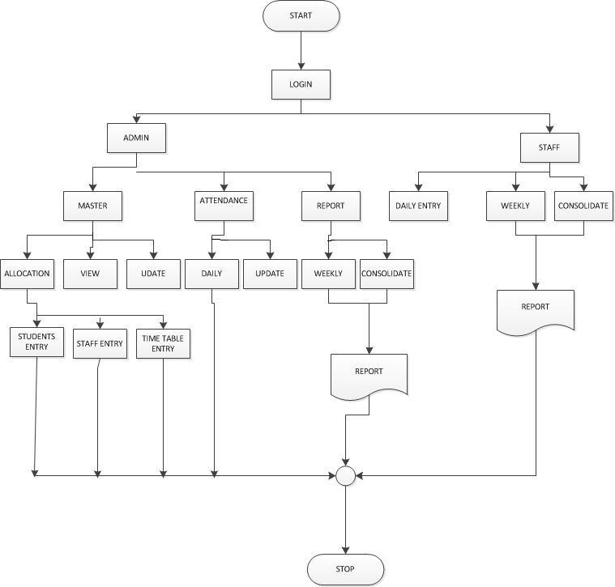

**Fig 3.1:** System Flow Chart

**3.5 SYSTEM DESIGN:**

**3.5.1 Entity Relationship Diagram:**

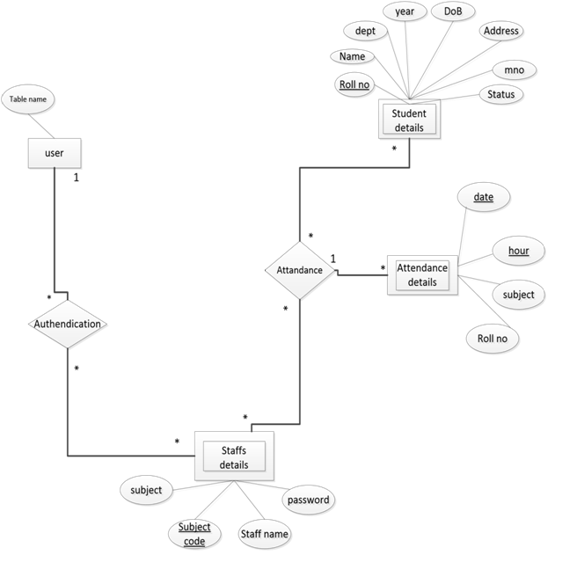

**Fig 3.2:** Entity Relationship Diagram

**3.6 UML DIAGRAMS**

**3.6.1 AN OVERVIEW OF UML**

Unified Modeling Language (UML) is a standardized general purpose modeling language in the field of software engineering..The unified modeling language (UML) is an open method to specify, visualize, construct and document the artifacts of the object oriented software intensive system under development.UML offers a standard way to write a systems blueprint.

**3.6.2 RELATIONSHIPS IN THE UML**

There are four kinds of relationships in the UML

* Dependency
* Association
* Generalization
* Realization

**3.6.3 USE CASE DIAGRAM**

Use case diagram describes the functionality provided by a system in terms of actors, their goals represented as use cases and any dependencies among these use cases.

Use case describes set of sequence of actions that a system performs that yields an observable result of value to particular actor.

Now as we know to discuss that the use case diagram is dynamic in nature, there should be some internal or external factors for making the interaction.

There internal and external agents are known as actor. Use case diagram consists of actors, use cases and their relationships. The diagram is used to model the system/subsystem of an application. A single use case diagram captures a particular functionality of a system.

Hence to model the entire system, a number of use case diagrams are used.

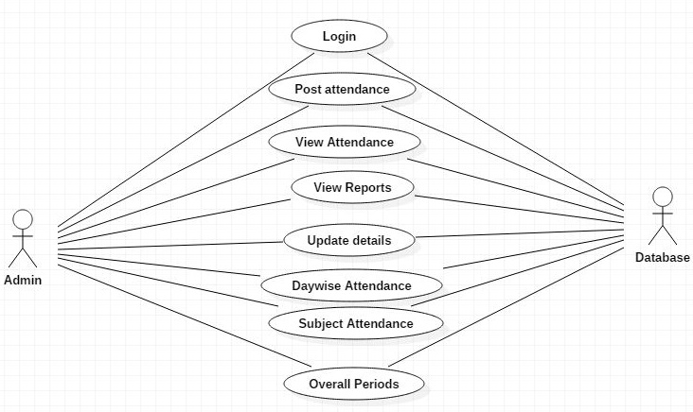

**Fig 3.3:** Use case diagram

**3.6.4 CLASS DIAGRAM**

A Class diagram shows a set of classes and interfaces, collaborations and their relationships. Graphically, a class diagram is a collection of vertices and arcs.

Class diagram commonly contain the following things.

* + Classes
  + Interfaces
  + Collaboration.
  + Dependency, generalization and association relationships.

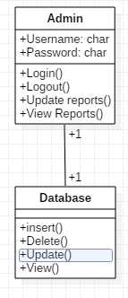

**Fig 3.4:** Class Diagram

**3.6.5 SEQUENCE DIAGRAM**

A sequence diagram is an interaction diagram that emphasizes the time ordering of messages.

* Sequence diagram contains
  + **Object lifeline**

An object life line is vertical dashed lines that represent the existence of an object over a period of time.

* + **Focus of control**

It is represented by rectangle shows the period of time during which an object performs some actions.

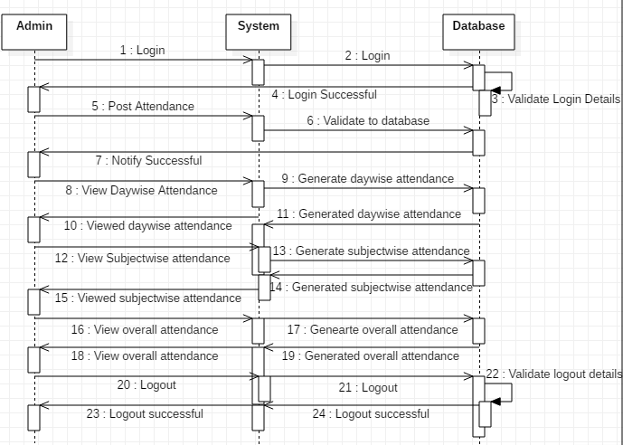

**Fig 3.5:** Sequence Diagram

**3.6.6 STATE CHART DIAGRAM**

A state chart diagram shows a state machine, consisting of states, transactions, events and activities.

* State chart diagrams are used to model the dynamic aspects of the system.
* A state chart diagram show a state machine emphasizing the flow of control from state to state. Event refers to happening of an activity at a given time and place.

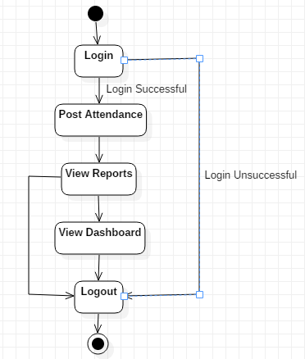

**Fig 3.6:** State Chart Diagram

**3.6.7 ACTIVITY DIAGRAM**

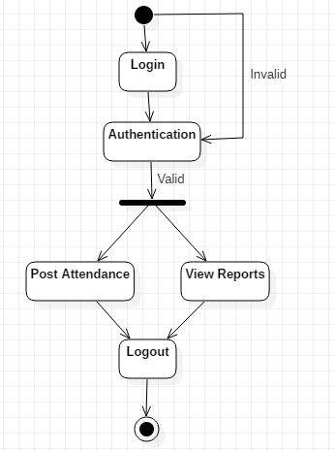

**Fig 3.7:** Activity Diagram

* An activity diagram is a special kind of state chart diagram that shows flow from activity to activity within a system, which are connected by a trigger less transaction.
* We can check some conditions using decision box which is denoted by a diamond.

**3.6.8 COMPONENT DIAGRAM**

Component diagram describes how a software system is split up into components and shows the dependencies among these components.

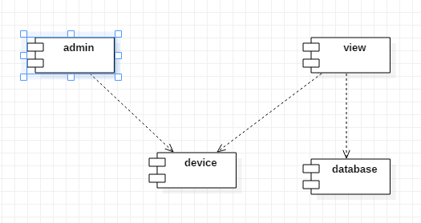

**Fig 3.8:** Component Diagram

**3.6.9 DEPLOYMENT DIAGRAM**

* A Deployment diagram shows the configuration of runtime processing nodes and the components that are present in them.
* Deployment diagram describes the hardware used in system implementations and the execution environments and artifacts deployed on the hardware.

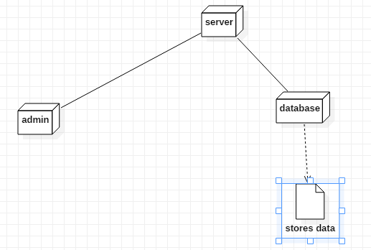

**Fig 3.9:** Deployment Diagram

### **3.7 INPUT DESIGN**

Input design is part of overall system design that requires special attention designing input data is to make the data entered easy and free from **errors**. The input forms are designed using HTML and bootstrap. Validation is made for each and every data that is entered. Help information is provided for the users during when the customer feels difficult.

Input design is the process of converting the user originated inputs to a computer based format. A system user interacting through a workstation must be able to tell the system whether to accept the input to produce reports. The collection of input data is considered to be most expensive part of the system design. Since the input has to be planned in such a manner so as to get relevant information, extreme care is taken to obtain pertinent information

This project first will entered to the input of allocation forms it will be created on student details form and subject entry form, time table form .it will helps to calculate subject wise attendance system. next one if u want any verification on your data’s also available in details show forms. Attendance to entered single subject wise or all subject wise attendance system available in this project.

### **3.8 OUTPUT DESIGN**

Output design this application “**Student Attendance management system”** generally refers to the results and information that are generated by the system for many end-users; output is the main reason for developing the system and the basis on which they evaluate the usefulness of the application.

The output is designed in such a way that it is attractive, convenient and informative. Forms are designed with various features, which make the console output more pleasing.

As the outputs are the most important sources of information to the users, better design should improve the system’s relationships with us and also will help in decision making. Form design elaborates the way output is presented and the layout available for capturing information.

One of the most important factors of the system is the output it produces. This system refers to the results and information generated. Basically the output from a computer system is used to communicate the result of processing to the user.

Attendance management system to show the report subject wise attendance maintaining by staffs. Taken as a whole report obtain on a administrator privileges only. this forms will show weekly report and consolidate report generated date, batch, and class wise to our end user. we want to change our report to convert Excel format .if you want change any modification.

# CHAPTER 4

**SYSTEM SPECIFICATION**

## 4.1 HARDWAREREQUIREMENTS (Minimum Requirement)

* Minimum RAM**:-**1GB
* Hard Disk**:-**128 GB
* Processor**:-**i3

## 4.2SOFTWAREREQUIREMENTS (minimum Requirement)

* **Operating System :**Windows 7
* **Front-end:** HTML, CSS, Javascript, Bootstrap
* **Back-end:** PHP
* **Database:** MySQL

## 4.3 INTRODUCTION TO TECHNOLOGIES:

**4.3.1 ROLE OF PHP IN DATABASE**

PHP is the most popular scripting language for web development. It is free, open source and server-side (the code is executed on the server). MySQL is a Relational Database Management System (RDBMS) that uses Structured Query Language (SQL). It is also free and open source. The combination of PHP and MySQL gives unmet options to create just about any kind of website - from small contact form to large corporate portal**.**

Five important characteristics make PHP's practical nature possible:

* Simplicity
* Efficiency
* Security
* Flexibility
* Familiarity

**4.3.2 STRUCTURED QUERY LANGUAGE (SQL)**

SQL is an inter-active language used to query the database and access data

in database. SQL has the following features:

1. It is a unified language.

2. It is a common language for relational database

3. It is a non-procedural language.

**Why SQL?**

SQL is widely popular because it offers the following advantages:

* Allows users to access data in the relational database management systems.
* Allows users to describe the data.
* Allows users to define the data in a database and manipulate that data.
* Allows to embed within other languages using SQL modules, libraries & pre-compilers.
* Allows users to create and drop databases and tables.
* Allows users to create view, stored procedure, functions in a database.
* Allows users to set permissions on tables, procedures and views.

When you are executing an SQL command for any RDBMS, the system determines the best way to carry out your request and SQL engine figures out how to interpret the task. There are various components included in this process.

These components are –

* Query Dispatcher
* Optimization Engines
* Classic Query Engine
* SQL Query Engine, etc.

A classic query engine handles all the non-SQL queries, but a SQL query engine won't handle logical files.

**4.3.3 INTRODUCTION TO HTML**

* XML stands for Extensible Mark-up Language.
* XML is a Mark-up language much like HTML.
* XML was designed to describe data.
* XML tags are not predefined in XML. You must define your own tags.
* XML is self describing.
* XML uses a DTD (Document Type Definition) to formally describe the data

XML is a file extension for an Extensible Markup Language (XML) file format used to create common information formats and share both the format and the data on the World Wide Web, intranets, and elsewhere using standard ASCII text. XML is similar to HTML.

XML feeds are a form of paid inclusion where a search engine is fed information about an advertiser's web pages by XML. XML is a data delivery language that stands for “Extensible Markup Language” and allows users to define their own elements for sharing.

HTML stands for **H**yper**t**ext **M**arkup **L**anguage, and it is the most widely used language to write Web Pages.

* **Hypertext** refers to the way in which Web pages (HTML documents) are linked together. Thus, the link available on a webpage is called Hypertext.
* As its name suggests, HTML is a **Markup Language** which means you use HTML to simply "mark-up" a text document with tags that tell a Web browser how to structure it to display.

Originally, HTML was developed with the intent of defining the structure of documents like headings, paragraphs, lists, and so forth to facilitate the sharing of scientific information between researchers.

Now, HTML is being widely used to format web pages with the help of different tags available in HTML language.

* HTML is the standard markup language for creating Web pages.
* HTML stands for Hyper Text Markup Language

* HTML describes the structure of Web pages using markup
* HTML elements are the building blocks of HTML pages.
* HTML elements are represented by tags
* HTML tags label pieces of content such as "heading", "paragraph", "table", and so on.

**CHAPTER-5**

**CODING**

**SAMPLE CODE**

<!DOCTYPE html>

<html xmlns="http://www.w3.org/1999/xhtml">

<head>

<meta charset="utf-8" />

<meta name="viewport" content="width=device-width, initial-scale=1.0" />

<title>VSM Group of Institutions</title>

<?php

include("dbConfig.php");

session_start();

include("checklogin.php");

$errormsg= '';

$user=$_SESSION["username"];

?>

<!-- BOOTSTRAP STYLES-->

<link href="css/bootstrap.css" rel="stylesheet" />

<!-- FONTAWESOME STYLES-->

<link href="css/font-awesome.css" rel="stylesheet" />

<!--CUSTOM BASIC STYLES-->

<link href="css/basic.css" rel="stylesheet" />

<!--CUSTOM MAIN STYLES-->

<link href="css/custom.css" rel="stylesheet" />

<!-- GOOGLE FONTS-->

<link href='http://fonts.googleapis.com/css?family=Open+Sans' rel='stylesheet' type='text/css' />

<link href="css/ui.css" rel="stylesheet" />

<link href="css/jquery-ui-1.10.3.custom.min.css" rel="stylesheet" />

<link href="css/datepicker.css" rel="stylesheet" />

<link href="css/datatable/datatable.css" rel="stylesheet" />

<script src="js/jquery-1.10.2.js"></script>

<script type='text/javascript' src='js/jquery/jquery-ui-1.10.1.custom.min.js'></script>

<script type="text/javascript" src="js/validation/jquery.validate.min.js"></script> <script src="js/dataTable/jquery.dataTables.min.js"></script>

<script src="js/jquery.min.js"></script>

<script type="text/javascript">

function downloadCSV(csv, filename) {

var csvFile;

var downloadLink;

// CSV file

csvFile = new Blob([csv], {type: "text/csv"});

// Download link

downloadLink = document.createElement("a");

// File name

downloadLink.download = filename;

// Create a link to the file

downloadLink.href = window.URL.createObjectURL(csvFile);

// Hide download link

downloadLink.style.display = "none";

// Add the link to DOM

document.body.appendChild(downloadLink);

// Click download link

downloadLink.click();

}

function exportTableToCSV(filename) {

var csv = [];

var rows = document.querySelectorAll("table tr");

for (var i = 0; i < rows.length; i++) {

var row = [], cols = rows[i].querySelectorAll("td, th");

for (var j = 0; j < cols.length; j++)

row.push(cols[j].innerText);

csv.push(row.join(","));

}

// Download CSV file

downloadCSV(csv.join("\n"), filename);

}

</script>

<script type="text/javascript">

$(document).ready(function(){

$('#programcode').on('change',function(){

var programcode= $(this).val();

if(programcode){

$.ajax({

type:'POST',

url:'ajaxDept.php',

data:'programcode='+programcode,

success:function(html){

$('#deptcode').html(html);

}

});

$.ajax({

type:'POST',

url:'ajaxperiods.php',

data:'ucoursesem='+programcode,

success:function(html){

$('#semester').html(html);

}

});

$.ajax({

type:'POST',

url:'ajaxperiods.php',

data:'ucourseyear='+programcode,

success:function(html){

$('#studyyear').html(html);

}

});

}else{

$('#deptcode').html('<option value="">Select Program first </option>');

}

});

$('#deptcode').on('change',function(){

var deptcode= $(this).val();

if(deptcode){

$.ajax({

type:'POST',

url:'ajaxDept.php',

data:'deptcode='+deptcode,

success:function(html){

var d= html.split(";")

$('#coursecode').html(d[0]);

$('#facultycode').html(d[1]);

}

});

}else{

$('#coursecode').html('<option value="">Select Department first </option>');

$('#facultycode').html('<option value="">Select Department first </option>');

}

});

$('#semester').on('change',function(){

var facultycode= $('#facultycode').val();

var studyyear= $('#studyyear').val();

var semester= $('#semester').val();

var coursecode= $('#coursecode').val();

var section= $('#section').val();

var adate= $('#adate').val();

var acyear= $('#acyear').val();

var semester= $(this).val();

if(semester){

$.ajax({

type:'POST',

url:'ajaxDept.php',

data:{facultycode:facultycode,studyyear:studyyear,semester:semester,section:section,coursecode:coursecode},

success:function(html){

$('#papercode').html(html);

}

});

}else{

$('#papercode').html('<option value="">Select Course first </option>');

}

});

$('#facultycode').on('change',function(){

var facultycode= $(this).val();

if(facultycode){

$.ajax({

type:'POST',

url:'ajaxDept.php',

data:'facultycode='+facultycode,

success:function(html){

$('#papercode').html(html);

}

});

}else{

$('#papercode').html('<option value="">Select Course first </option>');

}

});

$('#studyyear').on('change',function(){

var year= $(this).val();

var course = $('#programcode').val();

if(year){

$.ajax({

type:'POST',

url:'ajaxperiods.php',

data:'usdyear='+year+'&usdcourse='+course,

success:function(html){

$('#semester').html(html);

}

});

}else{

$('#studyyear').html('<option value="">Select Study Year first </option>');

}

});

$('#papercode').on('change',function(){

var papercode= $(this).val();

var course = $('#programcode').val();

if(papercode){

$.ajax({

type:'POST',

url:'ajaxperiods.php',

data:'papercode='+papercode+'&usdcourse='+course,

success:function(html){

if(html=="Practical")

{ $('.z').show(); }

Else { $('.z').hide(); }

}

});

}else{

$('#studyyear').html('<option value="">Select Paper Code first </option>');

}

});

});

</script>

<!--//paymentHeders-->

<?php

include("headerEN.php");

?>

</head>

<BODY >

<div id="page-wrapper">

<div id="page-inner">

<div class="row">

<div class="col-md-12">

<h1 class="page-head-line">Subject based Attendance </h1>

</div></div>

<?php

echo $errormsg;

date_default_timezone_get('Asia/Kolkata');

$d=date('Y-m-d-H:i:s');

$d1=date('Y-m-d');

$atdate= date("d-m-Y", strtotime($d)); ?>

<div class="row" style="margin-bottom:20px;">

<div class="col-md-12">

<fieldset class="scheduler-border" >

<legend class="scheduler-border">View Student List :</legend>

<?php

$deptcode="";

$coursecode="";

$programcode="";

$batch="";

$studyyear="";

$semester="";

$section="";

if(isset($_POST['deptcode']))

$deptcode=$_POST['deptcode'];

if( !isset($_POST['bulksearch']))

{ ?>

<form action="atten_subject_hrs.php" method="post" id="signupForm1" class="form-horizontal">

<div class="panel-body">

<div class="form-group">

<label class="col-sm-4 control-label" style="text-align: left" for="acyear">Academic year</label>

<div class="col-sm-10">

<input type="text" class="form-control" id="acyear" name="acyear" value="<?php

if(date('n')<=5) echo (date('Y')-1).'-'.(date('Y')); else echo (date('Y')).'-'.(date('Y')+1); ?>" />

</div> </div>

<div class="form-group">

<label class="col-sm-4 control-label" style="text-align: left" for="programcode"> Program Name</label>

<?php

$sql = "select * from tblProgram ";

$rs_result = $conn->query ($sql);

echo "<div class='col-sm-10'> <select class='form-control' name='programcode' id='programcode'>";

echo " <option value=''>Select Program Code</option>";

while ($row = $rs_result->fetch_assoc()) { ?>

<option <?php if ($programcode== $row['programcode'] ) echo 'selected' ;?> value=<?php echo $row['programcode'];?> > <?php echo $row['programname'];?> </option>

<?php }

mysqli_free_result ($rs_result);

echo "</select></div>";

?> </div>

<div class="form-group">

<label class="col-sm-4 control-label" style="text-align: left" for="deptcode">Department Name</label>

<?php

$sql = "select * from tblDept ";

$rs_result = $conn->query ($sql);

echo "<div class='col-sm-10'> <select class='form-control' name='deptcode' id='deptcode'>";

while ($row = $rs_result->fetch_assoc()) { ?>

<option <?php if ($deptcode== $row['deptcode'] ) echo 'selected' ;?> value=<?php echo $row['deptcode'];?> > <?php echo $row['deptname'];?> </option>

<?php }

mysqli_free_result ($rs_result);

echo "</select></div>";

?>

</div>

<div class="form-group">

<label class="col-sm-4 control-label" style="text-align: left" for="coursecode">CourseName</label>

<?php

$sql = "select * from tblCourses ";

$rs_result = $conn->query ($sql);

echo "<div class='col-sm-10'> <select class='form-control' name='coursecode' id='coursecode' required>";

if(substr($coursecode,0,9)=="BTECH-HBS")

$coursecode1=substr($coursecode,0,5).substr($coursecode,9,4);

while ($row = $rs_result->fetch_assoc()) {

if(substr($coursecode,0,9)=="BTECH-HBS"){ ?>

<option <?php if ($coursecode1== $row['coursecode'] ) echo 'selected' ;?> value=<?php echo $row['coursecode'];?> > <?php echo $row['coursename'];?> </option>

<?php

}

else

{ ?>

<option <?php if ($coursecode== $row['coursecode'] ) echo 'selected' ;?> value=<?php echo $row['coursecode'];?> > <?php echo $row['coursename'];?> </option>

<?php }

}

mysqli_free_result ($rs_result);

echo "</select></div>";?></div>

<div class="form-group">

<label class="col-sm-4 control-label" style="text-align: left" for="section">Section</label>

<div class='col-sm-10'> <select class='form-control' name='section' id='section'>

<?php if($studyyear!='') echo " <option value=$section>$section</option>"; ?>

<option value='A'>A</option><option value='B'>B</option>

<option value='C'>C</option> <option value='D'>D</option></select></div></div> <div class="form-group">

<label class="col-sm-4 control-label" style="text-align: left" for="studyyear">Study Year</label>

<?php

echo "<div class='col-sm-10'> <select class='form-control' name='studyyear' id='studyyear' required>";

if($studyyear!="")

echo " <option value='$studyyear'>$studyyear</option>";

echo " <option value=''>Select Study Year</option>";

echo " <option value='I Year'>I Year</option>";

echo " <option value='II Year'>II Year</option>";

echo " <option value='III Year'>III Year</option>";

echo " <option value='IV Year'>IV Year</option>";

echo "</select></div>";

?> </div>

<div class="form-group">

<label class="col-sm-4 control-label" style="text-align: left" for="semester">Semester</label>

<?php

echo "<div class='col-sm-10'> <select class='form-control' name='semester' id='semester' required>";

if($studyyear!="")

echo " <option value='$semester'>$semester</option>";

echo " <option value=''>Select Semester</option>";

echo "</select></div>";

?></div>

<div class="form-group">

<label class="col-sm-4 control-label" style="text-align: left" for="facultycode">Subject/Paper Name</label>

<?php

$cc="";

if ($coursecode=="BTECH-CIVIL") $cc="CVL";

if ($coursecode=="BTECH-CSE") $cc="CSE";

if ($coursecode=="BTECH-MECH") $cc="MEC";

if ($coursecode=="BTECH-ECE") $cc="ECE";

if ($coursecode=="BTECH-EEE") $cc="EEE";

if ($coursecode=="DIPLO-DME") $cc="DME";

if ($coursecode=="DIPLO-DEC") $cc="DEC";

if ($coursecode=="DIPLO-DEE") $cc="DEE";

$sql = "select * from tblPapers where subjectcode like '%$cc%' and studyyear='$studyyear' and semester='$semester' and section='$section'";

$rs_result = $conn->query ($sql);

echo "<div class='col-sm-10'> <select class='form-control' name='papercode' id='papercode' required >";

while ($row = $rs_result->fetch_assoc()) { ?>

<option <?php if ($papercode== $row['papercode'] ) echo 'selected' ;?> value=<?php echo $row[papercode];?> > <?php echo $row[papername];?> </option>

<?php }

mysqli_free_result ($rs_result);

echo "</select></div>";

?>

</div>

<div style='display:none;' class='z'>

<div class="form-group"><label class="col-sm-4 control-label" style="text-align: left" for="batch">Lab Batch</label><?php

echo "<div class='col-sm-10'> <select class='form-control' name='batch' id='batch' >";

if($batch!="")

echo " <option value='$batch'>$batch</option>";

echo " <option value=''>Select Lab Batch</option>";

echo " <option value='Batch-I'>Batch-I</option>";

echo " <option value='Batch-II'>Batch-II</option>";

echo " <option value='Batch-III'>Batch-III</option>";

echo " <option value='Batch-IV'>Batch-IV</option>";

echo "</select></div>";

?> </div></div>

<div class="form-group"><label class="col-sm-4 control-label" style="text-align: left" for="adate">From Date</label>

<div class="col-sm-10">

<input type="date" class="form-control" id="fromdate" name="fromdate" value="<?php echo date('Y-m-d'); ?>" />

</div> </div> <div class="form-group">

<label class="col-sm-4 control-label" style="text-align: left" for="adate">To Date</label>

<div class="col-sm-10">

<input type="date" class="form-control" id="todate" name="todate" value="<?php echo date('Y-m-d'); ?>" />

</div> </div><br> <div class="form-group">

<div class="col-sm-8 col-sm-offset-2">

<input type="hidden" name="id" value="<?php echo $deptcode;?>">

<input type="hidden" name="action" value="<?php echo $action;?>">

<button type="submit" name="bulksearch" class= "btn btn-primary">Get Students List </button></div></div> </div></form>

<?php

}

?>

<!--search by pin-->

<?php if(isset($_POST['bulkpost']))

{

$course=$_POST['pcourse'];

$date=$_POST['pdate'];

$branch=$_POST['pbranch'];

$section=$_POST['psection'];

$studyyear=$_POST['pstudyyear'];

$semester=$_POST['psemester'];

$deptcode=$_POST['pdeptcode'];

$papercode=$_POST['ppapercode'];

$batch=$_POST['pbatch'];

$prd=$_POST['pprds'];

$prds=explode(" ",$prd);

$rno=array();

$pat=array();

$i=0;

foreach($_POST['prollno'] as $no){

$rno[$i]= $no;

$i++;

}

$k=0;

foreach($_POST['patn'] as $no){

$pat[$k]= $no;

$k++;

}

$count=0;

for($m=1;$m<sizeof($prds);$m++){

for($j=0;$j<$i;$j++){

for($l=0;$l<$k;$l++){

$vsql = $conn->query("select * from tblattendancehrs where rollno='".$rno[$j]."' and adate='".date($date)."' ");

if($rno[$j] == $pat[$l])

{

if($vsql->num_rows<=0)

{

if($prds[$m]==1)

$sql= "insert into tblattendancehrs(adate,rollno,h1,pc1) values('".$date."','".$rno[$j]."','a','".$papercode."')";

if($prds[$m]==2)

$sql= "insert into tblattendancehrs(adate,rollno,h2,pc2) values('".$date."','".$rno[$j]."','a','".$papercode."')";

if($prds[$m]==3)

$sql= "insert into tblattendancehrs(adate,rollno,h3,pc3) values('".$date."','".$rno[$j]."','a','".$papercode."')";

if($prds[$m]==4)

$sql= "insert into tblattendancehrs(adate,rollno,h4,pc4) values('".$date."','".$rno[$j]."','a','".$papercode."')";

if($prds[$m]==5)

$sql= "insert into tblattendancehrs(adate,rollno,h5,pc5) values('".$date."','".$rno[$j]."','a','".$papercode."')";

if($prds[$m]==6)

$sql= "insert into tblattendancehrs(adate,rollno,h6,pc6) values('".$date."','".$rno[$j]."','a','".$papercode."')";

if($prds[$m]==7)

$sql= "insert into tblattendancehrs(adate,rollno,h7,pc7) values('".$date."','".$rno[$j]."','a','".$papercode."')";

if($prds[$m]==8)

$sql= "insert into tblattendancehrs(adate,rollno,h8,pc8) values('".$date."','".$rno[$j]."','a','".$papercode."')";

if($conn->query($sql)==false)

echo $conn->error;

}

else

{

if($prds[$m]==1)

$sql= "update tblattendancehrs set h1 ='a',pc1='".$papercode."' where adate='".$date."' and rollno='".$rno[$j]."'";

if($prds[$m]==2)

$sql= "update tblattendancehrs set h2 ='a',pc2='".$papercode."' where adate='".$date."' and rollno='".$rno[$j]."'";

if($prds[$m]==3)

$sql= "update tblattendancehrs set h3 ='a',pc3='".$papercode."' where adate='".$date."' and rollno='".$rno[$j]."'";

if($prds[$m]==4)

$sql= "update tblattendancehrs set h4 ='a',pc4='".$papercode."' where adate='".$date."' and rollno='".$rno[$j]."'";

if($prds[$m]==5)

$sql= "update tblattendancehrs set h5 ='a',pc5='".$papercode."' where adate='".$date."' and rollno='".$rno[$j]."'";

if($prds[$m]==6)

$sql= "update tblattendancehrs set h6 ='a',pc6='".$papercode."' where adate='".$date."' and rollno='".$rno[$j]."'";

if($prds[$m]==7)

$sql= "update tblattendancehrs set h7 ='a',pc7='".$papercode."' where adate='".$date."' and rollno='".$rno[$j]."'";

if($prds[$m]==8)

$sql= "update tblattendancehrs set h8 ='a',pc8='".$papercode."' where adate='".$date."' and rollno='".$rno[$j]."'";

$conn->query($sql);

}

break;

}

else if($vsql->num_rows<=0)

{

if($prds[$m]==1)

$sql= "insert into tblattendancehrs(adate,rollno,h1,pc1) values('".$date."','".$rno[$j]."','p','".$papercode."')";

if($prds[$m]==2)

$sql= "insert into tblattendancehrs(adate,rollno,h2,pc2) values('".$date."','".$rno[$j]."','p','".$papercode."')";

if($prds[$m]==3)

$sql= "insert into tblattendancehrs(adate,rollno,h3,pc3) values('".$date."','".$rno[$j]."','p','".$papercode."')";

if($prds[$m]==4)

$sql= "insert into tblattendancehrs(adate,rollno,h4,pc4) values('".$date."','".$rno[$j]."','p','".$papercode."')";

if($prds[$m]==5)

$sql= "insert into tblattendancehrs(adate,rollno,h5,pc5) values('".$date."','".$rno[$j]."','p','".$papercode."')";

if($prds[$m]==6)

$sql= "insert into tblattendancehrs(adate,rollno,h6,pc6) values('".$date."','".$rno[$j]."','p','".$papercode."')";

if($prds[$m]==7)

$sql= "insert into tblattendancehrs(adate,rollno,h7,pc7) values('".$date."','".$rno[$j]."','p','".$papercode."')";

if($prds[$m]==8)

$sql= "insert into tblattendancehrs(adate,rollno,h8,pc8) values('".$date."','".$rno[$j]."','p','".$papercode."')";

$conn->query($sql);

}

else

{

if($prds[$m]==1)

$sql= "update tblattendancehrs set h1 ='p',pc1='".$papercode."' where adate='".$date."' and rollno='".$rno[$j]."'";

if($prds[$m]==2)

$sql= "update tblattendancehrs set h2 ='p',pc2='".$papercode."' where adate='".$date."' and rollno='".$rno[$j]."'";

if($prds[$m]==3)

$sql= "update tblattendancehrs set h3 ='p',pc3='".$papercode."' where adate='".$date."' and rollno='".$rno[$j]."'";

if($prds[$m]==4)

$sql= "update tblattendancehrs set h4 ='p',pc4='".$papercode."' where adate='".$date."' and rollno='".$rno[$j]."'";

if($prds[$m]==5)

$sql= "update tblattendancehrs set h5 ='p',pc5='".$papercode."' where adate='".$date."' and rollno='".$rno[$j]."'";

if($prds[$m]==6)

$sql= "update tblattendancehrs set h6 ='p',pc6='".$papercode."' where adate='".$date."' and rollno='".$rno[$j]."'";

if($prds[$m]==7)

$sql= "update tblattendancehrs set h7 ='p',pc7='".$papercode."' where adate='".$date."' and rollno='".$rno[$j]."'";

if($prds[$m]==8)

$sql= "update tblattendancehrs set h8 ='p',pc8='".$papercode."' where adate='".$date."' and rollno='".$rno[$j]."'";

$conn->query($sql);

} } } }

echo "<script language='javascript' type='text/javascript'>";

echo "alert(' Attendance is posted!');";

echo "</script>";

}

?>

<?php if(isset($_POST['bulksearch']))

{

$course=$_POST['coursecode'];

$programcode= $_POST['programcode'];

$fromdate=$_POST['fromdate'];

$todate=$_POST['todate'];

$acyear=$_POST['acyear'];

$deptcode=$_POST['deptcode'];

$section=$_POST['section'];

$studyyear=$_POST['studyyear'];

$semester=$_POST['semester'];

$papercode=$_POST['papercode'];

$batch=$_POST['batch'];

$rollno="";

$acount=0;

$scount=0;

$namequery = $conn->query("select * from students where course='$course' and acyear='$acyear' and studyyear='$studyyear' and semester='$semester' ");

$namecount = $namequery->num_rows;

$sno=1;

$psql = $conn->query("select papername from tblPapers where papercode='$papercode'");

$prs1=$psql->fetch_assoc();

$vsql = $conn->query("select distinct(adate) as adate from tblattendancehrs where (pc1='".$papercode."' or pc2='".$papercode."' or pc3='".$papercode."' or pc4='".$papercode."' or pc5='".$papercode."' or pc6='".$papercode."' or pc7='".$papercode."' or pc8='".$papercode."') and adate>='".date($fromdate)."' and adate<='".date($todate)."' ");

$dcnt=0;

while($row1 = $vsql->fetch_assoc())

{

$dcnt++;

}

?>

<form method="post" class="form-inline" name="bulkpayform" action="atten_subject_hrs.php" >

<table border="1">

<tr>

<td colspan=<?php echo $dcnt+5;?> STYLE="color: red; font-family: Verdana; font-weight: bold; font-size: 17px; background-color: #EEE;"><?php echo $course."<br>".$studyyear ; ?>

<?php echo $semester." Section: ".$section; ?>

<?php echo " From:" .date("d-m-Y", strtotime($fromdate)); ?>

<?php echo " To:". date("d-m-Y", strtotime($todate)); ?> </td> <input type="hidden" id="batch" name="batch" value="<?php echo $batch; ?>" </tr> <tr>

<td colspan=<?php echo $dcnt+5;?> STYLE="color: green; font-family: Verdana; font-weight: bold; font-size: 17px; background-color: #EEE;"><?php echo $papercode." ".$prs1['papername'];?></td>

</tr>

<tr STYLE="color: red; font-family: Verdana; font-weight: bold; font-size: 15px; background-color: #0EE;">

<th>S.No</th> <th>RollNo</th> <th>Student Name</th>

<?php

$vsql = $conn->query("select distinct(adate) as adate from tblattendancehrs where (pc1='".$papercode."' or pc2='".$papercode."' or pc3='".$papercode."' or pc4='".$papercode."' or pc5='".$papercode."' or pc6='".$papercode."' or pc7='".$papercode."' or pc8='".$papercode."') and adate>='".date($fromdate)."' and adate<='".date($todate)."' ");

$dcnt=0;

while($row1 = $vsql->fetch_assoc())

{

echo "<th>". date("d-m", strtotime($row1['adate']))."</th>";

$dcnt++;

}

?></th>

<th>No.of Periods</th> <th>Percent%</th> </tr>

<?php

date_default_timezone_get('Asia/Kolkata');

$d=date('Y-m-d-H:i:s');

$d1=date('Y-m-d');

$rcptdate = date("d-m-Y", strtotime($d));

$psql = $conn->query("select papertype from tblPapers where papercode='$papercode'");

$prs1=$psql->fetch_assoc();

if($prs1['papertype']=="Practical" and $batch !="")

{

$psql = $conn->query("select * from tbllabsections where papercode='$papercode' and batch='$batch' ");

$prs=$psql->fetch_assoc();

$rolls= $prs['rollnos'];

$rnos=explode(",",$rolls);

for($i=0;$i<sizeof($rnos);$i++)

{

$pat="";

$pat='pat'.$rnos[$i];

$psqlname = $conn->query("select studentname from tblstudents where rollno='$rnos[$i]' ");

$prsname=$psqlname->fetch_assoc();

?> <tr>

<td><?php echo $sno; $sno++; ?></td>

<td STYLE="color: red; font-family: Verdana; font-weight: bold; font-size: 15px;background-color: #EEE;" ><?php echo $rnos[$i]; ?> </td>

<td STYLE="color: red; font-family: Verdana; font-weight: bold; font-size: 15px;background-color: #EEE;" ><?php echo $prsname['studentname']; ?></td>

<?php

$vsql = $conn->query("select distinct(adate) as adate from tblattendancehrs where (pc1='".$papercode."' or pc2='".$papercode."' or pc3='".$papercode."' or pc4='".$papercode."' or pc5='".$papercode."' or pc6='".$papercode."' or pc7='".$papercode."' or pc8='".$papercode."') and adate>='".date($fromdate)."' and adate<='".date($todate)."' ");

$preat=0;

$at=0;

$c1=0; $c2=0;$c3=0;$c4=0;$c5=0;$c6=0;$c7=0;$c8=0;

$thcnt=0;

while($row1 = $vsql->fetch_assoc())

{

$hcnt=0;

$vsql2 = $conn->query("select h1 from tblattendancehrs where (pc1='".$papercode."' ) and adate='".$row1['adate']."' and rollno='".$rnos[$i]."' ");

if($vsql2->num_rows>0)

{

$hcnt++;

$row2 = $vsql2->fetch_assoc();

if($row2['h1']=="p")

$c1=1 ;

else

$c1=0 ;

}

$vsql2 = $conn->query("select h2 from tblattendancehrs where (pc2='".$papercode."' ) and adate='".$row1['adate']."' and rollno='".$rnos[$i]."' ");

if($vsql2->num_rows>0)

{

$hcnt++;

$row2 = $vsql2->fetch_assoc();

if($row2['h2']=="p")

$c2=1 ;

else

$c2=0 ;

}

$vsql2 = $conn->query("select h3 from tblattendancehrs where (pc3='".$papercode."' ) and adate='".$row1['adate']."' and rollno='".$rnos[$i]."' ");

if($vsql2->num_rows>0)

{

$hcnt++;

$row2 = $vsql2->fetch_assoc();

if($row2['h3']=="p")

$c3=1 ;

else

$c3=0 ;

}

$vsql2 = $conn->query("select h4 from tblattendancehrs where (pc4='".$papercode."' ) and adate='".$row1['adate']."' and rollno='".$rnos[$i]."' ");

if($vsql2->num_rows>0)

{

$hcnt++;

$row2 = $vsql2->fetch_assoc();

if($row2['h4']=="p")

$c4=1 ;

else

$c4=0 ;

}

$vsql2 = $conn->query("select h5 from tblattendancehrs where (pc5='".$papercode."' ) and adate='".$row1['adate']."' and rollno='".$rnos[$i]."' ");

if($vsql2->num_rows>0)

{

$hcnt++;

$row2 = $vsql2->fetch_assoc();

if($row2['h5']=="p")

$c5=1 ;

else

$c5=0 ;

}

$vsql2 = $conn->query("select h6 from tblattendancehrs where (pc6='".$papercode."' ) and adate='".$row1['adate']."' and rollno='".$rnos[$i]."' ");

if($vsql2->num_rows>0)

{

$hcnt++;

$row2 = $vsql2->fetch_assoc();

if($row2['h6']=="p")

$c6=1 ;

else

$c6=0 ;

}

$vsql2 = $conn->query("select h7 from tblattendancehrs where (pc7='".$papercode."' ) and adate='".$row1['adate']."' and rollno='".$rnos[$i]."' ");

if($vsql2->num_rows>0)

{

$hcnt++;

$row2 = $vsql2->fetch_assoc();

if($row2['h7']=="p")

$c7=1 ;

else

$c8=0 ;

}

$vsql2 = $conn->query("select h8 from tblattendancehrs where (pc8='".$papercode."' ) and adate='".$row1['adate']."' and rollno='".$rnos[$i]."' ");

if($vsql2->num_rows>0)

{

$hcnt++;

$row2 = $vsql2->fetch_assoc();

if($row2['h4']=="p")

$c8=1 ;

else

$c8=0 ;

}

$at= $preat+$c1+$c2+$c3+$c4+$c5+ $c6+$c7+$c8;

if($at !=0)

echo "<td>". $at."</td>";

else

echo "<td>". $preat."</td>";

$preat=$at;

$thcnt=$thcnt+$hcnt ;

}

$percent=round(($at*100)/($thcnt),2);

echo "<td>". $at."</td>";

echo "<td>". $percent."</td>";

?> </tr> <?php } }

else

{

while($feemaster = $namequery->fetch_assoc())

{

$rollno=$feemaster['student_id'];

$pat="";

$pat='pat'.$rollno ;

$psqlname = $conn->query("select studentname from tblstudents where rollno='$rollno' ");

$prsname=$psqlname->fetch_assoc();

?>

<tr>

<td><?php echo $sno; $sno++; ?></td>

<td STYLE="color: red; font-family: Verdana; font-weight: bold; font-size: 15px;background-color: #EEE;" ><?php echo $rollno; ?> </td>

<td STYLE="color: red; font-family: Verdana; font-weight: bold; font-size: 15px;background-color: #EEE;" ><?php echo $prsname['studentname']; ?></td>

<?php

$vsql = $conn->query("select distinct(adate) as adate from tblattendancehrs where (pc1='".$papercode."' or pc2='".$papercode."' or pc3='".$papercode."' or pc4='".$papercode."' or pc5='".$papercode."' or pc6='".$papercode."' or pc7='".$papercode."' or pc8='".$papercode."') and adate>='".date($fromdate)."' and adate<='".date($todate)."' ");

$preat=0;$at=0;$thcnt=0;

while($row1 = $vsql->fetch_assoc())

{

$c1=0; $c2=0;$c3=0;$c4=0;$c5=0;$c6=0;$c7=0;$c8=0;

$hcnt=0;

$vsql2 = $conn->query("select h1 from tblattendancehrs where (pc1='".$papercode."' ) and adate='".$row1['adate']."' and rollno='".$rollno."' ");

if($vsql2->num_rows>0)

{

$hcnt++;

$row2 = $vsql2->fetch_assoc();

if($row2['h1']=="p")

$c1=1 ;

else

$c1=0 ;

}

$vsql2 = $conn->query("select h2 from tblattendancehrs where (pc2='".$papercode."' ) and adate='".$row1['adate']."' and rollno='".$rollno."' ");

if($vsql2->num_rows>0)

{

$hcnt++;

$row2 = $vsql2->fetch_assoc();

if($row2['h2']=="p")

$c2=1 ;

else

$c2=0 ;

}

$vsql2 = $conn->query("select h3 from tblattendancehrs where (pc3='".$papercode."' ) and adate='".$row1['adate']."' and rollno='".$rollno."' ");

if($vsql2->num_rows>0)

{

$hcnt++;

$row2 = $vsql2->fetch_assoc();

if($row2['h3']=="p")

$c3=1 ;

else

$c3=0 ;

}

$vsql2 = $conn->query("select h4 from tblattendancehrs where (pc4='".$papercode."' ) and adate='".$row1['adate']."' and rollno='".$rollno."' ");

if($vsql2->num_rows>0)

{

$hcnt++;

$row2 = $vsql2->fetch_assoc();

if($row2['h4']=="p")

$c4=1 ;

else

$c4=0 ;

}

$vsql2 = $conn->query("select h5 from tblattendancehrs where (pc5='".$papercode."' ) and adate='".$row1['adate']."' and rollno='".$rollno."' ");

if($vsql2->num_rows>0)

{

$hcnt++;

$row2 = $vsql2->fetch_assoc();

if($row2['h5']=="p")

$c5=1 ;

else

$c5=0 ;

}

$vsql2 = $conn->query("select h6 from tblattendancehrs where (pc6='".$papercode."' ) and adate='".$row1['adate']."' and rollno='".$rollno."' ");

if($vsql2->num_rows>0)

{

$hcnt++;

$row2 = $vsql2->fetch_assoc();

if($row2['h6']=="p")

$c6=1 ;

else

$c6=0 ;

}

$vsql2 = $conn->query("select h7 from tblattendancehrs where (pc7='".$papercode."' ) and adate='".$row1['adate']."' and rollno='".$rollno."' ");

if($vsql2->num_rows>0)

{

$hcnt++;

$row2 = $vsql2->fetch_assoc();

if($row2['h7']=="p")

$c7=1 ;

else

$c7=0 ;

}

$vsql2 = $conn->query("select h8 from tblattendancehrs where (pc8='".$papercode."' ) and adate='".$row1['adate']."' and rollno='".$rollno."' ");

if($vsql2->num_rows>0)

{

$hcnt++;

$row2 = $vsql2->fetch_assoc();

if($row2['h8']=="p")

$c8=1 ;

else

$c8=0 ;

}

$at= $preat+$c1+$c2+$c3+$c4+$c5+$c6+$c7+$c8;

if($at !=0)

echo "<td>". $at."</td>";

else

echo "<td>". $preat."</td>";

$preat=$at;

$thcnt=$thcnt+$hcnt ;

}

$percent=round(($at*100)/($thcnt),2);

echo "<td>". $at."</td>";

echo "<td>". $percent."</td>";

?></tr><?php} } ?>

<input type="hidden" id="sno" name="sno" value="<?php echo $sno;?>" >

<input type="hidden" id="pcourse" name="pcourse" value="<?php echo $course;?>">

<input type="hidden" id="pbatch" name="pbatch" value="<?php echo $batch;?>" >

<input type="hidden" id="pbranch" name="pbranch" value="<?php echo $branch;?>" >

<input type="hidden" id="pdate" name="pdate" value="<?php echo $date;?>" >

<input type="hidden" id="psection" name="psection" value="<?php echo $section;?>" >

<input type="hidden" id="pstudyyear" name="pstudyyear" value="<?php echo $studyyear;?>" >

<input type="hidden" id="psemester" name="psemester" value="<?php echo $semester;?>" >

<input type="hidden" id="pdeptcode" name="pdeptcode" value="<?php echo $deptcode;?>" >

<input type="hidden" id="ppapercode" name="ppapercode" value="<?php echo $papercode;?>" >

<input type="hidden" id="pprds" name="pprds" value="<?php echo $prds;?>" >

<input type="hidden" id="pprds" name="pprds" value="<?php echo $prds;?>" >

<tr><td colspan=<?php echo $dcnt+5;?> align="center" STYLE="color: blue; font-family: Verdana; font-weight: bold; font-size: 25px;background-color: #EEE;"> <?php echo "No.of Days: ". $dcnt; ?>

<?php echo " No.of Periods: ". $thcnt; ?></td></tr>

<tr><td colspan=<?php echo $dcnt+5;?> align="center">

<input type="button" name="bulkpost" class="btn btn-success " style="height:50px;font-size:20px;" value="Export CSV(Excel) File" onclick="exportTableToCSV('Attendance.csv')" >

</td></tr> </table> </form></fieldset><?php }?>

<!--paymentform-->

</style>

</form>

</div>

</div>

</div>

</div>

<style>

#doj .ui-datepicker-calendar

{

display:none;

}

</style>

<div id="footer-sec">

VSM | Developed By : <a href="#" target="_blank">VSM</a>

</div>

<!-- BOOTSTRAP SCRIPTS -->

<script src="js/bootstrap.js"></script>

<!-- METISMENU SCRIPTS -->

<script src="js/jquery.metisMenu.js"></script>

<!-- CUSTOM SCRIPTS -->

<script src="js/custom1.js"></script>

</body>

</html><?php //} ?

**5.2 DATA DICTIONARY**

**5.2.1 ADMIN TABLE**

|  |  |  |  |  |
| --- | --- | --- | --- | --- |
| **Column**  **Name** | **Data type** | **Size** | **Constraints** | **Description** |
| User id | Varchar2 | 15 | PRIMARY KEY | Admin login id |
| Password | Varchar2 | 15 | Not NULL | Admin password |

**Fig 5.1:** Admin Table

**5.2.2 SUBJECTS TABLE:**

|  |  |  |  |  |
| --- | --- | --- | --- | --- |
| **Column name** | **Data type** | **Size** | **Constraint** | **Description** |
| Course code | Varchar2 | 5 | Not NULL | Selected course code |
| Regulation | Varchar2 | 5 | Not NULL | Selected regulation |
| Subject Code | Varchar2 | 5 | Not NULL | Selected Subject code |
| Subject name | Varchar2 | 25 | Not NULL | Selected Subject |
| Status | Varchar2 | 2 | Not NULL | Status |

# Fig 5.2: Subjects Table

**5.2.3 DEPARTMENT TABLE**

|  |  |  |  |  |
| --- | --- | --- | --- | --- |
| **Column name** | **Data Type** | **Size** | **Constraint** | **Description** |
| Dept Code | Varchar2 | 5 | NOT NULL | Selected Code |
| Dept Name | Varchar2 | 30 | NOT NULL | Selected Department |
| Program code | Varcher2 | 10 | NOT NULL | Selected Program code |
| Dept location | Varchar2 | 20 |  | Department location |
| Dept phone | Int | 10 |  | Department Phone number |
| User id | Varchar2 | 15 | PRIMARY KEY | User id |
| Password | Varchar2 | 15 | NOT NULL | Password of the user |
| Type | Varchar2 | 15 | NOT NULL | Type of User |
| Email id | Varchar2 | 25 |  | Specific email id |
| Modified date | Date |  |  | Modified date |
| Status | Int | 1 |  | Status |

**Fig 5.3:** Department Table

# CHAPTER 6

# SYSTEM TESTING

**6.1 Introduction**

Once source code has been generated, software must be tested to uncover (and correct) as many errors as possible before delivery to customer. Our goal is to design a series of test cases that have a high likelihood of finding errors. To uncover the errors software techniques are used. These techniques provide systematic guidance for designing test that

1. Exercise the internal logic of software components, and
2. Exercise the input and output domains of the program to uncover errors. In program function, behavior and performance.

**6.1.1 Steps**

Software is tested from two different perspectives:

(1)Internal program logic is exercised using ―White box‖ test case design Techniques.

(2)Software requirements are exercised using ―block box‖ test case Design techniques.

In both cases, the intent is to find the maximum number of errors with the Minimum amount of effort and time.

**6.2Testing Methodologies**

A strategy for software testing must accommodate low-level tests that are necessary to verify that a small source code segment has been correctly implemented as well as high-level tests that validate major system functions against customer requirements. A strategy must provide guidance for the practitioner and a set of milestones for the manager. Because the steps of the test strategy occur at a time when deadline pressure begins to rise, progress must be measurable and problems must surface as early as possible. Following testing techniques are well known and the same strategy is adopted during this project testing.

**6.2.1 Unit testing**

Unit testing focuses verification effort on the smallest unit of software design- the software component or module. The unit test is white-box oriented. The unit testing implemented in every module of student attendance management System. by giving correct manual input to the system ,the datas are stored in database and retrieved. If you want required module to access input or get the output from the End user. any error will accrued the time will provide handler to show what type of error will accrued .

**6.2.2 System testing**

System testing is actually a series of different tests whose primary purpose is to fully exercise the computer-based system. Below we have described the two types of testing which have been taken for this project. it is to check all modules worked on input basis .if you want change any values or inputs will change all information. so specified input is must.

**6.2.3 Performance Testing**

Performance testing is designed to test the run-time performance of software within the context of an integrated system. Performance testing occurs throughout all steps in the testing process. Even at the unit level, the performance of an individual module may be assessed as white-box tests are conducted.

This project reduce attendance table, codes. it will generate report fast.no have extra time or waiting of results .entered correct data will show result few millisecond. just used only low memory of our system. Automatically do not getting access at another software. Get user permission and access to other applications.

**6.3 Test Cases :**

|  |  |  |  |  |  |  |  |
| --- | --- | --- | --- | --- | --- | --- | --- |
| **Sno** | **Test case id** | **Testcase name** | **Test case description** | **Step** | **Expected result** | **Actual Result** | **Test case status pass**  **Or fail** |
| 1 | Login admin | Validate login | To verify that login  name on login page | Enter the login name and password and click submit button | Login successful  or an error message “In valid login or password” must be displayed | Login successful | Pass |
| 2 | Login Staff | Validate login | To verify that login  name on login page | Enter the login name and password and click submit button | Login successful  or an error message “In valid login or password” must be displayed | Login successful | Pass |
| 3 | Password | Validate password | To verify that  password on login page | Enter password  and login  name  click submit button | An error message “password invalid” must be displayed | An error message  “password invalid” must be displayed | fail |

|  |  |  |  |  |  |  |  |
| --- | --- | --- | --- | --- | --- | --- | --- |
| **Sno** | **Test case id** | **Testcase name** | **Test case description** | **Step** | **Expected result** | **Actual Result** | **Test case status pass**  **Or fail** |
| 1 | Fine Amount | To generate fine amount | To generate fine amount for the students whose percentage is less than 75 | The percentage is calculated dynamically. | The fine amount will be generated for the students whose percentage is less than 75. | Fine amount will be generated to the students whose percentage is less than 75. | Pass |
| 2 | Fine Amount | To generate fine amount | To generate fine amount for the students whose percentage is less than 75 | The percentage is calculated dynamically | The fine amount will be generated for the students whose percentage is less than 75. | Fine amount is not generated to the students whose percentage is less than 75. | Fail |

**CHAPTER 7**

**SCREEN SHOTS**

**7.1 ATTENDANCE DASHBOARD**

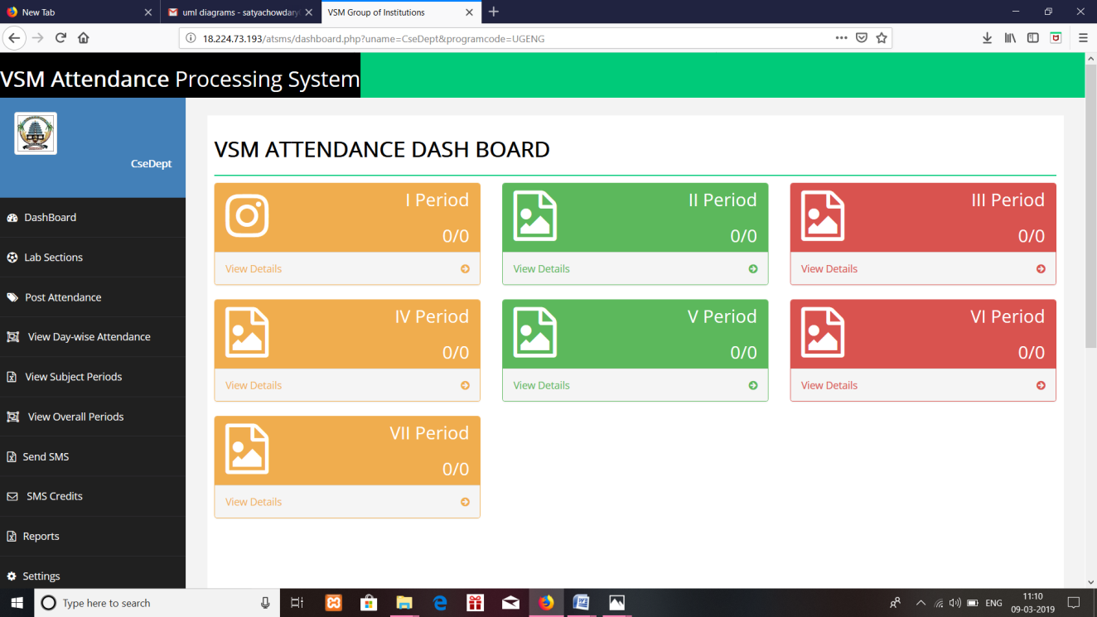

**Fig 7.1:** Attendance Dashboard

**7.2 POST ATTENDANCE**

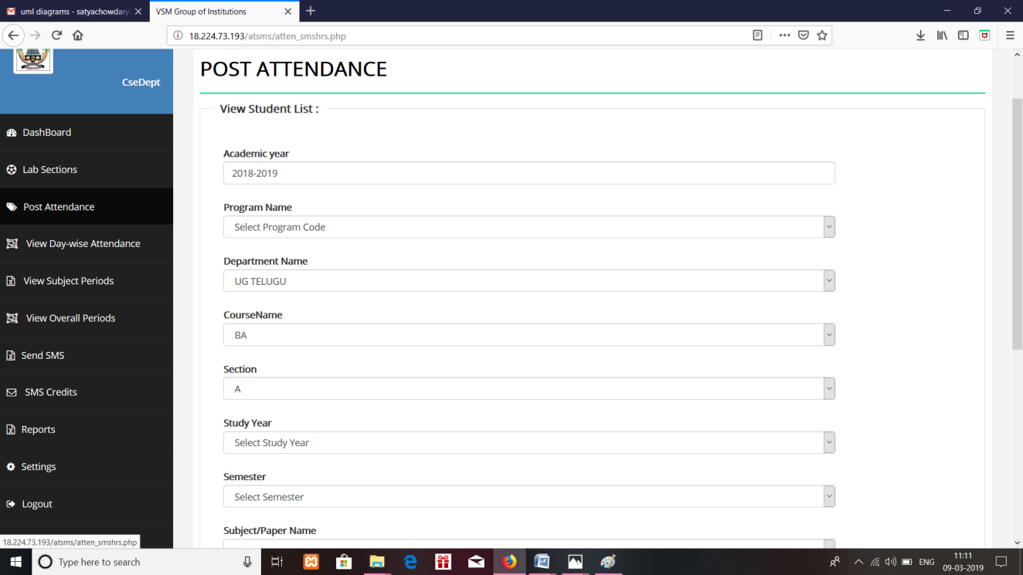

**Fig 7.2:** Post Attendance

**7.3 STUDENTS LIST**

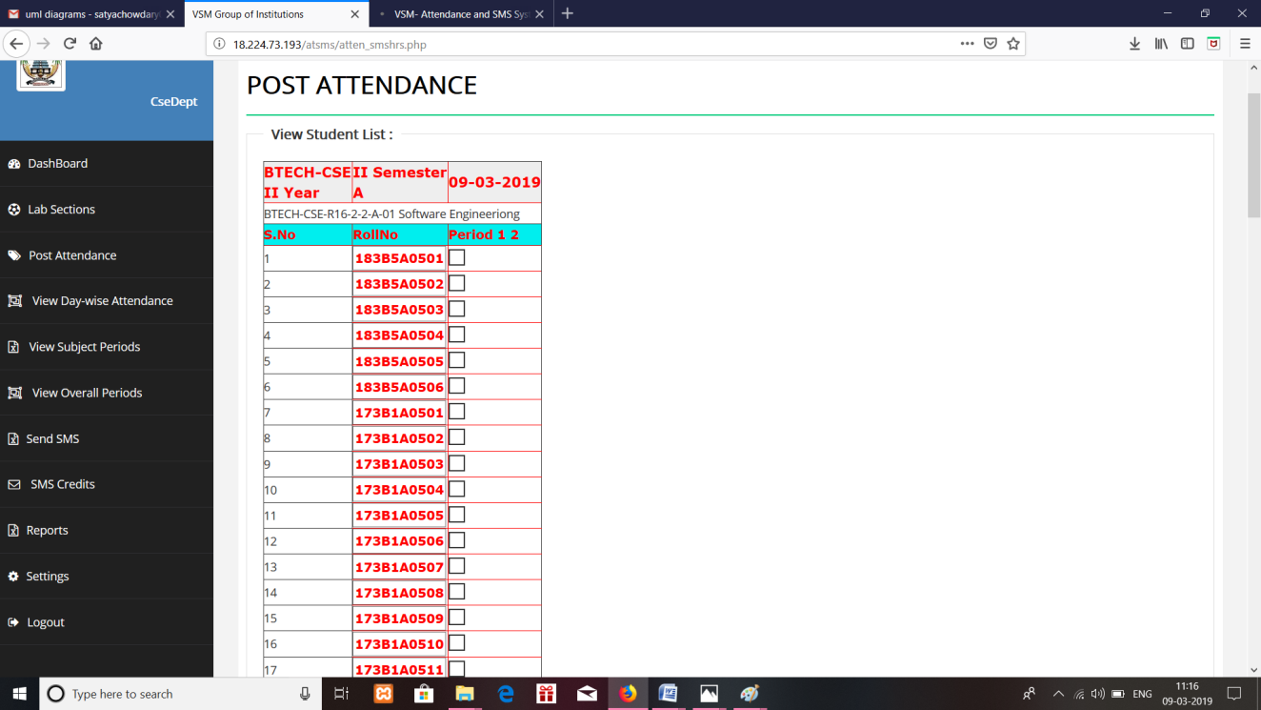

**Fig 7.3:** Students List

**7.4 VIEW DAY ATTENDANCE**

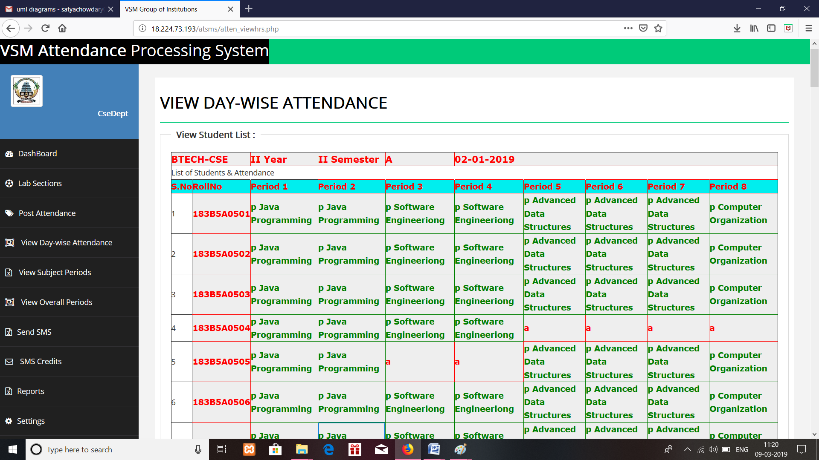

**Fig 7.4:** View Day Attendance

**7.5 SUBJECT ATTENDANCE**

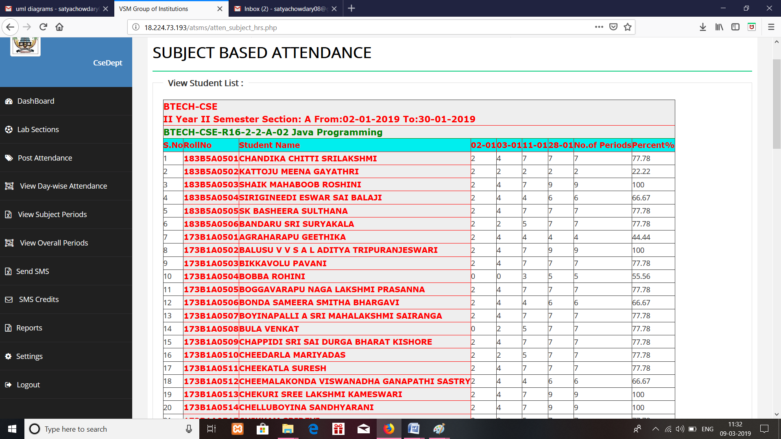

**Fig 7.5:** Subject Attendance

**7.6 OVERALL ATTENDANCE**

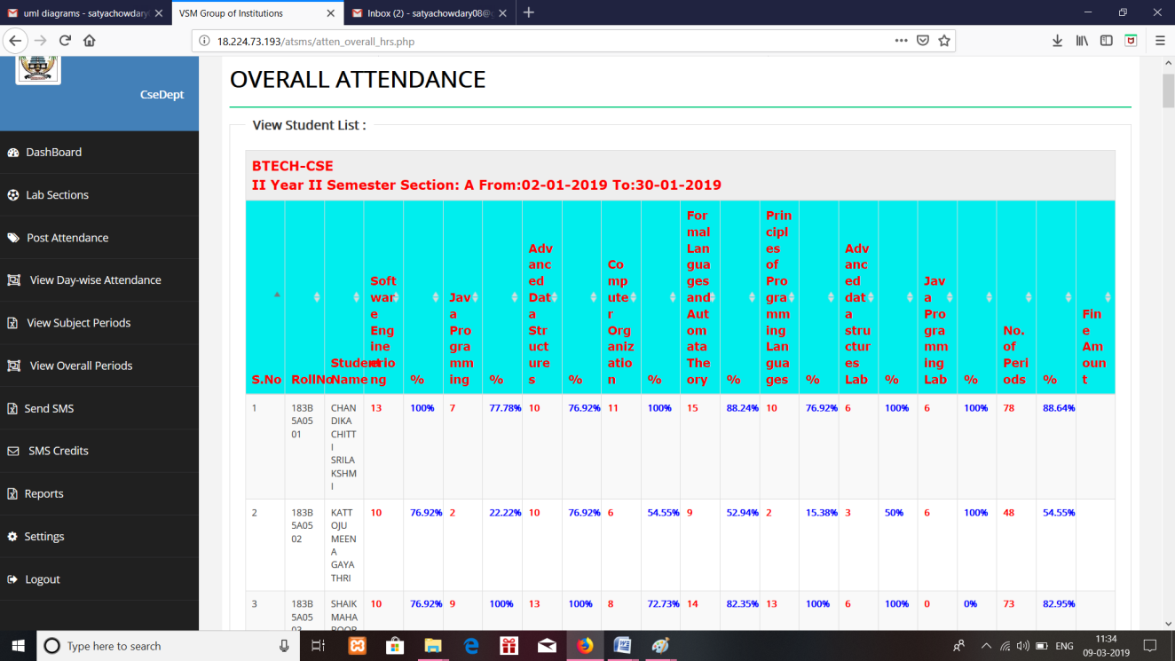

**Fig 7.6:** Overall Attendance

# CHAPTER 8

# CONCLUSION AND FUTURE ENHANCEMENT

## 8.1 Conclusion

To conclude, Project Data Grid works like a component which can access all the databases and picks up different functions. It overcomes the many limitations incorporated in the attendance.

* Easy implementation Environment
* Generate report Flexibly

## 8.2 Scope for future development

The project has a very vast scope in future. The project can be implemented on intranet in future. Project can be updated in near future as and when requirement for the same arises, as it is very flexible in terms of expansion. With the proposed software of database Space Manager ready and fully functional the client is now able to manage and hence run the entire work in a much better, accurate and error free manner. The following are the future scope for the project.

* Bar code Reader based attendance system.
* Individual Attendance system with photo using Student login.

## CHAPTER 9

## BIBLIOGRAPHY&REFERENCES

**Bibliography:**

1. Software Engineering, 8/e, Sommerville, Pearson.

2. Software Engineering, 7/e , Roger S.Pressman , TMH

3. Software Engineering, concepts and practices, UgrasenSuman, Cengage learning

4. Web Technologies, HTML&lt; JavaScript, PHP, Java, JSP, XML and AJAX, Black book, Dream Tech.

5. Programming the World Wide Web, Robet W Sebesta, 7ed, Pearson.

6. The Unified Modeling Language Reference Manual 2nd Edition English, Grady Booch, James Rumbaugh, Ivar Jacobson.

**Reference:**

7. [www.w3schools.com](http://www.w3schools.com)

8. <https://www.tutorialspoint.com/uml/index.htm>

9. <https://www.javatpoint.com/php-tutorial>

10. <https://www.tutorialspoint.com/software_engineering/index.htm>