* **REGISTERED REQUIRED JARS**

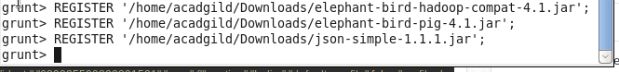

* **load_tweets = LOAD '/user/flume/tweets/' USING com.twitter.elephantbird.pig.load.JsonLoader('-nestedLoad') AS myMap;**

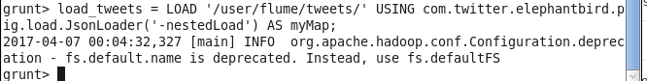

* **dump load_tweets;**

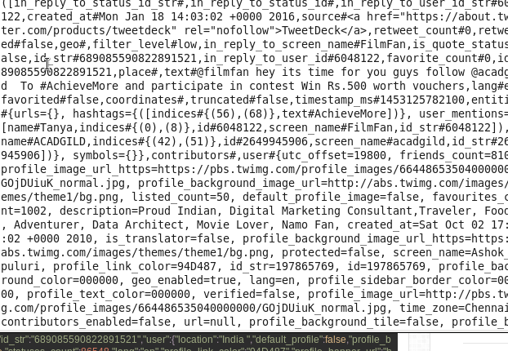

* **extract_details = FOREACH load_tweets GENERATE myMap#'id' as id,myMap#'text' as text;**

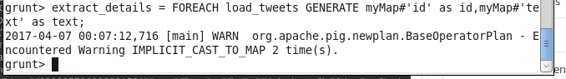

* **dump extract_details;**

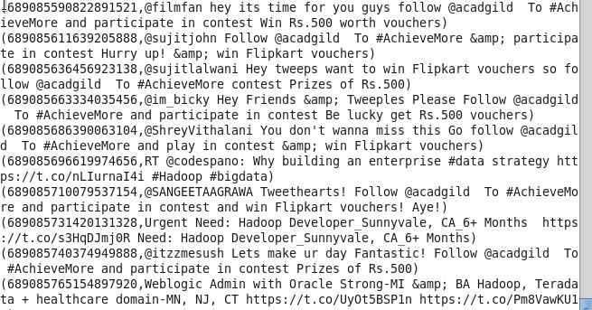

* **tokens = foreach extract_details generate id,text, FLATTEN(TOKENIZE(text)) As word;**

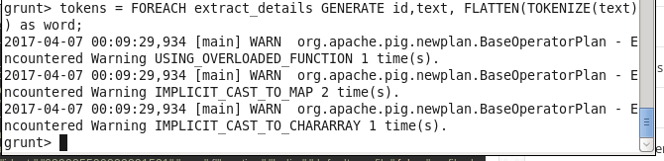

* **dump tokens;**

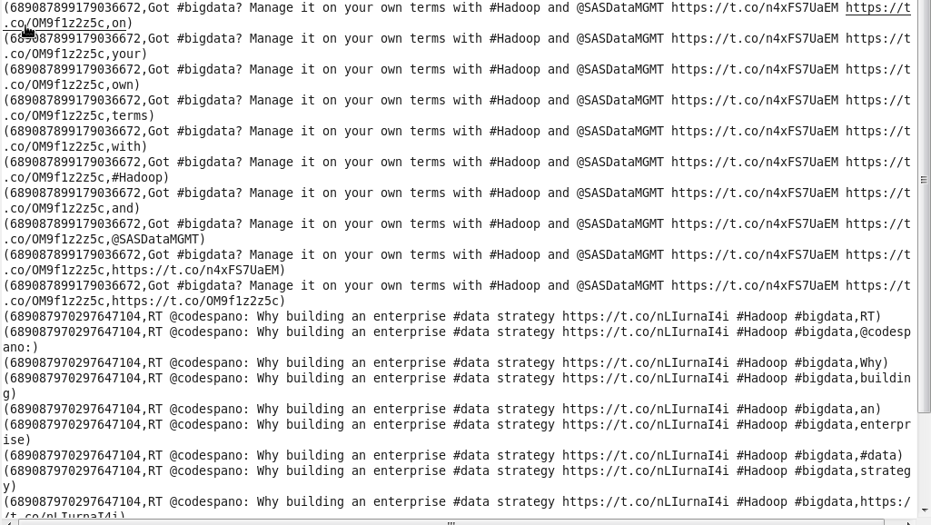

* **dictionary = load '/user/acadgild/hadoop/AFINN.txt' using PigStorage('\t') AS(word:chararray,rating:int);**

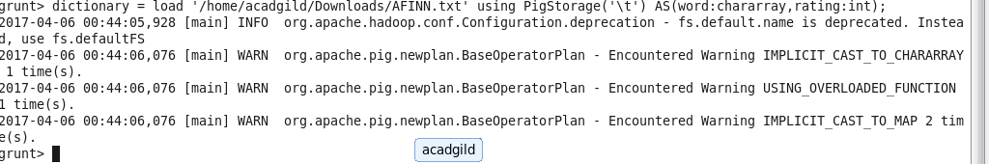

* **dump dictionary(LIMITED by 25);**

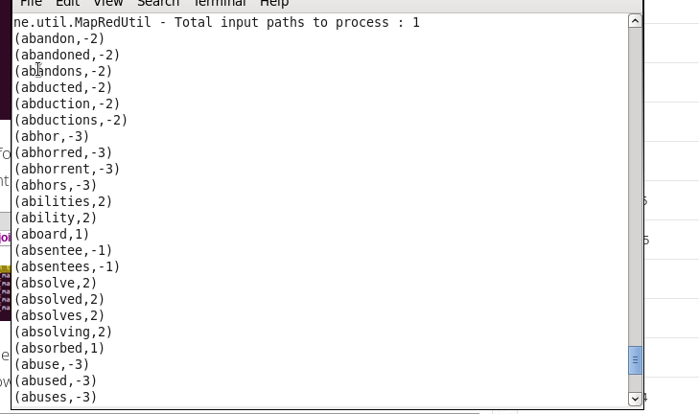

* **word_rating = join tokens by word left outer, dictionary by word using 'replicated';**

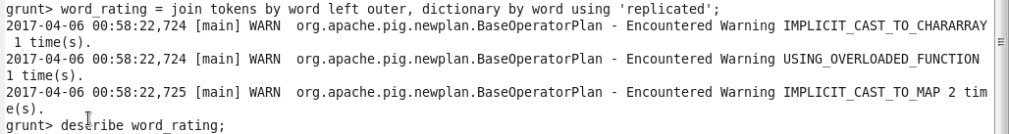

* **describe word_rating;**

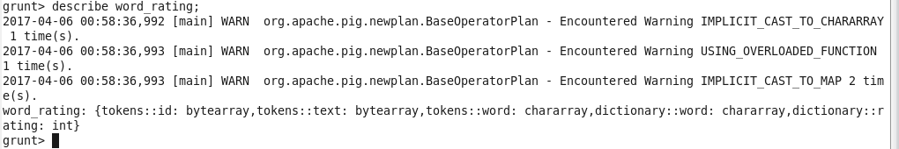

* **rating = foreach word_rating generate tokens::id as id,tokens::text as text, dictionary::rating as rate;**

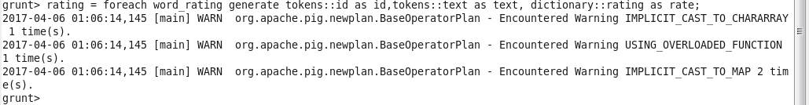

* **describe rating;**

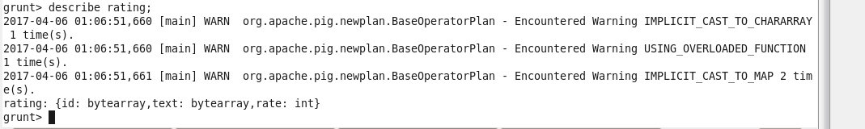

* **word_group = group rating by (id,text);**

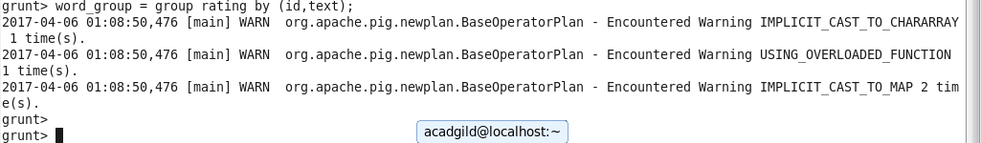

* **avg_rate = foreach word_group generate group, AVG(rating.rate) as tweet_rating;**

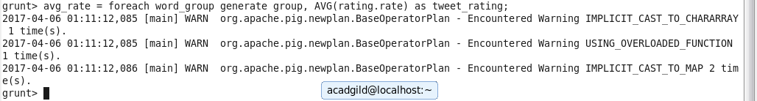

* **dump avg_rate;**

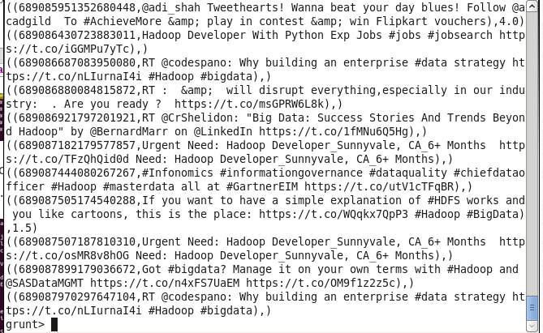

* **positive_tweets = filter avg_rate by tweet_rating>=0;**

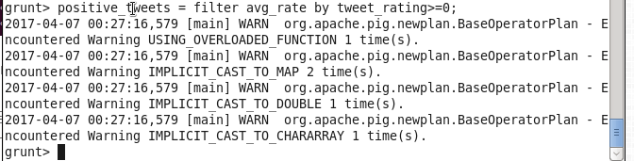

* **dump positive_tweets;**

