***Case Study***: Shopping Cart

***Module***: Registration

***Tech Stack***: Spring MVC, Hibernate, MVC, UI (Bootstrap/AngularJS / Spring Tiles/JQuery with HTML5)

Task: Create a shopping cart application module to demonstrate the customer registration process inside a shopping cart application.

To do List:

1. Create a registration form with proper validation and persist the data
2. And on successful registration display a list of already registered users.
3. Validation Rules as follows
   1. None of the fields should left blank
   2. Password and Confirm Password should match
   3. DOB should be selected through as calendar
   4. Age field should be disabled and automatically calculated based on DOB
   5. Country, State and City should be auto populated.
   6. Mobile No should validated as 10 digits
   7. Email Should be checked for valid format
   8. Zip should be six digits.
   9. Display error messages on rules violation.

Screens:

Screen 1: Registration

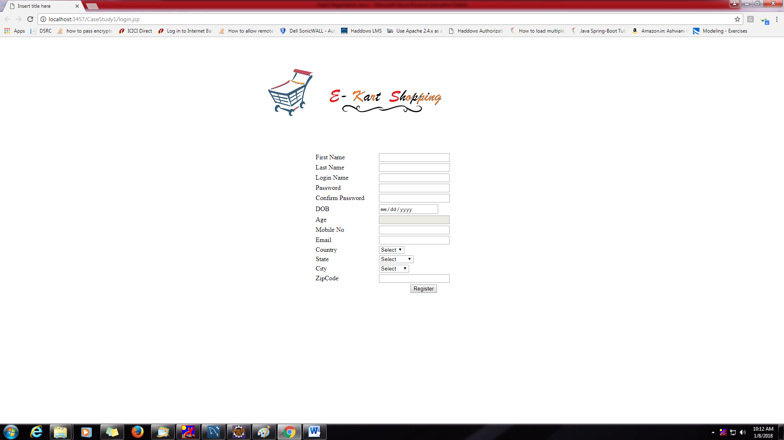

Screen 2:

Display All Registered Users.

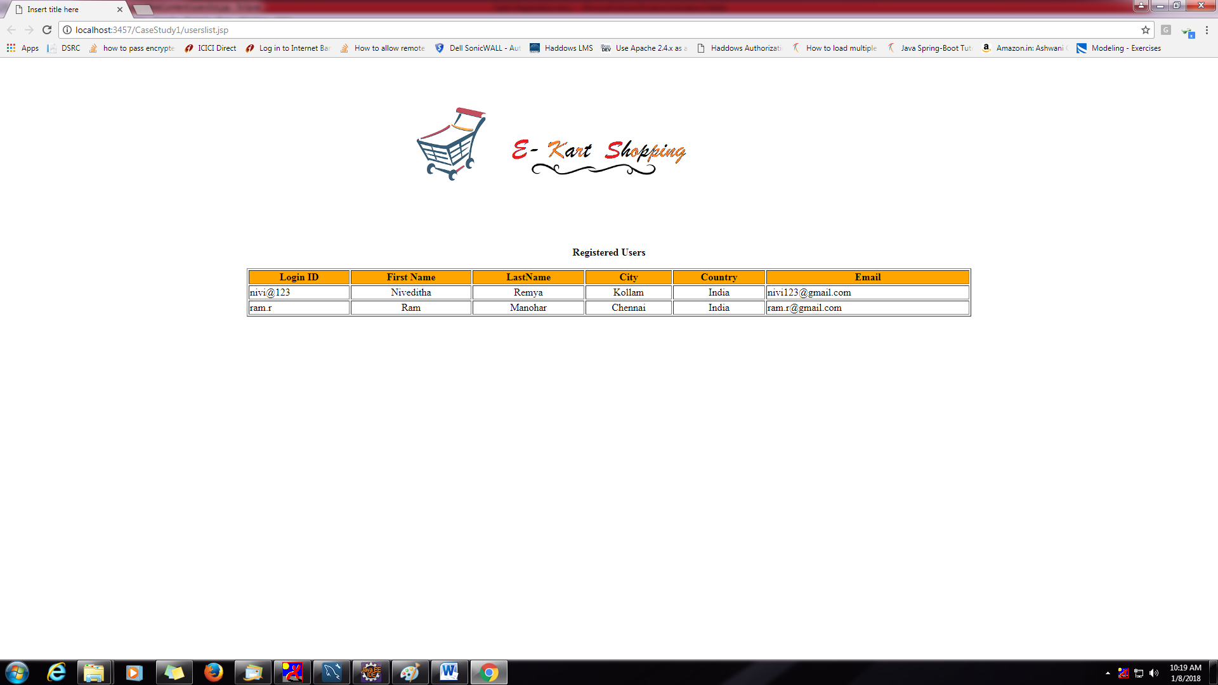

Database Design

