***Case Study***: Shopping Cart

***Module***: Product Management

***Tech Stack***: Spring MVC, Hibernate, MVC, UI (Bootstrap/AngularJS / Spring Tiles/JQuery with HTML5)

Task: Create a shopping cart application module to demonstrate the product management inside a shopping cart application.

To do List:

1. Create a form to add product details with data validation
2. The added products should be displayed as a grid it the same screen
3. The grid should provide the edit/delete buttons for data editing

Screens are as follows:

Add Product Screen:

The products screen must be validated before data persistence. Price and Quantity must me positive integers.

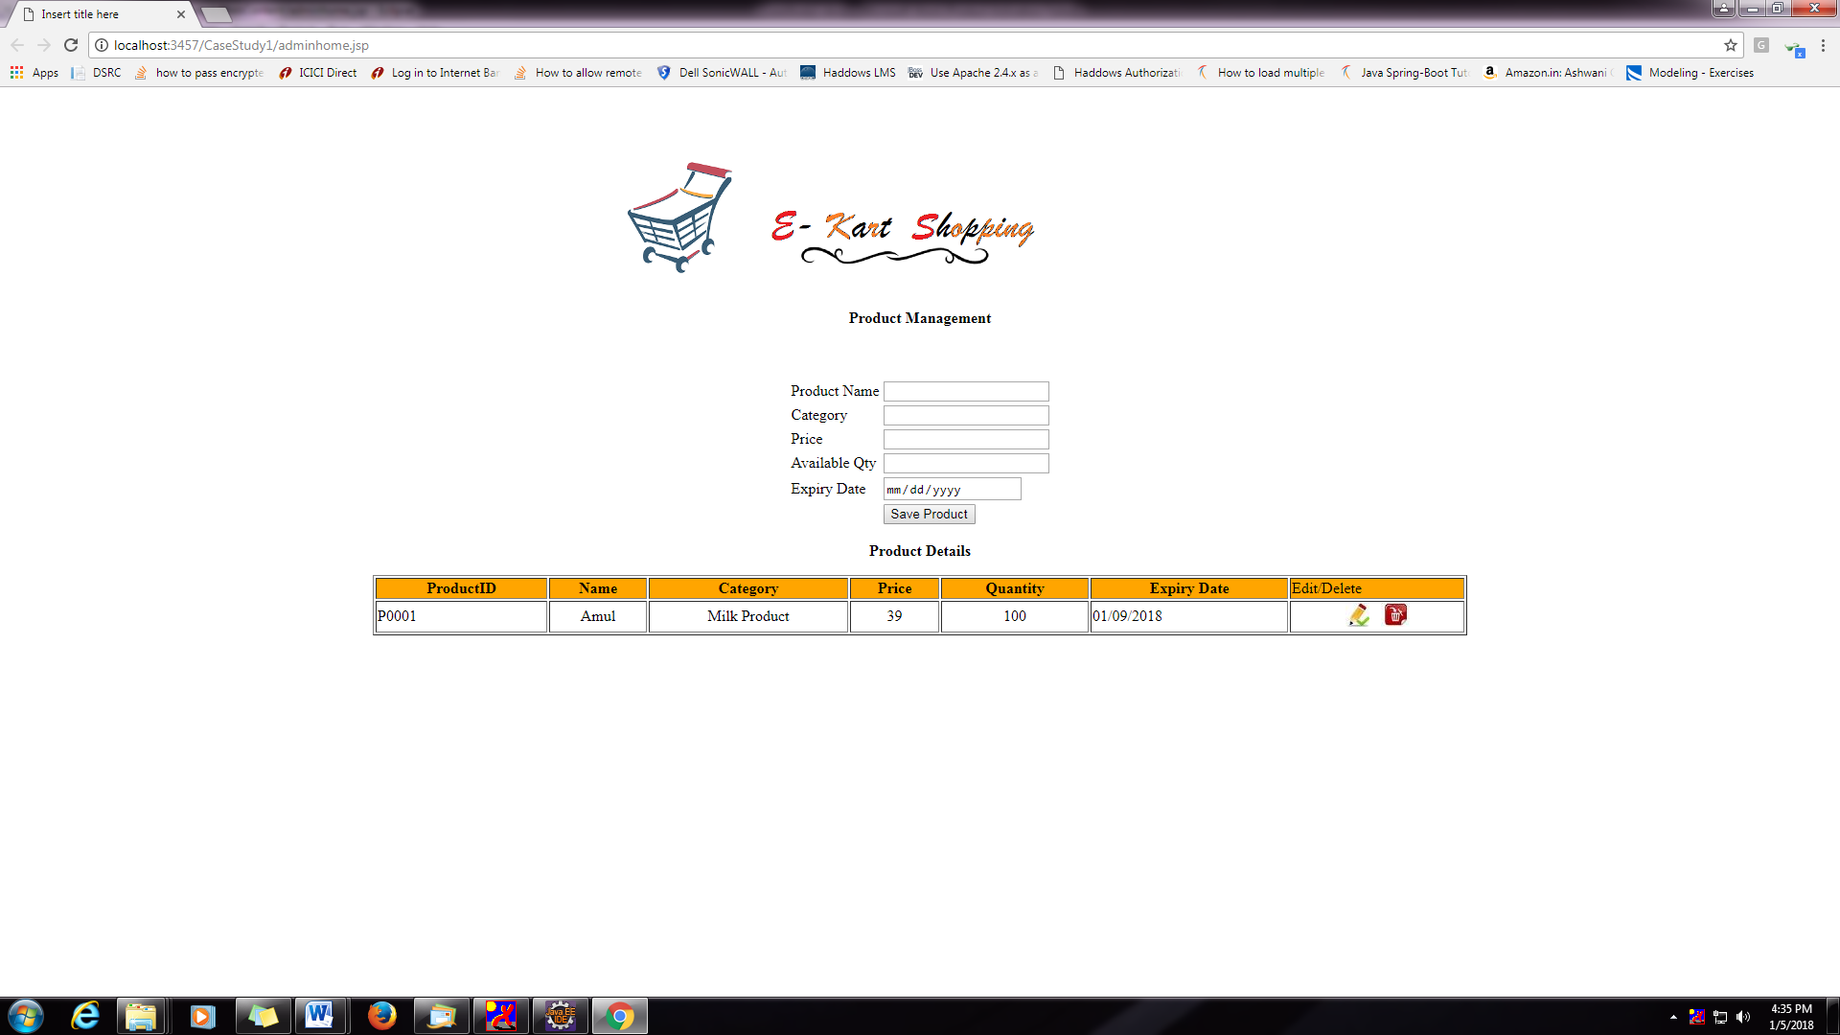

Add Product:

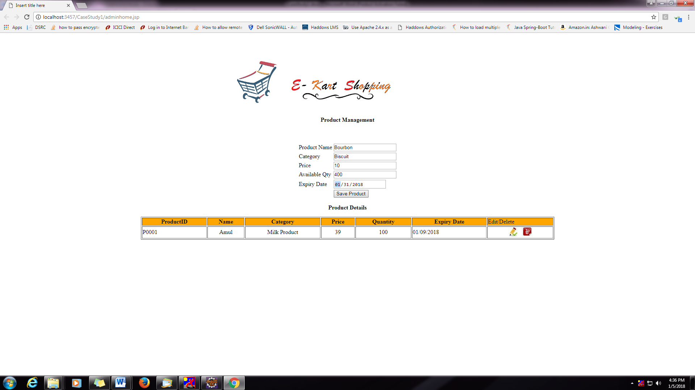

Add Another Product:

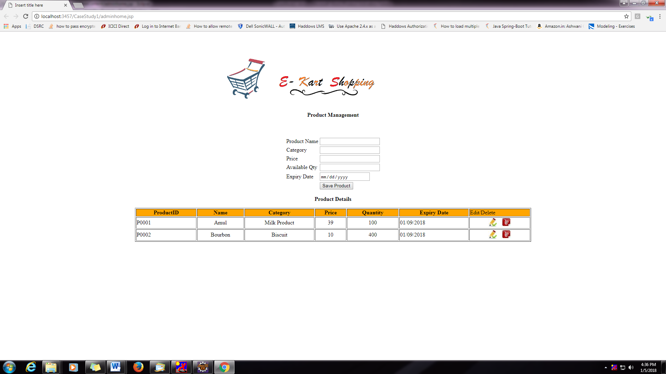

Edit Product:

While selecting the edit button, the selected product information should be filled in the form .

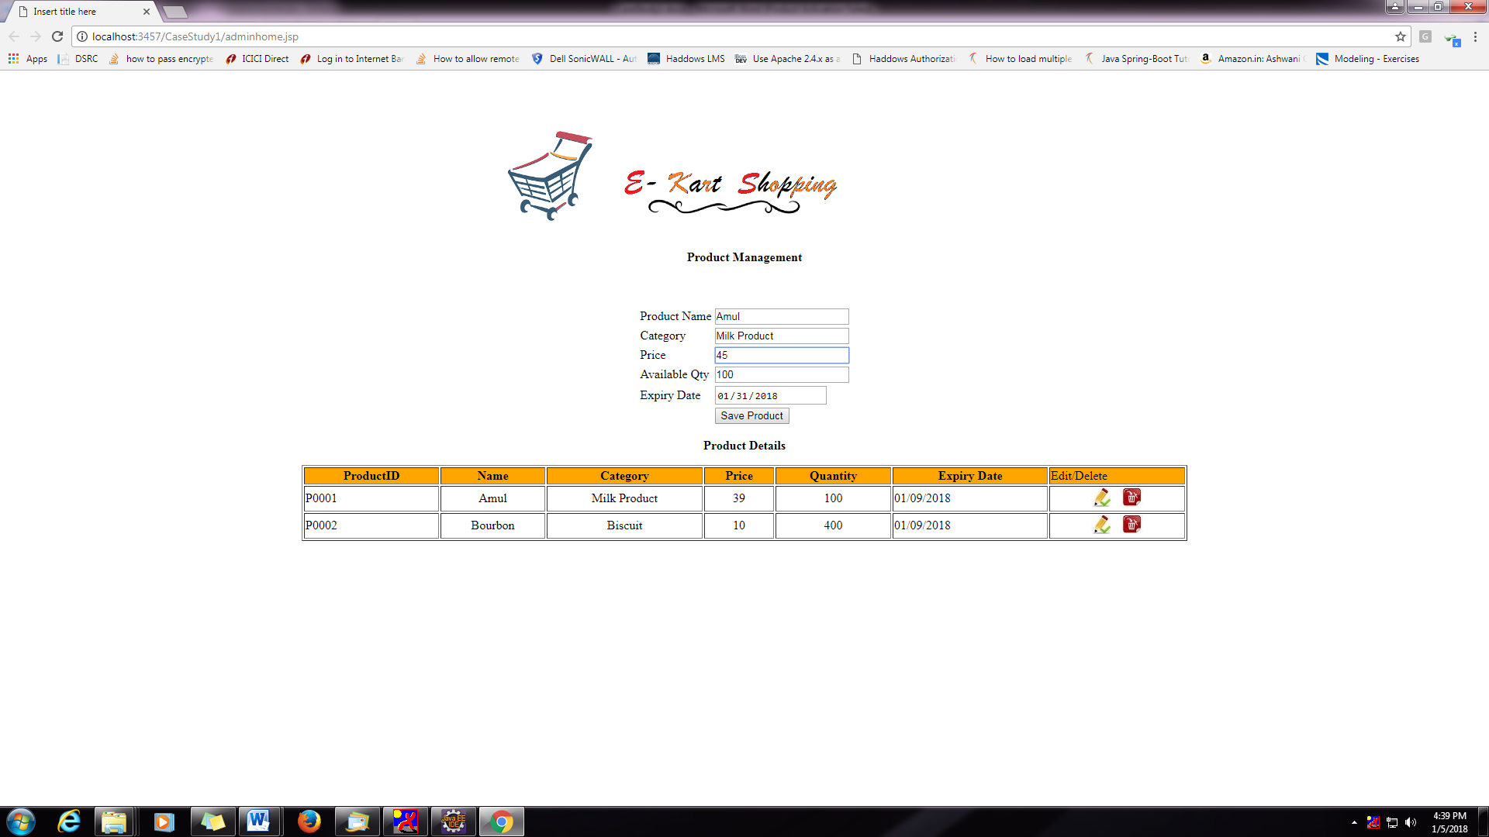

Edit Product:

On Save Product the new modified data should be reflected on the grid as follows.

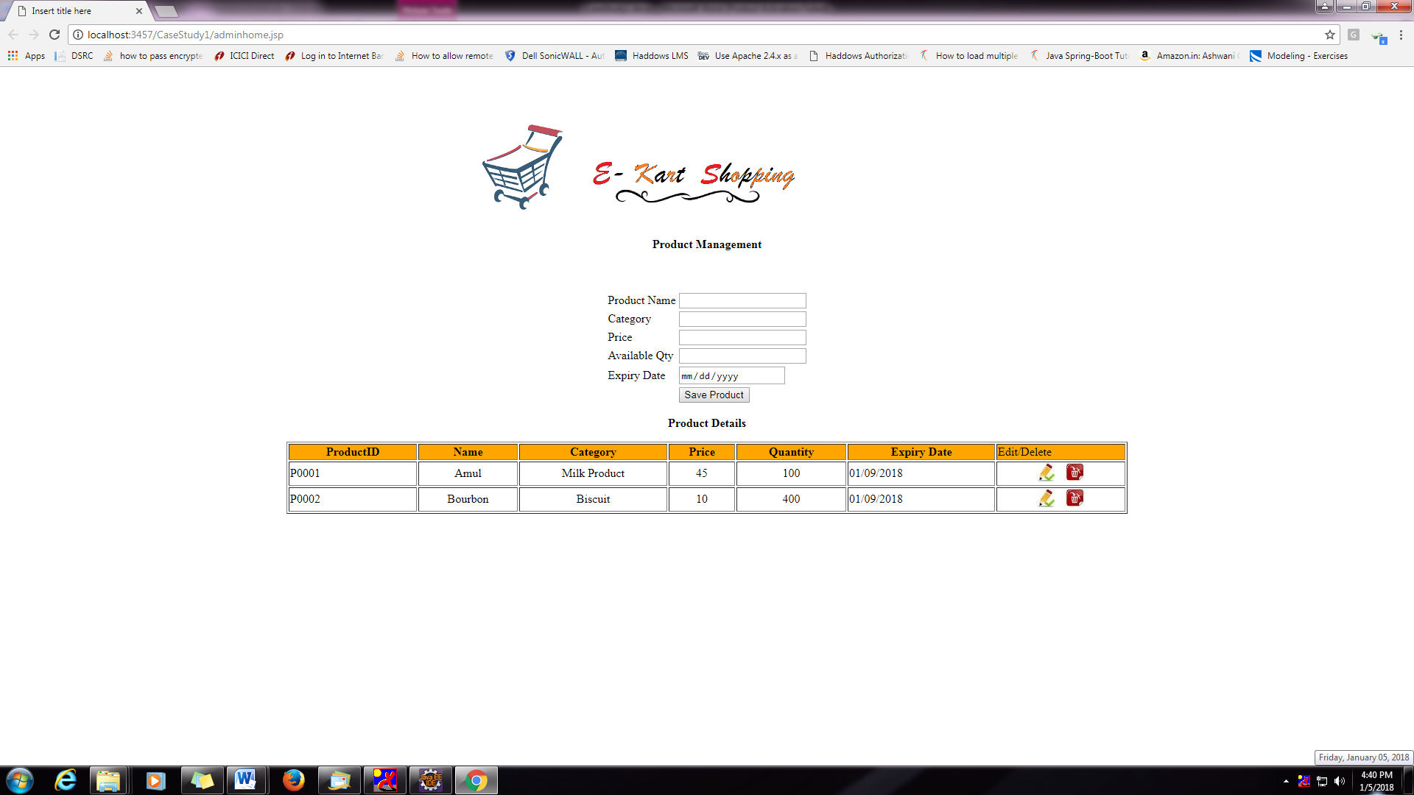

Delete Product:

When clicks the delete button the records to be deleted and refreshed grid should be displayed as follows.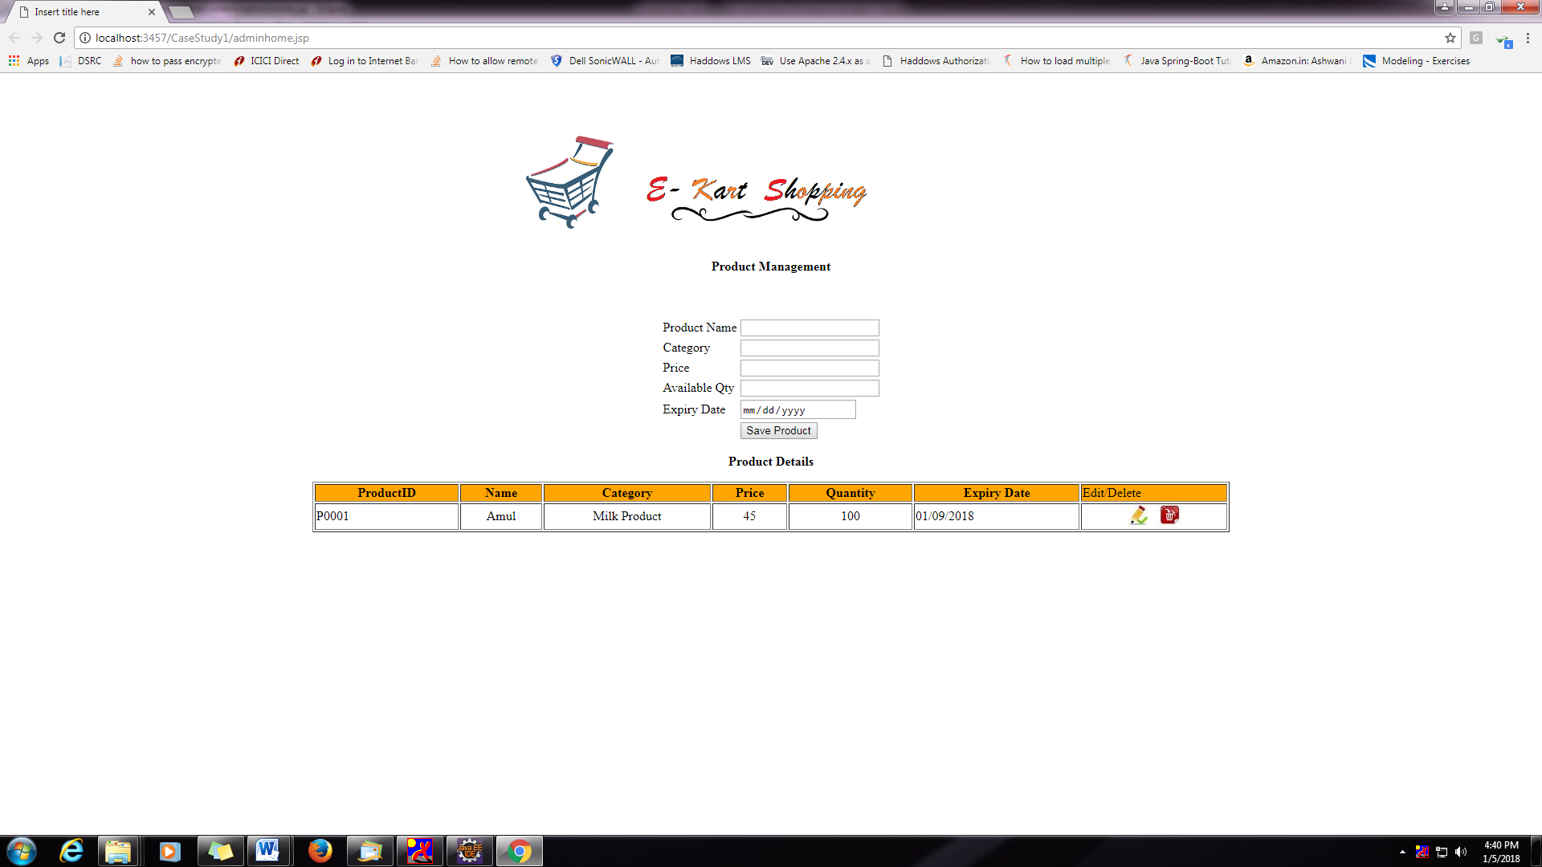

DB Design:

