***Case Study***: Shopping Cart

***Module***: Search

***Tech Stack***: Spring MVC, Hibernate, MVC, UI (Bootstrap/AngularJS / Spring Tiles/JQuery with HTML5)

Task: Create a shopping cart application module to demonstrate the search process inside a shopping cart application.

To do List:

1. When the search page is loaded the Categories should be auto populated
2. If no category selected , display all products
3. If category selected and no search text , display all products in that category
4. If category selected and search text entered, display the products contains the search text in the selected category.
5. If not category selected and search text entered , display the products which contains the search text in all categories

Screens:

Screen 1:

Page Loading

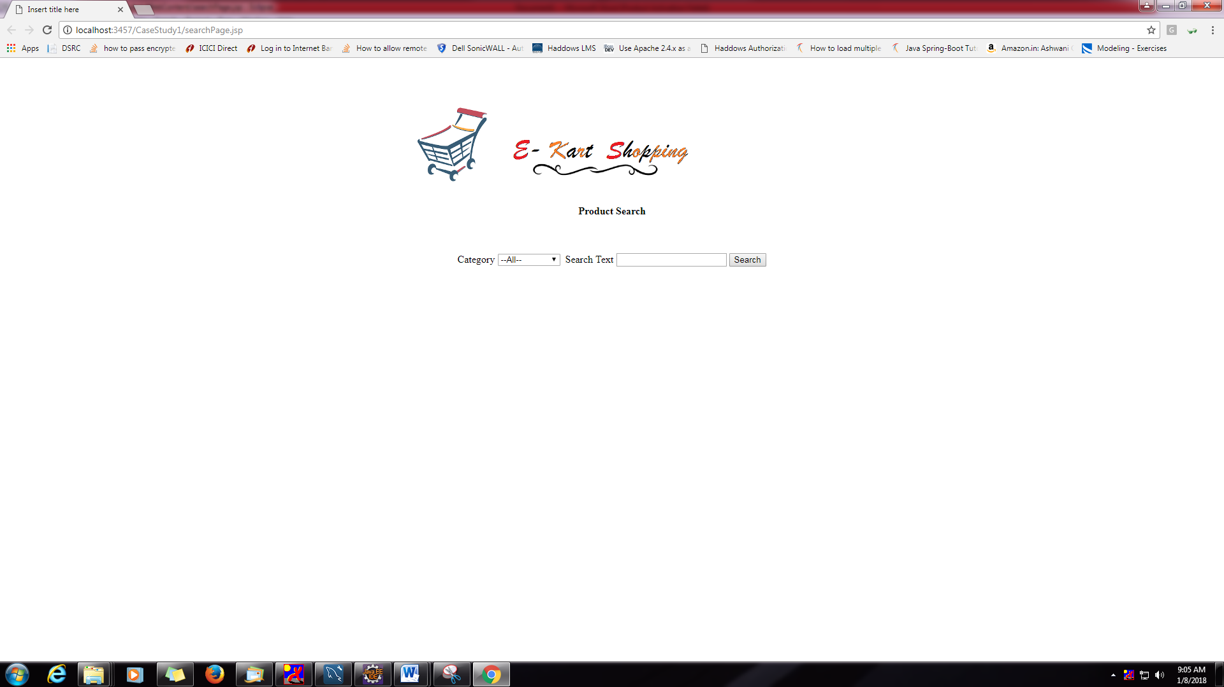

Screen 2:

No category – All Products

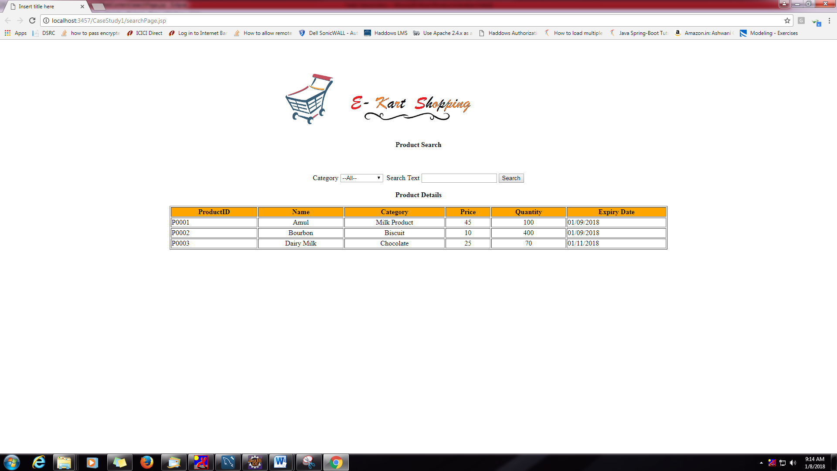

Screen 3:

Category Search:

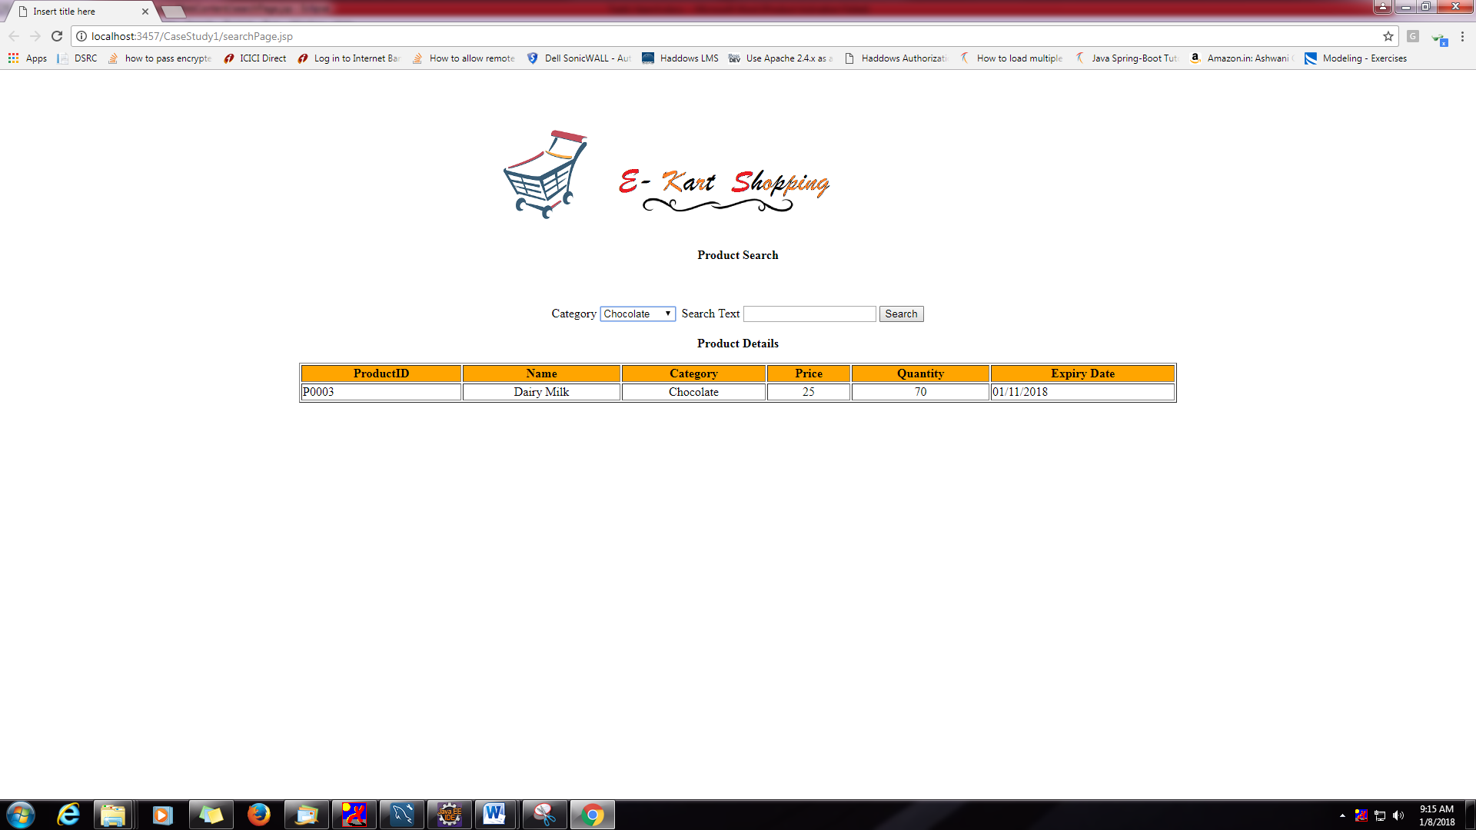

Screen 4:

With category and search text

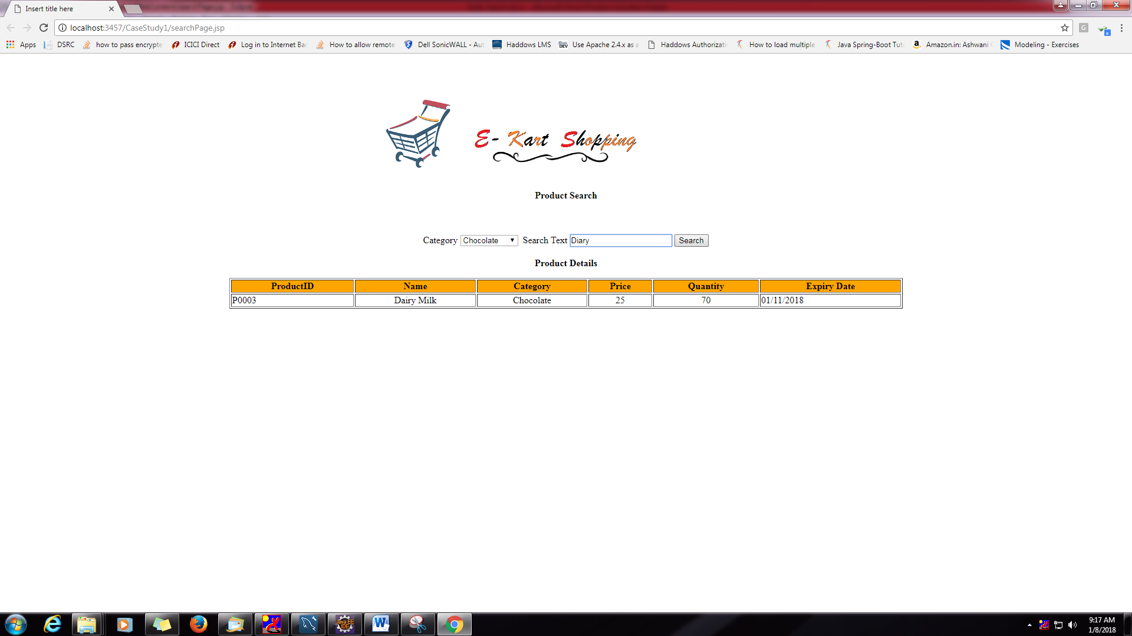

Screen 5:

When no products found.

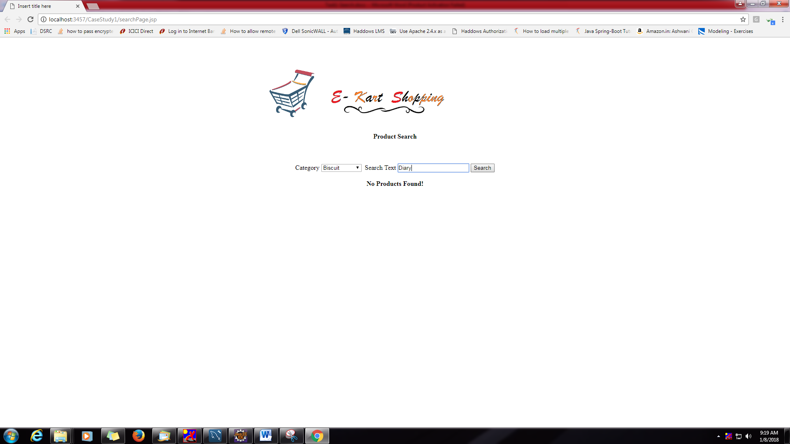

DB Design:

Table Design:

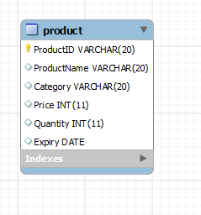

Sample Data:

