EXPT NO: 8 | MINI PROJECT – ANALYTICAL FRAMEWORK FOR CRIME RATE EVALUATION: BEHAVIORAL AND QUANTITATIVE PERSPECTIVES

AIM

To analyze and visualize crime rate patterns across Indian cities using real-world crime data. The project aims to identify key factors influencing crime rates—such as population density, unemployment, victim demographics, weapon usage, and police deployment—and to represent these insights visually through Python’s Matplotlib library. The findings help understand trends, hotspots, and correlations for effective policy and law enforcement planning.

ALGORITHM
- Open Tableau and connect the crime_dataset_india.csv file for analysis.
- Inspect fields, rename columns, and ensure correct data types (date, city, crime type).
- Create calculated fields such as Year, Month, or Crime Count per City.
- Build charts — bar (city-wise crimes), pie (gender ratio), map (crime hotspots), and line (monthly trends).
- Combine all visualizations into a single interactive dashboard with filters for city and year.

CODING

<?xml version='1.0' encoding='utf-8' ?>

<!-- build 20252.25.1003.1601 -->
<workbook original-version='18.1' source-build='2025.2.4 (20252.25.1003.1601)' source-platform='win' version='18.1' xmlns:user='http://www.tableausoftware.com/xml/user'>
<document-format-change-manifest>
<AccessibleZoneTabOrder />
<AnimationOnByDefault />
<AutoCreateAndUpdateDSDPhoneLayouts />
<MapboxVectorStylesAndLayers />
<MarkAnimation />
<ObjectModelEncapsulateLegacy />
<ObjectModelExtractV2 />
<ObjectModelTableType />
<SchemaViewerObjectModel />
<SetMembershipControl />
<SheetIdentifierTracking />
<_.fcp.VConnDownstreamExtractsWithWarnings.true...VConnDownstreamExtractsWithWarnings />

<WindowsPersistSimpleIdentifiers />
</document-format-change-manifest>
<preferences>
<preference name='ui.encoding.shelf.height' value='24' />
<preference name='ui.shelf.height' value='26' />
</preferences>
<datasources>
<datasource caption='crime_dataset_india (crime_dataset_india)' inline='true' name='federated.073j1bj0boa0r41deb9sa00yab7x' version='18.1'>
<connection class='federated'>
<named-connections>
<named-connection caption='crime_dataset_india' name='excel-direct.0kf80i50reqxvr1emso7y1nifpfc'>
<connection class='excel-direct' cleaning='no' compat='no' dataRefreshTime='' filename='C:/Users/vasan/Downloads/crime_dataset_india.xls' interpretationMode='0' password='' server='' validate='no' />
</named-connection>
</named-connections>
<relation connection='excel-direct.0kf80i50reqxvr1emso7y1nifpfc' name='crime_dataset_india' table='[crime_dataset_india$]' type='table'>
<columns gridOrigin='A1:N40161:no:A1:N40161:0' header='yes' outcome='6'>
<column datatype='integer' name='Report Number' ordinal='0' />
<column datatype='string' name='Date Reported' ordinal='1' />
<column datatype='string' name='Date of Occurrence' ordinal='2' />
<column datatype='string' name='Time of Occurrence' ordinal='3' />
<column datatype='string' name='City' ordinal='4' />
<column datatype='integer' name='Crime Code' ordinal='5' />
<column datatype='string' name='Crime Description' ordinal='6' />
<column datatype='integer' name='Victim Age' ordinal='7' />
<column datatype='string' name='Victim Gender' ordinal='8' />
<column datatype='string' name='Weapon Used' ordinal='9' />
<column datatype='string' name='Crime Domain' ordinal='10' />
<column datatype='integer' name='Police Deployed' ordinal='11' />
<column datatype='string' name='Case Closed' ordinal='12' />
<column datatype='string' name='Date Case Closed' ordinal='13' />
</columns>
</relation>
<metadata-records>
<metadata-record class='capability'>
<remote-name />
<remote-type>0</remote-type>
<parent-name>[crime_dataset_india]</parent-name>
<remote-alias />
<aggregation>Count</aggregation>
<contains-null>true</contains-null>
<attributes>
<attribute datatype='integer' name='context'>0</attribute>
<attribute datatype='string' name='gridOrigin'>&quot;A1:N40161:no:A1:N40161:0&quot;</attribute>
<attribute datatype='boolean' name='header'>true</attribute>
<attribute datatype='integer' name='outcome'>6</attribute>
</attributes>
</metadata-record>

<metadata-record class='column'>
<remote-name>Report Number</remote-name>
<remote-type>20</remote-type>
<local-name>[Report Number]</local-name>
<parent-name>[crime_dataset_india]</parent-name>
<remote-alias>Report Number</remote-alias>
<ordinal>0</ordinal>
<local-type>integer</local-type>
<aggregation>Sum</aggregation>
<contains-null>true</contains-null>
<attributes>
<attribute datatype='string' name='DebugRemoteType'>&quot;I8&quot;</attribute>
</attributes>
<object-id>[crime!dataset!india_5554EA9BEF114AB287DBEF31D764466B]</object-id>
</metadata-record>
<metadata-record class='column'>
<remote-name>Date Reported</remote-name>
<remote-type>130</remote-type>
<local-name>[Date Reported]</local-name>
<parent-name>[crime_dataset_india]</parent-name>
<remote-alias>Date Reported</remote-alias>
<ordinal>1</ordinal>
<local-type>string</local-type>
<aggregation>Count</aggregation>
<contains-null>true</contains-null>
<collation flag='1' name='LEN_RIN_S2' />
<attributes>
<attribute datatype='string' name='DebugRemoteType'>&quot;WSTR&quot;</attribute>
</attributes>
<object-id>[crime!dataset!india_5554EA9BEF114AB287DBEF31D764466B]</object-id>
</metadata-record>
<metadata-record class='column'>
<remote-name>Date of Occurrence</remote-name>
<remote-type>130</remote-type>
<local-name>[Date of Occurrence]</local-name>
<parent-name>[crime_dataset_india]</parent-name>
<remote-alias>Date of Occurrence</remote-alias>
<ordinal>2</ordinal>
<local-type>string</local-type>
<aggregation>Count</aggregation>
<contains-null>true</contains-null>
<collation flag='1' name='LEN_RIN_S2' />
<attributes>
<attribute datatype='string' name='DebugRemoteType'>&quot;WSTR&quot;</attribute>
</attributes>
<object-id>[crime!dataset!india_5554EA9BEF114AB287DBEF31D764466B]</object-id>
</metadata-record>
<metadata-record class='column'>
<remote-name>Time of Occurrence</remote-name>
<remote-type>130</remote-type>
<local-name>[Time of Occurrence]</local-name>
<parent-name>[crime_dataset_india]</parent-name>
<remote-alias>Time of Occurrence</remote-alias>
<ordinal>3</ordinal>
<local-type>string</local-type>
<aggregation>Count</aggregation>
<contains-null>true</contains-null>
<collation flag='1' name='LEN_RIN_S2' />
<attributes>
<attribute datatype='string' name='DebugRemoteType'>&quot;WSTR&quot;</attribute>
</attributes>
<object-id>[crime!dataset!india_5554EA9BEF114AB287DBEF31D764466B]</object-id>
</metadata-record>
<metadata-record class='column'>
<remote-name>City</remote-name>
<remote-type>130</remote-type>
<local-name>[City]</local-name>
<parent-name>[crime_dataset_india]</parent-name>
<remote-alias>City</remote-alias>
<ordinal>4</ordinal>
<local-type>string</local-type>
<aggregation>Count</aggregation>
<contains-null>true</contains-null>
<collation flag='1' name='LEN_RIN_S2' />
<attributes>
<attribute datatype='string' name='DebugRemoteType'>&quot;WSTR&quot;</attribute>
</attributes>
<object-id>[crime!dataset!india_5554EA9BEF114AB287DBEF31D764466B]</object-id>
</metadata-record>
<metadata-record class='column'>
<remote-name>Crime Code</remote-name>
<remote-type>20</remote-type>
<local-name>[Crime Code]</local-name>
<parent-name>[crime_dataset_india]</parent-name>
<remote-alias>Crime Code</remote-alias>
<ordinal>5</ordinal>
<local-type>integer</local-type>
<aggregation>Sum</aggregation>
<contains-null>true</contains-null>
<attributes>
<attribute datatype='string' name='DebugRemoteType'>&quot;I8&quot;</attribute>
</attributes>
<object-id>[crime!dataset!india_5554EA9BEF114AB287DBEF31D764466B]</object-id>
</metadata-record>
<metadata-record class='column'>
<remote-name>Crime Description</remote-name>
<remote-type>130</remote-type>
<local-name>[Crime Description]</local-name>
<parent-name>[crime_dataset_india]</parent-name>
<remote-alias>Crime Description</remote-alias>
<ordinal>6</ordinal>
<local-type>string</local-type>
<aggregation>Count</aggregation>
<contains-null>true</contains-null>
<collation flag='1' name='LEN_RIN_S2' />
<attributes>
<attribute datatype='string' name='DebugRemoteType'>&quot;WSTR&quot;</attribute>
</attributes>
<object-id>[crime!dataset!india_5554EA9BEF114AB287DBEF31D764466B]</object-id>
</metadata-record>
<metadata-record class='column'>
<remote-name>Victim Age</remote-name>
<remote-type>20</remote-type>
<local-name>[Victim Age]</local-name>
<parent-name>[crime_dataset_india]</parent-name>
<remote-alias>Victim Age</remote-alias>
<ordinal>7</ordinal>
<local-type>integer</local-type>
<aggregation>Sum</aggregation>
<contains-null>true</contains-null>
<attributes>
<attribute datatype='string' name='DebugRemoteType'>&quot;I8&quot;</attribute>
</attributes>
<object-id>[crime!dataset!india_5554EA9BEF114AB287DBEF31D764466B]</object-id>
</metadata-record>
<metadata-record class='column'>
<remote-name>Victim Gender</remote-name>
<remote-type>130</remote-type>
<local-name>[Victim Gender]</local-name>
<parent-name>[crime_dataset_india]</parent-name>
<remote-alias>Victim Gender</remote-alias>
<ordinal>8</ordinal>
<local-type>string</local-type>
<aggregation>Count</aggregation>
<contains-null>true</contains-null>
<collation flag='1' name='LEN_RIN_S2' />
<attributes>
<attribute datatype='string' name='DebugRemoteType'>&quot;WSTR&quot;</attribute>
</attributes>
<object-id>[crime!dataset!india_5554EA9BEF114AB287DBEF31D764466B]</object-id>
</metadata-record>
<metadata-record class='column'>
<remote-name>Weapon Used</remote-name>
<remote-type>130</remote-type>
<local-name>[Weapon Used]</local-name>
<parent-name>[crime_dataset_india]</parent-name>
<remote-alias>Weapon Used</remote-alias>
<ordinal>9</ordinal>
<local-type>string</local-type>
<aggregation>Count</aggregation>
<contains-null>true</contains-null>
<collation flag='1' name='LEN_RIN_S2' />
<attributes>
<attribute datatype='string' name='DebugRemoteType'>&quot;WSTR&quot;</attribute>
</attributes>
<object-id>[crime!dataset!india_5554EA9BEF114AB287DBEF31D764466B]</object-id>
</metadata-record>
<metadata-record class='column'>
<remote-name>Crime Domain</remote-name>
<remote-type>130</remote-type>

<local-name>[Crime Domain]</local-name>
<parent-name>[crime_dataset_india]</parent-name>
<remote-alias>Crime Domain</remote-alias>
<ordinal>10</ordinal>
<local-type>string</local-type>
<aggregation>Count</aggregation>
<contains-null>true</contains-null>
<collation flag='1' name='LEN_RIN_S2' />
<attributes>
<attribute datatype='string' name='DebugRemoteType'>&quot;WSTR&quot;</attribute>
</attributes>
<object-id>[crime!dataset!india_5554EA9BEF114AB287DBEF31D764466B]</object-id>
</metadata-record>
<metadata-record class='column'>
<remote-name>Police Deployed</remote-name>
<remote-type>20</remote-type>
<local-name>[Police Deployed]</local-name>
<parent-name>[crime_dataset_india]</parent-name>
<remote-alias>Police Deployed</remote-alias>
<ordinal>11</ordinal>
<local-type>integer</local-type>
<aggregation>Sum</aggregation>
<contains-null>true</contains-null>
<attributes>
<attribute datatype='string' name='DebugRemoteType'>&quot;I8&quot;</attribute>
</attributes>
<object-id>[crime!dataset!india_5554EA9BEF114AB287DBEF31D764466B]</object-id>
</metadata-record>
<metadata-record class='column'>
<remote-name>Case Closed</remote-name>
<remote-type>130</remote-type>
<local-name>[Case Closed]</local-name>
<parent-name>[crime_dataset_india]</parent-name>
<remote-alias>Case Closed</remote-alias>
<ordinal>12</ordinal>
<local-type>string</local-type>
<aggregation>Count</aggregation>
<contains-null>true</contains-null>
<collation flag='1' name='LEN_RIN_S2' />
<attributes>
<attribute datatype='string' name='DebugRemoteType'>&quot;WSTR&quot;</attribute>
</attributes>
<object-id>[crime!dataset!india_5554EA9BEF114AB287DBEF31D764466B]</object-id>
</metadata-record>
<metadata-record class='column'>
<remote-name>Date Case Closed</remote-name>
<remote-type>130</remote-type>
<local-name>[Date Case Closed]</local-name>
<parent-name>[crime_dataset_india]</parent-name>
<remote-alias>Date Case Closed</remote-alias>
<ordinal>13</ordinal>
<local-type>string</local-type>
<aggregation>Count</aggregation>
<contains-null>true</contains-null>
<collation flag='1' name='LEN_RIN_S2' />
<attributes>
<attribute datatype='string' name='DebugRemoteType'>&quot;WSTR&quot;</attribute>
</attributes>
<object-id>[crime!dataset!india_5554EA9BEF114AB287DBEF31D764466B]</object-id>
</metadata-record>
</metadata-records>
</connection>
<aliases enabled='yes' />
<column datatype='string' name='[City]' role='dimension' semantic-role='[City].[Name]' type='nominal' />
<column datatype='integer' name='[Crime Code]' role='dimension' type='ordinal' />
<column datatype='integer' name='[Police Deployed (bin)]' role='dimension' type='quantitative'>
<calculation class='bin' decimals='0' formula='[Police Deployed]' peg='0' size='2.13' />
</column>
<column datatype='integer' name='[Police Deployed]' role='measure' type='quantitative' />
<column datatype='integer' name='[Report Number]' role='dimension' type='ordinal' />
<column caption='crime_dataset_india' datatype='table' name='[__tableau_internal_object_id__].[crime!dataset!india_5554EA9BEF114AB287DBEF31D764466B]' role='measure' type='quantitative' />
<extract _.fcp.VConnDownstreamExtractsWithWarnings.true...user-specific='false' count='-1' enabled='true' object-id='' units='records'>
<connection access_mode='readonly' author-locale='en_US' class='hyper' dbname='C:/Users/vasan/AppData/Local/Temp/TableauTemp/#TableauTemp_1oxvpan1mgl5kk1cp6lbh07ok176.hyper' default-settings='hyper' schema='Extract' sslmode='' tablename='Extract' update-time='11/03/2025 11:37:43 AM' username='tableau_internal_user'>
<relation name='Extract' table='[Extract].[Extract]' type='table' />
<metadata-records>
<metadata-record class='column'>
<remote-name>Report Number</remote-name>
<remote-type>20</remote-type>
<local-name>[Report Number]</local-name>
<parent-name>[Extract]</parent-name>
<remote-alias>Report Number</remote-alias>
<ordinal>0</ordinal>
<family>crime_dataset_india</family>
<local-type>integer</local-type>
<aggregation>Sum</aggregation>
<approx-count>40160</approx-count>
<contains-null>true</contains-null>
<object-id>[crime!dataset!india_5554EA9BEF114AB287DBEF31D764466B]</object-id>
</metadata-record>
<metadata-record class='column'>
<remote-name>Date Reported</remote-name>
<remote-type>129</remote-type>
<local-name>[Date Reported]</local-name>
<parent-name>[Extract]</parent-name>
<remote-alias>Date Reported</remote-alias>
<ordinal>1</ordinal>
<family>crime_dataset_india</family>
<local-type>string</local-type>
<aggregation>Count</aggregation>
<approx-count>19600</approx-count>
<contains-null>true</contains-null>
<collation flag='1' name='LEN_RIN_S2' />
<object-id>[crime!dataset!india_5554EA9BEF114AB287DBEF31D764466B]</object-id>
</metadata-record>
<metadata-record class='column'>
<remote-name>Date of Occurrence</remote-name>
<remote-type>129</remote-type>
<local-name>[Date of Occurrence]</local-name>
<parent-name>[Extract]</parent-name>
<remote-alias>Date of Occurrence</remote-alias>
<ordinal>2</ordinal>
<family>crime_dataset_india</family>
<local-type>string</local-type>
<aggregation>Count</aggregation>
<approx-count>40160</approx-count>
<contains-null>true</contains-null>
<collation flag='1' name='LEN_RIN_S2' />
<object-id>[crime!dataset!india_5554EA9BEF114AB287DBEF31D764466B]</object-id>
</metadata-record>
<metadata-record class='column'>
<remote-name>Time of Occurrence</remote-name>
<remote-type>129</remote-type>
<local-name>[Time of Occurrence]</local-name>
<parent-name>[Extract]</parent-name>
<remote-alias>Time of Occurrence</remote-alias>
<ordinal>3</ordinal>
<family>crime_dataset_india</family>
<local-type>string</local-type>
<aggregation>Count</aggregation>
<approx-count>40160</approx-count>
<contains-null>true</contains-null>
<collation flag='1' name='LEN_RIN_S2' />
<object-id>[crime!dataset!india_5554EA9BEF114AB287DBEF31D764466B]</object-id>
</metadata-record>
<metadata-record class='column'>
<remote-name>City</remote-name>
<remote-type>129</remote-type>
<local-name>[City]</local-name>
<parent-name>[Extract]</parent-name>
<remote-alias>City</remote-alias>
<ordinal>4</ordinal>
<family>crime_dataset_india</family>
<local-type>string</local-type>
<aggregation>Count</aggregation>
<approx-count>29</approx-count>
<contains-null>true</contains-null>
<collation flag='1' name='LEN_RIN_S2' />
<object-id>[crime!dataset!india_5554EA9BEF114AB287DBEF31D764466B]</object-id>
</metadata-record>
<metadata-record class='column'>
<remote-name>Crime Code</remote-name>
<remote-type>20</remote-type>
<local-name>[Crime Code]</local-name>
<parent-name>[Extract]</parent-name>
<remote-alias>Crime Code</remote-alias>
<ordinal>5</ordinal>
<family>crime_dataset_india</family>
<local-type>integer</local-type>
<aggregation>Sum</aggregation>
<approx-count>1051</approx-count>
<contains-null>true</contains-null>
<object-id>[crime!dataset!india_5554EA9BEF114AB287DBEF31D764466B]</object-id>
</metadata-record>
<metadata-record class='column'>
<remote-name>Crime Description</remote-name>
<remote-type>129</remote-type>
<local-name>[Crime Description]</local-name>
<parent-name>[Extract]</parent-name>
<remote-alias>Crime Description</remote-alias>
<ordinal>6</ordinal>
<family>crime_dataset_india</family>
<local-type>string</local-type>
<aggregation>Count</aggregation>
<approx-count>21</approx-count>
<contains-null>true</contains-null>
<collation flag='1' name='LEN_RIN_S2' />
<object-id>[crime!dataset!india_5554EA9BEF114AB287DBEF31D764466B]</object-id>
</metadata-record>
<metadata-record class='column'>
<remote-name>Victim Age</remote-name>
<remote-type>20</remote-type>
<local-name>[Victim Age]</local-name>
<parent-name>[Extract]</parent-name>
<remote-alias>Victim Age</remote-alias>
<ordinal>7</ordinal>
<family>crime_dataset_india</family>
<local-type>integer</local-type>
<aggregation>Sum</aggregation>
<approx-count>70</approx-count>
<contains-null>true</contains-null>
<object-id>[crime!dataset!india_5554EA9BEF114AB287DBEF31D764466B]</object-id>
</metadata-record>
<metadata-record class='column'>
<remote-name>Victim Gender</remote-name>
<remote-type>129</remote-type>
<local-name>[Victim Gender]</local-name>
<parent-name>[Extract]</parent-name>
<remote-alias>Victim Gender</remote-alias>
<ordinal>8</ordinal>
<family>crime_dataset_india</family>
<local-type>string</local-type>
<aggregation>Count</aggregation>
<approx-count>3</approx-count>
<contains-null>true</contains-null>
<collation flag='1' name='LEN_RIN_S2' />
<object-id>[crime!dataset!india_5554EA9BEF114AB287DBEF31D764466B]</object-id>
</metadata-record>
<metadata-record class='column'>
<remote-name>Weapon Used</remote-name>
<remote-type>129</remote-type>
<local-name>[Weapon Used]</local-name>
<parent-name>[Extract]</parent-name>
<remote-alias>Weapon Used</remote-alias>
<ordinal>9</ordinal>
<family>crime_dataset_india</family>
<local-type>string</local-type>
<aggregation>Count</aggregation>
<approx-count>7</approx-count>
<contains-null>true</contains-null>
<collation flag='1' name='LEN_RIN_S2' />
<object-id>[crime!dataset!india_5554EA9BEF114AB287DBEF31D764466B]</object-id>
</metadata-record>
<metadata-record class='column'>
<remote-name>Crime Domain</remote-name>
<remote-type>129</remote-type>
<local-name>[Crime Domain]</local-name>
<parent-name>[Extract]</parent-name>
<remote-alias>Crime Domain</remote-alias>
<ordinal>10</ordinal>
<family>crime_dataset_india</family>
<local-type>string</local-type>
<aggregation>Count</aggregation>
<approx-count>4</approx-count>
<contains-null>true</contains-null>
<collation flag='1' name='LEN_RIN_S2' />
<object-id>[crime!dataset!india_5554EA9BEF114AB287DBEF31D764466B]</object-id>
</metadata-record>
<metadata-record class='column'>
<remote-name>Police Deployed</remote-name>
<remote-type>20</remote-type>
<local-name>[Police Deployed]</local-name>
<parent-name>[Extract]</parent-name>
<remote-alias>Police Deployed</remote-alias>
<ordinal>11</ordinal>
<family>crime_dataset_india</family>
<local-type>integer</local-type>
<aggregation>Sum</aggregation>
<approx-count>19</approx-count>
<contains-null>true</contains-null>
<object-id>[crime!dataset!india_5554EA9BEF114AB287DBEF31D764466B]</object-id>
</metadata-record>
<metadata-record class='column'>
<remote-name>Case Closed</remote-name>
<remote-type>129</remote-type>
<local-name>[Case Closed]</local-name>
<parent-name>[Extract]</parent-name>
<remote-alias>Case Closed</remote-alias>
<ordinal>12</ordinal>
<family>crime_dataset_india</family>
<local-type>string</local-type>
<aggregation>Count</aggregation>
<approx-count>2</approx-count>
<contains-null>true</contains-null>
<collation flag='1' name='LEN_RIN_S2' />
<object-id>[crime!dataset!india_5554EA9BEF114AB287DBEF31D764466B]</object-id>
</metadata-record>
<metadata-record class='column'>
<remote-name>Date Case Closed</remote-name>
<remote-type>129</remote-type>
<local-name>[Date Case Closed]</local-name>
<parent-name>[Extract]</parent-name>
<remote-alias>Date Case Closed</remote-alias>
<ordinal>13</ordinal>
<family>crime_dataset_india</family>
<local-type>string</local-type>
<aggregation>Count</aggregation>
<approx-count>16343</approx-count>
<contains-null>true</contains-null>
<collation flag='1' name='LEN_RIN_S2' />
<object-id>[crime!dataset!india_5554EA9BEF114AB287DBEF31D764466B]</object-id>
</metadata-record>
</metadata-records>
</connection>
</extract>
<layout dim-ordering='alphabetic' measure-ordering='alphabetic' rowDisplayCount='100' show-structure='true' />
<semantic-values>
<semantic-value key='[Country].[Name]' value='&quot;India&quot;' />
</semantic-values>
<object-graph>
<objects>
<object caption='crime_dataset_india' id='crime!dataset!india_5554EA9BEF114AB287DBEF31D764466B'>
<properties context=''>
<relation connection='excel-direct.0kf80i50reqxvr1emso7y1nifpfc' name='crime_dataset_india' table='[crime_dataset_india$]' type='table'>
<columns gridOrigin='A1:N40161:no:A1:N40161:0' header='yes' outcome='6'>
<column datatype='integer' name='Report Number' ordinal='0' />
<column datatype='string' name='Date Reported' ordinal='1' />
<column datatype='string' name='Date of Occurrence' ordinal='2' />
<column datatype='string' name='Time of Occurrence' ordinal='3' />
<column datatype='string' name='City' ordinal='4' />
<column datatype='integer' name='Crime Code' ordinal='5' />
<column datatype='string' name='Crime Description' ordinal='6' />
<column datatype='integer' name='Victim Age' ordinal='7' />
<column datatype='string' name='Victim Gender' ordinal='8' />
<column datatype='string' name='Weapon Used' ordinal='9' />
<column datatype='string' name='Crime Domain' ordinal='10' />
<column datatype='integer' name='Police Deployed' ordinal='11' />
<column datatype='string' name='Case Closed' ordinal='12' />
<column datatype='string' name='Date Case Closed' ordinal='13' />
</columns>
</relation>
</properties>
<properties context='extract'>
<relation name='Extract' table='[Extract].[Extract]' type='table' />
</properties>
</object>
</objects>
</object-graph>
</datasource>
</datasources>
<mapsources>
<mapsource name='Tableau' />
</mapsources>
<worksheets>
<worksheet name='Sheet 1'>
<table>
<view>
<datasources>
<datasource caption='crime_dataset_india (crime_dataset_india)' name='federated.073j1bj0boa0r41deb9sa00yab7x' />
</datasources>
<datasource-dependencies datasource='federated.073j1bj0boa0r41deb9sa00yab7x'>
<column datatype='string' name='[Crime Domain]' role='dimension' type='nominal' />
<column datatype='integer' name='[Police Deployed]' role='measure' type='quantitative' />
<column datatype='string' name='[Weapon Used]' role='dimension' type='nominal' />
<column-instance column='[Crime Domain]' derivation='None' name='[none:Crime Domain:nk]' pivot='key' type='nominal' />
<column-instance column='[Weapon Used]' derivation='None' name='[none:Weapon Used:nk]' pivot='key' type='nominal' />
<column-instance column='[Police Deployed]' derivation='Sum' name='[sum:Police Deployed:qk]' pivot='key' type='quantitative' />
</datasource-dependencies>
<aggregation value='true' />
</view>
<style />
<panes>
<pane selection-relaxation-option='selection-relaxation-allow'>
<view>
<breakdown value='on' />
</view>
<mark class='Automatic' />
<encodings>
<size column='[federated.073j1bj0boa0r41deb9sa00yab7x].[sum:Police Deployed:qk]' />
<color column='[federated.073j1bj0boa0r41deb9sa00yab7x].[sum:Police Deployed:qk]' />
<text column='[federated.073j1bj0boa0r41deb9sa00yab7x].[none:Crime Domain:nk]' />
<text column='[federated.073j1bj0boa0r41deb9sa00yab7x].[none:Weapon Used:nk]' />
</encodings>
<style>
<style-rule element='mark'>
<format attr='mark-labels-show' value='true' />
<format attr='mark-labels-cull' value='true' />
<format attr='mark-labels-line-first' value='true' />
<format attr='mark-labels-line-last' value='true' />
<format attr='mark-labels-range-min' value='true' />
<format attr='mark-labels-range-max' value='true' />
<format attr='mark-labels-mode' value='all' />
<format attr='mark-labels-range-scope' value='pane' />
<format attr='mark-labels-range-field' value='' />
</style-rule>
</style>
</pane>
</panes>
<rows />
<cols />
</table>
<simple-id uuid='{FC6A62BD-2951-458B-9EEC-D95844678851}' />
</worksheet>
<worksheet name='Sheet 2'>
<table>
<view>
<datasources>
<datasource caption='crime_dataset_india (crime_dataset_india)' name='federated.073j1bj0boa0r41deb9sa00yab7x' />
</datasources>
<datasource-dependencies datasource='federated.073j1bj0boa0r41deb9sa00yab7x'>
<column datatype='integer' name='[Police Deployed]' role='measure' type='quantitative' />
<column datatype='string' name='[Victim Gender]' role='dimension' type='nominal' />
<column-instance column='[Victim Gender]' derivation='None' name='[none:Victim Gender:nk]' pivot='key' type='nominal' />
<column-instance column='[Police Deployed]' derivation='Sum' name='[sum:Police Deployed:qk]' pivot='key' type='quantitative' />
</datasource-dependencies>
<aggregation value='true' />
</view>
<style />
<panes>
<pane selection-relaxation-option='selection-relaxation-allow'>
<view>
<breakdown value='auto' />
</view>
<mark class='Automatic' />
</pane>
</panes>
<rows>[federated.073j1bj0boa0r41deb9sa00yab7x].[sum:Police Deployed:qk]</rows>
<cols>[federated.073j1bj0boa0r41deb9sa00yab7x].[none:Victim Gender:nk]</cols>
</table>
<simple-id uuid='{F8DE5A45-88FA-42DE-884B-D3BD674E046E}' />
</worksheet>
<worksheet name='Sheet 3'>
<table>
<view>
<datasources>
<datasource caption='crime_dataset_india (crime_dataset_india)' name='federated.073j1bj0boa0r41deb9sa00yab7x' />
</datasources>
<mapsources>
<mapsource name='Tableau' />
</mapsources>
<datasource-dependencies datasource='federated.073j1bj0boa0r41deb9sa00yab7x'>
<column datatype='string' name='[City]' role='dimension' semantic-role='[City].[Name]' type='nominal' />
<column-instance column='[City]' derivation='None' name='[none:City:nk]' pivot='key' type='nominal' />
</datasource-dependencies>
<aggregation value='true' />
</view>
<style>
<style-rule element='axis'>
<encoding attr='space' class='0' field='[federated.073j1bj0boa0r41deb9sa00yab7x].[Longitude (generated)]' field-type='quantitative' max='12450657.563694447' min='5282812.7147433599' projection='EPSG:3857' range-type='fixed' scope='cols' type='space' />
<encoding attr='space' class='0' field='[federated.073j1bj0boa0r41deb9sa00yab7x].[Latitude (generated)]' field-type='quantitative' max='4594666.8549588826' min='988203.84172380948' projection='EPSG:3857' range-type='fixed' scope='rows' type='space' />
</style-rule>
<style-rule element='map'>
<format attr='washout' value='0.0' />
</style-rule>
</style>
<panes>
<pane selection-relaxation-option='selection-relaxation-allow'>
<view>
<breakdown value='auto' />
</view>
<mark class='Multipolygon' />
<encodings>
<lod column='[federated.073j1bj0boa0r41deb9sa00yab7x].[none:City:nk]' />
<geometry column='[federated.073j1bj0boa0r41deb9sa00yab7x].[Geometry (generated)]' />
</encodings>
</pane>
</panes>
<rows>[federated.073j1bj0boa0r41deb9sa00yab7x].[Latitude (generated)]</rows>
<cols>[federated.073j1bj0boa0r41deb9sa00yab7x].[Longitude (generated)]</cols>
</table>
<simple-id uuid='{29ACB62A-0668-4795-8A9A-49D728E73DCF}' />
</worksheet>
<worksheet name='Sheet 4'>
<table>
<view>
<datasources>
<datasource caption='crime_dataset_india (crime_dataset_india)' name='federated.073j1bj0boa0r41deb9sa00yab7x' />
</datasources>
<datasource-dependencies datasource='federated.073j1bj0boa0r41deb9sa00yab7x'>
<column datatype='string' name='[Date Case Closed]' role='dimension' type='nominal' />
<column datatype='integer' name='[Police Deployed]' role='measure' type='quantitative' />
<column-instance column='[Police Deployed]' derivation='Count' name='[cnt:Police Deployed:qk]' pivot='key' type='quantitative' />
<column-instance column='[Date Case Closed]' derivation='None' name='[none:Date Case Closed:nk]' pivot='key' type='nominal' />
<column-instance column='[Police Deployed]' derivation='Sum' name='[sum:Police Deployed:qk]' pivot='key' type='quantitative' />
</datasource-dependencies>
<aggregation value='true' />
</view>
<style>
<style-rule element='refline'>
<format attr='stroke-color' id='refline0' value='#000000' />
</style-rule>
</style>
<panes>
<pane selection-relaxation-option='selection-relaxation-allow'>
<view>
<breakdown value='auto' />
</view>
<mark class='Circle' />
<encodings>
<size column='[federated.073j1bj0boa0r41deb9sa00yab7x].[cnt:Police Deployed:qk]' />
<text column='[federated.073j1bj0boa0r41deb9sa00yab7x].[none:Date Case Closed:nk]' />
<color column='[federated.073j1bj0boa0r41deb9sa00yab7x].[sum:Police Deployed:qk]' />
</encodings>
<style>
<style-rule element='mark'>
<format attr='mark-labels-show' value='true' />
<format attr='mark-labels-cull' value='true' />
<format attr='mark-labels-line-first' value='true' />
<format attr='mark-labels-line-last' value='true' />
<format attr='mark-labels-range-min' value='true' />
<format attr='mark-labels-range-max' value='true' />
<format attr='mark-labels-mode' value='all' />
<format attr='mark-labels-range-scope' value='pane' />
<format attr='mark-labels-range-field' value='' />
</style-rule>
</style>
</pane>
</panes>
<rows />
<cols />
</table>
<simple-id uuid='{9D864C57-55A6-47CD-B9A0-A23C83C5E436}' />
</worksheet>
</worksheets>
<dashboards>
<dashboard enable-sort-zone-taborder='true' name='Dashboard 1'>
<style />
<size sizing-mode='automatic' />
<zones>
<zone h='100000' id='4' type-v2='layout-basic' w='100000' x='0' y='0'>
<zone h='98142' id='7' param='horz' type-v2='layout-flow' w='99034' x='483' y='929'>
<zone h='98142' id='5' type-v2='layout-basic' w='89378' x='483' y='929'>
<zone h='49071' id='3' name='Sheet 1' w='44689' x='483' y='929'>
<zone-style>
<format attr='border-color' value='#000000' />
<format attr='border-style' value='none' />
<format attr='border-width' value='0' />
<format attr='margin' value='4' />
</zone-style>
</zone>
<zone h='49071' id='9' name='Sheet 2' w='44689' x='45172' y='929'>
<zone-style>
<format attr='border-color' value='#000000' />
<format attr='border-style' value='none' />
<format attr='border-width' value='0' />
<format attr='margin' value='4' />
</zone-style>
</zone>
<zone h='49071' id='10' name='Sheet 3' w='44689' x='483' y='50000'>
<zone-style>
<format attr='border-color' value='#000000' />
<format attr='border-style' value='none' />
<format attr='border-width' value='0' />
<format attr='margin' value='4' />
</zone-style>
</zone>
<zone h='49071' id='11' name='Sheet 4' w='44689' x='45172' y='50000'>
<zone-style>
<format attr='border-color' value='#000000' />
<format attr='border-style' value='none' />
<format attr='border-width' value='0' />
<format attr='margin' value='4' />
</zone-style>
</zone>
</zone>
<zone fixed-size='160' h='98142' id='6' is-fixed='true' param='vert' type-v2='layout-flow' w='9656' x='89861' y='929'>
<zone h='8478' id='8' name='Sheet 1' pane-specification-id='0'
param='[federated.073j1bj0boa0r41deb9sa00yab7x].[sum:Police Deployed:qk]' type-v2='color' w='9656' x='89861' y='929'>
<zone-style>
<format attr='border-color' value='#000000' />
<format attr='border-style' value='none' />
<format attr='border-width' value='0' />
<format attr='margin' value='4' />
</zone-style>
</zone>
<zone h='8478' id='12' name='Sheet 4' pane-specification-id='0' param='[federated.073j1bj0boa0r41deb9sa00yab7x].[sum:Police Deployed:qk]' type-v2='color' w='9656' x='89861' y='9407'>
<zone-style>
<format attr='border-color' value='#000000' />
<format attr='border-style' value='none' />
<format attr='border-width' value='0' />
<format attr='margin' value='4' />
</zone-style>
</zone>
<zone h='2787' id='13' name='Sheet 4' pane-specification-id='0' param='[federated.073j1bj0boa0r41deb9sa00yab7x].[sum:Police Deployed:qk]' type-v2='size' w='9656' x='89861' y='17885'>
<zone-style>
<format attr='border-color' value='#000000' />
<format attr='border-style' value='none' />
<format attr='border-width' value='0' />
<format attr='margin' value='4' />
</zone-style>
</zone>
</zone>
</zone>
<zone-style>
<format attr='border-color' value='#000000' />
<format attr='border-style' value='none' />
<format attr='border-width' value='0' />
<format attr='margin' value='8' />
</zone-style>
</zone>
</zones>
<devicelayouts>
<devicelayout auto-generated='true' name='Phone'>
<size maxheight='1400' minheight='1400' sizing-mode='vscroll' />
<zones>
<zone h='100000' id='15' type-v2='layout-basic' w='100000' x='0' y='0'>
<zone h='98142' id='14' param='vert' type-v2='layout-flow' w='99034' x='483' y='929'>
<zone fixed-size='280' h='49071' id='3' is-fixed='true' name='Sheet 1' w='44689' x='483' y='929'>
<zone-style>
<format attr='border-color' value='#000000' />
<format attr='border-style' value='none' />
<format attr='border-width' value='0' />
<format attr='margin' value='4' />
<format attr='padding' value='0' />
</zone-style>
</zone>
<zone h='8478' id='8' name='Sheet 1' pane-specification-id='0' param='[federated.073j1bj0boa0r41deb9sa00yab7x].[sum:Police Deployed:qk]' type-v2='color' w='9656' x='89861' y='929'>
<zone-style>
<format attr='border-color' value='#000000' />
<format attr='border-style' value='none' />

<format attr='border-width' value='0' />
<format attr='margin' value='4' />
<format attr='padding' value='0' />
</zone-style>
</zone>
<zone fixed-size='280' h='49071' id='9' is-fixed='true' name='Sheet 2' w='44689' x='45172' y='929'>
<zone-style>
<format attr='border-color' value='#000000' />
<format attr='border-style' value='none' />
<format attr='border-width' value='0' />
<format attr='margin' value='4' />
<format attr='padding' value='0' />
</zone-style>
</zone>
<zone fixed-size='280' h='49071' id='10' is-fixed='true' name='Sheet 3' w='44689' x='483' y='50000'>
<zone-style>
<format attr='border-color' value='#000000' />
<format attr='border-style' value='none' />
<format attr='border-width' value='0' />
<format attr='margin' value='4' />
<format attr='padding' value='0' />
</zone-style>
</zone>
<zone fixed-size='280' h='49071' id='11' is-fixed='true' name='Sheet 4' w='44689' x='45172' y='50000'>
<zone-style>
<format attr='border-color' value='#000000' />
<format attr='border-style' value='none' />
<format attr='border-width' value='0' />
<format attr='margin' value='4' />
<format attr='padding' value='0' />
</zone-style>
</zone>
<zone h='8478' id='12' name='Sheet 4' pane-specification-id='0' param='[federated.073j1bj0boa0r41deb9sa00yab7x].[sum:Police Deployed:qk]' type-v2='color' w='9656' x='89861' y='9407'>
<zone-style>
<format attr='border-color' value='#000000' />
<format attr='border-style' value='none' />
<format attr='border-width' value='0' />
<format attr='margin' value='4' />
<format attr='padding' value='0' />
</zone-style>
</zone>
<zone h='2787' id='13' name='Sheet 4' pane-specification-id='0' param='[federated.073j1bj0boa0r41deb9sa00yab7x].[sum:Police Deployed:qk]' type-v2='size' w='9656' x='89861' y='17885'>
<zone-style>
<format attr='border-color' value='#000000' />
<format attr='border-style' value='none' />
<format attr='border-width' value='0' />
<format attr='margin' value='4' />
<format attr='padding' value='0' />
</zone-style>
</zone>
</zone>
<zone-style>
<format attr='border-color' value='#000000' />
<format attr='border-style' value='none' />
<format attr='border-width' value='0' />
<format attr='margin' value='8' />
</zone-style>
</zone>
</zones>
</devicelayout>
</devicelayouts>
<simple-id uuid='{B1056941-6C2A-427E-BE10-539793A1FD4C}' />
</dashboard>
</dashboards>
<windows saved-dpi-scale-factor='1.25' source-height='37'>
<window class='worksheet' name='Sheet 1'>
<cards>
<edge name='left'>
<strip size='160'>
<card type='pages' />
<card type='filters' />
<card type='marks' />
</strip>
</edge>
<edge name='top'>
<strip size='2147483647'>
<card type='columns' />
</strip>
<strip size='2147483647'>
<card type='rows' />
</strip>
<strip size='2147483647'>
<card type='title' />
</strip>
</edge>
<edge name='right'>
<strip size='160'>
<card pane-specification-id='0' param='[federated.073j1bj0boa0r41deb9sa00yab7x].[sum:Police Deployed:qk]' type='color' />
</strip>
</edge>
</cards>
<viewpoint>
<highlight>
<color-one-way>
<field>[federated.073j1bj0boa0r41deb9sa00yab7x].[none:Crime Domain:nk]</field>
<field>[federated.073j1bj0boa0r41deb9sa00yab7x].[none:Weapon Used:nk]</field>
</color-one-way>
</highlight>
</viewpoint>
<simple-id uuid='{44A5CAFF-6FE2-4F3E-8132-ABD332B25421}' />
</window>
<window class='worksheet' name='Sheet 2'>
<cards>
<edge name='left'>
<strip size='160'>
<card type='pages' />
<card type='filters' />
<card type='marks' />
</strip>
</edge>
<edge name='top'>
<strip size='2147483647'>
<card type='columns' />
</strip>
<strip size='2147483647'>
<card type='rows' />
</strip>
<strip size='2147483647'>
<card type='title' />
</strip>
</edge>
</cards>
<viewpoint>
<highlight>
<color-one-way>
<field>[federated.073j1bj0boa0r41deb9sa00yab7x].[none:Date Reported:nk]</field>
<field>[federated.073j1bj0boa0r41deb9sa00yab7x].[none:Victim Gender:nk]</field>
</color-one-way>
</highlight>
</viewpoint>
<simple-id uuid='{478613E8-874B-4550-886E-C7E5E2D974A0}' />
</window>
<window class='worksheet' name='Sheet 3'>
<cards>
<edge name='left'>
<strip size='160'>
<card type='pages' />
<card type='filters' />
<card type='marks' />
</strip>
</edge>
<edge name='top'>
<strip size='2147483647'>
<card type='columns' />
</strip>
<strip size='2147483647'>
<card type='rows' />
</strip>
<strip size='2147483647'>
<card type='title' />
</strip>
</edge>
</cards>
<viewpoint>
<highlight>
<color-one-way>
<field>[federated.073j1bj0boa0r41deb9sa00yab7x].[none:City:nk]</field>
</color-one-way>
</highlight>
</viewpoint>
<simple-id uuid='{AA7A9D7B-3298-44AC-856B-DB5F759ADB87}' />
</window>
<window class='worksheet' name='Sheet 4'>
<cards>
<edge name='left'>
<strip size='160'>
<card type='pages' />
<card type='filters' />
<card type='marks' />
</strip>
</edge>
<edge name='top'>
<strip size='2147483647'>
<card type='columns' />
</strip>
<strip size='2147483647'>
<card type='rows' />
</strip>
<strip size='2147483647'>
<card type='title' />
</strip>
</edge>
<edge name='right'>
<strip size='160'>
<card pane-specification-id='0' param='[federated.073j1bj0boa0r41deb9sa00yab7x].[sum:Police Deployed:qk]' type='color' />
</strip>
</edge>
</cards>
<viewpoint>
<highlight>
<color-one-way>
<field>[federated.073j1bj0boa0r41deb9sa00yab7x].[none:Case Closed:nk]</field>
<field>[federated.073j1bj0boa0r41deb9sa00yab7x].[none:Date Case Closed:nk]</field>
<field>[federated.073j1bj0boa0r41deb9sa00yab7x].[none:Date of Occurrence:nk]</field>
</color-one-way>
</highlight>
</viewpoint>
<simple-id uuid='{0D0A2197-4EDD-401F-BD0F-FB7E82F6906F}' />
</window>
<window class='dashboard' maximized='true' name='Dashboard 1'>
<viewpoints>
<viewpoint name='Sheet 1' />
<viewpoint name='Sheet 2'>
<zoom type='entire-view' />
</viewpoint>
<viewpoint name='Sheet 3'>
<zoom type='entire-view' />
</viewpoint>
<viewpoint name='Sheet 4'>
<highlight>
<color-one-way>
<field>[federated.073j1bj0boa0r41deb9sa00yab7x].[sum:Police Deployed:qk]</field>
</color-one-way>
</highlight>
</viewpoint>
</viewpoints>
<active id='11' />
<simple-id uuid='{CC34D774-7D39-42AE-8342-56F3649F32AC}' />
</window>
</windows>
</workbook>

OUTPUT

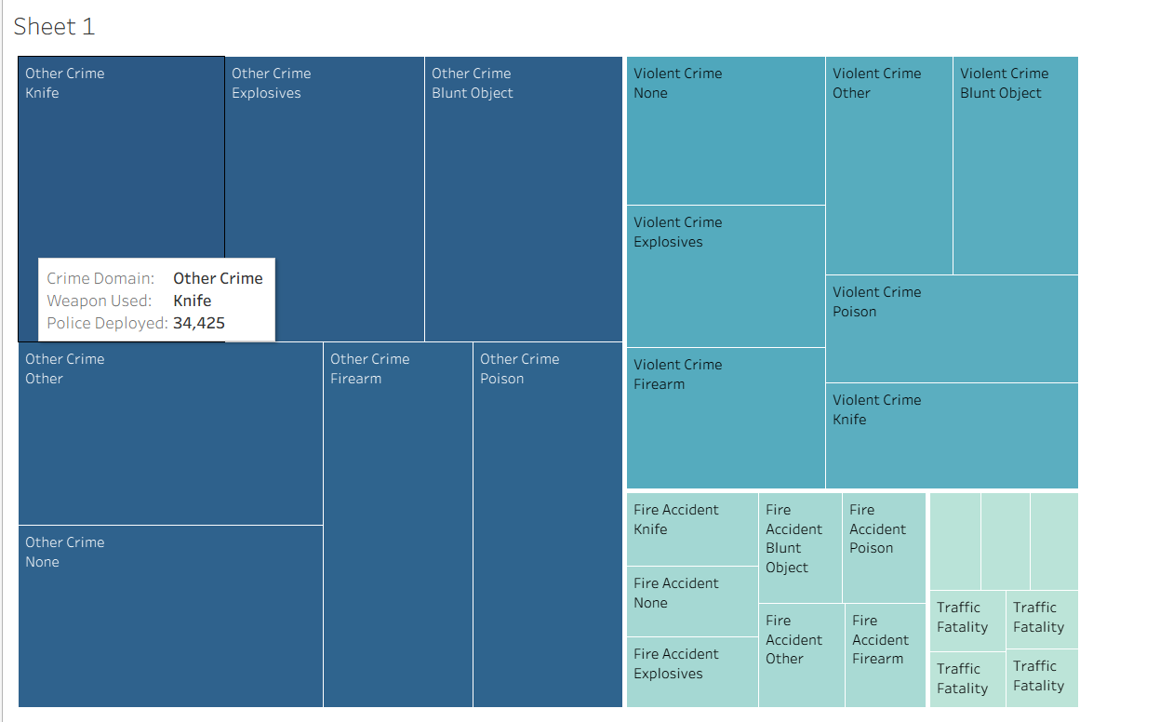

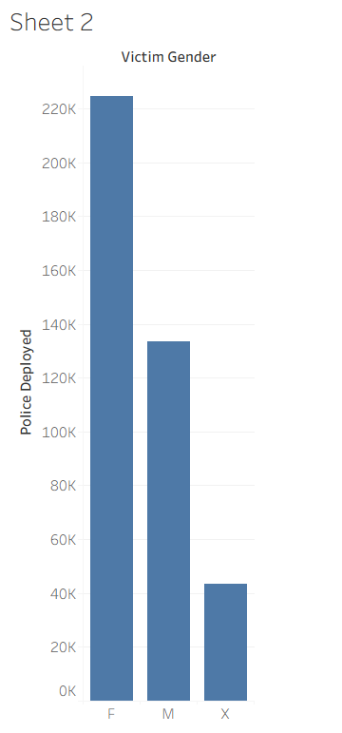
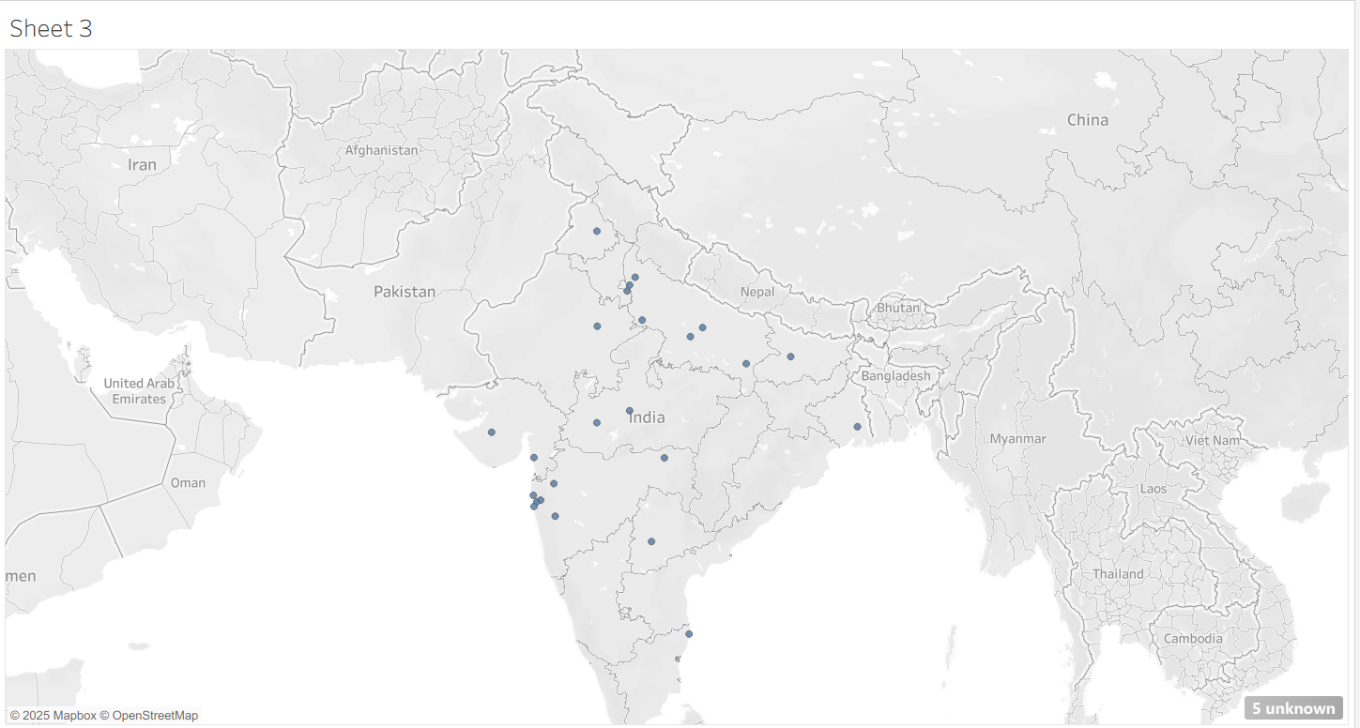

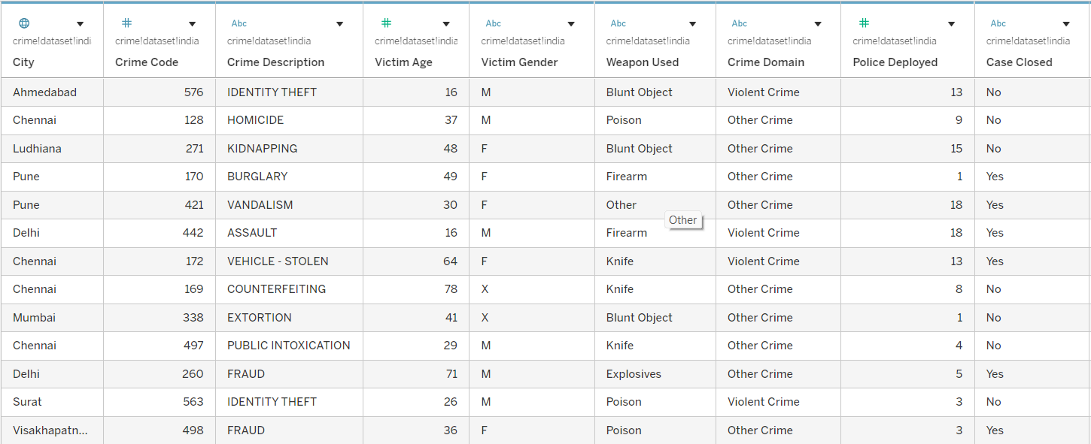
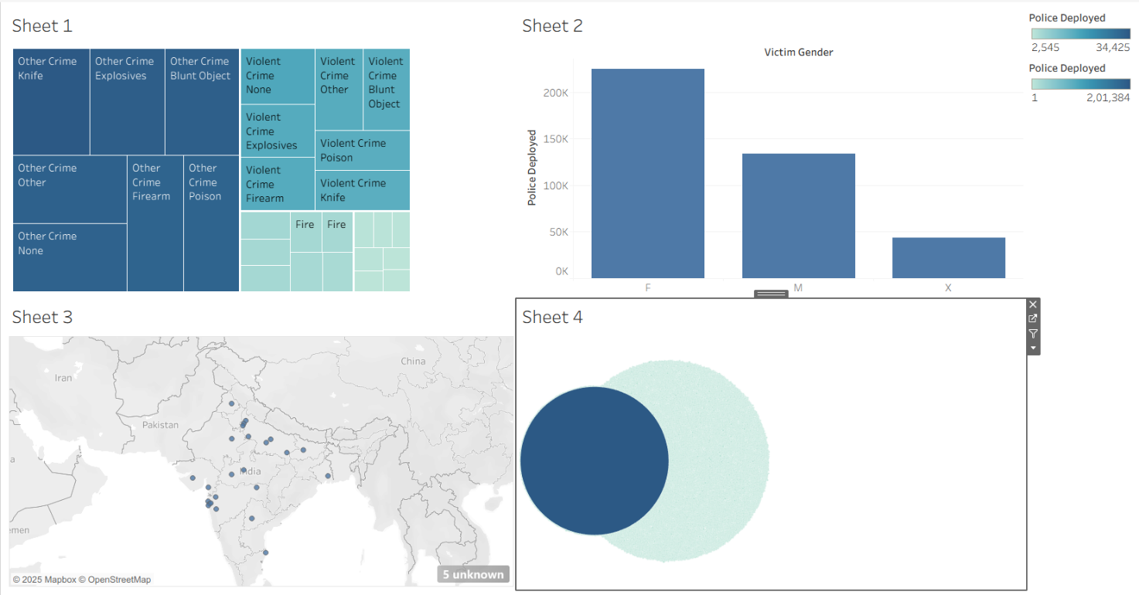

RESULT:
The Tableau dashboard provided clear visual insights into crime patterns across Indian cities. It highlighted regions with high crime rates, revealed gender-based victim trends, and showcased temporal variations through monthly and yearly charts. The interactive filters enabled deeper exploration, making it easier to identify crime hotspots and support data-driven decision-making.

