PubMedIQ
LangSmith Observability Integration

1. Overview
PubMedIQ integrates LangSmith to provide tracing, structured metrics, and offline evaluation for its LangGraph-based biomedical research pipeline. The integration is organized into four modules under app/observability: langsmith.py, metrics.py, tracing.py, and evaluation.py, exposed through a package __init__.py.

2. Module Reference

2.1 langsmith.py — Core Configuration
Handles environment setup and low-level tracing utilities for LangSmith.
- setup_langsmith() — configures LANGCHAIN_* and LANGSMITH_* environment variables (API key, project, endpoint) from application settings, guarded by settings.langsmith_enabled.
- trace(name, tags) — an async decorator that wraps a function with LangSmith's traceable(), falling back to the original function if LangSmith is disabled, not installed, or errors during tracing.
- get_langsmith_client() — returns a LangSmith Client instance for dataset and evaluation operations, or None if unavailable.

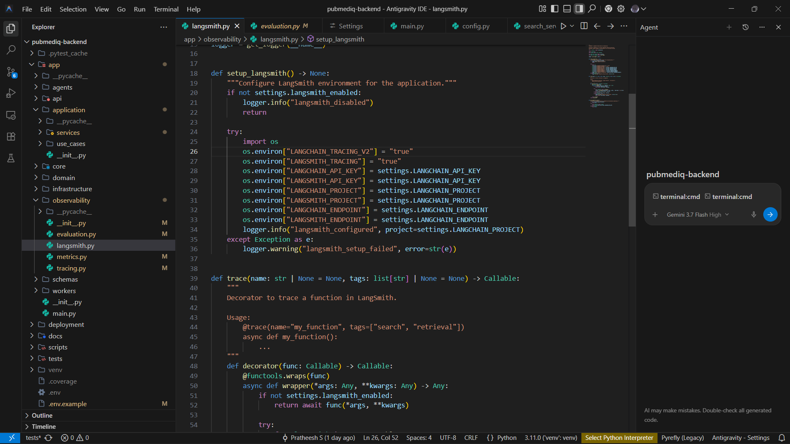

2.2 metrics.py — Structured Execution Metrics
Provides in-process measurement and structured logging of pipeline runs.
- SearchExecutionMetrics — a dataclass capturing session_id, total_duration_ms, retrieval_count, quality_score, refinement_count, intent, and a cached flag, with a log() method that emits a structured search_metrics log entry.
- MetricsTimer — a context manager that records elapsed wall-clock time (in milliseconds) around a block of code using time.perf_counter().
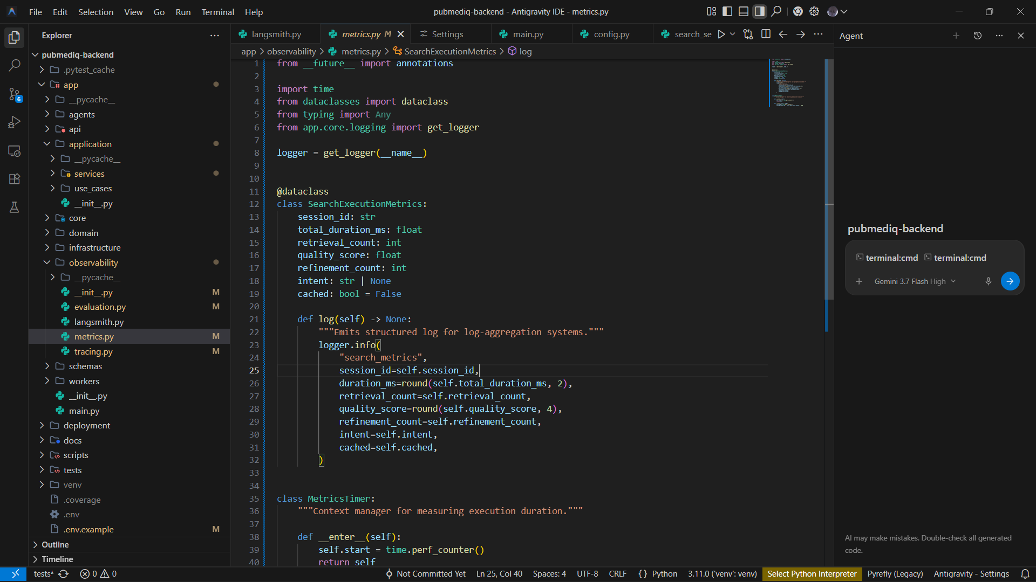

2.3 tracing.py — LangGraph Run Configuration
Bridges the pipeline to LangGraph's runnable configuration and callback system.
- get_graph_run_config(session_id, user_id, tags, metadata) — builds the config dict passed to graph.ainvoke(state, config=...), setting a run_name, merged tags (including "pubmediq" and the current environment), and metadata such as user_id, app_version, and llm_provider.
- PipelineTracingCallback — an AsyncCallbackHandler subclass with on_chain_start, on_chain_end, and on_chain_error hooks; only on_chain_error currently performs an action (structured error logging).

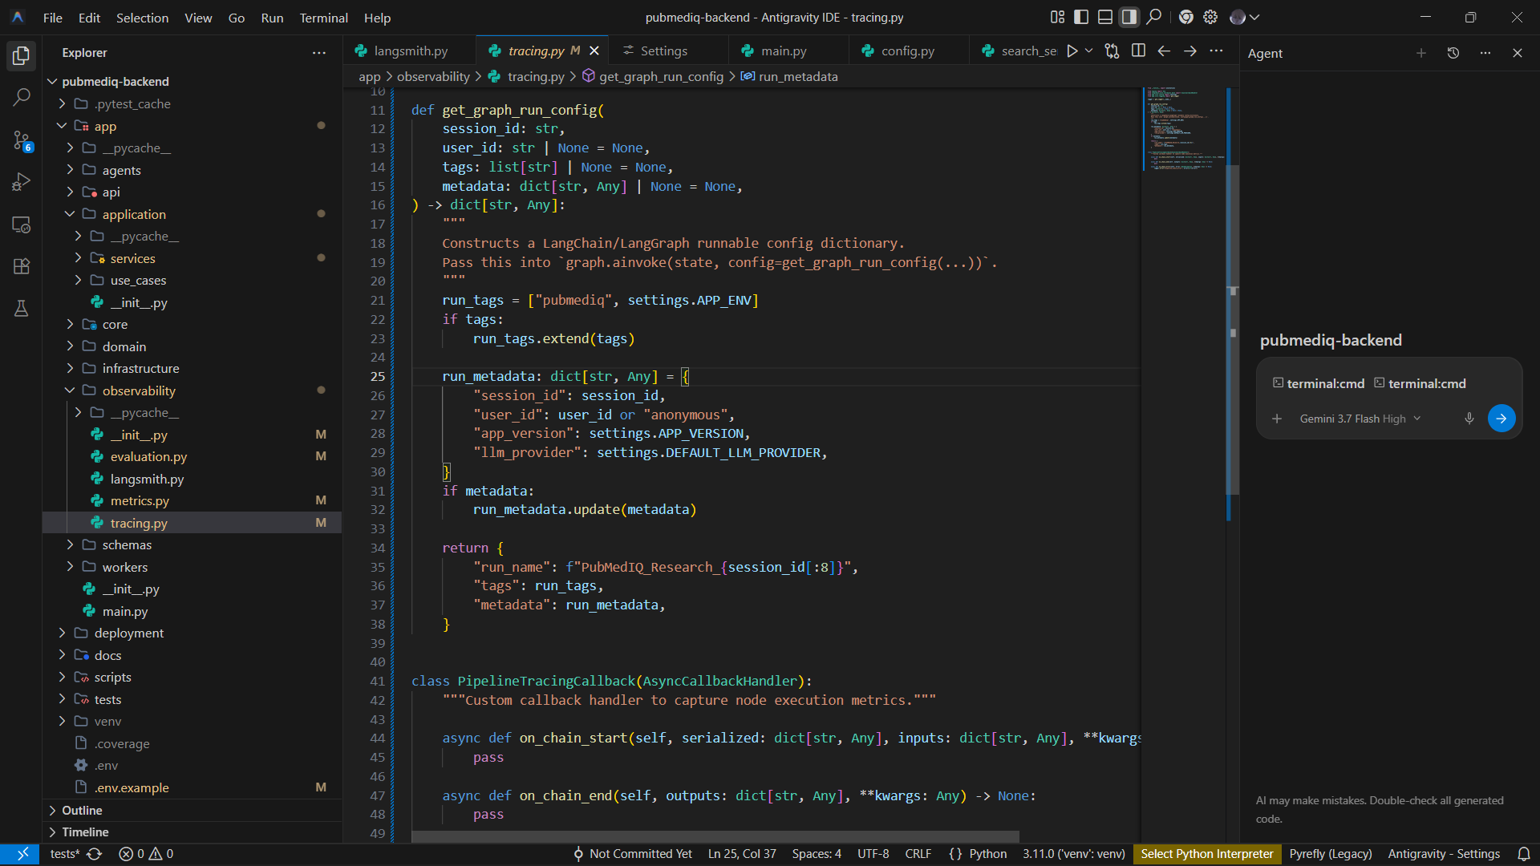

2.4 evaluation.py — Offline Evaluation
Supports building golden datasets and scoring pipeline outputs in LangSmith.
- create_or_get_evaluation_dataset(dataset_name) — fetches an existing LangSmith dataset named "pubmediq-golden-dataset" or creates it if absent, for biomedical query and PubMed citation-grounding evaluation.
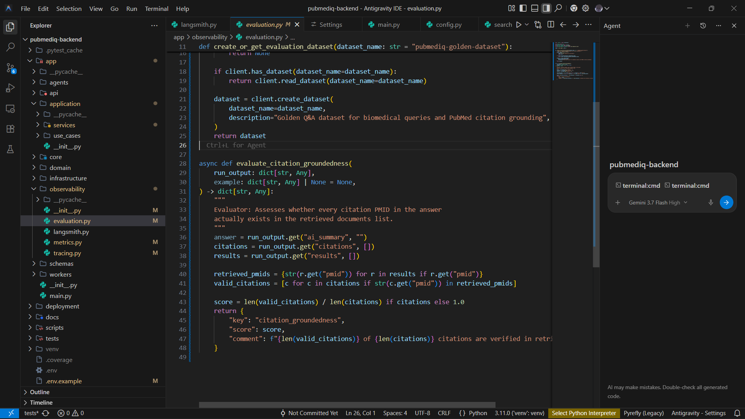

3. Package Exports (__init__.py)
The app.observability package re-exports the public interface of all four modules:
setup_langsmith, trace, get_langsmith_client,
get_graph_run_config, PipelineTracingCallback,
SearchExecutionMetrics, MetricsTimer,
create_or_get_evaluation_dataset, evaluate_citation_groundedness

4. Module Summary
Module | Responsibility | Key Exports
langsmith.py | Environment setup, tracing decorator, client factory | setup_langsmith, trace, get_langsmith_client
metrics.py | Structured metrics + timing | SearchExecutionMetrics, MetricsTimer
tracing.py | LangGraph run config + callback handler | get_graph_run_config, PipelineTracingCallback
evaluation.py | Golden dataset + citation-groundedness evaluator | create_or_get_evaluation_dataset, evaluate_citation_groundedness

5. Steps involved in Integrating LangSmith
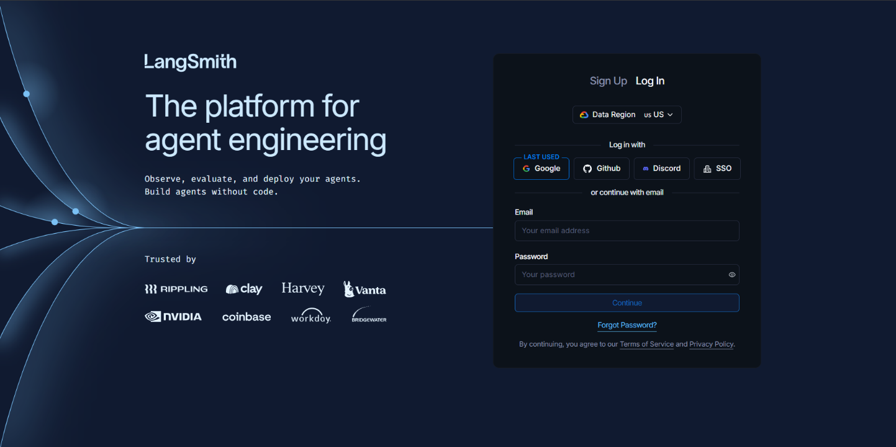
- Login into the LangSmith web using your git or google account

- Create a project and give a project name or click on the settings and select API key option and give description and click create API key

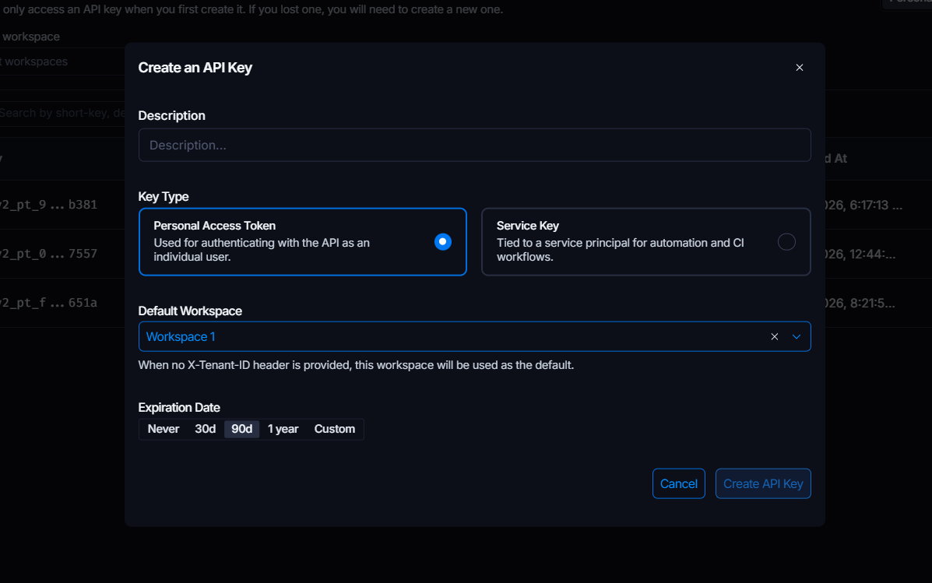

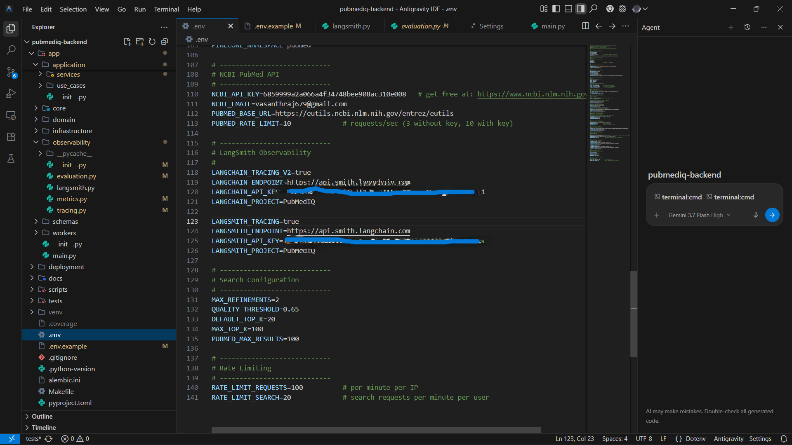
- Now copy the API key and paste it in your env file to activate tracing and monitoring the project using LangSmith
- After pasting your api code in env file your project and LAngSmith tool gets connected where you can trace and monitor the cost & Tokens, Traces, LLM calls, Run types etc..

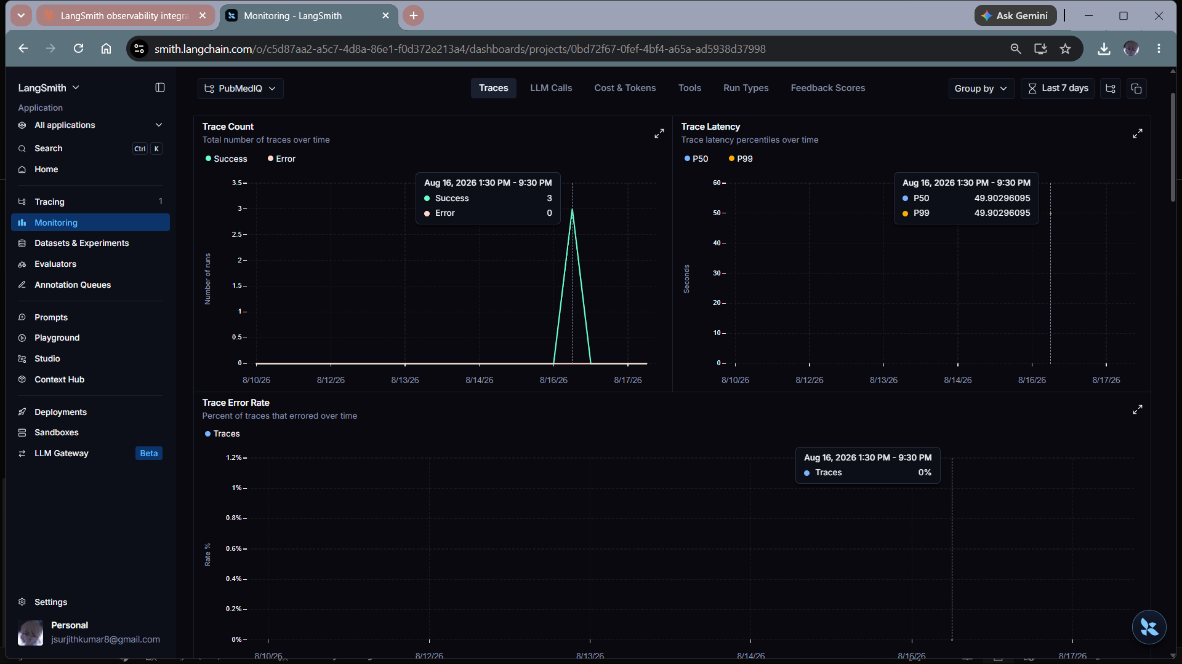

- The Final Output
