Entity–Relationship (ER) Diagram Document

Sematic Search PubMed

Team Members | Contributions
PRAVEEN KUMAR K
ROHIT T J
ROSHAN S
SAIFULLAH A
SHAHEENUR RAHMAN M
SUJAN G
SURJITH KUMAR J
VASANTHA RAJ M

Section | Title | Page
1 | Introduction | 3
2 | Purpose of the ER Diagram | 3
3 | The ER Diagram | 3
4 | Entities Overview | 4
4.1 | users (Parent / Independent Entity) | 4
4.2 | feedback (Child Entity) | 5
4.3 | saved_papers (Child Entity) | 5
4.4 | search_history (Child Entity) | 6
5 | Relationships Between Tables | 6
5.1 | How to read the notation | 7
6 | Keys and Referential Integrity | 7
6.1 | Primary Keys | 7
6.2 | Foreign Keys | 7
7 | Design Observations | 7
8 | Summary | 8

TABLE OF CONTENTS

1. Introduction
An Entity–Relationship (ER) diagram is a technical modelling tool used in database design to visually represent the entities (tables) in a system, the attributes (columns) each entity holds, and the relationships that connect those entities. It gives a single-page, structural view of how data is organised and how different parts of an application's database are linked to one another.
The ER diagram produced for this project models the backend database of a research-assistant style platform, where registered users can search for academic papers, save papers of interest, and leave feedback on their search sessions. The diagram consists of four entities: users, feedback, saved_papers, and search_history. The users table sits at the centre of the model, and the remaining three tables each depend on it through a foreign key relationship.

2. Purpose of the ER Diagram
The ER diagram was created to:
- Provide a clear, visual reference of the database structure before/alongside implementation.
- Communicate how records in one table relate to records in another (parent–child dependencies).
- Confirm that every child table correctly traces ownership back to a user via user_id.
- Serve as documentation for reviewers, teammates, or future developers who need to understand the schema quickly.
- Act as a reference for enforcing referential integrity constraints (foreign keys) at the database level.

3. The ER Diagram
The diagram below is the schema view exported from the database design tool. It shows all four tables with their columns, data types, primary keys (key icon), and the connecting relationship lines between users and the three dependent tables.
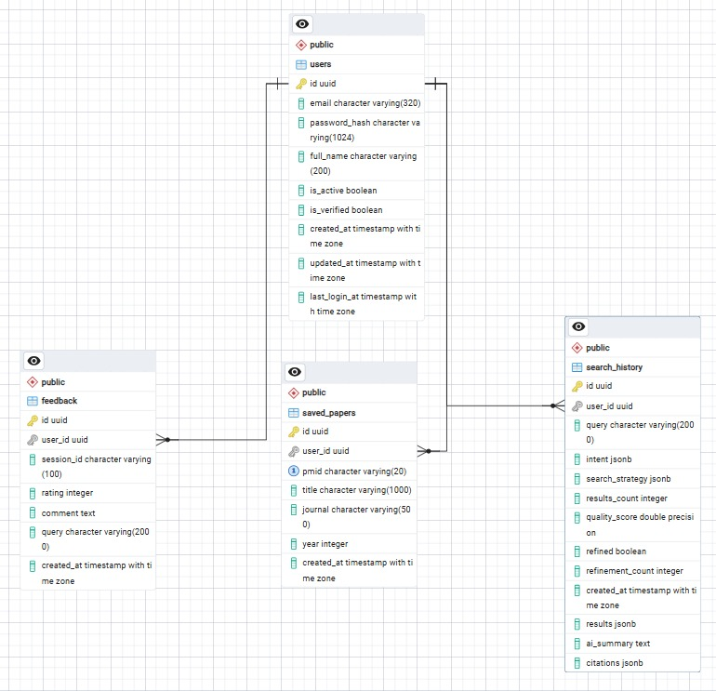
Figure 1: ER diagram of the platform's core database schema (users, feedback, saved_papers, search_history).

4. Entities Overview
The schema is composed of one independent (parent) entity and three dependent (child) entities. An independent entity can exist on its own, while a dependent entity's rows only make sense in relation to a row in the parent entity.

4.1 users (Parent / Independent Entity)
Stores the account record for every registered person on the platform. Every other table in the schema ultimately refers back to a row in this table, which is why it is drawn at the centre of the diagram with lines fanning out to the three child tables.

Column | Data Type | Key | Description
id | uuid | PK | Unique identifier for the user; referenced by all child tables as user_id.
email | varchar(320) |  | The user's login email address; used for authentication and communication.
password_hash | varchar(1024) |  | Securely hashed password (never stored as plain text).
full_name | varchar(200) |  | The user's display name.
is_active | boolean |  | Flags whether the account is currently active/enabled.
is_verified | boolean |  | Flags whether the user has verified their email address.
created_at | timestamptz |  | Timestamp when the account was created.
updated_at | timestamptz |  | Timestamp of the last profile update.
last_login_at | timestamptz |  | Timestamp of the user's most recent login.

4.2 feedback (Child Entity)
Captures feedback a user submits, typically about a search session — a rating, an optional comment, and the query it relates to.
Column | Data Type | Key | Description
id | uuid | PK | Unique identifier for the feedback record.
user_id | uuid | FK | References users.id — identifies who submitted the feedback.
session_id | varchar(100) |  | Identifier grouping feedback to a specific user session.
rating | integer |  | Numeric rating given by the user (e.g., 1–5).
comment | text |  | Free-text comment/explanation from the user.
query | varchar(2000) |  | The search query the feedback refers to.
created_at | timestamptz |  | Timestamp when the feedback was submitted.

4.3 saved_papers (Child Entity)
Stores academic papers that a user has bookmarked or saved for later reference.
Column | Data Type | Key | Description
id | uuid | PK | Unique identifier for the saved-paper record.
user_id | uuid | FK | References users.id — identifies who saved the paper.
pmid | varchar(20) |  | PubMed ID (or similar external identifier) of the paper.
title | varchar(1000) |  | Title of the saved paper.
journal | varchar(500) |  | Name of the journal the paper was published in.
year | integer |  | Publication year of the paper.
created_at | timestamptz |  | Timestamp when the paper was saved by the user.

4.4 search_history (Child Entity)
Logs every search a user performs, including how the query was interpreted (intent), what strategy was used to run it, and how well it performed.
Column | Data Type | Key | Description
id | uuid | PK | Unique identifier for the search-history record.
user_id | uuid | FK | References users.id — identifies who ran the search.
query | varchar(2000) |  | The raw search query text entered by the user.
intent | jsonb |  | Structured data describing the detected intent behind the query.
search_strategy | jsonb |  | Structured data describing the strategy/parameters used to execute the search.
results_count | integer |  | Number of results returned for the query.
quality_score | double |  | A computed score reflecting the quality/relevance of results.
refined | boolean |  | Whether the user refined/modified this search.
refinement_count | integer |  | Number of times the query was refined.
created_at | timestamptz |  | Timestamp when the search was performed.
results | jsonb |  | Full result payload returned for the query, including paper metadata and ranking scores.
ai_summary | text |  | AI-generated summary of the retrieved evidence, presented to the user as the final answer.
citations | jsonb |  | Structured citation data (e.g., PMIDs) backing the AI-generated summary, used for evidence grounding.

5. Relationships Between Tables
All three relationships in this schema follow the same pattern: users is the 'one' side and the other table is the 'many' side, connected through the user_id foreign key. In the diagram this is shown using crow's-foot notation — a single tick mark (１) at the users end and a crow's-foot (many) mark at the other end of each line.

Parent Entity | Cardinality | Child Entity | Relationship Meaning
users | 1 : N | feedback | One user can submit many pieces of feedback. Each feedback row belongs to exactly one user (feedback.user_id → users.id).
users | 1 : N | saved_papers | One user can save many papers. Each saved_papers row belongs to exactly one user (saved_papers.user_id → users.id).
users | 1 : N | search_history | One user can perform many searches. Each search_history row belongs to exactly one user (search_history.user_id → users.id).

5.1 How to read the notation
- The straight bar (｜) near users represents 'exactly one' — every feedback, saved_papers, or search_history row must belong to one, and only one, user.
- The crow's-foot (many) symbol near the child tables means a single user can have zero, one, or many related rows in that table.
- There are no direct relationships between feedback, saved_papers, and search_history — they only relate to each other indirectly, through the shared user.

6. Keys and Referential Integrity

6.1 Primary Keys
Every table uses a uuid column named id as its primary key. Using UUIDs (rather than auto-incrementing integers) means IDs are globally unique, non-sequential, and safe to expose in URLs or APIs without revealing how many records exist.

6.2 Foreign Keys
feedback.user_id, saved_papers.user_id, and search_history.user_id are all foreign keys referencing users.id. This enforces that:
- A feedback, saved_papers, or search_history row cannot be created for a user that does not exist.
- The database can enforce cascading rules (e.g., delete a user's related records when the user account is deleted), depending on how the FK constraint is configured.
- Query joins between users and any child table are efficient and unambiguous.

7. Design Observations
- The schema is in a star-like shape: one central entity (users) with three independent dependent entities — a common and clean pattern for user-centric applications.
- jsonb columns (intent, search_strategy, results, and citations in search_history) are used to store flexible, semi-structured data that doesn't need its own relational table.
- The search_history table now also stores the AI-facing layer of a search: results (the returned paper set), ai_summary (the generated evidence summary), and citations (the PMIDs backing that summary) — supporting evidence-grounded, GenAI-assisted result presentation.
- Timestamps (created_at, and updated_at/last_login_at for users) are present across the schema for auditing and activity tracking.
- No many-to-many relationships exist in this schema, so no junction/bridge table is required.
- The design follows standard normalization principles — each table stores attributes relevant only to its own entity, avoiding data duplication.

8. Summary
In short, this ER diagram describes a single-user-centric schema: the users table is the anchor of the entire system, and feedback, saved_papers, and search_history each independently track a different kind of user activity — submitting feedback, saving papers, and running searches. Every activity record is traceable back to exactly one user through a one-to-many relationship, ensuring data stays organized, consistent, and easy to query.

