**Applied Data Science Assignment-1**

**Name: Vasanth Kumar Duggimpudi**

**Student No: 22018255**

**Course: MSc Data Science**

# **Repository: https://github.com/Vasanthkumar09/visualisation**

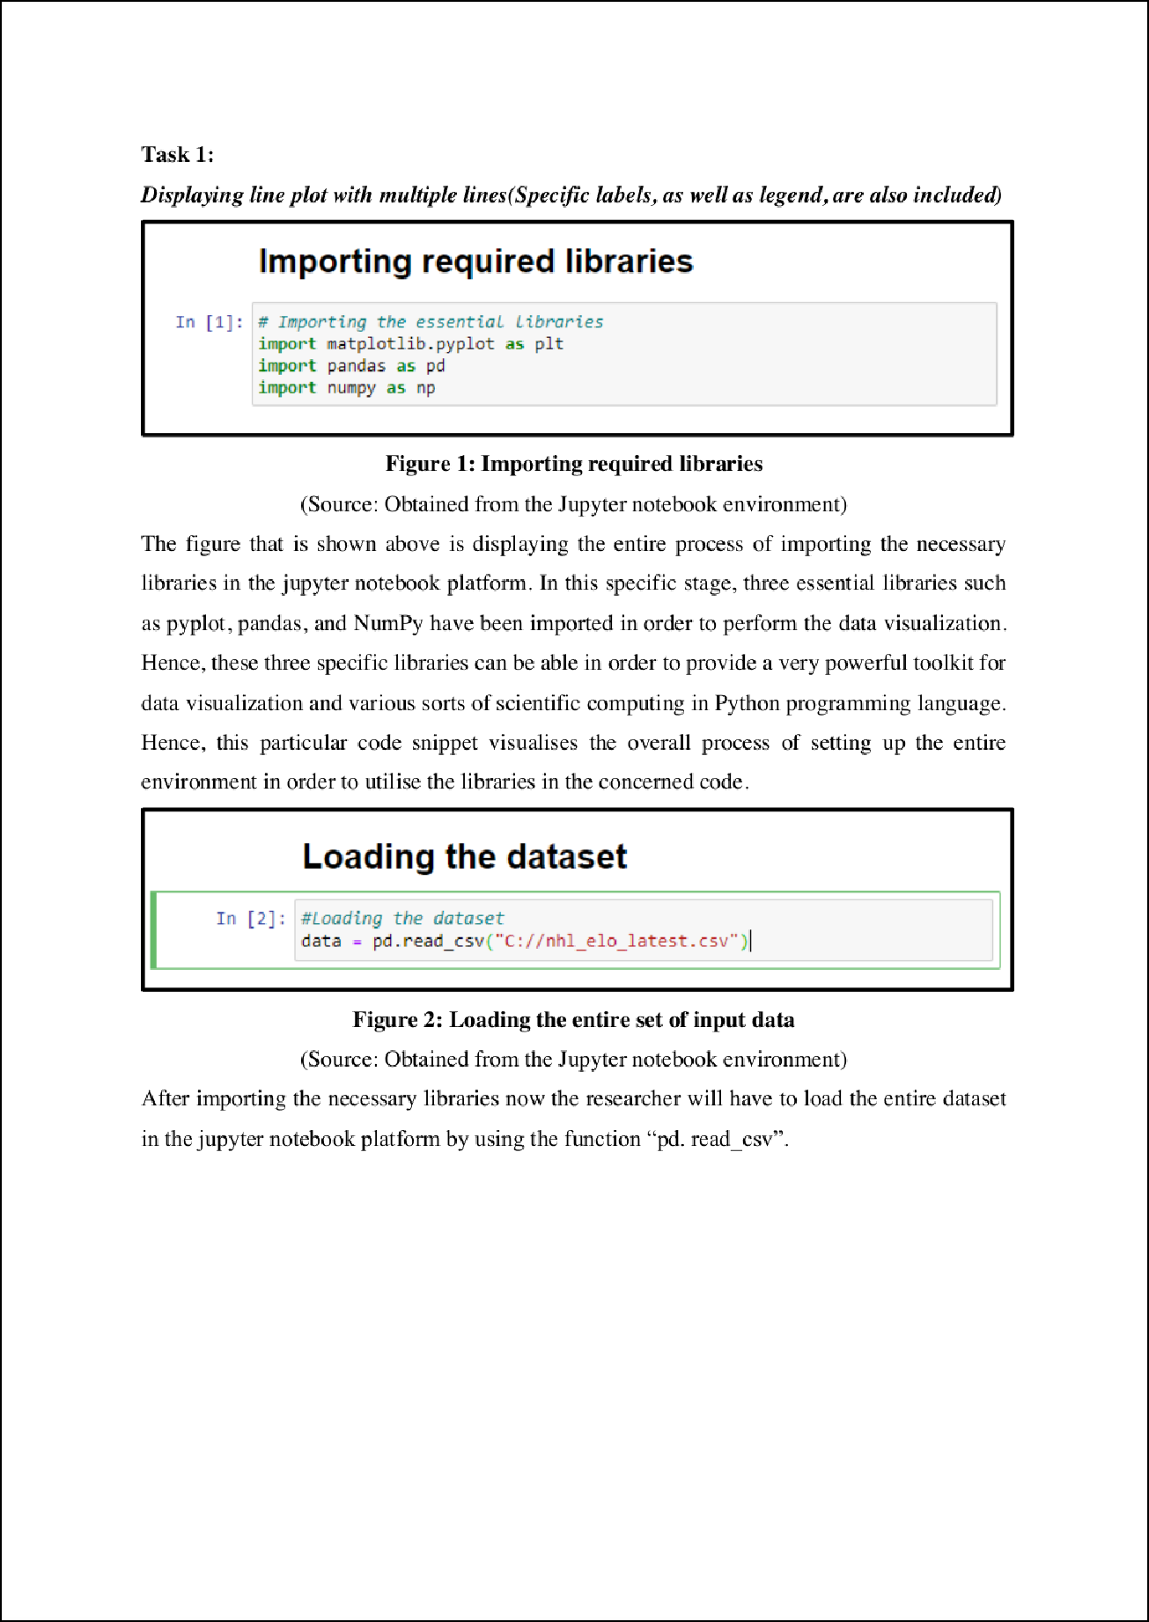

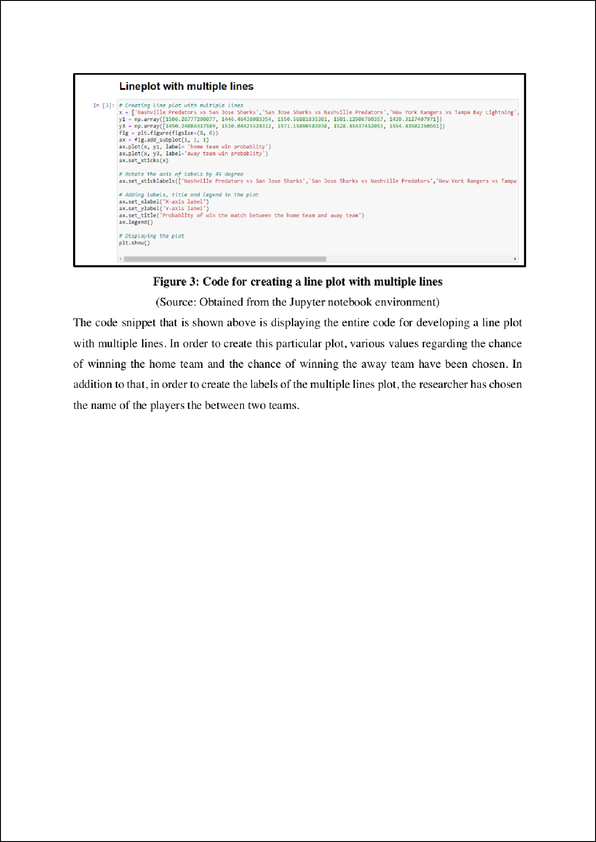

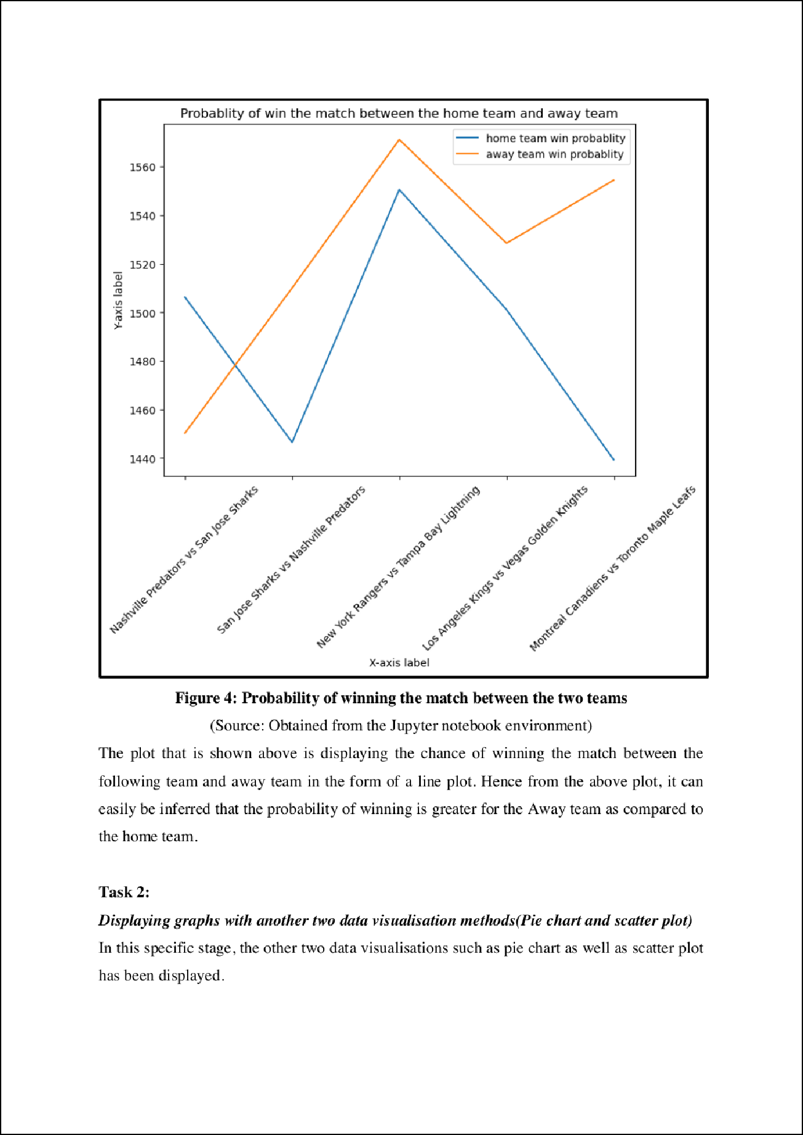

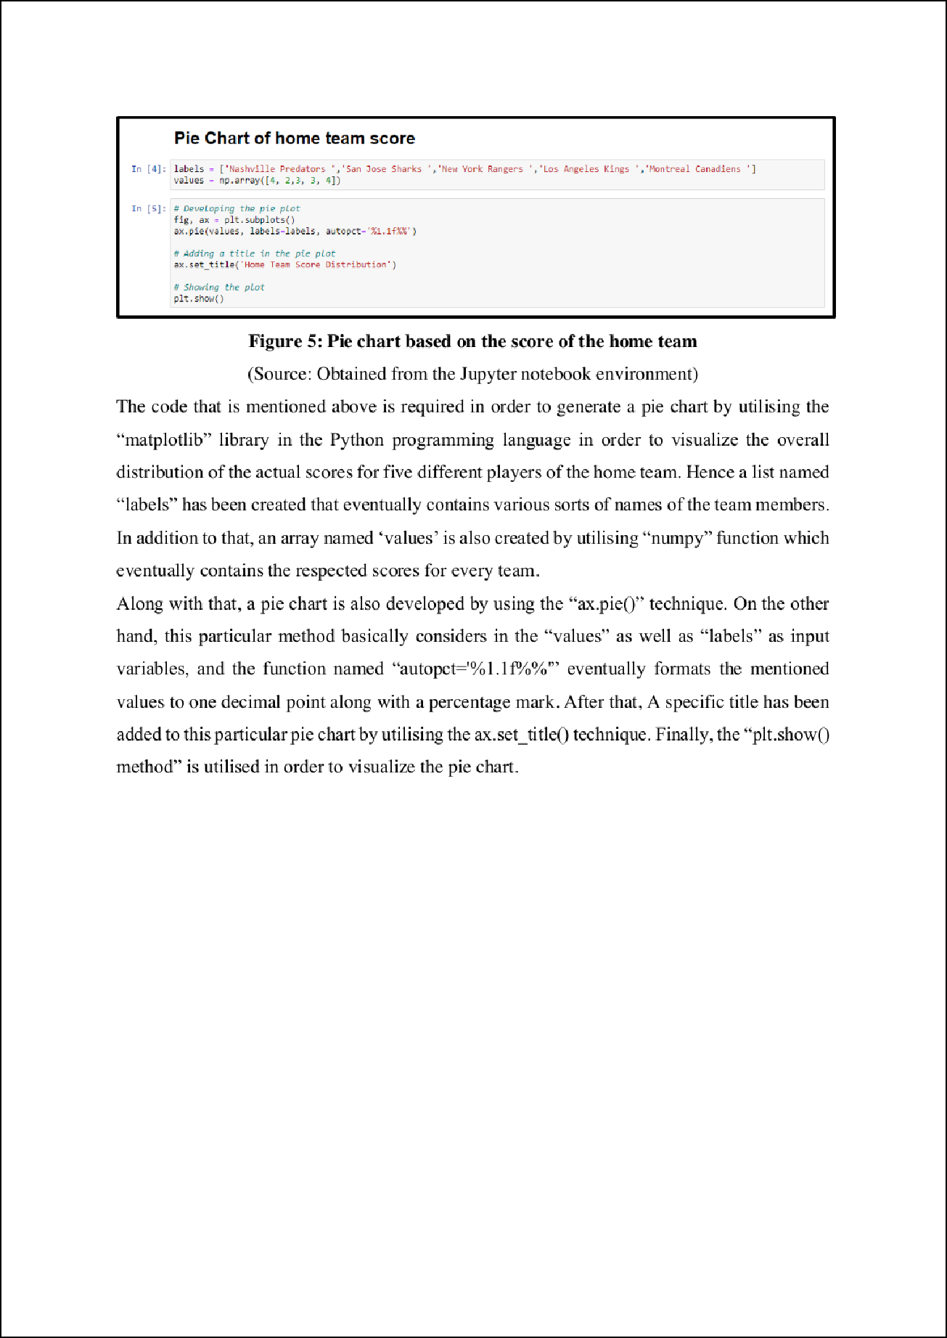

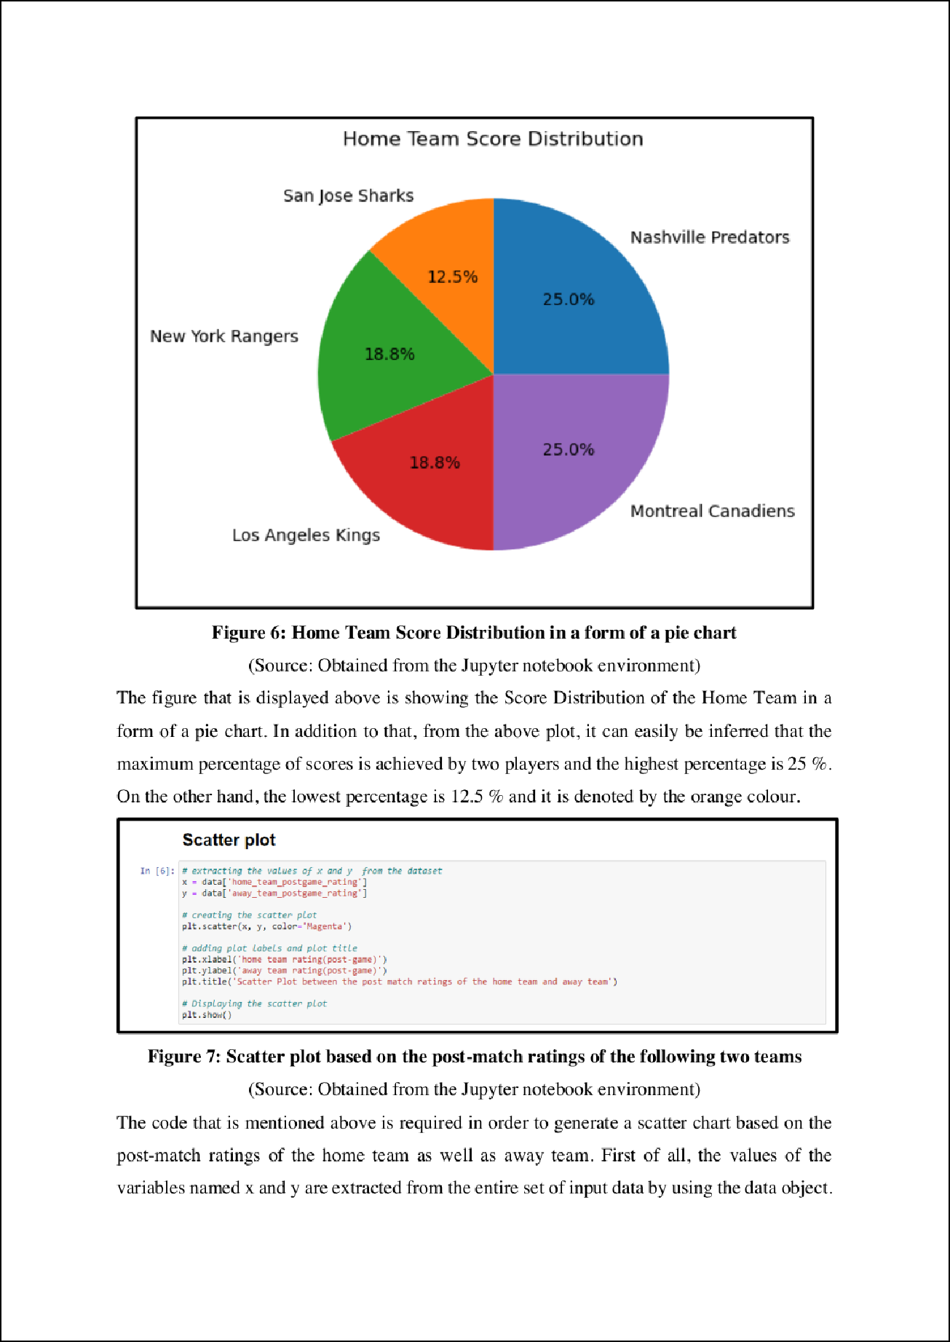

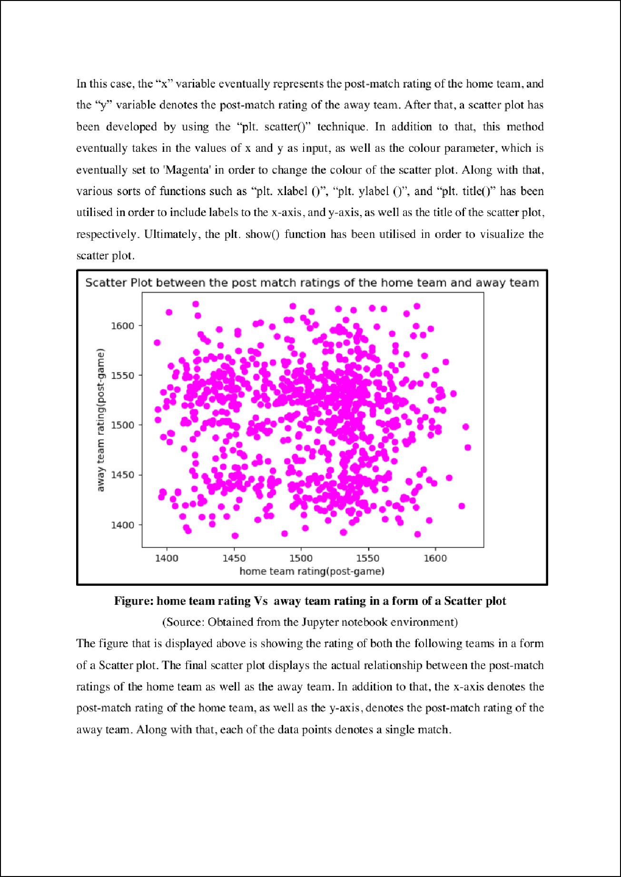

Plag_report

ORIGINALITY REPORT

0

bibliography On

Exclude matches Off