IBM Naan Mudhalvan-Data Analytics with cognos Group2

Student Name : Vasantharaj V
Register Number : 620821104125
Branch : B.E CSE
Year : 3 year
Topic : Data Analytics with cognos
Title : Product Sales Analysis
College &Code : Gnanamani college of technology ( 6208)

PRODUCT SALES ANALYSIS

- Introduction

*. What about that products
*. What is the product sales
analysis
*.How to sales the products to
the costumers
2.Data collections
3.Visualization strategy
4.Actionable Insights
5.Conclusion

What about that products ?
->.In digital marketing or marketing product is an object.
->.It is available for consumers.
->.it is used to the urban life and
rural life peoples.

What is PRODUCT SALES ANALYSIS?
->.In sales analysis is reviews your sales data.
->.To identify the trends and patterns
->.sales data is our products or objects
->.The customers needs to the business.
How to sales products to the customers?
->.The seller know the products.
->. we can give the advertisement to
based on that products.
->.The seller sales the products into online and offline to the consumers
->.Finally the seller sales the
Products.

DATA COLLECTION
ABOUT DATA SET
This dataset contains phone features including price of popular brands. Every phone in this dataset continued to be manufactured. Does not include discontinued phones
Phone-name brands OS inches battery storage
Y6ll compact Huawei android5 5 2200 32
K20 plus LG andriod5.1 5 2200 32
Redmi note 4 Xiaomi andriod6 5.5 3200 64
P10 lite Huawei andriod7 5.1 3200 64
A39 Oppo andriod5.1 6 2900 32
Mi6 Xiaomi andriod7.1 7 4000 64
K8 Lenovo android 8 5 4000 64
Pixel Google android 8 5 2700 62

PHONE PRICE
Usability
8.82
License
Attribution 4.0 international (cc BY 4.0)
Expected updates frequency
Never
Activity overview
Views Downloads
6459 1644
download per view ratio Total unique contributes
0.25 13

INCLUDING TRANSATION RECORDS
The shopkeeper identifiers the transaction type ,account, and amounts ,
Type: purchase
Accounts: purchase accounts and cash accounts
Amounts:$50,000

ACCOUNT DEBIT CREDIT
Purchase account $50,00,00 $50,00,000
Cash account $50,000 $10,00,00
PRODUCT INFORMATION.
Product information refer to any information held an organization about the products it produces, buys, sell or distributes.
In the context of product information management(PIM), this typically refers to information relating to the selling and/or marketing of products via digital channels.

.COSTOMER DEMOGRAPHICS.
Customer demographics are categories of consumer groups used for business purposes
The most commonly used categories include.
.AGE
.INCOME
.EDUCATION
.ETHNICITY
.GENDER
.MARITAL STATUS
.FAMILY
.EMPLOYMENT
.RELIGION
.HOME OWNERSHIP
.R,A,C,E
.NUMBER OF CHILDREN
.LOCATION

Phone quality and storage:

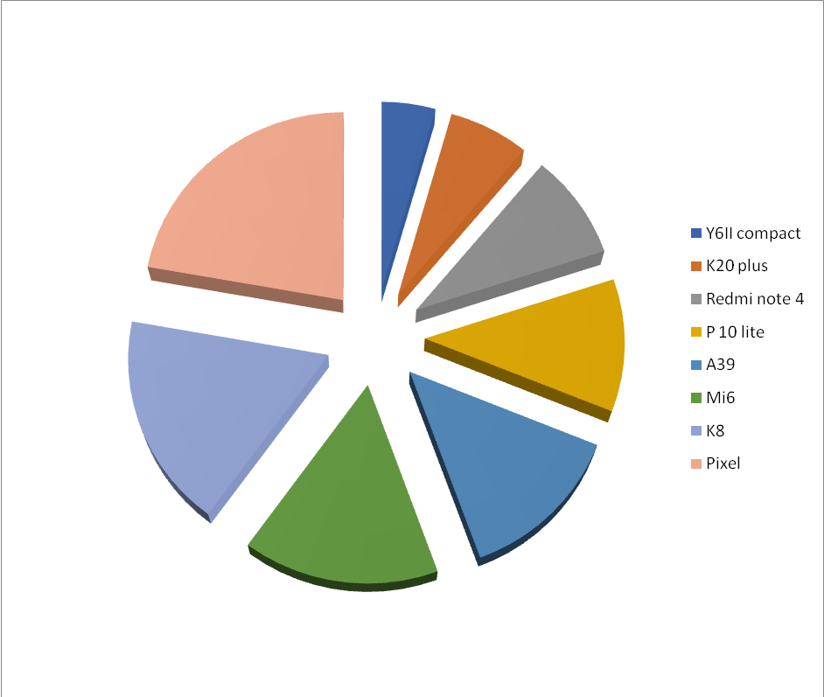

Viewers and Downloads:

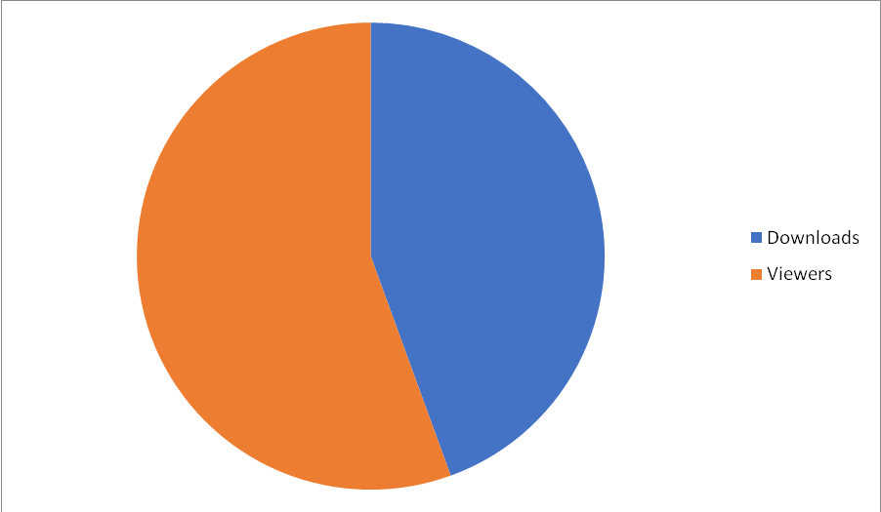

Investment and Profit:

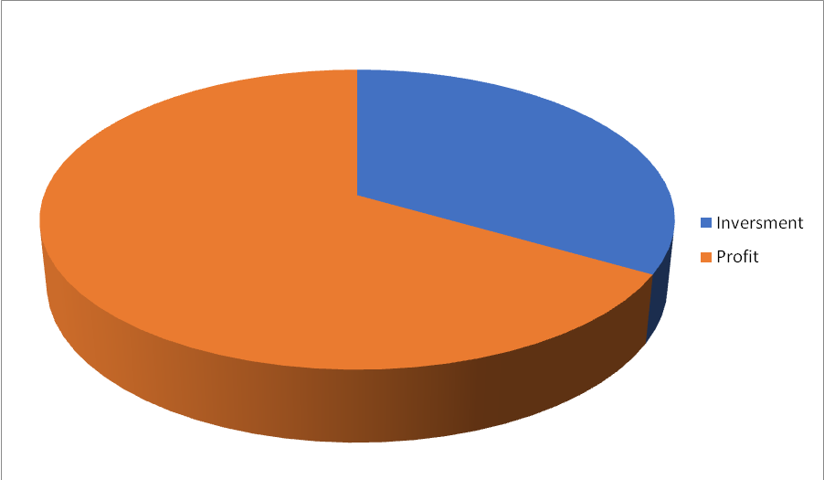

Marketing strategy
- Your Sales and Marketing strategy is your plan for reaching , engaging, and converting target prospects into profitable customers.
- Its the character that guides marketing and Sales in their daily activities, helping them clarify shared objectives and how to achieve them.
- Our own research found that 54% of sales and Marketing professional note collaborations positive contribution to financial performance.

Conclusion
- A good marketing plan includes how the organization should respond to various scenario if the market changes .
- Also, keep in mind that a marketing plan is created at a single point in time.
- Also, it should once again be noted that the marketing plan is a communication device .

