ADB-Assignment05

Name :Vasanth Sai Aitha

919646291

Sid: S571903

Write a procedure that takes a patient_ID as input and updates the discharge date  
for that patient in the Patients table. If the patient is already discharged, display an  
appropriate message.

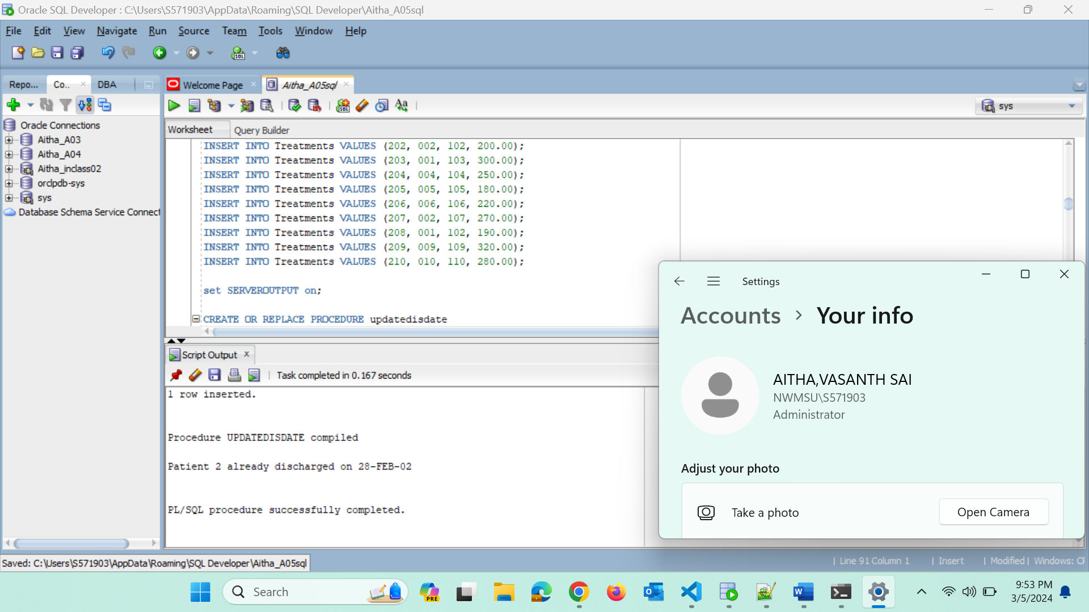

Write another procedure of your own using the given database schema and  
explain it in your own words where it can be used in the real world.

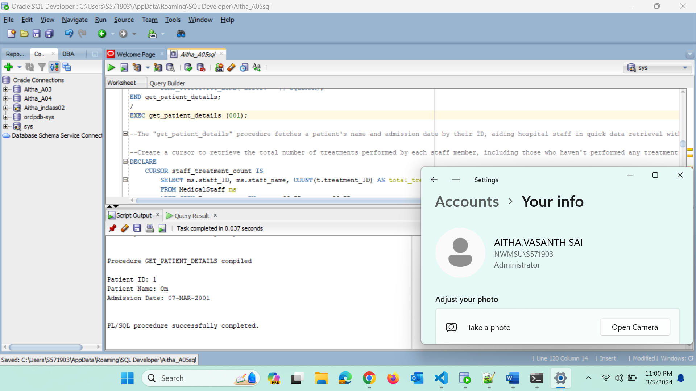

Create a cursor to retrieve the total number of treatments performed by each staff  
member, including those who haven't performed any treatments. Display the staff ID,  
staff name, and the total number of treatments.

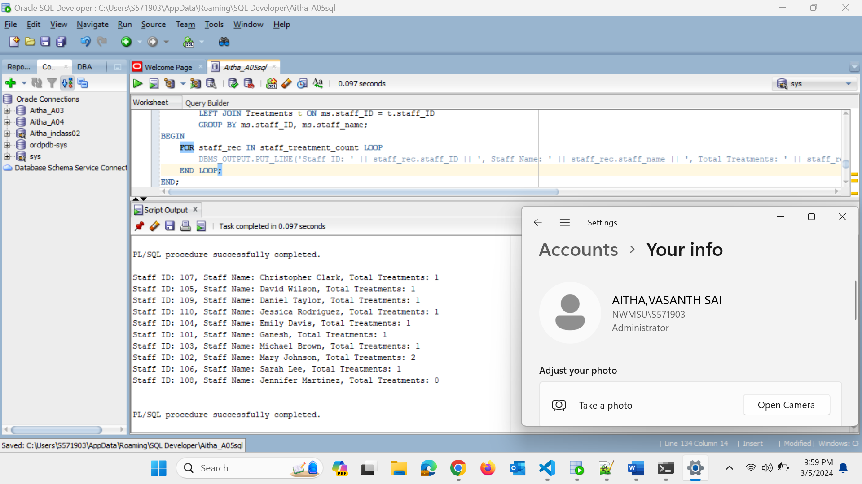

Create another cursor of your own using the given database schema and explain  
it in your own words.

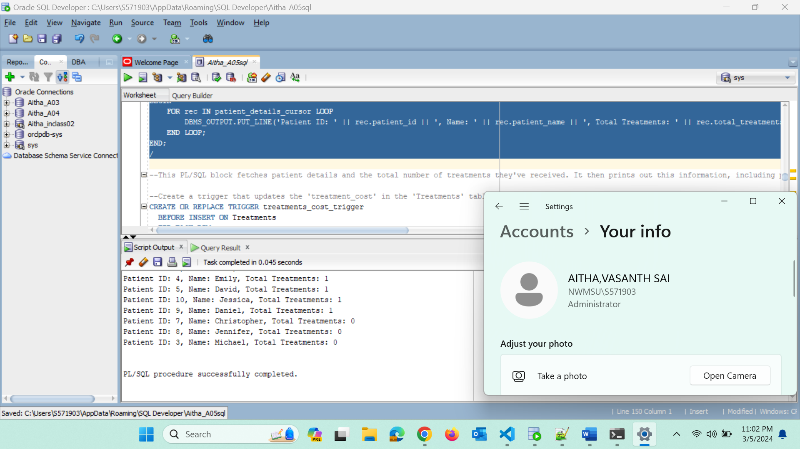

Create a trigger that updates the 'treatment_cost' in the 'Treatments' table whenever  
a new treatment is inserted, ensuring that it does not exceed a predefined maximum  
cost (use your own maximum cost).

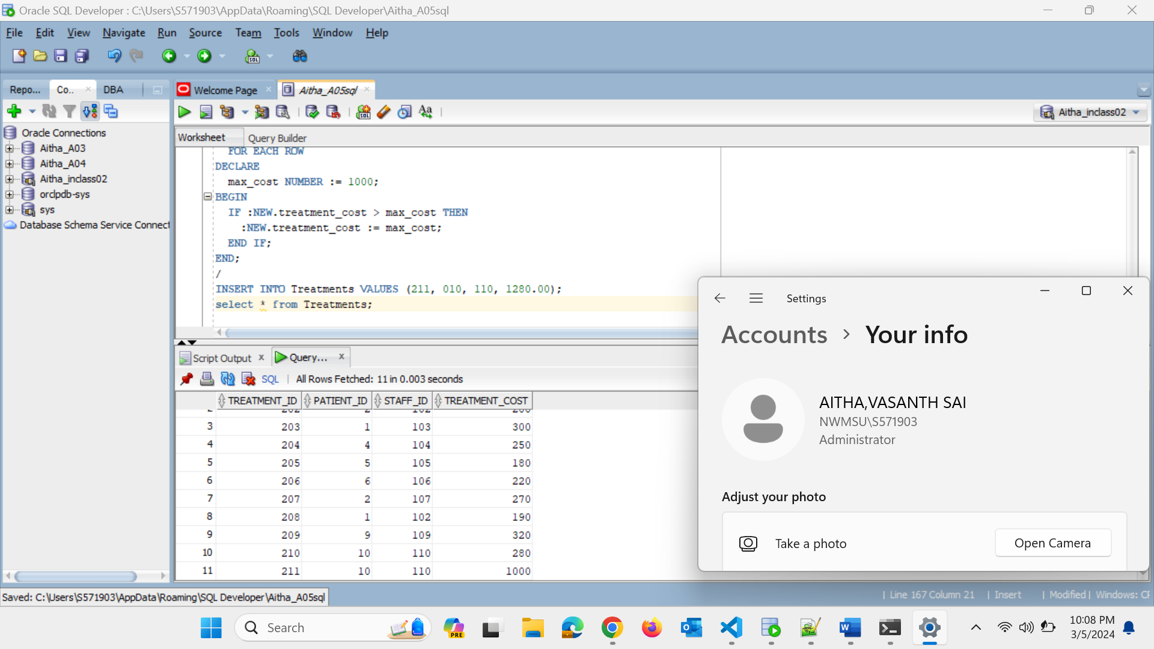

Create another 'Treatment History' table with at least two attributes of your  
choice and populate it with the history of each insertion whenever an update is  
performed on the Treatment table.

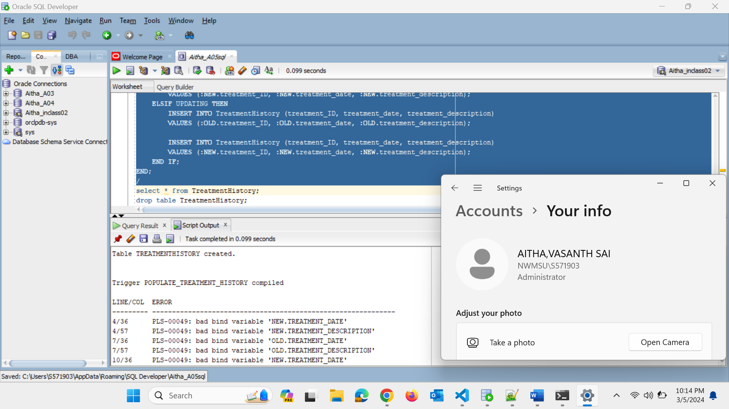

Can you create an SQL function named GetTotalPatientsCountFunction to retrieve  
the total count of patients from the 'Patients' table in a Hospital Management  
database? Write a procedure to use the function and display it.

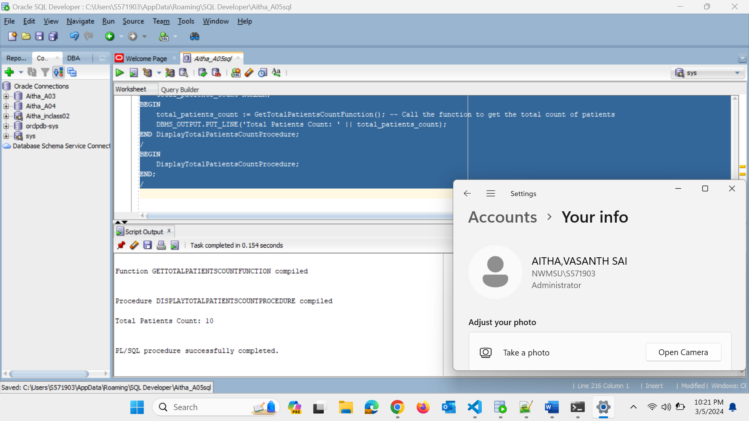

Write a subquery to retrieve patients who have been treated by medical staff  
members with the highest treatment cost.

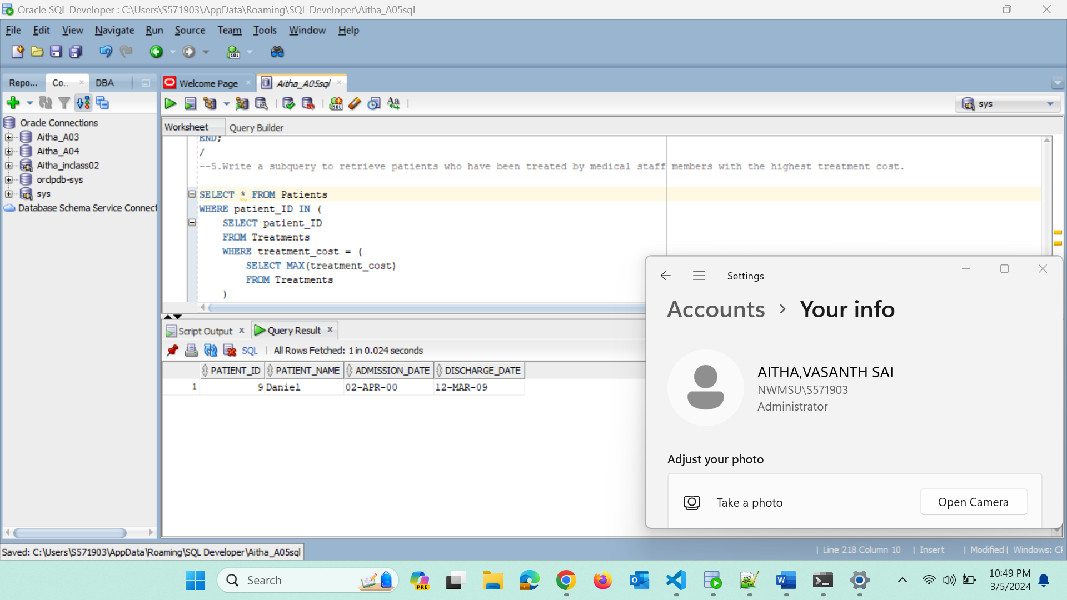

Write a query to retrieve patients who have been treated by medical staff members  
of all types available in the MedicalStaff.

