ANALYZING ARTIFICIAL INTELLIGENCE IN SUPPLY CHAIN MANAGEMENT

PROBLEM STATEMENT:

In today's rapid business industry, the need for a website where it connects transportation, logistics, and e-commerce services has become more apparent. Existing platforms on this lack to offer a solution for suppliers, customers, and shipping needs. The lack of a combined platform results in inefficiencies, higher costs, and bad user experiences.

This project aims to address these challenges by creating a multifunctional website that combines transportation and logistics services with a shopping platform. The platform will allow suppliers sell their products, customers to make purchases, and the seamless shipping services, whether the goods are sourced from the platform or external suppliers or the goods belong to an individual everything can be transported to their desired destination. By providing a central point for supply chain activities, the project seeks to optimize the entire process, offering convenience, reliability, and cost-effectiveness to all stakeholders involved.

ABSTRACT:

This project concentrates on the development of an integrated transportation, logistics, and e-commerce platform to streamline the supply chain process. The platform will serve as a best solution, allowing suppliers to showcase and sell their products, customers to make purchases, and goods to be efficiently transported and delivered. The key features of the platform include a user-friendly e-commerce application for customers, a supplier onboarding system, and a logistics management module for efficient order fulfillment.

By combining these services into a single platform, the project aims to decrease the existing problems, offering a unified and efficient experience for suppliers, customers, and shipping needs. This initiative has the potential to revolutionize the way businesses handle their supply chain operations, increasing growth, and increasing overall efficiency in the global marketplace.

EXISTING:

There are many existing platforms like

* Amazon: While primarily an e-commerce platform, Amazon has an extensive logistics and supply chain network.
* Alibaba: Like Amazon, Alibaba is a major e-commerce platform that also provides logistics and supply chain services.
* UPS and FedEx: These are major logistics companies that offer shipping solutions to businesses.
* Flexport: It is a modern international technology to streamline logistics and shipping.
* Shopify: While mainly an e-commerce platform, Shopify also provides integrations with shipping and logistics services.
* Yusen Logistics: It is a global logistics and transportation website. Where it will provide solutions and services to the users.
* Meesho: It is a social commerce platform. It also enables individuals to start their own online business.

All the above-mentioned websites have at least one feature which we will incorporate in our project combined and provide all services to the suppliers, customers.

PROPOSED:

We propose the development of an innovative online platform that can manage transportation, logistics, and e-commerce services. This solution aims to revolutionize the supply chain process by offering a single platform where suppliers can showcase and sell their products directly to customers. The e-commerce module provides a user-friendly interface for customers to make purchases, while a logistics management system ensures efficient order fulfillment and real-time tracking.

Additionally, the platform distinguishes itself by offering shipping services not only for products listed on the platform but also for external goods. With a focus on empowering businesses and individuals, the platform provides a unique opportunity for entrepreneurs to start their online ventures. The proposed project ensures scalability and security, while guarantees a trustworthy environment. This project is not just an e-commerce website but an end-to-end supply chain optimization.

REQUIREMENTS:

SOFTWARE:

Operating System: Windows 11

Visual Studio Code

HARDWARE:

Intel Core i3 11th gen

8 GB RAM

SYSTEM FLOWCHART:

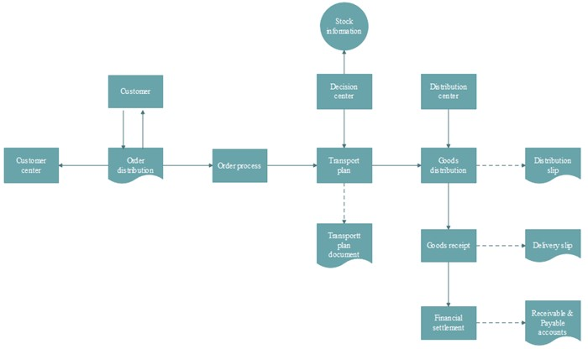

DATABASE SCHEMA:

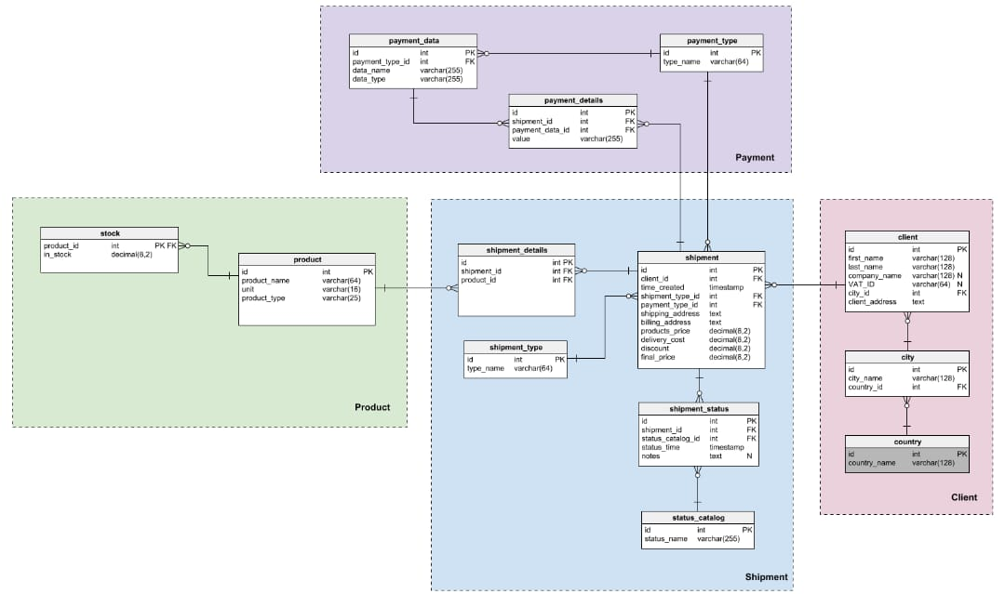

OUTPUT:

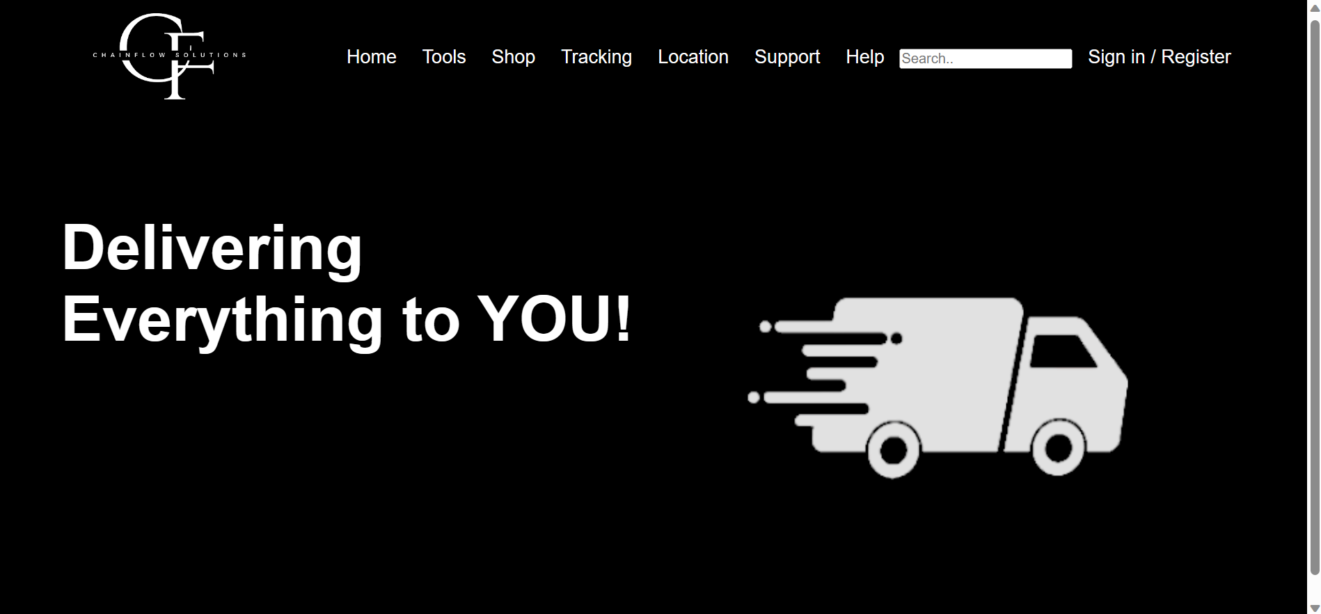

CONCLUSION:

In conclusion, ChainFlow Solutions represents a pioneering venture that converges the realms of transportation, logistics, and e-commerce into a unified platform. With a seamless supply chain management, our project not only facilitates direct transactions between suppliers and customers but also introduces a comprehensive shipping ecosystem. By integrating innovative technologies and optimizing the end-to-end supply chain process, ChainFlow Solutions aims to redefine the landscape of commerce.

This project envisions a future where businesses, consumers enjoy unparalleled convenience, and the global movement of goods reaches new levels. Join us in shaping this transformative journey towards a more connected and efficient supply chain ecosystem.

REFERENCES:

<https://html.com/>

<https://www.w3.org/Style/CSS/Overview.en.html>

[www.elsevier.com/locate/eswa](http://www.elsevier.com/locate/eswa)

[www.sciencedirect.com](http://www.sciencedirect.com)

<https://www.researchgate.net/publication/247523024>

<https://www.linkedin.com/pulse/artificial-intelligence-logistics-supply?utm_source=share&utm_medium=member_android&utm_campaign=share_via>

<https://throughput.world/blog/ai-in-supply-chain-and-logistics/>