**Assignment-1**

**Final report view page after installation**

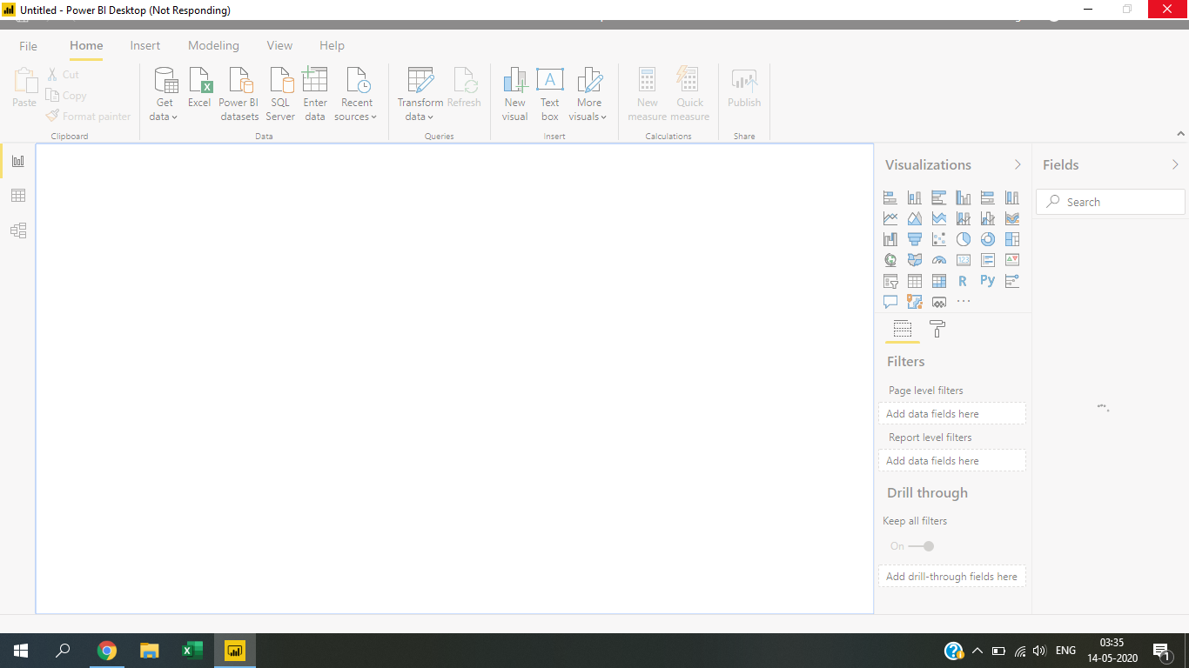

**Report View**

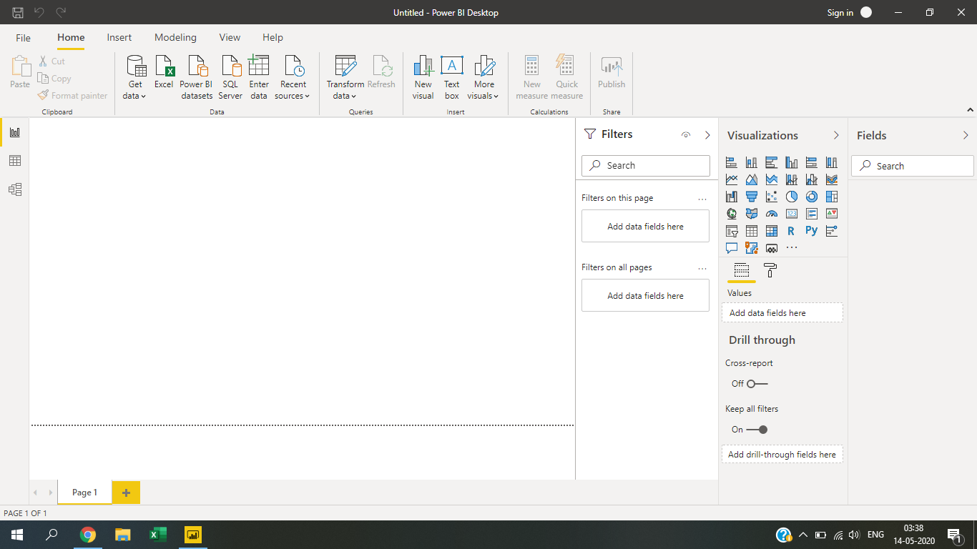

**Data View**

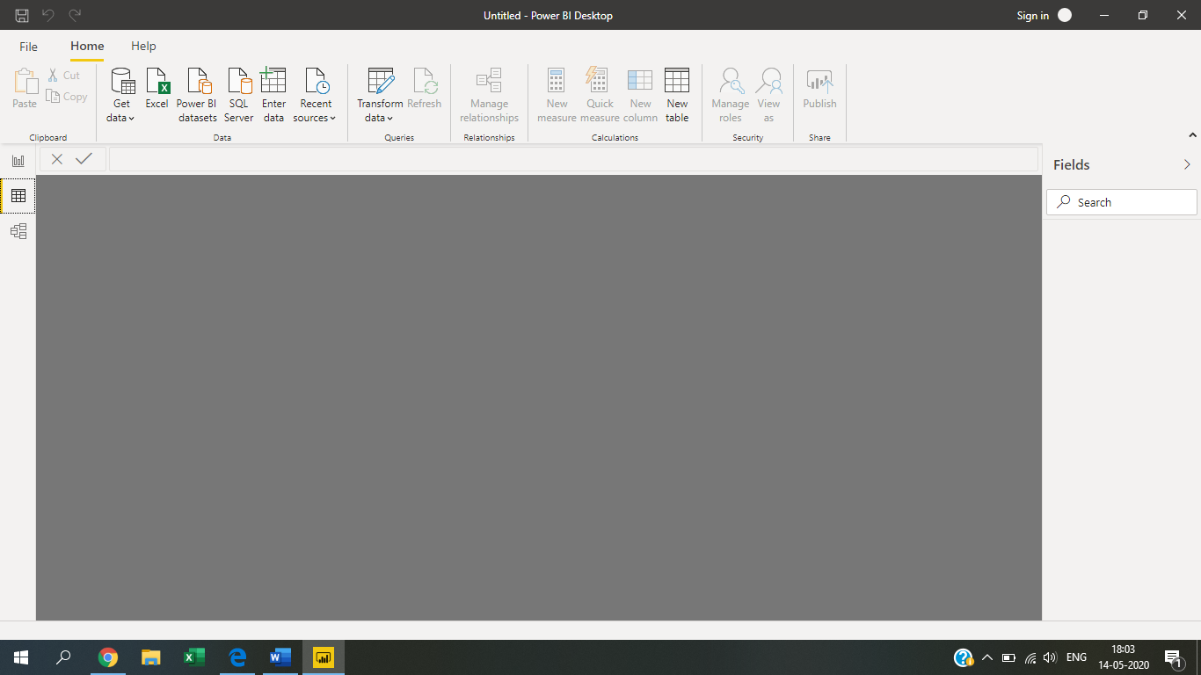

**Model View**

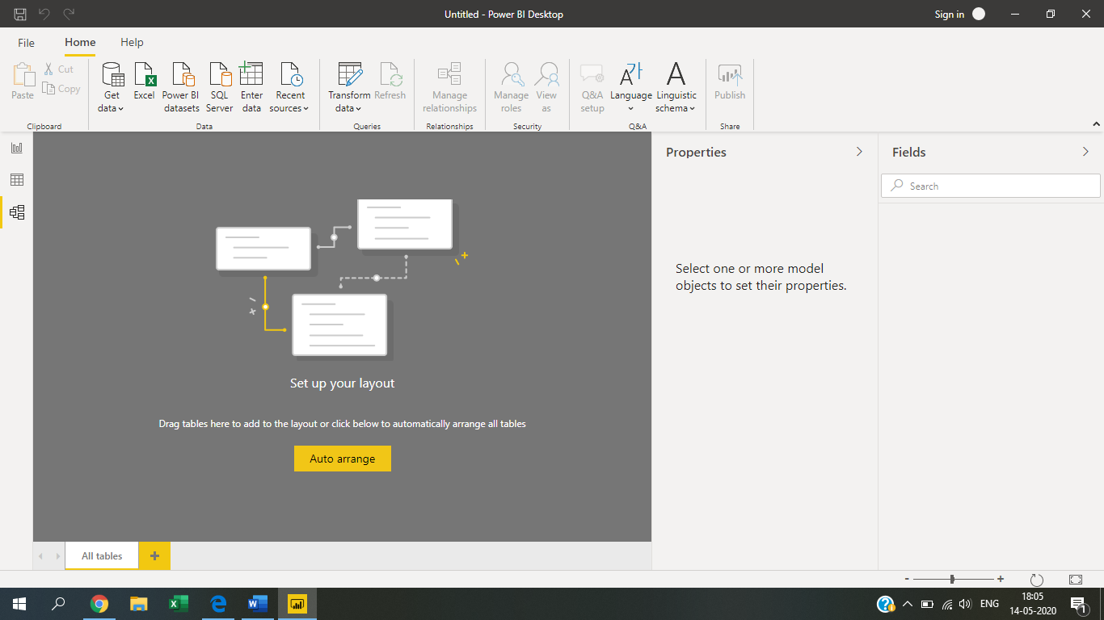

**Power Query Editor**

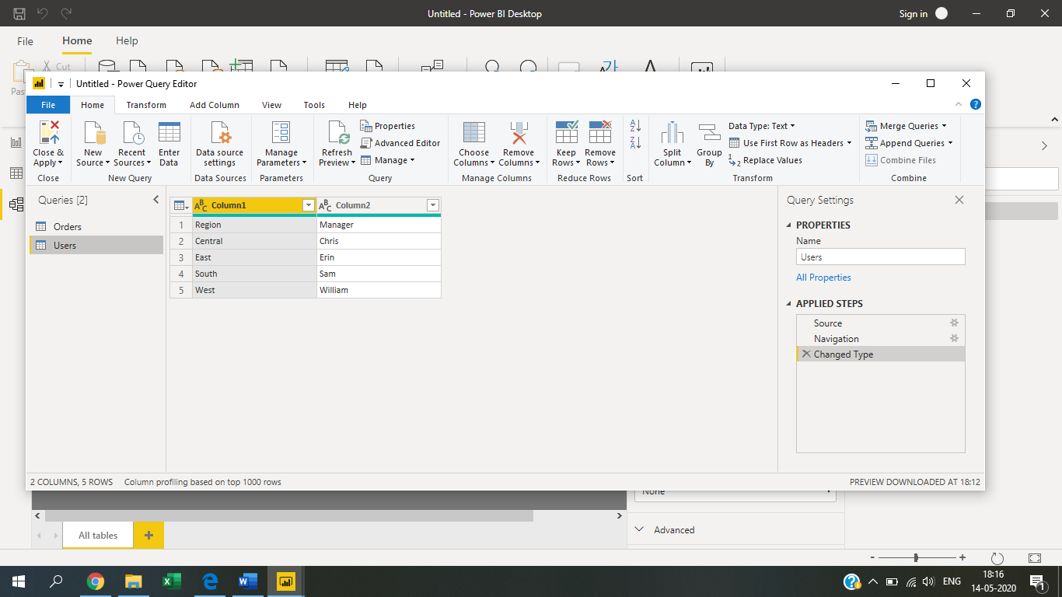

**Power BI Pro**

Cost- Rs.660 user/month

**Power BI Desktop**

Cost- Rs.660 user/month

**Power BI Premium**

Cost- Rs.660 user/month