Lab 3: Web API Using Custom Model Class, Authorization Filter, and Exception Filter
Hands-on in this document

Objective
To create a Web API using a custom model class, implement CRUD operations, create a custom authorization filter to validate request headers, and create a custom exception filter to log exceptions and return appropriate HTTP status codes.

Part 1: Web API using Custom Model Class
Step 1: Created Model Classes
Created the following model classes inside the Models folder:
- Employee
- Department
- Skill
The Employee model contains the following properties:
- Id
- Name
- Salary
- Permanent
- Department
- Skills
- DateOfBirth Department contains:
- Id
- Name Skill contains:
- Id
- Name
Step 2: Created EmployeeController
Created a new API controller named EmployeeController. Configured the controller using:
- ApiController attribute
- Route attribute Step 3: Created Constructor

Created a constructor inside EmployeeController.
The constructor initializes the employee list by calling the GetStandardEmployeeList() method. Step 4: Created GetStandardEmployeeList()
Created a private method named GetStandardEmployeeList().
This method returns a list of Employee objects containing sample employee data. Each employee record includes:
- Employee Id
- Employee Name
- Salary
- Permanent status
- Department details
- Skill details
- Date of Birth
Step 5: Implemented GET Method
Created the GET action method to return the list of employees. Added the following attribute: [ProducesResponseType(StatusCodes.Status200OK)]
The GET method returns ActionResult<List>. Step 6: Implemented GET by Id
Created a GET action method with an Id parameter.
This method searches for an employee using the given Id. If the employee exists, employee details are returned.
Otherwise, 404 Not Found is returned. Step 7: Implemented POST Method Created the POST action method.
The POST method accepts an Employee object from the request body. The new employee is added to the employee list.
Step 8: Implemented PUT Method Created the PUT action method.
The PUT method updates an existing employee using the given Id. If the employee exists, the details are updated.
Otherwise, 404 Not Found is returned.

Step 9: Implemented DELETE Method Created the DELETE action method.
The DELETE method removes an employee using the given Id. If the employee exists, it is removed from the list.
Otherwise, 404 Not Found is returned.

Output
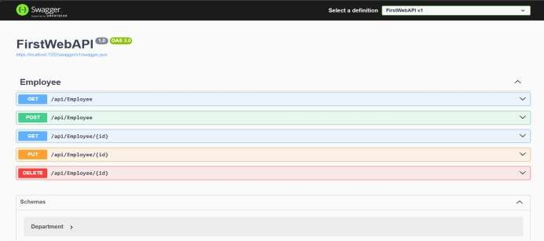
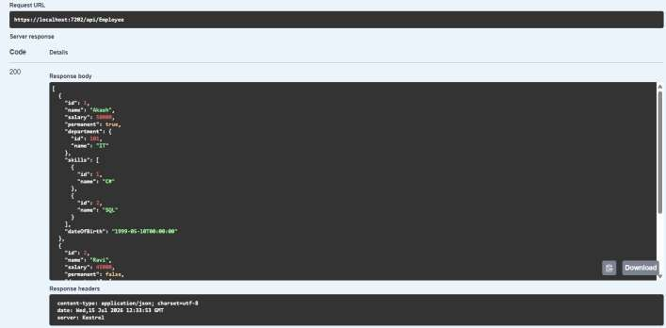

Part 2: Custom Authorization Filter
Step 1: Created Filters Folder Created a folder named Filters. Step 2: Created CustomAuthFilter
Created a class named CustomAuthFilter. Inherited the class from ActionFilterAttribute. Overrode the OnActionExecuting() method.
The filter checks whether the incoming request contains the Authorization header. Step 3: Authorization Validation
The filter performs the following validations:
- Checks whether the Authorization header is present.
- Checks whether the Authorization header contains the word Bearer. If the Authorization header is missing, the request returns:
Invalid request - No Auth token
If the Authorization header does not contain Bearer, the request returns: Invalid request - Token present but Bearer unavailable
Step 4: Applied Filter
Applied the CustomAuthFilter to EmployeeController using the following attribute: [CustomAuthFilter]
All requests to EmployeeController are validated before executing the action methods.

Output:
Case 1
Authorization header not provided.
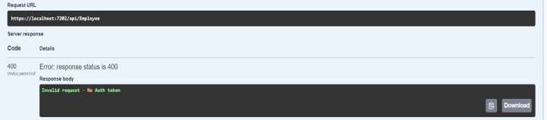

Case 2
Authorization header:

Authorization: abc123 Output:
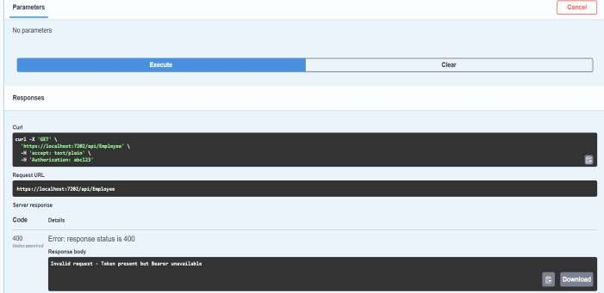

Case 3
Authorization header: Authorization: Bearer abc123 Output:
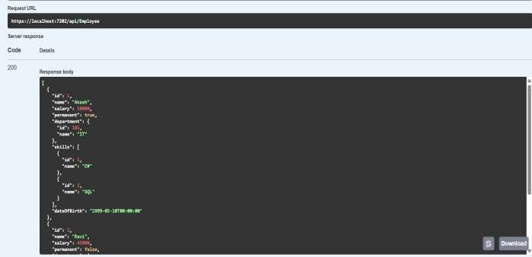

Part 3: Custom Exception Filter Step 1: Installed NuGet Package Installed the following NuGet package:
Microsoft.AspNetCore.Mvc.WebApiCompatShim Step 2: Created CustomExceptionFilter
Created a class named CustomExceptionFilter. Implemented IExceptionFilter.
Implemented the OnException() method. Step 3: Exception Logging
Inside the OnException() method:
- Captured exception details.
- Created the folder: C:\Temp
- Created the file:
ExceptionLog.txt
- Stored the exception details in the log file. Step 4: Registered Exception Filter
Registered the CustomExceptionFilter globally in Program.cs using: builder.Services.AddControllers(options =>
{
options.Filters.Add<CustomExceptionFilter>();
});
Step 5: Modified GET Method
Modified the GET action method to throw an exception for testing. Added: [ProducesResponseType(StatusCodes.Status500InternalServerError)] Step 6: Tested in Swagger
Executed the GET request.
The exception filter handled the exception. The response returned:
500 Internal Server Error

The exception details were written into: C:\Temp\ExceptionLog.txt

Output:
Swagger Response:
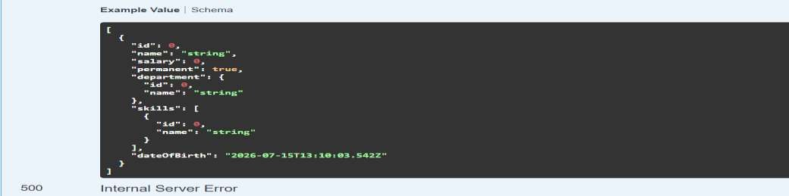

Response Body:
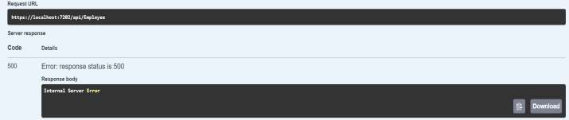
Log File:
C:\Temp\ExceptionLog.txt
