12. ReactJS-HOL
Hands-on in this document
Aim
To create a React application named ticketbookingapp and implement conditional rendering so that guest users can browse flight details, while logged-in users can book flight tickets.
Objective
The objectives of this lab are:
- To understand conditional rendering in React.
- To create Guest and User pages.
- To display different pages based on the user's login status.
- To implement Login and Logout functionality.
- To allow guest users to browse available flight details.
- To allow only logged-in users to book flight tickets.
- To use React state and props for managing the login status.
Procedure
Step 1: Create React Application
The React application was created using the following command:
npx create-react-app ticketbookingapp
Step 2: Navigate to the Project Folder
cd ticketbookingapp
Step 3: Start the React Application
npm start
The application runs on:
http://localhost:3000
Step 4: Implement Conditional Rendering
The application was designed with two different pages:
- Guest Page
- User Page
The Guest Page is displayed when the user is not logged in.
The User Page is displayed after the user clicks the Login button.
When the user clicks Logout, the application returns to the Guest Page.
Implementation
The application uses a state variable called isLoggedIn to determine whether the user is logged in.
Initially:
const [isLoggedIn, setIsLoggedIn] = useState(false);
When the user clicks Login:
setIsLoggedIn(true);
When the user clicks Logout:
setIsLoggedIn(false);
The Greeting component checks the value of isLoggedIn.
If it is true, the User Page is displayed.
If it is false, the Guest Page is displayed.
Complete Source Code
1. App.js
import React, { useState } from "react";
import "./App.css";

// Login Button Component
function LoginButton(props) {
return (
<button onClick={props.onClick}>
Login
</button>
);
}

// Logout Button Component
function LogoutButton(props) {
return (
<button onClick={props.onClick}>
Logout
</button>
);
}

// Guest Page
function GuestGreeting(props) {
return (
<div>
<h1>Please sign up.</h1>

<h2>Available Flight Details</h2>

<table>
<thead>
<tr>
<th>Flight No</th>
<th>From</th>
<th>To</th>
<th>Departure</th>
<th>Price</th>
</tr>
</thead>

<tbody>
<tr>
<td>AI101</td>
<td>Hyderabad</td>
<td>Delhi</td>
<td>10:00 AM</td>
<td>₹5,000</td>
</tr>

<tr>
<td>6E202</td>
<td>Chennai</td>
<td>Mumbai</td>
<td>2:00 PM</td>
<td>₹4,500</td>
</tr>

<tr>
<td>SG303</td>
<td>Delhi</td>
<td>Bangalore</td>
<td>6:00 PM</td>
<td>₹6,000</td>
</tr>
</tbody>
</table>

<p>
Guest users can browse the available flight details.
</p>

<p>
Please login to book your flight ticket.
</p>

<LoginButton
onClick={props.onLoginClick}
/>
</div>
);
}

// User Page
function UserGreeting(props) {
return (
<div>
<h1>Welcome back</h1>

<h2>Book Your Flight Ticket</h2>

<p>
You are logged in. You can now book your flight ticket.
</p>

<label>
Select Flight:
</label>

<select>
<option>
AI101 - Hyderabad to Delhi - ₹5,000
</option>

<option>
6E202 - Chennai to Mumbai - ₹4,500
</option>

<option>
SG303 - Delhi to Bangalore - ₹6,000
</option>
</select>

<br />
<br />

<button
onClick={() =>
alert("Ticket booked successfully!")
}
>
Book Ticket
</button>

<br />
<br />

<LogoutButton
onClick={props.onLogoutClick}
/>
</div>
);
}

// Conditional Rendering Component
function Greeting(props) {
const isLoggedIn = props.isLoggedIn;

if (isLoggedIn) {
return (
<UserGreeting
onLogoutClick={props.onLogoutClick}
/>
);
}

return (
<GuestGreeting
onLoginClick={props.onLoginClick}
/>
);
}

// Main App Component
function App() {
const [isLoggedIn, setIsLoggedIn] = useState(false);

function handleLoginClick() {
setIsLoggedIn(true);
}

function handleLogoutClick() {
setIsLoggedIn(false);
}

return (
<div className="App">
<Greeting
isLoggedIn={isLoggedIn}
onLoginClick={handleLoginClick}
onLogoutClick={handleLogoutClick}
/>
</div>
);
}

export default App;
2. App.css
.App {
text-align: center;
padding: 50px;
font-family: Arial, sans-serif;
}

h1 {
color: #222;
}

h2 {
margin-top: 30px;
}

table {
margin: 20px auto;
border-collapse: collapse;
width: 80%;
}

th,
td {
border: 1px solid black;
padding: 12px;
}

th {
background-color: #f2f2f2;
}

button {
padding: 10px 20px;
margin: 10px;
cursor: pointer;
}

select {
padding: 10px;
margin: 10px;
}
3. index.js
import React from "react";
import ReactDOM from "react-dom/client";
import "./index.css";
import App from "./App";

const root = ReactDOM.createRoot(
document.getElementById("root")
);

root.render(
<React.StrictMode>
<App />
</React.StrictMode>
);
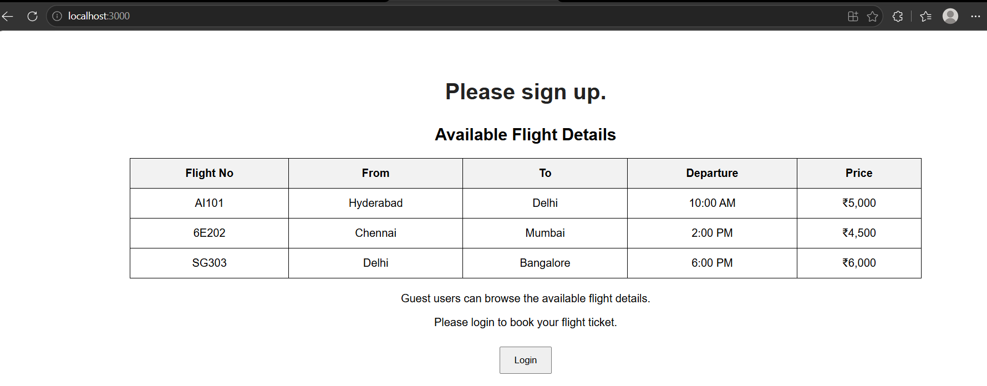
Output:

