1.ReactJS-HOL
Hands-on in this document
Objective
- Understand Single Page Application (SPA).
- Learn the basics of React.
- Set up the React development environment.
- Create the first React application using Create React App.
Procedure
Step 1: Install Node.js
Downloaded and installed Node.js from the official website.
Verified the installation using the following commands:
node -v
Output
v24.13.0
Checked npm version:
npm -v
Output
11.6.2
Step 2: Create Project Folder
Created a folder named:
React1
Location:
Desktop
Step 3: Open PowerShell
Navigated to the React1 folder.
cd Desktop\React1
Step 4: Create React Application
Executed the following command:
npx create-react-app myfirstreact
The React application named myfirstreact was created successfully.
Step 5: Open Project
Moved inside the project folder.
cd myfirstreact
Opened the project in Visual Studio Code.
code .
Step 6: Modify App.js
Opened
src → App.js
Removed the existing code and replaced it with:
function App() {
return (
<div>
<h1 style={{ textAlign: "center" }}>
Welcome to the first session of React
</h1>
</div>
);
}
export default App;
Saved the file.
Step 7: Run the Application
Executed the following command:
npm start
The development server started successfully.
Step 8: View the Application
Opened the browser.
Entered the URL:
http://localhost:3000
The React application loaded successfully.
Program
function App() {
return (
<div>
<h1 style={{ textAlign: "center" }}>
Welcome to the first session of React
</h1>
</div>
);
}
export default App;
Commands Used
node -v
npm -v
cd Desktop\React1
npx create-react-app myfirstreact
cd myfirstreact
code .
npm start
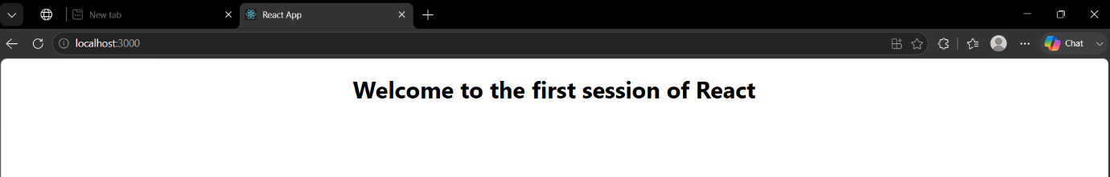
Output

