11. ReactJS-HOL
Hands-on in this document
Aim
To create a React application named eventexamplesapp to demonstrate event handling in React applications using different events and event handlers.
Objectives
In this hands-on lab, I learned how to:
- Implement Event Handling concepts in React applications.
- Use the this keyword in React class components.
- Use React Synthetic Events.
- Handle button click events using onClick.
- Pass arguments to event handler functions.
- Handle form events using onSubmit.
- Handle input changes using onChange.
- Create a Currency Converter component.
- Convert Indian Rupees (INR) to Euro (EUR).
Procedure
Step 1: Create React Application
I created a React application named eventexamplesapp using the following command:
npx create-react-app eventexamplesapp
Then I entered the project folder:
cd eventexamplesapp
I started the React application using:
npm start
The application runs at:
http://localhost:3000
Step 2: Event Handling Examples
I created the following event handling functionalities:
1. Increment Button
The Increment button increases the counter value by 1.
The Increment button invokes multiple methods:
- increment() method to increase the counter.
- sayWelcome() method to display "Hello Member!".
2. Decrement Button
The Decrement button decreases the counter value by 1.
3. Say Welcome Button
The Say Welcome button calls a function by passing "welcome" as an argument.
4. Synthetic Event
The Click on me button handles the React Synthetic Event and displays:
I was clicked
5. Currency Converter
I created a CurrencyConvertor component that accepts:
- Amount in Indian Rupees.
- Currency name.
When the Submit button is clicked, the handleSubmit event is invoked and the amount is converted from Indian Rupees to Euro.
For this application, I used the following fixed conversion rate for demonstration:
1 Euro = ₹100
Step 3: Complete Code
File 1: src/App.js
import React, { Component } from "react";
import "./App.css";

// ===============================
// Currency Converter Component
// ===============================
class CurrencyConvertor extends Component {
constructor(props) {
super(props);

this.state = {
amount: "",
currency: "",
result: ""
};

// Binding handleSubmit method
this.handleSubmit = this.handleSubmit.bind(this);
}

// Handle Amount Change
handleAmountChange = (event) => {
this.setState({
amount: event.target.value
});
};

// Handle Currency Change
handleCurrencyChange = (event) => {
this.setState({
currency: event.target.value
});
};

// Handle Submit Event
handleSubmit(event) {
// Prevent page refresh
event.preventDefault();

// Convert entered amount into number
const rupees = parseFloat(this.state.amount);

// Check whether amount is valid
if (isNaN(rupees) || rupees <= 0) {
alert("Please enter a valid amount");
return;
}

// Example conversion rate
// 1 Euro = 100 Indian Rupees
const euroRate = 100;

// Convert Rupees to Euro
const euros = rupees / euroRate;

// Store conversion result
this.setState({
result:
"₹" +
rupees +
" = €" +
euros.toFixed(2)
});
}

render() {
return (
<div className="currency-converter">

<h1>Currency Convertor!!!</h1>

<form onSubmit={this.handleSubmit}>

{/* Amount */}
<div className="form-row">
<label>Amount:</label>

<input
type="number"
value={this.state.amount}
onChange={this.handleAmountChange}
placeholder="Enter Rupees"
/>
</div>

{/* Currency */}
<div className="form-row">
<label>Currency:</label>

<textarea
value={this.state.currency}
onChange={this.handleCurrencyChange}
placeholder="Enter Currency"
></textarea>
</div>

{/* Submit Button */}
<button type="submit">
Submit
</button>

</form>

{/* Conversion Result */}
{this.state.result && (
<h3 className="result">
{this.state.result}
</h3>
)}

</div>
);
}
}

// ===============================
// Main App Component
// ===============================
class App extends Component {

constructor(props) {
super(props);

this.state = {
counter: 0
};

// Binding methods
this.increment = this.increment.bind(this);
this.decrement = this.decrement.bind(this);
this.sayWelcome = this.sayWelcome.bind(this);
this.onPress = this.onPress.bind(this);
}

// ===============================
// Increment Method
// ===============================
increment() {
this.setState({
counter: this.state.counter + 1
});
}

// ===============================
// Decrement Method
// ===============================
decrement() {
this.setState({
counter: this.state.counter - 1
});
}

// ===============================
// Say Welcome Method
// ===============================
sayWelcome(message) {
alert(message);
}

// ===============================
// Synthetic Event
// ===============================
onPress() {
alert("I was clicked");
}

// ===============================
// Multiple Methods
// ===============================
handleIncrement = () => {

// Method 1: Increment counter
this.increment();

// Method 2: Display Hello message
this.sayWelcome("Hello Member!");
};

render() {
return (
<div className="App">

{/* Counter */}
<div className="counter">
{this.state.counter}
</div>

{/* Increment Button */}
<button onClick={this.handleIncrement}>
Increment
</button>

<br />

{/* Decrement Button */}
<button onClick={this.decrement}>
Decrement
</button>

<br />

{/* Say Welcome Button */}
<button
onClick={() => this.sayWelcome("welcome")}
>
Say Welcome
</button>

<br />

{/* Synthetic Event Button */}
<button onClick={this.onPress}>
Click on me
</button>

{/* Currency Converter */}
<CurrencyConvertor />

</div>
);
}
}

export default App;
File 2: src/App.css
.App {
text-align: left;
margin: 15px;
font-family: Arial, sans-serif;
}

/* Counter */
.counter {
font-size: 18px;
margin-bottom: 10px;
}

/* Buttons */
button {
font-size: 16px;
padding: 4px 10px;
margin: 2px 0;
cursor: pointer;
}

/* Currency Converter */
.currency-converter {
margin-top: 25px;
}

/* Heading */
.currency-converter h1 {
color: green;
font-size: 32px;
margin-bottom: 30px;
}

/* Form Row */
.form-row {
display: flex;
align-items: center;
margin-bottom: 8px;
}

/* Labels */
.form-row label {
width: 100px;
font-size: 18px;
}

/* Amount Input */
.form-row input {
width: 170px;
height: 25px;
font-size: 16px;
padding: 3px;
}

/* Currency Textarea */
.form-row textarea {
width: 170px;
height: 35px;
font-size: 16px;
padding: 3px;
resize: none;
}

/* Submit Button */
.currency-converter form button {
margin-left: 144px;
margin-top: 5px;
}

/* Conversion Result */
.result {
color: green;
margin-top: 20px;
}
File 3: src/index.js
import React from "react";
import ReactDOM from "react-dom/client";
import App from "./App";

const root = ReactDOM.createRoot(
document.getElementById("root")
);

root.render(
<React.StrictMode>
<App />
</React.StrictMode>
);
File 4: public/index.html
<!DOCTYPE html>
<html lang="en">
<head>
<meta charset="utf-8" />

<meta
name="viewport"
content="width=device-width, initial-scale=1"
/>

<meta
name="theme-color"
content="#000000"
/>

<meta
name="description"
content="React Event Examples Application"
/>

<title>React App</title>
</head>

<body>

<noscript>
You need to enable JavaScript to run this app.
</noscript>

<div id="root"></div>

</body>
</html>
Step 4: Run the Application
I ran the application using:
npm start
The application opened in the browser at:
http://localhost:3000
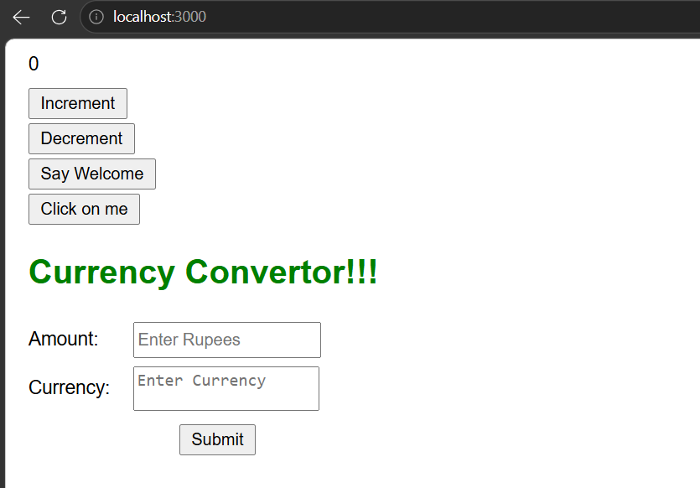
Outputs

