Lab 4: Web API CRUD Operation – Update Employee using HTTP PUT Hands-on in this document

Objective
- To implement the HTTP PUT action method.
- To update employee details based on the user input.
- To validate employee ID before updating.
- To return appropriate responses using ActionResult<Employee>.
- To test the API using Swagger.

Procedure
Step 1: Open the Existing Web API Project
Opened the FirstWebAPI project in Visual Studio. Step 2: Open EmployeeController
Opened the EmployeeController.cs file located inside the Controllers folder. Step 3: Modify the PUT Action Method
Modified the PUT action method to return ActionResult instead of IActionResult. Added validation to check whether the employee ID is valid.
Implemented the following validations:
- If the employee ID is less than or equal to zero, return BadRequest("Invalid employee id")
- If the employee ID is not found in the hardcoded employee list, return BadRequest("Invalid employee id")
- If the employee ID is valid, update the employee information using the JSON request body.
- Return the updated employee details using Ok(updatedEmployee)
Step 4: Build the Project
Built the project successfully using Build → Build Solution
No compilation errors were found. Step 5: Run the Application
Executed the application using F5

Swagger UI opened successfully. Step 6: Authorize the Request
Clicked the Authorize button in Swagger. Entered the Authorization header:
Bearer abc123
Clicked Authorize and then Close. Step 7: Test the PUT Method
Opened
PUT /api/Employee/{id} Clicked Try it Out.
Entered different employee IDs to verify the validations.

Test Case 1 Input
PUT /api/Employee/0
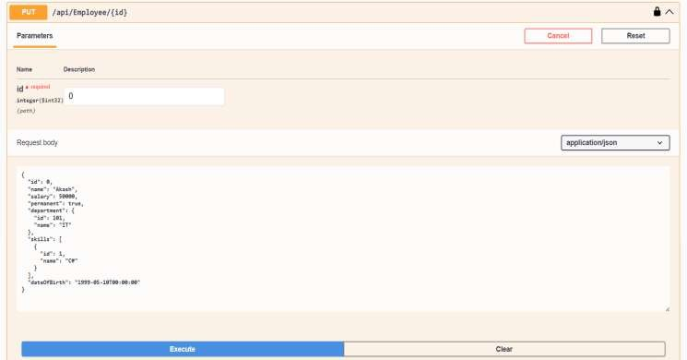

Output
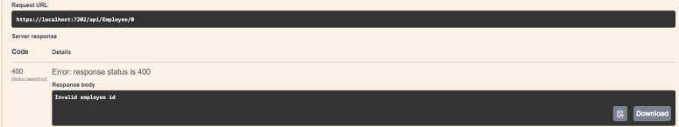

Test Case 2 Input
PUT /api/Employee/10
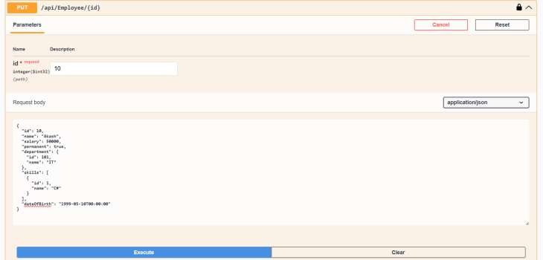

Output
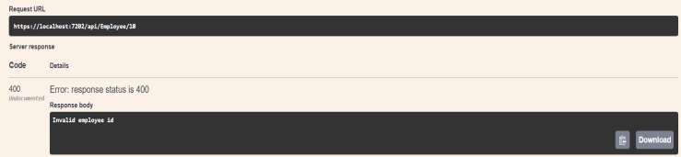

Test Case 3 Input
PUT /api/Employee/1

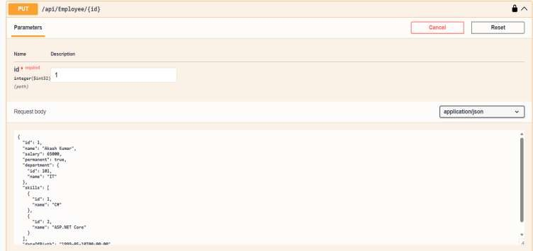

Output
