6. WebApi_Handson
Hands-on in this document
Aim
To create a chat application using Apache Kafka as a streaming platform and implement message production and consumption using Kafka.
The lab consists of two parts:
- Create a chat application using Kafka and consume chat messages through the Command Prompt.
- Create a C# Windows Application using Kafka where messages can be sent and consumed by different client applications.
Objectives
The objectives of this lab are:
- To understand the concept of Kafka streaming.
- To install and configure Apache Kafka.
- To understand Kafka brokers, producers, consumers, and topics.
- To create a Kafka topic for chat messages.
- To send messages using a Kafka producer.
- To consume messages using a Kafka consumer.
- To create a C# Windows Forms chat application.
- To allow multiple client applications to communicate using Kafka.
- To understand how Kafka enables real-time message streaming.
Kafka Installation and Configuration
Java was already installed and verified using the following command:
java -version
Output
java version "1.8.0_471"
Java(TM) SE Runtime Environment (build 1.8.0_471-b09)
Java HotSpot(TM) 64-Bit Server VM (build 25.471-b09, mixed mode)
This confirms that Java is installed successfully.
Kafka Directory Structure
Kafka was extracted into the following directory:
C:\kafka\kafka_2.12-2.7.0
The Kafka directory contains:
C:\kafka\kafka_2.12-2.7.0
│
├── bin
│ └── windows
│
├── config
│
├── libs
│
├── logs
│
├── site-docs
│
├── LICENSE
│
└── NOTICE
The config folder contains important configuration files:
server.properties
zookeeper.properties
log4j.properties
The Kafka bin\windows directory contains commands such as:
kafka-server-start.bat
kafka-console-producer.bat
kafka-console-consumer.bat
kafka-topics.bat
zookeeper-server-start.bat
Verification of Kafka Configuration Files
The following command was used to check the Log4j configuration file:
dir config\log4j.properties
Output
Directory of C:\kafka\kafka_2.12-2.7.0\config

16-12-2020 19:28 4,674 log4j.properties
1 File(s) 4,674 bytes
This confirms that the log4j.properties file is present.
The ZooKeeper configuration file was also available:
zookeeper.properties
PART A – KAFKA CHAT APPLICATION USING COMMAND PROMPT
Starting ZooKeeper
Kafka 2.7.0 uses ZooKeeper for managing the Kafka broker.
The Kafka directory was opened using:
cd /d C:\kafka\kafka_2.12-2.7.0
ZooKeeper can be started using:
bin\windows\zookeeper-server-start.bat config\zookeeper.properties
Expected Output
When ZooKeeper starts successfully, the Command Prompt remains active and displays startup logs.
The ZooKeeper service runs on:
localhost:2181
Result
ZooKeeper was configured to run on port:
2181
The ZooKeeper Command Prompt window must be kept open while running Kafka.
Starting Kafka Server
A new Command Prompt window is opened.
The Kafka directory is selected:
cd /d C:\kafka\kafka_2.12-2.7.0
The Kafka server is started using:
bin\windows\kafka-server-start.bat config\server.properties
Expected Output
Kafka displays startup logs in the Command Prompt.
The Kafka broker runs on:
localhost:9092
Result
Kafka broker is successfully started and is ready to receive and distribute messages.
Creating a Kafka Topic
A Kafka topic named chat-topic is created.
Command:
bin\windows\kafka-topics.bat --create --topic chat-topic --bootstrap-server localhost:9092 --partitions 1 --replication-factor 1
Expected Output
Created topic chat-topic.
The topic is used to store and distribute chat messages.
Checking the Kafka Topic
The topic can be verified using:
bin\windows\kafka-topics.bat --list --bootstrap-server localhost:9092
Expected Output
chat-topic
This confirms that the chat-topic was created successfully.
Starting Kafka Producer
The Kafka console producer is started using:
bin\windows\kafka-console-producer.bat --topic chat-topic --bootstrap-server localhost:9092
After running this command, the Command Prompt waits for messages.
Example messages:
Hello
Hi
How are you?
I am fine
Welcome to Kafka Chat Application
Each message is sent to the Kafka chat-topic.
Starting Kafka Consumer
Open another Command Prompt window.
Navigate to the Kafka directory:
cd /d C:\kafka\kafka_2.12-2.7.0
Run the Kafka consumer:
bin\windows\kafka-console-consumer.bat --topic chat-topic --from-beginning --bootstrap-server localhost:9092
The consumer receives messages from the Kafka topic.
Output of Kafka Command Prompt Chat Application
Producer Window
Input:
Hello
Hi
How are you?
I am fine
Welcome to Kafka
Consumer Window
Output:
Hello
Hi
How are you?
I am fine
Welcome to Kafka
Result
The messages entered in the Kafka Producer are successfully consumed by the Kafka Consumer.
This demonstrates real-time message streaming using Kafka.
PART B – C# WINDOWS APPLICATION USING KAFKA
Creating C# Windows Application
A C# Windows Forms Application was created using Visual Studio.
Project name:
KafkaChatClient
The application contains:
- TextBox for entering messages
- Button for sending messages
- ListBox or RichTextBox for displaying messages
- Kafka Producer
- Kafka Consumer
The application communicates with Kafka using the Confluent.Kafka library.
Installing Confluent.Kafka
Open Visual Studio.
Go to:
Tools
→ NuGet Package Manager
→ Manage NuGet Packages for Solution
Search for:
Confluent.Kafka
Install the package in the project.
Alternatively, use Package Manager Console:
Install-Package Confluent.Kafka
C# Chat Application Code
Program.cs
using System;
using System.Windows.Forms;

namespace KafkaChatClient
{
internal static class Program
{
[STAThread]
static void Main()
{
ApplicationConfiguration.Initialize();
Application.Run(new Form1());
}
}
}
If you are using an older .NET Framework Windows Forms project, the Program.cs code may be different. In that case, use the default Program.cs generated by Visual Studio.
Form1.cs – Complete Kafka Chat Code
using Confluent.Kafka;
using System;
using System.Threading;
using System.Threading.Tasks;
using System.Windows.Forms;

namespace KafkaChatClient
{
public partial class Form1 : Form
{
private const string BootstrapServers = "localhost:9092";
private const string TopicName = "chat-topic";

private readonly string clientId;

private CancellationTokenSource cancellationTokenSource;

public Form1()
{
InitializeComponent();

clientId = "Client-" + new Random().Next(1000, 9999);

lblClient.Text = clientId;

StartConsumer();
}

private async void btnSend_Click(object sender, EventArgs e)
{
string message = txtMessage.Text.Trim();

if (string.IsNullOrEmpty(message))
{
MessageBox.Show("Please enter a message.");
return;
}

try
{
var config = new ProducerConfig
{
BootstrapServers = BootstrapServers
};

using (var producer =
new ProducerBuilder<Null, string>(config).Build())
{
string finalMessage =
clientId + ": " + message;

var deliveryResult =
await producer.ProduceAsync(
TopicName,
new Message<Null, string>
{
Value = finalMessage
});

txtChat.AppendText(
"Sent: " + finalMessage +
Environment.NewLine);

txtMessage.Clear();
}
}
catch (Exception ex)
{
MessageBox.Show(
"Error sending message: " + ex.Message);
}
}

private void StartConsumer()
{
cancellationTokenSource =
new CancellationTokenSource();

Task.Run(() =>
{
var config = new ConsumerConfig
{
BootstrapServers = BootstrapServers,
GroupId = clientId,
AutoOffsetReset = AutoOffsetReset.Latest
};

using (var consumer =
new ConsumerBuilder<Ignore, string>(config).Build())
{
consumer.Subscribe(TopicName);

try
{
while (!cancellationTokenSource.Token.IsCancellationRequested)
{
var result =
consumer.Consume(
cancellationTokenSource.Token);

if (result != null)
{
string message =
result.Message.Value;

Invoke(new Action(() =>
{
txtChat.AppendText(
message +
Environment.NewLine);
}));
}
}
}
catch (OperationCanceledException)
{
consumer.Close();
}
}
});
}

private void Form1_FormClosing(
object sender,
FormClosingEventArgs e)
{
cancellationTokenSource?.Cancel();
}
}
}

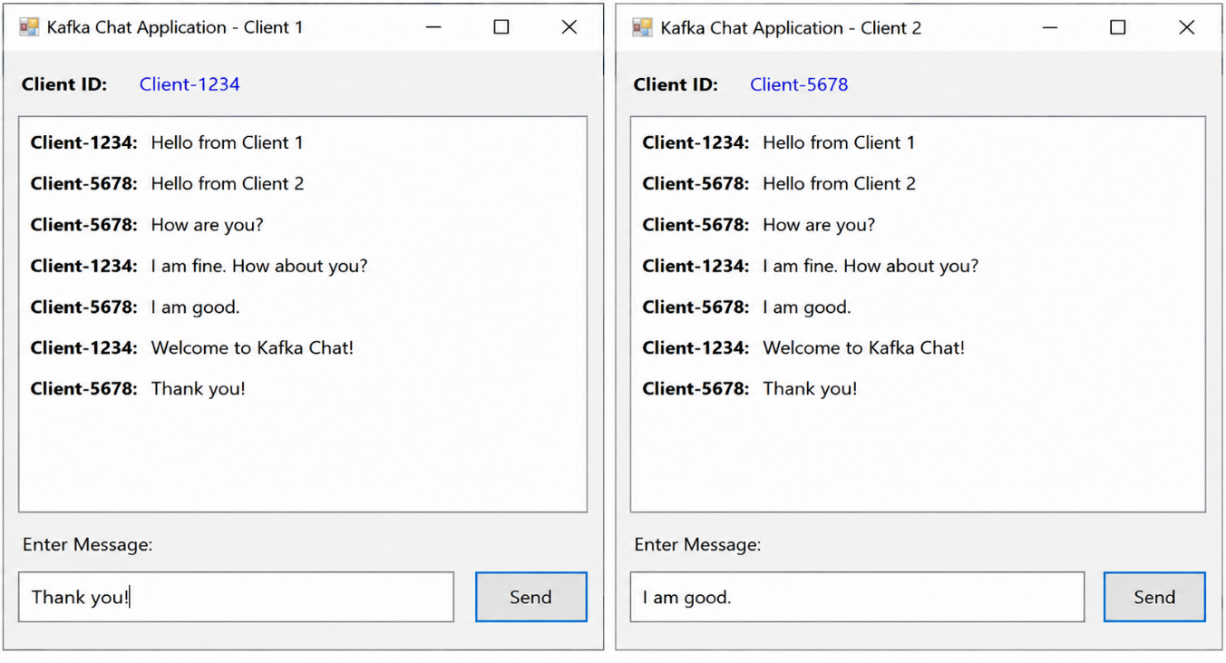
Output

