10. ReactJS-HOL
Hands-on in this document
Aim
To create a React application named officespacerentalapp using React JSX to:
- Create JSX elements.
- Use JSX attributes.
- Render elements to the DOM.
- Display an image of office space.
- Create an object containing office details such as Name, Rent, and Address.
- Create a list of office space objects.
- Loop through the list of objects using the map() function.
- Apply CSS based on the rent amount.
- Display the rent in red if it is ₹60,000 or below.
- Display the rent in green if it is above ₹60,000.
Procedure
Step 1: Create React Application
Open the terminal in Visual Studio Code and execute:
npx create-react-app officespacerentalapp
Navigate to the project folder:
cd officespacerentalapp
Start the React application:
npm start
The application will run at:
http://localhost:3000
Step 2: Create Images Folder
Inside the src folder, create a folder named:
images
Keep three office images inside the folder.
Step 3: App.js
The App.js file contains the main React JSX code.

import React from "react";
import "./App.css";

// Import office images
import dbsImage from "./images/dbs.jpg";
import tcsImage from "./images/tcs.jpg";
import infosysImage from "./images/infosys.jpg";

function App() {

// Create an element
const element = "Office Space";

// Create a list of office objects
const officeList = [
{
Name: "DBS",
Rent: 50000,
Address: "Chennai",
Image: dbsImage
},
{
Name: "TCS",
Rent: 75000,
Address: "Hyderabad",
Image: tcsImage
},
{
Name: "Infosys",
Rent: 60000,
Address: "Bangalore",
Image: infosysImage
}
];

return (
<div className="container">

{/* Display heading */}
<h1>{element}, at Affordable Range</h1>

{/* Loop through officeList */}
{officeList.map((ItemName, index) => {

// Create colors array
let colors = [];

// Check rent
if (ItemName.Rent <= 60000) {
colors.push("textRed");
} else {
colors.push("textGreen");
}

return (
<div className="office" key={index}>

{/* Display office image */}
<img
src={ItemName.Image}
width="250"
height="200"
alt="Office Space"
/>

{/* Display office name */}
<h2>
Name: {ItemName.Name}
</h2>

{/* Display rent */}
<h3 className={colors[0]}>
Rent Rs. {ItemName.Rent}
</h3>

{/* Display address */}
<h3>
Address: {ItemName.Address}
</h3>

</div>
);
})}

</div>
);
}

export default App;
Step 4: App.css
The following CSS code is used to style the Office Space Rental App.
body {
margin: 0;
font-family: Arial, sans-serif;
background-color: white;
}

.container {
width: 60%;
margin: auto;
padding: 30px;
}

h1 {
font-size: 32px;
margin-bottom: 30px;
}

.office {
margin-bottom: 40px;
}

.office img {
width: 250px;
height: 200px;
object-fit: cover;
display: block;
margin-bottom: 20px;
}

h2 {
font-size: 24px;
}

h3 {
font-size: 18px;
}

/* Rent below or equal to 60000 */
.textRed {
color: red;
}

/* Rent above 60000 */
.textGreen {
color: green;
}
Step 5: index.js
The index.js file renders the React application into the DOM.
import React from "react";
import ReactDOM from "react-dom/client";
import App from "./App";

const root = ReactDOM.createRoot(
document.getElementById("root")
);

root.render(
<React.StrictMode>
<App />
</React.StrictMode>
);
Step 6: public/index.html
The index.html file contains the root element where the React application is rendered.
<!DOCTYPE html>
<html lang="en">
<head>
<meta charset="utf-8" />
<meta
name="viewport"
content="width=device-width, initial-scale=1"
/>
<title>Office Space Rental App</title>
</head>
<body>
<noscript>
You need to enable JavaScript to run this app.
</noscript>
<div id="root"></div>
</body>
</html>
Step 7: Run the Application
Open the terminal in Visual Studio Code and execute:
npm start
The application will open in the browser at:
http://localhost:3000
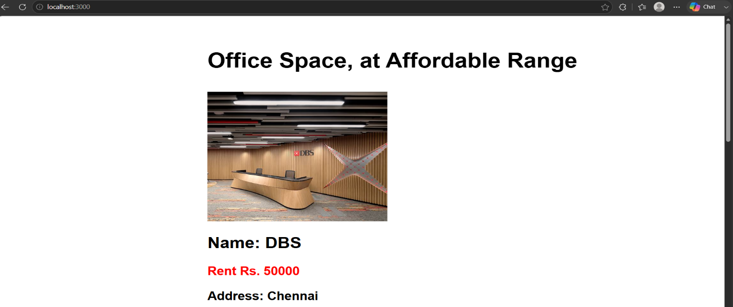
Output

