9. ReactJS-HOL
Hands-on in this document
Aim
To develop a React application named cricketapp demonstrating various ES6 features such as map(), Arrow Functions, Destructuring, Spread Operator (Merge), and Conditional Rendering.
Objectives
- List the features of ES6.
- Explain JavaScript let.
- Identify the differences between var and let.
- Explain JavaScript const.
- Explain ES6 class fundamentals.
- Explain ES6 class inheritance.
- Define ES6 Arrow Functions.
- Identify set() and map().
- Use map() method of ES6.
- Apply Arrow Functions.
- Implement Destructuring features.
- Merge arrays using Spread Operator.
Procedure
Step 1: Create a React Application
Open Command Prompt or Terminal.
npx create-react-app cricketapp
Move into the project directory.
cd cricketapp
Start the application.
npm start
Step 2: Create the Components
Create the following files inside the src folder.
App.js
ListofPlayers.js
IndianPlayers.js

App.js
import React from "react";
import ListofPlayers, { Scorebelow70 } from "./ListofPlayers";
import {
OddPlayers,
EvenPlayers,
ListofIndianPlayers
} from "./IndianPlayers";

function App() {

var flag = true;

const IndianTeam = [
"Sachin1",
"Dhoni2",
"Virat3",
"Rohit4",
"Yuvraj5",
"Raina6"
];

if (flag === true) {
return (
<div>

<h1>List of Players</h1>

<ListofPlayers />

<hr />

<h1>List of Players having Scores Less than 70</h1>

<Scorebelow70 />

</div>
);
}

else {

return (

<div>

<h1>Indian Team</h1>

<h2>Odd Players</h2>

<OddPlayers IndianTeam={IndianTeam} />

<hr />

<h2>Even Players</h2>

<EvenPlayers IndianTeam={IndianTeam} />

<hr />

<h2>List of Indian Players Merged</h2>

<ListofIndianPlayers />

</div>

);
}

}

export default App;
ListofPlayers.js
import React from "react";

const players = [

{ name: "Jack", score: 50 },
{ name: "Michael", score: 70 },
{ name: "John", score: 40 },
{ name: "Ann", score: 61 },
{ name: "Elisabeth", score: 61 },
{ name: "Sachin", score: 95 },
{ name: "Dhoni", score: 100 },
{ name: "Virat", score: 84 },
{ name: "Jadeja", score: 64 },
{ name: "Raina", score: 75 },
{ name: "Rohit", score: 80 }

];

export default function ListofPlayers() {

return (

players.map((item) =>

<div key={item.name}>

<li>

Mr. {item.name}

<span> {item.score}</span>

</li>

</div>

)

);

}

export function Scorebelow70() {

let players70 = [];

players.map((item) => {

if (item.score <= 70)

players70.push(item);

});

return (

players70.map((item) =>

<div key={item.name}>

<li>

Mr. {item.name}

<span> {item.score}</span>

</li>

</div>

)

);

}
IndianPlayers.js
import React from "react";

export function OddPlayers({ IndianTeam }) {

const [first, , third, , fifth] = IndianTeam;

return (

<div>

<li>First : {first}</li>

<li>Third : {third}</li>

<li>Fifth : {fifth}</li>

</div>

);

}

export function EvenPlayers({ IndianTeam }) {

const [, second, , fourth, , sixth] = IndianTeam;

return (

<div>

<li>Second : {second}</li>

<li>Fourth : {fourth}</li>

<li>Sixth : {sixth}</li>

</div>

);

}

const T20Players = [

"First Player",

"Second Player",

"Third Player"

];

const RanjiTrophyPlayers = [

"Fourth Player",

"Fifth Player",

"Sixth Player"

];

const IndianPlayers = [

...T20Players,

...RanjiTrophyPlayers

];

export function ListofIndianPlayers() {

return (

IndianPlayers.map((item, index) =>

<div key={index}>

<li>Mr. {item}</li>

</div>

)

);

}
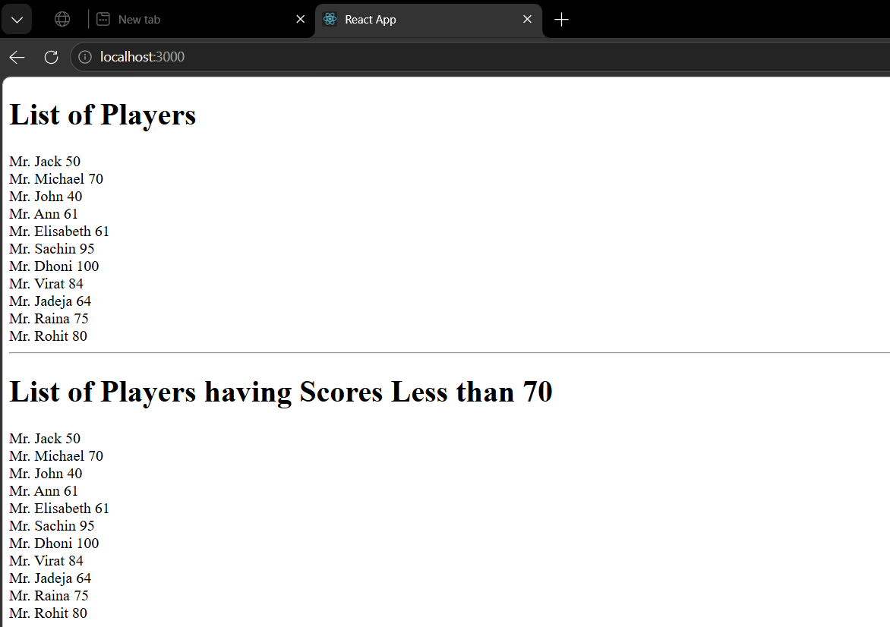
Output 1 (When flag = true)

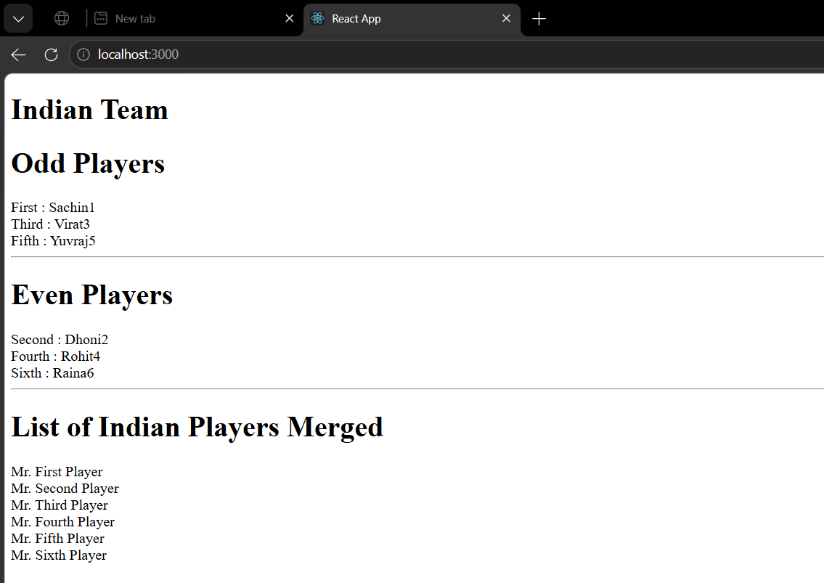
Output 2 (When flag = false)

