Hands-on in this document
Lab 2: Web API using .NET Core with Swagger and Postman

Objective
To create an ASP.NET Core Web API application, configure Swagger for API documentation, test Web API endpoints using Swagger and Postman, and modify the routing of the Employee controller.

Task 1: Configure Swagger in ASP.NET Core Web API
- Created an ASP.NET Core Web API project using the API template.
- Installed the Swashbuckle.AspNetCore NuGet package to enable Swagger support.
- Configured Swagger services in Program.cs using AddSwaggerGen().
- Configured Swagger middleware using UseSwagger() and UseSwaggerUI().
- Executed the application.
- Opened the Swagger page using the URL:
https://localhost:7202/swagger
- Verified that the Swagger page displayed: Title: Swagger Demo
Version: v1 Description: TBD
Contact Details: John Doe License Information
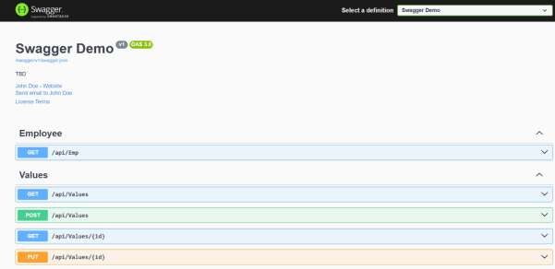

- Verified that the Values Controller displayed all HTTP methods: GET
POST PUT
DELETE
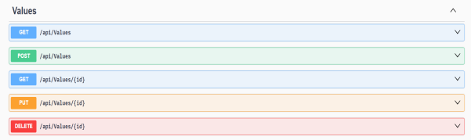

- Expanded the GET method of the Values controller.
- Clicked Try it out and then Execute.
- Verified that the API returned the following response:
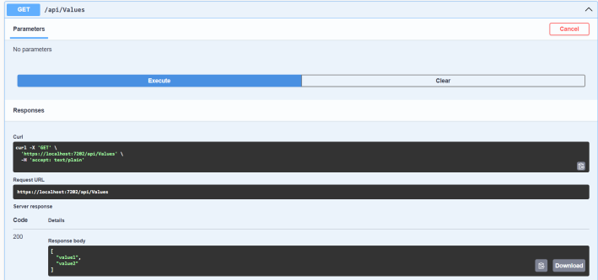

- Verified that the HTTP Status Code was:

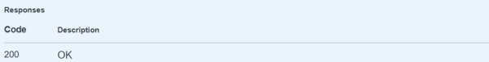

Task 2: Testing Employee Controller using Postman
- Created a Models folder.
- Added an Employee.cs model containing:
  - Id
  - Name
  - Department
  - Salary
- Created an EmployeeController inside the Controllers folder.
- Added sample employee records inside the controller.
- Implemented the GET action method to return the list of employees.
- Executed the Web API project.
- Opened Postman.
- Created a new GET request.
- Entered the API URL:
https://localhost:7202/api/Employee
- Clicked Send.
- Verified that the response body displayed the employee details:
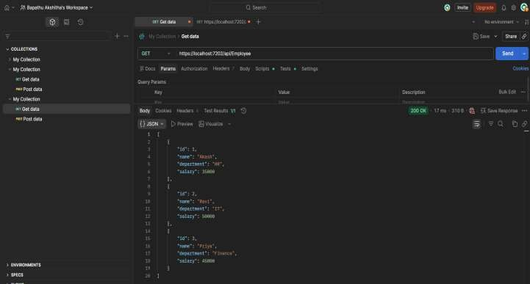

- Verified that the Status Code was: 200 OK
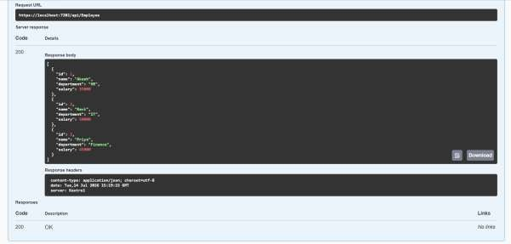

This confirmed that the Employee API was working successfully.

Task 3: Modifying the Route Attribute
- Opened EmployeeController.cs.
- Modified the Route attribute from: [Route("api/[controller]")]
to
[Route("api/Emp")]
- Saved the project.
- Executed the application again.
- Opened Postman.
- Sent a GET request using the new URL: https://localhost:7202/api/Emp

- Verified that the employee list was displayed successfully.
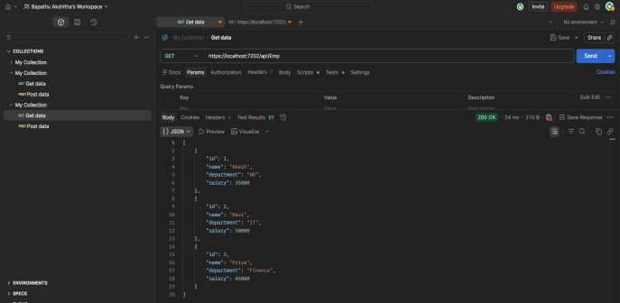

- Verified that the Status Code was: 200 OK
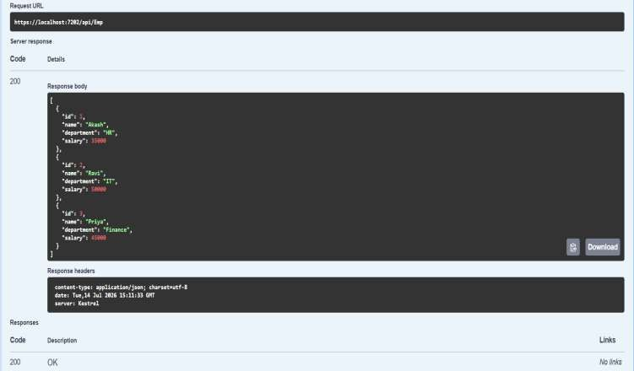

- Tested the old URL:
https://localhost:7202/api/Employee
- Verified that the old URL returned:
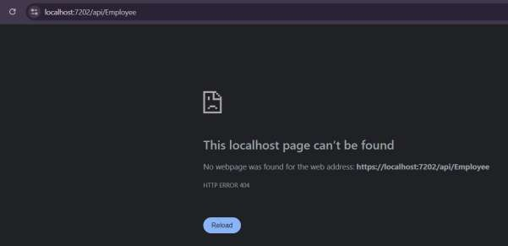
This confirmed that the routing was successfully changed from Employee to Emp.

