5. ReactJS-HOL
Hands-on in this document
Aim
To style React components using CSS Modules and inline styles.
Objective
- Understand the need for styling React components.
- Work with CSS Modules.
- Apply styles using className and style properties.
- Change the heading color dynamically based on the cohort status.
Procedure
Step 1: Download the React Application
Download the Cohort Tracker React application provided by Cognizant.
Step 2: Extract the Project
Extract the project into a folder.
Example:
C:\Users\AKSHITHA\Documents\cohorttracker
Step 3: Install Node Modules
Open Command Prompt inside the project folder.
Run the following command:
npm install
Packages were installed successfully.
Step 4: Start the React Application
Run
npm start
The application starts on
http://localhost:3000
Step 5: Create CSS File
Created a CSS file named
CohortDetails.css
Step 6: Add CSS
.box{
width:300px;
display:inline-block;
margin:10px;
padding:10px 20px;
border:1px solid black;
border-radius:10px;
vertical-align:top;
}

dt{
font-weight:500;
}

dd{
margin-left:20px;
margin-bottom:10px;

Step 7: Modify CohortDetails.js
Imported the CSS file.
import "./CohortDetails.css";
Applied CSS class.
<div className="box">
Applied inline styling.
<h3
style={{
color:
cohort.currentStatus==="Ongoing"
?"green"
:"blue"
}}
>
{cohort.cohortCode} - {cohort.technology}
</h3>
Step 8: Modify App.js
Imported CohortDetails component.
import CohortDetails from './CohortDetails';
Displayed only the first three cohorts.
{CohortsData.slice(0,3).map((cohort,index)=>(
<CohortDetails
key={index}
cohort={cohort}
/>
))}
App.js
import './App.css';
import { CohortsData } from './Cohort';
import CohortDetails from './CohortDetails';

function App() {
return (
<div>
<h1>Cohorts Details</h1>

{CohortsData.slice(0,3).map((cohort,index)=>(
<CohortDetails
key={index}
cohort={cohort}
/>
))}
</div>
);
}

export default App;

CohortDetails.js
import React from 'react';
import './CohortDetails.css';

function CohortDetails(props){

const cohort=props.cohort;

return(

<div className="box">

<h3
style={{
color:
cohort.currentStatus==="Ongoing"
?
"green"
:
"blue"
}}
>

{cohort.cohortCode} - {cohort.technology}

</h3>

<dl>

<dt>Started On</dt>
<dd>{cohort.startDate}</dd>

<dt>Current Status</dt>
<dd>{cohort.currentStatus}</dd>

<dt>Coach</dt>
<dd>{cohort.coachName}</dd>

<dt>Trainer</dt>
<dd>{cohort.trainerName}</dd>

</dl>

</div>

);

}

export default CohortDetails;
CohortDetails.css
.box{
width:300px;
display:inline-block;
margin:10px;
padding:10px 20px;
border:1px solid black;
border-radius:10px;
vertical-align:top;
}

dt{
font-weight:500;
}

dd{
margin-left:20px;
margin-bottom:10px;
}
App.css
body{
font-family:Arial, Helvetica, sans-serif;
}

h1{
margin-left:10px;
}
Commands Used
npm install
npm start
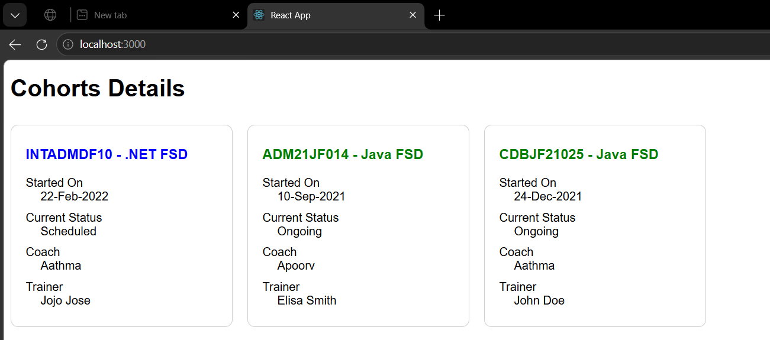
Output

