Six step commutation of BLDC motor
A Ashmit , Shobit Dutt
School of electrical engineering
(SELECT)
Vellore Institute of Technology
Vellore, Tamil Nadu, India
ashmit.a2023@vitstudent.ac.in

Abstract—BLDC motors are a class of permanent-magnet machines which utilize electronic switching of their stator windings (commutation) to sustain rotation. This paper presents the six-step (or trapezoidal) commutation method for three-phase BLDC motors. It first introduces BLDC motors and elaborates on the necessity of commutation in their operation. Then, it describes the principles of operation of the six-step method: switching sequence and the role of Hall sensors in the determination of rotor position. Mathematical modeling of the motor's electrical dynamics is presented: the equations of phase voltage with trapezoidal back-EMF and the torque equation in terms of phase currents and flux linkage. Six-step commutation is compared to sinusoidal commutation and Field-Oriented Control (FOC), in respect to efficiency, torque ripples, and complexity of control. At the end, typical applications and the advantages of six-step BLDC drives are outlined, including high-speed operation, simple implementation, and high torque capability. Statements will be supported by academic and technical literature references.

Introduction
BLDC motors are three-phase permanent-magnet synchronous machines that eliminate mechanical brushes by using electronic switching to control current in the stator windings. Their stator generally has three windings (U, V, W) connected in a WYE or DELTA configuration, and their rotor contains one or more permanent-magnet pole pairs. Unlike brushed DC motors, BLDCs require a controller to commutate the currents: that is, to switch which windings are energized as the rotor moves, so that the stator magnetic field continuously chases the rotor’s permanent-magnet field. Proper commutation maximizes torque production: torque in a BLDC is roughly proportional to the current supplied (assuming the commutation is synchronized with rotor position). Commutation is typically performed every 60 electrical degrees using rotor position feedback.
Fig 1. 3 Block diagram of our model 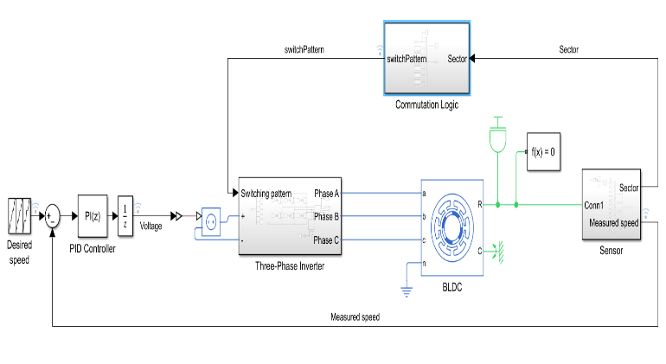

Six Step commutation method
Also known as trapezoidal commutation or 120 degrees commutation, which uses six steps or sectors of an electric cycle to energize the motor . So, during any instant , only two switches will be turned on and rest remain off. Motor commutation is the process of applying the currents to the stator windings in a defined sequence. The phase pair to drive is selected based on rotor position, typically sensed by three Hall-effect sensors spaced 120° apart on the stator. As the rotor begins to rotate, the Hall outputs cycle through six possible states, each corresponding to a 60° electrical sector of the rotation. In our simulation model, the BLDC motor will be connected to a Hall sensor to measure the angular speed. In each step, two phases will conduct, producing a magnetic field. When the rotor magnets begin chasing the field, the next step takes place and other two phases will be energized. The commutation sequence is given by the following table.
Position  (in degrees) | Switching Sequence |  |  | Sector/step
 | AA’ | BB’ | CC’
(-30,30] | 00 | 10 | 01 | 1
(-30,90] | 01 | 10 | 00 | 2
(90,150] | 01 | 00 | 10 | 3
(150,210] | 00 | 01 | 10 | 4
(210,270] | 10 | 01 | 00 | 5
(270,330] | 10 | 00 | 01 | 6

- Commutation sequence table
Fig 2. 3 phase current output of a 3 phase inverter
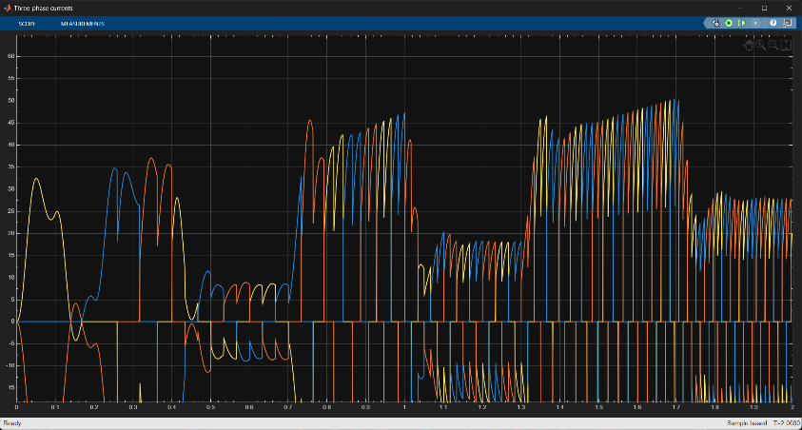

Mathematical modelling of six step commutation
The BLDC motor is mathematically modelled by the standard three-phase synchronous motor equations. For a Y connected motor no neutral terminal, the phase currents will satisfy the condition $i_{a}+i_{b}+i_{c}=0$. The electrical dynamics in each conducting phase follow:
$$\begin{matrix}V_{a} & =R i_{a}+L \frac{di_{a}}{dt}+e_{a}\left(θ\right) (1) \\ V_{b} & =R i_{b}+L \frac{di_{b}}{dt}+e_{b}\left(θ\right) (2) \\ V_{c} & =R i_{c}+L \frac{di_{c}}{dt}+e_{c}\left(θ\right) (3)\end{matrix}$$where $R$is the stator resistance per phase and $L$is the (self) inductance which is assumed equal for all phases. The back-EMFs $e_{a,b,c}\left(θ\right)$ are functions of rotor angle $θ$ and have trapezoidal shapes (flat tops) for a typical BLDC winding. They scale with rotor speed $ω$(rad/s) via $e_{phase}=K_{e} ω$, where $K_{e}$is the back-EMF constant.

The electromagnetic torque is expressed in terms of the phase currents and back emfs. This can be mathematically written as:
Te​=1.5​p[λa​(θ)ia​+λb​(θ)ib​+λc​(θ)ic​] (4)

here $p$is the number of pole pairs and $λ_{a,b,c}\left(θ\right)$are the flux linkage functions (proportional to the trapezoidal waveform shapes of $e_{a,b,c}$). In six step commutation, any two currents will remain non-zero at any instant.

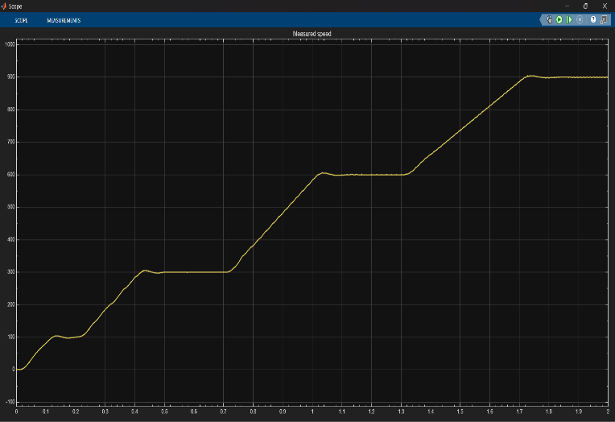
Fig 3. The waveform of the measured speed which is fed again in the system.

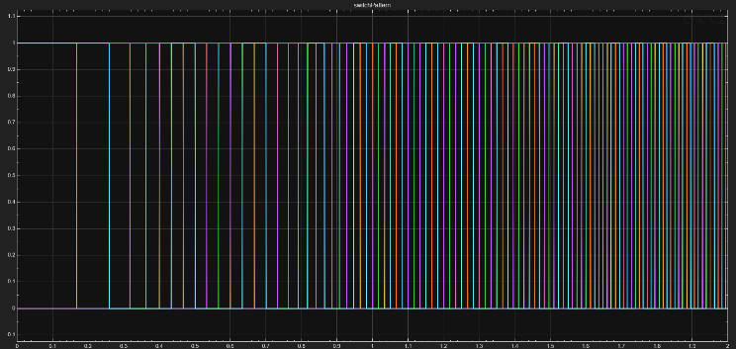
Fig 4. Waveform of the switching pattern

Instantaneous torque is given by the Back EMF and the corresponding currents. Because the BEMF is ideally trapezoidal, feeding flat-top currents aligned with these BEMF regions produces nearly constant torque within each step. Between steps, there are some transient effects (the inductive currents switching, and a short free-wheeling interval for the floating phase). In sensorless drives, it is common to measure the zero-crossing of the floating-phase Back EMF to determine when to commutate. For modeling purposes, one can include the commutation by changing which $V_{a},V_{b},V_{c}$(and $i_{a},i_{b},i_{c}$) equations are active in each 60° sector. The rotor dynamics follow $J\frac{dω}{dt}=T_{e}-T_{L}-Bω$(inertia $J$, friction $B$, load torque $T_{L}$), but the core of six-step modeling lies in the above phase equations and their switching sequence.

Comparision between Sinusoidal commutation and field oriented control (FOC)
Three-phase BLDC motors can also be driven with sinusoidal (120°) commutation or with Field-Oriented Control (FOC) (vector control). In sinusoidal commutation, all three phases carry current simultaneously with sinusoidal waveforms that match a nearly sinusoidal back-EMF, producing very smooth torque. In FOC, the three-phase currents are continuously controlled via Clarke/Park transforms to align the stator field vector at 90° to the rotor flux, yielding ideal torque control at any speed. The trade-offs between methods include efficiency, torque ripple, noise, and complexity:

• Torque and ripple: Six-step (trapezoidal) commutation inherently produces torque ripple at each 60° step. In practice, this can be audible vibration at low speeds. Sinusoidal commutation or FOC produce much lower ripple because the torque is nearly constant over each electrical cycle. For example, under equal thermal limits, sinusoidal (FOC-like) drive can yield about 4.7% more average torque than six-step for the same losses.
• Efficiency and harmonics: The flat-top currents in six-step inject more harmonic content into the motor, leading to higher core losses and audible noise. Sinusoidal/FOC excitation has lower harmonic distortion, which typically gives higher efficiency especially at high speeds. However, because only two transistors switch at a time, six-step can achieve lower switching losses and simpler inverter operation.
• Control complexity: Six-step control is simpler to implement: it requires only discrete Hall/encoder signals and a small lookup table (or a simple commutation state machine) to switch transistors, without the need for high-bandwidth current control loops. Sinusoidal commutation requires phase current sensing or estimation and sin/cosine algorithms to modulate PWM appropriately. Full FOC requires sensors for rotor position and current feedback plus real-time calculations of d-q axes control, making it much more computationally intensive.
• Speed range: Six-step allows very high maximum electrical speed because it simply advances commutations as fast as possible – ideal for applications like fans or pumps that run at very high RPM. Sinusoidal/FOC can also run high speeds but often require faster sampling and may incur more losses at high PWM rates.
• Low-speed performance: Sinusoidal and FOC offer superior low-speed smoothness and finer torque control (especially if position encoders are used). Six-step may struggle at very low speeds without closed-loop current control, due to stepped torque and difficulty sensing back-EMF when speed is low.

Applications and advantages of six step commutation
Six-step commutation is widely used in practical BLDC drives where its strengths align with application needs. Because it delivers very high torque and speed capability and requires only simple controllers and Hall sensors (or sensor-less zero-crossing), it is common in applications like electric fans, pump drives, power tools, and automotive blower/fuel pumps. The method yields high power density ; the motor can produce near-maximum torque with straightforward DC excitation, and the inverter only needs basic PWM signals. Additionally, since only two phases conduct at once, one current sensor per phase is often sufficient, and switching losses are low. The primary advantages of six-step BLDC drives are:
- Simplicity: No elaborate vector math is needed; a simple state-machine or lookup table suffices for commutation. This lowers software development time and hardware cost.
- High torque per amp: The flat current waveform aligned with the trapezoidal back-EMF can produce greater instantaneous torque than a sinusoidal drive at the same current.
- Wide speed range: By switching sectors rapidly, the drive can run at extremely high speeds (limited only by transistor switching and back-EMF voltage).
- Robustness: The six-step drive is inherently robust to noise and sensor faults; it typically only uses digital Hall inputs and simple PWM.
- Cost-effectiveness: Yields a lower-cost solution for many consumer and industrial motors where ultimate smoothness is not critical.

Acknowledgments
We would like to express our sincere gratitude to our guiding professor, Dr. Subramaniam K, for their invaluable guidance and support throughout this research on the six-step commutation of BLDC motors. Their expertise and dedicated mentorship helped us navigate complex technical challenges and refine our approach at every stage of this study. We are also grateful for the insightful feedback and patience they provided during the writing process, which significantly improved the clarity and quality of this paper.

References
- Kim, T., Lee, H.W., & Ehsani, M., “Sensorless Control of the BLDC Motors from Near-Zero to High Speeds,” IEEE Transactions on Power Electronics, Vol. 19, No. 6, pp. 1635–1645, Nov. 2004.
- Shi, J. & Li, T.C., “New method to eliminate commutation torque ripple of brushless DC motor with minimum commutation time,” IEEE Transactions on Industrial Electronics, Vol. 60, No. 5, pp. 2139–2146, May 2013.
- Lee, H.W., Kim, T., & Ehsani, M., “Practical control for improving power density and efficiency of the BLDC generator,” IEEE Transactions on Power Electronics, Vol. 20, No. 2, pp. 192–199, Mar. 2005.

[4] Adila, A.F., Ridwan, M., Ferdiansyah, I., Rizani Rusli, M. “Modeling and Simulation of BLDC Motor Drive with Bipolar PWM Six-Step Commutation for Speed Regulation System,” Proceedings of the 2024 IEEE 2nd International Conference on Electrical Engineering, Computer and Information Technology (ICEECIT), Nov. 22-23 2024, Jember, Indonesia, DOI: 10.1109/ICEECIT63698.2024.10859942.

[5] Tashakori, A. & Ektesabi, M., “Stability analysis of sensorless BLDC motor drive using digital PWM technique for electric vehicles,” in Proceedings of the 38th Annual Conference on IEEE Industrial Electronics Society (IECON 2012), pp. 4898–4903, Oct. 2012.

