Diamond sizes

Vasco Ayere Avoka

2023

smaller <- diamonds %>% filter(carat <= 1)

We have data about 53940 diamonds. Only 17502 are larger than 1 carat. The distribution of the remainder is shown below:

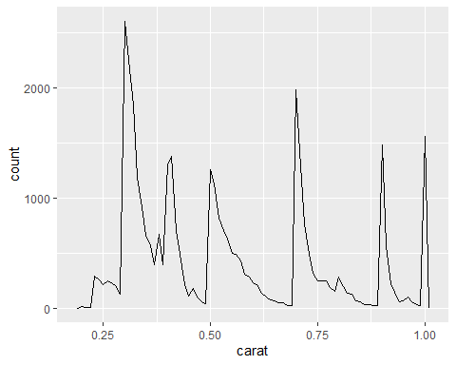

smaller %>% ggplot(aes(carat)) + geom_freqpoly(binwidth = 0.01)