 | INSTITUTO SUPERIOR TÉCNICO  Departamento de Engenharia Informática  Forensics Cyber Security  MEIC / METI 2025-2026 – 1st Period

Digital Forensics Report Lab2
Group number: |  | Name | IST Number
Student 1: |  | Olha Buts | 116276
Student 2: |  | Vasco Conceição | 106481
Student 3: |  | Nuno Martins | 107273

Acquired artifacts
Name | Type | SHA-256 Value
backup_1758589201.zip | ZIP Archive | 6ccd58ef578e0c2d13c5e47c9af78ab274aff059a42422872902a11f9e1689d7
backup_1758588601.zip | ZIP Archive | a9e69f5431616bfe086748105c8a23360c807635de076bedc6b1e4118ea9efd9
backup_1758588001.zip | ZIP Archive | 4fbf84cd93743ba7b732f05aaf93d17f8d03eb197366a93aff23129cc18b0ade
backup_1758587401.zip | ZIP Archive | 8819b97c7af26b2983b8b0130d0d578dc1b9c40e2fa19aab7aa58cc704a1c471
backup_1758586801.zip | ZIP Archive | ebbdba595a739862685e16c2e95de119de3f957b87da8d6e9ecd70612c3cf6c8
backup_1758586202.zip | ZIP Archive | 8de6d689252e61c65c930762f0be8650a8ee4c1dd7931bbf5cbad2e8fdb02f5d
backup_1758585623.zip | ZIP Archive | f42a540046f87d7745c6a06fbc706d2dbdb441319de10d3196b80256ace87393
backup_1758495226.zip | ZIP Archive | eb2956ad880fd0ef02ed9b124f6635ea2dfdb53886d5b3cd88e4f8f96d107e71
Dv34.js | JS File | 3cd0b50e08450c75cb3e77d1e4e3b5fd30932393f3e5c10fe30cf1fab3f0a136
entries.json | JSON File | 1797ec14bcabfddac1264c5761ad3c86a2281163f076d77f87f5f819e0df67ee
N9hg.js | JS File | e4549908b21c4feec4bf73e06fd4bd96629eaba791f277701c29056e30961119
deploy.sh | Bash Script | d74a4123e4299e5aef90b74bee62bd314b5d2f437ad09ab3f31fac65da19d314
backups.sh | Bash Script | 1d4d463a45f75fda04a8d5af8e0d21b4f0fa8f640ae5597ede13f19b823f46d8
/#thebasement.09-23.log | IRC Log | 8752362a3747ebf027b86864b2950e427b1688cc343d9257682538945
pass_gen.sh | Bash Script | 83363303d40cbcef23466bb540d7a5bbe0f574d87db3655e01525a01dd4f2503
K306ao9voUZ.log | Keystroke Log | 68e1ed95b0fdd91831a913fd27a9c4e314bdf46f8f3a05eac1e3ba57910bc8a4
Bash_history | Log File | c368617ef9982ae9be3f776584ac1dae533e83b9460dbc10da5c14b460153324
syslog | System Log | a639407dc14b8de805773a7decb414a0700ab8b4b1f4e98c37b71aec4e7d8fb6
history.log | APT Log | a639407dc14b8de805773a7decb414a0700ab8b4b1f4e98c37b71aec4e7d8fb6
recovered_inbox.txt | Text File | a833bceceb829721591585eae6fe3dd8a572a17452da8db6088fe2251bf940cb
source.py | Python File | c31987bce7265cdacd3329769acada11b26f8d57cc6a9676e3a6dda3b5c90200
Exploit.htpl | HTML Template | 0f9fe89cc0108f9e1b933bd8daff74dfbde17444ce737665b7f1bac7c2df9b06
cookieSteal.html | HTML File | 9a65dadabe142ceb15bbe5232c00a411571e85efedb88ab3f808e5cd7c776a53
reflectedXSS.html | HTML File | 68b02362b9d62c67ba19ded67ca5bdc16ad78811162a8bd7cb463a79a40b6fb5
exploit.py | Python File | ccbfd54f6c3fe06c214aea28927a76a7f508269f76c3e5ef3692a8ad2022ae3b
obfuscator_decompiled.py | Python File | 782d396713f7c6f85331c29c5394ac5c85e35a3167279d0401c4d4a5dac7438e
Seed.txt | Text File | 98b073309a566415455c7f57b56b6d280fde814147dae61363363632e5a5fc47
Auth.log | System Log | 47c8b7c3132827f578b68ed07fc90e447a3d1a4f70bad6b40945dc1e06f3e52a
Webhistory.txt | Text File | 6218d229a19986930cb6fac470df641dd35e99b57b4f2aff3792c0c3cee7ea3f
obfuscator | Python Bytecode | 86a89e4c96282492bbabb364b5a601a9e187d8f9365c3c1c900c79c7db244560
Places.sqlite | Database | 30faeefb762d91a45a371bad4e4cecb274f13d614b75d9235cdf47b265995a8f
recently-used.xbel | XML Bookmark | 6f661b31f9df96cefd9f1de6f96fc5e4247bc1c22a9f6d78614fcd9e39176c7a
Password.kdbx | Database | 076f4fea500f73b89e50530482194e76867f403620c13b261e9458f53e8f9739
.gitconfig | Config File | 345fdb845a85735f71775dd873d17dc6c36a98fa2b07325124bffde8ee71a983
.ssh/config | Config File | 41999c1f215420945e1b5e3173d8a5db93e1e35b461376362c7e667b83677bbf

Report of all findings
Artifacts were extracted from the seized disk images (johnny.dd from the workstation and backup.dd from the backup server). The workstation disk was mounted read-only, and files were analyzed using file,cat, stat, ls and “mousepad” across directories. For the backup server, we employed The Sleuth Kit (TSK) tools fls and icat to extract files from the disk image. Despite anti-forensic measures (e.g., srm), evidence was recovered from caches, logs, and backups, with timestamps validated against /var/log/auth.log, /var/log/syslog and bash history. Below is a tabulated summary of key artifacts, including how they were located
Name | Discovery Method and Context | Evidentiary Value
backup_1758589201.zip | Extracted from /home/ironcaesar/backups/ on backup using fls and icat; unlocked with derived password | Contains ZYRA site snapshot, linking to phishing deployment.
backup_1758588601.zip | Extracted from /home/ironcaesar/backups/ on backup using fls and icat; unlocked with derived password | Holds hidden artifacts (e.g., Invoice.pdf) and tools, confirming concealment.
backup_1758588001.zip | Extracted from /home/ironcaesar/backups/ on backup using fls and icat; unlocked with derived password | Holds hidden artifacts (e.g., diff.txt) and tools.
backup_1758587401.zip | Extracted from /home/ironcaesar/backups/ on backup using fls and icat; unlocked with derived password | Supports backup routine evidence.
backup_1758586801.zip | Extracted from /home/ironcaesar/backups/ on backup using fls and icat; unlocked with derived password | Indicates regular backup schedule.
backup_1758586202.zip | Extracted from /home/ironcaesar/backups/ on backup using fls and icat; unlocked with derived password | Indicates regular backup schedule.
backup_1758585623.zip | Extracted from /home/ironcaesar/backups/ on backup using fls and icat; unlocked with derived password | Indicates regular backup schedule.
backup_1758495226.zip | Extracted from /home/ironcaesar/backups/ on backup using fls and icat; unlocked with derived password | Early evidence of site development.
Dv34.js | Recovered from home/johhnymusk/.config/Code/User/History/34ce7173/ on workstation opened with “mousepad” | Phishing server.js remnant, shows QR code logic.
entries.json | Same directory; opened with “mousepad” | Logs phishing code modifications.
N9hg.js | Same; opened with “mousepad” | Another server.js backup, reinforces phishing evidence.
deploy.sh | Located in /home/johhnymusk/scripts/ on workstation via ls and cat; executed | Deploys ZYRA site to INESC-ID, key to attribution.
backups.sh | Found in /home/johhnymusk/backups/ on workstation; traced via rsync logs | Manages encrypted backups and links to server activity.
#thebasement.09-23.log | Identified in /snap/irssi/common/irclogs/2025/freenode/ on workstation; | Reveals “CatDucky” collaboration and motives.
pass_gen.sh | Located in /home/johhnymusk/backups/ on workstation; decompiled obfuscator | Generates zip passwords, critical for decryption.
K306ao9voUZ.log | Hidden in /var/tmp/ on workstation; | Captures “ILoveMyMomTheQueen”and code edits.
obfuscator | Found in /home/johhnymusk/backups/ on workstation; decompiled online | Implements password hashing, unlocks zips.
Bash_history | Located in /home/johhnymusk/ on workstation | Shows site edits, hiding, and deletions
syslog | Retrieved from /var/log/ on workstation; parsed | Records power-off and network activity.
history.log | Found in /var/log/apt/ on workstation; grep searched | Logs secure-delete install.
recovered_inbox.txt | Found in Firefox cache | Contains CatDucky's tip email.
source.py | Recovered from /home/johhnymusk/scripts on workstation using ls and cat | Matches ZYRA attack vector (ChaCha20).
Exploit.htpl | Recovered from /home/johhnymusk/scripts on workstation | Phishing exploit code.
cookieSteal.html | Recovered from /home/johhnymusk/scripts on workstation | Indicates credential theft mechanism.
reflectedXSS.html | Recovered from /home/johhnymusk/scripts on workstation | Reflects XSS attack vector.
exploit.py | Recovered from /home/johhnymusk/scripts on workstation | Contains RCE via pickle, ties to phishing.
obfuscator_decompiled.py | Decompiled from obfuscator.pyc; analyzed manually | Reveals password generation logic.
Seed.txt | Found in /home/johhnymusk /backups/ on workstation; file search | Provides number, seed for password derivation.
Auth.log | Retrieved from /var/log/ on workstation; parsed | Confirms sudo commands and session data.
Webhistory.txt | Extracted from places.sqlite; SQL queried | Shows GitHub and QR phishing research.
Places.sqlite | Found in Firefox profile on workstation; SQL analyzed | Web history linking to attack planning.
recently-used.xbel | Located in/home/johhnymusk / .local/share/ on workstation; XML parsed | Records access to artifacts.
Password.kdbx | Found in /home/johhnymusk/ on workstation; opened with KeePassXC | Contains "TheByteOf78" seed, critical for decryption.
.gitconfig | Located in /home/johhnymusk/ on workstation; file search | Links "muskyboi" to GitHub activities.
.ssh/config | Located in /home/johhnymusk/ .ssh/ on workstation; file search | Authorizes "muskyboi" for INESC-ID and backup server.

Analysis of relevant findings

Do the seized disk images contain traces of the phishing website (source code, deployment scripts, logs) and/or the hidden artifacts discovered in Lab 1? If so, identify them, their locations on disk, and their SHA-256 values as recovered from the images.
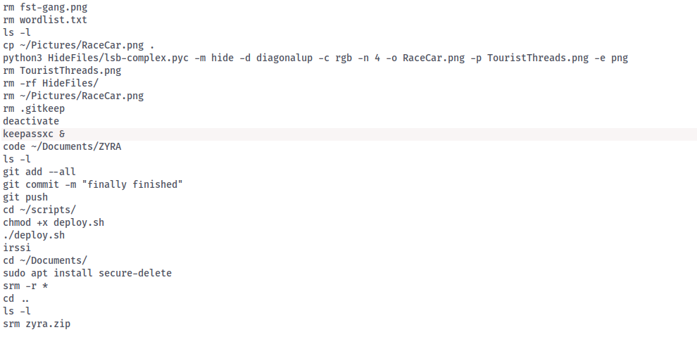
Our analysis of disk images from João's workstation and backup server confirmed that both disk images contain traces of the phishing website. Although João tried to erase them using secure-delete, some remnants survived.
Figure 1 - Bash history
We started by looking at user activity logs and code editors since the bash history (see Figure 1) mentioned editing files in VS Code. Although home/johnnymusk/Documents/Zyra was wiped, the VS Code caches and backups on the workstation kept some traces alive and the backup server had complete zipped copies of the files.
We discovered files named Dv34.js and N9hg.js, which are copies of the original server.js by examining VS Code’s history files located at /home/johhnymusk/.config/Code/User/
34ce7173/History/. The entries.json file showed edits made on September 23 at 01:03 and 01:59 UTC. (SHA-256: 3cd0b50e08450c75cb3e77d1e4e3b5fd30932393f3e5c10fe30cf1fab3f0a136 - Dv34.js
1797ec14bcabfddac1264c5761ad3c86a2281163f076d77f87f5f819e0df67ee - entries.json
e4549908b21c4feec4bf73e06fd4bd96629eaba791f277701c29056e30961119 - N9hg.js)
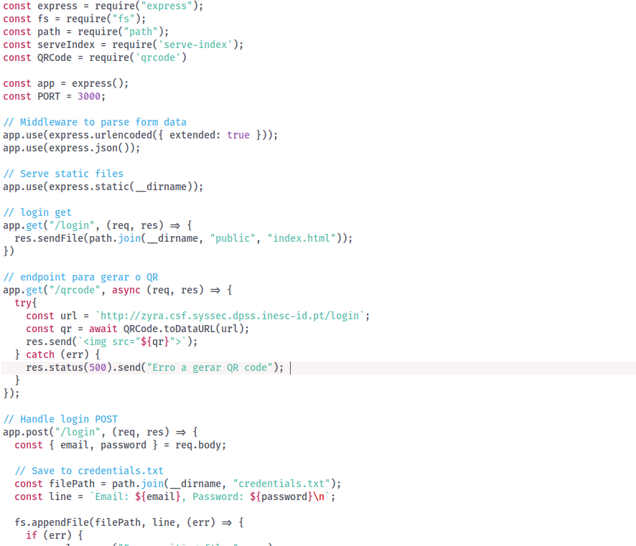
Figure 2 - Dv34.js
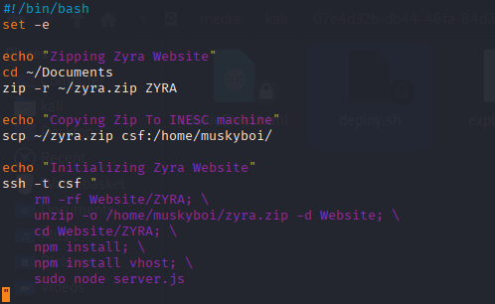
For the deployment, there’s a script called deploy.sh (SHA-256 -d74a4123e4299e5aef90b74bee62bd314b5d2f437ad09ab3f31fac65da19d314), a Bash file that zips the website, sends it to the INESC-ID machine at csf:146.193.41.109, and runs node server.js. The bash history revealed commands like chmod +x deploy.sh and ./deploy.sh localized in the home/johnnymusk/scripts/ directory.
Figure 3 - Deploy.sh
The backup process was handled by a script named home/backup/backup.sh (SHA-256 - 1d4d463a45f75fda04a8d5af8e0d21b4f0fa8f640ae5597ede13f19b823f46d8). This script creates a timestamp, sets up a user and host for the backup server, generates a password using home/johnnymusk/backup/pass_gen.sh (SHA-256 - 83363303d40cbcef23466bb540d7a5
bbe0f574d87db3655e01525a01dd4f2503), zips the ~/Documents/ZYRA/ folder with that password, syncs it to the backup server, and then removes the local zip file.
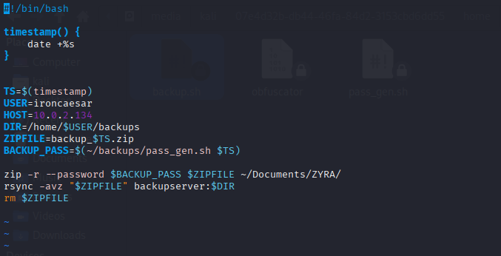
Figure 4 - Backup.sh
We also found logs related to the phishing setup. These include IRC conversations in /snap/irssi/common/irclogs/3035/freenode/#thebasement.09-23.log (SHA-256 - 0ed38c4
8752362a3747ebf027b86864b2950e427b1688cc343d9257682538945)}, where João talks about hosting the site, and web history from places.sqlite (sha256 - 30faeefb762d91a45a371bad4e4cecb274f13d614b75d9235cdf47b265995a8f}, which shows searches for tools on GitHub.

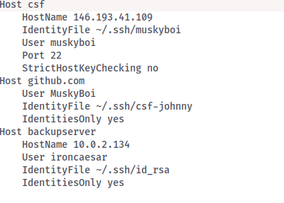
In the folder /home/johnnymusk/.ssh, we found a config file (SHA-256 - 41999c1f215420945e1b5e3173d8a5db93e1e35b461376362c7e667b83677bbf) containing accounts information, as well as RSA keys (both public and private) indicating authorization for the muskyboi account. We also found a .gitconfig file with the same username.

Figure 5 - .ssh/config
During our investigation, we came across several images that played a role in hiding information that served as containers for steganography or were used on the site. Many of them were found in the .cache/thumbnails/ directory, with subfolders normal and large. The large folder had various PNG images, including BarragemFagilde and BarragemOdelouca, which were used to hide the algorithm diff.txt.
Phishing Website (ZYRA clone): Backup server has zipped versions in /home/ironcaesar/backups/ (e.g., backup_1758589201.zip). SHA-256 of backup_1758589201.zip: 6ccd58ef578e0c2d13c5e47c9af78ab274aff059a42422872902a11f9
e1689d7.
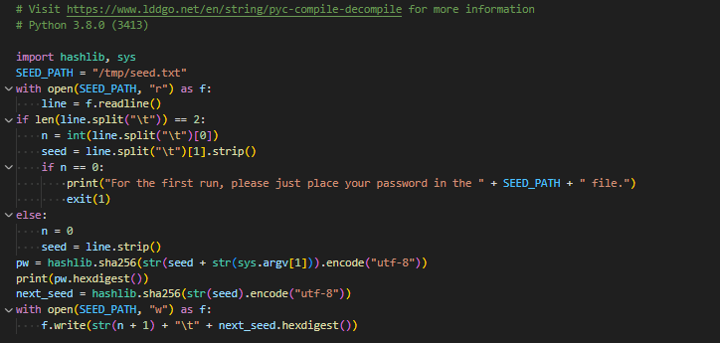
The artifacts were hidden using steganography from the HideFiles GitHub repository. We found them as thumbnails on the workstation and on the backup server. The passwords for the zips were dynamically generated using pass_gen.sh, which calls the obfuscator script with timestamps. We uncovered the master password "ILoveMyMomTheQueen" in the keystroke log at /var/tmp/K306ao9voUZ.log (SHA-256 - 68e1ed95b0fdd91831a913fd27a9c4e3
Figure 6 - Obfuscador_decompiled
14bdf46f8f3a05eac1e3ba57910bc8a4, where it was typed while using KeePassXC (noting the shift key presses). Opening the Passwords.kdbx file with KeePassXC revealed “TheByteOf78” as the initial seed. Using the seed.txt file, which showed n = 76 and a seed hash, and decompiling obfuscator.pyc with an online tool, we simulated password generations in python. This process helped us unlock the zips. For example, the password for backup_1758586801.zip was calculated as 78b4d2bd8a5a270605194e5f610094e51a4a2ce008710510bb00c0c59fc16988, derived from hashing “TheByteOf78” iterated 74 times with the timestamp 1758586801. The SHA-256 sum of backup_1758586801.zip is a9e69f5431616bfe086748105c8a233
60c807635de076bedc6b1e4118ea9efd9.
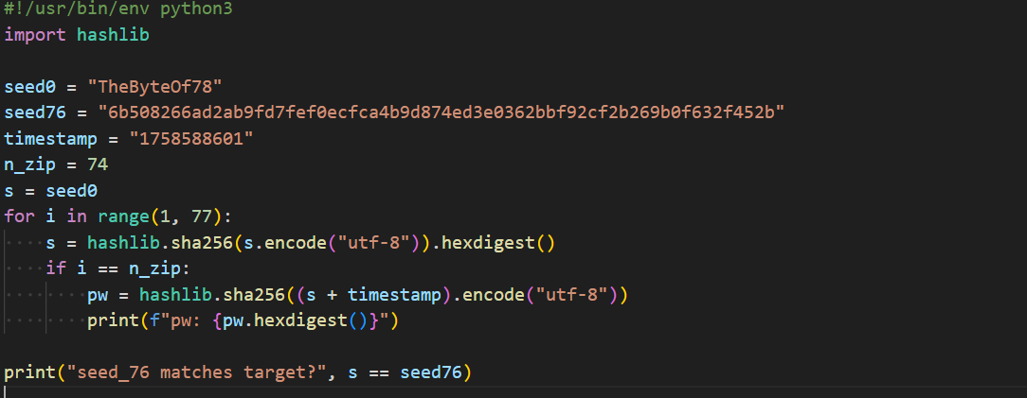
Figure 7 - Screenshot of code used to discover ZIP password

The FinancialReport.pdf file was referenced in the recently-used.xbel (sha256 - 6f661b31f9df96cefd9f1de6f96fc5e4247bc1c22a9f6d78614fcd9e39176c7a) bookmark XML, confirming it existed at /home/johhnymusk/Documents/ZYRA/resources/FinancialReport.pdf and was opened with Evince on September 23 at 00:34:52 UTC. The bash history shows it was later deleted with srm, which removed its traces from the filesystem. However, this bookmark reference remains as proof of its existence after deletion. On the backup server, we could extract it from backup_1758586801.zip in the /home/johhnymusk/ZYRA/resources/FinancialReport.pdf
(SHA-256 - fde6e8582b5b4763e4e574c5eb293876f5894339215d12bffd224f929e559cc9)
after unlocking zip with the calculated password.
Similarly, the Invoice.pdf file, a Futuro Inteligente invoice, was opened with Evince on September 23 at 00:35:43 UTC, as noted in recently-used.xbel. The bash history indicates it was hidden using hide_base64.sh Invoice.pdf ~/scripts/steghide, then deleted along with ~/scripts/steghide and Invoice. We recovered the unmodified steghide file from /home/johhnymusk/. cache/vmware/drag_and_drop/N2JdwH/steghide, with a SHA-256 value of eb98a185541c4be01f523a264c923944cd47a21fb50c190aacc1abce334b9db9.
On the backup server, Invoice.pdf (SHA256 -748e7358ccbba0b769b94ecb3c96c161f
d8366454acf076a6f95b5f404515e1d) is extractable from the backup_1758586801.zip.
The parking.db database extract was initially verified on September 23 at 00:37:52 UTC, then embedded in MingleGame.wav and deleted with srm. Recovering remnants on the workstation was challenging due to the secure deletion, but the original is recoverable from /backup_1758588001.zip on the backup server (SHA256 -23108d6552bbd633ed80c
3de50449e0698294c0da3a049a61bbaed41e0edcea0). The unmodified MingleGame.wav can still be found at /home/johhnymusk/.cache/vmware/drag_and_drop/DJ6jmh/MingleGame.wav. (SHA-256 - cfaad93ccd6e2891b5c1fb1f4d8fa2cb876797daa595ecc3e1f231a85a1ccd27).
The TouristThreads.png (Reddit thread) and wpp.png (WhatsApp conversation) were opened on September 23 at 00:37:37 and 00:39:07 UTC, respectively, according to recently-used.xbel. Despite being deleted later, the system saved thumbnails located at /home/johhnymusk/. cache/thumbnails/normal. These thumbnails have different SHA-256 values due to resizing: 3cc8df3b8781ad72490ecb32c5e29dff0c772bd5928da809f190
a090094b6730 for TouristThreads.png and b90aec208015897d5740dd87629f97d3d789
361ac84d3a64902fcce40aafe7ac for wpp.png. The originals are located on the backup server at
/backup_1758586801.zip/home/johhnymusk/ZYRA/resources/. Their SHA-256 hashes are c938a05b84f2d749fc6ac65a88f57ccc0c860d4169577947425cc01aa1bbd1c3 for wpp.png and ff56d339f5affe0279530214dec0ef01950828beb4af6bfa83fe8465a71da7d8 for TouristThreads.png
Finally, the diff.txt was hidden in ~/Pictures/BarragemFagilde.tiff and ~/Pictures/BarragemOdelouca.jpg. Like the other artifacts, diff.txt (SHA256 –
80373bc7994731717f3fe753685848541bb81cbf906a85c3f42415e5ed05bd86) is recoverable from the backup server (/backup_1758586801.zip/home/johhnymusk/ZYRA/resources/diff.txt)
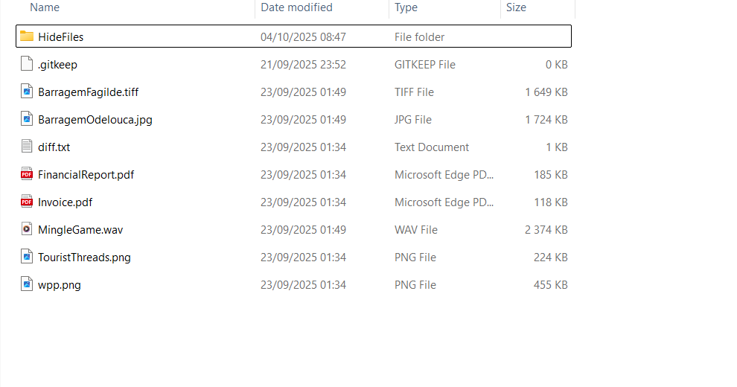
Figure 8 - Folder structure of Zyra/resource

Can you reconstruct the provenance and handling of these files? Provide a timeline of relevant events that shows how the phishing site was built and operated, and how the hidden artifacts were managed on the seized machines.

Time | Description | Source
2025-09-18 01:11:25 | Boot: VMware Tools services are initialized, the kernel detects the 'VMware Hypervisor', creates virtual devices, and enables drag-and-drop functionality | Var/log/syslog (2025-09-18T00:11:25.563805+00:00 johnnymusk systemd-modules-load[397]: Inserted module 'lp'  2025-09-18T00:11:25.566303+00:00 johnnymusk systemd-modules-load[397]: Inserted module 'ppdev' , …)
2025-08-25 17:34 | On the host, several scripts are created exploit.py, exploit.htpl, cookieSteal.html, reflectedXSS.html,source.py, wordlistFromPdf.py, deploy.sh. | home/johhnymusk/scripts (stat -> Modify)
2025-09-16 23:20–23:43 | Several documents and images with original timestamps (e.g. Teorica_6_2017_2018.pdf, Teorica_7_2017_2018.pdf, .jpg/.gif)
2025-09-21 21:00–21:01 | Drag and Drop import of scripts (created 08/25) + PDFs and images. | Stat drag_and_drop/
2025-09-21 23:50 | deploy.sh created | home/johhnymusk/scripts/deploy.sh
2025-09-21 23:50 | Creating backup.sh in home/johhnymusk /backup
  home/johhnymusk/backups/backup.sh
2025-09-21 22:53:55 | Git clone: from https://github.com/MuskyBoi/ZYRA.git | .git/logs/refs/main
2025-09-23 01:03:16 | Johnny opened VSCode using the command “code .” to edit the phishing site’s code | Var/log/syslog (2025-09-23T00:03:16.446497+00:00 johnnymusk systemd[2762]: Started snap. code.code-6315aa92-b94c-4baf-b102-5808a1b306b5.scope.),  Bash_history (code.) and .config/Code/logs/20252923T010317/editSessions.log (2025-09-23 01:03:23.991 [info] Prompting to enable ..)
2025-09-23 01:03:39 | Johnny opened Firefox and started browsing official Formula 1 ticket sites, exploring options for upcoming races and grandstands. Afterward, he shifted gears to YouTube, searching for jazz music (ambient studying aid.) | Places.sqlite (extracted timestamps and URLs; converted from local 01:03:39)
2025-09-23  01:05:17 | Johnny joins IRC channel #thebasement as "johhnymusk" and converses with “CatDucky”. He discusses a broken leg from a ZYRA bike incident, expresses intent to create a phishing site to steal ZYRA client credentials, and mentions hosting it on a “Syssec” machine (zyra.csf.syssec.dpss.inesc-id.pt) under Professor Nuno's supervision for his thesis. Cat warns against illegal actions. | #thebasement.09-23.log (--- Log opened Tue Sep 23 01:05:17 2025  01:05 -!- johhnymusk [~johhnymus@freenode-uip.cj2.jjp4uo.IP] has joined #thebasement)
2025-09-23  01:10:00 | “CatDucky” receives an anonymous email (from totallyaveragedude@tutamail.com via Proton Mail) revealing MELE's “smart parking” system is rigged (tourists overcharged, allies spared via premium zones and ghost company “Futuro Inteligente, Lda.”). The email directs her/him to retrieve proof files from a physical locker at CTT IST Lisbon (Locker 03, Code: 666). | Home/johhnymusk/thunderbird/common/.thunderbird/kl1zswcm.default/Mail/pop.gmail.com/inbox
2025-09-23  01:10:00 -02:00:00 | Periodic execution via CRON of the backup script located at home/johhnymusk /backups/backup.sh | Var/log/syslog (2025-09-23T00:10:02.013942+00:00 johnnymusk CRON [23244]: (johhnymusk) CMD (sh ~/backups/backup.sh)  2025-09-23T00:20:01.836349+00:00 johnnymusk CRON [23537]: (johhnymusk) CMD (sh ~/backups/backup.sh), ..)
2025-09-23 01:20:00 | An anonymous email originally sent to itscatducky@proton.me was subsequently forwarded to sussyjohnnyhacker. | Home/johhnymusk/thunderbird/common/.thunderbird/kl1zswcm.default/Mail/pop.gmail.com/inbox
2025-09-23 01:21:44 | Johnny rejoins the IRC channel #thebasement and questions the email he received. | Home/johhnymusk/irssi/common/irssilogs/2025/freenode / #thebasement.09-23.log
2025-09-23 01:33:49 | Johnny retrieves a USB drive labeled “Intenso” with serial number 3D32E2CD from the locker. The device is mounted at /media/johhnymusk/Intenso. He copies several sensitive files to the directory ~/Documents/ZYRA/resources/, including: diff.txt, FinancialReport.pdf, Invoice.pdf,  parking.db, TouristThreads.png and wpp.png. | Var/log/syslog (2025-09-23T00:  33:49.838174+00:00 johnnymusk kernel: usb 2-1: New USB device found, idVendor=058f, idProduct=6387, bcdDevice= 1.03) and bach_history (cp /media/johhnymusk/Inte  nso/* .)
2025-09-23  01:34:52-01:39:07 | He views artifacts using commands like cat diff.txt, xdg-open for PDFs/images, and code parking.db (likely to inspect contents). | home/johhnymusk/.local/share/recently-used.xbel (<bookmark href="file:///home/johhnymusk/Documents/ZYRA/resources/FinancialReport.pdf" added="2025-09-23T00:34:52.935690Z" modified="2025-09-23T00:34:52.935784Z" visited="2025-09-23T00:34:52.935691Z">) and bash_history (cat diff.txt)
2025-09-23 01:40:08 | Browsed the Portugal Smart Cities Summit 2025 website (turismodeportugal.pt) | Places,sqlite(2025-09-23 01:40:08|https://business.turismodeportugal.pt/pt/Agenda/Eventos/Paginas/portugal-smart-cities-summit.aspx|Portugal Smart Cities Summit 2025|2)
2025-09-23 01:40:20 | Visited the Barracuda blog discussing phishing attacks using QR codes. | Places.sqlite (https://blog.barracuda.com/2024/10/22/threat-spotlight-evolving-qr-codes-phishing-attacks|Threat Spotlight: The evolving use of QR codes in phishing attacks | Barracuda Networks Blog)
2025-09-23  01:41:00 | Johnny rejoins IRC #thebasement, informs Cat he has proof of MEMEL rigging (preferential plates, unpaid parking, money funneled to Futuro Inteligente). Cat suggests hiding files using a GitHub repo like "shadowexploit" (FileHider/HideFiles). | Home/johhnymusk/irssi/common/irssilogs/2025/freenode / #thebasement.09-23.log
2025-09-23  01:44:24 | Johnny searches for ‘HideFiles’ repositories (matching Cat's suggestion; likely identifies shadowexploitthunder-web/HideFiles.git). | Places.sqlite:2025-09-23 01:44:36|https://github.com/search?q=HideFiles&type=repositories|Repository search results · GitHub|1)
≈2025-09-23  01:44:00 -02:00:00 | Johnny clones the HideFiles repo (git clone https://github.com/shadowexploitthunder-web/HideFiles.git), views its code (code .), makes scripts executable (chmod +x), and hides the leaked files using steganography: - parking.db hidden in ~/Music/MingleGame.wav via wav_hider.py. diff.txt hidden in TIFF/JPG images via hide_in_comments.sh. - Invoice.pdf hidden in ~/scripts/steghide via hide_base64.sh (venv activated). wpp.png hidden in fst-gang.png via lsb.py. FinancialReport.pdf converted to PNG and hidden. TouristThreads.png hidden in RaceCar.png via lsb-complex.pyc. Additional steps: Generates wordlist from Modern_Cars.pdf, hides in ZIP via create_zip.sh. Deletes originals with rm, removes HideFiles repo (rm -rf HideFiles/), deactivates venv. | bash_history: (full command sequence post-git clone; inferred timing between GitHub browse and next edit).
2025-09-23-02:01:01 | Final edits to server.js; git commit/push. | entries.json. Keystroke log (typing code like const qr = await QR..., git commit -m [shift]@finally finished[shift]@, git push[enter][shift]MUsky[shift]Boi). recovered_bash_history.txt (git commands).
2025-09-23-02:03:01 | Johnny deploys the phishing site via ~/scripts/deploy.sh. | bash_history: (cd ~/scripts/, chmod +x deploy.sh, ./deploy.sh)
2025-09-23-02:04:00 | Johnny rejoins IRC, tells Cat “All is ready” and that “ZYRA is gonna suffer.” Cat suggests using srm for secure deletion. | Home/johhnymusk/irssi/common/irssilogs/2025/freenode / #thebasement.09-23.log
2025-09-23 02:06:00 | Johnny install secure-delete package, entering sudo password “squidGamer”. | var/log/auth.log (sudo command at 2025-09-23T01:06:00+00:00). Keystroke log (secu[tab]-delete[enter]squid[shift]Gamer[enter])
≈2025-09-23  02:43:00 | Johnny deletes files: srm -r * in ~/Documents/, then srm zyra.zip. | bash_history. (final commands). Keystroke log (srm -r [shift]{[enter], srm [shift]zy[tab][enter])
2025-09-23 03:43:31 | System shutdown initiated, ending session. | Var/log/syslog (power off messages at 2025-09-23T02:43:31+00:00) and auth.log (session closed at same time).

Did you find any evidence of anti-forensic activity? If so, describe the techniques observed and the evidence that supports your claim.
Yes, evidence of anti-forensic activity was found.
Secure Deleting Tool
The workstation had the “secure-delete” package installed and with “srm” command was used. This tool erases data fully, evading simple recovery.
Evidence:
- Installed via “sudo apt install secure-delete” (auth.log, history.log).
- Commands like “srm -r *” in bash history and keystrokes.
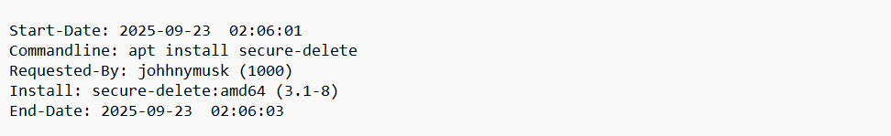
Figure 9 - history.log

Steganography Tools
João cloned “HideFiles” repo from GitHub. Used scripts to hide files in images, audio, and more.
Techniques:
- LSB in images (lsb.py, lsb-complex.pyc).
- Base64 encoding (hide_base64.sh).
- Comments in images (hide_in_comments.sh).
- Audio hiding (wav_hider.py).
- PDF to PNG and ZIP hiding.
Evidence:
- Bash history shows cloning, chmod, and running scripts.
- Recovered hidden files from backup_1758588601.
- Keystrokes confirm deletions after hiding.
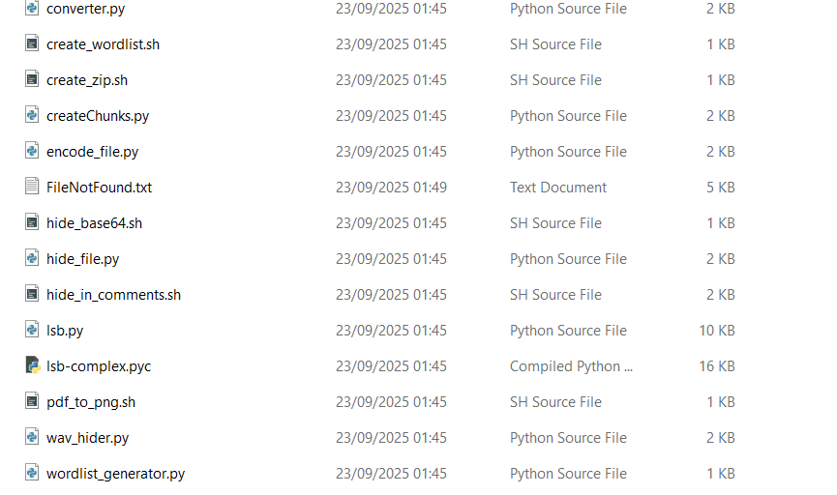
Figure 10 - backup_1758588601/HideFiles

QR Codes in Phishing Attacks
The suspect searched “The evolving use of QR codes in phishing attacks” on Barracuda blog. Used ideas for phishing site.
From blog: QR codes evade email filters by hiding URLs. Dynamic codes change links, hard to trace. Example: Fake login pages via QR.
Evidence:
- Web history: Visited https://blog.barracuda.com/2024/10/22/threat-spotlight-evolving-qr-codes-phishing-attacks.
- Code in server.js generates QR for fake login.
Figure 11 - web history

  - What new discoveries emerge from the seized images that were not visible in Lab 1? Do these findings strengthen the attribution of the phishing attack to João Musk, or point to other relevant actors (collaborators, external servers)? Based on your analysis, what hypotheses can you form about the larger scheme hinted at by the hidden artifacts, and what recommendations would you make for further investigative steps by Prof. Alexandre Magno and the Polícia Judiciária?
New findings:
- IRC logs reveal motive (ZYRA bike accident), collaboration (CatDucky aids hiding/deletion), shift to MEMEL exposure.
- Email (recovered_inbox.txt): Cat forwards anonymous tip (totallyaveragedude@tutamail.com) about fraud associated with Futuro Inteligente.
- Web history links to phishing research (QR code attacks) and GitHub searches for hiding tools.
- APT history shows recent installs like secure-delete, aligning with cleanup.
- Relevant PDFs (csf2526-*) are course materials on forensics, suggesting João studied evasion techniques.
- Keystroke log (K306ao9voUZ.log) captures phishing site code edits (e.g., QR code for ZYRA login).
- deploy.sh shows deployment to “csf.syssec.dpss.inesc-id.pt" - a university server, tying to his thesis.
- backups of the Zyra site are located on the backup server.
- Bash history.
- Phishing code in “source.py” and “exploit.py” mirrors ZYRA attack vectors (e.g., ChaCha20 encryption, RCE via pickle).
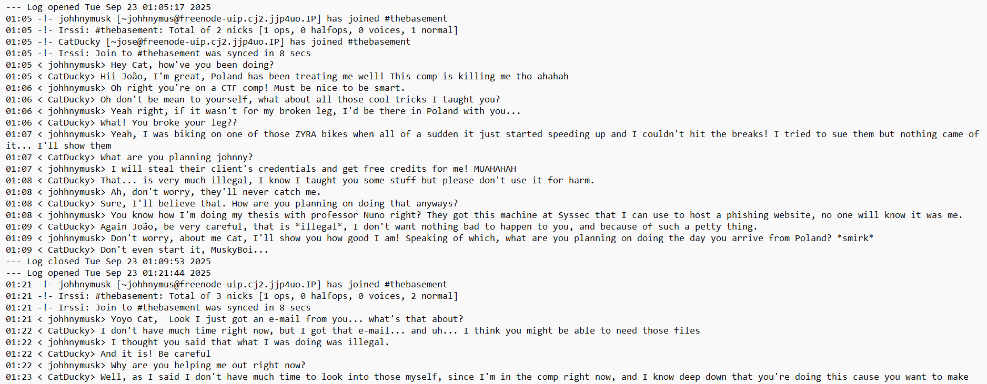
These strengthen attribution to João Musk. Additionally, nicks/emails match (johhnymusk, sussyjohnnyhacker@gmail.com). IRC logs and email highlights collaborators—CatDucky advised on hiding/deletion; an anonymous tipster (totallyaveragedude@tutamail.com) via forwarded email.
Figure 12 - IRC (#thebasement): Musk discusses ZYRA phishing revenge

Hypotheses: Musk's phishing was revenge but uncovered MEMEL cartel (AI rigging for tourists/allies, laundering via Futuro Inteligente). He's pivoting to whistleblower (locker stash); Cat enables; Futuro as front for Trocos.
Recommendations for Prof. Magno and Polícia Judiciária:
Raid locker for physical artifacts.
Subpoena INESC logs (csf server), GitHub (MuskyBoi), backupserver (IP trace).
Interview CatDucky (verify Poland CTF); trace Tutamail.
Audit Futuro finances; cross-check MEMEL db/logs.
Network forensics on seized devices for exfil; victim interviews (ZYRA breaches).

