Módulo 10: Gerência de Processos Distribuídos
Referência: Tanenbaum Chapter 3 (Processes) Tópicos das aulas: Migração de processos, estações de trabalho.
Chapter 3, Question 15
Q: Strong mobility in UNIX systems could be supported by allowing a process to fork a child on a remote machine. Explain how this would work.
A: Forking in UNIX means that a complete image of the parent is copied to the child, meaning that the child continues just after the call to fork. A similar approach could be used for remote cloning, provided the target platform is exactly the same as where the parent is executing. The first step is to have the target operating system reserve resources and create the appropriate process and memory map for the new child process. After this is done, the parent's image (in memory) can be copied, and the child can be activated. (It should be clear that we are ignoring several important details here.)
Chapter 3, Question 16
Q: In Fig. 3-18 it is suggested that strong mobility cannot be combined with executing migrated code in a target process. Give a counterexample.
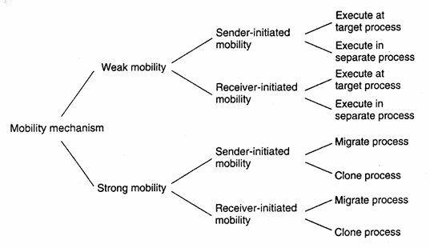
A: If strong mobility takes place through thread migration, it should be possible to have a migrated thread be executed in the context of the target process.
Chapter 3, Question 17
Q: Consider a process P that requires access to file F which is locally available on the machine where P is currently running. When P moves to another machine, it still requires access to F. If the file-to-machine binding is fixed, how could the systemwide reference to F be implemented?
A: The simplest solution is to create a separate process Q that handles remote requests for F. Process P is offered the same interface to F as before, for example in the form of a proxy. Effectively, process Q operates as a file server.

Módulo 9: Serviços de Nomes
Referência: Tanenbaum Chapter 5 (Naming) Tópicos das aulas: Identificadores vs Endereços, Resolução de Nomes, DNS.
Chapter 5, Question 1
Q: Give an example of where an address of an entity E needs to be further resolved into another address to actually access E.
A: IP addresses in the Internet are used to address hosts. However, to access a host, its IP address needs to be resolved to, for example, an Ethernet address.
Chapter 5, Question 2
Q: Would you consider a URL such as http://www.acme.org/index.html to be location independent? What about http://www.acme.nl/index.html?
A: Both names can be location independent, although the first one gives fewer hints on the location of the named entity. Location independent means that the name of the entity is independent of the address of the associated entity. By just considering a name, nothing can be said about the address of the associated entity.
Chapter 5, Question 3
Q: Give some examples of true identifiers.
A: Examples are ISBN numbers for books, identification numbers for software and hardware products, employee numbers within a single organization, and Ethernet addresses (although some addresses are used to identify a machine instead of just the Ethernet board).
Chapter 5, Question 4
Q: Is an identifier allowed to contain information on the entity it refers to?
A: Yes, but that information is not allowed to change, because that would imply changing the identifier. The old identifier should remain valid, so that changing it would imply that an entity has two identifiers, violating the second property of identifiers.
Chapter 5, Question 16
Q: Give an example of how the closure mechanism for a URL could work.
A: Assuming a process knows it is dealing with a URL, it first extracts the scheme identifier from the URL, such as the string ftp:. It can subsequently look up this string in a table to find an interface to a local implementation of the FTP protocol. The next part of the closure mechanism consists of extracting the host name from the URL, such as www.cs.vu.nl, and passing that to the local DNS name server. Knowing where and how to contact the DNS server is an important part of the closure mechanism. It is often hard-coded into the URL name resolver that the process is executing. Finally, the last part of the URL, which refers to a file that is to be looked up, is passed to the identified host. The latter uses its own local closure mechanism to start the name resolution of the file name.
Chapter 5, Question 19
Q: Explain how DNS can be used to implement a home-based approach to locating mobile hosts.
A: The DNS name of a mobile host would be used as (rather poor) identifier for that host. Each time the name is resolved, it should return the current IP address of the host. This implies that the DNS server responsible for providing that IP address will act as the host's name server. Each time the host moves, it contacts this home server and provides it with its current address. Note that a mechanism should be available to avoid caching of the address. In other words, other name servers should be told not to cache the address found.

Módulo 12: Relógios Lógicos, Exclusão Mútua e Deadlock
Referência: Tanenbaum Chapter 6 (Synchronization) Tópicos das aulas: Relógios de Lamport, Algoritmos de Exclusão Mútua (Centralizado, Distribuído/Ricart-Agrawala, Anel), Eleição.
Chapter 6, Question 5
Q: Add a new message to Fig. 6-9 that is concurrent with message A, that is, it neither happens before A nor happens after A.
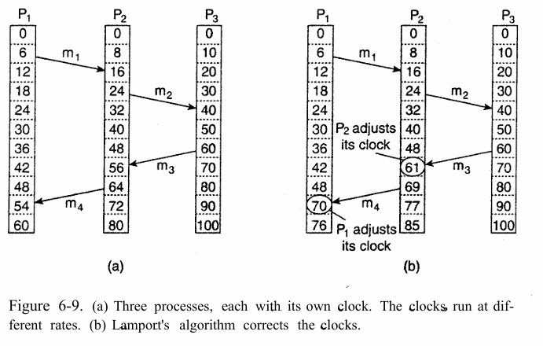
A: The solution cannot involve 0 or it would be ordered. Thus it must be a message from 1 to 2 or from 2 to 1. If it departs or arrives from 1 after 16, it will be ordered with respect to A, so it must depart or arrive before 16. The possibilities are a message leaving process 2 at 0 and arriving at process 1 at 8, or a message leaving process 1 at 0 and arriving at process 2 at 10. Both of these are concurrent with A.
Chapter 6, Question 9
Q: In the centralized approach to mutual exclusion (Fig. 6-14), upon receiving a message from a process releasing its exclusive access to the resources it was using, the coordinator normally grants permission to the first process on the queue. Give another possible algorithm for the coordinator.
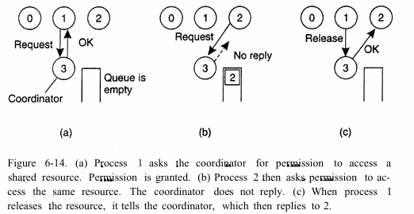
A: Requests could be associated with priority levels, depending on their importance. The coordinator could then grant the highest priority request first.
Chapter 6, Question 10
Q: Consider Fig. 6-14 again [Centralized MutEx]. Suppose that the coordinator crashes. Does this always bring the system down? If not, under what circumstances does this happen? Is there any way to avoid the problem and make the system able to tolerate coordinator crashes?
A: Suppose that the algorithm is such that every request is answered immediately, either with permission or with denial. If there are no processes accessing resources and no processes queued, then a crash is not fatal. The next process to request permission will fail to get any reply at all, and can initiate the election of a new coordinator. The system can be made even more robust by having the coordinator store every incoming request on disk before sending back a reply. In this way, in the event of a crash, the new coordinator can reconstruct the list of accessed resources and the queue by reading the file from the disk.
Chapter 6, Question 11 (Algoritmo de Ricart e Agrawala)
Q: Ricart and Agrawala's algorithm has the problem that if a process has crashed and does not reply to a request from another process to access a resources, the lack of response will be interpreted as denial of permission. We suggested that all requests be answered immediately to make it easy to detect crashed processes. Are there any circumstances where even this method is insufficient? Discuss.
A: Suppose that a process denies permission and then crashes. The requesting process thinks that it is alive, but permission will never come. One way out is to have the requester not actually block, but rather go to sleep for a fixed period of time, after which it polls all processes that have denied permission to see if they are still running.
Chapter 6, Question 12 (Algoritmo Distribuído em LAN)
Q: How do the entries in Fig. 6-17 change if we assume that the algorithms can be implemented on a LAN that supports hardware broadcasts?
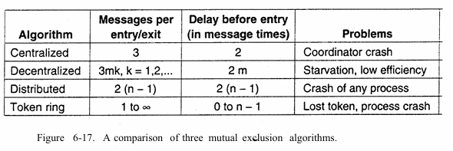
A: Only the entries for the distributed case change. Because sending a point-to-point message is as expensive as doing a broadcast, we need only send one broadcast message to all processes requesting access to the resource. Likewise, only one release broadcast message is needed. The delay becomes $1+(n-1)$: one delay coming from the broadcast request, and an additional $n-1$ as we still need to receive a message from each other process before being allowed to access the resource.
Chapter 6, Question 13 (Deadlock e Exclusão Mútua)
Q: A distributed system may have multiple, independent resources. Imagine that process 0 wants to access resource A and process 1 wants to access resource B. Can Ricart and Agrawala's algorithm lead to deadlocks? Explain your answer.
A: It depends on the ground rules. If processes access resources strictly sequentially, that is, a process holding a resource may not attempt to access another one, then there is no way that it can block while holding a resource that some other process wants. The system is then deadlock free. On the other hand, if process 0 may hold resource A and then try to access resource B, a deadlock can occur if some other process tries to acquire them in the reverse order. The Ricart and Agrawala algorithm itself does not contribute to deadlock since each resource is handled independently of all the others.
Chapter 6, Question 15 (Eleição)
Q: In Fig. 6-21 we have two ELECTION messages circulating simultaneously. While it does no harm to have two of them, it would be more elegant if one could be killed off. Devise an algorithm for doing this without affecting the operation of the basic election algorithm.
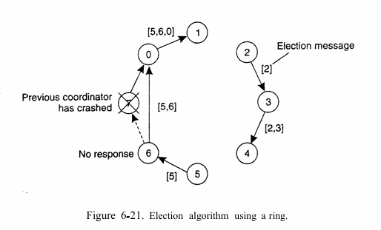
A: When a process receives an ELECTION message, it checks to see who started it. If it itself started it (i.e., its number is at the head of the list), it turns the message into a COORDINATOR message as described in the text. If it did not start any ELECTION message, it adds its process number and forwards it along the ring. However, if it did send its own ELECTION message earlier and it has just discovered a competitor, it compares the originator's process number with its own. If the other process has a lower number, it discards the message instead of passing it on. If the competitor is higher, the message is forwarded in the usual way. In this way, if multiple ELECTION messages are started, the one whose first entry is highest survives. The rest are killed off along the route.

Módulo 14: Sistemas de Arquivos Distribuídos
Referência: Tanenbaum Chapter 11 (DFS) e Chapter 7 (Replication - Quorum) Tópicos das aulas: NFS, Modelo de acesso (Upload/Download vs Acesso remoto), Cache, Replicação (Quorum).
Chapter 11, Question 2
Q: Explain whether or not NFS is to be considered a distributed file system.
A: One can argue that it is not a file system, but merely a protocol that allows local file systems to become accessible to remote clients. In fact, most of the actual file system functionality is not implemented by NFS. Instead, it relies on the Virtual File System interface available in most operating systems.
Chapter 11, Question 10
Q: Taking into account cache coherence as discussed in Chap. 7, which kind of cache-coherence protocol does NFS implement?
A: Because multiple write operations can take place before cached data is flushed to the server, NFS clients implement a write-back cache.
Chapter 11, Question 11
Q: Does NFS implement entry consistency?
A: Yes. Because share reservations and file locking are associated with specific files, and because a client is forced to revalidate a file when opening it and flush it back to the server when closing it, it can be argued that NFS implements entry consistency.
Chapter 11, Question 12 (Modelos de Acesso)
Q: We stated that NFS implements the remote access model to file handling. It can be argued that it also supports the upload/download model. Explain why.
A: Because a server can delegate a file to a client, it can effectively support whole-file caching and putting that client in charge of further handling of the file. This model comes close to uploading a file to a client and downloading it later when when the client is finished.
Chapter 7, Question 20 (Replicação/Quorum) Esta questão está no capítulo 7 (Replicação), mas refere-se diretamente ao "Método do Quorum" discutido no slide 17 do Módulo 14.
Q: A file is replicated on 10 servers. List all the combinations of read quorum and write quorum that are permitted by the voting algorithm.
A: The following possibilities of (read quorum, write quorum) are legal: (1, 10), (2, 9), (3, 8), (4, 7), (5, 6), (6, 5), (7, 4), (8, 3), (9, 2), and (10, 1).

