Kynning
Við fórum í það að hreinsa og laga kóðann til að hægt væri að nota fjarstýringuna til að stoppa og starta mismunandi verkefnum.
Hvert og eitt verkefni annarinnar var gefið takka á fjarstýringunni.
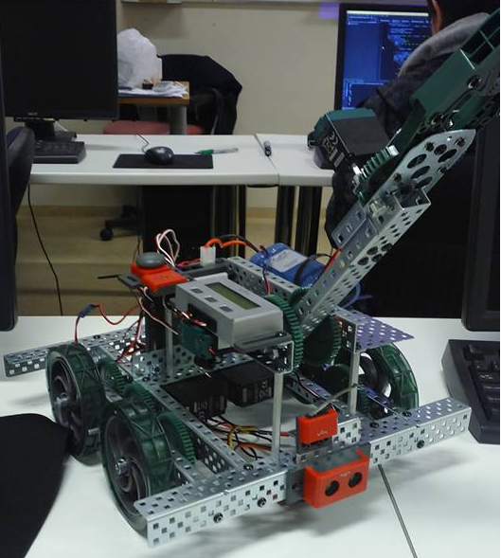

Flæðiritið

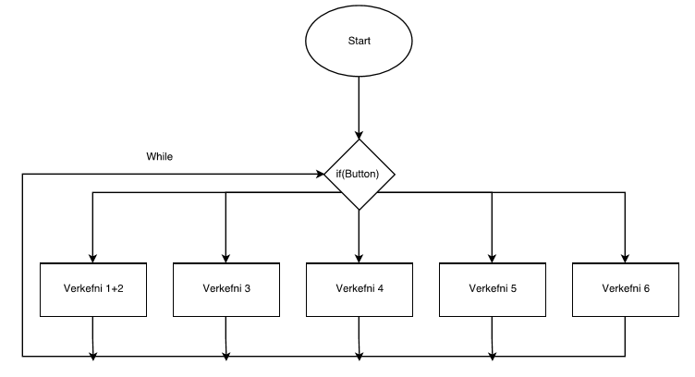
Lokaverkefni:
#pragma config(Sensor, in1, lineFollowerLEFT, sensorLineFollower)
#pragma config(Sensor, in2, lineFollowerRIGHT, sensorLineFollower)
#pragma config(Sensor, in3, lineFollowerCENTER, sensorLineFollower)
#pragma config(Sensor, in5, lightSensor, sensorReflection)
#pragma config(Sensor, dgtl6, sonarSensor, sensorSONAR_cm)
#pragma config(Motor, port1, rightMotor, tmotorVex393, openLoop, reversed)
#pragma config(Motor, port2, armMotor, tmotorVex269, openLoop)
#pragma config(Motor, port4, clawMotor, tmotorVex269, openLoop)
#pragma config(Motor, port10, leftMotor, tmotorVex393, openLoop)
//*!!Code automatically generated by 'ROBOTC' configuration wizard !!*//

/*----------------------------------------------------------------------------------------------------*\
|* - Triple Sensor Line Tracking - *|
|* ROBOTC on VEX 2.0 CORTEX *|
|* *|
|* This program switches between multiple tasks by assis *|
|* *|
|* *|
*|
|* *|
|* MOTORS & SENSORS: *|
|* [I/O Port] [Name] [Type] [Description] *|
|* Motor - Port 1 rightMotor VEX 3-wire module Right side motor *|
|* Motor - Port 10 leftMotor VEX 3-wire module Left side motor *|
|* Analog - Port 2 lineFollowerRIGHT VEX Light Sensor Front-right, facing down *|
|* Analog - Port 3 lineFollowerCENTER VEX Light Sensor Front-center, facing down *|
|* Analog - Port 1 lineFollowerLEFT VEX Light Sensor Front-left, facing down *|
|* Digital - Port 1 sonarSensor Vex Sonic Sensor Distance detector *|
\*-----------------------------------------------------------------------------------------------4246-*/

//+++++++++++++++++++++++++++++++++++++++++++++| MAIN |+++++++++++++++++++++++++++++++++++++++++++++++

void stopMotors(int waitTime)
{
motor(rightMotor) = 0;
motor(leftMotor) = 0;
motor(armMotor) = 0;
motor(clawMotor) = 0;
wait1Msec(waitTime);
}

void clawOpen()
{
motor(clawMotor) = -127;
wait1Msec(3000);
}

void armDown()
{
motor(armMotor) = -64;
wait1Msec(1000);
}

void drive()
{
motor(leftMotor) = 40;
motor(rightMotor) = 40;
wait1Msec(1000);
}

void clawClose()
{
motor(clawMotor) = 127;
wait1Msec(1000);
}

void armUp()
{
motor(armMotor) = 64;
wait1Msec(500);
}

void turn180()
{
motor(rightMotor) = 67;
motor(leftMotor) = -67;
wait1Msec(500);
}

#include "verk1.h"
#include "verk2.h"
#include "verk3.h"
#include "verk4.h"
#include "verk5.h"

task main()
{
while(true)
{
if(vexRT[Btn7L] == 1)
{
beeptest();
}

if(vexRT[Btn7R] == 1)
{
verk2();
}

if(vexRT[Btn7D] == 1)
{
verk3();
}

if(vexRT[Btn7U] == 1)
{
verk4();
}

if(vexRT[Btn8R] == 1)
{
verk5();
}
}
}
Verkefni 1&2:
void beeptest()
{
for (int i = 1; i < 3; i++)
{
motor[rightMotor] = 127; // Motor on port2 is run at full (127) power forward
motor[leftMotor] = 127; // Motor on port3 is run at full (127) power forward
wait1Msec(700 * i);
motor[rightMotor] = -127; // Motor on port2 is run at full (127) power forward
motor[leftMotor] = -127; // Motor on port3 is run at full (127) power forward
wait1Msec(700 * i);
}
}
Verkefni 3:
void verk2()
{
while((SensorValue(sonarSensor) > 20 || SensorValue(sonarSensor) == -1) && vexRT[Btn8L] == 0)
{
motor[leftMotor] = (vexRT[Ch2] + vexRT[Ch4])/2; // (y + x)/2
motor[rightMotor] = (vexRT[Ch2] - vexRT[Ch4])/2; // (y - x)/2

if(vexRT[Btn6U] == 1)//Makes arm go forward//
{
motor[armMotor] = -63;
}
else if(vexRT[Btn6D] == 1)//Makes arm go backwards//
{
motor[armMotor] = 63;
}

if(vexRT[Btn5U] == 1) //Makes claw open//
{
motor[clawMotor] = -63;
}
else if(vexRT[Btn5D] == 1)//Makes claw close//
{
motor[clawMotor] = 63;
}

else
{
motor[armMotor] = 0;//Makes arm stop when not pressing button//
motor[clawMotor] = 0;//Makes claw stop when not pressing button//
}

if(vexRT[Btn8R])//Brakes by stopping motors//
{
motor[rightMotor] = 0;
motor[leftMotor] = 0;
}
}
}
Verkefni 4:
void verk3()
{
wait1Msec(2000); // Robot waits for 2000 milliseconds before executing program
while(SensorValue(lightSensor) < 200 && vexRT[Btn8L] == 0)
{
if(SensorValue(sonarSensor) > 20 || SensorValue(sonarSensor) == -1) // Loop while robot's Ultrasonic sensor is further than 20 inches away from an object
{ // || (or) it is '-1'. (-1 is the value returned when nothing is in it's visable range)
motor[rightMotor] = 63; // Motor on port2 is run at half (63) power forward
motor[leftMotor] = 63; // Motor on port3 is run at half (63) power forward
}
else if(SensorValue(sonarSensor) < 20)
{
motor[rightMotor] = 0;
motor[leftMotor] = 0;

motor[rightMotor] = 63; // Motor on port2 is run at half (63) power forward
motor[leftMotor] = -63;
wait1Msec(750);
}
}
}
Verkefni 5:
void verk4()
{
clawClose();
armUp();
wait1Msec(2000); // The program waits for 2000 milliseconds before continuing.

int threshold = 2400; /* found by taking a reading on both DARK and LIGHT */
/* surfaces, adding them together, then dividing by 2. */

while(SensorValue(sonarSensor) >= 30 && vexRT[Btn8L] == 0)
{
// - - - - - - - - - - - - - - - - - - - - - - - - - - - - - - - - - -+
displayLCDCenteredString(0, "LEFT CNTR RGHT"); // Display |
displayLCDPos(1,0); // Sensor |
displayNextLCDNumber(SensorValue(lineFollowerLEFT)); // Readings |
displayLCDPos(1,6); // to LCD. |
displayNextLCDNumber(SensorValue(lineFollowerCENTER)); // |
displayLCDPos(1,12); // L C R |
displayNextLCDNumber(SensorValue(lineFollowerRIGHT)); // x x x |
// - - - - - - - - - - - - - - - - - - - - - - - - - - - - - - - - - -+

// RIGHT sensor sees dark:
if(SensorValue(lineFollowerRIGHT) > threshold)
{
// counter-steer right:
motor[leftMotor] = 67;
motor[rightMotor] = 0;
}
// CENTER sensor sees dark:
if(SensorValue(lineFollowerCENTER) > threshold)
{
// go straight
motor[leftMotor] = 67;
motor[rightMotor] = 67;
}
// LEFT sensor sees dark:
if(SensorValue(lineFollowerLEFT) > threshold)
{
// counter-steer left:
motor[leftMotor] = 0;
motor[rightMotor] = 67;
}
if(SensorValue(sonarSensor) <= 30)
{
stopMotors(1000);
clawOpen();
armDown();
drive();
stopMotors(3000);
clawClose();
armUp();
}
}
}
Verkefni 6:
void verk5()
{
while(vexRT[Btn8L] == 0)
{
clawClose();
armUp();
wait1Msec(2000); // The program waits for 2000 milliseconds before continuing.

int threshold = 2400; /* found by taking a reading on both DARK and LIGHT */
/* surfaces, adding them together, then dividing by 2. */

for(int i = 1; i <= 2;)
{
while(true)
{
// - - - - - - - - - - - - - - - - - - - - - - - - - - - - - - - - - -+
displayLCDCenteredString(0, "LEFT CNTR RGHT"); // Display |
displayLCDPos(1,0); // Sensor |
displayNextLCDNumber(SensorValue(lineFollowerLEFT)); // Readings |
displayLCDPos(1,6); // to LCD. |
displayNextLCDNumber(SensorValue(lineFollowerCENTER)); // |
displayLCDPos(1,12); // L C R |
displayNextLCDNumber(SensorValue(lineFollowerRIGHT)); // x x x |
// - - - - - - - - - - - - - - - - - - - - - - - - - - - - - - - - - -+

// RIGHT sensor sees dark:
if(SensorValue(lineFollowerRIGHT) > threshold)
{
// counter-steer right:
motor[leftMotor] = 67;
motor[rightMotor] = 0;
}
// CENTER sensor sees dark:
if(SensorValue(lineFollowerCENTER) > threshold)
{
// go straight
motor[leftMotor] = 67;
motor[rightMotor] = 67;
}
// LEFT sensor sees dark:
if(SensorValue(lineFollowerLEFT) > threshold)
{
// counter-steer left:
motor[leftMotor] = 0;
motor[rightMotor] = 67;
}
if(i == 1)
{
i++;
if(SensorValue(sonarSensor) <= 30)
{
stopMotors(1000);
clawOpen();
armDown();
drive();
stopMotors(3000);
clawClose();
armUp();
turn180();
}
}

if(i == 2)
{
if(SensorValue(sonarSensor) <= 10)
{
stopMotors(1000);
clawOpen();
armDown();
drive();
stopMotors(3000);
clawClose();
armUp();
turn180();
}
}
}
}
}
}

VEX ARM® Cortex®-based Microcontroller
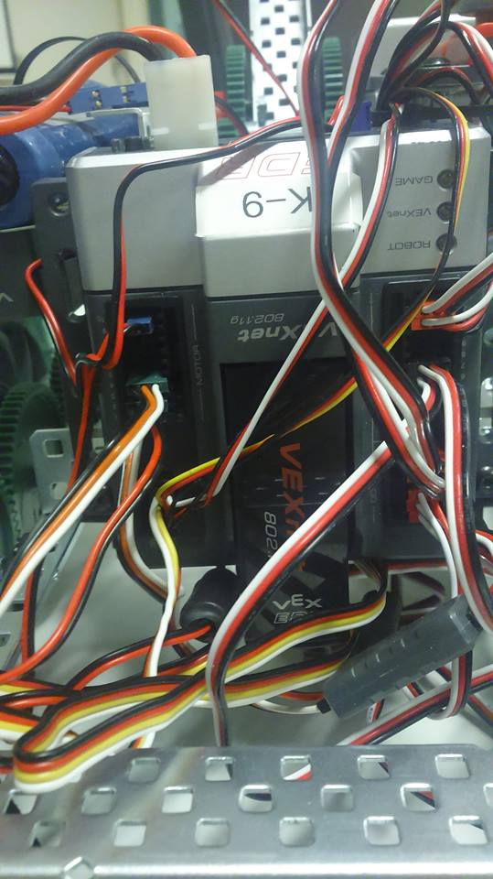
Master tölva sem sér um að vinna úr kóðanum til allra componenta.
Battery Specs:
- Voltage - 7.2 volts nominal, 5 to 12 volts min/max
- Type - Six AA batteries or 7.2V Robot Battery
- Current - 150mA for Controller & Receiver plus Motors, Servos & VEXnet
STMicroelectronics ARM® Cortex® M3 Specs:
- Speed - 90 MIPS (Million Instructions Per Second)
- RAM - 64KB
- Flash - 384KB program space
Size & Weight:
- Dimensions - 4.5" W x 3.9" L x 1" H
- Weight - 0.302 lbs (137 grams)

I/O Ports
- (8) 3-wire Motor Outputs
  - Usage: For 3-wire VEX motors, Motor Controller 29s or servos
  - Type: Hobby standard PWM
  - Refresh: Every 18.5 mSec
- (2) 2-wire Motor Outputs
  - Usage: For 2-wire VEX motors
  - Type: H-Bridge
  - Refresh: Every 1 mSec
- (1) I2C "Smart Sensor" Port
  - Usage: Future I2C Products
  - 0 to 3.3v logic I/O
  - Data rate, word width, etc set by compiler
  - See Cortex Pin-out for wiring details
- (2) UART Serial Ports
  - Usage: VEX LCD Module
  - 0 to 3.3v logic I/O, 5V tolerant
  - Data rate, word width, etc set by compiler
  - Factory default: 19.2 kbaud, 8 data bits, no parity, talks with VEX LCD.
  - See Cortex Pin-out for wiring details
- (8) 12-bit Analog Inputs
  - Analog In: 12-bit resolution. 10 μSec access time.
- (12) Fast Digital I/O (can be used as interrupts)
  - Digital In: 150 kHz input frequency.
- (1) DAC Speaker Output
  - Usage: Output sound, voice, and music to an external speaker.
- (2) Rx1 & Rx2
  - Connects to 75 MHz receivers
  - Pin 1 - Power +5 volts (the right most pin when looking at the front connector on the VEX Controller)
  - Pin 2 - Receiver
  - Pin 3 - Gnd
  - Pin 4 - Tether Detect (the left most pin when looking at the front connector on the VEX Controller)

I/O port Specification

Analog Input Impedance: The 8 analog inputs each consist of a 470K pull-up to +5V, a series resistance of 10K and a 20K pull-down resistance to the uP
Analog characteristics:
- 3 dB bandwidth of 16 kHz
- Analog input range: 0.0 v to 5.0 v
- Tolerant of -0.5v to +5.5v
- Only configurable as analog inputs
Digital Input Impedance: The 12 digital inputs each consist of a 1K series resistance and a weak processor pull-up to +3.3V. Each Digital Input can also be configured as a Digital Output
Interrupts: All digital inputs can be configured as interrupts except for Digital 10
Digital characteristics:
- 3 dB bandwidth of 150 kHz
- Needs 0.0 to 0.6 volts for a low and 2.5 to 5.0 volts for a high
- Tolerant of -0.5v to +5.5v
- Can drive a 1 mA load to 1.6v or lower or a low and 1.4 volts or higher for a high
- All digital lines can be configured as inputs or outputs
SP characteristic:
- SP Output: A Digital-to-Analog (DAC) output when configured by compiler
- Drive primarily limited by 5K processor resistance
- Output swing into open load is 0.2v to 3.1v, typical
PWM Outputs:
- These 8 ports can drive an open circuit to 0.6v or lower for a low and 2.4 volts or higher for a high
- They can drive a 1 mA load to 1.0v or lower for a low and 2.4 volts or higher for a high
Pinout:
- Digital, Analog, PWM Outputs: Outside pin (closest to the controller edge) Ground
- Digital, Analog Outputs: Center pin (or middle pin) + 5 Volts, 1 Amp Max combined total from all pins
- PWM Outputs: Center pin (or middle pin) + Battery Power, 4 Amps Max combined total from all pins for Motors 2 - 5 and 4 amps combined for Motors 6 - 9
- Digital, Analog, PWM Outputs: Inside pin (furt.hest from the controller edge) Signal / Control line
2-Wire Motor Outputs:
- Two pins each for Motor 1 and for Motor 10
- Motor 1 shares 4 amp max with Motors 2 - 5
- Motor 10 shares 4 amp max with Motors 6 - 9

Bumper Switch 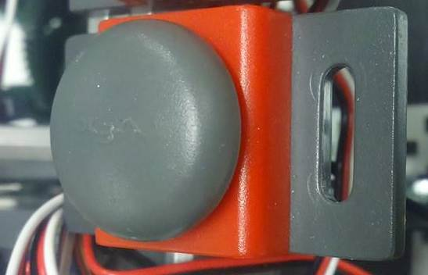
Basic rofi sem getur drepið á eða breytt skipunum þegar ítt er á hann mjög þægilegur sem killswitch.
Bumper Switch Sensor: The bumper sensor is a physical switch. It tells the robot whether the bumper on the front of the sensor is being pushed in or not.
Benefits:The bumper switch can help the robot avoid dangerous collision automatically.
Switch Info: SPST switch (“Single Pole, Single Throw”) configured for Normally Open behavior.
Switch Connection: Wired to normally open (OFF)
Signal Behavior: When the switch is not being pushed in, the sensor maintains a digital HIGH signal on its sensor port. This High signal is coming from the Microcontroller. When an external force (like a collision or being pressed up against a wall) pushes the switch in, it changes its signal to a digital LOW until the switch is released. An unpressed switch is indistinguishable from an open port.
Range Limits: Forces less than a pound can trigger the bumper switch (5.06 oz typical).

Claw

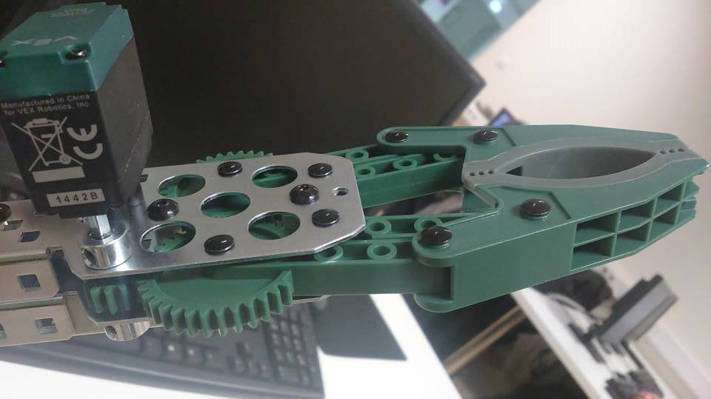

Kló notuð til að grípa hluti.
With the VEX Robotics Claw Kit, your robot can easily grab and manipulate various objects. Motor required and not included.
- Strong enough to hold a 12 oz soda can.
- Dexterous enough to grab a feather.
- Comes partially assembled.
- Compatible with all VEX Mechanical Parts.

Weight: 0.400 lbs. (0.1814 kg)
Size: Length 8" x Width 3.125" x Height 1.500"
Limit Switch
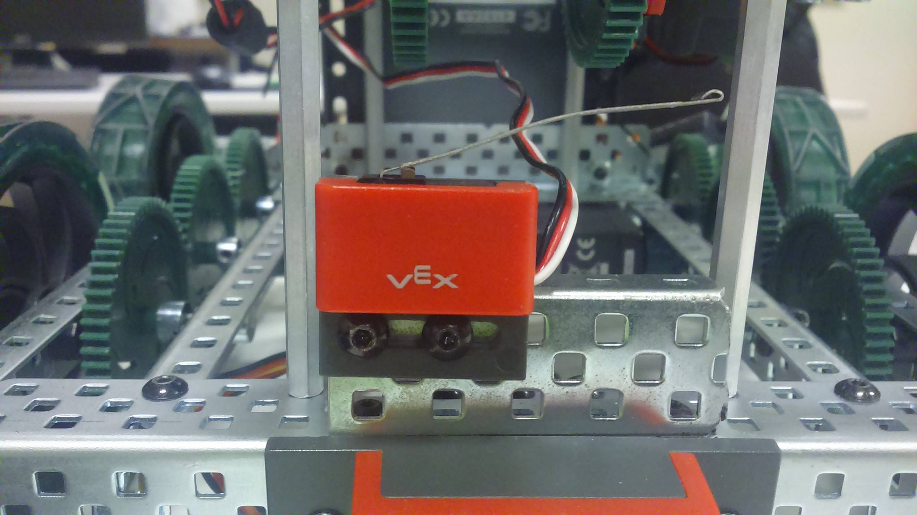
Hann var ekki notaður hjá okkur en var á upprunalegu leiðbeiningum um samsettningu.
These switches are great for signaling when a robot arm has reached the top or bottom of its motion.
- Bendable sheet metal switch "arm" is very versatile
- Useful as a trigger in a variety of applications
- Functionality is pre-programmed in the VEX ARM® Cortex®-based Microcontroller

VEX 2-Wire Motor 269

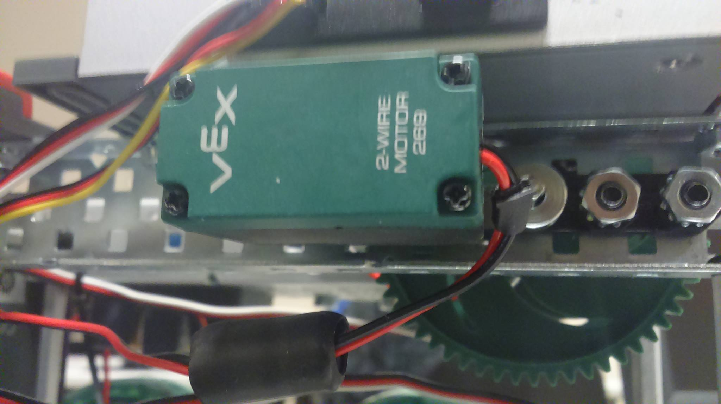
Arm mótorinn okkar notaður við að hreyfa arminn upp og niður annar eins er notaður við að opna og lokak klónni.
Specifications | - Free Speed:100 rpm  - Stall Torque:8.6 in-lbs  - Stall Current:2.6A  - Free Current:0.18A  All motor specifications are at 7.2 volts. Actual motor specifications are within 20% of the values above.

Vex Potentiometer 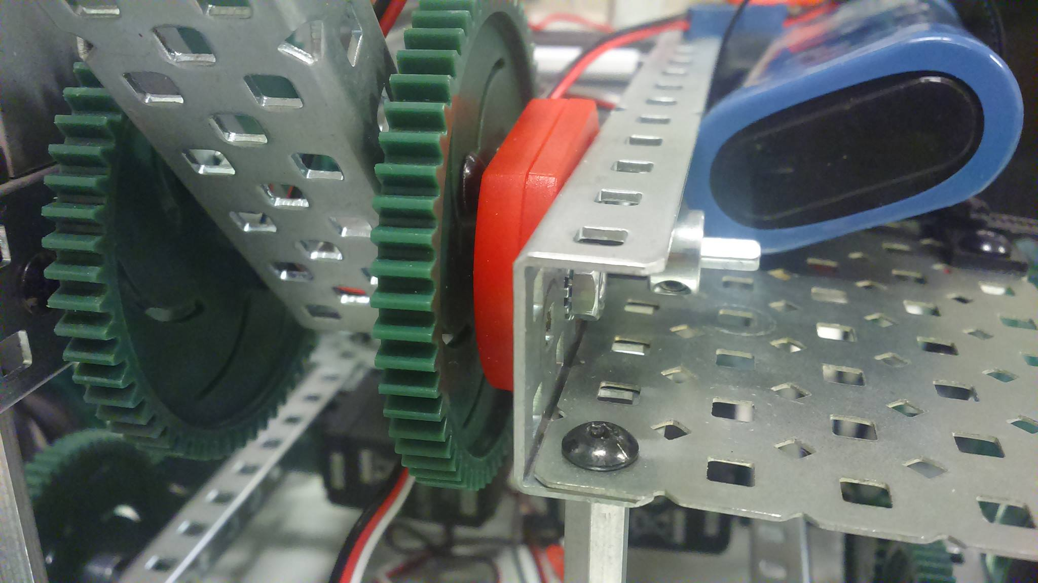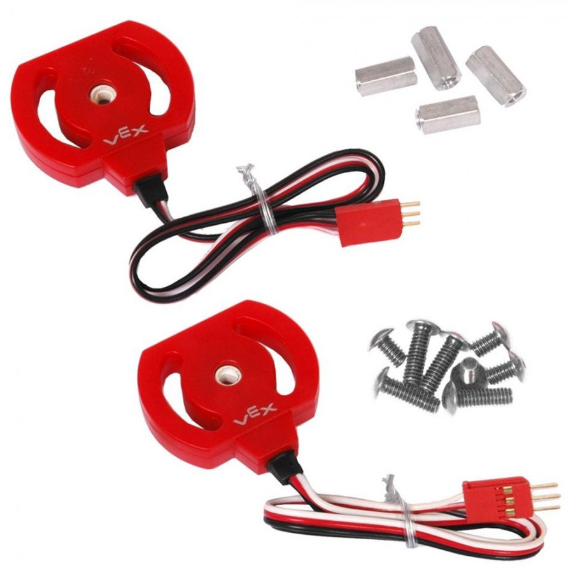

Halla skynjari notaður við að finna stöðu arms til að breyta eða halda honum þar.
With the Potentiometer you can determine both position and direction of rotation. Use this sensor to get an analog measurement of angular position. This measurement can help to understand the position of robot arms or other mechanisms. A Programming Kit is needed to change the program in the VEX Controller to use the Potentiometer.
- Measure Angular Position
- 250-Degrees of Adjustment
- Adjustable mounting angle

Vex Ultrasonic sensor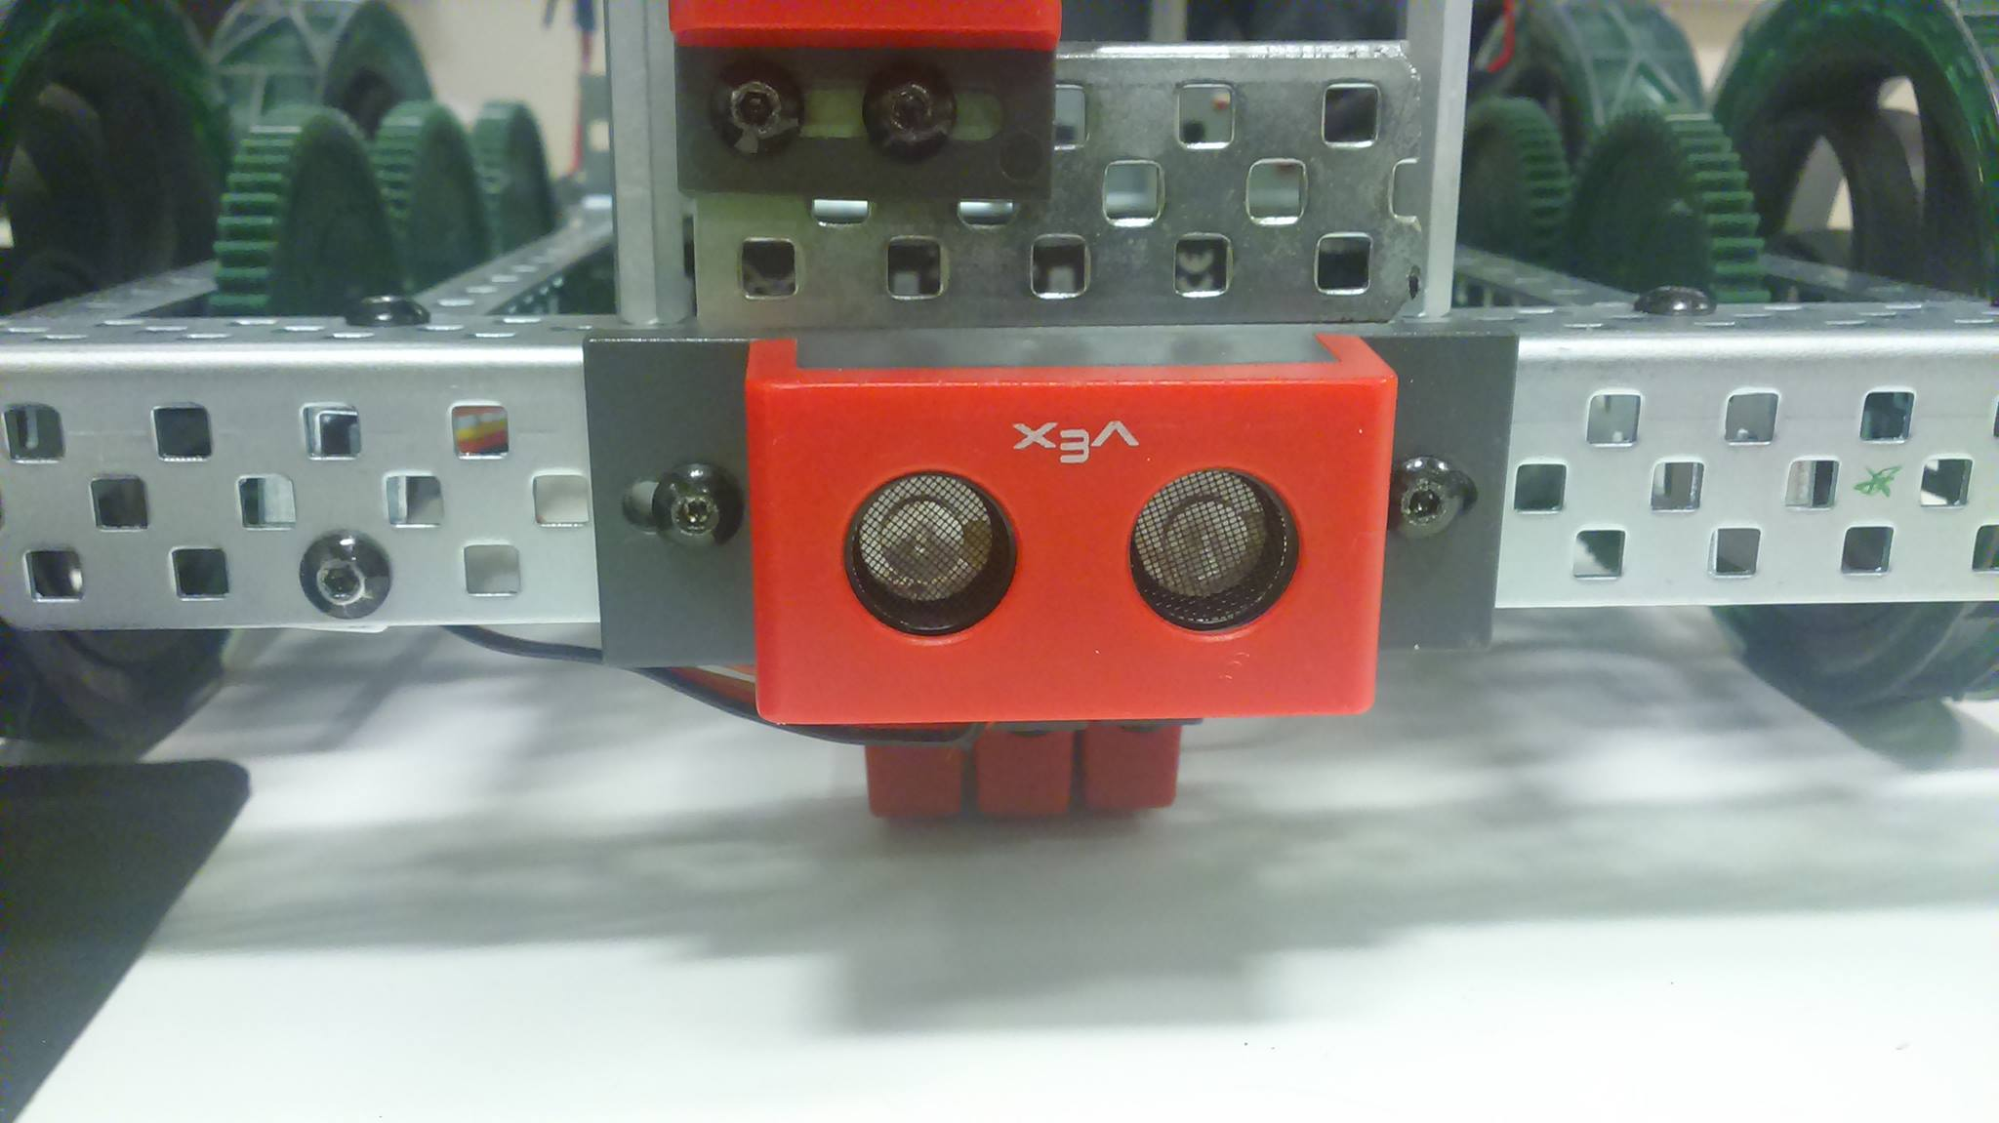

Sonar sensor er notaður til að finna hvort eitthvað sé í návígi við robotinn svo hann geti sem dæmi forðast að klessa á vegg.
Avoid obstacles and measure distances with the ultrasonic range finder. Device emits a high-frequency sound wave that alerts the robot to things in its path. A Programming Kit is needed to change the program in the VEX Controller.
- Measure distances from 1.5in to 115in
- Detect obstacles using high frequency sound waves
- Create more autonomous function
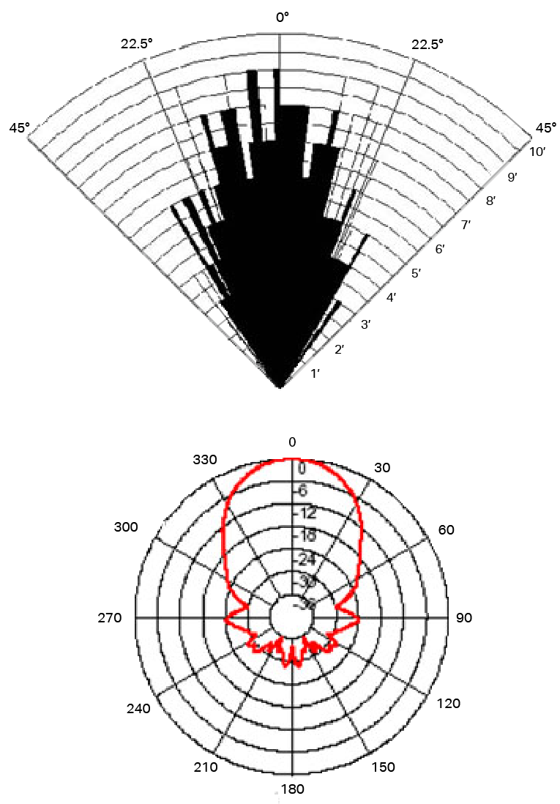
The sensitivity of the sensor depends on the objects’ surfaces that are detected by the emitted sound waves. For example, a reflective surface may produce a different reading than a non-reflective surface. The resolution of the sensor also depends on the sound waves. However, sound waves can reflect or be absorbed and possibly not return with enough power.

- Sensitivity: Detect a 3cm diameter pole at greater than 2m.
- Usable Range: 3.0 centimeters - 3.0 meter / 1.5 inches - 115 inches
- Frequency: 40 KHz
- Resolution: 1 inch

Power pack
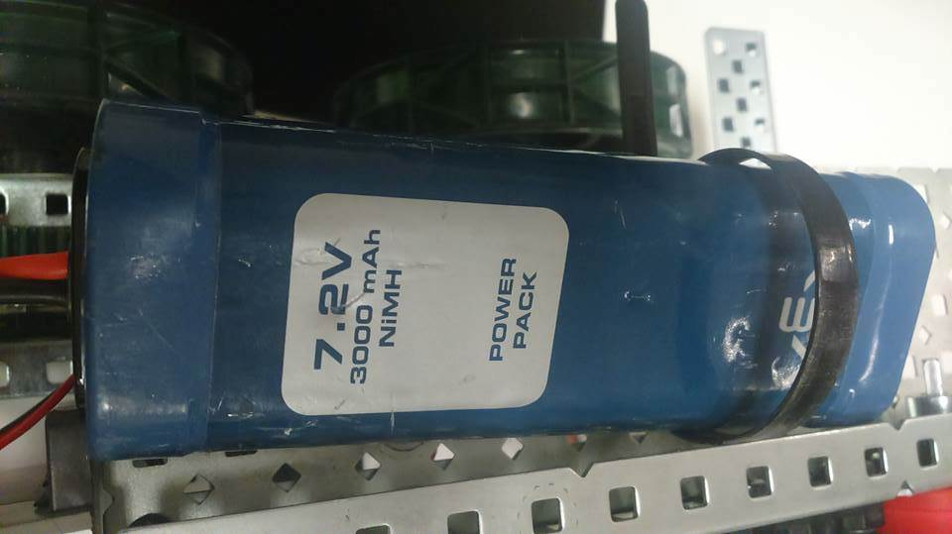
Battery til að keyra allt rafkerfið.

LCD Display
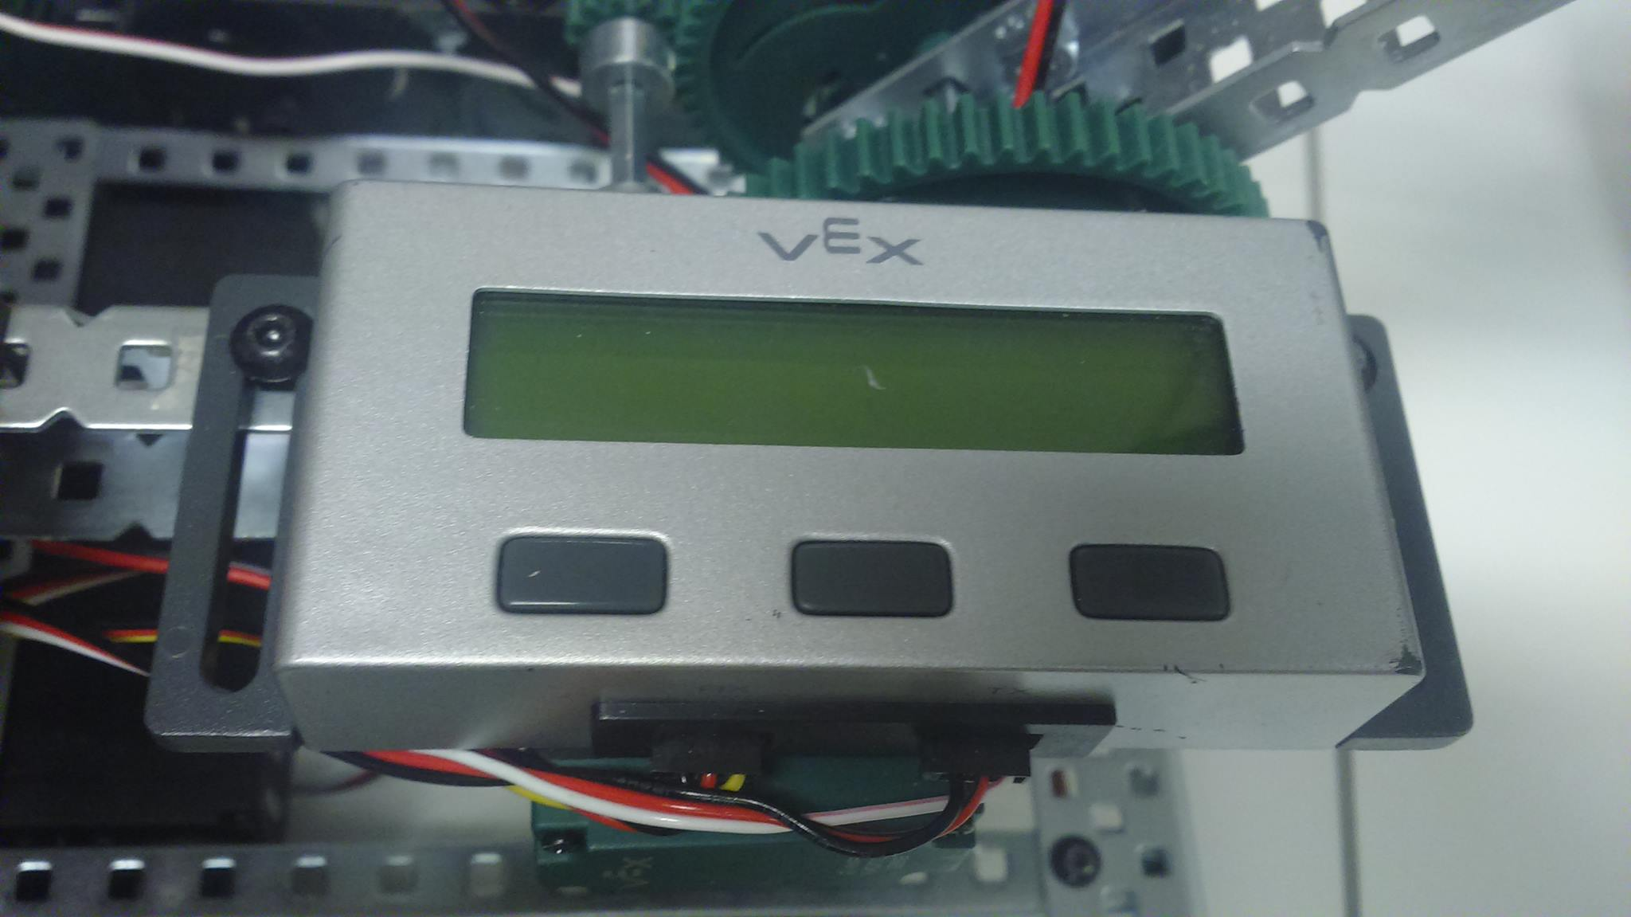
I/O Ports: (1) RX Port & (1) TX Port
Size:
Module: 4.5in W x 1.7in L x 0.8in H
Screen: 2.6in W x 0.63in H, 16 x 2 Character LCD
Character Size: 0.12in W x 0.22in H
Weight: 0.158 lbs
Compatible with:
PIC Microcontroller V0.5: Requires (2) 3-Wire Extension Cables
VEX ARM® Cortex®-based Microcontroller: Requires (1) 4-Wire to dual 3-Wire Cable

Light Sensor 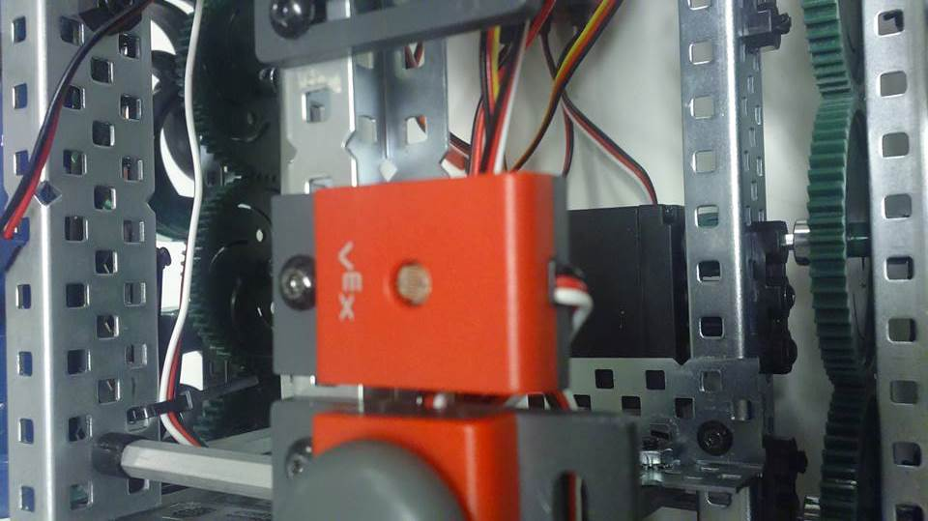
Birtuskynjari sem nemur ljósmagn þar sem hann er þá er sem dæmi hægt að láta robotinn ekki keyra nema það sé kveikt ljós þar sem hann er eða öfugt.
The Light Sensor uses a photocell that allows your robot to detect and react to light. With the light sensor, you can program a whole new range of capabilities to your robot. A Programming Kit is needed to change the program in the VEX Controller.
- Analog input of light levels
- Usable range of 0 to 6 feet
- Find dark or bright areas
- Create more autonomous function

Line Tracker
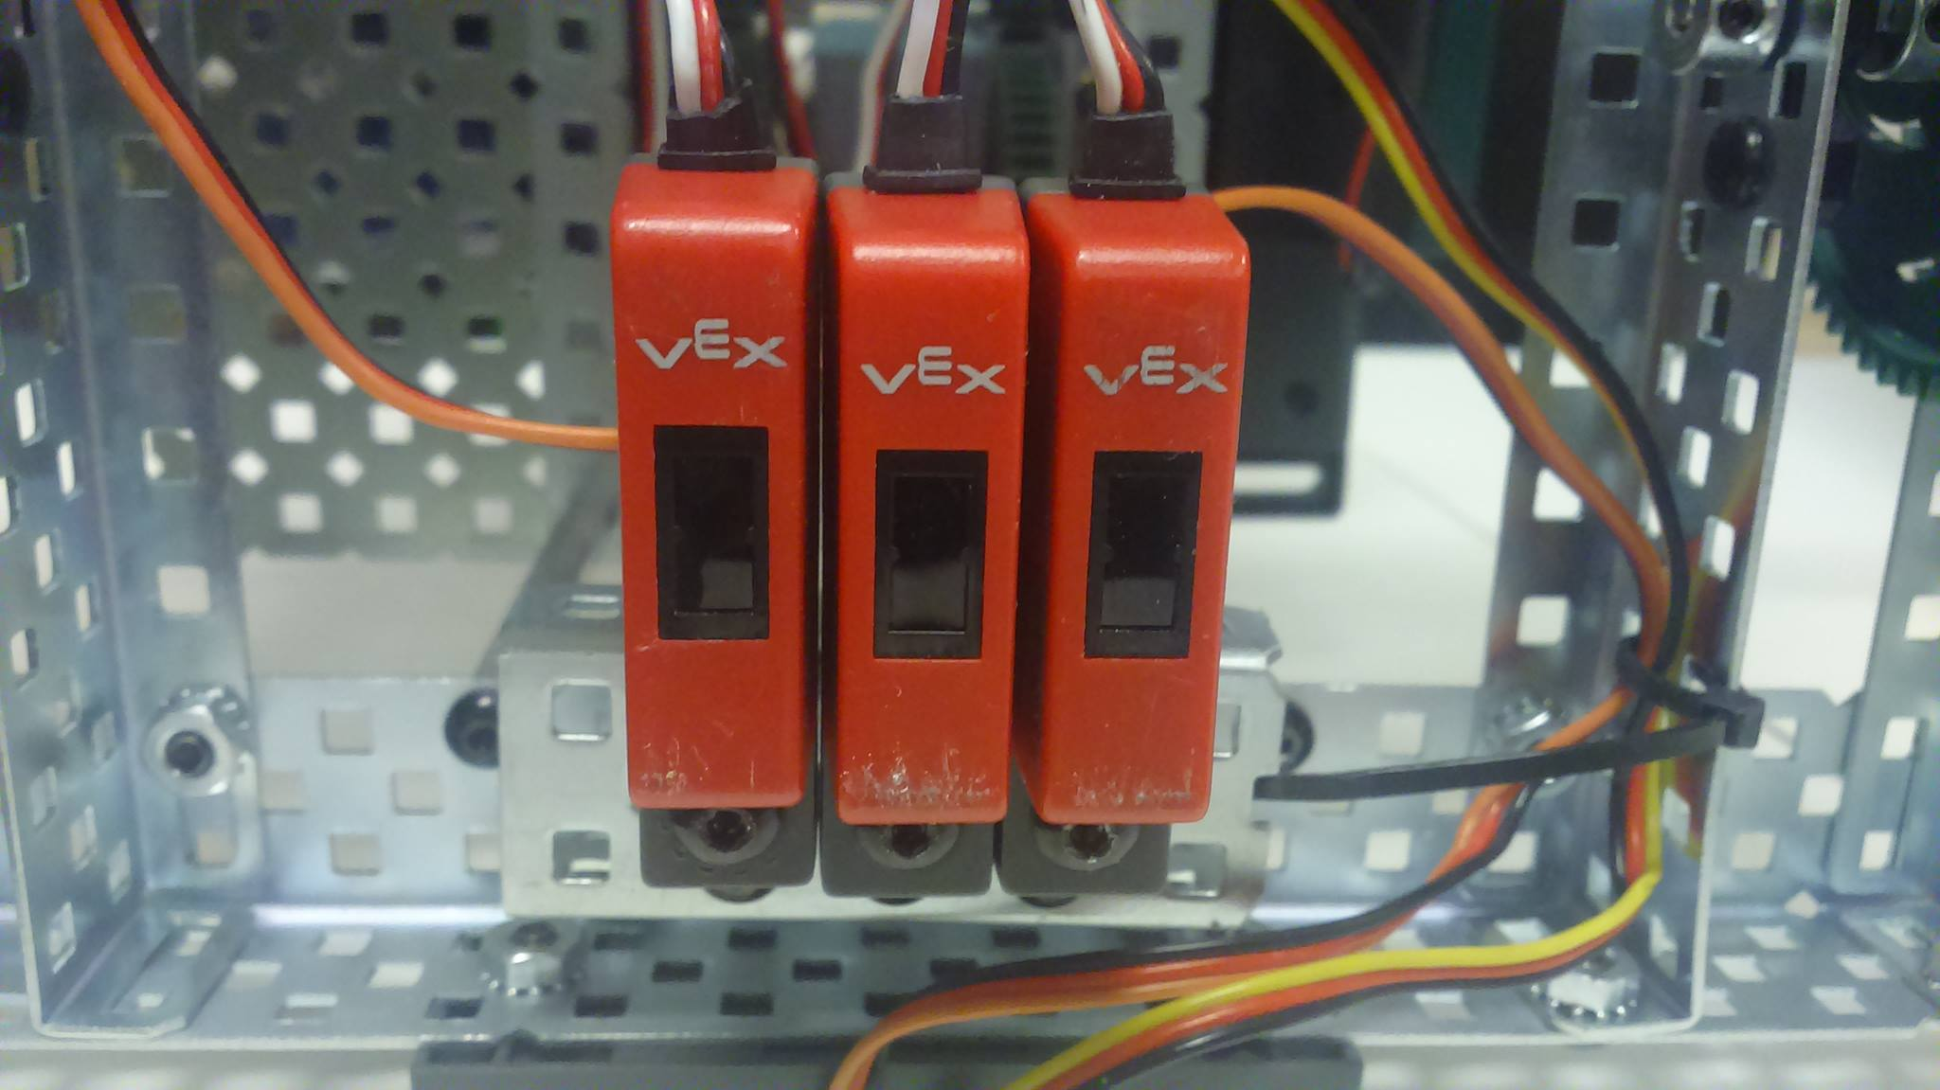
Með þremur er línutrackerum getur hann fylgt eftir línu á jörðinni.
A Line Tracker mostly consists of an infrared light sensor and an infrared LED. It functions by illuminating a surface with infrared light; the sensor then picks up the reflected infrared radiation and, based on its intensity, determines the reflectivity of the surface in question. Lightly colored surfaces will reflect more light than dark surfaces; therefore, lightly colored surfaces will appear brighter to the sensor. This allows the sensor to detect a dark line on a pale surface, or a pale line on a dark surface.
The Line Tracker allows your robot to follow a pre-marked path and allows humans to indirectly control the robot while it is autonomous.
Program your robot to follow a black line over a white surface. This kit provides more design flexibility--you can also use it to program your robot for light sensing. A Programming Kit is needed to change the program in the VEX Controller.
- Navigate down a marked path
- Use for light sensing
- More autonomous function
Sensor Type: Infrared light sensor and infrared LED
Line width: 0.25in minimum; optimal line width is 0.5in
Response Frequency: 50Hz
Light Source: GaAs infrared LED with a peak wavelength of 940nm
Receiver: Si phototransistor with a sensing wavelength of 850nm (max)

VEX 2-Wire Motor 383/393

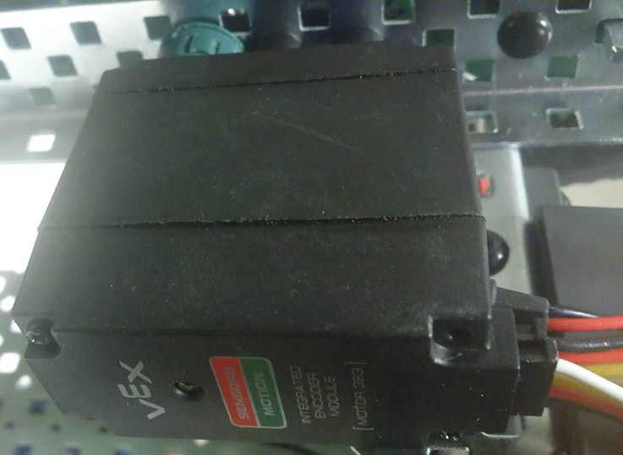
The 2-Wire Motor 393 is the primary actuator used in the VEX EDR. Build rotational mechanisms, drive bases, rotational joints, conveyor belts - anything that spins can be built using the 2-wire Motor 393.
The 2 Wire Motor 393 provides 60% more output power than the standard motor, which allows for more powerful mechanisms and drive bases.
- Strong,
Specifications | 2 Wire Motor 393  - Free Speed:100 rpm (As Shipped)/160 rpm (High Speed Option)  - Stall Torque:1.67 N-m (14.76 in-lbs) (As Shipped)/1.04 N-m (9.2 in-lbs) (High Speed Option)  - Stall Current:4.8A  - Free Current:0.37A
- steel internal gears.
- Can be configured into a "high speed" version.

