**Q1) Pull any image from the docker hub, create its container, and execute it showing the output.**

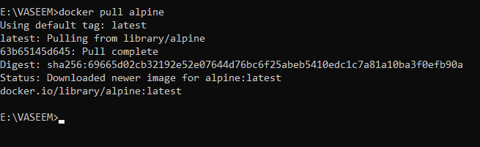

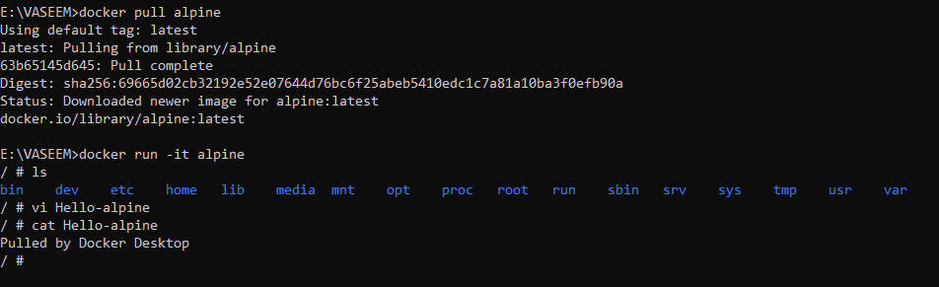

**Q2) Create the basic java application, generate its image with necessary files, and execute it with docker.**

To create a java-app first I have created a folder named java-docker-app and I have added the files Hello.java and Dockerfile

Hello.java contains the content that will display when we run the java-app application and the Dockerfile contains the commands that should be carried out while creating the java-app image. To create the java-app image the following command is used

docker build –t java-app .

At last, to run the java-app I have executed the command

docker run java-app

