Projeto Teste

JavaScript  
Tecnologias WEB

**Submetido por:**

Cesar Ricardo Stati, PR

Fernando Vinicius de Araújo, MG

Gustavo Henrique Da Silva, SP

**Conteúdo**

1. **Introdução 3**
2. **Descrição do projeto e tarefas 3**
   1. Endpoints a serem utilizados 3
   2. Montagem dos computadores 6
   3. Validação dos computadores montados 8
   4. Entrega 8
3. **Ficha de Avaliação Simplificada 9**

# Introduction

Alatech created an API to validate computer assemblies to prevent them from selling machines with incompatibilities between the parts. To make this accessible to users, your task now is to create a client-side rendered website that consumes this API, ie using JavaScript frameworks.

# Project description and tasks

## Endpoints to be used

The types of parts made available by the API and their respective endpoints (relative to /alatech/api) are:

● motherboard: motherboards

● processor: processors

● RAM memory: ram-memories

● storage device: storage-devices

● video card: graphic-cards

● power supply: power-supplies

● machines: machines

You will receive a Postman collection for testing API endpoints.

Your website should present the login screen whenever an unauthenticated user tries to access it. If the credentials are incorrect, the message should be displayed to the user in modal format.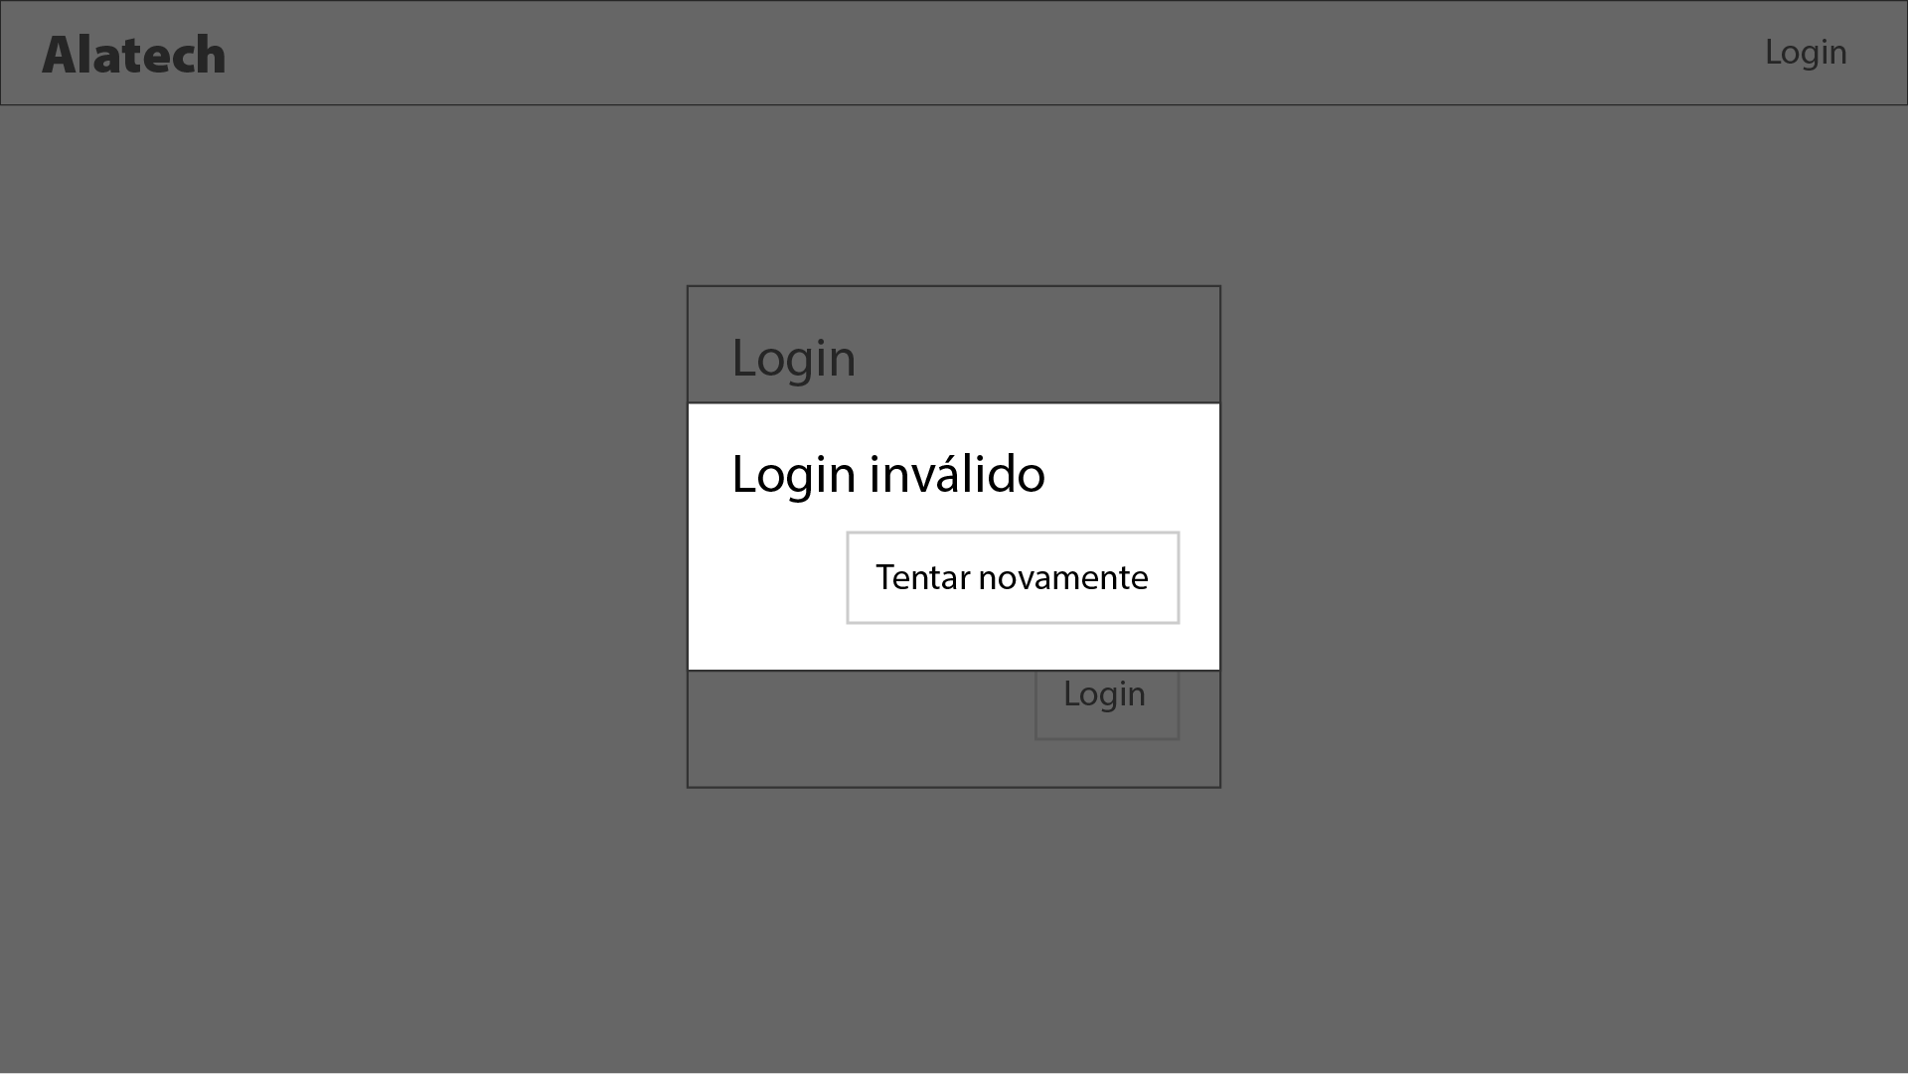

In addition, upon successful login, there should be a listing of endpoint machines, which should be highlighted, and separate parts separated into tabs. There should be a New button when the Machines tab is selected. You can follow the layout proposed below, but feel free to propose the best design.

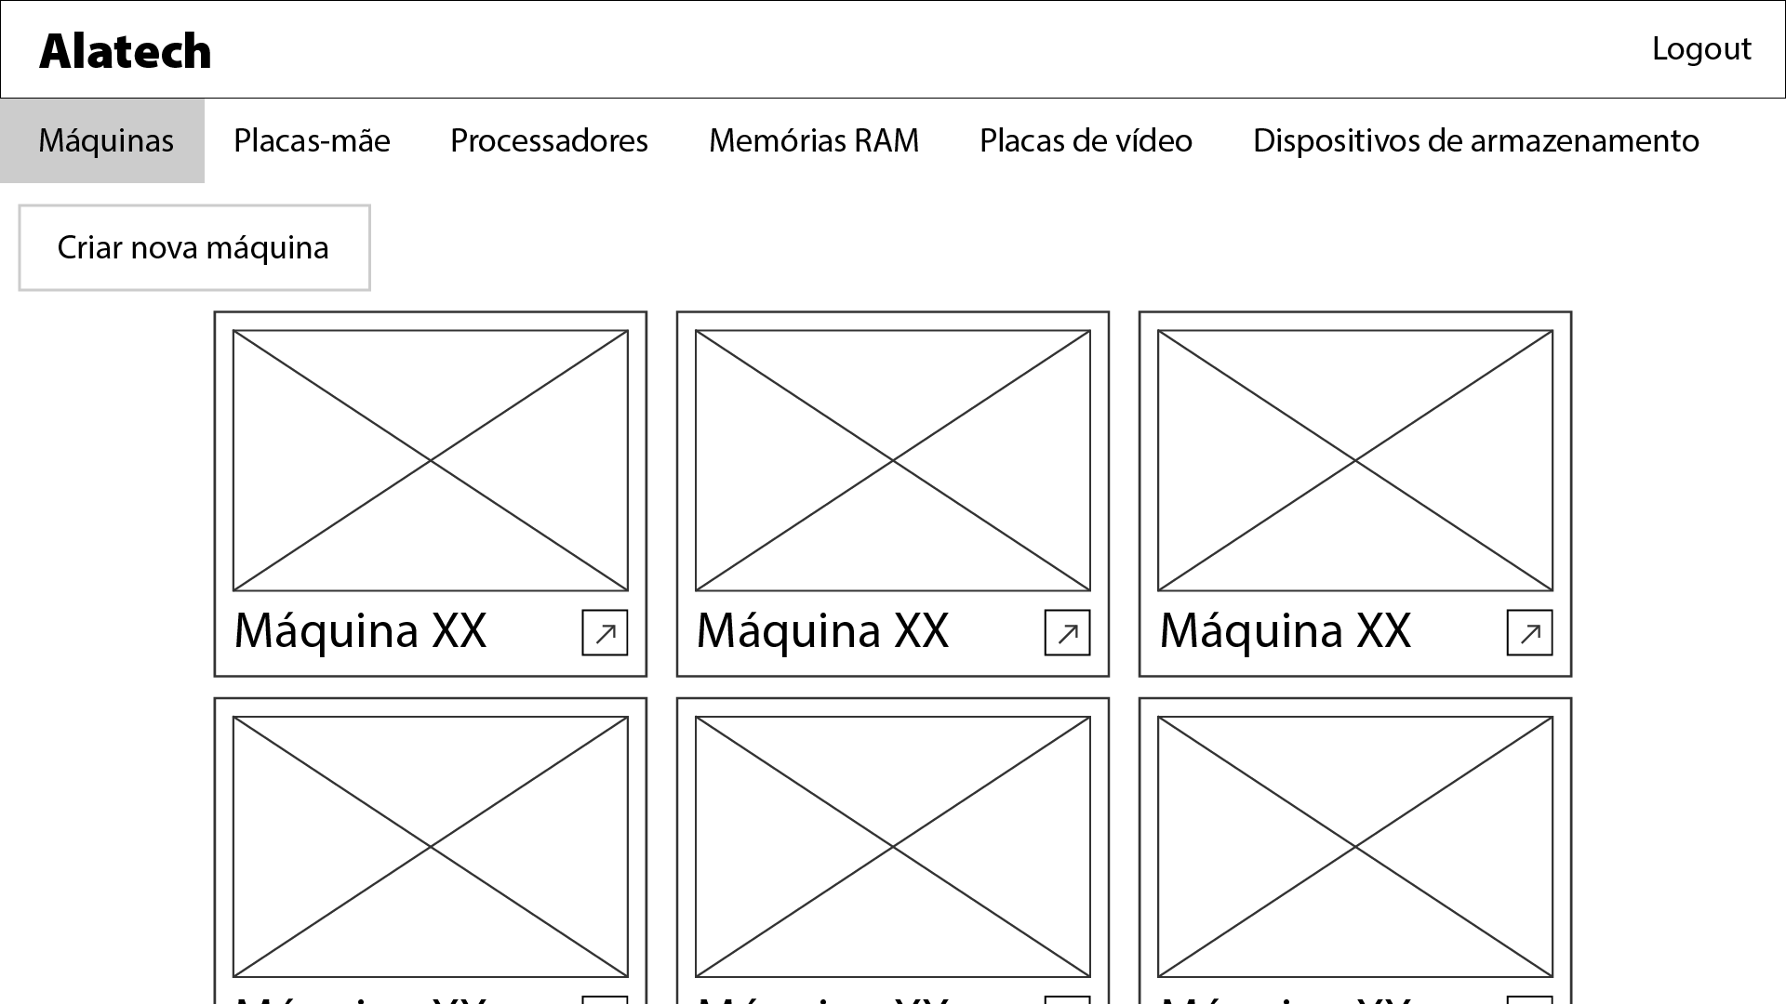

When clicking the New button on the ready machines tab, the screen interface should change and display a listing on the left side of the screen with the types of parts (referred to in the attachment “EndPoints.pdf Attachment”). When selecting a "part type", the parts of the selected type must be presented as follows:

● in the listing (default): only your images and names;

● when holding the mouse over the item: the name and brand should be displayed in a popover or similar next to the image and name.

There must be a part type selected by default.

An example is below: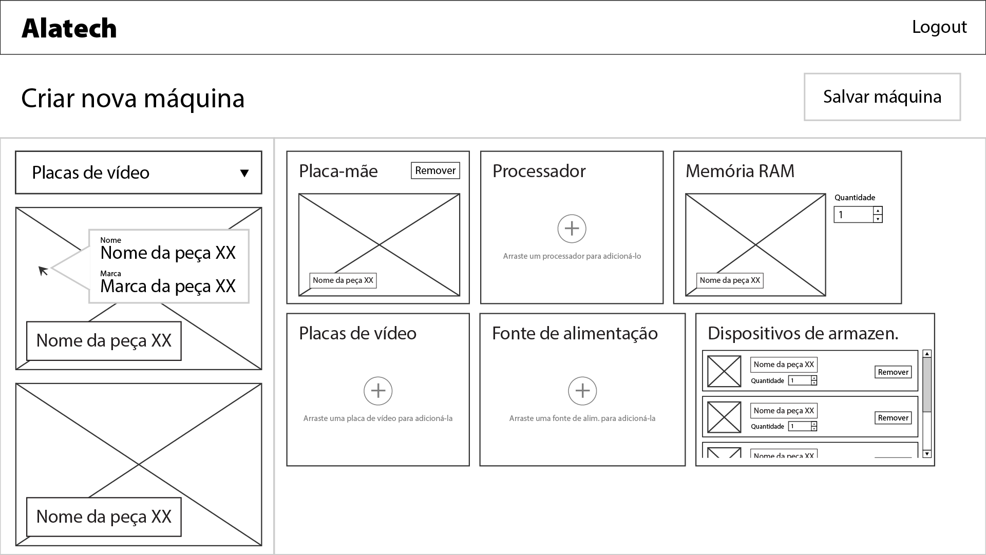

## Computer assembly

Initially the machine assembly will show the parts insertion areas, with no parts placed on it. The only parts that can be put in at this point are power supplies or motherboards, as the other parts depend on them. When the machine has these two pieces, for each new piece placed, the current state of the machine will be revalidated through the API (by the verify-compatibility endpoint).

● POST (verify-compatibility): Check the compatibility between two or more parts, not necessarily an entire machine, however there must always be a motherboard and a power supply:

o Required parameters:

▪ motherboardId: Motherboard ID

▪ powerSupplyId: Power supply ID

o Optional parameters:

▪ processorId: Processor ID

▪ memoryId: RAM memory ID

▪ memoryAmount: amount of RAM memories

▪ storageDevices: array of JSON objects containing:

● id: storage device IDs

● amount: number of devices in this model

▪ graphicCardId: video card ID

▪ graphicCardAmount: number of video cards

the comeback:

▪ 200/OK: whole machine model is valid (does not contain incompatibilities and parts work together).

▪ 400/BAD REQUEST: Part quantities were invalid or mismatches between them were found.

▪ 401/UNAUTHORIZED: If a token is not provided in the Authorization header.

▪ 403/FORBIDDEN: If an invalid token is provided in the Authorization header.

▪ Other: Error must be returned in JSON format.

Inserting parts is done by Drag and Drop from the listing to the machine (in the region corresponding to the part). Finalizing the machine creation process can only be done when there is at least one part of each type on the machine. When the mouse is over the insertion area of ​​one of the pieces, it will be possible to remove that piece by clicking on a “Remove” button that should appear in the upper right corner.

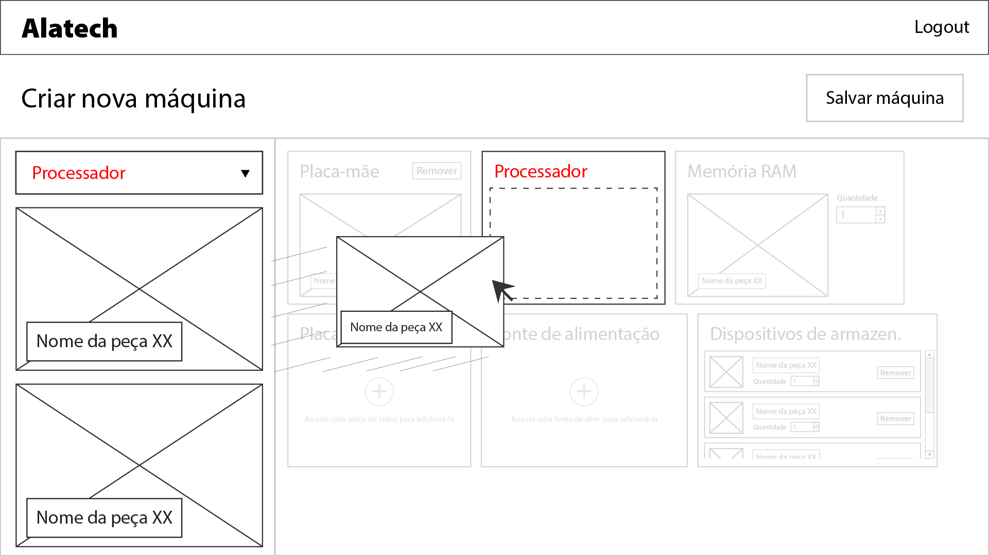

When inserting a new motherboard, all parts must be removed from the computer to avoid incompatibilities and allow the assembly process to be restarted. When any other part is inserted, the part that was in its place must be removed, that is, the part must be replaced.

When a new machine is created, the user must be able to insert an image and this must be sent to the API in base64 format. (See endpoint definition for creating machines)

## Validation of assembled computers

If the API identifies any incompatibility in the machine, the last part moved must have a shake effect and be removed in a transitional way until the listing, in addition to having a red filter and maximum opacity of 60% (to show the user that this was a “invalid movement”). The image shown below exemplifies the insertion process of a given incompatible part to the machine, always respecting the API validation.

When inserting a storage device already present in the machine, this movement must be considered invalid and the error effect described above must be applied.

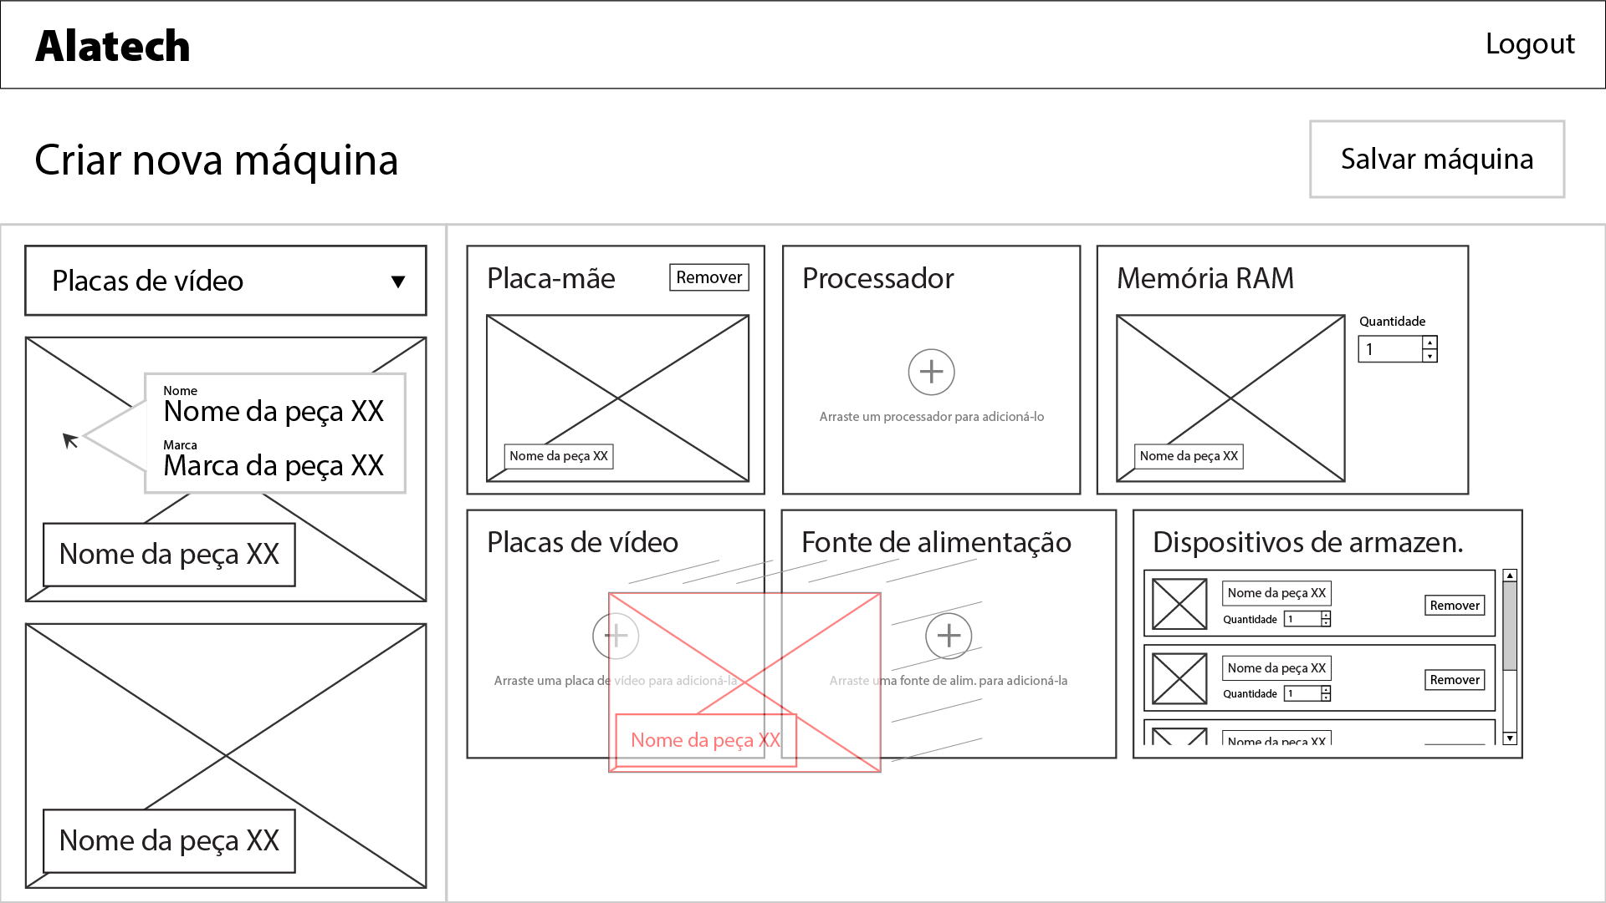

## Delivery

You must deliver a functional website accessible via the server and at the URL /XX/alatech/ (it is your responsibility to provide the host address and port. XX corresponds to the abbreviation of your delegation)

**Simplified Evaluation Sheet**

|  |  |  |  |  |
| --- | --- | --- | --- | --- |
| SECTION | CRITERION | JUDG. MARKS | MEAS. MARKS | TOTAL |
| A | Work Organization and Management | 2,00 | - | 2,00 |
| B | Interpersonal skills and abilities | 2,00 | - | 2,00 |
| C | User Interface Design | 5,00 | - | 5,00 |
| D | User Interface Layout | 3,00 | - | 3,00 |
| E | Client Side Development | - | 10,00 | 10,00 |
| Total | | 12,00 | 10,00 | **22,00** |