HR Attrition Analysis Project Documentation
Executive Summary
This project presents a comprehensive Exploratory Data Analysis (EDA) on employee attrition using the IBM HR Analytics dataset. The objective is to identify the key factors influencing employee turnover and provide actionable insights to improve employee retention.
Total Employees Analyzed: 1,470 Attrition Rate: 16.12% (237 employees left)
1. Business Problem
High employee attrition leads to:
- Increased recruitment and training costs
- Loss of institutional knowledge
- Reduced team productivity
- Negative impact on company culture
Goal: Understand why employees leave and which segments are at highest risk.
2. Dataset Overview
- Source: IBM HR Employee Attrition Dataset
- Number of Records: 1,470
- Number of Features: 35
- Target Variable: Attrition (Yes/No)
Key Features:
- Demographics: Age, Gender, MaritalStatus
- Compensation: MonthlyIncome, PercentSalaryHike
- Job Related: Department, JobRole, JobSatisfaction, OverTime
- Personal: DistanceFromHome, WorkLifeBalance, YearsAtCompany
3. Data Cleaning & Preparation
- Removed redundant columns (EmployeeCount, Over18, StandardHours)
- Created binary target column Attrition_Binary
- Verified data types and handled missing values (if any)
- Exported cleaned dataset: cleaned_hr_data.csv

4. Key Insights & Findings
4.1 Overall Attrition
- Attrition Rate: 16.12%
- Employees who left: 237
- Employees who stayed: 1,233
4.2 Department-wise Attrition
Department | Attrition Rate
Sales | ~20.0%
Human Resources | ~19.0%
Research & Development | ~13.8%
4.3 High Impact Factors
1. Overtime (Strongest Predictor)
- Employees working Overtime: 30.4% attrition
- Employees not working Overtime: 10.4% attrition
2. Monthly Income
- Lower income groups show significantly higher attrition
- Clear negative correlation between income and attrition
3. Age Group
- Younger employees (<35 years) have higher attrition rates
4. Job Roles at Risk
- Laboratory Technician
- Sales Representative
- Human Resources

5. Visualizations
5.1 Python Generated Plots
- Income Distribution by Attrition
- Attrition Count (Yes vs No)
- Attrition Rate by Overtime
- Attrition Rate by Department
5.2 Tableau Dashboard
Features:
- Interactive Department-wise attrition
- Overtime impact comparison
- Income band analysis
- Job role attrition breakdown
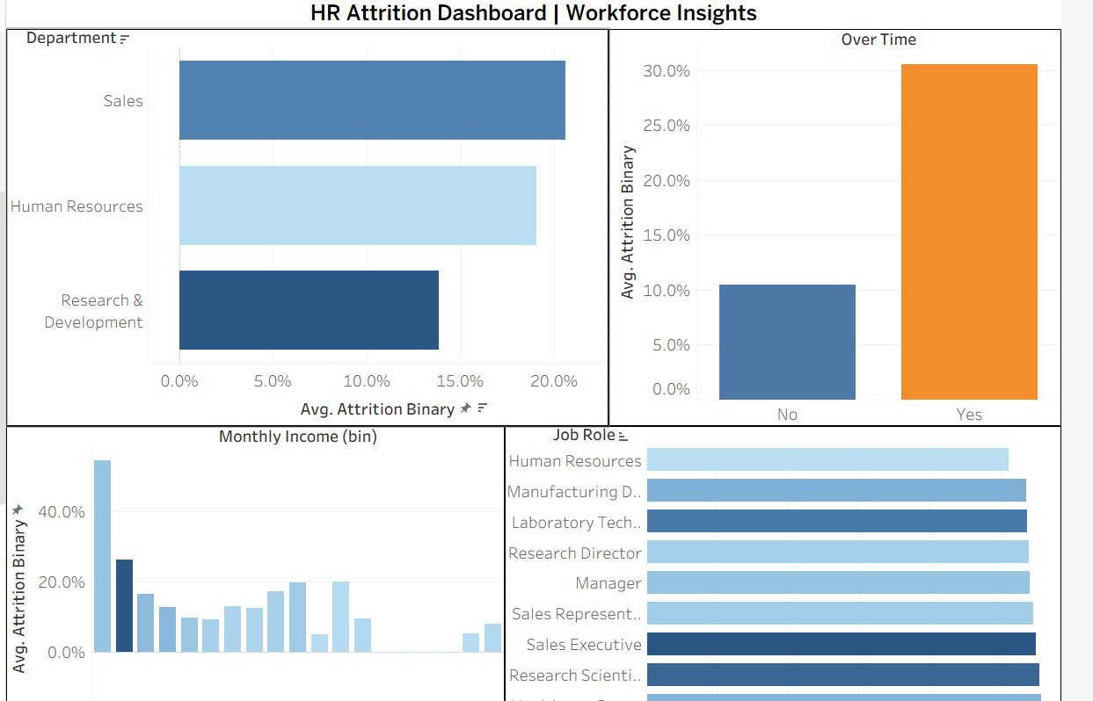
6. SQL Analytical Queries
The project includes ready-to-use SQL queries for:
- Overall attrition rate
- Department performance
- Overtime impact analysis
- Income bracket segmentation
- High-risk role identification
7. Tools & Technologies
Tool | Purpose
Python | Data Cleaning & EDA
Pandas / Seaborn | Analysis & Visualization
Jupyter Notebook | Complete workflow
SQL | Business reporting
Tableau | Interactive Dashboard

8. Recommendations for HR
- Address Overtime Culture – Implement better workload distribution or fair compensation
- Salary Review – Focus on lower income brackets
- Targeted Retention Programs – Especially for Sales and Lab Technicians
- Improve Work-Life Balance – Policies and wellness programs
- Career Progression – Clear growth paths for younger talent
9. Project Files
- raw_hr_data.csv → Original data
- cleaned_hr_data.csv → Cleaned & processed data
- hr_analysis.ipynb → Complete Python analysis
- sql_queries.sql → Analytical SQL queries
- HR_Attrition_Dashboard.twbx → Tableau dashboard file
- attachments/ → All plots and screenshots

