Stock Performance & Risk Analysis
Project Goal
10-year historical analysis (2016–2026) of 10 major US stocks (AAPL, AMZN, DIS, GOOGL, JPM, META, MSFT, NFLX, NVDA, TSLA). Focuses on returns vs risk, best/worst years, and seasonal patterns to support smarter investment decisions.

Tools: PostgreSQL · Microsoft Excel
Dataset: 10 US stocks · 26,331 rows · April 2016 – April 2026
Stocks: AAPL · AMZN · DIS · GOOGL · JPM · META · MSFT · NFLX · NVDA · TSLA
Project Duration: 1 Week

Questions Answered:
- Which stocks delivered the best returns, and how do they compare on risk and efficiency?
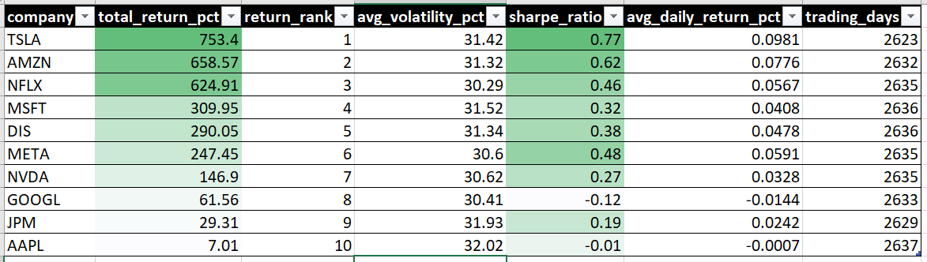
- How did each stock perform year by year — which years were strong and which were losses?
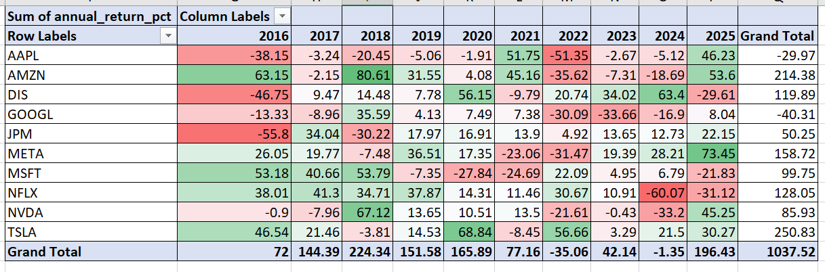

- Are there consistent monthly patterns — which months are historically best or worst for each stock?
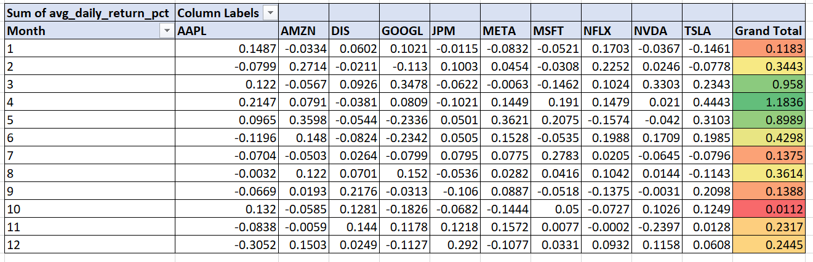
Key Insights
From the Stock Scorecard:
- TSLA was the top performer with 753% cumulative return, but also carries one of the highest average annualised volatilities (~31.4%) — rewarding but extremely risky
- AMZN and NFLX ranked 2nd and 3rd with 658% and 624% respectively, both with solid Sharpe ratios (0.62 and 0.46), meaning their returns were relatively well-compensated for the risk taken
- MSFT and DIS rank 4th and 5th — MSFT is the most consistent quality compounder with a steady Sharpe of 0.32
- GOOGL and AAPL have negative Sharpe Ratios (-0.12 and -0.01), meaning over this period they technically did not compensate investors adequately for the risk they carried
- JPM (0.19 Sharpe) delivered modest but positive risk-adjusted returns — the most "defensive" stock in the group

From Year-by-Year Return:
- 2021 was the best single year across the portfolio — AAPL (+51.75%), AMZN (+45.16%), TSLA positive, and most stocks strongly positive
- 2022 was the worst year universally — AAPL -51.35%, GOOGL -30.09%, META -31.47%, MSFT -24.69%. Only JPM (+4.92%) and DIS (+20.74%) held up — a classic growth-to-value rotation driven by rising interest rates
- TSLA is the most volatile year-to-year stock: swings between +68.84% (2020) and deep negatives in other years
- DIS had a remarkable 2024 (+63.4%) after years of underperformance — showing late-cycle recovery behaviour

From Monthly Seasonality:
- April is the strongest month across the portfolio — TSLA averages +0.44%, MSFT +0.19%, META +0.14% in April, driven by Q1 earnings season
- December is the weakest month for AAPL (-0.31% avg daily return annualised) and META (-0.11%), contradicting the popular "Santa Rally" narrative for these specific stocks
- March is strong for GOOGL (+0.35%) and NVDA (+0.33%) — likely driven by institutional rebalancing and pre-earnings positioning
- September and November are weak months for NVDA (-0.0031% and -0.24% respectively), showing a clear seasonal vulnerability in the semiconductor sector
- TSLA shows the most dramatic monthly extremes: very strong April/May/March, very weak January and August

