Criterion C - Development

Techniques Used

- Asynchronous Programming
- Abstract Data Strictures (Array Lists)
- If statement
- Switch statement
- Activity and fragment management
- Intents
- Material UI
- Recyclerview
- Firebase
- Data Class
- Time and date parsing
- Creating notifications and cloud messaging

UML design

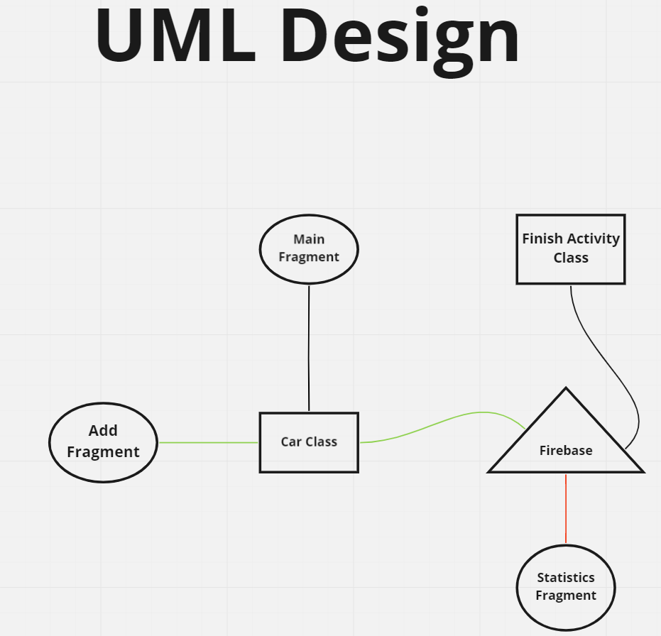

Car Class

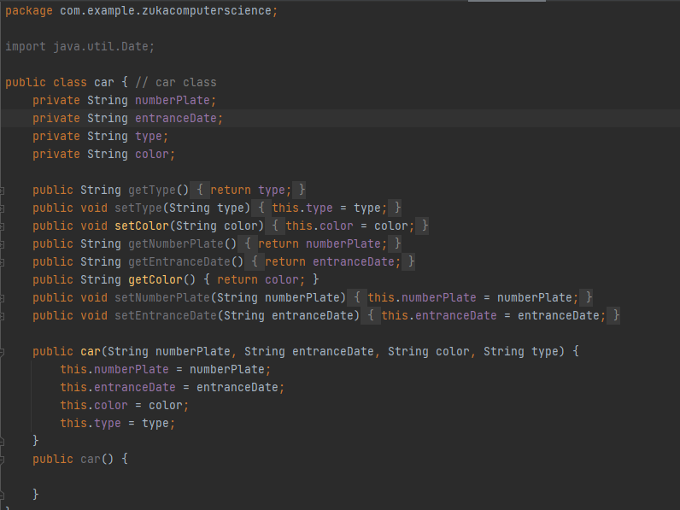

These class contains 4 variables, which are all string types. “numberPlate” contains car’s number plate. “entranceDate” contains car’s entrance date. “type” contains car’s brand, for example a Toyota. “color” contains car’s color.

Database structure

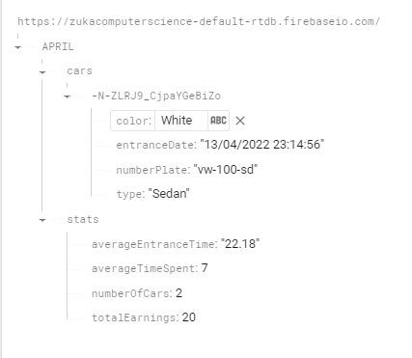

Root elements are months. Each month contains 2 child elements. First element is “cars”. Second element is “stats”. “cars” contains all the active cars, each car has their unique ID (key) for identification. Each car element is based on “cars” class.”stats” contains all the statistics of this month. This statistics include: average time spent, average time of entry, number of cars and total earnings. We are distinguishing “cars” and “stats” because they are independent child elements. When a car goes out of the parking, it is removed from the “cars” but its statistics remain in “stats”.

Inputting data into Firebase

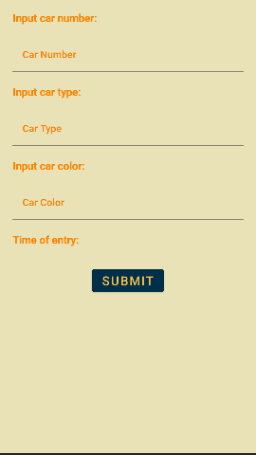
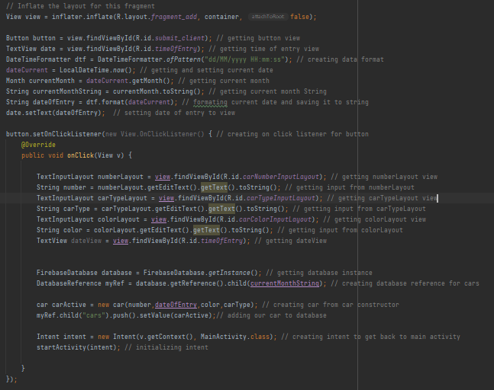

User inputs car number plate, type, and color. And along with the date, it is gathered along with car class object, and that object is pushed into the database under “cars” element. Push method is used because it automatically generates a unique key (ID) which is crucial when it comes to identifying and manipulating different individual elements.

Date and time manipulation

In application, I use two date formats. First format is “localDateTime”, and “localTime”. “localDateTime” is used when the fool date and time is displayed and “localTime” is used when is used when only time is displayed. “localTime” is also used when calculating the average entrance time for the parking. To calculate average time of entrance, I first convert local date times of entrance and departure and using “duration” between these two times. Using “duration” we find difference in these time, and that difference is added to “entranceTime”. Which gives us average entrance time.

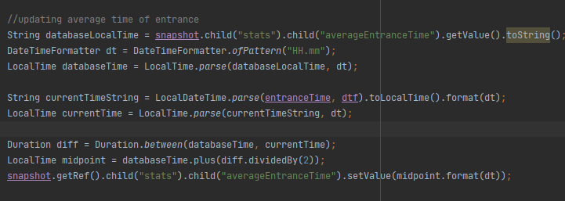

Navigation

To navigate between activities, intents are used. By giving intent current activity and destination activity, the application jumps goes from current activity to desired activity. Intents are also used to pass information between activities.

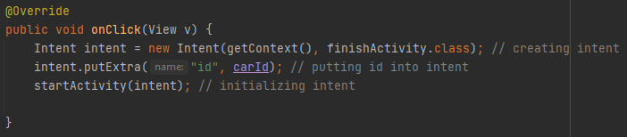

To navigate between fragments, bottom navigation bar, and fragment manager, switch statements are used. Each icon on bottom navigation bar corresponds to different fragments. When clicked, listener is activated. Which triggers switch statement, that based on the icon clicked, changes the fragment. Using fragment manager, selected fragment is inflated. Switch statement provides versatility in terms of using using single statement and not multiple ones.

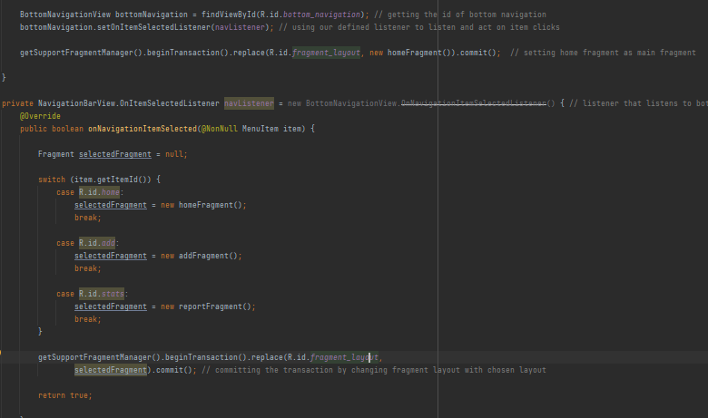

Displaying Data

The home fragment outputs data into a recyclerview.This is happening, in asynchronously inside “onDataChange” method. Meaning that every time data is changed, recyclerview is updated. All of this is possible by having a viewholder, which holds all the views inside the recyclerview and thanks to recyclerview options the recyclerview is populated automatically.
Recyclerview adapter is used to connect and bind specific data to a view. In this case the date contains all the active cars and the view is the car layout which is inflated separately. Recyclerview is used because it has the ability to re-use the view for new elements, which were already scrolled down.

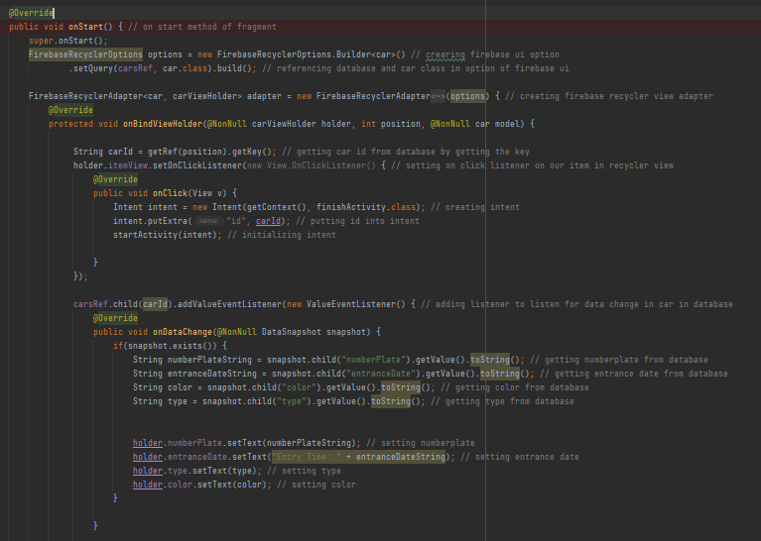
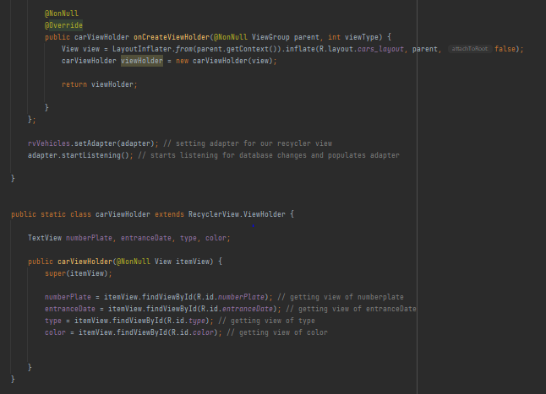

Layout

For application material components like buttons, navigation bars, and themes were used. This guarantees that the application has user friendly UI. Along with that, complex layout like recyclerviews were broken into different parts. For example each car is assigned to separate car layout, which is then inflated inside the recyclerview, based on the number of active cars there are. This makes it easy to apply changes to all of the car layouts, and provide the opportunity for easy debugging.

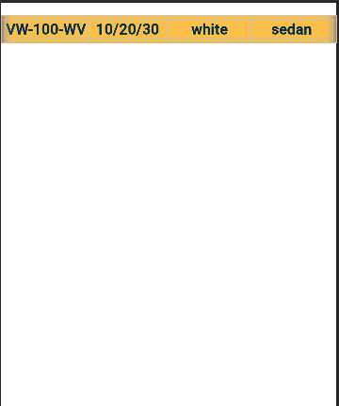

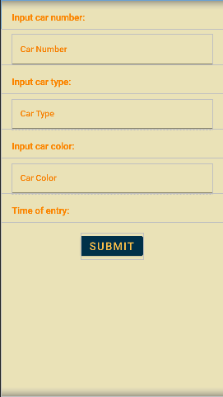

Other Elements

When the the car view is clicked, it opens a new activity which displays most of the information about the car and its parking. The user has the ability to either finish the parking which calculates the price and upgrades the statistics or deletes the car from the parking, which removes the car from the database, without saving its information and adding it to statistics.

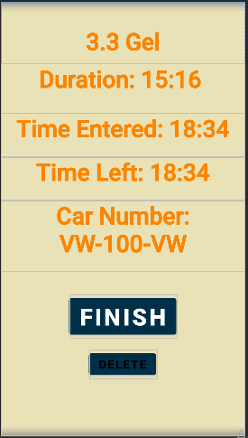

To calculate the price of parking the time spent in parking is calculated using chronounit, which calculated the number of hours between two dates, and for each hour, after the first one, adds 2GEL to final price.
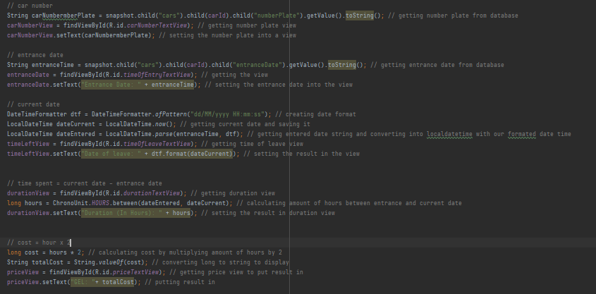

Handling Notifications

To handle notifications, first Firebase cloud messaging is used to schedule messages every 30 days, and send the notifications. Notification Class handles getting the notifications and displaying them. Using “onMessageRecieved” method, we get the message sent from the Firebase, and using notification builder, we create a notification, based on the data received from the Firebase and display it.

