Criterion B

UML diagram

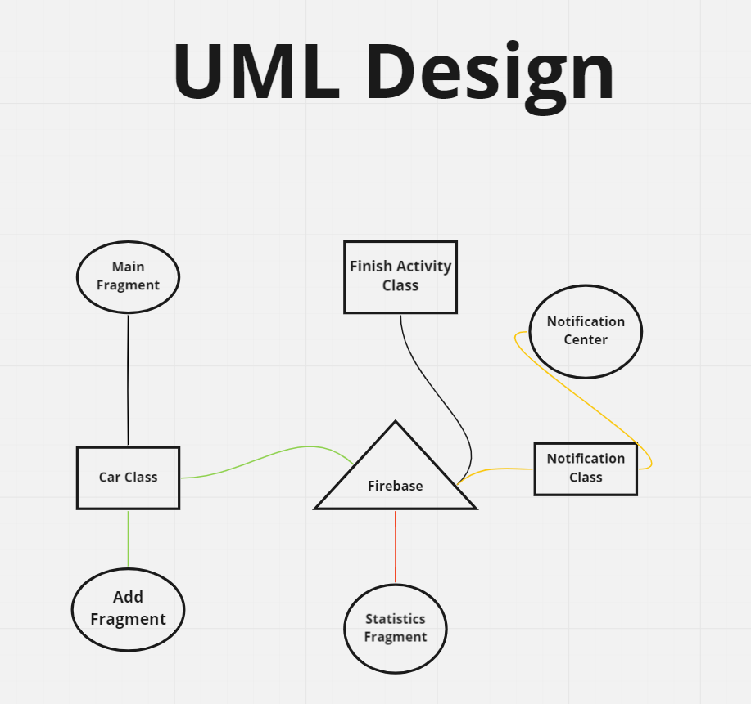

Flow chart of the application

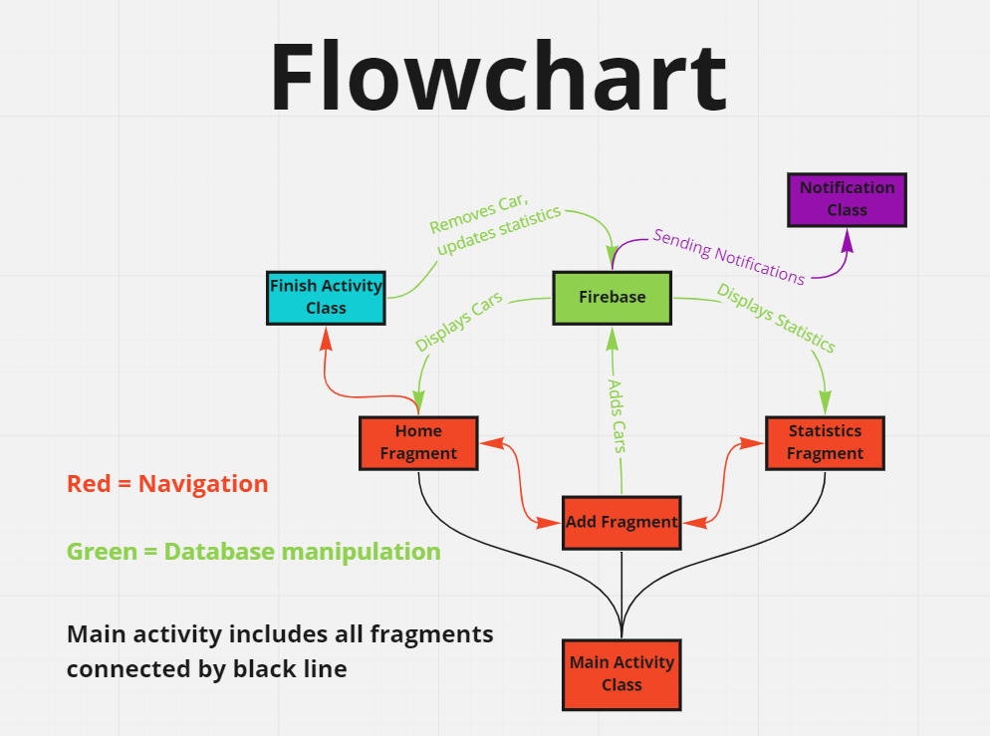

Interface

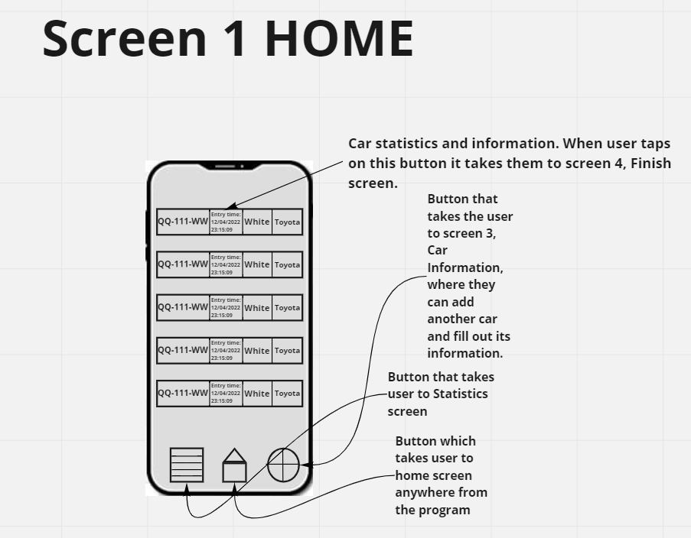
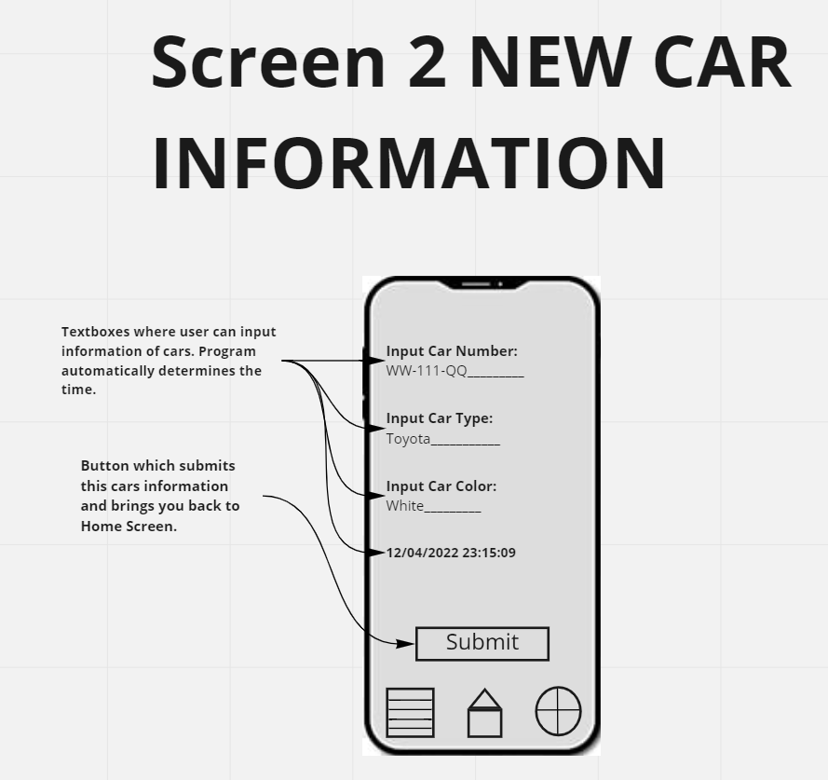

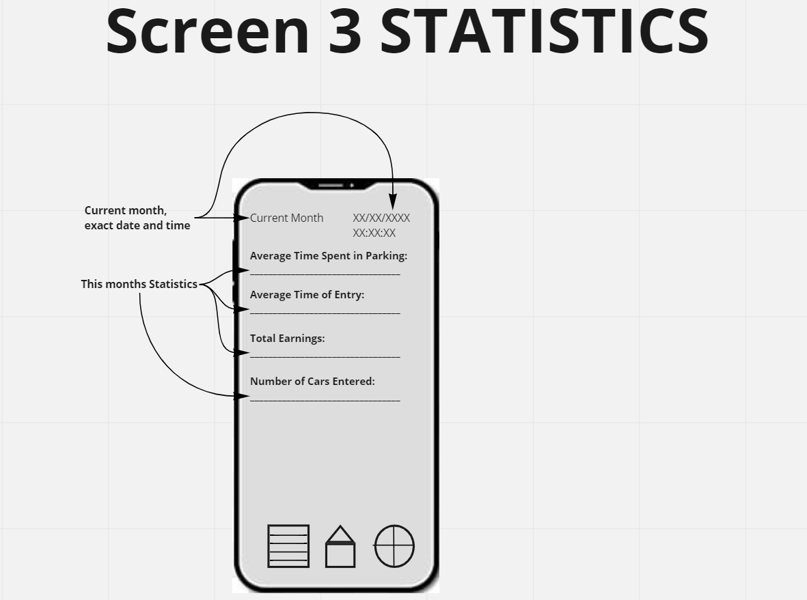

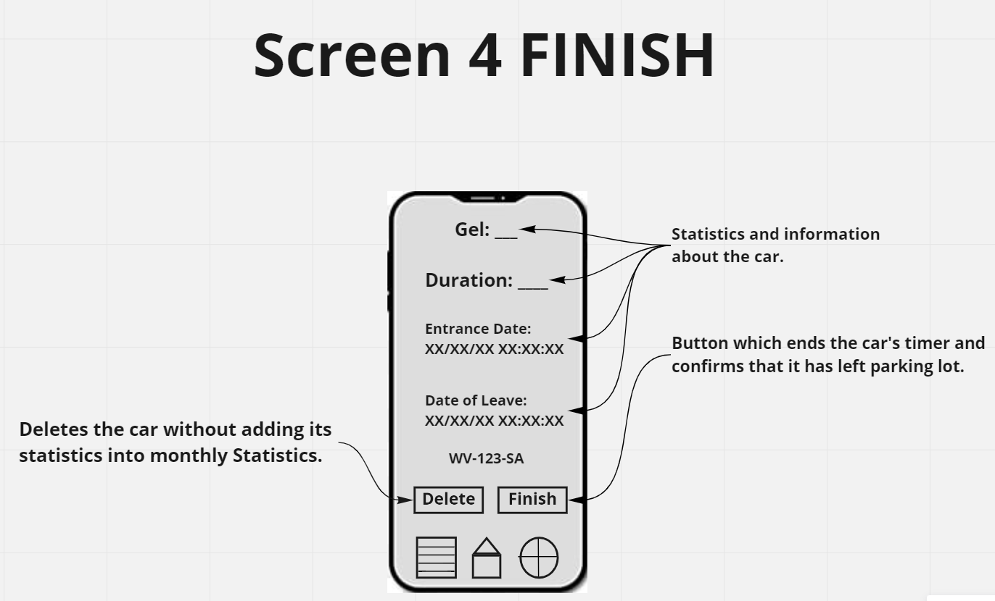

Test plan
Test | Results
Check if the application opens | Clicked on application and it opened on Home screen successfully.
Check buttons for each screen send you to designated screens | Clicked on each buttons of different screens, they took me to correct designated screens, like Car Information Screen, Statistics, Finish Screen
Check if all the required inputs can be filled properly | I filled in all the required inputs and they were displayed properly and were functional.
Check if Submit Button works | I filled in every required information for Submitting a car into a parking lot. Then I pressed Submit button and the car was correctly added to Home screen
Check if user can go to Finish screen | I pressed on already submitted car on the home screen, and it brought me to Finish screen
Check if Finish button works | I pressed on Finish button on already submitted car, which then brought me back to home screen, where the submitted car was removed.
Check if timer and dates work properly | Put in a random car’s information in the application, it then displayed the time and date of the entry, after an hour I finished the car’s time. End time and date were properly displayed.
Check if pricing works correctly | I added a car to timer, then I finished its time after 2 hours. First hour is free of charge and each hour after first is 2 GEL. Final price of the car was 2 GEL, meaning pricing was correctly calculated.
Check if statistics display correct numbers | I filled in around 20 cars throughout the day. At the end of the day I checked statistics. Number of cars entered, average time spent, average time entered and total earnings were correctly displayed on the screen.
Check if information of cars are displayed on home screen properly | All the predetermined information of the cars are correctly displayed on the home screen: car’s number plate, entry time and date, color, and brand of the car.
Check if deleting a car works properly | I added a car on add screen, then went to home screen and tapped on the newly added car. It took me to Finish screen where I tapped on the button delete. The car was succesfuly deleted from the home screen.
Check if deleting a car adds its information into monthly statistics. | I added and then deleted a car, its information was not added to the monthly statistics.
Check if scheduling a notification for monthly statistics reports works. | I added a scheduled date on Firebase. After waiting few minutes, the notification arrived in the notifications bar of the android, I then tapped on that notification which brought me to the statistics screen on the application.
Check if tapping on the notification button takes you to the application. | I tapped on the notification message and it successfully took me to the app and opened it.

