**Question: 1**

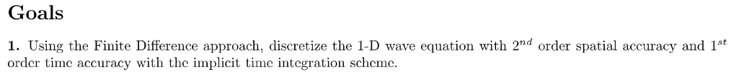

**Goal 1 Solution**

Equation to be solved:

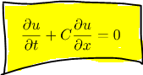…………. Eq(1)

NOTE :

Suffix used below represent the following:

i represent x(space)

j represent t(time)

h = ∆x

k = ∆t

$2^{nd}$ Order accurate spatial:

$\frac{∂u}{∂x}=\frac{U_{i+1,j} –{ U}_{i-1,j}}{2h}$……….. Eq(2)

$1^{st}$ Order accurate time derivative:

$\frac{∂u}{∂t}=\frac{U_{i,j} –{ U}_{i,j-1}}{k}$………….Eq(3)

Putting (ii) & (iii) in (i) we get

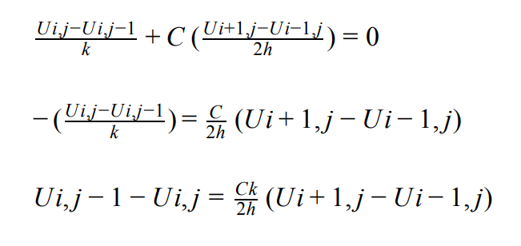

Replace j to j + 1 and $\frac{Ck}{2h}$ = λ

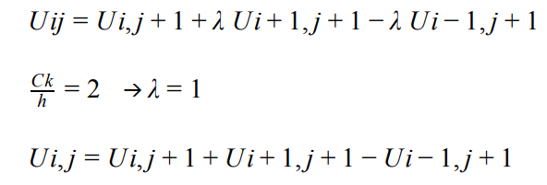

**RESULT:**

**eq5.PNG**