

Veer Narmad South Gujarat University, Surat.

Major Project Report

On
“Food Delivery Application”

As a partial fulfillment for degree of
Bachelor Of Computer Application
T.Y.B.C.A.(6th Semester)
Year 2025-2026

Submitted To:
Narmada College Of Science & Commerce, Zadeshwar , Bharuch-392001.

Guided By: | Developed By:
Mrs.Isha A.Shah | Devraj Vashi
 | Divyang Dudhat

Acknowledgement
We are delighted to present this report on the “Food Delivery App” project. We would like to express our deepest appreciation to all individuals who contributed to its success, particularly our project guide, Mrs.Isha A.Shah , who guided us with her expertise and constant motivation.
We also acknowledge the valuable support and encouragement received from the computer department staff and our peers. Their insights and suggestions helped us refine our project and documentation.
We are grateful to Narmada College of Science & Commerce, Bharuch, for its conducive learning environment, facilities, and support throughout this project.
Finally, we extend our sincere thanks to our friends and classmates for their unwavering support, which made our academic journey in T.Y.B.C.A (Sem-6) truly rewarding.

THANKING YOU
Index

Sr. No. | Chapter | Page No.
1 | Project Overview | 1
2 | Tools To Be Used | 7
3 | Goals of Project | 16
4 | Objectives of Project | 18
5 | Scope of Project | 19
6 | Functions to be performed | 20
7 | Module Specification | 24
8 | DFD Diagram | 29
9 | ER Diagram | 36
10 | Database Design | 38
11 | Screenshot & Description | 45
12 | Conclusion | 52
13 | Future Scope | 56
14 | Resources | 61

Project Profile

Project Title | - | Food Delivery App
Project Description | - | The Food Delivery Application is a mobile-based system developed using Java in Android Studio with Firebase Realtime Database as the backend. The application is designed to simplify the process of ordering food online by connecting users, restaurant admins, and delivery personnel on a single platform.  The system consists of three main modules:  - User Module – allows customers to browse food items, add items to cart, place orders, track deliveries, and manage their profiles.  - Admin Module (Restaurant) – enables restaurant managers to add/update food items, manage orders, monitor user activity, and handle order processing.  - Delivery Boy Module – allows delivery personnel to accept/reject orders, view delivery details, and update delivery status in real-time.  The application includes features such as secure login and registration using Firebase Authentication, real-time order updates, cart management, address handling, order tracking, and notifications.  Firebase Realtime Database ensures fast and synchronized data updates across all modules, making the system efficient and reliable.  This project provides a digital, user-friendly, and efficient solution for food ordering and delivery, reducing manual work and improving customer experience.
Front-end | - | JAVA, XML
Back-end | - | Firebase Database
Documentation Tool | - | MS Word, draw.io
IDE | - | Android Studio
Application Software | - | Android Studio Narwhal 3

Project Overview
The Food Delivery App is a fully functional Android-based mobile application developed in Java using Android Studio, designed to digitally streamline and manage the complete food ordering and delivery process through a single, centralized platform. The system is built to eliminate the traditional barriers of food ordering — such as phone calls, manual tracking, and communication gaps — by bringing together all key stakeholders in one seamlessly connected ecosystem.
The application supports three distinct roles — User (Customer), Admin (Restaurant Manager), and Delivery Boy — each equipped with their own dedicated interface, dashboard, and set of functionalities tailored specifically to their responsibilities within the food delivery workflow.

User (Customer) Panel
The User panel is designed with simplicity and convenience in mind, ensuring that any customer — regardless of their technical background — can navigate the app with ease and place orders without confusion.
Upon launching the application, users are greeted with a login and registration screen powered by Firebase Authentication, ensuring that every account is secure and uniquely identified. Once logged in, users land on a Home Screen that displays available food categories and featured or popular food items. Users can browse through the menu, tap on any food item to view its full details including name, description, price, and image, and directly add items to their cart with a single tap.
The Cart Screen gives users a complete summary of all selected items along with their individual prices and the total payable amount. Users can increase or decrease item quantities, remove items from the cart, and proceed to checkout when ready. During checkout, users can enter or select a saved delivery address, review their order, and confirm the placement. Once an order is placed, it is instantly pushed to the Firebase Realtime Database and becomes visible to the admin for processing.
Users also have access to a dedicated Order History section where they can view all previously placed orders along with their current status — whether it is pending, confirmed, out for delivery, or delivered. This gives customers full transparency into their order journey. Additionally, users can manage and update their Profile — including their name, phone number, and delivery address — at any time from the profile section.

Admin (Restaurant Manager) Panel
The Admin panel serves as the central command center for restaurant managers, giving them complete control over the menu, incoming orders, and overall platform activity.
After logging in through the admin credentials, the admin is directed to a Dashboard that provides a quick overview of active orders, total food items listed, and registered users on the platform. The admin can

manage the Food Menu by adding new food items with details such as item name, description, price, category, and image. Existing items can be edited or removed at any time to keep the menu accurate and up to date.
When a customer places an order, it appears in the Order Management section of the admin panel in real time. The admin can view the full order details — including the items ordered, quantities, total price, customer name, and delivery address — and then either confirm or reject the order. Once confirmed, the order is made available to delivery personnel for pickup and delivery. The admin can also monitor ongoing deliveries and track which orders are pending, in progress, or successfully delivered.
The admin panel also provides visibility into user activity, allowing the restaurant manager to see registered users, their order history, and overall platform engagement. This makes it easy to identify loyal customers, handle complaints, and ensure smooth operations at all times.

Delivery Boy Panel
The Delivery Boy panel is purpose-built for delivery personnel, designed to be straightforward and fast so that delivery staff can focus entirely on completing their deliveries efficiently.
Once logged in, a delivery boy is presented with a list of available or assigned orders that are ready for pickup. Each order card displays key information such as the customer's name, delivery address, contact number, and the list of items to be delivered. The delivery boy can accept or reject an order based on their current availability and location.
After accepting an order, the delivery boy proceeds to the restaurant for pickup and then heads to the customer's address for delivery. Throughout this journey, they can update the delivery status in real time — marking it as "Picked Up", "Out for Delivery", or "Delivered" — so that both the customer and admin are always kept informed without any need for manual communication.
This real-time status update system, powered by Firebase Realtime Database, ensures that all three panels remain perfectly synchronized at every step of the process, providing a smooth and transparent experience for everyone involved.

Key Features:
The Food Delivery App is packed with a wide range of carefully designed features that cater to the needs of all three user roles — Customer (User), Admin (Restaurant Manager), and Delivery Boy. Each feature has been developed to ensure a smooth, efficient, and real-time experience across the entire food ordering and delivery workflow. Below is a detailed breakdown of all the key features available within the application.

1. User Authentication & Role-Based Access
One of the most fundamental and important features of the application is its secure authentication system, built entirely on Firebase Authentication. Every user — whether a customer, admin, or delivery boy — must register and log in through their respective portal before accessing any part of the application.
During registration, users provide essential details such as their name, email address, phone number, and password. The system automatically verifies the credentials and stores them securely in Firebase. Role-based access control ensures that once a user logs in, they are directed only to their respective panel — customers see the food ordering interface, admins see the restaurant management dashboard, and delivery boys see their delivery task list. This prevents unauthorized access and ensures that each role operates strictly within its defined boundaries.

2. Home Screen & Food Browsing
The Home Screen of the User panel serves as the primary entry point for customers after login. It is designed to be visually appealing and easy to navigate. The screen displays food categories such as Burgers, Pizza, Biryani, Desserts, Drinks, and more, allowing users to quickly filter and find what they are craving.
Users can scroll through the available food items, each displayed as a card with the food image, name, a short description, and the price. Tapping on any food item opens a detailed item view that provides a full description, the price, and the option to add the item to the cart. The home screen also highlights featured or popular items, giving the restaurant a way to promote their best-selling dishes directly to customers.

3. Cart Management
The Cart feature allows users to build their order before finalizing it. As customers browse through food items and add them to the cart, each item is stored temporarily and displayed on the Cart Screen with its name, quantity, individual price, and a subtotal. Users have full control to increase or decrease the quantity of any item or remove it entirely from the cart.
The cart dynamically calculates and displays the total payable amount based on the items and quantities selected. This ensures full transparency so that customers are never surprised by the final bill. Once satisfied with their selection, users can proceed to the checkout process directly from the cart screen.

4. Order Placement & Checkout
The Order Placement feature is the heart of the entire application. Once a user is done selecting items and reviewing the cart, they can move to the Checkout Screen. Here, users are required to confirm or enter their delivery address, review the complete order summary one final time, and then place the order with a single tap.
Upon confirmation, the order details — including the list of items, quantities, total price, customer information, and delivery address — are instantly pushed to the Firebase Realtime Database and become immediately visible to the admin. The customer receives an on-screen confirmation that their order has been successfully placed and is now awaiting restaurant confirmation. This entire process happens in a matter of seconds, thanks to the real-time capabilities of Firebase.

5. Real-Time Order Tracking & Status Updates
One of the standout features of the Food Delivery App is its real-time order tracking system. Once an order is placed, its status changes dynamically throughout the delivery lifecycle. Customers can monitor their order at every stage directly from the Order Status Screen, which reflects live updates as they happen.
The order goes through the following stages:
- Pending — Order has been placed and is awaiting admin confirmation
- Confirmed — Admin has reviewed and accepted the order
- Out for Delivery — A delivery boy has picked up the order and is on the way
- Delivered — The order has been successfully delivered to the customer
Each of these status changes is updated in real time by the respective party — admin or delivery boy — and is instantly reflected on the customer's screen without requiring any manual page refresh.

6. Food Menu Management (Admin)
The Admin Food Menu Management feature gives restaurant managers complete authority over what is displayed to customers on the app. Admins can add new food items by filling in details such as the item name, category, description, price, and uploading a food image. All uploaded images are stored and served through Firebase Storage, ensuring fast loading times for customers.

Existing food items can be edited at any time — whether it's updating the price, changing the description, or swapping the image — and items that are no longer available can be deleted from the menu instantly. Any change made by the admin is reflected on the customer's home screen in real time, ensuring the menu is always accurate and current.

7. Order Management & Processing (Admin)
The Order Management section of the admin panel is where all incoming customer orders are displayed and handled. As soon as a customer places an order, it appears in the admin's order list with full details — including the customer's name, delivery address, list of items ordered, quantities, and total bill amount.
The admin has the ability to confirm or reject each order based on the restaurant's current capacity or item availability. Once an order is confirmed, it is automatically pushed to the Delivery Boy panel where available delivery personnel can view and accept it. The admin can also monitor the progress of all active orders and keep a record of all past orders for reference.

8. Delivery Management (Delivery Boy)
The Delivery Boy panel is a streamlined and focused interface that helps delivery personnel manage their tasks efficiently. Upon login, the delivery boy sees a list of orders available for pickup that have been confirmed by the admin. Each order card displays all necessary information including the customer's name, phone number, delivery address, and the list of items to be delivered.
The delivery boy can accept or reject an order based on their current location and availability. After accepting, they proceed to pick up the order from the restaurant and then navigate to the delivery address. As they progress, they can update the order status to "Picked Up", "Out for Delivery", and finally "Delivered" — each update being pushed to Firebase instantly and reflected on both the customer's and admin's screens in real time.

9. Order History
Both users and admins have access to a detailed Order History section that maintains a complete record of all past orders. For customers, this section shows every order they have ever placed — including the date, items ordered, total amount, and final delivery status. This helps users keep track of their spending and quickly reorder their favourite meals.
For admins, the order history provides a comprehensive log of all transactions processed through the platform, making it easy to review past orders, resolve disputes, and analyze ordering patterns over time.

10. Profile Management
Every user on the platform — whether a customer, admin, or delivery boy — has access to a Profile Management section where they can view and update their personal information. Customers can update their name, phone number, email address, and saved delivery addresses. Delivery boys can update their contact details and availability status.
This feature ensures that all user information stays accurate and current, which is especially important for delivery logistics where the correct address and contact number are critical to successful order fulfilment.

11. Real-Time Notifications & Updates
The application leverages Firebase Realtime Database listeners to push instant updates to all connected panels whenever there is a change in order status, a new order is placed, or a delivery is completed. This eliminates the need for manual refreshing and ensures that every stakeholder — customer, admin, and delivery boy — is always looking at the most current and accurate information at all times.

12. Firebase Realtime Database Integration
All data within the application — including user profiles, food items, orders, cart contents, delivery status, and addresses — is stored and managed using Firebase Realtime Database. This NoSQL cloud database ensures that data is synchronized across all three modules simultaneously, providing a fast, reliable, and scalable backend without the need for a traditional server setup.
The tree-structured JSON format of Firebase makes it easy to organize and retrieve data efficiently, while its built-in offline support ensures that the app remains functional even in low-connectivity conditions, syncing all changes once the connection is restored.

TOOLS USED :-

FRONT END
What is an Android Studio?
Android Studio, an Integrated Development Environment (IDE), serves as a comprehensive workshop for building Android apps.
This powerful toolset provides real-time design previews, enabling you to visualize your app's layout and user interface. Additionally, Android Studio's advanced code editor detects errors in your code, offering corrective suggestions to streamline the development process.
How Does An Android Studio Work?

Android Studio empowers developers to craft their ideal apps through efficient coding and seamless project management. Its essential features enable effortless code refinement, optimization, and debugging, ensuring a seamless user experience. With Android Studio's simulation capabilities, you can preview your app's performance on mobile or computer devices in real-time.

The Integrated Development Environment (IDE) streamlines the development process by identifying and resolving issues promptly. By consolidating multiple developer tools into one platform, Android Studio significantly simplifies and accelerates app development, saving valuable time and resources.

The Key Elements of Android Studio

Android Studio comprises four core elements that work in harmony to facilitate Android app development. Understanding these elements is crucial for effective app creation:
- Software Development Kits (SDK): This element encompasses essential tools, documentation, and frameworks necessary for development. The SDK also includes an emulator for testing and tracking progress.

- Integrated Development Environment (IDE): The IDE serves as the central hub for writing and managing code. It integrates the SDK components, plugins, and other tools, streamlining the development process.

- Programming Languages: Android Studio supports two official languages, Java and Kotlin, and also allows the use of C and C++ through third-party tools. However, compatibility issues may arise with certain third-party apps.

- Libraries: These libraries enable rapid code writing through automated systems, error detection, and rewriting. The API system recognizes coding patterns, offering suggestions and enhancing the development experience.

These four elements form the foundation of Android Studio, working together to provide a comprehensive and efficient development environment for creating Android apps.

Android Studio - Advantages

Android Studio is a tool that helps you as a developer to build an android app with absolute proficiency. It holds several advantages for you, which help you create high-quality applications for any android device.
Let’s have a quick look over the Android Studio’s Advantages.
- Intelligent Code Editor
Android Studio has an intelligent Code editing system that helps you code faster. This system can easily detect any code errors and mark them and provide suggestions for changes.
It helps you to be more efficient with automated code completion. It reads the previous code writing patterns and provides completion codes according to the previously written codes.
- Fast & Feature-rich Emulator
Android Studio features a built-in Android Emulator, enabling developers to test and refine their apps on a virtual Android device. This emulator allows you to run and interact with your app directly on your computer, simulating a real Android environment.
- Code Templates & Lint checks
Android Studio's Code Templates feature is a valuable asset for developers of all levels, providing pre-built code patterns that simplify the writing of complex code. This feature serves as a guiding system, streamlining the development process.
Additionally, Android Studio's Lint Check feature ensures the structural integrity of your code, identifying weaknesses and providing suggestions for improvement. This feature helps maintain high-quality code, saving time and resources by: Detecting structural flaws ,Offering corrective suggestions ,Enhancing code maintainability
By leveraging Code Templates and Lint Check, developers can work more efficiently, producing robust and well-structured code with ease
- Testing Tools and Frameworks
Android Studio Test your app's code frameworks with Android Studio's JUnit4 and Functional-UI tools. They record code, generate tests, and simulate UI interactions to ensure seamless app performance
- Flexible System Build
Android Studio's UI system is designed for maximum flexibility, allowing developers to customize their workspace, integrate third-party tools and services, and configure their environment to optimize productivity and workflow.
- C++ & NDK Support
Android Studio supports C and C++ development, enabling easy editing of C++ projects and creation of JNI components, with syntax highlighting and debugging tools for efficient coding.

- Eliminates Tiresome Tasks
The GUI tool in Android Studio reduces development time by automating routine tasks, including layout design, APK analysis, and translation.

Android Studio - disadvantages
No app is completely flawless, and Android Studio is no exception, balancing benefits with drawbacks.
- High System Requirements
Android Studio's minimum system requirements, including an i3 processor and 4GB of RAM, can be a significant obstacle for users with lower-end computers, limiting its accessibility.
- System Lags
The app’s system lag is a sudden cause of events, which might not occur. Sometimes when you’re writing code on Android Studio, its system freezes and stops working and sometimes restarts on its own. Thus, affecting the overall efficiency of the work.
- Slow Emulator
The emulator in Android Studio Provides is slow compared to other third-party android emulators. This slow emulator interface can’t keep up with more than one app testing.
- Heavy Ram Usage
Android Studio is a RAM-hungry app that needs at least 4 gigs of ram to run properly. If your computer has a lower RAM capacity, then you won’t be able to get the best experience with this app.
- Long Installation Process
The long installation process is another drawback of the Android Studio. It has a lengthy installation system that requires at least 3 minutes to complete, no matter your computer’s configuration.

Java
Java is a powerful, versatile, and widely used object-oriented programming language that has been the backbone of Android application development for decades. It is a class-based, platform-independent language that follows the principle of "Write Once, Run Anywhere," meaning that Java code compiled on one platform can run on any other platform that supports the Java Virtual Machine (JVM). In the context of Android development, Java remains one of the most reliable and well-supported languages, offering a massive ecosystem of libraries, frameworks, and community resources that make it ideal for building robust mobile applications. The Food Delivery App has been developed entirely using Java in Android Studio, taking full advantage of its stability, compatibility, and extensive Android SDK support.

Features of Java
- Object-Oriented: Java is built entirely around the concept of objects and classes, making it easy to model real-world entities, manage code structure, and build scalable applications through the principles of inheritance, encapsulation, polymorphism, and abstraction.
- Platform Independence: Java code is compiled into bytecode which can run on any device or operating system that has a Java Virtual Machine installed, making it highly portable across different environments.
- Strongly Typed Language: Java enforces strict type checking at both compile time and runtime, which helps in catching errors early during development and producing more reliable and predictable application behaviour.
- Rich Standard Library: Java comes with an extensive standard library that provides ready-made classes and methods for data structures, networking, input/output operations, database connectivity, and much more, significantly reducing development time.
- Multithreading Support: Java has built-in support for multithreading, allowing developers to run multiple tasks simultaneously within a single application, which is especially useful in mobile apps where background tasks and UI operations must run in parallel.
- Automatic Memory Management: Java includes a built-in garbage collector that automatically manages memory allocation and deallocation, reducing the risk of memory leaks and making the application more stable over time.
- Exception Handling: Java provides a robust and structured exception handling mechanism that allows developers to gracefully handle runtime errors and unexpected situations without causing the application to crash.

Advantages of Java
Java Code is Widely Supported in Android Development Java has been the official and primary language for Android development since the very beginning of the Android platform. The Android SDK, all major Android libraries, and the majority of open-source Android projects are written in or fully compatible with Java, making it the most natural and well-supported choice for building Android applications.
Java Has a Large and Mature Community Java has one of the largest developer communities in the world, meaning that solutions to almost any problem are readily available through forums, documentation, and open-source projects. For students and developers working on projects like the Food Delivery App, this makes troubleshooting significantly easier and faster.
Java Offers Strong Object-Oriented Structure Java's strict object-oriented architecture encourages developers to write clean, modular, and reusable code. In a project with multiple modules such as User, Admin, and Delivery Boy, this structure makes it much easier to manage separate components without causing conflicts or code duplication.
Java Provides Excellent Integration with Firebase Java integrates seamlessly with Firebase SDKs for Android, including Firebase Realtime Database, Firebase Authentication, and Firebase Storage. All Firebase documentation and official code samples for Android are primarily written in Java, making implementation straightforward and well-documented.

Java Ensures Application Stability and Reliability Java's strong type system, compile-time error checking, and mature runtime environment contribute to building applications that are stable, predictable, and less prone to unexpected crashes during real-world usage.

Disadvantages of Java
Verbose Syntax Java is known for being quite verbose compared to modern programming languages. Even simple operations require several lines of code, which can slow down the development process and make the codebase longer and harder to read for beginners who are just starting out with Android development.
Slower Development Speed Due to its verbose nature and strict structure, writing code in Java generally takes more time compared to newer languages. Developers must write more boilerplate code — such as getter and setter methods, constructor definitions, and interface implementations — which adds to development time without necessarily adding functionality.
No Built-In Null Safety Unlike modern languages, Java does not have built-in null safety features. This means that NullPointerExceptions are a common and frustrating source of crashes in Java applications if developers do not carefully handle null values throughout the codebase.
Higher Memory Consumption Java applications tend to consume more memory compared to applications built with lighter languages, primarily due to the overhead of the JVM and the object-oriented structure. On low-end Android devices, this can sometimes lead to slower performance or increased battery usage.
XML
XML, or Extensible Markup Language, is a text-based markup language designed for storing and transporting data. Originating from Standard Generalized Markup Language (SGML), XML utilizes tags to identify, store, and organize data, differing from HTML tags which focus on data display. There are some advantages and disadvantages of using XML. Let us see them in detail.
Advantages of XML
- The platform and language independence of XML enables it to be used on any system, supporting seamless integration and adaptation to changing technologies.

- XML enables effortless data exchange between systems, regardless of platform or architecture.

- By adopting Unicode, XML ensures that each character, digit, or symbol is uniquely identified, allowing data to be transmitted and understood across different platforms, programs, and languages.

- The use of XML for data storage and transportation enables modifications to be made at any point without affecting the presentation layer, which is typically handled by HTML. This separation of concerns allows for flexible and efficient data updates.

- XML provides robust validation mechanisms through DTD (Document Type Definition) and Schema, which thoroughly check the document's syntax, ensuring it is free from errors and conforms to predefined standards.
Disadvantages of XML
- XML syntax is verbose and redundant compared to other text-based data transmission formats such as JSON.
- Large datasets in XML incur higher storage and transport costs due to syntax redundancy.
- XML documents are more difficult to read and understand due to their complex structure, Compared to JSON.
- Arrays are not supported in XML.
- XML file sizes are usually very large due to its verbose nature, it is totally dependent on who is writing it.

BACKEND

Firebase
Firebase is a Backend-as-a-Service (BaaS) platform developed by Google that provides a comprehensive suite of cloud-based tools and services to help developers build, improve, and grow web and mobile applications. It abstracts away much of the traditional backend infrastructure, enabling developers to focus on application features rather than server management.
Unlike SQLite, which is primarily a local embedded database, Firebase provides real-time cloud-based data storage and services, making it ideal for modern apps requiring online connectivity, synchronization, and scalability.
Firebase’s ease of integration, cross-platform compatibility, and powerful features have made it a go-to choice for mobile and web developers worldwide.

Firebase Advantages

1) Real-time Database & Firestore
- Firebase’s Realtime Database and Cloud Firestore allow you to store and sync data across clients in real-time.
- Every connected device automatically receives updates when data changes, eliminating the need for manual refresh or polling mechanisms.

- This feature is essential for apps like chat messengers, live dashboards, collaboration tools, or IoT-based systems where data must be instantly reflected on multiple devices.

2) Seamless Scalability
- Firebase automatically handles scaling behind the scenes. As your user base grows from hundreds to millions, Firebase adjusts the infrastructure without manual intervention.
- No need to worry about servers, bandwidth, or provisioning databases—Google Cloud takes care of everything.

3) Cross-Platform Support
- Firebase provides SDKs for Android, iOS, Web, Flutter, Unity, and C++, ensuring a consistent backend experience across all platforms.
- This makes it easy to develop apps with a single codebase but deploy them on multiple systems.

4) Authentication Services
- Firebase Authentication offers a complete identity solution with support for email/password login, phone number verification, Google, Facebook, Twitter, GitHub, and custom identity providers.
- Built-in secure authentication flows save time and reduce the risk of vulnerabilities compared to custom-built login systems.

5) Hosting & Serverless Features
- Firebase Hosting provides fast, secure, and reliable web hosting for static and dynamic content.
- Developers can deploy websites with a single command using Firebase CLI.
- Cloud Functions for Firebase enable you to run backend code in a serverless environment, meaning you only pay for the resources your code uses.

6) Analytics & Monitoring
- Firebase integrates with Google Analytics for detailed insights into user behavior, engagement, and retention.
- Crashlytics monitors app stability and automatically logs crashes, stack traces, and performance issues
- Performance Monitoring helps track app speed, network response times, and other metrics across user devices.

7) Push Notifications
- Firebase Cloud Messaging (FCM) provides a robust and scalable push notification system to deliver messages to users across devices.
- Developers can send targeted notifications to specific groups or even individual devices.

8) Machine Learning Features
- Firebase ML (formerly ML Kit) offers ready-to-use machine learning APIs like text recognition, image labeling, face detection, and more.
- Developers can deploy their own custom models as well.

9) Offline Capabilities
- Firebase supports offline persistence, allowing apps to work even without an internet connection.
- Changes made offline sync automatically once connectivity is restored, ensuring a seamless user experience.

10) Secure by Default
- Firebase Security Rules let developers control data access at a granular level (per-user or per-node).
- Built-in SSL encryption ensures data is transmitted securely between clients and Firebase servers.

11) Cost-Effective
- Firebase offers a generous free tier (Spark Plan), making it accessible to startups and students.
- Pay-as-you-go pricing ensures you only pay for what you use.

Firebase Disadvantages
- Internet Dependency: Firebase’s cloud-based nature makes it less suitable for offline-only apps compared to SQLite’s local storage.
- Vendor Lock-in: Migrating away from Firebase to another backend provider can be complex.

- Limited Query Flexibility: While Firestore and Realtime Database are powerful, they are not as flexible as SQL databases when it comes to complex queries and joins.
- Pricing at Scale: While Firebase starts free, heavy usage can lead to increased costs.

What is Firebase Console?
The Firebase Console is the centralized web-based management interface where developers can manage all Firebase services. It offers:
- Real-time database view
- Authentication and user management
- Analytics dashboards
- Hosting configurations
- Crash and performance monitoring reports
It simplifies backend management, similar to how DB Browser for SQLite simplifies local database management.

What Do You Need to Start Using Firebase?
- A Google Account to access Firebase Console.
- Basic knowledge of your app’s programming language (Android/Java/Kotlin, iOS/Swift, Web/JavaScript).
- Integration of the Firebase SDK (available for all supported platforms) into your app.
- Setup of Firebase services (e.g., Database, Authentication, Hosting) via the console.
Once integrated, your app can immediately start leveraging Firebase’s features without the need to manage servers or manual configuration.

Real-World Use Cases of Firebase
- Messaging Apps: WhatsApp-like chat systems powered by real-time synchronization.
- E-Commerce: Real-time inventory tracking and push notifications for promotions.
- IoT Systems: Device states updated live across dashboards and mobile apps.
- Gaming: Leaderboards, matchmaking, and push notifications.

Goal of the Project
The primary goal of the Food Delivery App is to develop a fully functional, reliable, and user-friendly Android mobile application that digitizes and streamlines the complete food ordering and delivery process for customers, restaurant administrators, and delivery personnel. The project aims to replace traditional and manual methods of food ordering — such as phone calls, walk-in orders, and handwritten records — with a modern, real-time, and organized digital platform that benefits all parties involved in the food delivery ecosystem.
The following points elaborate on the specific goals that this project aims to achieve:
- To provide customers with a convenient and efficient food ordering experience by allowing them to browse the restaurant menu, select food items, manage their cart, place orders, and track their delivery status — all from the comfort of their mobile device without the need for any physical interaction or phone communication.
- To give restaurant administrators complete digital control over their menu and order management process, enabling them to add, update, and remove food items in real time, process incoming orders, assign deliveries, and monitor the overall activity on the platform through a dedicated and easy-to-use admin panel.
- To empower delivery personnel with a dedicated mobile interface that allows them to view assigned orders, accept or reject deliveries based on their availability, update their delivery status at each stage of the journey, and ensure that customers receive their orders on time with full transparency.
- To implement a real-time data synchronization system using Firebase Realtime Database that ensures all three panels — User, Admin, and Delivery Boy — are always displaying the most current and accurate information simultaneously, eliminating delays, miscommunication, and the need for manual updates between parties.
- To ensure secure and role-based access across all modules of the application using Firebase Authentication, so that every user is uniquely identified, their data is protected, and each role has access only to the features and information relevant to their responsibilities within the platform.
- To maintain a complete and organized record of all orders, including their status history, delivery details, and customer information, so that both users and administrators can review past transactions, resolve any disputes, and analyze ordering patterns for better decision-making.
- To design an intuitive and visually clean user interface using Java and XML in Android Studio that is easy to navigate for users of all age groups and technical backgrounds, ensuring that the application is accessible, responsive, and pleasant to use on any Android device.
- To reduce operational inefficiency and human error that commonly occurs in manual food ordering systems, such as missed orders, incorrect addresses, communication gaps between the restaurant and delivery staff, and lack of real-time visibility into order progress.
- To create a scalable and maintainable application architecture that can easily accommodate future enhancements such as online payment integration, multiple restaurant support, GPS-based delivery tracking, customer reviews and ratings, and promotional offers or discount coupons.
- To demonstrate the practical application of modern Android development technologies — specifically Java, XML, Firebase Realtime Database, and Firebase Authentication — in solving a real-world problem, and to serve as a comprehensive major project that reflects strong understanding of mobile application development concepts.
In summary, the goal of this project is not just to build an application but to create a complete digital ecosystem that brings together customers, restaurant management, and delivery operations under one unified platform — making food delivery faster, smarter, more transparent, and more convenient for everyone involved.

Objective of Project
The Food Delivery App has been developed with a set of clear and well-defined objectives that together form the foundation of the entire project. Each objective represents a specific functionality or outcome that the application is designed to achieve, ensuring that the final product is complete, practical, and purposeful for all its users.
- User Registration and Authentication: Both customers and admins, as well as delivery personnel, should be able to register and log in securely through their respective panels using Firebase Authentication. The system ensures that each user is uniquely identified and that their session is managed safely, with the option to log out from the profile screen at any time.
- Profile Management: Users including customers, admins, and delivery boys should be able to view and update their personal profile information such as their name, phone number, email address, and delivery address. Admins should additionally be able to view the details of all registered users and delivery personnel from within the admin panel for better oversight and management.
- Food Menu Management: The admin should have complete control over the restaurant's food menu, including the ability to add new food items with details such as name, category, description, price, and image, as well as the ability to edit existing items or remove items that are no longer available, with all changes reflected in real time on the customer-facing interface.
- Cart Management: Customers should be able to add food items to a cart, adjust item quantities, remove items, and view the dynamically updated total amount before proceeding to checkout, ensuring a smooth and transparent pre-order experience.
- Order Placement and Checkout: The application should allow customers to place orders by confirming their selected items and delivery address through a checkout process, after which the order details are instantly pushed to the Firebase Realtime Database and made visible to the admin for processing without any delay.
- Order Management for Admin: The admin panel should display all incoming customer orders in real time, with full details including the customer name, delivery address, items ordered, and total bill, allowing the admin to confirm or reject each order based on restaurant availability and then assign it for delivery.
- Delivery Boy Module: Delivery personnel should have a dedicated panel where they can view orders that have been confirmed and are ready for pickup, with the ability to accept or reject an order and then update the delivery status at each stage — from picked up to out for delivery to delivered — so that all parties remain informed throughout the process.
- Real-Time Order Tracking: The application should provide customers with live order status updates that reflect every change made by the admin or delivery boy in real time, covering all stages from order placement and confirmation through to final delivery, without requiring any manual refresh from the customer's end.
- Order History: The system should maintain a complete and organized record of all past orders for each user, displaying relevant details such as the date of the order, items purchased, total amount paid, and final delivery status, so that users can review their transaction history at any time.
- Data Storage and Security: All application data including user profiles, food items, orders, cart contents, and delivery status updates should be stored securely in Firebase Realtime Database under a well-structured node hierarchy. Firebase Authentication should enforce role-based access control to ensure that each user type can only access the features and data that are relevant to their designated role within the platform.

Scope of the project

In Scope
The current version of the Food Delivery App includes the following features and components that have been fully developed and tested as part of this major project:
- An Android mobile application developed using Java and XML in Android Studio
- Three distinct user roles — Customer, Admin, and Delivery Boy — each with a separate and dedicated interface
- Secure login and registration for all three user types using Firebase Authentication with role-based access control
- A customer-facing home screen with food category browsing, food item listings with images, names, descriptions, and prices
- Cart management allowing customers to add, remove, and adjust quantities of food items along with real-time total calculation
- A complete order placement and checkout flow including delivery address entry and order confirmation
- Real-time order status tracking for customers covering all stages from pending to delivered
- An admin panel for complete food menu management including adding, editing, and deleting food items with image support
- An admin order management system for viewing, confirming, and rejecting incoming customer orders in real time
- A delivery boy panel for viewing assigned orders, accepting or rejecting deliveries, and updating order status at each stage
- Order history access for all three user roles showing past transactions with relevant details
- Profile management for all users allowing updates to personal information and contact details
- Firebase Realtime Database integration for all data storage, retrieval, and real-time synchronization across all three panels

Out of Scope
The following features and functionalities are not included in the current version of the application and are considered outside the boundaries of this major project:
- iOS version or any cross-platform version of the application
- Online payment gateway integration for in-app order payments
- AI-based or machine learning powered food recommendations for customers
- GPS-based live map tracking of the delivery boy's location during delivery
- Full offline functionality without an active internet connection
- Push notification system for order updates and promotional alerts
- Multiple restaurant support on a single platform
- Customer review and rating system for food items and delivery experience
- Advanced analytics and reporting dashboards beyond the basic order history currently available
- Coupon codes, discount systems, or promotional offer management

Functions Performed

Functions Performed
The Food Delivery App performs a wide range of functions across its three user roles — Customer, Admin, and Delivery Boy. Each function has been developed to address a specific need within the food ordering and delivery workflow, ensuring that the application operates smoothly, efficiently, and reliably for all its users. The following is a detailed description of every major function performed by the system.

1. User Registration and Authentication
Role: Customer / Admin / Delivery Boy
New users can create an account on the platform by providing essential details such as their full name, email address, phone number, and password. During registration, each user is assigned a specific role — Customer, Admin, or Delivery Boy — which determines what panel and features they will have access to after logging in. All account credentials are stored and managed securely using Firebase Authentication, and additional profile information is saved under the users node in Firebase Realtime Database, organized under each user's unique Firebase UID to prevent any cross-user data access.
2. Login and Logout
Role: Customer / Admin / Delivery Boy
The application provides a secure login system where users authenticate using their registered email address and password through Firebase Authentication. Once authenticated, the system reads the user's assigned role from the Firebase database and automatically routes them to their respective panel — customers are directed to the food browsing home screen, admins are taken to the restaurant management dashboard, and delivery boys are taken to their order task list. A logout option is available from the profile screen of each panel, allowing users to securely end their session at any time.
3. Profile View and Edit
Role: Customer / Admin / Delivery Boy
Every user on the platform has access to a dedicated profile screen where they can view and update their personal information. Customers can edit their name, phone number, email address, and saved delivery addresses. Delivery boys can update their contact details. Admins can manage their own profile as well as view the details of all registered customers and delivery personnel from within the admin panel. All profile changes are written instantly to the Firebase Realtime Database, ensuring that the updated information is reflected across the application without any delay.
4. Food Menu Browsing
Role: Customer
Once logged in, customers are presented with a home screen that displays the restaurant's food menu organized by categories such as Burgers, Pizza, Biryani, Desserts, and Drinks. Each food item is shown as a card with its image, name, short description, and price. Customers can tap on any item to view its full details and add it to their cart. The home screen also highlights featured or popular items, giving customers a quick view of the restaurant's best offerings.
5. Cart Management
Role: Customer
The cart feature allows customers to build their order by adding food items from the menu. The Cart Screen displays all selected items along with their individual quantities, unit prices, and a dynamically calculated total amount. Customers can increase or decrease the quantity of any item or remove it from the cart entirely before proceeding to checkout. The cart ensures that customers have full visibility and control over their order before it is placed.
6. Order Placement and Checkout
Role: Customer
After reviewing the cart, customers can proceed to the checkout screen where they confirm or enter a delivery address and review their complete order summary one final time. Upon confirmation, the full order details — including items, quantities, total price, customer name, and delivery address — are instantly pushed to the Firebase Realtime Database and made immediately visible to the admin for processing. The customer receives an on-screen confirmation that their order has been successfully placed.
7. Order Management and Processing
Role: Admin
All incoming customer orders appear in the admin panel's order management section in real time as soon as they are placed. Each order entry displays the complete order details including customer name, delivery address, list of items with quantities, and total bill amount. The admin can review each order and either confirm or reject it based on the restaurant's current capacity and item availability. Once an order is confirmed, it is pushed to the Delivery Boy panel where it becomes visible for acceptance.
8. Food Menu Management
Role: Admin
The admin has full control over the restaurant's food menu through the admin panel. New food items can be added by filling in details such as the item name, category, description, price, and uploading a food image. Existing items can be edited at any time to update pricing, descriptions, or images, and items that are no longer available can be deleted from the menu. All changes are reflected instantly on the customer-facing interface through Firebase's real-time synchronization.
9. Delivery Order Acceptance and Status Updates
Role: Delivery Boy
Once an order has been confirmed by the admin, it becomes visible in the Delivery Boy panel as an available delivery task. The delivery boy can view the full order details including the customer's name, phone number, delivery address, and the list of items. They can accept or reject the order based on their current availability. After accepting, they update the order status progressively — marking it as Picked Up when the order is collected from the restaurant, Out for Delivery when they are en route to the customer, and Delivered once the order has been successfully handed over. Each status update is pushed to Firebase instantly and reflected on both the customer's and admin's screens in real time.
10. Real-Time Order Tracking
Role: Customer / Admin / Delivery Boy
The application maintains a live order tracking system powered by Firebase Realtime Database listeners. As the order status changes at any point in the delivery lifecycle — whether it is being confirmed by the admin, picked up by the delivery boy, or marked as delivered — the updated status is instantly reflected across all three panels simultaneously. Customers can monitor their order progress from the order status screen without needing to refresh the page, ensuring full transparency throughout the delivery journey.
11. Order History
Role: Customer / Admin / Delivery Boy
The system maintains a complete and organized record of all past orders for every user on the platform. Customers can access their order history to review previous orders including the date, items ordered, total amount, and final delivery status. Admins can view a full log of all processed orders across the platform, which is useful for reviewing transactions, resolving disputes, and understanding ordering trends. Delivery boys can also view a record of their past deliveries for reference.
12. Real-Time Notifications and Updates
Role: Customer / Admin / Delivery Boy
Firebase Realtime Database listeners are used throughout the application to push instant updates to all connected panels whenever there is a change in data. When a customer places an order, the admin sees it immediately. When the admin confirms the order, the delivery boy and customer are updated instantly. When the delivery boy marks the order as delivered, the customer's order status updates in real time. This eliminates any communication gaps and ensures that every stakeholder always has the most current information without manual intervention.

13. Data Storage and Security
Role: System
All application data — including user profiles, food items, orders, cart contents, delivery statuses, and addresses — is stored and managed securely in Firebase Realtime Database under a well-organized node structure. Each user's data is stored under their unique Firebase UID, preventing any unauthorized cross-user data access. Firebase Authentication enforces role-based access control across all three panels, ensuring that customers, admins, and delivery boys can only access the features and data that are relevant to their assigned role within the platform.

Module Specification
The Food Delivery App is divided into well-defined modules, each responsible for handling a specific set of functions within the application. Every module has clearly identified inputs, processing logic, and outputs, and all modules communicate with Firebase Realtime Database as the central backend for data storage and real-time synchronization.

7.1 User Module
Sub-modules: Registration, Login, Profile Management
This module handles everything related to user accounts across all three roles — Customer, Admin, and Delivery Boy. During registration, users provide their full name, email address, password, and phone number. The system validates all inputs, creates a secure account using Firebase Authentication, and stores the user's details in the Firebase Realtime Database under the users/[uid] node with fields including the user's name, email, phone number, role type, and delivery address. During login, Firebase Authentication verifies the credentials and the system reads the accountType field to route the user to their respective panel. Profile management allows users to update their personal details at any time, with all changes instantly written back to Firebase.
Input: name, email, password, phone number, delivery address, role type
Processing: input validation, account creation via Firebase Authentication, user data stored in Realtime Database under users/[uid] with fields for uid, email, name, phone, accountType, and address
Output: successful registration confirmation, role-based dashboard redirection upon login, updated profile details saved and displayed instantly.

7.2 Food Menu Module
Sub-modules: Menu Browsing (Customer), Menu Management (Admin)
This module manages the complete food menu of the restaurant. On the admin side, the restaurant manager can add new food items by providing the item name, category, description, price, and image. All food item data is stored under the foodItems node in Firebase Realtime Database. Admins can edit or delete existing items at any time. On the customer side, food items are retrieved from Firebase and displayed on the home screen organized by category. Customers can tap on any item to view full details and add it to their cart.
Input: food item name, category, description, price, image (Admin); browsing and selection (Customer)
Processing: admin writes food item data to the foodItems/[itemId] node in Firebase with fields for id, name, category, description, price, and imageUrl; customers retrieve and display items filtered by category in real time.

Output: updated menu visible on customer home screen immediately after admin changes, food item detail view with add-to-cart option for customers.

7.3 Cart Module
Sub-modules: Add to Cart, Update Cart, Remove from Cart, View Cart Total
This module manages the customer's cart throughout the ordering process. When a customer adds a food item to the cart, the item details including name, price, and quantity are stored temporarily and displayed on the Cart Screen. The module dynamically recalculates the total amount as items are added, removed, or updated. Cart data is stored under the cart/[uid] node in Firebase, ensuring it persists even if the user navigates away and returns.
Input: food item selection, quantity adjustments, item removal
Processing: cart items stored under cart/[uid]/[itemId] with fields for itemId, name, price, quantity, and imageUrl; total amount calculated dynamically based on quantity multiplied by price for each item
Output: cart screen displaying all selected items with individual prices, quantities, and total payable amount; updated total recalculated after every change

7.4 Order Module
Sub-modules: Order Placement (Customer), Order Processing (Admin), Order Delivery (Delivery Boy), Order History (All Roles)
This is the core module of the entire application. When a customer confirms their order from the checkout screen, the complete order data is written to the orders node in Firebase. The admin sees the order instantly and can confirm or reject it. Once confirmed, the order becomes visible to delivery boys. The delivery boy accepts the order and updates the status at each stage. All status changes are reflected in real time across all three panels through Firebase listeners.
Input: cart items, delivery address, customer details (Customer); order confirmation or rejection (Admin); delivery status updates — Picked Up, Out for Delivery, Delivered (Delivery Boy)
Processing: order data stored under orders/[orderId] with fields for orderId, customerId, customerName, customerAddress, customerPhone, items, totalAmount, orderStatus, assignedDeliveryBoy, and timestamps for each status change; Firebase listeners on all three panels detect and display status changes in real time
Output: order confirmation screen for customer, incoming order notification in admin panel, assigned order visible in delivery boy panel, real-time status updates across all three panels, complete order record saved for history.

7.5 Order Tracking Module
Sub-modules: Status Display (Customer), Status Update (Admin and Delivery Boy)
This module provides live visibility into the current state of every active order. The order status progresses through four defined stages — Pending, Confirmed, Out for Delivery, and Delivered. Each stage is updated by the responsible party and instantly pushed to Firebase. Customers view the current status on their order tracking screen, which updates automatically through Firebase Realtime Database listeners without requiring any manual page refresh.
Input: status update actions by Admin — Confirm or Reject, and by Delivery Boy — Picked Up, Out for Delivery, Delivered
Processing: orderStatus field under orders/[orderId] updated in real time; Firebase listeners on customer, admin, and delivery boy panels react to every status change and refresh the displayed status immediately
Output: live order status visible to customer at all times, order progress reflected accurately on admin dashboard, current task status shown in delivery boy panel

7.6 Delivery Boy Module
Sub-modules: View Available Orders, Accept or Reject Order, Update Delivery Status
This module handles all functions specific to the delivery personnel. After an order is confirmed by the admin, it appears in the delivery boy's available orders list with all necessary details. The delivery boy can accept or reject the order. Upon acceptance, the order is assigned to that delivery boy and removed from the general available list. As the delivery progresses, the delivery boy updates the status step by step until the order is marked as delivered.
Input: order acceptance or rejection, delivery status updates at each stage
Processing: assignedDeliveryBoy field updated under orders/[orderId] upon acceptance; orderStatus field updated progressively by delivery boy; all updates written to Firebase and propagated to customer and admin panels in real time
Output: assigned order details displayed in delivery boy panel, updated delivery status visible to customer and admin instantly after each status change

7.7 Profile Management Module
Sub-modules: View Profile, Edit Profile (All Roles)
This module allows all three types of users to manage their personal information within the application. Customers can update their name, phone number, and saved delivery address. Delivery boys can update their contact information and availability. Admins can view all registered user profiles from the admin panel. All updates are written directly to the corresponding user's node in Firebase Realtime Database and are reflected immediately throughout the application.
Input: updated name, phone number, email address, delivery address
Processing: updated values written to users/[uid] node in Firebase with the relevant fields overwritten; changes reflected immediately across all screens that reference the user's profile data
Output: updated profile information displayed on the profile screen and used across the application for order placement, delivery assignment, and admin oversight

7.8 Admin Dashboard Module
Sub-modules: Food Menu Management, Order Management, User Management, Delivery Management
The Admin Dashboard is the central control panel for the restaurant manager, providing complete oversight and management of all platform activities. It is organized into clearly defined sections — Menu Management for adding and updating food items, Order Management for processing incoming customer orders, User Overview for monitoring registered customers and delivery boys, and Delivery Oversight for tracking the progress of active deliveries. All data displayed on the dashboard is retrieved from Firebase in real time, ensuring that the admin always has the most current information.
Input: admin actions including adding food items, confirming or rejecting orders, and monitoring platform activity
Processing: all admin actions trigger read and write operations directly to the relevant Firebase nodes — foodItems, orders, users — with Firebase listeners ensuring the dashboard reflects the latest state of all data at all times
Output: fully updated dashboard showing current menu items, incoming and active orders, registered users, and delivery statuses all synchronized in real time across the platform

7.9 Security and Access Control Module
Sub-modules: Authentication, Role-Based Access, Data Privacy
This module governs the security and access management of the entire application. Firebase Authentication is used to verify the identity of every user during login. The accountType field stored under each user's Firebase node determines which panel they are directed to and which features they can access. Customer data, order details, and delivery information are all stored under unique Firebase UIDs, ensuring that no user can access another user's private data.
Input: login credentials including email and password, accountType field value from Firebase
Processing: Firebase Authentication validates credentials; accountType field read from users/[uid] node to determine role and route user to the correct panel; all database rules structured to restrict data access based on the authenticated user's UID and role
Output: secure and role-appropriate access granted to each user upon login, unauthorized access to other users' data prevented at the database level through Firebase security rules

Data Flow Diagram

A data flow diagram is graphical tool used to describe and analyze movement of data through a system. These are the central tool and the basis from which the other components are developed. The transformation of data from input to output through processed, may be described logically and independently of physical components associated with the system. These are known as the logical data flow diagrams. The physical data flow diagrams show the actual implements and movement of data between people, departments and workstations. A full description of a system actually consists of a set of data flow diagrams. Using two familiar notations Yourdon, Gane and Sarson notation develops the data flow diagrams. Each component in a DFD is labeled with a descriptive name. Process is further identified with a number that will be used for identification purpose. The development of DFD’S is done in several levels. Each process in lower-level diagrams can be broken down into a more detailed DFD in the next level. The top-level diagram is often called a “context diagram”.
A DFD is also known as a “bubble chart” has the purpose of clarifying system requirements and identifying major transformations that will become programs in system design. So it is the starting point of the design to the lowest level of detail. A DFD consists of a series of bubbles joined by data flows in the system
In the DFD, there are four symbols
- A square defines a source(originator) or destination of system data
- An arrow identifies data flow. It is the pipeline through which the information flows. Data move in a specific direction from an origin to a destination.
- A circle or a bubble represents a process that transforms incoming data flow into outgoing data flows.
- An open rectangle is a data store, data at rest or a temporary repository of data
Symbols Description

Process that transforms data flow
Data Flow
Source or Destination of data (Entity)
Data Store

Context Level Diagram (Level 0)
It contains a single process, but it plays a very important role in studying the current system. The context diagram defines the system that will be studied in the sense that it determines the boundaries. Anything that is not inside the process identified in the context diagram will not be part of the system study. It represents the entire software element as a single bubble with input and output data indicated by incoming and outgoing arrows respectively.

DFD Level 0
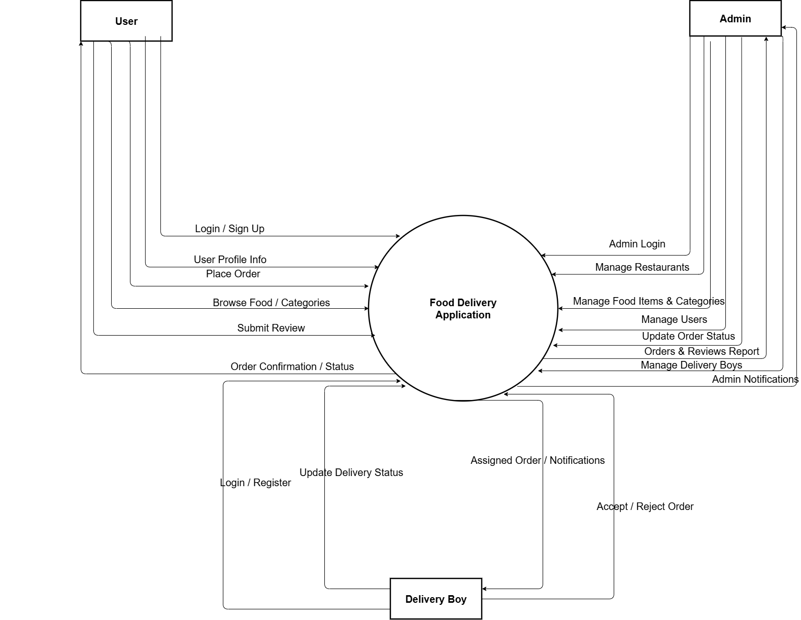

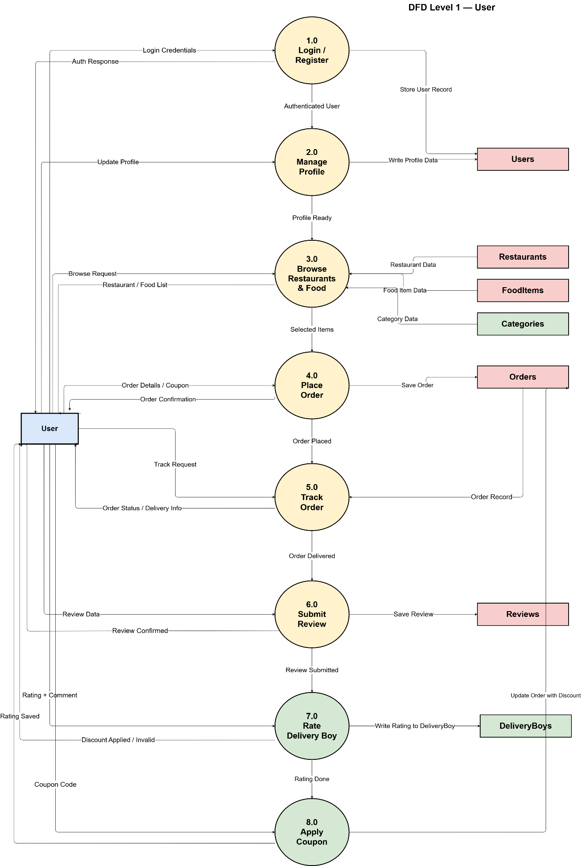
DFD Level 1 -User

DFD Level 1-Admin
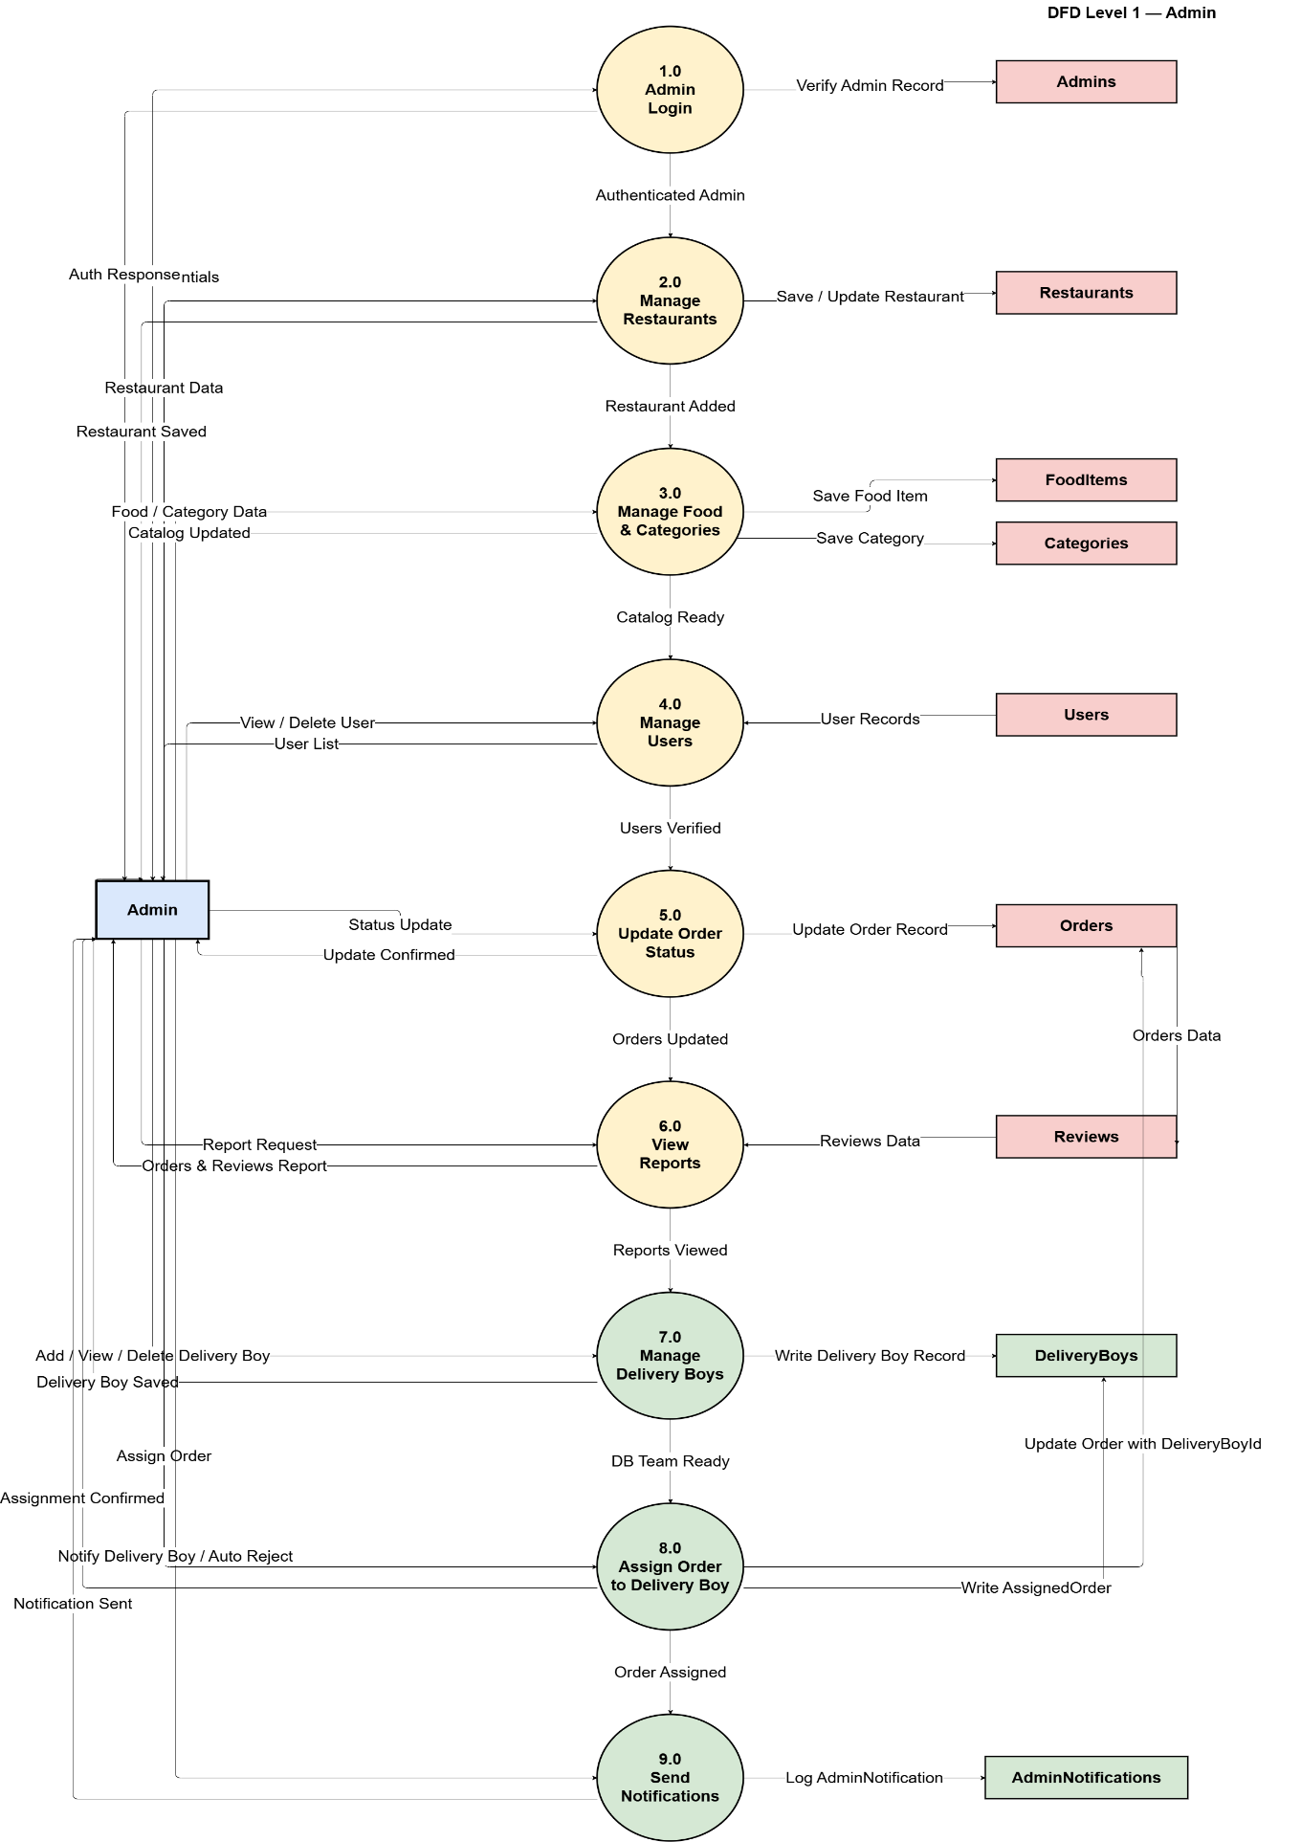

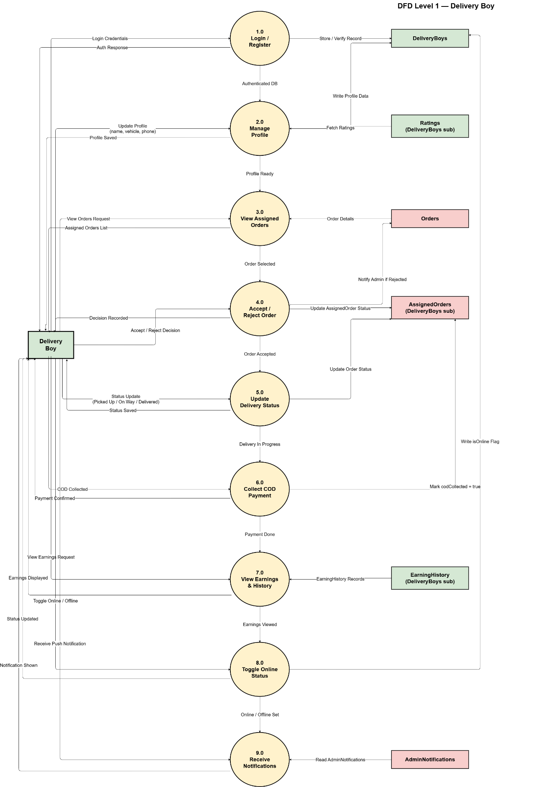
DFD Level 1-Delivery Boy

DFD Level 2-Process 6.8 Delivery Assignment & Tracking
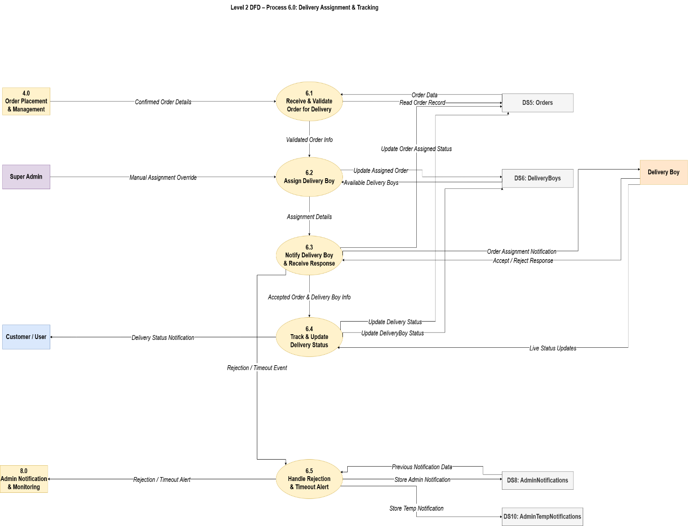

ER Diagram

E-R (Entity-Relationship) Diagram is used to represents the relationship between entities in the table.

ER Notation
There is no standard for representing data objects in ER diagrams. The symbols used for the basic ER constructs are:
- Entities are represented by labeled rectangles. The label is the name of the entity. Entity names should be singular nouns.
- Relationships are represented by a solid line connecting two entities. The name of the relationship is written above the line. Relationship names should be verbs
- Attributes, when included, are listed inside the entity rectangle. Attributes which are identifiers are underlined. Attribute names should be singular nouns.
- Links are represented by a solid line connecting attributes to entity or entity to relationship

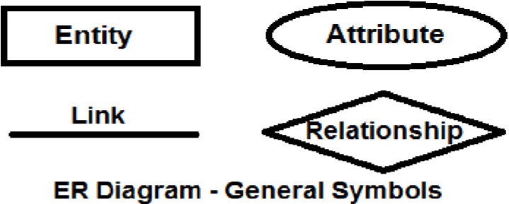

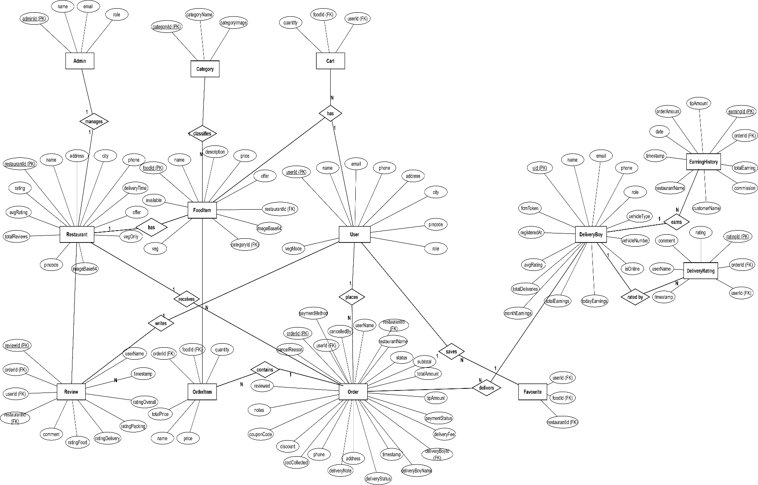
DataBase Design
The Food Delivery App uses Firebase Realtime Database as its backend, which stores all data in a structured JSON tree format. Although Firebase is a NoSQL database, the data has been logically organized into clearly defined table-like structures to ensure fast retrieval, organized storage, and real-time synchronization across all three panels — Customer, Admin, and Delivery Boy. The following tables describe the complete database design of the application.

1. User Table (Customer / Admin / Delivery Boy)
Field Name | Data Type | Description
userId (PK) | VARCHAR(50) | Unique Firebase UID assigned to each user upon registration
name | VARCHAR(100) | Full name of the user
email | VARCHAR(100) | User's registered email address (unique)
phone | VARCHAR(15) | User's contact phone number
accountType | ENUM('customer', 'admin', 'deliveryboy') | Defines the user's role and determines dashboard routing
address | TEXT | Default delivery address saved by the customer
profileImageUrl | VARCHAR(255) | URL of the user's profile image (optional)
Description: Every registered user on the platform is stored under the users/[uid] node in Firebase Realtime Database. The accountType field is the key field that controls which panel the user is routed to after login. Each user's data is isolated under their unique Firebase UID, preventing any cross-user data access and ensuring complete privacy.

2. Food Item Table
Field Name | Data Type | Description
itemId (PK) | VARCHAR(50) | Unique ID for each food item
name | VARCHAR(100) | Name of the food item
category | VARCHAR(50) | Food category such as Burger, Pizza, Biryani, Dessert, or Drink
description | TEXT | Short description of the food item
price | DECIMAL(8,2) | Price of the food item in rupees
imageUrl | VARCHAR(255) | URL of the food item's image stored in Firebase Storage
isAvailable | BOOLEAN | Indicates whether the item is currently available on the menu
Description: All food items are stored under the foodItems node in Firebase Realtime Database. The admin manages this data from the food menu management section of the admin panel. Any addition, update, or deletion made by the admin is reflected instantly on the customer's home screen through Firebase real-time listeners.

3. Cart Table
Field Name | Data Type | Description
cartItemId (PK) | VARCHAR(50) | Unique ID for each cart entry
userId (FK) | VARCHAR(50) | References Users.userId
itemId (FK) | VARCHAR(50) | References FoodItems.itemId
name | VARCHAR(100) | Name of the food item in the cart
price | DECIMAL(8,2) | Price of the item at the time it was added to the cart
quantity | INT | Number of units of the item added to the cart
imageUrl | VARCHAR(255) | Image URL of the item for display on the cart screen
Description: Cart data for each customer is stored under the cart/[uid]/[itemId] node in Firebase. The cart persists across sessions so that customers do not lose their selections if they navigate away from the app. The total payable amount is calculated dynamically on the client side by multiplying each item's price by its quantity and summing the results.

4. Order Table
Field Name | Data Type | Description
orderId (PK) | VARCHAR(50) | Unique ID generated for each order using Firebase push key
customerId (FK) | VARCHAR(50) | References Users.userId of the customer who placed the order
customerName | VARCHAR(100) | Full name of the customer at the time of order
customerPhone | VARCHAR(15) | Phone number of the customer for delivery contact
deliveryAddress | TEXT | Full delivery address provided by the customer at checkout
totalAmount | DECIMAL(8,2) | Total payable amount for the order
orderStatus | ENUM('Pending', 'Confirmed','Outfor Delivery', 'Delivered', 'Rejected') | Current status of the order updated in real time
assignedDeliveryBoyId | VARCHAR(50) | Firebase UID of the delivery boy assigned to this order
assignedDeliveryBoyName | VARCHAR(100) | Name of the assigned delivery boy
placedAt | TIMESTAMP | Date and time when the order was placed
confirmedAt | TIMESTAMP | Date and time when the admin confirmed the order
pickedUpAt | TIMESTAMP | Date and time when the delivery boy picked up the order
deliveredAt | TIMESTAMP | Date and time when the order was delivered to the customer
Description: All orders are stored under the orders/[orderId] node in Firebase Realtime Database. This is the most critical table in the application as it connects all three panels. Firebase listeners on the customer, admin, and delivery boy panels monitor this node and update the displayed order status in real time whenever any field changes.

5. Order Items Table
Field Name | Data Type | Description
orderItemId (PK) | VARCHAR(50) | Unique ID for each item entry within an order
orderId (FK) | VARCHAR(50) | References Orders.orderId
itemId (FK) | VARCHAR(50) | References FoodItems.itemId
name | VARCHAR(100) | Name of the food item at the time of order
price | DECIMAL(8,2) | Price of the item at the time of order
quantity | INT | Quantity of the item ordered
imageUrl | VARCHAR(255) | Image URL of the item for display in order summary and history
Description: The items belonging to each order are stored as a nested list under orders/[orderId]/items in Firebase. Storing the item name and price directly within the order record ensures that the order history remains accurate even if the admin later updates or removes the food item from the menu.

6. Delivery Boy Assignment Table
Field Name | Data Type | Description
assignmentId (PK) | VARCHAR(50) | Unique ID for each delivery assignment
orderId (FK) | VARCHAR(50) | References Orders.orderId
deliveryBoyId (FK) | VARCHAR(50) | References Users.userId of the delivery boy
deliveryBoyName | VARCHAR(100) | Name of the delivery boy assigned
assignedAt | TIMESTAMP | Date and time when the delivery was assigned
currentStatus | VARCHAR(50) | Current delivery status updated by the delivery boy
Description: Delivery assignment records are stored under the deliveryAssignments/[orderId] node in Firebase. This table tracks which delivery boy is handling which order and the progression of the delivery. It works in conjunction with the Orders table to provide a complete view of each order's delivery lifecycle.

7. Address Table
Field Name | Data Type | Description
addressId (PK) | VARCHAR(50) | Unique ID for each saved address
userId (FK) | VARCHAR(50) | References Users.userId
fullAddress | TEXT | Complete delivery address including street, area, and landmark
city | VARCHAR(100) | City name
pincode | VARCHAR(10) | Postal code of the delivery location
isDefault | BOOLEAN | Indicates whether this is the user's default delivery address
Description: Customer addresses are stored under the addresses/[uid]/[addressId] node in Firebase. Customers can save multiple addresses and select one during checkout. The isDefault flag identifies the primary address that is pre-selected when the customer reaches the checkout screen.

8. Notification Table
Field Name | Data Type | Description
notificationId (PK) | VARCHAR(50) | Unique ID for each notification
userId (FK) | VARCHAR(50) | References Users.userId of the recipient
message | TEXT | Notification message content
type | VARCHAR(50) | Type of notification such as Order Confirmed, Out for Delivery, or Delivered
orderId (FK) | VARCHAR(50) | References Orders.orderId related to the notification
isRead | BOOLEAN | Indicates whether the notification has been read by the user
createdAt | TIMESTAMP | Date and time when the notification was generated
Description: Notifications are stored under the notifications/[uid]/[notificationId] node in Firebase. Whenever an order status changes, a new notification entry is created for the relevant customer. This ensures that customers are always informed of their order progress even if they are not actively viewing the order status screen.

Firebase Realtime Database Node Structure
The overall structure of the Firebase Realtime Database for the Food Delivery App is organized as follows:
- foodItems
  - itemId (full food item details)
- orders
  - orderId (full order details including nested items list)
- cart
  - uid (customer's cart items keyed by itemId)
- users
  - uid
    - accountType
    - name
    - email
    - phone
    - address
    - profileImageUrl
- addresses
  - uid
    - addressId (full address details)
- deliveryAssignments
  - orderId (assignment details)
- notifications
  - uid
    - notificationId (notification details)

Relationship Overview
- One User (Customer) → Many Orders
- One User (Customer) → One Cart with Many Items
- One User (Customer) → Many Saved Addresses
- One Order → Many Order Items
- One Order → One Delivery Assignment
- One Order → Many Notifications
- One User (Delivery Boy) → Many Delivery Assignments
- One Admin → Many Food Items managed
- One Food Item → Many Order Items across different orders
This structured database design ensures organized and efficient data storage, fast real-time retrieval across all three panels, clear separation of data between different user roles, and a scalable foundation that can accommodate future enhancements such as multiple restaurant support, payment integration, and advanced order analytics.

Screenshot & Description

1)Login Pages:-
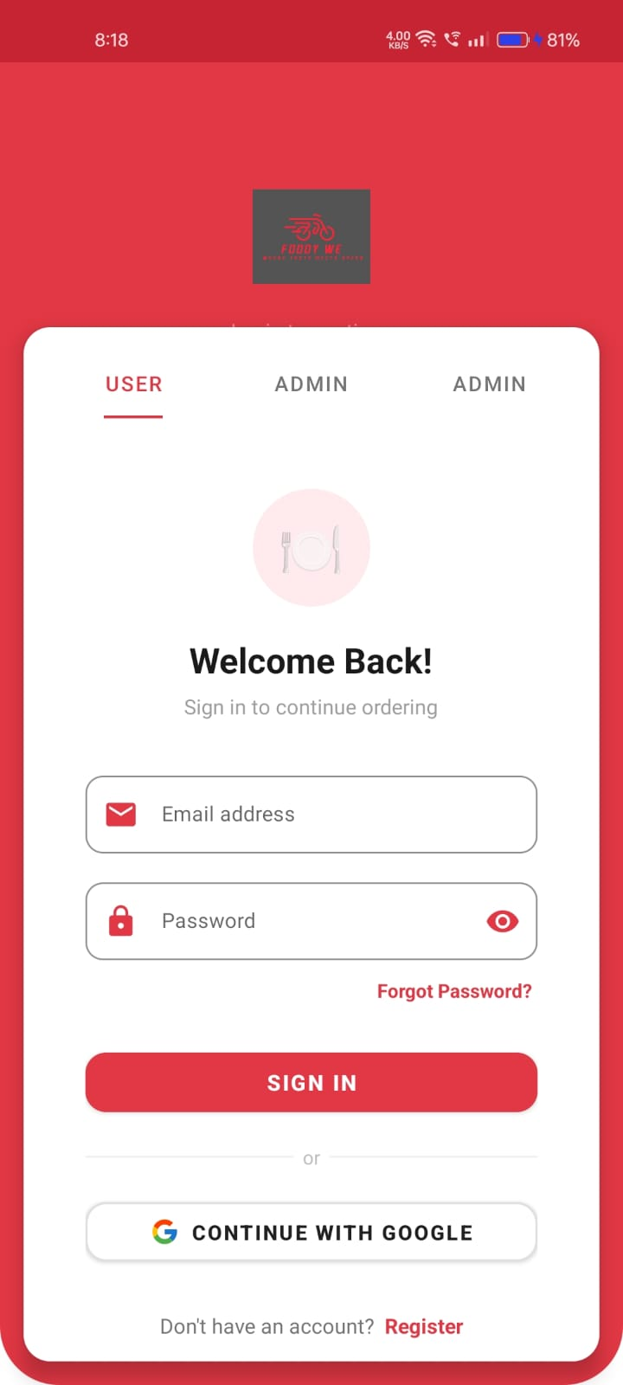
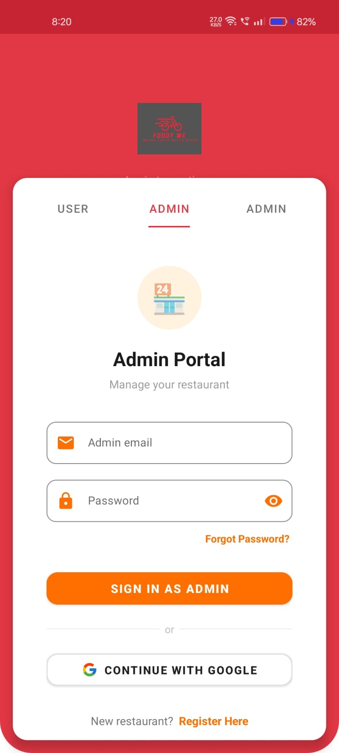
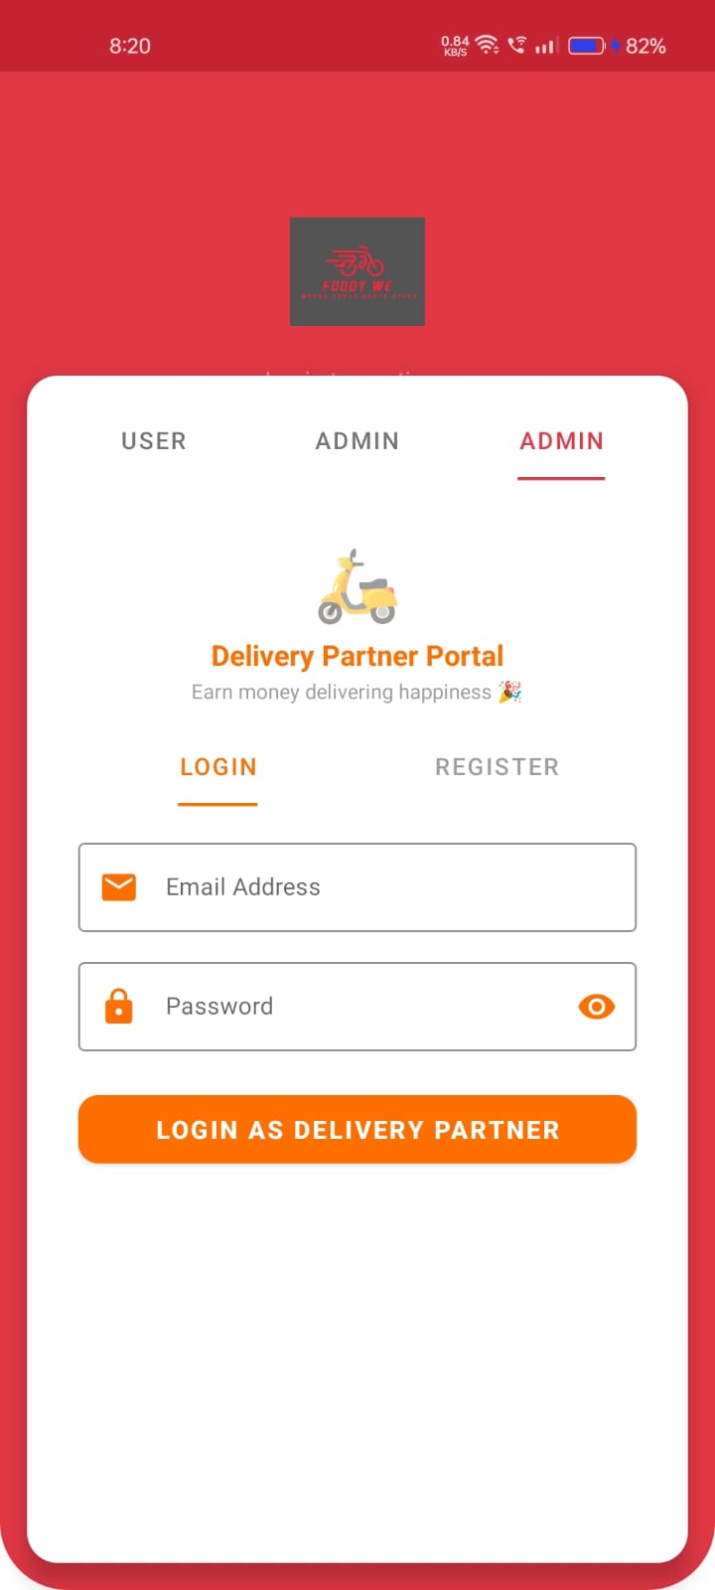

User Login Fragment Admin Login Fragment DeliveryBoy Login

2)User side pages

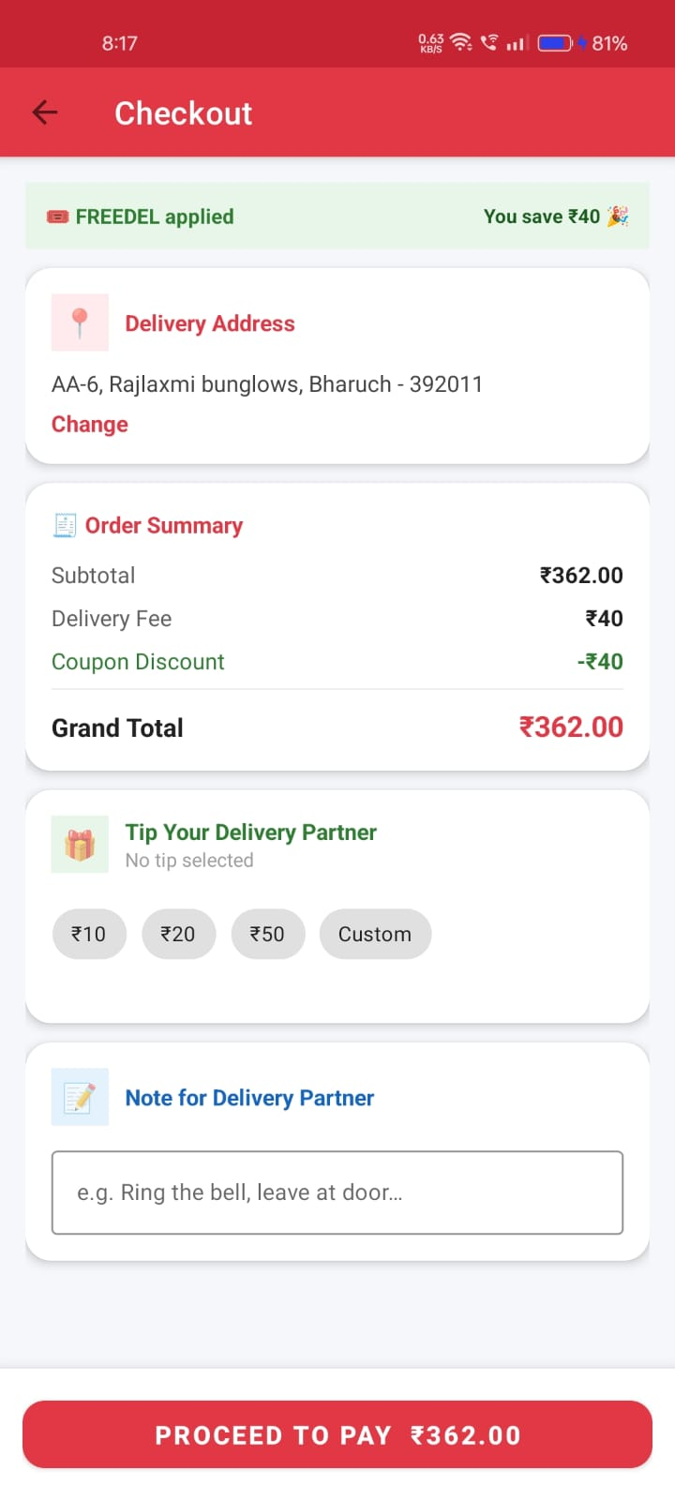
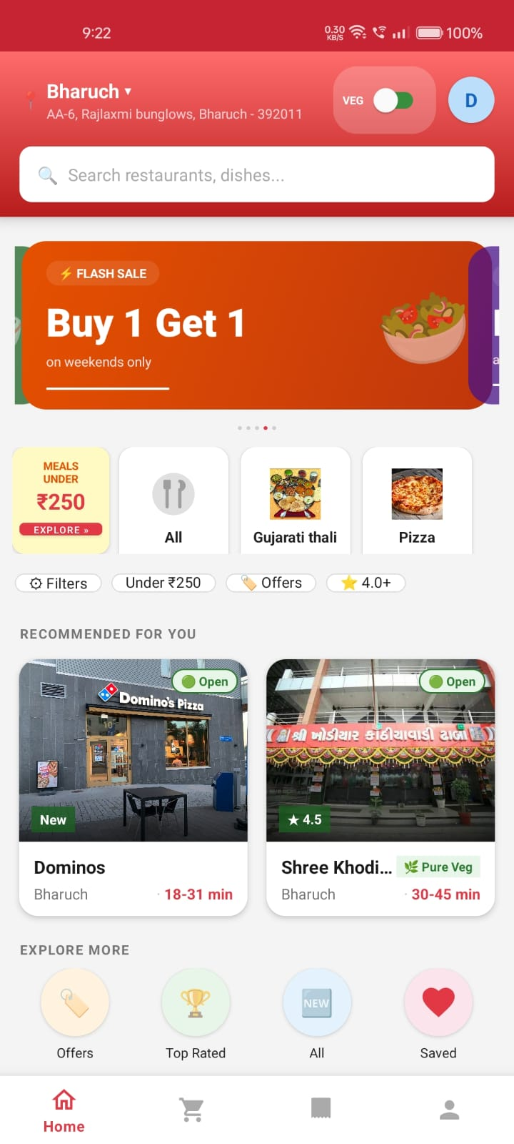
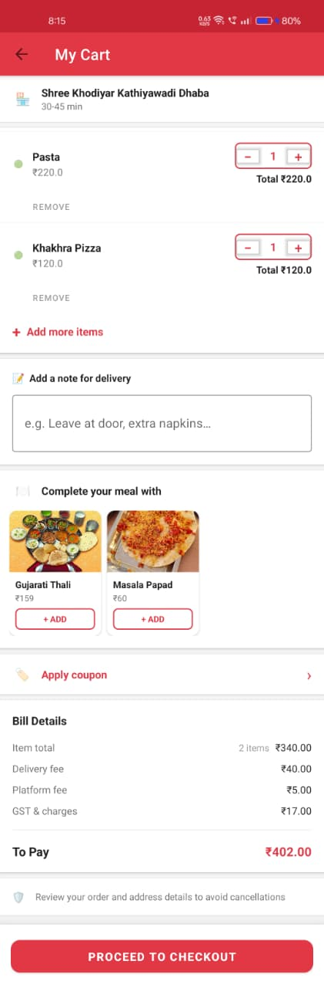
Home Page Cart Activity CheckOut Activity

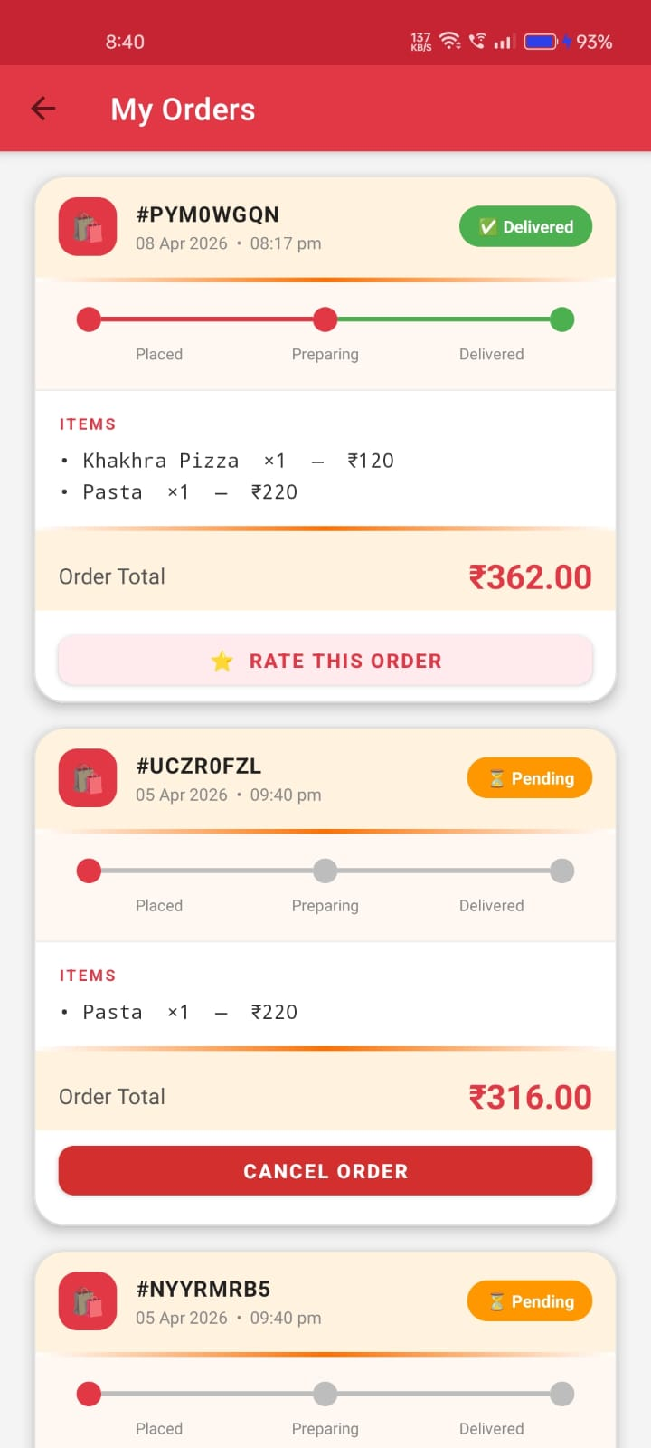
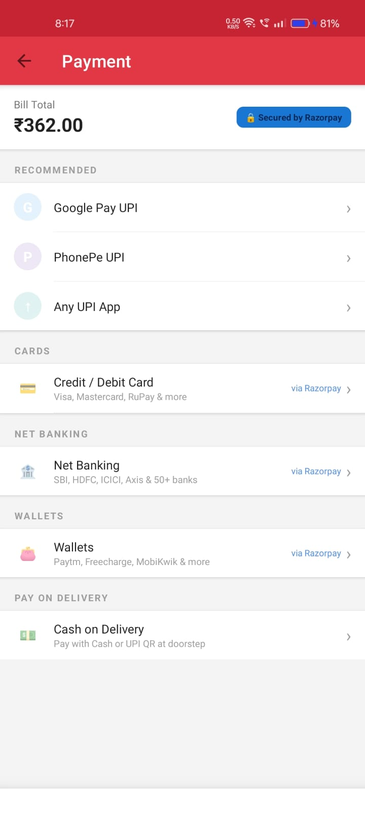
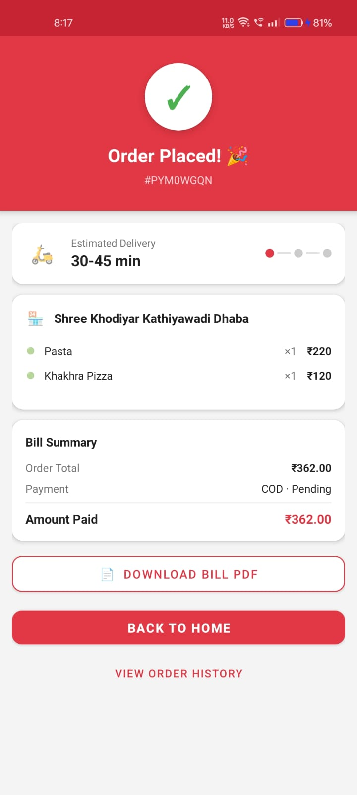

Payment Activity Order Confirmation Page Order History Page

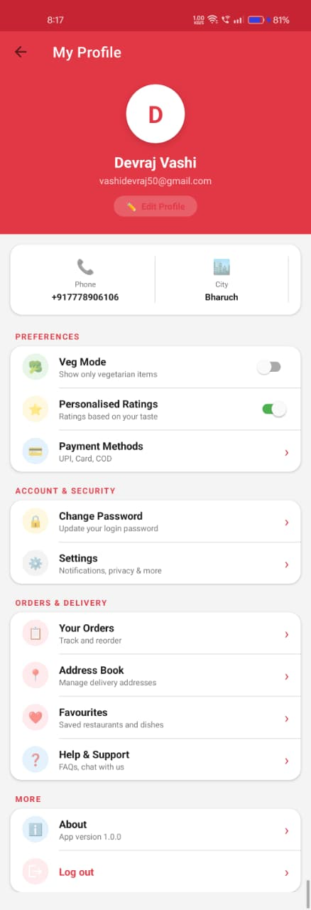
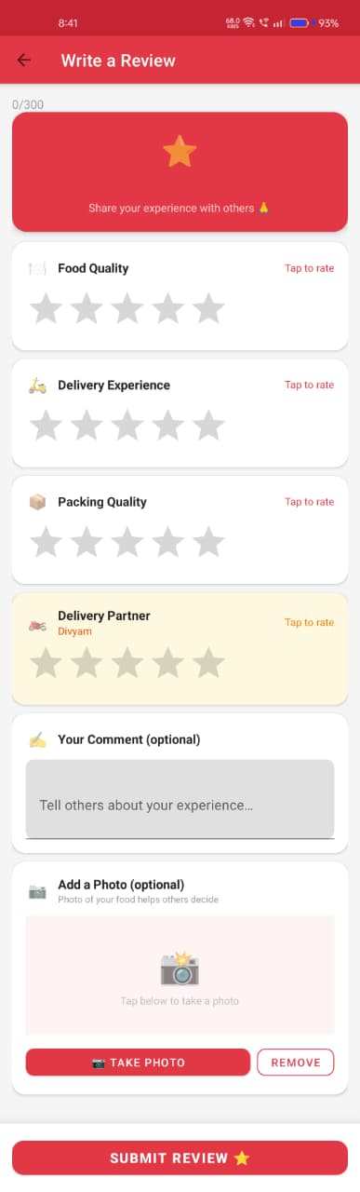

User Profile Activity Write Review Activity

Admin Pages:-
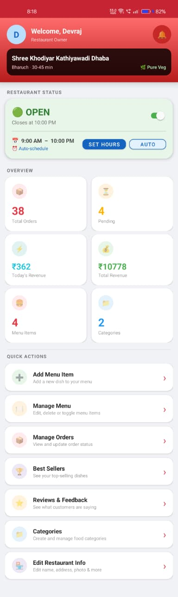
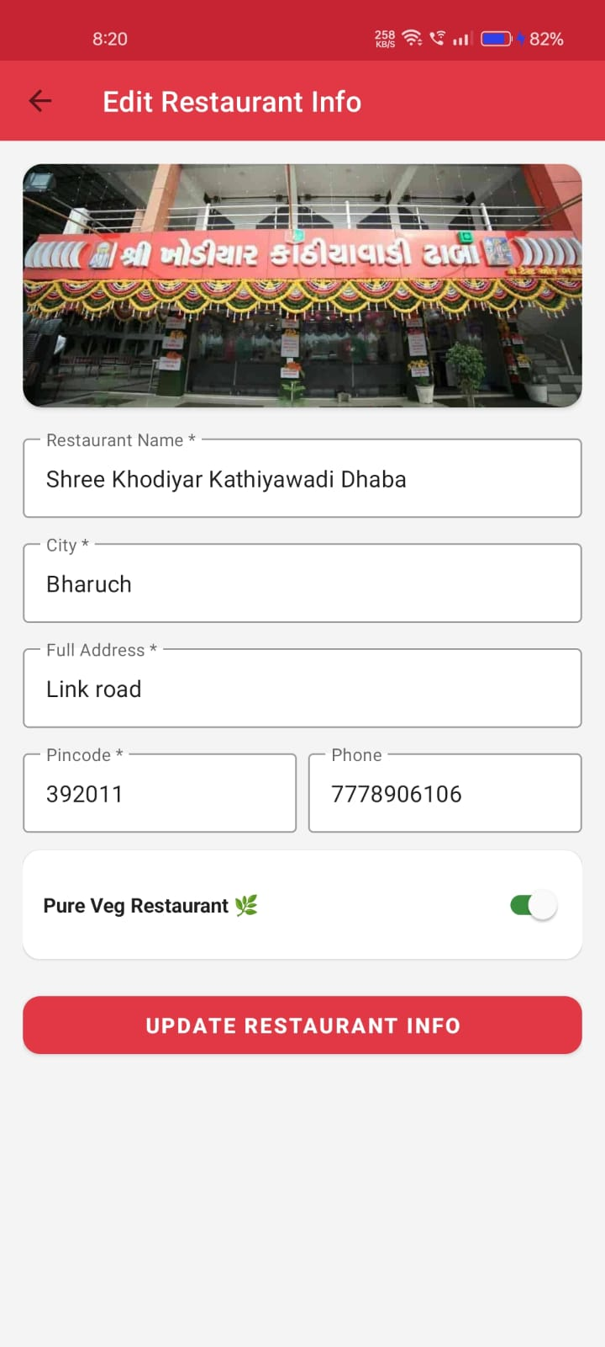
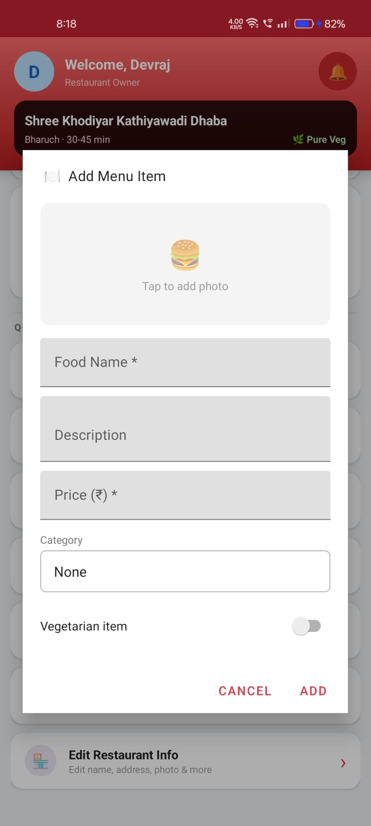
Admin Home page Add Menu Activity Add/Edit Restaurant Page

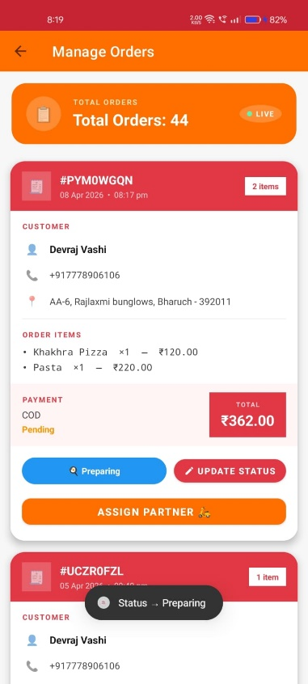
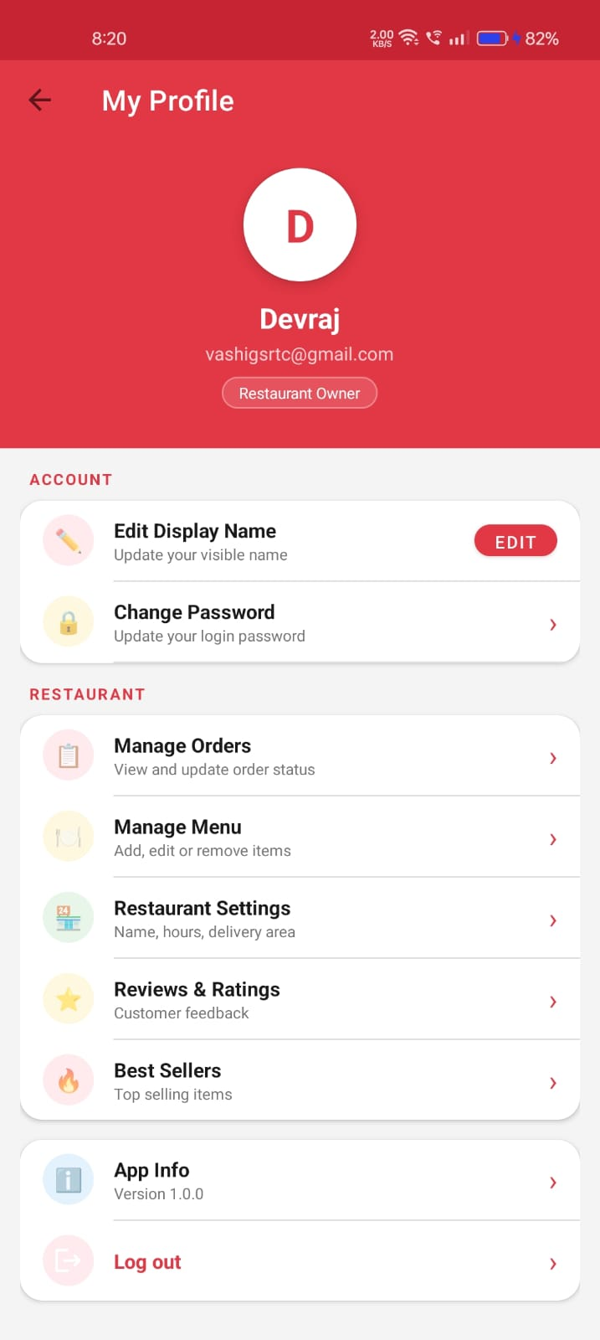
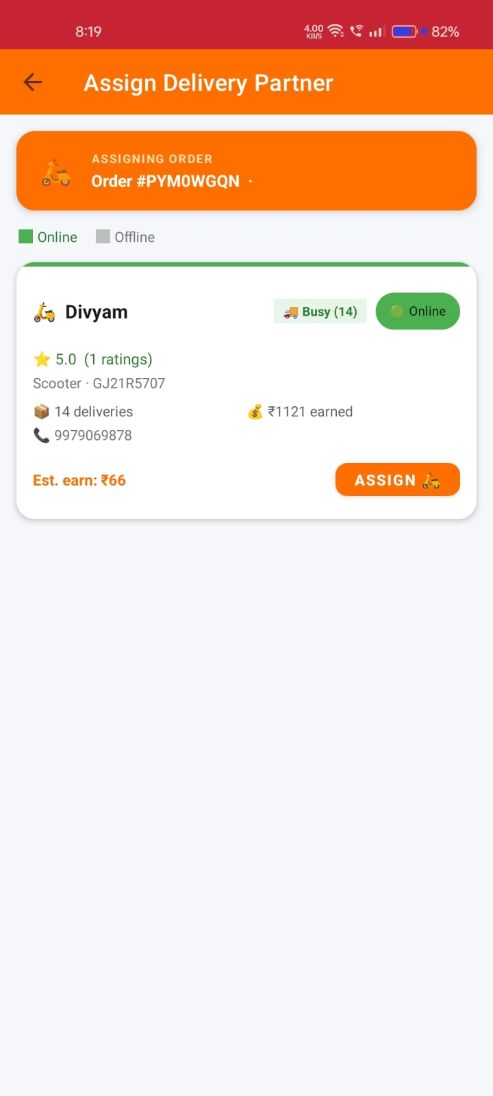
Admin Manage Orders Page Assign Delivery Partner Admin Profile

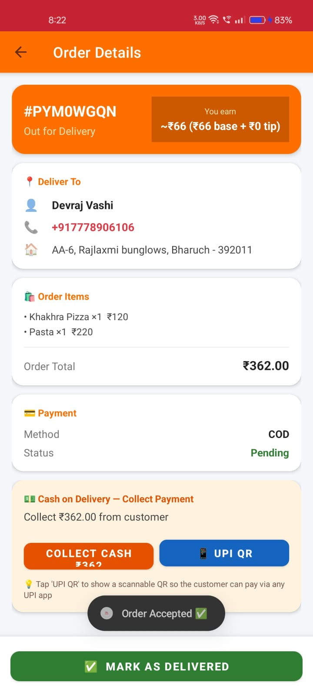
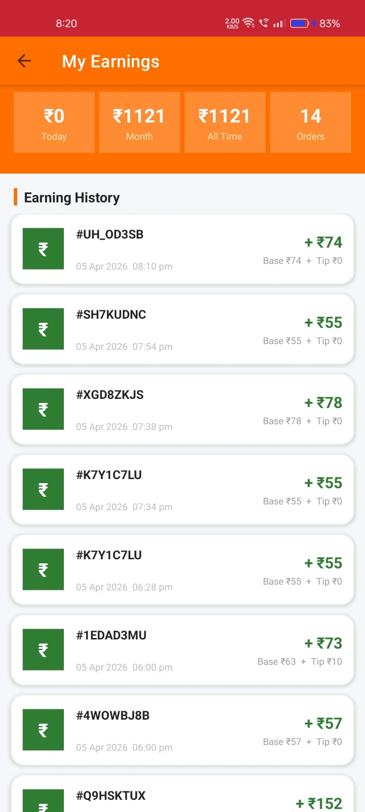
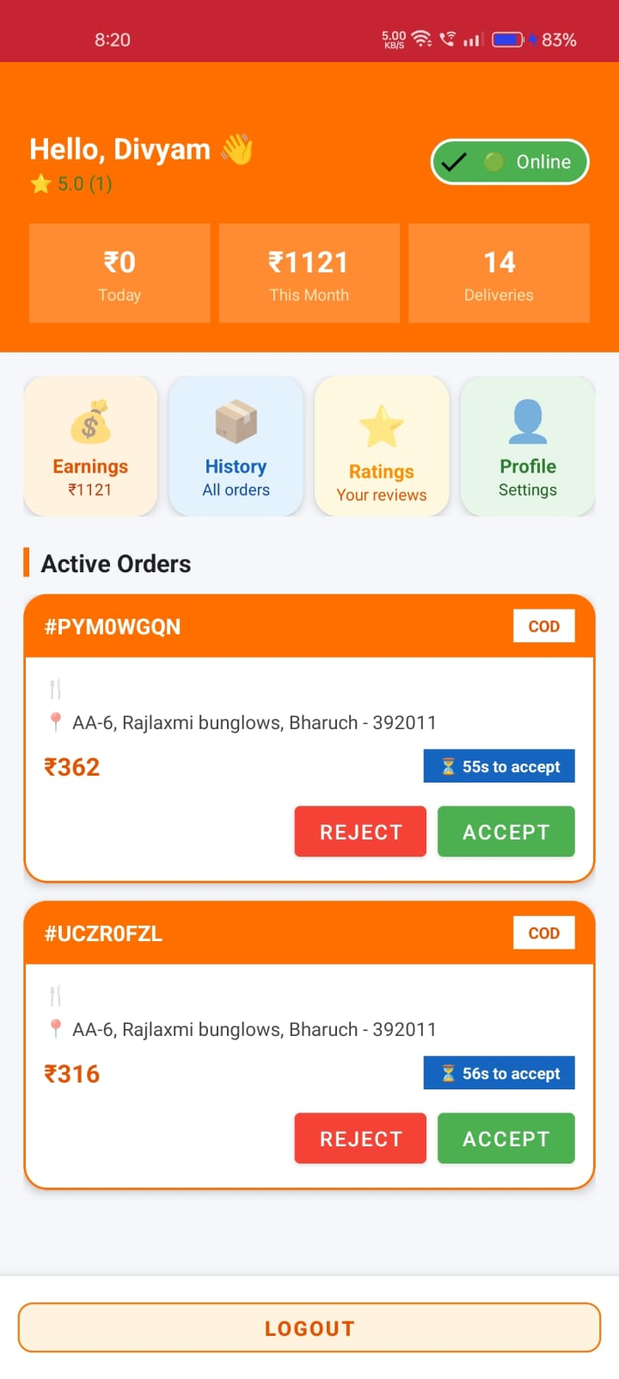
Delivery Boy Pages:-

DeliveryBoy Home page Order Details Page Earnings Page

Conclusion

The Food Delivery App successfully fulfills its core objective of building a structured, multi-role, and user-friendly digital platform that bridges the gap between restaurants, customers, and delivery personnel. Developed entirely in Java for the Android platform and powered by Google Firebase as the backend infrastructure, this application replaces the need for any traditional order management with a dynamic, cloud-synced, and real-time mobile solution. What started as an academic project for the BCA Sixth Semester Major Project has been shaped into a complete and production-quality Android application, carefully built to serve the practical needs of all three roles involved in a food delivery ecosystem.

At its foundation, the application is structured around a three-role architecture — User (Customer), Admin (Restaurant Owner), and Delivery Boy — each with a fully separate dashboard, dedicated data paths, and role-specific features. This architecture ensures that responsibilities and data visibility are clearly separated, which is essential for a real-world delivery platform. Firebase Authentication handles secure login, registration, and role-based routing at the entry point itself, so each user type is always directed to the correct experience without any risk of overlap or unauthorized access.

From the customer's perspective, the application provides a rich and engaging browsing experience. The User Dashboard features auto-scrolling offer banners, category-wise food filtering, a spotlight section for featured restaurants, and a horizontally scrollable list of all available restaurants along with top food items. A real-time search bar with autocomplete suggestions powered by Firebase allows users to instantly find food items or restaurants by name. Users can mark their preferred restaurants and food items in a dedicated Favourites section, which is synced to the cloud so it persists across sessions. The Food Detail Activity shows full item descriptions and allows direct cart addition, while the Restaurant Menu Activity shows the full menu organized by categories for a particular restaurant.

The ordering workflow has been designed to be smooth, complete, and commercially realistic. The Cart Activity allows users to adjust item quantities, apply up to two discount coupons (including a FREEDEL coupon that waives the delivery fee), view the running subtotal with live price updates, and proceed to checkout with a single tap. The Checkout Activity presents the final order summary, delivery address, delivery instructions for the delivery boy, and a tip selection module with preset chips (₹10, ₹20, ₹50) plus a custom tip input. Payment is handled through a fully integrated PaymentActivity that supports Razorpay (card/UPI/netbanking), legacy UPI deep-link, and Cash on Delivery (COD) — covering virtually every payment method a real user might prefer. Upon successful payment, the order is written to Firebase and the user is taken to a polished Order Success screen with the order ID and status.

Once an order is placed, users can track it in real time through the Order History Activity, which shows all past and active orders with their current statuses — from Pending → Accepted → Picked Up → Delivered. After an order is delivered, users are prompted to submit a review through the Write Review Activity, which captures separate star ratings for Food Quality, Delivery Speed, and Packaging along with a written comment. The overall rating is auto-calculated as an average of the three sub-ratings and is stored under the restaurant's review node in Firebase. Crucially, the delivery boy's rating from the delivery sub-rating is also synced to the DeliveryBoys node, directly impacting their average rating displayed on their dashboard. This end-to-end review pipeline makes quality feedback a core part of the user journey rather than an afterthought.

The Admin (Restaurant Owner) Panel provides powerful management tools through a well-organized interface. The Admin Dashboard allows the admin to set up and manage their restaurant profile including name, address, cuisine type, delivery time, vegOnly flag, operating hours, and a toggle for manual open/close override. Food items are managed through a structured Add Food dialog that supports category selection, image upload (encoded as Base64), pricing, and description. Through the Admin Menu Activity, the admin can edit, delete, or toggle the availability of individual food items in real time. The Admin Orders Activity presents all incoming orders with full details, and allows the admin to accept, assign a delivery boy, or reject orders with an "Assign Delivery Boy" button that also triggers an FCM push notification to the selected delivery personnel via the Firebase Cloud Messaging legacy HTTP API running on a background thread.

Beyond order management, the admin has access to a Best Sellers Activity that automatically calculates and ranks the most ordered food items by analyzing historical order data from Firebase — a genuinely useful business intelligence feature. The Admin Reviews Activity displays all customer reviews submitted for their restaurant, organized in tabs by restaurant scope, so the owner can clearly see the feedback their customers are providing. The admin can also create and manage discount coupons that are made available to users during checkout, with configurable discount amounts, minimum order values, new-user restrictions, and free-delivery coupons.

The Delivery Boy module is a fully self-contained experience that begins with a dedicated login and registration flow, including optional vehicle number entry (which is skipped for bicycle riders). The Delivery Boy Dashboard shows an online/offline toggle that syncs instantly to Firebase, today's earnings, total deliveries, average rating, and a live list of assigned orders. When an order is assigned, the delivery boy can open the Delivery Order Detail Activity to view the full order — customer name, address, phone number, all ordered items, payment method, and delivery note. From there, they can update the order status to Picked Up and then Delivered, with each update reflected instantly for the admin and customer. Completed deliveries automatically credit the earnings history of the delivery boy, and their Delivery Earnings Activity provides a breakdown of today's, monthly, and total earnings with a full history list. The Delivery Order History Activity shows all past completed orders, and their Profile Activity lets them update personal details. The Admin Delivery Boys Activity allows the admin to view and manage the list of all registered delivery personnel.

The Firebase Realtime Database structure underpinning the app is carefully organized into eleven top-level nodes: Users, Admins, DeliveryBoys, Restaurants, FoodItems, Categories, Orders, Reviews, AdminNotifications, AdminTempNotifications, and adminFcmTokens. This structure supports a dual-write pattern where food items are stored both globally under FoodItems and under the admin's restaurant node, ensuring fast retrieval for users while keeping the admin's ownership clear. Orders carry full order details including restaurant ID, user ID, delivery boy ID, payment method, status, and all item references, making order tracking across roles seamless without requiring any cross-table joins — a design necessity for Firebase's document-based nature.

On the UI/UX side, the application takes clear inspiration from industry-leading apps like Swiggy and Zomato. Vibrant food cards and restaurant cards with Base64-decoded images, color-coded status badges, animated heart toggles for favourites, gradient admin panels, Material Design components throughout, a clean bottom navigation bar with four tabs, and well-designed splash and authentication screens all combine to give the app a genuinely polished and professional appearance. This attention to visual design is intentional — the goal was never just to build something functional for the sake of coursework, but to build something that would be usable in a real-world context.

Although the current version does not include certain advanced capabilities such as AI-based food recommendations, real-time GPS delivery tracking on a map, automated SMS notifications, cross-platform (iOS) support, or a dedicated web-based admin panel, the application provides a solid and well-structured foundation that can support these additions with relatively straightforward extensions. The existing Firebase architecture, modular activity structure, and role-based session management are all designed with scalability in mind, making future enhancements practical rather than requiring a rebuild.

In summary, this project demonstrates hands-on practical implementation of multi-role Firebase authentication, real-time cloud database integration, structured multi-node data storage, a complete three-sided marketplace workflow, payment gateway integration (Razorpay), FCM push notifications, coupon and discount management, a sub-rating review system, earnings tracking, and a clean and intuitive mobile interface — all within a single Android application built in Java. It reflects not just the technical skills developed through the BCA programme, but a genuine effort to understand and implement how a real digital product is engineered from the ground up.

Future Scope

The current version of the Food Delivery App provides a strong and well-structured foundation for a real-world digital food ordering and delivery platform. However, there is significant potential to expand and enhance the system in the future. The following improvements and extensions can make the application.

1. Growing Market Demand and Expansion
The food delivery industry in India is growing at a rapid pace, driven by rising internet penetration, smartphone adoption, and changing consumer habits where people increasingly prefer ordering food online over dining out or cooking. This creates a strong real-world demand for exactly the kind of platform this application represents.
The app can be upgraded from a single-restaurant model to a true multi-restaurant marketplace where several restaurant owners can register independently, manage their own menus and orders, and operate under one centralized platform — similar to how Zomato or Swiggy work at scale. A centralized super-admin panel can be introduced to oversee all registered restaurants, monitor platform-wide orders, manage delivery personnel allocation, and handle disputes or complaints. This would transform the application into a commercial SaaS-based food delivery platform that small and medium restaurant chains could subscribe to and use without building their own technology.

2. Cross-Platform and Wider Accessibility
Currently the application is built exclusively for the Android platform. Developing an iOS version of the app would significantly expand the potential user base, as a large portion of smartphone users in urban markets use Apple devices. A React Native or Flutter-based cross-platform rewrite could allow the same codebase to serve both Android and iOS simultaneously.
A web-based admin dashboard would make restaurant management far more practical for owners who prefer working on a desktop or laptop rather than a mobile device. Features like bulk menu uploads, detailed sales reports, and order monitoring are far easier to use on a larger screen. A tablet-optimized interface could serve as a front-desk ordering terminal for restaurants that want to manage dine-in and delivery orders from one device. Multi-language support would further open the application to regional markets across different Indian states.

3. Real-Time GPS Delivery Tracking
One of the most requested features in any food delivery application is the ability for customers to see their delivery boy's live location on a map as the order makes its way to them. Currently the app tracks order status through stages such as Accepted, Picked Up, and Delivered, but does not show geographic

movement. Integrating Google Maps SDK with real-time location sharing from the delivery boy's device would allow customers to watch their order move toward them on a live map, dramatically improving the experience and reducing anxious follow-up calls or messages.
This can be extended further with estimated time of arrival calculations based on live traffic data, automatic notifications when the delivery boy is nearby, and route optimization suggestions for the delivery boy to reach the customer faster.

4. AI-Based Personalization and Recommendations
Artificial intelligence and machine learning can be integrated to make the application significantly smarter in understanding user preferences and behavior. By analyzing a user's order history, browsing patterns, time of day, and location, the system can generate personalized food recommendations on the home screen — similar to how Netflix recommends content based on viewing history.
Beyond recommendations, AI can be used for dynamic pricing during peak hours, demand forecasting to help restaurants prepare the right quantity of food items in advance, and churn prediction to identify users who have not ordered in a while and trigger targeted discount offers to bring them back. Chatbot-based customer support powered by natural language processing could also handle common queries such as order status, refund requests, or menu information without requiring human intervention.

5. Advanced Analytics and Reporting
For the Admin (Restaurant Owner), a comprehensive analytics dashboard can provide actionable business insights. This would include monthly revenue reports, peak ordering hours, best-selling food items by time period, customer retention rates, average order value trends, and delivery performance metrics broken down by individual delivery boys. Currently the app includes a Best Sellers Activity that calculates top items from order history, but this can be extended into a full visual reporting suite with charts, graphs, and downloadable reports.
For Users, a personal order history analysis can show how many orders they have placed, how much they have spent, their most ordered items, and their average spending per order — creating an engaging and personalized account experience that makes them feel valued as a customer.

6. Enhanced Notification System
The current implementation uses Firebase Cloud Messaging to notify delivery boys when an order is assigned to them. This notification system can be expanded significantly. Customers can receive real-time push notifications at every stage of their order — when it is accepted by the restaurant, when food

preparation begins, when it is picked up, and when it is out for delivery. Restaurants can receive sound-based alerts for new orders arriving. Promotional notifications can be sent to users when a new restaurant joins, when a discount coupon is created, or when a limited-time offer is live. SMS-based notifications through services like Twilio or MSG91 can serve as a fallback for users who have disabled push notifications on their devices.

7. Virtual Ordering and Subscription Features
A scheduled ordering feature can allow users to pre-schedule meals for specific times — for example, setting up a daily lunch order that gets placed automatically every weekday at 12:30 PM. This is particularly useful for office-goers and working professionals.
Subscription-based meal plans can be offered in partnership with restaurants, where users subscribe to a weekly or monthly tiffin plan and receive home-cooked style meals delivered every day. This creates a recurring revenue model for restaurants and a hassle-free meal solution for users. In-app loyalty programs where users accumulate points with every order and redeem them for discounts or free deliveries would further improve retention and encourage repeat ordering.

8. Monetization Opportunities
The current application does not include a revenue generation mechanism beyond order placement. In a commercial version, several monetization strategies can be layered in. Restaurants can be charged a commission percentage on every order placed through the platform. Premium restaurant listings and sponsored placements in the spotlight section can be offered to restaurants willing to pay for better visibility. Surge pricing during peak hours or high-demand periods can be implemented with transparent communication to the user. Delivery fee tiering based on distance can be calculated dynamically rather than using a fixed flat fee.

9. Enhanced Security and Data Privacy
As the application handles sensitive user data including names, phone numbers, delivery addresses, payment information, and order history, stronger security measures are important for a commercial deployment. Multi-factor authentication with OTP-based login via SMS or email would add an additional layer of protection beyond the current email-password Firebase Authentication. End-to-end encryption for sensitive data fields, compliance with data protection standards, and secure payment gateway integration with PCI-DSS compliant providers like Razorpay (already partially integrated) at its full production level would all be necessary for a production release. Role-based data visibility controls ensuring that delivery boys cannot see other delivery boys' data, and that restaurant admins cannot access user account details beyond what is needed for delivery, should also be tightened.

10. Offline Mode and Performance Optimization
Currently, the application requires an active internet connection for all operations since it reads and writes to Firebase Realtime Database in real time. An offline mode using Firebase's built-in local persistence or a local Room database can allow users to browse cached restaurant menus and view their order history even without connectivity, with changes syncing automatically once the connection is restored.
Performance improvements such as image lazy loading, paginated data fetching to handle large restaurant or food item lists without loading everything at once, and better memory management for Base64-decoded images would make the app faster and more responsive, especially on lower-end Android devices which make up a significant portion of the Indian smartphone market.

Overall Future Vision
The Food Delivery App has been designed with a modular and scalable architecture, making it well-positioned to grow beyond its current academic scope into a comprehensive, enterprise-level food delivery and restaurant management platform. While the present version successfully digitizes the complete ordering pipeline — from restaurant browsing and cart management to payment processing, delivery assignment, and customer reviews — there is significant potential for technological enhancement in future iterations.
In future versions, the application can evolve into a smart food delivery ecosystem by integrating Artificial Intelligence and Machine Learning for personalized recommendations, demand forecasting, and customer behavior analysis. Real-time GPS tracking would elevate the customer experience to match that of industry leaders. A multi-restaurant marketplace model with a super-admin layer would make the platform commercially deployable at scale.
The Firebase-based backend infrastructure already provides a solid foundation for real-time data synchronization, user authentication, and cloud storage, which makes expanding and adding new modules straightforward without requiring a complete architectural overhaul. Cross-platform development for iOS and a web-based admin portal would broaden accessibility, while advanced analytics and a loyalty program would deepen user engagement and generate sustainable revenue.
Overall, with continued development and integration of modern technologies, the Food Delivery App has the potential to become a fully automated, intelligent, and user-centric platform that serves restaurants, customers, and delivery personnel with equal effectiveness — enhancing operational efficiency, customer satisfaction, and business growth in a competitive and fast-growing market.

References
Web Resources
The following websites were referred to during the analysis and development phase of the project:
(1) https://developer.android.com/docs — Official Android developer documentation covering Activity lifecycle, Firebase integration, RecyclerView, Material Design components, and ViewBinding.
(2) https://firebase.google.com/docs — Firebase official documentation for Realtime Database, Firebase Authentication, and Firebase Cloud Messaging (FCM).
(3) https://razorpay.com/docs/payments/payment-gateway/android-integration — Razorpay Android SDK integration guide used for implementing the payment gateway.
(4) https://developer.android.com/courses — Android developer training courses covering Java-based Android development fundamentals.
(5) https://www.cheezycode.com — Android and Java development tutorials referenced for practical implementation guidance.
Book Resources
The following books were referred to during the analysis and development phase of the project:
- "Android Programming with Kotlin for Beginners" by John Horton
- "Android App Development for Dummies" by Michael Burton
- "Head First Android Development" by Dawn Griffiths and David Griffiths
- "Firebase Cookbook" by Houssem Yahiaoui

