**Movie.txt File Content Must Be In The Given Format:**

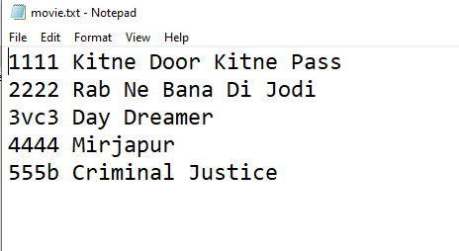

**File Explanation:**

**movieId movieName**

**1111 AAAA**

**2222 BBBB**