1. Write a program to display the complete contents (until the last node) of any given folder.

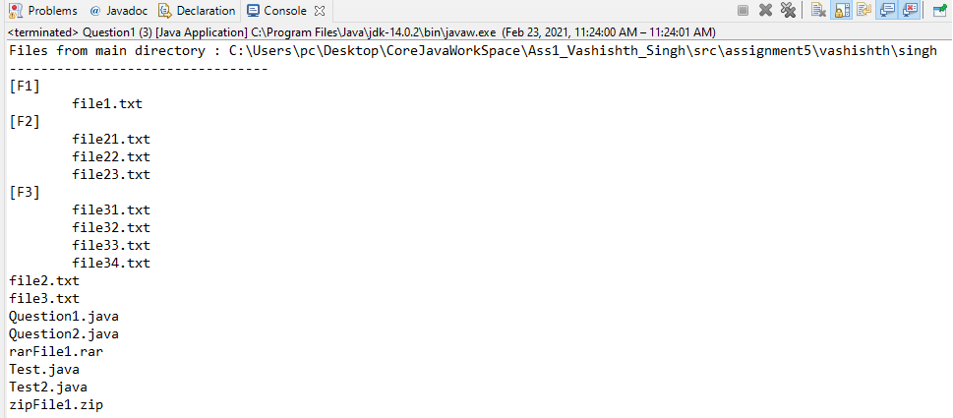

1. Store list of file names for each folder in a Map in the same above method.

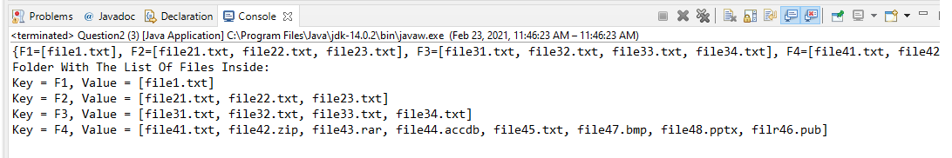

1. Create a file search utility which searches for a given file in a given path.

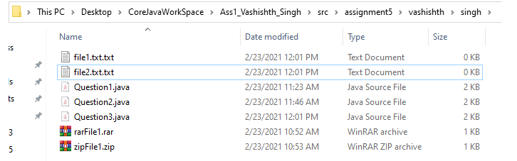

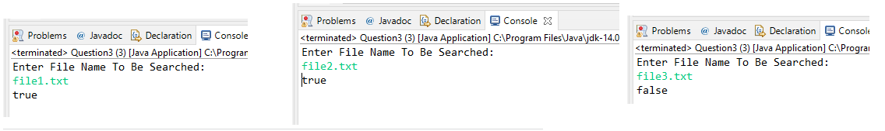

1. Write a program to Finds the number of words in a text file.

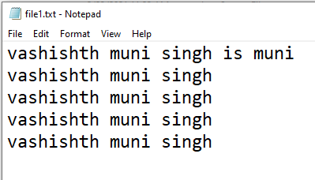

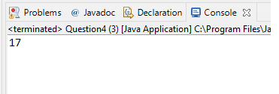

1. Write a program to initialize movie data from file movies.txt

Movies.txt file data

