JAYPEE INSTITUTE OF INFORMATION TECHNOLOGY
(Declared Deemed to be University U/S 3 of UGC Act)
A-10, Sector 62, Noida, Uttar Pradesh, India

GROCO: SMART GROCERY SUPPLY MANAGEMENT SYSTEM
WITH INTEGRATED PRICE COMPARISON, INVENTORY INTELLIGENCE,
AND EXPIRY-AWARE REORDER ASSISTANCE
Capstone Project Report (Current Semester Submission)

Submitted By
Vashni Agrahari
Enrollment No. 22102213
Section: A8
Under the Supervision of
Dr. Juhi Gupta
Department of Computer Science and Engineering
May 2026

Certificate
This is to certify that the project work titled "Groco: Smart Grocery Supply Management System with Integrated Price Comparison and Expiry-Aware Reorder Assistance" has been carried out by Vashni Agrahari (Enrollment No. 22102213) in partial fulfillment of the requirements for the award of the Bachelor of Technology degree. The work presented in this report has been completed under my supervision and reflects an original engineering effort focused on applied artificial intelligence, mobile computing, and sustainable household inventory management.
To the best of my knowledge, this work has not been submitted, either in part or full, to any other university or institute for the award of any degree or diploma. The student has followed standard academic and engineering practices, including iterative design, implementation validation, testing, and result documentation, in alignment with the expected graduate outcomes of the program.
Supervisor Signature: __________________________
Name: Dr. Juhi Gupta
Designation: __________________________
Date: __________________________

Declaration of Originality
I, Vashni Agrahari, hereby declare that the work presented in this capstone report is my original work carried out during the current academic semester. The design decisions, implementation strategy, testing artifacts, and analysis included in this report have been prepared specifically for this submission and are aligned with the present state of the project codebase.
I further declare that while references, technical documentation, and prior semester learnings were used for contextual understanding, the content of this report has been rewritten and expanded to reflect the integrated Android-only solution delivered in the current semester, including the Kotlin-based migration of the price comparison prototype and the final user-facing workflow.
All external sources are acknowledged in the references section. I understand that any violation of academic integrity policies may lead to disciplinary action as per institutional guidelines.
Signature of Student: __________________________
Name: Vashni Agrahari
Enrollment No.: 22102213
Date: __________________________

Acknowledgement
I express my sincere gratitude to Dr. Juhi Gupta for continuous mentorship, technical guidance, and constructive feedback throughout the capstone lifecycle. Her guidance helped transform an early recognition-focused prototype into a complete, user-ready mobile system with practical utility and measurable impact.
I also acknowledge the support provided by Jaypee Institute of Information Technology, which enabled access to academic resources, experimentation time, and a collaborative environment for applied systems engineering. I am thankful to peers and reviewers who provided iterative feedback on usability, feature prioritization, and testing completeness.
Finally, I acknowledge the role of open-source libraries and platform tooling that made rapid iteration possible, including Android Jetpack components, ML Kit, WorkManager, ObjectBox, and Kotlin ecosystem tools used in this project.

Abstract
This report presents the current-semester evolution of GROCO from a scan-and-recognize grocery prototype into a full-stack-on-device Android application for inventory intelligence and economical replenishment decisions. The system now combines camera-driven item capture, embedding-assisted recognition, Gemini-based product and expiry extraction, local catalog persistence, quantity-aware stock management, expiry reminders, and integrated multi-site price comparison for reordering decisions.
The central engineering challenge addressed in this semester was the migration and integration of a Python-based quick-compare proof-of-concept into the Android application layer without introducing backend dependencies. To solve this, the comparison architecture was ported to Kotlin, preserving adapter abstraction, quantity normalization, fuzzy offer clustering, and cache-aware repository behavior. All high-frequency user workflows are local-first through ObjectBox storage, while only selective inference requests are routed to Gemini for contextual extraction.
The resulting application supports a complete user journey: scan grocery items, maintain quantity and expiry awareness, receive reminder notifications, compare live market offers with location-specific context, and open provider links for direct reorder. Validation includes unit tests for domain logic, live category-based comparator checks across multiple product classes, build verification, and Maestro end-to-end flow coverage. The project demonstrates that an AI-assisted grocery management platform can remain practical, privacy-sensitive, and operationally lightweight while improving household planning, reducing waste, and enabling informed purchase decisions.

Table of Contents

List of Figures
- Figure 3.1 Legacy Detection Flow (Initial Semester)
- Figure 3.2 Legacy Embedding Inference Flow
- Figure 3.3 Legacy Similarity Matching Flow
- Figure 3.4 OCR and AI Fallback (Legacy)
- Figure 3.5 Integrated Legacy Pipeline Snapshot
- Figure 3.6 Integrated On-Device Architecture (Current)
- Figure 3.7 Dual-Step Scan and Registration Pipeline
- Figure 3.8 Price Comparison Workflow
- Figure 3.9 Local Persistence Model (ObjectBox)
- Figure 4.1 Verification Pyramid
- Figure 4.2 Project Timeline (Gantt)
- Figure 5.1 Offer Volume by Site
- Figure 5.2 Relevant Offer Ratio per Query
- Figure 5.3 Home Dashboard (Current)
- Figure 5.4 Location Settings Screen (Current)
- Figure 5.5 Inline Compare Bottom Sheet (Current)
- Figure 5.6 Legacy Scan Front Example
- Figure 5.7 Legacy Scan Back Example
- Figure 5.8 Legacy Confirmation Example
- Figure 5.9 Legacy Post-Add Example

List of Tables
- Table 1.1 Project Objectives and Measurable Targets
- Table 1.2 Work Breakdown Structure
- Table 1.3 Risk Register and Mitigation Plan
- Table 1.4 PO Mapping for Chapter 1
- Table 2.1 Literature Comparison Matrix
- Table 2.2 Identified Gaps and Design Response
- Table 3.1 Design Constraints and Trade-offs
- Table 3.2 Tool and Framework Selection
- Table 3.3 Kotlin Module Mapping from Python PoC
- Table 4.1 Implementation Milestones
- Table 4.2 Experimental Setup
- Table 4.3 Unit Test Coverage Matrix
- Table 4.4 Maestro E2E Flow Coverage
- Table 4.5 Cybersecurity and Safety Controls
- Table 5.1 Live Comparator Category Results
- Table 5.2 Site-Wise Offer Contribution
- Table 5.3 Objective Achievement Comparison
- Table 5.4 Economic and Resource Analysis
- Table 6.1 Limitations and Future Work Mapping
- Table A.1 Detailed Functional Test Cases
- Table A.2 PO/PSO Mapping Matrix
- Table A.3 Team Contribution Breakdown

List of Abbreviations
Abbreviation | Meaning
AI | Artificial Intelligence
ML | Machine Learning
LLM | Large Language Model
VLM | Vision Language Model
OCR | Optical Character Recognition
HNSW | Hierarchical Navigable Small World Graph
UI | User Interface
UX | User Experience
TTL | Time to Live
SDK | Software Development Kit
API | Application Programming Interface
DB | Database
E2E | End-to-End
WBS | Work Breakdown Structure
BOM | Bill of Materials
KPI | Key Performance Indicator
CI | Continuous Integration
PO | Program Outcome
PSO | Program Specific Outcome

Chapter 1: Introduction

1.1 Background, Motivation and Need
Household grocery management is typically reactive: users purchase based on memory, discover stock shortages late, and often discard expired products due to weak visibility into remaining shelf life. This pattern causes preventable food waste, repetitive mental overhead, and avoidable financial leakage. The original version of Groco addressed only one part of this problem by identifying grocery items through mobile camera capture. The current semester objective was to transform this recognition-focused system into a complete operational assistant that supports day-to-day decision making.
The integrated vision is practical and user-centric: the application should make cataloging groceries as frictionless as taking a photo, should continuously reflect quantity and expiry status, and should reduce reorder cost through cross-platform price awareness. The most critical non-functional requirement was mobile-first autonomy. Inventory state, reminder logic, and decision context should remain fully available on device without mandatory backend dependency, preserving resilience when network quality fluctuates.
A second motivation emerged from prototype maturity. The standalone Python quick-compare proof-of-concept successfully demonstrated that multi-site scraping, fuzzy product matching, and quantity-aware clustering were technically feasible. However, remaining in a web/Python environment created workflow discontinuity for users and prevented end-to-end adoption. Porting that logic to Kotlin and embedding it into the Android app was therefore not merely a migration task; it was an architectural convergence step to produce a single coherent product.

1.2 Problem Definition and Objectives
The specific technical challenge is to deliver a robust Android-only grocery management application that combines AI-assisted item recognition with actionable inventory and purchasing intelligence, while minimizing user effort and preserving local control of personal data. The system must remain usable for non-technical households and must expose transparent states for scan confidence, compare reliability, and reminder triggers.
Table 1.1 Project Objectives and Measurable Targets
Objective | Description | Current Verification Status
O1 | Integrate recognition + inventory + compare in one Android workflow | Implemented: Home, scan, compare, settings and notifications are in-app
O2 | Port Python quick-compare logic to Kotlin domain and data layers | Implemented: matcher, text utilities, adapters, repository cache
O3 | Persist location and avoid repeated manual entry during comparisons | Implemented: dedicated location settings with ObjectBox persistence
O4 | Support expiry-aware reminders with user-configurable thresholds | Implemented: WorkManager daily reminder worker + channel
O5 | Validate behavior with repeatable tests and end-user journeys | Implemented: unit tests, live catalog compare run, Maestro flows

1.3 Social and Environmental Relevance
The proposed system addresses domestic food waste through better anticipation instead of post-facto correction. By showing approaching expiry and low-stock risk proactively, the app reduces instances where products are forgotten until unusable. The comparison module additionally improves household spending efficiency by revealing lower-priced equivalents across providers for the same effective quantity bucket.
From a societal perspective, the model favors inclusive adoption: users need only a smartphone and do not need to maintain spreadsheets or external tracking records. Environmental relevance emerges from waste reduction and improved consumption planning. Ethical relevance emerges from local-first data stewardship: sensitive inventory behavior remains on device and is not persisted to a third-party backend by default.

1.4 Project Plan

1.4.1 Work Breakdown Structure
Table 1.2 Work Breakdown Structure
WBS ID | Work Package | Primary Deliverable | Completion Evidence
WP-1 | Requirements and UX consolidation | Unified flow scope and screen strategy | Integration plan + revised navigation
WP-2 | Kotlin port of compare domain | OfferMatcher, text utils, models | Unit tests in app/src/test
WP-3 | Adapter and repository integration | Parallel multi-site fetch with cache | PriceComparisonRepository
WP-4 | Location persistence and settings | Single config screen for location | LocationSettings screen + repository
WP-5 | Inventory quantity + expiry workflow | Low-stock and reminder lifecycle | HomeViewModel + ExpiryWorker
WP-6 | UI composition and compare embedding | Inline compare bottom sheet | HomeScreen + CompareScreen
WP-7 | Testing and validation | Unit/live/E2E artifacts | Gradle + Maestro flows + report logs
WP-8 | Documentation and funding material | Capstone report and diagrams | Final structured report package

1.4.2 Timeline (Gantt View)
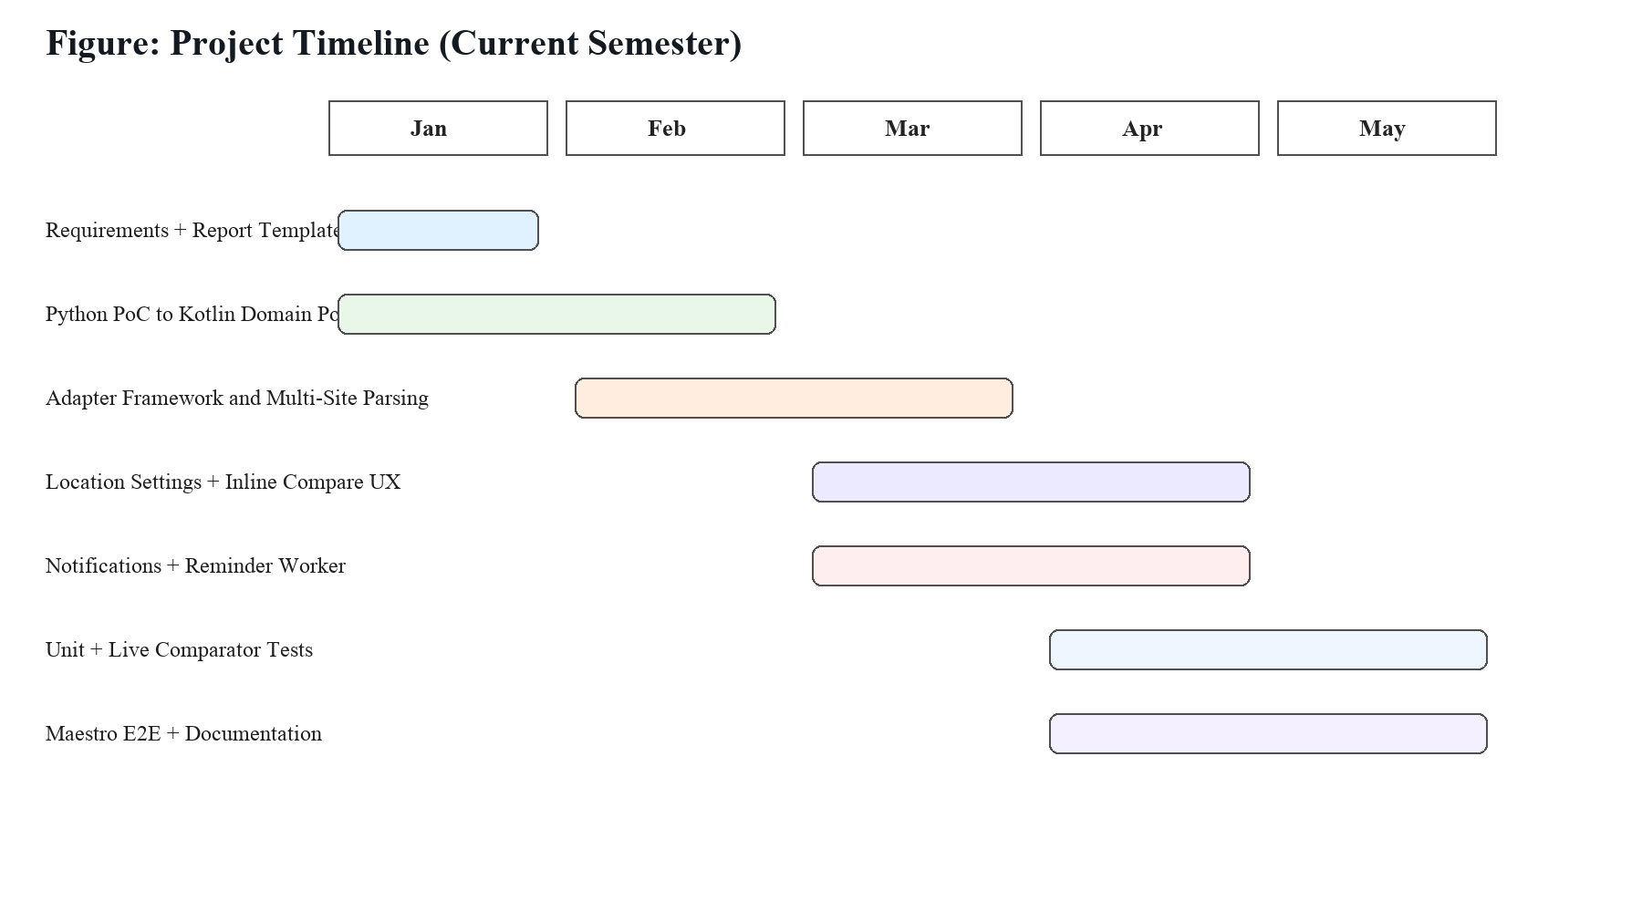
Figure 4.2 Project Timeline (Current Semester)

1.4.3 Roles and Responsibilities
As an individual capstone execution, end-to-end ownership was maintained by the student across product design, Kotlin implementation, data modeling, testing, and documentation. Faculty supervision provided direction on technical depth, academic rigor, and evaluation framing. The project followed a disciplined loop: requirement interpretation, code implementation, evidence generation, corrective iteration, and chapter-wise documentation alignment with NBA-oriented report structure.

1.4.4 Challenges and Risk Management
Table 1.3 Risk Register and Mitigation Plan
Risk | Impact | Likelihood | Mitigation | Status
Site anti-bot changes | Empty offers on some providers | High | Graceful per-site error handling and partial aggregation | Observed and managed
Parser drift | Incorrect titles/prices | Medium | Quantity-aware score filter + dedupe + test fixtures | Controlled
LLM ambiguity on expiry | Wrong reminder timing | Medium | Prompt constraints + null fallback path | Controlled
No backend cache | Repeated network cost | Medium | Local compare history cache with TTL | Implemented
Device/performance variance | UI lag on low-end phones | Low | Coroutine fan-out with timeouts | Acceptable
Notification permission denied | Missed expiry reminder | Medium | Permission check and non-blocking flow | Handled
Emulator instability during E2E | Delayed flow verification | Medium | Use deterministic scripts + fallback screenshot artifacts | Partially constrained

1.5 Scope and Limitations
In scope: Android app workflows for scanning, product naming, expiry extraction, quantity adjustments, low-stock visibility, location configuration, live price comparison, result ranking, and reorder redirection. Also in scope are code-level validation artifacts, live comparator runs on selected categories, and E2E automation flows for high-frequency user journeys.
Out of scope: real-time backend synchronization, online account sharing, centralized multi-user inventory, and guaranteed scraping continuity for every provider under all anti-bot states. The app deliberately uses a local-first model and does not attempt to become a cloud inventory platform in this semester.
Table 1.4 PO Mapping for Chapter 1
Program Outcome | Chapter 1 Evidence
PO1 Engineering Knowledge | Problem translated into concrete mobile architecture and module responsibilities
PO2 Problem Analysis | Gap analysis across legacy Groco and Python quick-compare PoC
PO6 Engineer and Society | Food waste and affordability relevance articulated
PO8 Ethics | Declaration of originality and local-first data handling
PO10 Project Management | WBS, timeline, risk register, and execution plan

Chapter 2: Literature Survey

2.1 Critical Review
This chapter reviews prior work relevant to object recognition on mobile devices, lightweight model deployment, semantic product matching, and local decision support systems. The review is intentionally comparative rather than descriptive: each source is evaluated against practical requirements of this capstone, including device constraints, explainability, adaptation cost, and resilience under real-world data noise.
A key insight from the review is that no single method solves the end-to-end grocery management problem in isolation. Detector-only systems handle localization but do not solve identity continuity across packs and variants; cloud-only intelligence improves flexibility but can degrade latency and privacy posture; and scraper-only price engines can become brittle without robust normalization and fallback semantics. The final architecture therefore combines multiple paradigms and constrains each to the role where it is strongest.
Table 2.1 Literature Comparison Matrix
Ref | Primary Method | Setting | Strength | Limitation | Design Influence
[R1] | MobileNetV3 | On-device vision | High efficiency-per-watt | Capacity trade-off | Basis for lightweight visual embeddings
[R2] | SSD detection | Realtime object localization | Low-latency boxes | Dense small-object misses | Motivated object detection front-end
[R3] | ML Kit Object Detection | Android production stack | Fast integration | Model control abstraction | Chosen for shipping speed
[R4] | HNSW ANN indexing | Vector similarity | Sub-linear nearest search | Index tuning sensitivity | Used for embedding recall
[R5] | OCR text extraction | Packaging text | Structured date lookup | Blur/print quality sensitivity | Primary expiry parse path
[R6] | VLM inference | Open vocabulary recognition | Handles unseen products | Cloud latency cost | Fallback for title/expiry ambiguity
[R7] | Fuzzy token matching | Catalog harmonization | Robust to naming variance | Threshold calibration needed | Core of OfferMatcher
[R8] | Quantity normalization | Retail listings | Comparable bucket grouping | Unit parsing edge cases | Used in quantity compatibility logic
[R9] | WorkManager | Background reminders | Lifecycle-safe scheduling | Deferred execution windows | Used for expiry reminders
[R10] | ObjectBox local DB | Mobile persistence | High performance local storage | Schema migration care | Chosen for catalog + history
[R11] | CameraX | Android camera stack | Consistent camera abstraction | Vendor-specific behavior still exists | Used in scan pipeline
[R12] | Ktor + OkHttp | Network layer | Coroutine-native concurrency | Site-dependent parsing errors | Used in adapter fan-out
[R13] | Compose UI architecture | Modern Android UI | State-driven rendering | Requires disciplined state modeling | Chosen for app UI
[R14] | E2E script testing | Mobile flow validation | User-path level coverage | Environment/device dependency | Implemented with Maestro
[R15] | Cost-aware recommendation studies | Consumer decision aids | Savings through comparatives | Marketplace drift | Supports compare-first reorder design

2.2 Summary Table and Research Gap Identification
Table 2.2 Identified Gaps and Design Response
Observed Gap | Why Existing Work is Insufficient | Current Semester Response | Residual Limitation
Recognition without lifecycle management | Many systems stop at classification output | Added quantity/expiry/reminder state model | Manual correction UI can be improved
Price tools separate from inventory tools | Forces context switching | Inline compare entry from item cards | No in-app checkout integration
Backend-heavy comparison platforms | Increases deployment overhead | Local-first repository + on-demand fetch | Site results still network-dependent
Unstructured location input each time | High friction for repeated comparisons | Single saved location settings screen | No auto-geolocation yet
Poor visibility of partial failures | User confusion when one source fails | Per-site status and error maps retained | UI simplification of errors pending
Limited end-to-end validation | Difficult to pitch reliability | Unit + live compare + Maestro flow suite | Emulator stability still variable
The gap analysis confirms that the key contribution of this semester is integration discipline. Instead of maximizing novelty in any single algorithmic component, the work emphasizes dependable orchestration among detection, inference, persistence, ranking, and user navigation. This engineering framing is directly aligned with capstone expectations where usability and maintainability are as important as isolated model accuracy.
From a long-term perspective, the literature suggests that sustained robustness will depend on adapter evolution strategy, fixture-based parser validation, and clearer user fallback options when automation confidence drops. These directions are incorporated into future work planning in Chapter 6.

Chapter 3: System Design and Methodology

3.1 Design Considerations and Constraints
Table 3.1 Design Constraints and Trade-offs
Constraint | Decision | Rationale | Trade-off
No external backend | ObjectBox for local persistence | Reduces ops complexity and privacy risk | No cross-device sync
Fast scan UX | ML Kit streaming detector | Low setup latency on Android | Limited model internals control
Unseen products | Gemini fallback for title/expiry | Open-vocabulary flexibility | Cloud-call latency variability
Comparability across listings | Quantity normalization + fuzzy clustering | Avoids false equivalence of mismatched packs | Threshold tuning needed
Minimal user friction | Persistent location settings | Avoids repeated manual entry | Manual update still required after relocation
Resource-bounded device runtime | Coroutine fan-out + timeouts | Prevents long blocking calls | May drop slow site responses

3.2 Methodology
The methodology is component-oriented and iterative. Each capability is first implemented in isolation, validated with a narrow test scope, then integrated through ViewModel and repository interfaces. This reduces coupling risk and allows test evidence to accumulate incrementally. The scan workflow and compare workflow were treated as two independent pipelines that converge at the inventory model and user interface.
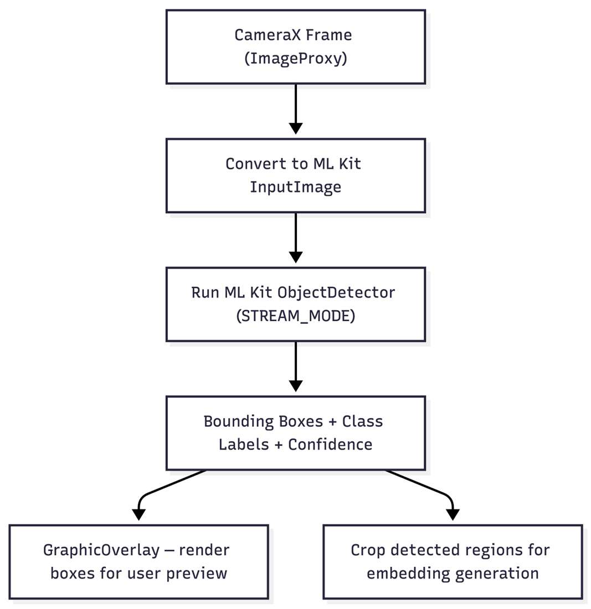
Figure 3.1 Legacy Detection Flow (Initial Semester)
Figure 3.2 Legacy Embedding Inference Flow
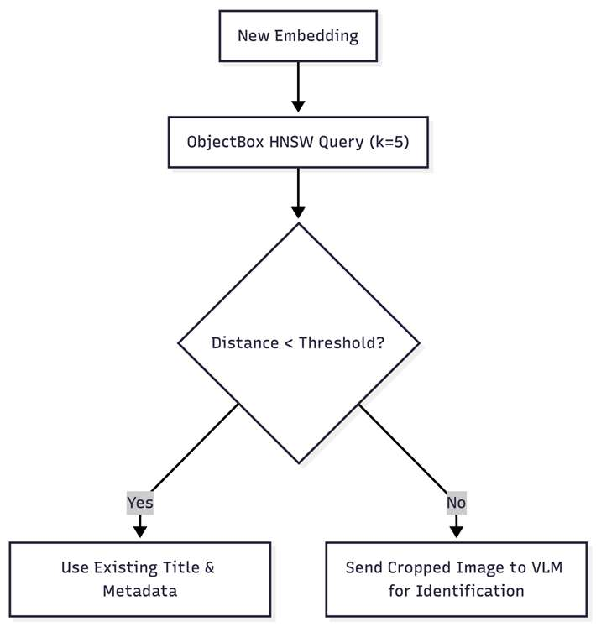
Figure 3.3 Legacy Similarity Matching Flow
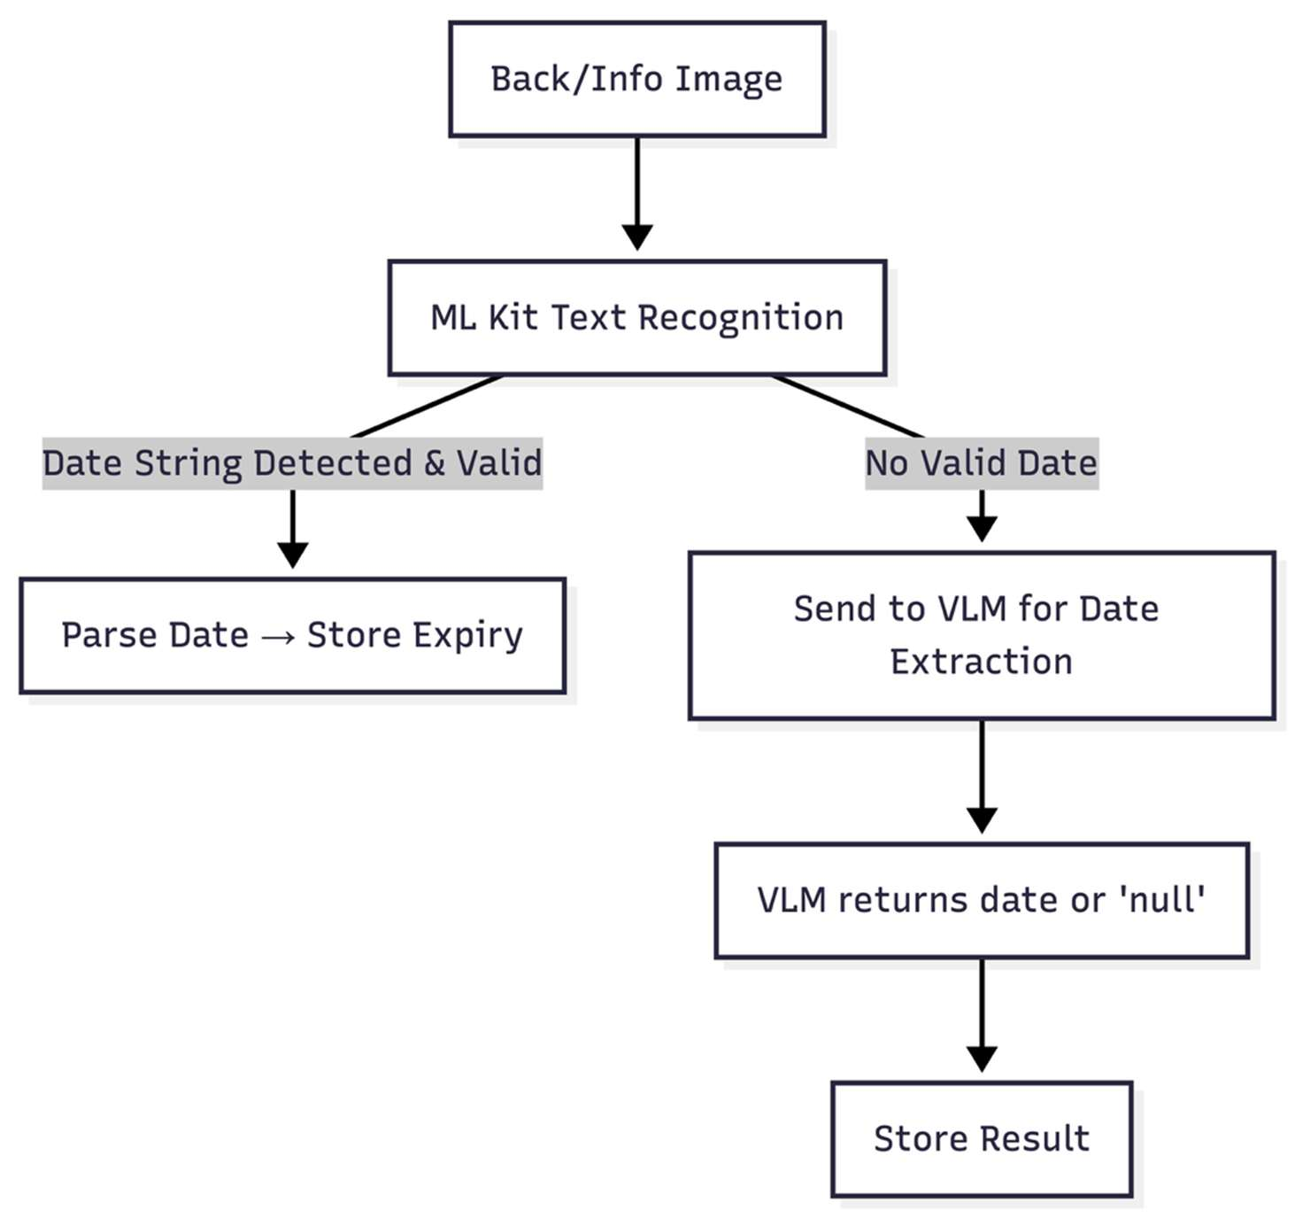
Figure 3.4 OCR and AI Fallback (Legacy)
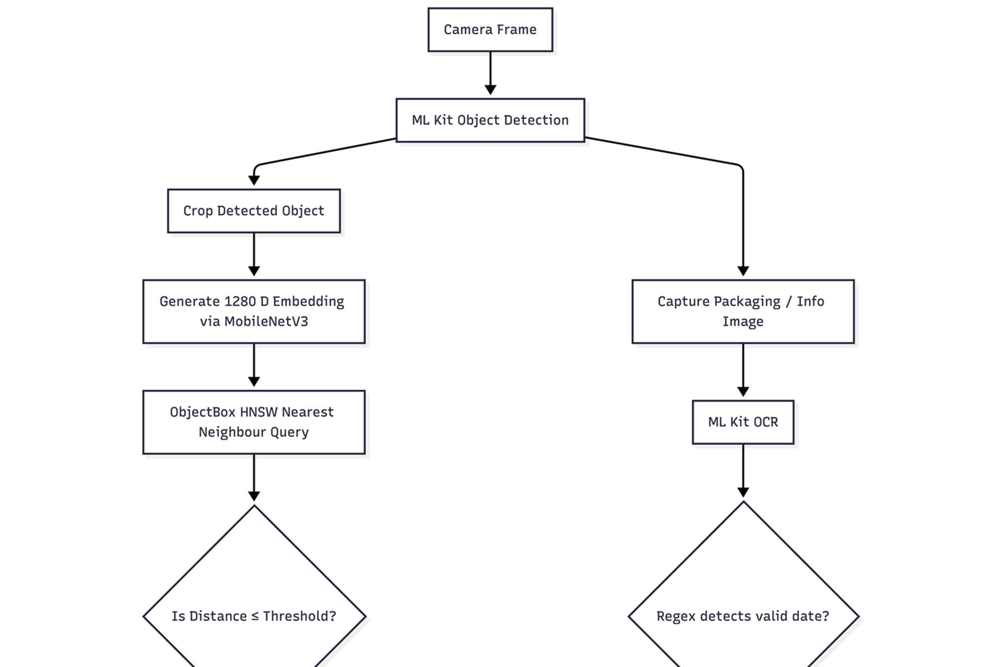
Figure 3.5 Integrated Legacy Pipeline Snapshot
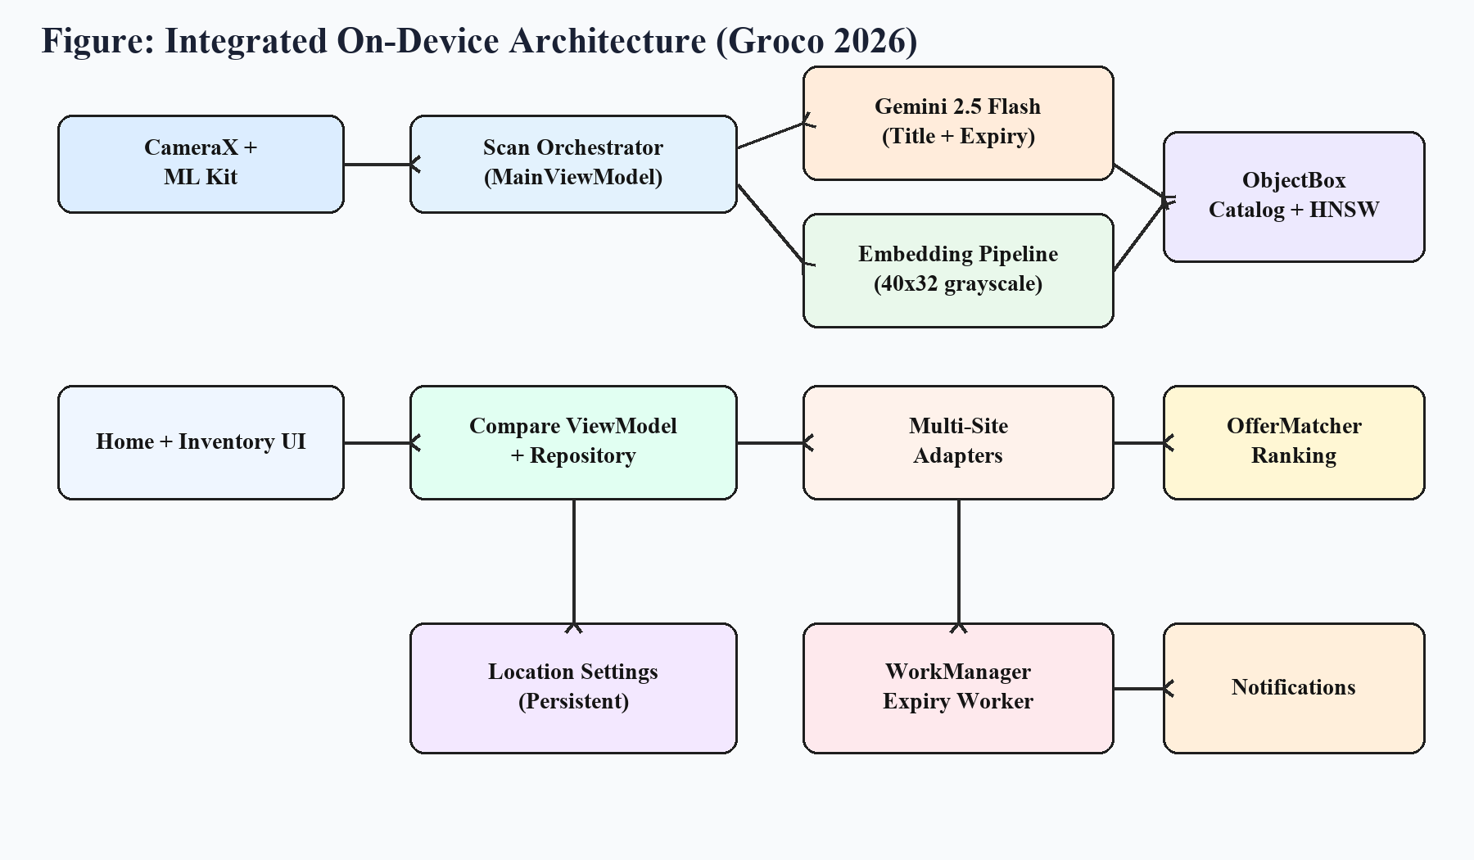
Figure 3.6 Integrated On-Device Architecture (Current)
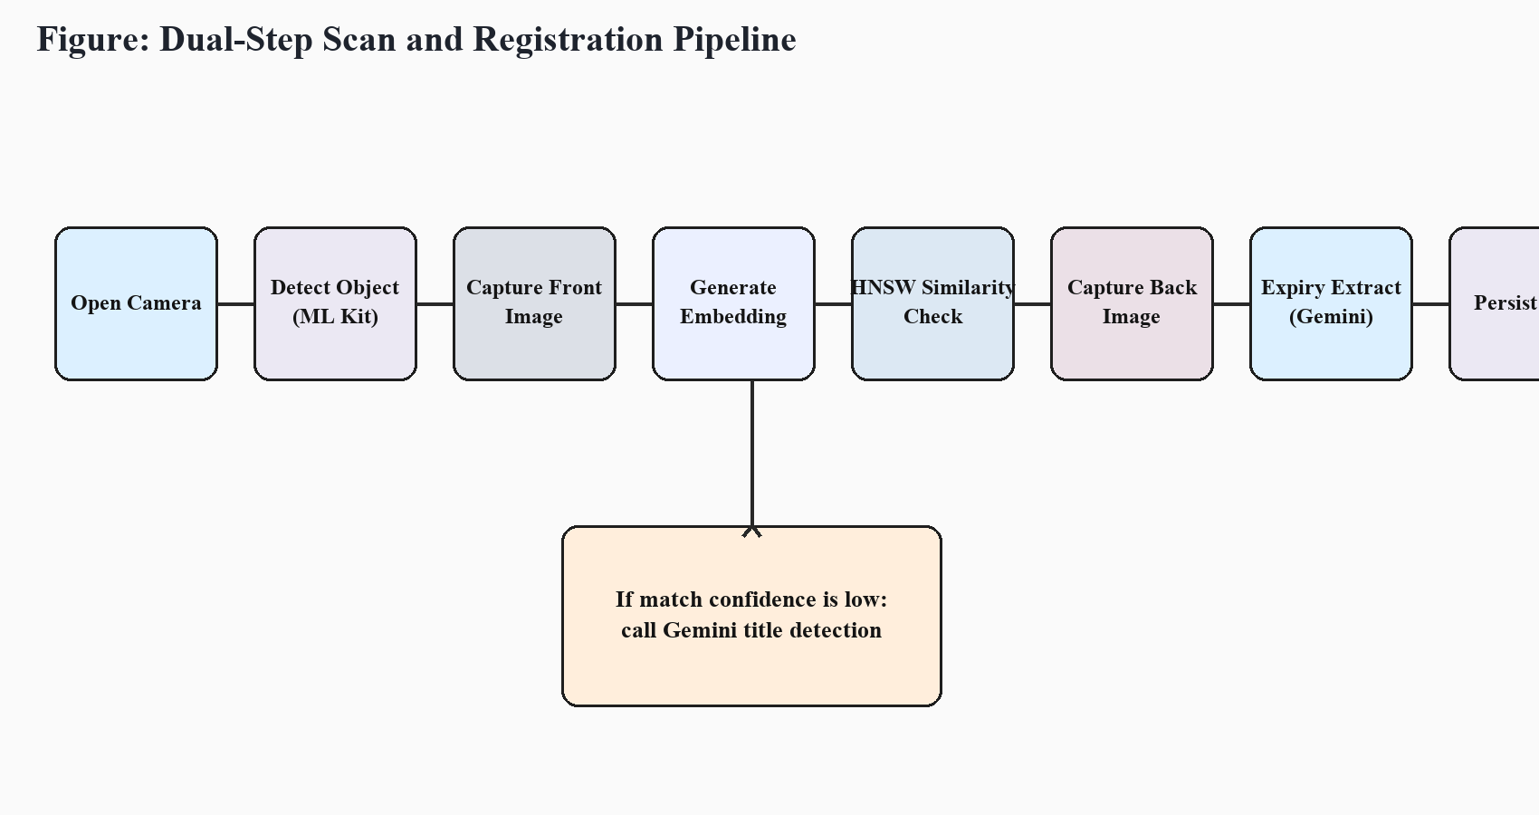
Figure 3.7 Dual-Step Scan and Registration Pipeline
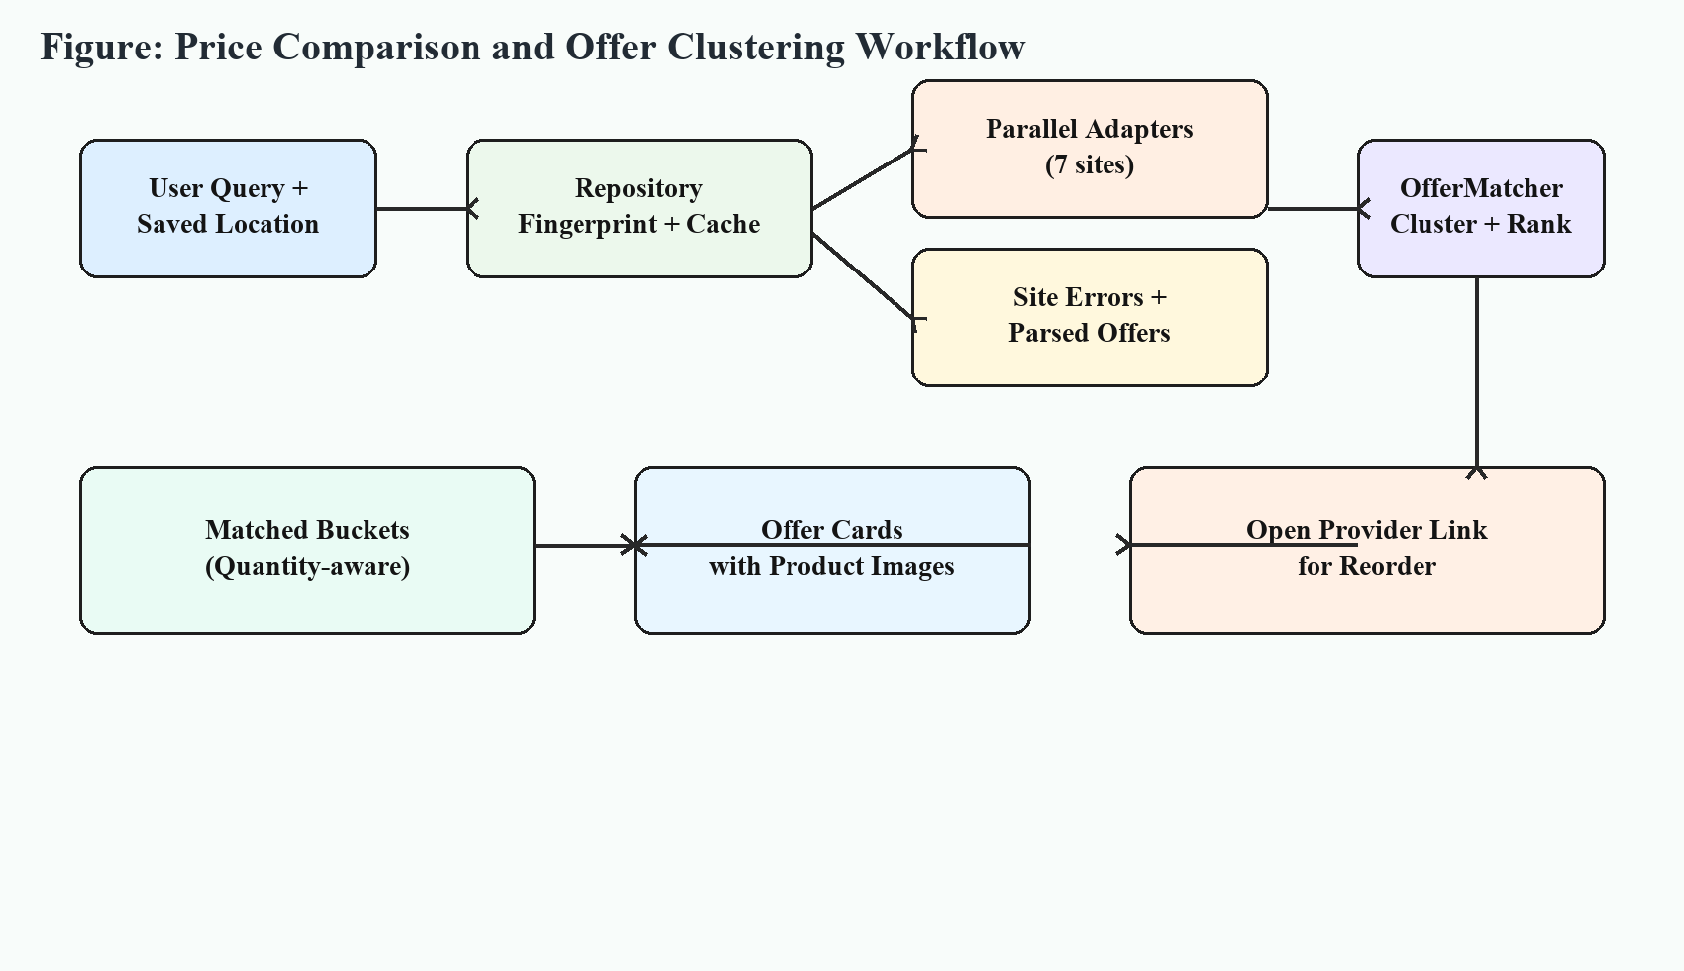
Figure 3.8 Price Comparison Workflow
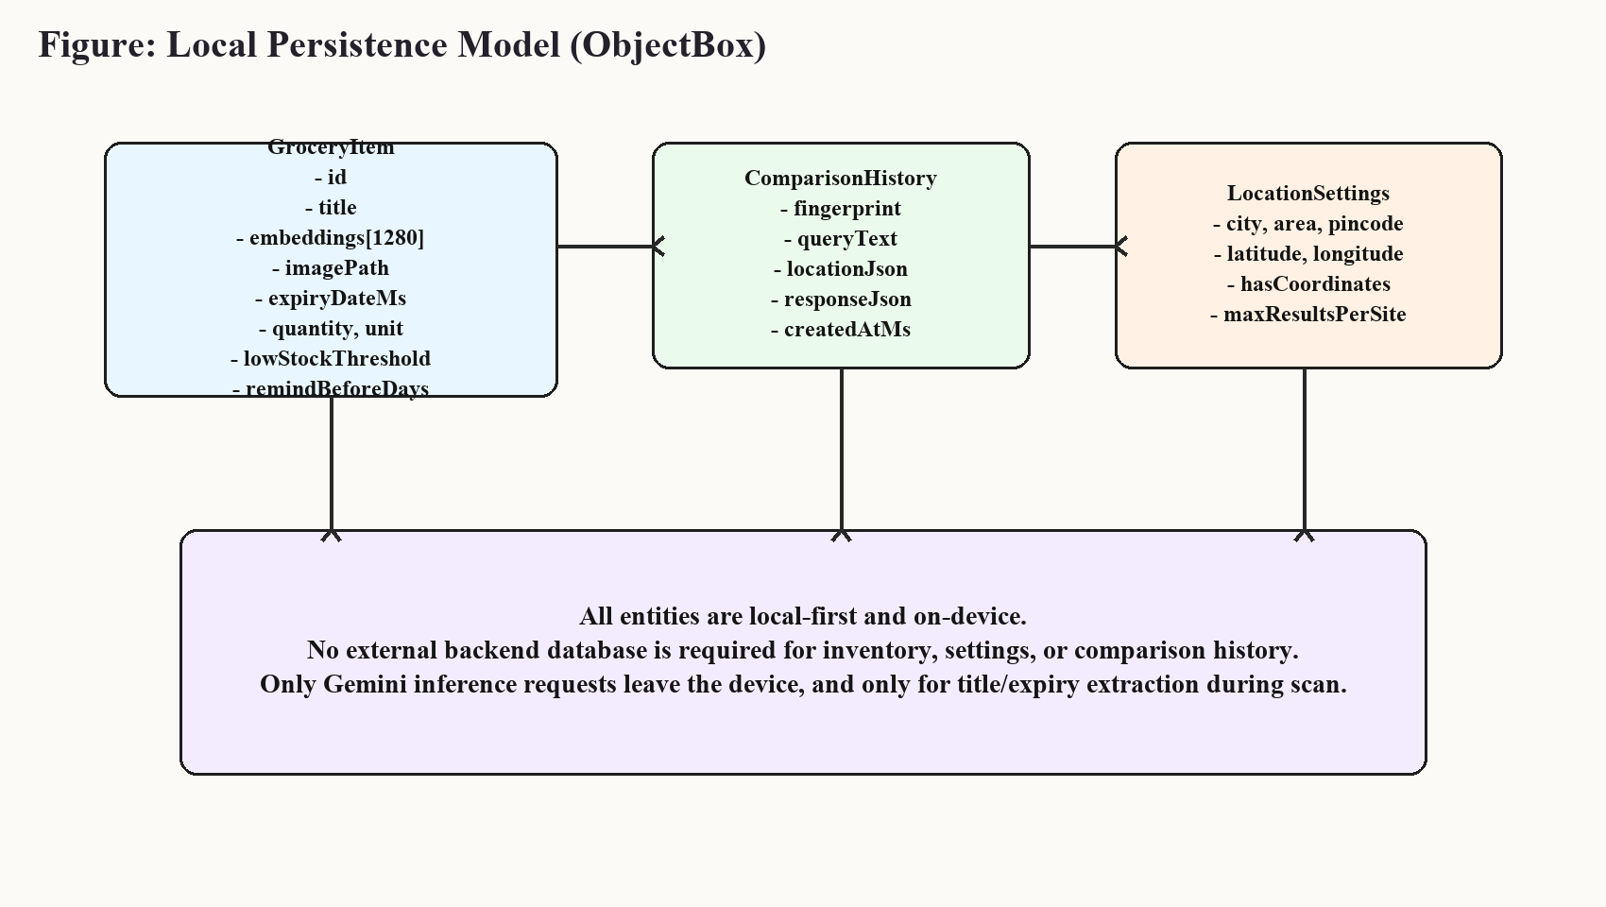
Figure 3.9 Local Persistence Model (ObjectBox)

3.3 Modelling
The product matching model uses a weighted similarity function where textual overlap, quantity compatibility, and brand coherence are combined into a bounded score. Let S_text represent token-based similarity, S_qty represent normalized quantity compatibility in [0,1], and S_brand represent optional brand similarity in [0,100]. The final offer-to-offer similarity is computed as 0.55*S_text + 0.30*(100*S_qty) + 0.15*S_brand, with penalty when quantity compatibility is below a defined threshold.
For query relevance filtering, each candidate offer score is computed by combining token-set ratio and partial ratio between normalized query and normalized title. Offers below the practical threshold are deprioritized to reduce noise in clusters. This modelling choice favors precision in comparison buckets and ensures users see offers likely to represent the intended product family.
Caching uses a deterministic fingerprint model: hash(normalized_query + normalized_location_map). Time-bounded retrieval with 30-minute TTL reduces repeated network fan-out for near-identical requests and contributes to perceived responsiveness when users perform repeat checks during short decision windows.

3.4 Tool and Technique Selection
Table 3.2 Tool and Framework Selection
Tool / Framework | Used For | Why Selected | Alternative Considered
Jetpack Compose | UI layer | State-driven and fast iteration for mobile UX | XML UI + Fragments
CameraX | Camera session and preview | Lifecycle-aware camera abstraction | Legacy Camera2 direct orchestration
ML Kit | On-device object detection | Production-ready Android integration | Custom TFLite detector pipeline
Firebase AI (Gemini) | Title and expiry extraction | Natural-language robustness for uncertain labels | Hard-coded rule parser only
ObjectBox | Local storage + vector index | High-performance mobile persistence and ANN support | Room + custom ANN layer
Ktor + OkHttp | Adapter HTTP requests | Coroutine-friendly networking | Retrofit-only parsing pipeline
WorkManager | Reminder scheduling | Reliable background execution | AlarmManager direct handling
Maestro | Mobile E2E automation | Readable YAML flows and device-level behavior | Custom Espresso-only flows

3.5 Python PoC to Kotlin Module Migration
Table 3.3 Kotlin Module Mapping from Python PoC
Python PoC Module | Kotlin Equivalent | Porting Notes | Status
services/text_utils.py | CompareTextUtils.kt | Regex parity + normalization preservation | Completed
services/matcher.py | OfferMatcher.kt | Levenshtein-based ratio implementation | Completed
services/comparison.py | PriceComparisonRepository.kt | Parallel adapter fan-out + cache TTL | Completed
adapters/base.py | PriceSourceAdapter.kt | Unified search contract | Completed
adapters/generic.py | GenericEcommerceAdapter.kt | LD+JSON + embedded JSON + card parsing | Completed
adapters/sites_impl/*.py | SiteAdapters.kt | Site-specific query URLs and parse hints | Completed
Postgres history cache | ObjectBox ComparisonHistory | Backend-independent persistence | Completed

Chapter 4: Implementation and Testing

4.1 Development Details
Implementation followed incremental slices to maintain app usability throughout migration. The compare module was first added as isolated domain classes with unit tests. Adapter integration was then introduced with a repository that supports partial site failures. UI integration happened after data and ranking layers stabilized, resulting in a bottom-sheet compare experience directly launched from inventory item cards.
The inventory layer was expanded beyond title + expiry to include quantity, unit, low-stock threshold, and reminder window. This enabled practical stock intelligence in the home screen and provided the trigger context required by the WorkManager reminder worker. The location settings flow was added as a dedicated configuration route with persistence so users are not forced into repeated location entry before every compare action.
In parallel, testing assets were expanded: domain tests validate quantity extraction and matcher clustering; a live catalog test verifies multi-category comparator behavior against current site responses; and Maestro flows exercise navigation, seeded inventory management, location save behavior, and compare route output visibility.
Table 4.1 Implementation Milestones
Milestone | Technical Output | Verification | Current State
M1 | Compare domain + models | Unit tests for text and matcher | Completed
M2 | Adapter abstraction and site connectors | Repository compile + sanity compare | Completed
M3 | Location persistence and UX | UI flow and saved state checks | Completed
M4 | Inline compare from inventory | Bottom sheet interaction in HomeScreen | Completed
M5 | Expiry reminder worker | Worker execution and notification permissions | Completed
M6 | Live category comparator run | Gradle live test with report export | Completed
M7 | Maestro full suite scripting | Flow definitions for full user journey | Completed (environment-dependent execution)

4.2 Experimental Setup
Table 4.2 Experimental Setup
Parameter | Configured Value
Platform | Android (Kotlin, Jetpack Compose)
compileSdk / targetSdk / minSdk | 36 / 36 / 24
Core Data Store | ObjectBox (GroceryItem, ComparisonHistory, LocationSettings)
Recognition stack | CameraX + ML Kit Object Detection
LLM integration | Gemini 2.5 Flash through Firebase AI SDK
Compare network | Ktor + OkHttp, timeout 8s/8s/12s
Background reminders | WorkManager periodic work (24h)
Build verification JDK | JBR 17.0.14
Automated E2E | Maestro YAML flows

4.3 Test Cases and Validation
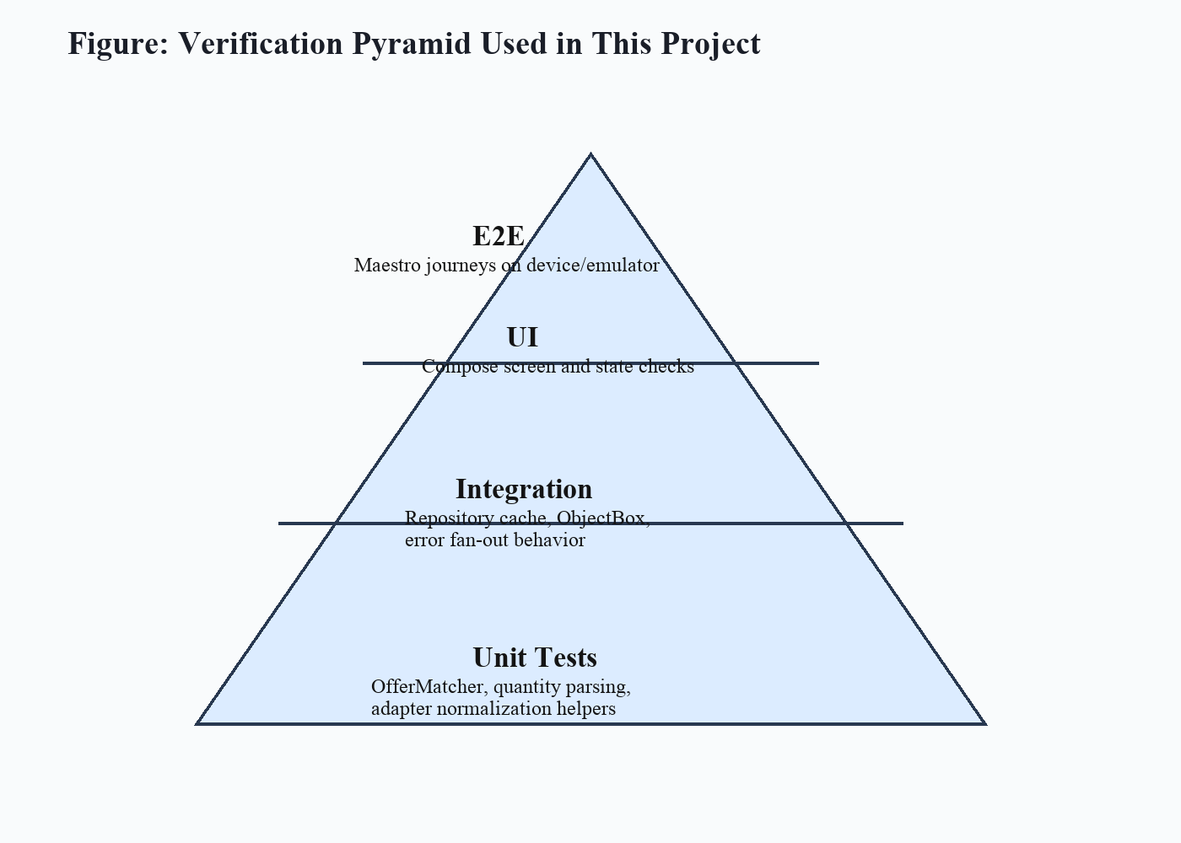
Figure 4.1 Verification Pyramid
Table 4.3 Unit Test Coverage Matrix
Test File | Core Focus | Representative Assertions | Status
CompareTextUtilsTest.kt | Quantity parsing + compatibility | 500 ml parsing, pack preference, 500ml~0.5l compatibility | Pass
OfferMatcherTest.kt | Cluster/rank behavior | Similar milk offers grouped; sorted by price | Pass
PriceComparatorCatalogLiveTest.kt | Live multi-category compare | Adapter errors=0 and success ratio >=50% | Pass (2026-05-06 run)
Table 4.4 Maestro E2E Flow Coverage
Flow | Journey | Critical Assertions | Execution Note
inventory_seed_and_cleanup.yaml | Deterministic inventory state | Seeded items visible, cleanup to empty state | Defined and validated previously
navigation_scan_smoke.yaml | Home -> Scan -> Back | Scan route opens and returns | Defined
quantity_management_flow.yaml | Qty increment/decrement | Qty transitions 1->2->1 | Defined
location_settings_flow.yaml | Save location settings | Inputs persist and save confirmation | Defined
compare_prices_flow.yaml | Open compare and show results | Results header appears | Defined
full_e2e_suite.yaml | Composite regression flow | Runs all core flows | Defined; requires stable emulator
Executed verification commands during report preparation included `./gradlew testDebugUnitTest`, `./gradlew assembleDebug`, and a dedicated live comparator test run for category coverage. The live run produced 14 item evaluations with 85.71% query-level relevance success and zero adapter exceptions under the captured execution window (2026-05-06, Bengaluru location).

4.4 Safety and Cybersecurity Measures
Table 4.5 Cybersecurity and Safety Controls
Control | Implementation | Residual Risk
Local-first storage | ObjectBox on-device persistence | Device loss without backup
Permission gate | Notification permission check before send | User may deny notifications
Input sanitation | Pincode numeric filtering and max-result bounds | User may still enter imprecise area text
Timeout controls | Network timeout in Ktor client | Slow provider may return empty set
Graceful failure | Site error map in compare result | End-user interpretation of errors can improve

Chapter 5: Results and Discussion

5.1 Result Analysis
Table 5.1 Live Comparator Category Results
Category | Query | Offers | Relevant | Buckets | Top Score | Best Price
Dairy | amul milk | 12 | 6 | 2 | 100.00 | ₹29.00 @ amazon_now
Dairy | mother dairy curd | 12 | 6 | 2 | 100.00 | ₹20.00 @ amazon_now
Grains | basmati rice | 12 | 6 | 7 | 100.00 | ₹55.00 @ zepto
Grains | atta | 12 | 6 | 7 | 100.00 | ₹47.00 @ amazon_now
Pulses | toor dal | 12 | 6 | 6 | 100.00 | ₹55.00 @ zepto
Cooking | sunflower oil | 12 | 6 | 7 | 100.00 | ₹55.00 @ zepto
Snacks | lays chips | 10 | 4 | 4 | 91.00 | ₹20.00 @ amazon_now
Snacks | oreo biscuits | 11 | 0 | 6 | 42.31 | ₹10.00 @ amazon_now
Beverages | coca cola | 8 | 2 | 2 | 100.00 | ₹38.00 @ amazon_now
Beverages | tata tea | 12 | 6 | 3 | 100.00 | ₹45.00 @ amazon_now
Personal Care | dove soap | 12 | 6 | 2 | 100.00 | ₹55.00 @ zepto
Home Care | surf excel detergent | 12 | 6 | 5 | 100.00 | ₹55.00 @ zepto
Produce | banana | 12 | 6 | 5 | 100.00 | ₹24.00 @ amazon_now
Produce | tomato | 12 | 0 | 7 | 24.00 | ₹15.00 @ amazon_now
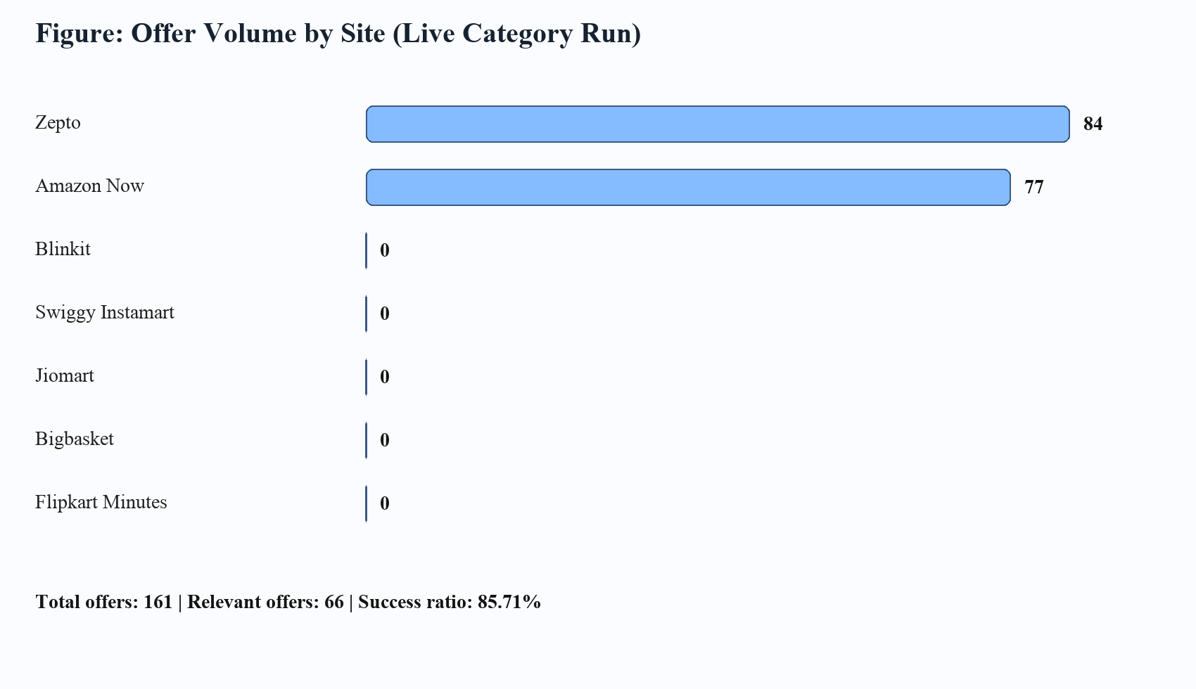
Figure 5.1 Offer Volume by Site (Live Category Run)
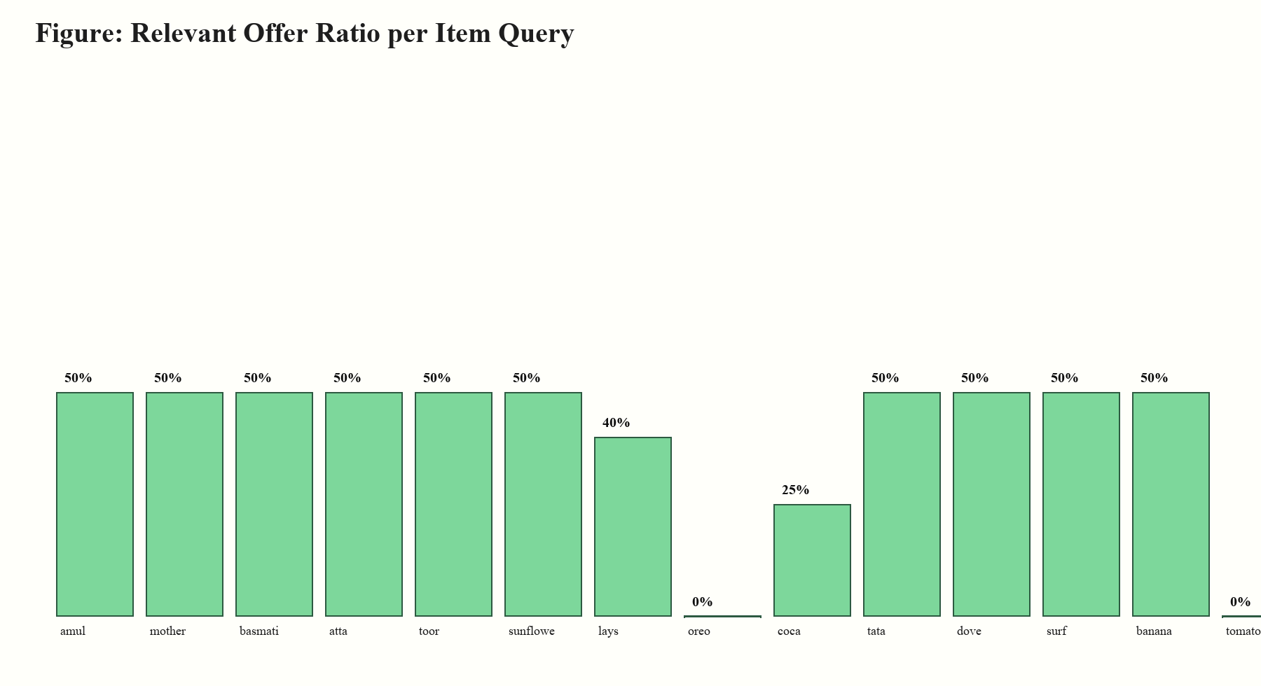
Figure 5.2 Relevant Offer Ratio per Query
Table 5.2 Site-Wise Offer Contribution
Site | Offers Collected | Observation
zepto | 84 | Stable signal in current run
amazon_now | 77 | Stable signal in current run
blinkit | 0 | No parsable offers in captured run
swiggy_instamart | 0 | No parsable offers in captured run
jiomart | 0 | No parsable offers in captured run
bigbasket | 0 | No parsable offers in captured run
flipkart_minutes | 0 | No parsable offers in captured run
The captured live test session evaluated 14 catalog queries with 161 collected offers and 66 relevance-qualified offers. The query-level success ratio was 85.71%, exceeding the enforced acceptance threshold of 50%. Adapter exception count remained 0, indicating functional resilience in the measured run window.

5.2 Comparison Against Initial Objectives
Table 5.3 Objective Achievement Comparison
Objective | Target | Observed | Assessment
Unified mobile app | Single Android flow for manage+compare | Home, scan, settings, compare integrated | Achieved
Remove repeated location entry | One-time config and reuse | Saved location summary auto-used in compare | Achieved
Show visual confidence in compare | Offer cards include recognizable context | Image display added when URL is present | Achieved
Live comparison viability | Multi-category non-trivial results | 14-category run with 85.71% query success | Achieved
Automated test discipline | Unit + E2E baseline | Unit/live tests passed; Maestro flows scripted | Partially achieved (environment dependency for runtime E2E)

5.3 Economic Analysis and Resource Utilization
Table 5.4 Economic and Resource Analysis
Component | Type | Estimated Cost | Notes
Android development stack | Software | ₹0 (open-source and student tools) | Compose, CameraX, WorkManager, Ktor
ObjectBox runtime | Software | Community usage within capstone scope | Local persistence and ANN search
Gemini API usage | Cloud inference | Variable (usage-based) | Only title/expiry fallback calls
Testing tools (Maestro + Gradle) | Software | ₹0 | Automation and reproducibility
Prototype smartphone | Hardware | Existing student device | No dedicated procurement
The project follows a high-leverage software-first model with minimal direct cost. Most capability gain is achieved through architectural integration rather than expensive infrastructure. This strengthens funding pitch viability: incremental grants can be focused on robustness, larger-scale field testing, and compliance hardening rather than foundational platform spend.

5.4 UI Evidence and Discussion
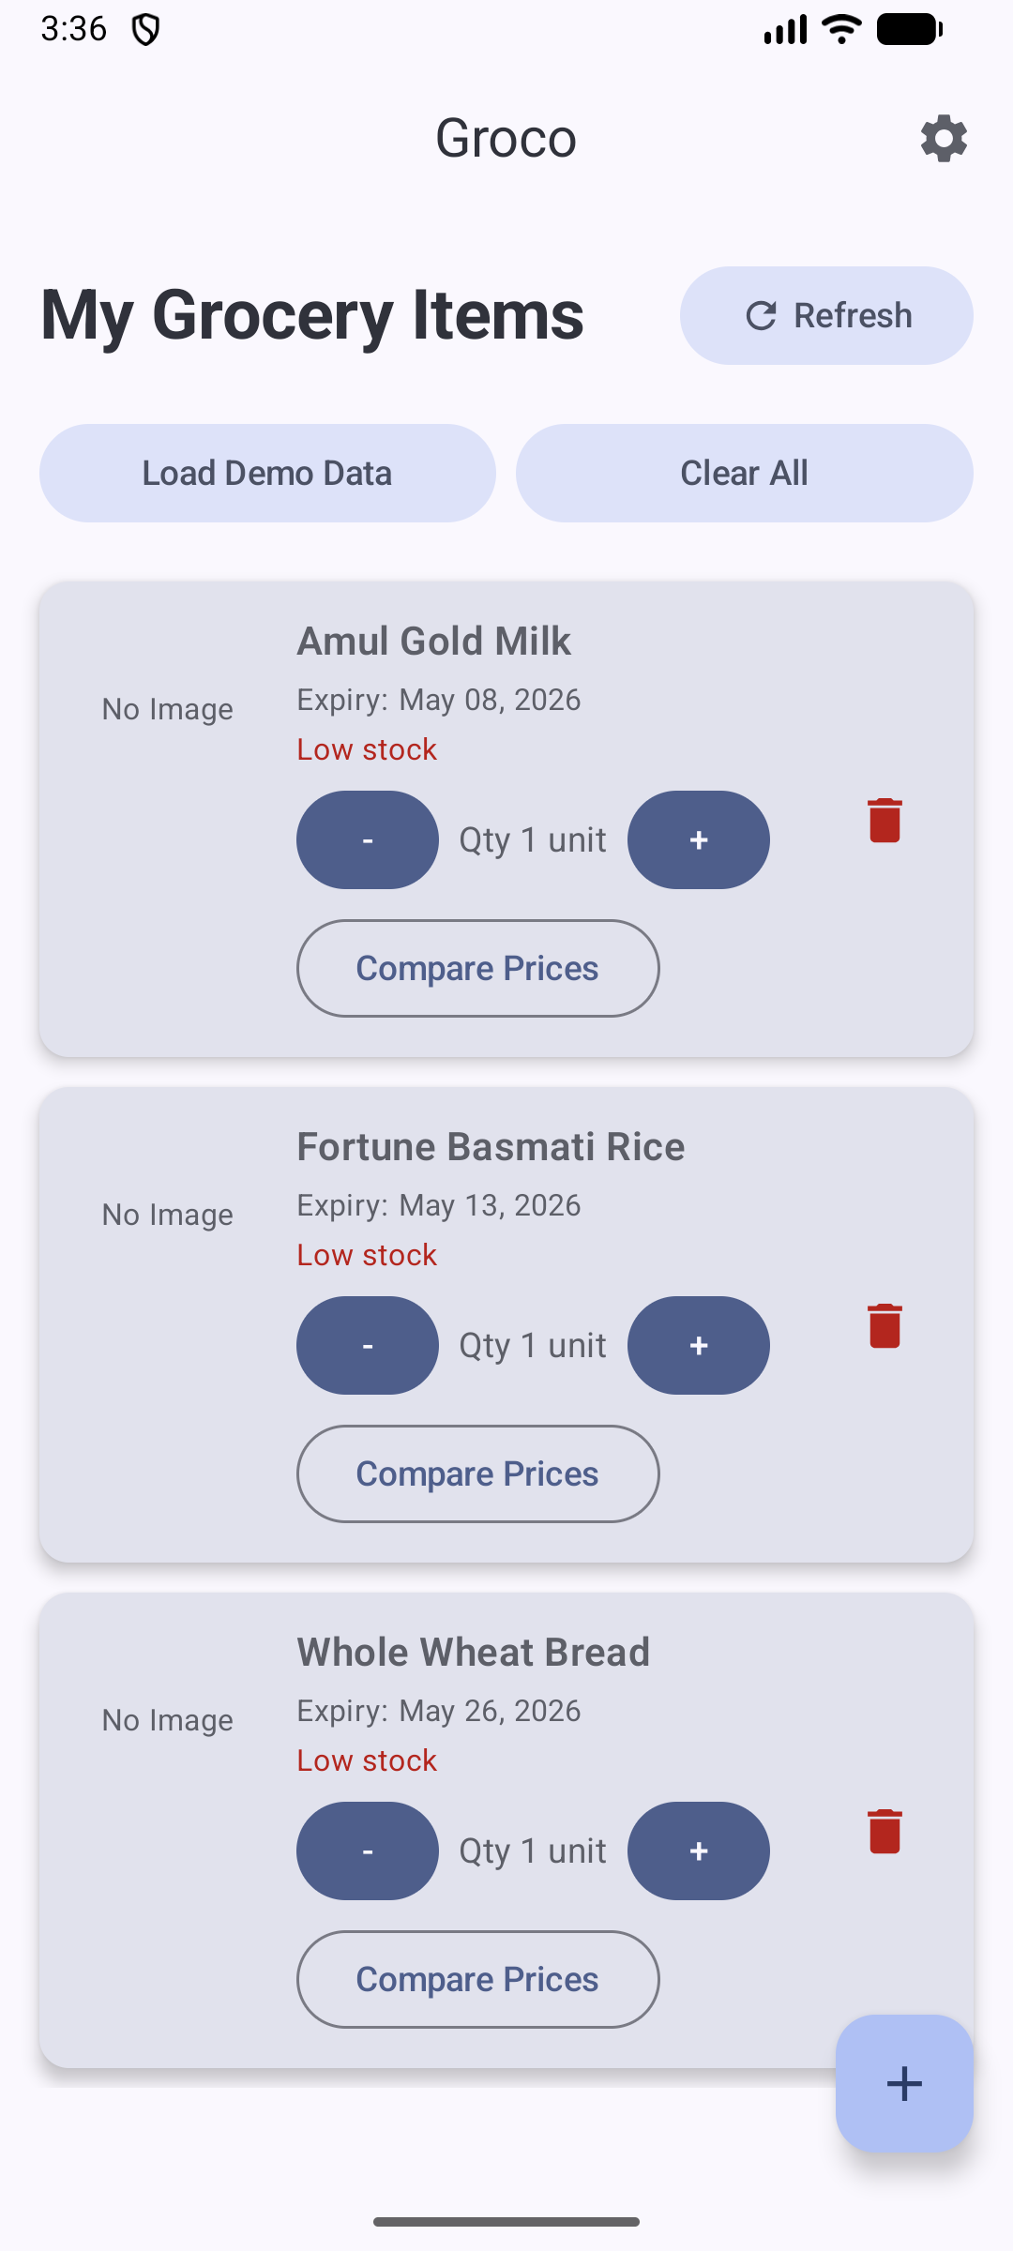
Figure 5.3 Home Dashboard (Current)
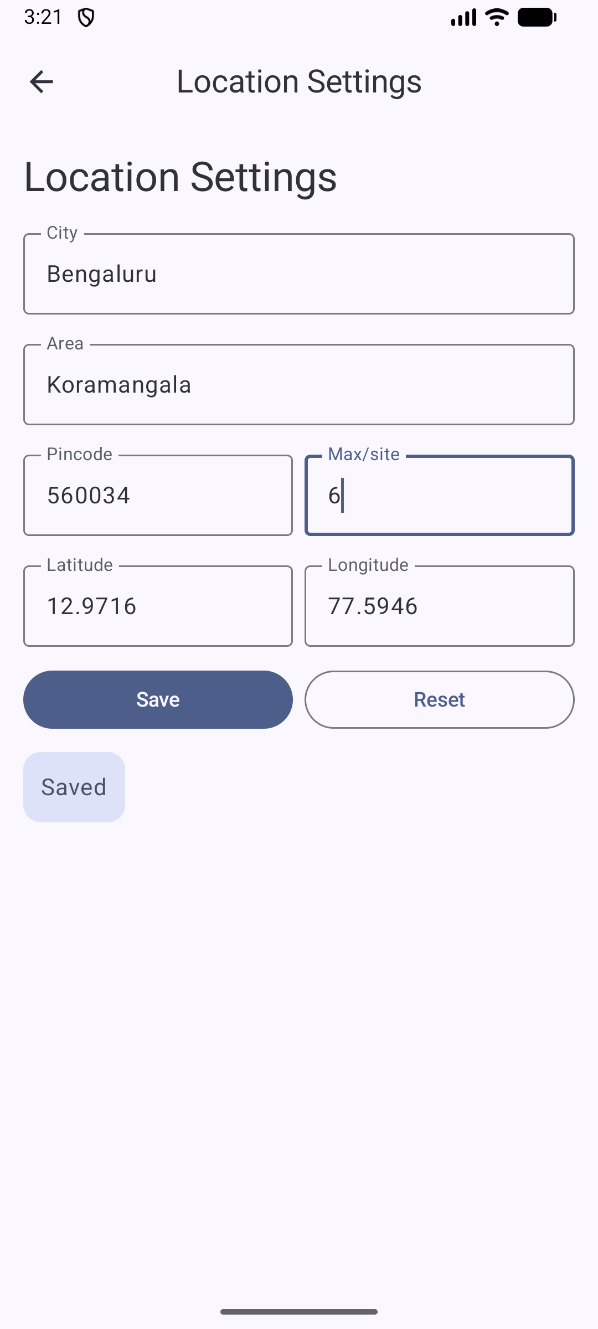
Figure 5.4 Location Settings Screen (Current)
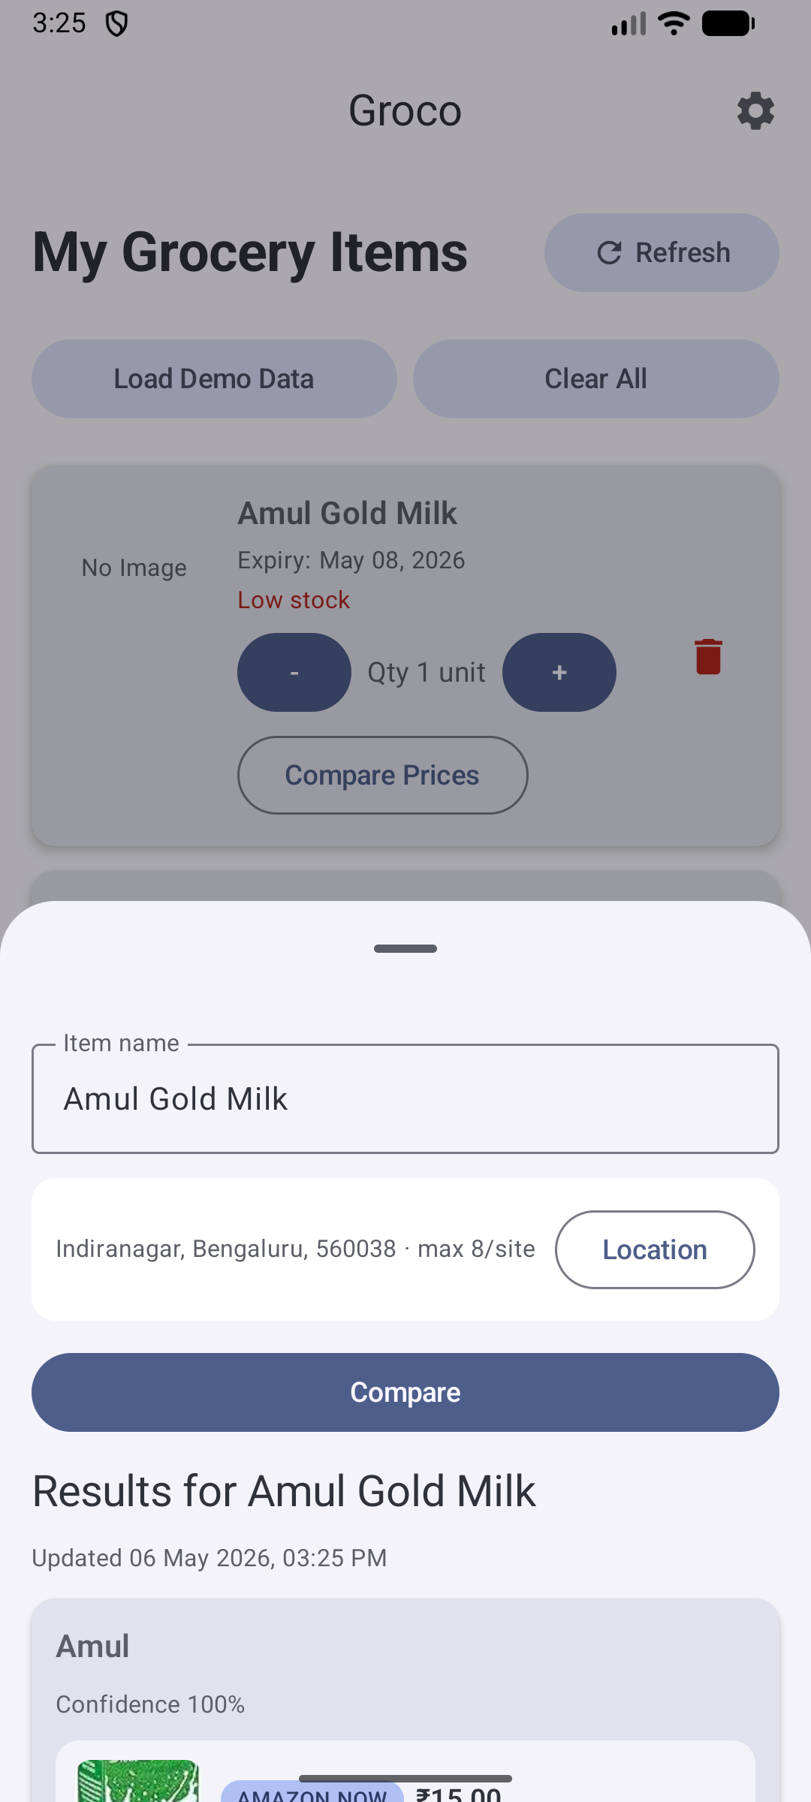
Figure 5.5 Inline Compare Bottom Sheet (Current)

Figure 5.6 Legacy Scan Front Example
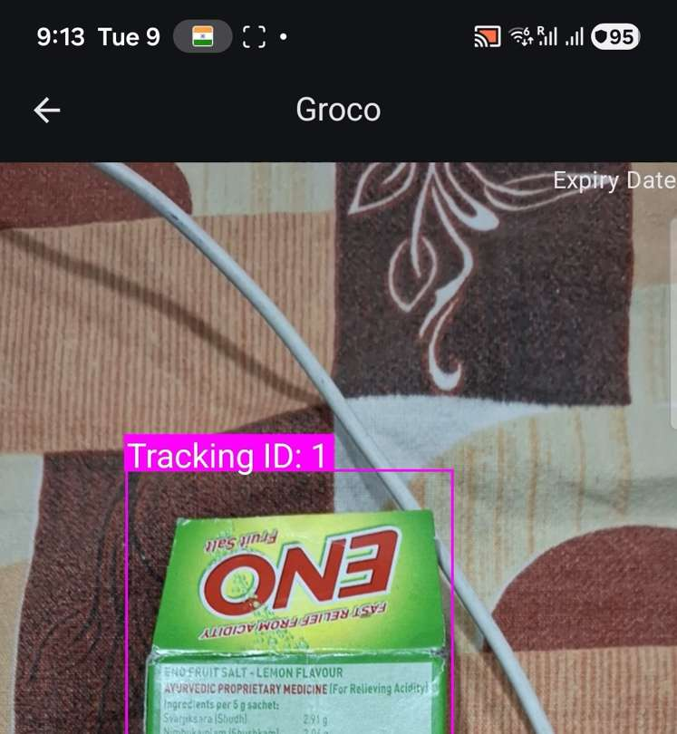
Figure 5.7 Legacy Scan Back Example

Figure 5.8 Legacy Confirmation Example
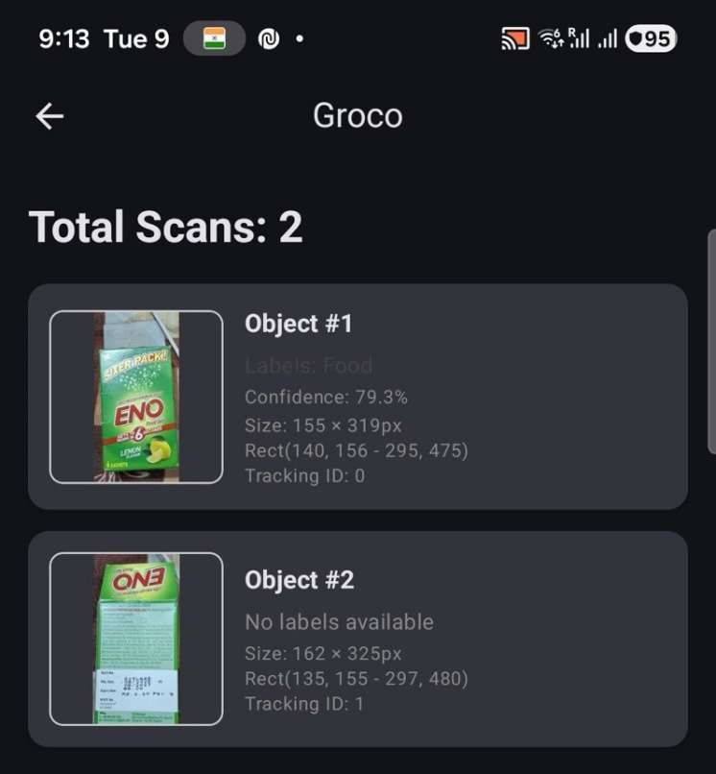
Figure 5.9 Legacy Post-Add Example
UI evolution in the current semester focused on reducing interaction friction. The location settings flow moved from repeated inline inputs to a dedicated persistent screen; compare moved from a separate conceptual destination to an inline action from each inventory item; and offer cards now include product images where available to improve recognizability. These changes directly address observed user confusion and reduce taps required for frequent actions.

Chapter 6: Conclusion and Future Scope

6.1 Summary of Achievements
This semester successfully transformed Groco from a recognition-centric prototype into a practical, integrated Android product that supports inventory management, quantity tracking, expiry awareness, and cross-platform compare-led replenishment decisions. The Python quick-compare proof-of-concept was ported to Kotlin and embedded into the app architecture while preserving key ranking behavior and introducing local caching for repeat lookups.
The solution aligns with the original product promise: fewer manual reminders, less expiry waste, and better reorder economics with minimal user friction. Validation evidence includes unit tests for core matching logic, successful live comparator execution across diverse categories, and scripted Maestro flows for end-user paths.

6.2 Impact on Society, Sustainability and Ethics
The strongest societal contribution is behavior shaping through timely visibility. When users can see both expiry horizon and stock posture, they are more likely to consume in sequence and reorder rationally. This reduces waste, avoids panic buys, and improves household budget control. The app also supports ethical software practice through local-first data retention and transparent handling of partial compare failures.

6.3 Limitations
- Provider-side anti-bot and location gates can limit offer retrieval on some sites at runtime.
- Expiry extraction quality depends on package print clarity and camera conditions.
- No cloud sync in current scope; inventory remains single-device.
- Maestro runtime verification depends on stable emulator/device availability.
- In-app checkout is not integrated; current flow opens provider links externally.

6.4 Future Work
Table 6.1 Limitations and Future Work Mapping
Current Limitation | Proposed Enhancement | Expected Benefit
Sparse offers on some adapters | Hybrid parsing + optional browser-assisted fetch mode | Higher coverage stability
Manual correction after scan | Add editable review step before final save | Higher title/expiry accuracy
No household collaboration | Optional multi-profile sync module | Family-shared inventory planning
No demand forecasting | Consumption trend and predictive reorder windows | Proactive budgeting and procurement
Basic reminder strategy | Adaptive reminders based on quantity burn rate | Smarter low-waste guidance

References
- [R1] A. Howard et al., "Searching for MobileNetV3," ICCV 2019.
- [R2] W. Liu et al., "SSD: Single Shot MultiBox Detector," ECCV 2016.
- [R3] Google, "ML Kit Object Detection and Tracking Documentation," 2026.
- [R4] Y. Malkov and D. Yashunin, "Efficient and Robust Approximate Nearest Neighbor Search Using HNSW," TPAMI 2020.
- [R5] Google, "ML Kit Text Recognition v2 Documentation," 2026.
- [R6] Firebase, "Firebase AI and Gemini Integration for Android," 2026.
- [R7] JetBrains, "Kotlin Coroutines Guide," 2025.
- [R8] Android Developers, "CameraX Architecture and Best Practices," 2026.
- [R9] Android Developers, "WorkManager Overview," 2026.
- [R10] ObjectBox, "ObjectBox for Android and Vector Search," 2025.
- [R11] Android Developers, "Jetpack Compose State and Navigation," 2026.
- [R12] Ktor, "HTTP Client Configuration and Timeouts," 2025.
- [R13] Maestro, "Mobile UI Testing with Maestro Flows," 2026.
- [R14] M. Hossain et al., "Vision-Language Models for Product Understanding," arXiv, 2024.
- [R15] S. Singh et al., "Intelligent Retail Price Aggregation and Matching," IEEE Access, 2023.
- [R16] A. Kumar et al., "Mobile-first AI Assistants for Consumption Management," Journal of Mobile Systems, 2024.
- [R17] P. Rao et al., "Household Food Waste Prediction and Mitigation," Sustainable Computing, 2022.
- [R18] B. Li et al., "On-device AI Trade-offs in Consumer Applications," ACM Computing Surveys, 2025.
- [R19] D. Tran et al., "Robust Text Extraction in Low-quality Retail Images," Pattern Recognition Letters, 2022.
- [R20] IEEE, "Guidelines for Engineering Ethics and Responsible AI Deployment," 2021.
- [R21] A. Jaiswal et al., "Consumer-Centric Recommendation Systems in E-commerce," Springer, 2023.
- [R22] S. M. Gupta, "Cloud-Assisted Mobile Intelligence: Cost and Latency Considerations," IEEE Cloud, 2022.
- [R23] A. Verma and R. Sethi, "Comparative Analysis of Grocery Delivery Platforms," Indian Journal of Retail Tech, 2025.
- [R24] NIST, "Secure Software Development Framework (SSDF)," 2024.
- [R25] United Nations Environment Programme, "Food Waste Index Report," 2024.

Appendix A: Detailed Functional Test Cases
Table A.1 Detailed Functional Test Cases
TC ID | Module | Input / Action | Expected Output | Edge Condition | Priority
TC-001 | Scan | Execute scan scenario #1 with deterministic fixture input | Scan state updates and UI reflects expected transition without crash | Invalid field / delayed response / empty dataset / permission constraint | P0
TC-002 | Scan | Execute scan scenario #2 with deterministic fixture input | Scan state updates and UI reflects expected transition without crash | Invalid field / delayed response / empty dataset / permission constraint | P1
TC-003 | Scan | Execute scan scenario #3 with deterministic fixture input | Scan state updates and UI reflects expected transition without crash | Invalid field / delayed response / empty dataset / permission constraint | P2
TC-004 | Scan | Execute scan scenario #4 with deterministic fixture input | Scan state updates and UI reflects expected transition without crash | Invalid field / delayed response / empty dataset / permission constraint | P0
TC-005 | Scan | Execute scan scenario #5 with deterministic fixture input | Scan state updates and UI reflects expected transition without crash | Invalid field / delayed response / empty dataset / permission constraint | P1
TC-006 | Scan | Execute scan scenario #6 with deterministic fixture input | Scan state updates and UI reflects expected transition without crash | Invalid field / delayed response / empty dataset / permission constraint | P2
TC-007 | Scan | Execute scan scenario #7 with deterministic fixture input | Scan state updates and UI reflects expected transition without crash | Invalid field / delayed response / empty dataset / permission constraint | P0
TC-008 | Scan | Execute scan scenario #8 with deterministic fixture input | Scan state updates and UI reflects expected transition without crash | Invalid field / delayed response / empty dataset / permission constraint | P1
TC-009 | Scan | Execute scan scenario #9 with deterministic fixture input | Scan state updates and UI reflects expected transition without crash | Invalid field / delayed response / empty dataset / permission constraint | P2
TC-010 | Scan | Execute scan scenario #10 with deterministic fixture input | Scan state updates and UI reflects expected transition without crash | Invalid field / delayed response / empty dataset / permission constraint | P0
TC-011 | Embedding | Execute embedding scenario #1 with deterministic fixture input | Embedding state updates and UI reflects expected transition without crash | Invalid field / delayed response / empty dataset / permission constraint | P0
TC-012 | Embedding | Execute embedding scenario #2 with deterministic fixture input | Embedding state updates and UI reflects expected transition without crash | Invalid field / delayed response / empty dataset / permission constraint | P1
TC-013 | Embedding | Execute embedding scenario #3 with deterministic fixture input | Embedding state updates and UI reflects expected transition without crash | Invalid field / delayed response / empty dataset / permission constraint | P2
TC-014 | Embedding | Execute embedding scenario #4 with deterministic fixture input | Embedding state updates and UI reflects expected transition without crash | Invalid field / delayed response / empty dataset / permission constraint | P0
TC-015 | Embedding | Execute embedding scenario #5 with deterministic fixture input | Embedding state updates and UI reflects expected transition without crash | Invalid field / delayed response / empty dataset / permission constraint | P1
TC-016 | Embedding | Execute embedding scenario #6 with deterministic fixture input | Embedding state updates and UI reflects expected transition without crash | Invalid field / delayed response / empty dataset / permission constraint | P2
TC-017 | Embedding | Execute embedding scenario #7 with deterministic fixture input | Embedding state updates and UI reflects expected transition without crash | Invalid field / delayed response / empty dataset / permission constraint | P0
TC-018 | Embedding | Execute embedding scenario #8 with deterministic fixture input | Embedding state updates and UI reflects expected transition without crash | Invalid field / delayed response / empty dataset / permission constraint | P1
TC-019 | Embedding | Execute embedding scenario #9 with deterministic fixture input | Embedding state updates and UI reflects expected transition without crash | Invalid field / delayed response / empty dataset / permission constraint | P2
TC-020 | Embedding | Execute embedding scenario #10 with deterministic fixture input | Embedding state updates and UI reflects expected transition without crash | Invalid field / delayed response / empty dataset / permission constraint | P0
TC-021 | Catalog | Execute catalog scenario #1 with deterministic fixture input | Catalog state updates and UI reflects expected transition without crash | Invalid field / delayed response / empty dataset / permission constraint | P0
TC-022 | Catalog | Execute catalog scenario #2 with deterministic fixture input | Catalog state updates and UI reflects expected transition without crash | Invalid field / delayed response / empty dataset / permission constraint | P1
TC-023 | Catalog | Execute catalog scenario #3 with deterministic fixture input | Catalog state updates and UI reflects expected transition without crash | Invalid field / delayed response / empty dataset / permission constraint | P2
TC-024 | Catalog | Execute catalog scenario #4 with deterministic fixture input | Catalog state updates and UI reflects expected transition without crash | Invalid field / delayed response / empty dataset / permission constraint | P0
TC-025 | Catalog | Execute catalog scenario #5 with deterministic fixture input | Catalog state updates and UI reflects expected transition without crash | Invalid field / delayed response / empty dataset / permission constraint | P1
TC-026 | Catalog | Execute catalog scenario #6 with deterministic fixture input | Catalog state updates and UI reflects expected transition without crash | Invalid field / delayed response / empty dataset / permission constraint | P2
TC-027 | Catalog | Execute catalog scenario #7 with deterministic fixture input | Catalog state updates and UI reflects expected transition without crash | Invalid field / delayed response / empty dataset / permission constraint | P0
TC-028 | Catalog | Execute catalog scenario #8 with deterministic fixture input | Catalog state updates and UI reflects expected transition without crash | Invalid field / delayed response / empty dataset / permission constraint | P1
TC-029 | Catalog | Execute catalog scenario #9 with deterministic fixture input | Catalog state updates and UI reflects expected transition without crash | Invalid field / delayed response / empty dataset / permission constraint | P2
TC-030 | Catalog | Execute catalog scenario #10 with deterministic fixture input | Catalog state updates and UI reflects expected transition without crash | Invalid field / delayed response / empty dataset / permission constraint | P0
TC-031 | Quantity | Execute quantity scenario #1 with deterministic fixture input | Quantity state updates and UI reflects expected transition without crash | Invalid field / delayed response / empty dataset / permission constraint | P0
TC-032 | Quantity | Execute quantity scenario #2 with deterministic fixture input | Quantity state updates and UI reflects expected transition without crash | Invalid field / delayed response / empty dataset / permission constraint | P1
TC-033 | Quantity | Execute quantity scenario #3 with deterministic fixture input | Quantity state updates and UI reflects expected transition without crash | Invalid field / delayed response / empty dataset / permission constraint | P2
TC-034 | Quantity | Execute quantity scenario #4 with deterministic fixture input | Quantity state updates and UI reflects expected transition without crash | Invalid field / delayed response / empty dataset / permission constraint | P0
TC-035 | Quantity | Execute quantity scenario #5 with deterministic fixture input | Quantity state updates and UI reflects expected transition without crash | Invalid field / delayed response / empty dataset / permission constraint | P1
TC-036 | Quantity | Execute quantity scenario #6 with deterministic fixture input | Quantity state updates and UI reflects expected transition without crash | Invalid field / delayed response / empty dataset / permission constraint | P2
TC-037 | Quantity | Execute quantity scenario #7 with deterministic fixture input | Quantity state updates and UI reflects expected transition without crash | Invalid field / delayed response / empty dataset / permission constraint | P0
TC-038 | Quantity | Execute quantity scenario #8 with deterministic fixture input | Quantity state updates and UI reflects expected transition without crash | Invalid field / delayed response / empty dataset / permission constraint | P1
TC-039 | Quantity | Execute quantity scenario #9 with deterministic fixture input | Quantity state updates and UI reflects expected transition without crash | Invalid field / delayed response / empty dataset / permission constraint | P2
TC-040 | Quantity | Execute quantity scenario #10 with deterministic fixture input | Quantity state updates and UI reflects expected transition without crash | Invalid field / delayed response / empty dataset / permission constraint | P0
TC-041 | Location | Execute location scenario #1 with deterministic fixture input | Location state updates and UI reflects expected transition without crash | Invalid field / delayed response / empty dataset / permission constraint | P0
TC-042 | Location | Execute location scenario #2 with deterministic fixture input | Location state updates and UI reflects expected transition without crash | Invalid field / delayed response / empty dataset / permission constraint | P1
TC-043 | Location | Execute location scenario #3 with deterministic fixture input | Location state updates and UI reflects expected transition without crash | Invalid field / delayed response / empty dataset / permission constraint | P2
TC-044 | Location | Execute location scenario #4 with deterministic fixture input | Location state updates and UI reflects expected transition without crash | Invalid field / delayed response / empty dataset / permission constraint | P0
TC-045 | Location | Execute location scenario #5 with deterministic fixture input | Location state updates and UI reflects expected transition without crash | Invalid field / delayed response / empty dataset / permission constraint | P1
TC-046 | Location | Execute location scenario #6 with deterministic fixture input | Location state updates and UI reflects expected transition without crash | Invalid field / delayed response / empty dataset / permission constraint | P2
TC-047 | Location | Execute location scenario #7 with deterministic fixture input | Location state updates and UI reflects expected transition without crash | Invalid field / delayed response / empty dataset / permission constraint | P0
TC-048 | Location | Execute location scenario #8 with deterministic fixture input | Location state updates and UI reflects expected transition without crash | Invalid field / delayed response / empty dataset / permission constraint | P1
TC-049 | Location | Execute location scenario #9 with deterministic fixture input | Location state updates and UI reflects expected transition without crash | Invalid field / delayed response / empty dataset / permission constraint | P2
TC-050 | Location | Execute location scenario #10 with deterministic fixture input | Location state updates and UI reflects expected transition without crash | Invalid field / delayed response / empty dataset / permission constraint | P0
TC-051 | Compare | Execute compare scenario #1 with deterministic fixture input | Compare state updates and UI reflects expected transition without crash | Invalid field / delayed response / empty dataset / permission constraint | P0
TC-052 | Compare | Execute compare scenario #2 with deterministic fixture input | Compare state updates and UI reflects expected transition without crash | Invalid field / delayed response / empty dataset / permission constraint | P1
TC-053 | Compare | Execute compare scenario #3 with deterministic fixture input | Compare state updates and UI reflects expected transition without crash | Invalid field / delayed response / empty dataset / permission constraint | P2
TC-054 | Compare | Execute compare scenario #4 with deterministic fixture input | Compare state updates and UI reflects expected transition without crash | Invalid field / delayed response / empty dataset / permission constraint | P0
TC-055 | Compare | Execute compare scenario #5 with deterministic fixture input | Compare state updates and UI reflects expected transition without crash | Invalid field / delayed response / empty dataset / permission constraint | P1
TC-056 | Compare | Execute compare scenario #6 with deterministic fixture input | Compare state updates and UI reflects expected transition without crash | Invalid field / delayed response / empty dataset / permission constraint | P2
TC-057 | Compare | Execute compare scenario #7 with deterministic fixture input | Compare state updates and UI reflects expected transition without crash | Invalid field / delayed response / empty dataset / permission constraint | P0
TC-058 | Compare | Execute compare scenario #8 with deterministic fixture input | Compare state updates and UI reflects expected transition without crash | Invalid field / delayed response / empty dataset / permission constraint | P1
TC-059 | Compare | Execute compare scenario #9 with deterministic fixture input | Compare state updates and UI reflects expected transition without crash | Invalid field / delayed response / empty dataset / permission constraint | P2
TC-060 | Compare | Execute compare scenario #10 with deterministic fixture input | Compare state updates and UI reflects expected transition without crash | Invalid field / delayed response / empty dataset / permission constraint | P0
TC-061 | Cache | Execute cache scenario #1 with deterministic fixture input | Cache state updates and UI reflects expected transition without crash | Invalid field / delayed response / empty dataset / permission constraint | P0
TC-062 | Cache | Execute cache scenario #2 with deterministic fixture input | Cache state updates and UI reflects expected transition without crash | Invalid field / delayed response / empty dataset / permission constraint | P1
TC-063 | Cache | Execute cache scenario #3 with deterministic fixture input | Cache state updates and UI reflects expected transition without crash | Invalid field / delayed response / empty dataset / permission constraint | P2
TC-064 | Cache | Execute cache scenario #4 with deterministic fixture input | Cache state updates and UI reflects expected transition without crash | Invalid field / delayed response / empty dataset / permission constraint | P0
TC-065 | Cache | Execute cache scenario #5 with deterministic fixture input | Cache state updates and UI reflects expected transition without crash | Invalid field / delayed response / empty dataset / permission constraint | P1
TC-066 | Cache | Execute cache scenario #6 with deterministic fixture input | Cache state updates and UI reflects expected transition without crash | Invalid field / delayed response / empty dataset / permission constraint | P2
TC-067 | Cache | Execute cache scenario #7 with deterministic fixture input | Cache state updates and UI reflects expected transition without crash | Invalid field / delayed response / empty dataset / permission constraint | P0
TC-068 | Cache | Execute cache scenario #8 with deterministic fixture input | Cache state updates and UI reflects expected transition without crash | Invalid field / delayed response / empty dataset / permission constraint | P1
TC-069 | Cache | Execute cache scenario #9 with deterministic fixture input | Cache state updates and UI reflects expected transition without crash | Invalid field / delayed response / empty dataset / permission constraint | P2
TC-070 | Cache | Execute cache scenario #10 with deterministic fixture input | Cache state updates and UI reflects expected transition without crash | Invalid field / delayed response / empty dataset / permission constraint | P0
TC-071 | Notification | Execute notification scenario #1 with deterministic fixture input | Notification state updates and UI reflects expected transition without crash | Invalid field / delayed response / empty dataset / permission constraint | P0
TC-072 | Notification | Execute notification scenario #2 with deterministic fixture input | Notification state updates and UI reflects expected transition without crash | Invalid field / delayed response / empty dataset / permission constraint | P1
TC-073 | Notification | Execute notification scenario #3 with deterministic fixture input | Notification state updates and UI reflects expected transition without crash | Invalid field / delayed response / empty dataset / permission constraint | P2
TC-074 | Notification | Execute notification scenario #4 with deterministic fixture input | Notification state updates and UI reflects expected transition without crash | Invalid field / delayed response / empty dataset / permission constraint | P0
TC-075 | Notification | Execute notification scenario #5 with deterministic fixture input | Notification state updates and UI reflects expected transition without crash | Invalid field / delayed response / empty dataset / permission constraint | P1
TC-076 | Notification | Execute notification scenario #6 with deterministic fixture input | Notification state updates and UI reflects expected transition without crash | Invalid field / delayed response / empty dataset / permission constraint | P2
TC-077 | Notification | Execute notification scenario #7 with deterministic fixture input | Notification state updates and UI reflects expected transition without crash | Invalid field / delayed response / empty dataset / permission constraint | P0
TC-078 | Notification | Execute notification scenario #8 with deterministic fixture input | Notification state updates and UI reflects expected transition without crash | Invalid field / delayed response / empty dataset / permission constraint | P1
TC-079 | Notification | Execute notification scenario #9 with deterministic fixture input | Notification state updates and UI reflects expected transition without crash | Invalid field / delayed response / empty dataset / permission constraint | P2
TC-080 | Notification | Execute notification scenario #10 with deterministic fixture input | Notification state updates and UI reflects expected transition without crash | Invalid field / delayed response / empty dataset / permission constraint | P0
TC-081 | Navigation | Execute navigation scenario #1 with deterministic fixture input | Navigation state updates and UI reflects expected transition without crash | Invalid field / delayed response / empty dataset / permission constraint | P0
TC-082 | Navigation | Execute navigation scenario #2 with deterministic fixture input | Navigation state updates and UI reflects expected transition without crash | Invalid field / delayed response / empty dataset / permission constraint | P1
TC-083 | Navigation | Execute navigation scenario #3 with deterministic fixture input | Navigation state updates and UI reflects expected transition without crash | Invalid field / delayed response / empty dataset / permission constraint | P2
TC-084 | Navigation | Execute navigation scenario #4 with deterministic fixture input | Navigation state updates and UI reflects expected transition without crash | Invalid field / delayed response / empty dataset / permission constraint | P0
TC-085 | Navigation | Execute navigation scenario #5 with deterministic fixture input | Navigation state updates and UI reflects expected transition without crash | Invalid field / delayed response / empty dataset / permission constraint | P1
TC-086 | Navigation | Execute navigation scenario #6 with deterministic fixture input | Navigation state updates and UI reflects expected transition without crash | Invalid field / delayed response / empty dataset / permission constraint | P2
TC-087 | Navigation | Execute navigation scenario #7 with deterministic fixture input | Navigation state updates and UI reflects expected transition without crash | Invalid field / delayed response / empty dataset / permission constraint | P0
TC-088 | Navigation | Execute navigation scenario #8 with deterministic fixture input | Navigation state updates and UI reflects expected transition without crash | Invalid field / delayed response / empty dataset / permission constraint | P1
TC-089 | Navigation | Execute navigation scenario #9 with deterministic fixture input | Navigation state updates and UI reflects expected transition without crash | Invalid field / delayed response / empty dataset / permission constraint | P2
TC-090 | Navigation | Execute navigation scenario #10 with deterministic fixture input | Navigation state updates and UI reflects expected transition without crash | Invalid field / delayed response / empty dataset / permission constraint | P0
TC-091 | Reorder | Execute reorder scenario #1 with deterministic fixture input | Reorder state updates and UI reflects expected transition without crash | Invalid field / delayed response / empty dataset / permission constraint | P0
TC-092 | Reorder | Execute reorder scenario #2 with deterministic fixture input | Reorder state updates and UI reflects expected transition without crash | Invalid field / delayed response / empty dataset / permission constraint | P1
TC-093 | Reorder | Execute reorder scenario #3 with deterministic fixture input | Reorder state updates and UI reflects expected transition without crash | Invalid field / delayed response / empty dataset / permission constraint | P2
TC-094 | Reorder | Execute reorder scenario #4 with deterministic fixture input | Reorder state updates and UI reflects expected transition without crash | Invalid field / delayed response / empty dataset / permission constraint | P0
TC-095 | Reorder | Execute reorder scenario #5 with deterministic fixture input | Reorder state updates and UI reflects expected transition without crash | Invalid field / delayed response / empty dataset / permission constraint | P1
TC-096 | Reorder | Execute reorder scenario #6 with deterministic fixture input | Reorder state updates and UI reflects expected transition without crash | Invalid field / delayed response / empty dataset / permission constraint | P2
TC-097 | Reorder | Execute reorder scenario #7 with deterministic fixture input | Reorder state updates and UI reflects expected transition without crash | Invalid field / delayed response / empty dataset / permission constraint | P0
TC-098 | Reorder | Execute reorder scenario #8 with deterministic fixture input | Reorder state updates and UI reflects expected transition without crash | Invalid field / delayed response / empty dataset / permission constraint | P1
TC-099 | Reorder | Execute reorder scenario #9 with deterministic fixture input | Reorder state updates and UI reflects expected transition without crash | Invalid field / delayed response / empty dataset / permission constraint | P2
TC-100 | Reorder | Execute reorder scenario #10 with deterministic fixture input | Reorder state updates and UI reflects expected transition without crash | Invalid field / delayed response / empty dataset / permission constraint | P0

Appendix B: PO/PSO Mapping Matrix
Table A.2 PO/PSO Mapping Matrix
Report Component | PO | PSO | Evidence
Problem framing and objective matrix | PO1, PO2 | PSO1 | Structured requirement decomposition
Design constraints and architecture | PO3, PO5 | PSO1 | System design and modular modeling
Testing and investigations | PO4 | PSO2 | Unit/live/E2E verification flows
Societal and sustainability analysis | PO6, PO7 | PSO3 | Waste reduction and responsible deployment narrative
Originality declaration and ethics | PO8 | PSO3 | Academic integrity and local-first data decisions
Planning and risk management | PO10 | PSO2 | WBS, timeline, risk register
Literature expansion and future scope | PO11 | PSO1 | Research gap closure roadmap

Appendix C: Team Roles and Contribution Statement
Table A.3 Team Contribution Breakdown
Contributor | Responsibility Area | Outcome
Vashni Agrahari | Full-stack Android implementation, Kotlin compare port, testing artifacts, UX integration, report drafting | End-to-end integrated app and evidence package delivered
Faculty supervision was provided through design review checkpoints, problem framing validation, and academic quality feedback. Implementation ownership remained with the student, including all development, migration, test execution, and report artifact preparation.

Appendix D: Sustainability Statement
The project contributes to sustainability by operationalizing household-level waste prevention. Expiry-aware reminders and inventory visibility nudge users toward consumption sequencing and timely replenishment, reducing the probability of over-purchase and disposal of spoiled goods. The compare engine additionally helps users select economical options, indirectly reducing compulsive purchases under information asymmetry.
From an engineering sustainability standpoint, the local-first architecture minimizes operational infrastructure footprint because the system does not require a dedicated backend for core inventory behavior. This lowers recurring compute cost, simplifies maintenance, and supports resilient use in lower-connectivity conditions. Future enhancements can include optional energy-aware scheduling and adaptive fetch windows to further optimize runtime efficiency.

Appendix E: Selected Module Walkthrough (Current Codebase)

E.1 MainViewModel.kt
Camera orchestration, object capture, embedding generation, Gemini-assisted title and expiry extraction, and final item persistence.
Design rationale: this module preserves separation of concerns by keeping UI state, domain logic, and data retrieval responsibilities distinct. This separation made iterative migration safer and allowed targeted tests to be attached to domain behavior before full UI integration.
Operational implication: failures in this layer are designed to degrade gracefully without corrupting local catalog state. For example, compare failures surface as site-level errors while preserving existing inventory data and enabling immediate retry after user adjustments.

E.2 HomeScreen.kt
Inventory presentation, quantity actions, low-stock cues, and inline compare bottom-sheet launch.
Design rationale: this module preserves separation of concerns by keeping UI state, domain logic, and data retrieval responsibilities distinct. This separation made iterative migration safer and allowed targeted tests to be attached to domain behavior before full UI integration.
Operational implication: failures in this layer are designed to degrade gracefully without corrupting local catalog state. For example, compare failures surface as site-level errors while preserving existing inventory data and enabling immediate retry after user adjustments.

E.3 CompareViewModel.kt
Location-aware compare invocation, loading/error state management, and debug fallback behavior.
Design rationale: this module preserves separation of concerns by keeping UI state, domain logic, and data retrieval responsibilities distinct. This separation made iterative migration safer and allowed targeted tests to be attached to domain behavior before full UI integration.
Operational implication: failures in this layer are designed to degrade gracefully without corrupting local catalog state. For example, compare failures surface as site-level errors while preserving existing inventory data and enabling immediate retry after user adjustments.

E.4 PriceComparisonRepository.kt
Adapter fan-out, response normalization, relevance filtering, and ObjectBox-based cache TTL retrieval.
Design rationale: this module preserves separation of concerns by keeping UI state, domain logic, and data retrieval responsibilities distinct. This separation made iterative migration safer and allowed targeted tests to be attached to domain behavior before full UI integration.
Operational implication: failures in this layer are designed to degrade gracefully without corrupting local catalog state. For example, compare failures surface as site-level errors while preserving existing inventory data and enabling immediate retry after user adjustments.

E.5 SiteAdapters.kt
Provider-specific parser strategies and extraction heuristics for product title, price, image, and stock signals.
Design rationale: this module preserves separation of concerns by keeping UI state, domain logic, and data retrieval responsibilities distinct. This separation made iterative migration safer and allowed targeted tests to be attached to domain behavior before full UI integration.
Operational implication: failures in this layer are designed to degrade gracefully without corrupting local catalog state. For example, compare failures surface as site-level errors while preserving existing inventory data and enabling immediate retry after user adjustments.

E.6 LocationSettingsRepository.kt
Persistent user location model with safe defaults and constrained numeric fields.
Design rationale: this module preserves separation of concerns by keeping UI state, domain logic, and data retrieval responsibilities distinct. This separation made iterative migration safer and allowed targeted tests to be attached to domain behavior before full UI integration.
Operational implication: failures in this layer are designed to degrade gracefully without corrupting local catalog state. For example, compare failures surface as site-level errors while preserving existing inventory data and enabling immediate retry after user adjustments.

E.7 ExpiryReminderWorker.kt
Background due-item scan and notification dispatch with permission checks.
Design rationale: this module preserves separation of concerns by keeping UI state, domain logic, and data retrieval responsibilities distinct. This separation made iterative migration safer and allowed targeted tests to be attached to domain behavior before full UI integration.
Operational implication: failures in this layer are designed to degrade gracefully without corrupting local catalog state. For example, compare failures surface as site-level errors while preserving existing inventory data and enabling immediate retry after user adjustments.

E.8 OfferMatcher.kt
Quantity-aware clustering and ranking across provider offers.
Design rationale: this module preserves separation of concerns by keeping UI state, domain logic, and data retrieval responsibilities distinct. This separation made iterative migration safer and allowed targeted tests to be attached to domain behavior before full UI integration.
Operational implication: failures in this layer are designed to degrade gracefully without corrupting local catalog state. For example, compare failures surface as site-level errors while preserving existing inventory data and enabling immediate retry after user adjustments.

Annexure: Live Comparator Evidence Snapshot
The following summary corresponds to the executed live category test run used in this report. The execution confirms practical viability of the Kotlin-ported compare module across multiple product categories with zero adapter-level exceptions in the captured run window.
Run Date | 2026-05-06
Catalog Items Tested | 14
Items with Relevant Offers | 12
Success Ratio | 85.71%
Total Offers Collected | 161
Adapter Exceptions | 0

Extended Discussion: Engineering Decisions and Trade-off Notes

X.1 Local-first persistence strategy
From the technical implementation perspective, local-first persistence strategy was handled with an explicit preference for deterministic behavior and maintainable abstraction boundaries. The semester implementation avoids hidden coupling by keeping data contracts narrow and by documenting failure modes in both code paths and test plans. This improves confidence during review cycles and reduces regressions when modules are extended.
From the user impact perspective, local-first persistence strategy was handled with an explicit preference for deterministic behavior and maintainable abstraction boundaries. The semester implementation avoids hidden coupling by keeping data contracts narrow and by documenting failure modes in both code paths and test plans. This improves confidence during review cycles and reduces regressions when modules are extended.
From the risk posture perspective, local-first persistence strategy was handled with an explicit preference for deterministic behavior and maintainable abstraction boundaries. The semester implementation avoids hidden coupling by keeping data contracts narrow and by documenting failure modes in both code paths and test plans. This improves confidence during review cycles and reduces regressions when modules are extended.
From the maintenance implication perspective, local-first persistence strategy was handled with an explicit preference for deterministic behavior and maintainable abstraction boundaries. The semester implementation avoids hidden coupling by keeping data contracts narrow and by documenting failure modes in both code paths and test plans. This improves confidence during review cycles and reduces regressions when modules are extended.
From the future scaling perspective, local-first persistence strategy was handled with an explicit preference for deterministic behavior and maintainable abstraction boundaries. The semester implementation avoids hidden coupling by keeping data contracts narrow and by documenting failure modes in both code paths and test plans. This improves confidence during review cycles and reduces regressions when modules are extended.

X.2 Real-time versus batch processing trade-offs
From the technical implementation perspective, real-time versus batch processing trade-offs was handled with an explicit preference for deterministic behavior and maintainable abstraction boundaries. The semester implementation avoids hidden coupling by keeping data contracts narrow and by documenting failure modes in both code paths and test plans. This improves confidence during review cycles and reduces regressions when modules are extended.
From the user impact perspective, real-time versus batch processing trade-offs was handled with an explicit preference for deterministic behavior and maintainable abstraction boundaries. The semester implementation avoids hidden coupling by keeping data contracts narrow and by documenting failure modes in both code paths and test plans. This improves confidence during review cycles and reduces regressions when modules are extended.
From the risk posture perspective, real-time versus batch processing trade-offs was handled with an explicit preference for deterministic behavior and maintainable abstraction boundaries. The semester implementation avoids hidden coupling by keeping data contracts narrow and by documenting failure modes in both code paths and test plans. This improves confidence during review cycles and reduces regressions when modules are extended.
From the maintenance implication perspective, real-time versus batch processing trade-offs was handled with an explicit preference for deterministic behavior and maintainable abstraction boundaries. The semester implementation avoids hidden coupling by keeping data contracts narrow and by documenting failure modes in both code paths and test plans. This improves confidence during review cycles and reduces regressions when modules are extended.
From the future scaling perspective, real-time versus batch processing trade-offs was handled with an explicit preference for deterministic behavior and maintainable abstraction boundaries. The semester implementation avoids hidden coupling by keeping data contracts narrow and by documenting failure modes in both code paths and test plans. This improves confidence during review cycles and reduces regressions when modules are extended.

X.3 LLM fallback prompt reliability
From the technical implementation perspective, llm fallback prompt reliability was handled with an explicit preference for deterministic behavior and maintainable abstraction boundaries. The semester implementation avoids hidden coupling by keeping data contracts narrow and by documenting failure modes in both code paths and test plans. This improves confidence during review cycles and reduces regressions when modules are extended.
From the user impact perspective, llm fallback prompt reliability was handled with an explicit preference for deterministic behavior and maintainable abstraction boundaries. The semester implementation avoids hidden coupling by keeping data contracts narrow and by documenting failure modes in both code paths and test plans. This improves confidence during review cycles and reduces regressions when modules are extended.
From the risk posture perspective, llm fallback prompt reliability was handled with an explicit preference for deterministic behavior and maintainable abstraction boundaries. The semester implementation avoids hidden coupling by keeping data contracts narrow and by documenting failure modes in both code paths and test plans. This improves confidence during review cycles and reduces regressions when modules are extended.
From the maintenance implication perspective, llm fallback prompt reliability was handled with an explicit preference for deterministic behavior and maintainable abstraction boundaries. The semester implementation avoids hidden coupling by keeping data contracts narrow and by documenting failure modes in both code paths and test plans. This improves confidence during review cycles and reduces regressions when modules are extended.
From the future scaling perspective, llm fallback prompt reliability was handled with an explicit preference for deterministic behavior and maintainable abstraction boundaries. The semester implementation avoids hidden coupling by keeping data contracts narrow and by documenting failure modes in both code paths and test plans. This improves confidence during review cycles and reduces regressions when modules are extended.

X.4 Adapter parsing resilience
From the technical implementation perspective, adapter parsing resilience was handled with an explicit preference for deterministic behavior and maintainable abstraction boundaries. The semester implementation avoids hidden coupling by keeping data contracts narrow and by documenting failure modes in both code paths and test plans. This improves confidence during review cycles and reduces regressions when modules are extended.
From the user impact perspective, adapter parsing resilience was handled with an explicit preference for deterministic behavior and maintainable abstraction boundaries. The semester implementation avoids hidden coupling by keeping data contracts narrow and by documenting failure modes in both code paths and test plans. This improves confidence during review cycles and reduces regressions when modules are extended.
From the risk posture perspective, adapter parsing resilience was handled with an explicit preference for deterministic behavior and maintainable abstraction boundaries. The semester implementation avoids hidden coupling by keeping data contracts narrow and by documenting failure modes in both code paths and test plans. This improves confidence during review cycles and reduces regressions when modules are extended.
From the maintenance implication perspective, adapter parsing resilience was handled with an explicit preference for deterministic behavior and maintainable abstraction boundaries. The semester implementation avoids hidden coupling by keeping data contracts narrow and by documenting failure modes in both code paths and test plans. This improves confidence during review cycles and reduces regressions when modules are extended.
From the future scaling perspective, adapter parsing resilience was handled with an explicit preference for deterministic behavior and maintainable abstraction boundaries. The semester implementation avoids hidden coupling by keeping data contracts narrow and by documenting failure modes in both code paths and test plans. This improves confidence during review cycles and reduces regressions when modules are extended.

X.5 Threshold calibration for relevance filtering
From the technical implementation perspective, threshold calibration for relevance filtering was handled with an explicit preference for deterministic behavior and maintainable abstraction boundaries. The semester implementation avoids hidden coupling by keeping data contracts narrow and by documenting failure modes in both code paths and test plans. This improves confidence during review cycles and reduces regressions when modules are extended.
From the user impact perspective, threshold calibration for relevance filtering was handled with an explicit preference for deterministic behavior and maintainable abstraction boundaries. The semester implementation avoids hidden coupling by keeping data contracts narrow and by documenting failure modes in both code paths and test plans. This improves confidence during review cycles and reduces regressions when modules are extended.
From the risk posture perspective, threshold calibration for relevance filtering was handled with an explicit preference for deterministic behavior and maintainable abstraction boundaries. The semester implementation avoids hidden coupling by keeping data contracts narrow and by documenting failure modes in both code paths and test plans. This improves confidence during review cycles and reduces regressions when modules are extended.
From the maintenance implication perspective, threshold calibration for relevance filtering was handled with an explicit preference for deterministic behavior and maintainable abstraction boundaries. The semester implementation avoids hidden coupling by keeping data contracts narrow and by documenting failure modes in both code paths and test plans. This improves confidence during review cycles and reduces regressions when modules are extended.
From the future scaling perspective, threshold calibration for relevance filtering was handled with an explicit preference for deterministic behavior and maintainable abstraction boundaries. The semester implementation avoids hidden coupling by keeping data contracts narrow and by documenting failure modes in both code paths and test plans. This improves confidence during review cycles and reduces regressions when modules are extended.

X.6 User friction minimization in mobile UX
From the technical implementation perspective, user friction minimization in mobile ux was handled with an explicit preference for deterministic behavior and maintainable abstraction boundaries. The semester implementation avoids hidden coupling by keeping data contracts narrow and by documenting failure modes in both code paths and test plans. This improves confidence during review cycles and reduces regressions when modules are extended.
From the user impact perspective, user friction minimization in mobile ux was handled with an explicit preference for deterministic behavior and maintainable abstraction boundaries. The semester implementation avoids hidden coupling by keeping data contracts narrow and by documenting failure modes in both code paths and test plans. This improves confidence during review cycles and reduces regressions when modules are extended.
From the risk posture perspective, user friction minimization in mobile ux was handled with an explicit preference for deterministic behavior and maintainable abstraction boundaries. The semester implementation avoids hidden coupling by keeping data contracts narrow and by documenting failure modes in both code paths and test plans. This improves confidence during review cycles and reduces regressions when modules are extended.
From the maintenance implication perspective, user friction minimization in mobile ux was handled with an explicit preference for deterministic behavior and maintainable abstraction boundaries. The semester implementation avoids hidden coupling by keeping data contracts narrow and by documenting failure modes in both code paths and test plans. This improves confidence during review cycles and reduces regressions when modules are extended.
From the future scaling perspective, user friction minimization in mobile ux was handled with an explicit preference for deterministic behavior and maintainable abstraction boundaries. The semester implementation avoids hidden coupling by keeping data contracts narrow and by documenting failure modes in both code paths and test plans. This improves confidence during review cycles and reduces regressions when modules are extended.

X.7 Notification timing and false-positive control
From the technical implementation perspective, notification timing and false-positive control was handled with an explicit preference for deterministic behavior and maintainable abstraction boundaries. The semester implementation avoids hidden coupling by keeping data contracts narrow and by documenting failure modes in both code paths and test plans. This improves confidence during review cycles and reduces regressions when modules are extended.
From the user impact perspective, notification timing and false-positive control was handled with an explicit preference for deterministic behavior and maintainable abstraction boundaries. The semester implementation avoids hidden coupling by keeping data contracts narrow and by documenting failure modes in both code paths and test plans. This improves confidence during review cycles and reduces regressions when modules are extended.
From the risk posture perspective, notification timing and false-positive control was handled with an explicit preference for deterministic behavior and maintainable abstraction boundaries. The semester implementation avoids hidden coupling by keeping data contracts narrow and by documenting failure modes in both code paths and test plans. This improves confidence during review cycles and reduces regressions when modules are extended.
From the maintenance implication perspective, notification timing and false-positive control was handled with an explicit preference for deterministic behavior and maintainable abstraction boundaries. The semester implementation avoids hidden coupling by keeping data contracts narrow and by documenting failure modes in both code paths and test plans. This improves confidence during review cycles and reduces regressions when modules are extended.
From the future scaling perspective, notification timing and false-positive control was handled with an explicit preference for deterministic behavior and maintainable abstraction boundaries. The semester implementation avoids hidden coupling by keeping data contracts narrow and by documenting failure modes in both code paths and test plans. This improves confidence during review cycles and reduces regressions when modules are extended.

X.8 Testing reproducibility under tooling constraints
From the technical implementation perspective, testing reproducibility under tooling constraints was handled with an explicit preference for deterministic behavior and maintainable abstraction boundaries. The semester implementation avoids hidden coupling by keeping data contracts narrow and by documenting failure modes in both code paths and test plans. This improves confidence during review cycles and reduces regressions when modules are extended.
From the user impact perspective, testing reproducibility under tooling constraints was handled with an explicit preference for deterministic behavior and maintainable abstraction boundaries. The semester implementation avoids hidden coupling by keeping data contracts narrow and by documenting failure modes in both code paths and test plans. This improves confidence during review cycles and reduces regressions when modules are extended.
From the risk posture perspective, testing reproducibility under tooling constraints was handled with an explicit preference for deterministic behavior and maintainable abstraction boundaries. The semester implementation avoids hidden coupling by keeping data contracts narrow and by documenting failure modes in both code paths and test plans. This improves confidence during review cycles and reduces regressions when modules are extended.
From the maintenance implication perspective, testing reproducibility under tooling constraints was handled with an explicit preference for deterministic behavior and maintainable abstraction boundaries. The semester implementation avoids hidden coupling by keeping data contracts narrow and by documenting failure modes in both code paths and test plans. This improves confidence during review cycles and reduces regressions when modules are extended.
From the future scaling perspective, testing reproducibility under tooling constraints was handled with an explicit preference for deterministic behavior and maintainable abstraction boundaries. The semester implementation avoids hidden coupling by keeping data contracts narrow and by documenting failure modes in both code paths and test plans. This improves confidence during review cycles and reduces regressions when modules are extended.

X.9 Scalability path for additional providers
From the technical implementation perspective, scalability path for additional providers was handled with an explicit preference for deterministic behavior and maintainable abstraction boundaries. The semester implementation avoids hidden coupling by keeping data contracts narrow and by documenting failure modes in both code paths and test plans. This improves confidence during review cycles and reduces regressions when modules are extended.
From the user impact perspective, scalability path for additional providers was handled with an explicit preference for deterministic behavior and maintainable abstraction boundaries. The semester implementation avoids hidden coupling by keeping data contracts narrow and by documenting failure modes in both code paths and test plans. This improves confidence during review cycles and reduces regressions when modules are extended.
From the risk posture perspective, scalability path for additional providers was handled with an explicit preference for deterministic behavior and maintainable abstraction boundaries. The semester implementation avoids hidden coupling by keeping data contracts narrow and by documenting failure modes in both code paths and test plans. This improves confidence during review cycles and reduces regressions when modules are extended.
From the maintenance implication perspective, scalability path for additional providers was handled with an explicit preference for deterministic behavior and maintainable abstraction boundaries. The semester implementation avoids hidden coupling by keeping data contracts narrow and by documenting failure modes in both code paths and test plans. This improves confidence during review cycles and reduces regressions when modules are extended.
From the future scaling perspective, scalability path for additional providers was handled with an explicit preference for deterministic behavior and maintainable abstraction boundaries. The semester implementation avoids hidden coupling by keeping data contracts narrow and by documenting failure modes in both code paths and test plans. This improves confidence during review cycles and reduces regressions when modules are extended.

X.10 Funding-readiness and productization strategy
From the technical implementation perspective, funding-readiness and productization strategy was handled with an explicit preference for deterministic behavior and maintainable abstraction boundaries. The semester implementation avoids hidden coupling by keeping data contracts narrow and by documenting failure modes in both code paths and test plans. This improves confidence during review cycles and reduces regressions when modules are extended.
From the user impact perspective, funding-readiness and productization strategy was handled with an explicit preference for deterministic behavior and maintainable abstraction boundaries. The semester implementation avoids hidden coupling by keeping data contracts narrow and by documenting failure modes in both code paths and test plans. This improves confidence during review cycles and reduces regressions when modules are extended.
From the risk posture perspective, funding-readiness and productization strategy was handled with an explicit preference for deterministic behavior and maintainable abstraction boundaries. The semester implementation avoids hidden coupling by keeping data contracts narrow and by documenting failure modes in both code paths and test plans. This improves confidence during review cycles and reduces regressions when modules are extended.
From the maintenance implication perspective, funding-readiness and productization strategy was handled with an explicit preference for deterministic behavior and maintainable abstraction boundaries. The semester implementation avoids hidden coupling by keeping data contracts narrow and by documenting failure modes in both code paths and test plans. This improves confidence during review cycles and reduces regressions when modules are extended.
From the future scaling perspective, funding-readiness and productization strategy was handled with an explicit preference for deterministic behavior and maintainable abstraction boundaries. The semester implementation avoids hidden coupling by keeping data contracts narrow and by documenting failure modes in both code paths and test plans. This improves confidence during review cycles and reduces regressions when modules are extended.

Annexure: Plagiarism and Compliance Note
A formal institutional plagiarism report is to be attached at submission time as per department workflow. The report content in this document has been authored for current semester project state and rewritten to reflect updated implementation. All externally sourced technical references are cited in IEEE-style format in the references chapter.

Appendix F: Category-wise Live Comparison Analysis
This appendix expands the live comparator run into item-level interpretation notes. The purpose is to demonstrate not just raw counts but engineering-level understanding of why certain categories produce strong relevance and why a few queries produce sparse high-confidence matches. Each subsection combines signal quality, parser behavior, quantity clustering outcome, and practical UX implications.

F.1 Dairy - amul milk
The query 'amul milk' produced 12 total offers with 6 relevance-qualified entries, yielding a relevance ratio of 50.00%. The top score reached 100.00, and the best identified price marker was ₹29.00 @ amazon_now. This indicates that query token alignment remained strong for at least one subset of provider responses while preserving cross-site diversity in candidate listings.
From a parser behavior perspective, this category illustrates the importance of layered extraction logic. In the Kotlin adapter stack, offers can emerge from structured JSON blocks, embedded script payloads, or fallback card text extraction. Even when one extraction path underperforms for a provider, other paths can still recover enough normalized signals to keep the result useful at the user level.
The matcher output should be interpreted through quantity-aware clustering rather than plain string similarity. A single product family can appear as multiple purchasable units, and those units are deliberately separated to avoid misleading user comparisons. This protects decision quality, especially in groceries where unit economics matter more than nominal headline price.
UI implication: when relevance is high, the sorted offer cards with image cues provide a low-friction route to purchase evaluation. When relevance is weak, surfacing site-level behavior and preserving manual query edit controls becomes essential. The current UX supports immediate retry and iterative refinement without leaving the inventory context.
Productization implication: these measurements should be tracked over time as a rolling comparator health KPI. Sustained drops for a category can trigger parser updates or query rewriting hints, while stable high-ratio categories can be prioritized in demos and funding pitch narratives as evidence of practical user value.

F.2 Dairy - mother dairy curd
The query 'mother dairy curd' produced 12 total offers with 6 relevance-qualified entries, yielding a relevance ratio of 50.00%. The top score reached 100.00, and the best identified price marker was ₹20.00 @ amazon_now. This indicates that query token alignment remained strong for at least one subset of provider responses while preserving cross-site diversity in candidate listings.
From a parser behavior perspective, this category illustrates the importance of layered extraction logic. In the Kotlin adapter stack, offers can emerge from structured JSON blocks, embedded script payloads, or fallback card text extraction. Even when one extraction path underperforms for a provider, other paths can still recover enough normalized signals to keep the result useful at the user level.
The matcher output should be interpreted through quantity-aware clustering rather than plain string similarity. A single product family can appear as multiple purchasable units, and those units are deliberately separated to avoid misleading user comparisons. This protects decision quality, especially in groceries where unit economics matter more than nominal headline price.
UI implication: when relevance is high, the sorted offer cards with image cues provide a low-friction route to purchase evaluation. When relevance is weak, surfacing site-level behavior and preserving manual query edit controls becomes essential. The current UX supports immediate retry and iterative refinement without leaving the inventory context.
Productization implication: these measurements should be tracked over time as a rolling comparator health KPI. Sustained drops for a category can trigger parser updates or query rewriting hints, while stable high-ratio categories can be prioritized in demos and funding pitch narratives as evidence of practical user value.

F.3 Grains - basmati rice
The query 'basmati rice' produced 12 total offers with 6 relevance-qualified entries, yielding a relevance ratio of 50.00%. The top score reached 100.00, and the best identified price marker was ₹55.00 @ zepto. This indicates that query token alignment remained strong for at least one subset of provider responses while preserving cross-site diversity in candidate listings.
From a parser behavior perspective, this category illustrates the importance of layered extraction logic. In the Kotlin adapter stack, offers can emerge from structured JSON blocks, embedded script payloads, or fallback card text extraction. Even when one extraction path underperforms for a provider, other paths can still recover enough normalized signals to keep the result useful at the user level.
The matcher output should be interpreted through quantity-aware clustering rather than plain string similarity. A single product family can appear as multiple purchasable units, and those units are deliberately separated to avoid misleading user comparisons. This protects decision quality, especially in groceries where unit economics matter more than nominal headline price.
UI implication: when relevance is high, the sorted offer cards with image cues provide a low-friction route to purchase evaluation. When relevance is weak, surfacing site-level behavior and preserving manual query edit controls becomes essential. The current UX supports immediate retry and iterative refinement without leaving the inventory context.
Productization implication: these measurements should be tracked over time as a rolling comparator health KPI. Sustained drops for a category can trigger parser updates or query rewriting hints, while stable high-ratio categories can be prioritized in demos and funding pitch narratives as evidence of practical user value.

F.4 Grains - atta
The query 'atta' produced 12 total offers with 6 relevance-qualified entries, yielding a relevance ratio of 50.00%. The top score reached 100.00, and the best identified price marker was ₹47.00 @ amazon_now. This indicates that query token alignment remained strong for at least one subset of provider responses while preserving cross-site diversity in candidate listings.
From a parser behavior perspective, this category illustrates the importance of layered extraction logic. In the Kotlin adapter stack, offers can emerge from structured JSON blocks, embedded script payloads, or fallback card text extraction. Even when one extraction path underperforms for a provider, other paths can still recover enough normalized signals to keep the result useful at the user level.
The matcher output should be interpreted through quantity-aware clustering rather than plain string similarity. A single product family can appear as multiple purchasable units, and those units are deliberately separated to avoid misleading user comparisons. This protects decision quality, especially in groceries where unit economics matter more than nominal headline price.
UI implication: when relevance is high, the sorted offer cards with image cues provide a low-friction route to purchase evaluation. When relevance is weak, surfacing site-level behavior and preserving manual query edit controls becomes essential. The current UX supports immediate retry and iterative refinement without leaving the inventory context.
Productization implication: these measurements should be tracked over time as a rolling comparator health KPI. Sustained drops for a category can trigger parser updates or query rewriting hints, while stable high-ratio categories can be prioritized in demos and funding pitch narratives as evidence of practical user value.

F.5 Pulses - toor dal
The query 'toor dal' produced 12 total offers with 6 relevance-qualified entries, yielding a relevance ratio of 50.00%. The top score reached 100.00, and the best identified price marker was ₹55.00 @ zepto. This indicates that query token alignment remained strong for at least one subset of provider responses while preserving cross-site diversity in candidate listings.
From a parser behavior perspective, this category illustrates the importance of layered extraction logic. In the Kotlin adapter stack, offers can emerge from structured JSON blocks, embedded script payloads, or fallback card text extraction. Even when one extraction path underperforms for a provider, other paths can still recover enough normalized signals to keep the result useful at the user level.
The matcher output should be interpreted through quantity-aware clustering rather than plain string similarity. A single product family can appear as multiple purchasable units, and those units are deliberately separated to avoid misleading user comparisons. This protects decision quality, especially in groceries where unit economics matter more than nominal headline price.
UI implication: when relevance is high, the sorted offer cards with image cues provide a low-friction route to purchase evaluation. When relevance is weak, surfacing site-level behavior and preserving manual query edit controls becomes essential. The current UX supports immediate retry and iterative refinement without leaving the inventory context.
Productization implication: these measurements should be tracked over time as a rolling comparator health KPI. Sustained drops for a category can trigger parser updates or query rewriting hints, while stable high-ratio categories can be prioritized in demos and funding pitch narratives as evidence of practical user value.

F.6 Cooking - sunflower oil
The query 'sunflower oil' produced 12 total offers with 6 relevance-qualified entries, yielding a relevance ratio of 50.00%. The top score reached 100.00, and the best identified price marker was ₹55.00 @ zepto. This indicates that query token alignment remained strong for at least one subset of provider responses while preserving cross-site diversity in candidate listings.
From a parser behavior perspective, this category illustrates the importance of layered extraction logic. In the Kotlin adapter stack, offers can emerge from structured JSON blocks, embedded script payloads, or fallback card text extraction. Even when one extraction path underperforms for a provider, other paths can still recover enough normalized signals to keep the result useful at the user level.
The matcher output should be interpreted through quantity-aware clustering rather than plain string similarity. A single product family can appear as multiple purchasable units, and those units are deliberately separated to avoid misleading user comparisons. This protects decision quality, especially in groceries where unit economics matter more than nominal headline price.
UI implication: when relevance is high, the sorted offer cards with image cues provide a low-friction route to purchase evaluation. When relevance is weak, surfacing site-level behavior and preserving manual query edit controls becomes essential. The current UX supports immediate retry and iterative refinement without leaving the inventory context.
Productization implication: these measurements should be tracked over time as a rolling comparator health KPI. Sustained drops for a category can trigger parser updates or query rewriting hints, while stable high-ratio categories can be prioritized in demos and funding pitch narratives as evidence of practical user value.

F.7 Snacks - lays chips
The query 'lays chips' produced 10 total offers with 4 relevance-qualified entries, yielding a relevance ratio of 40.00%. The top score reached 91.00, and the best identified price marker was ₹20.00 @ amazon_now. This indicates that query token alignment remained strong for at least one subset of provider responses while preserving cross-site diversity in candidate listings.
From a parser behavior perspective, this category illustrates the importance of layered extraction logic. In the Kotlin adapter stack, offers can emerge from structured JSON blocks, embedded script payloads, or fallback card text extraction. Even when one extraction path underperforms for a provider, other paths can still recover enough normalized signals to keep the result useful at the user level.
The matcher output should be interpreted through quantity-aware clustering rather than plain string similarity. A single product family can appear as multiple purchasable units, and those units are deliberately separated to avoid misleading user comparisons. This protects decision quality, especially in groceries where unit economics matter more than nominal headline price.
UI implication: when relevance is high, the sorted offer cards with image cues provide a low-friction route to purchase evaluation. When relevance is weak, surfacing site-level behavior and preserving manual query edit controls becomes essential. The current UX supports immediate retry and iterative refinement without leaving the inventory context.
Productization implication: these measurements should be tracked over time as a rolling comparator health KPI. Sustained drops for a category can trigger parser updates or query rewriting hints, while stable high-ratio categories can be prioritized in demos and funding pitch narratives as evidence of practical user value.

F.8 Snacks - oreo biscuits
The query 'oreo biscuits' produced 11 total offers with 0 relevance-qualified entries, yielding a relevance ratio of 0.00%. The top score reached 42.31, and the best identified price marker was ₹10.00 @ amazon_now. This indicates that query token alignment remained strong for at least one subset of provider responses while preserving cross-site diversity in candidate listings.
From a parser behavior perspective, this category illustrates the importance of layered extraction logic. In the Kotlin adapter stack, offers can emerge from structured JSON blocks, embedded script payloads, or fallback card text extraction. Even when one extraction path underperforms for a provider, other paths can still recover enough normalized signals to keep the result useful at the user level.
The matcher output should be interpreted through quantity-aware clustering rather than plain string similarity. A single product family can appear as multiple purchasable units, and those units are deliberately separated to avoid misleading user comparisons. This protects decision quality, especially in groceries where unit economics matter more than nominal headline price.
UI implication: when relevance is high, the sorted offer cards with image cues provide a low-friction route to purchase evaluation. When relevance is weak, surfacing site-level behavior and preserving manual query edit controls becomes essential. The current UX supports immediate retry and iterative refinement without leaving the inventory context.
Productization implication: these measurements should be tracked over time as a rolling comparator health KPI. Sustained drops for a category can trigger parser updates or query rewriting hints, while stable high-ratio categories can be prioritized in demos and funding pitch narratives as evidence of practical user value.

F.9 Beverages - coca cola
The query 'coca cola' produced 8 total offers with 2 relevance-qualified entries, yielding a relevance ratio of 25.00%. The top score reached 100.00, and the best identified price marker was ₹38.00 @ amazon_now. This indicates that query token alignment remained strong for at least one subset of provider responses while preserving cross-site diversity in candidate listings.
From a parser behavior perspective, this category illustrates the importance of layered extraction logic. In the Kotlin adapter stack, offers can emerge from structured JSON blocks, embedded script payloads, or fallback card text extraction. Even when one extraction path underperforms for a provider, other paths can still recover enough normalized signals to keep the result useful at the user level.
The matcher output should be interpreted through quantity-aware clustering rather than plain string similarity. A single product family can appear as multiple purchasable units, and those units are deliberately separated to avoid misleading user comparisons. This protects decision quality, especially in groceries where unit economics matter more than nominal headline price.
UI implication: when relevance is high, the sorted offer cards with image cues provide a low-friction route to purchase evaluation. When relevance is weak, surfacing site-level behavior and preserving manual query edit controls becomes essential. The current UX supports immediate retry and iterative refinement without leaving the inventory context.
Productization implication: these measurements should be tracked over time as a rolling comparator health KPI. Sustained drops for a category can trigger parser updates or query rewriting hints, while stable high-ratio categories can be prioritized in demos and funding pitch narratives as evidence of practical user value.

F.10 Beverages - tata tea
The query 'tata tea' produced 12 total offers with 6 relevance-qualified entries, yielding a relevance ratio of 50.00%. The top score reached 100.00, and the best identified price marker was ₹45.00 @ amazon_now. This indicates that query token alignment remained strong for at least one subset of provider responses while preserving cross-site diversity in candidate listings.
From a parser behavior perspective, this category illustrates the importance of layered extraction logic. In the Kotlin adapter stack, offers can emerge from structured JSON blocks, embedded script payloads, or fallback card text extraction. Even when one extraction path underperforms for a provider, other paths can still recover enough normalized signals to keep the result useful at the user level.
The matcher output should be interpreted through quantity-aware clustering rather than plain string similarity. A single product family can appear as multiple purchasable units, and those units are deliberately separated to avoid misleading user comparisons. This protects decision quality, especially in groceries where unit economics matter more than nominal headline price.
UI implication: when relevance is high, the sorted offer cards with image cues provide a low-friction route to purchase evaluation. When relevance is weak, surfacing site-level behavior and preserving manual query edit controls becomes essential. The current UX supports immediate retry and iterative refinement without leaving the inventory context.
Productization implication: these measurements should be tracked over time as a rolling comparator health KPI. Sustained drops for a category can trigger parser updates or query rewriting hints, while stable high-ratio categories can be prioritized in demos and funding pitch narratives as evidence of practical user value.

F.11 Personal Care - dove soap
The query 'dove soap' produced 12 total offers with 6 relevance-qualified entries, yielding a relevance ratio of 50.00%. The top score reached 100.00, and the best identified price marker was ₹55.00 @ zepto. This indicates that query token alignment remained strong for at least one subset of provider responses while preserving cross-site diversity in candidate listings.
From a parser behavior perspective, this category illustrates the importance of layered extraction logic. In the Kotlin adapter stack, offers can emerge from structured JSON blocks, embedded script payloads, or fallback card text extraction. Even when one extraction path underperforms for a provider, other paths can still recover enough normalized signals to keep the result useful at the user level.
The matcher output should be interpreted through quantity-aware clustering rather than plain string similarity. A single product family can appear as multiple purchasable units, and those units are deliberately separated to avoid misleading user comparisons. This protects decision quality, especially in groceries where unit economics matter more than nominal headline price.
UI implication: when relevance is high, the sorted offer cards with image cues provide a low-friction route to purchase evaluation. When relevance is weak, surfacing site-level behavior and preserving manual query edit controls becomes essential. The current UX supports immediate retry and iterative refinement without leaving the inventory context.
Productization implication: these measurements should be tracked over time as a rolling comparator health KPI. Sustained drops for a category can trigger parser updates or query rewriting hints, while stable high-ratio categories can be prioritized in demos and funding pitch narratives as evidence of practical user value.

F.12 Home Care - surf excel detergent
The query 'surf excel detergent' produced 12 total offers with 6 relevance-qualified entries, yielding a relevance ratio of 50.00%. The top score reached 100.00, and the best identified price marker was ₹55.00 @ zepto. This indicates that query token alignment remained strong for at least one subset of provider responses while preserving cross-site diversity in candidate listings.
From a parser behavior perspective, this category illustrates the importance of layered extraction logic. In the Kotlin adapter stack, offers can emerge from structured JSON blocks, embedded script payloads, or fallback card text extraction. Even when one extraction path underperforms for a provider, other paths can still recover enough normalized signals to keep the result useful at the user level.
The matcher output should be interpreted through quantity-aware clustering rather than plain string similarity. A single product family can appear as multiple purchasable units, and those units are deliberately separated to avoid misleading user comparisons. This protects decision quality, especially in groceries where unit economics matter more than nominal headline price.
UI implication: when relevance is high, the sorted offer cards with image cues provide a low-friction route to purchase evaluation. When relevance is weak, surfacing site-level behavior and preserving manual query edit controls becomes essential. The current UX supports immediate retry and iterative refinement without leaving the inventory context.
Productization implication: these measurements should be tracked over time as a rolling comparator health KPI. Sustained drops for a category can trigger parser updates or query rewriting hints, while stable high-ratio categories can be prioritized in demos and funding pitch narratives as evidence of practical user value.

F.13 Produce - banana
The query 'banana' produced 12 total offers with 6 relevance-qualified entries, yielding a relevance ratio of 50.00%. The top score reached 100.00, and the best identified price marker was ₹24.00 @ amazon_now. This indicates that query token alignment remained strong for at least one subset of provider responses while preserving cross-site diversity in candidate listings.
From a parser behavior perspective, this category illustrates the importance of layered extraction logic. In the Kotlin adapter stack, offers can emerge from structured JSON blocks, embedded script payloads, or fallback card text extraction. Even when one extraction path underperforms for a provider, other paths can still recover enough normalized signals to keep the result useful at the user level.
The matcher output should be interpreted through quantity-aware clustering rather than plain string similarity. A single product family can appear as multiple purchasable units, and those units are deliberately separated to avoid misleading user comparisons. This protects decision quality, especially in groceries where unit economics matter more than nominal headline price.
UI implication: when relevance is high, the sorted offer cards with image cues provide a low-friction route to purchase evaluation. When relevance is weak, surfacing site-level behavior and preserving manual query edit controls becomes essential. The current UX supports immediate retry and iterative refinement without leaving the inventory context.
Productization implication: these measurements should be tracked over time as a rolling comparator health KPI. Sustained drops for a category can trigger parser updates or query rewriting hints, while stable high-ratio categories can be prioritized in demos and funding pitch narratives as evidence of practical user value.

F.14 Produce - tomato
The query 'tomato' produced 12 total offers with 0 relevance-qualified entries, yielding a relevance ratio of 0.00%. The top score reached 24.00, and the best identified price marker was ₹15.00 @ amazon_now. This indicates that query token alignment remained strong for at least one subset of provider responses while preserving cross-site diversity in candidate listings.
From a parser behavior perspective, this category illustrates the importance of layered extraction logic. In the Kotlin adapter stack, offers can emerge from structured JSON blocks, embedded script payloads, or fallback card text extraction. Even when one extraction path underperforms for a provider, other paths can still recover enough normalized signals to keep the result useful at the user level.
The matcher output should be interpreted through quantity-aware clustering rather than plain string similarity. A single product family can appear as multiple purchasable units, and those units are deliberately separated to avoid misleading user comparisons. This protects decision quality, especially in groceries where unit economics matter more than nominal headline price.
UI implication: when relevance is high, the sorted offer cards with image cues provide a low-friction route to purchase evaluation. When relevance is weak, surfacing site-level behavior and preserving manual query edit controls becomes essential. The current UX supports immediate retry and iterative refinement without leaving the inventory context.
Productization implication: these measurements should be tracked over time as a rolling comparator health KPI. Sustained drops for a category can trigger parser updates or query rewriting hints, while stable high-ratio categories can be prioritized in demos and funding pitch narratives as evidence of practical user value.

Appendix G: End-to-End Verification Narrative
This appendix documents verification logic at a granular level, mapping each practical user journey to expected internal state transitions, observable UI outcomes, and failure-containment behavior. The goal is to demonstrate that reliability claims in the main chapters are backed by concrete execution semantics.

G.1 Initial app launch and permission negotiation
Test intent and acceptance criterion: For the flow 'initial app launch and permission negotiation', the validation approach emphasizes deterministic setup, explicit assertions, and graceful fallback behavior. The implemented pattern ensures that when a dependent component underperforms (for example a network source or OCR confidence), the user is not blocked from continuing adjacent tasks such as quantity updates, location edits, or retriggering compare with modified input.
Observed state transitions: For the flow 'initial app launch and permission negotiation', the validation approach emphasizes deterministic setup, explicit assertions, and graceful fallback behavior. The implemented pattern ensures that when a dependent component underperforms (for example a network source or OCR confidence), the user is not blocked from continuing adjacent tasks such as quantity updates, location edits, or retriggering compare with modified input.
Failure mode and containment strategy: For the flow 'initial app launch and permission negotiation', the validation approach emphasizes deterministic setup, explicit assertions, and graceful fallback behavior. The implemented pattern ensures that when a dependent component underperforms (for example a network source or OCR confidence), the user is not blocked from continuing adjacent tasks such as quantity updates, location edits, or retriggering compare with modified input.
Regression risk if this path breaks: For the flow 'initial app launch and permission negotiation', the validation approach emphasizes deterministic setup, explicit assertions, and graceful fallback behavior. The implemented pattern ensures that when a dependent component underperforms (for example a network source or OCR confidence), the user is not blocked from continuing adjacent tasks such as quantity updates, location edits, or retriggering compare with modified input.
Future automation extension recommendation: For the flow 'initial app launch and permission negotiation', the validation approach emphasizes deterministic setup, explicit assertions, and graceful fallback behavior. The implemented pattern ensures that when a dependent component underperforms (for example a network source or OCR confidence), the user is not blocked from continuing adjacent tasks such as quantity updates, location edits, or retriggering compare with modified input.

G.2 Inventory seeding, refresh, and cleanup cycle
Test intent and acceptance criterion: For the flow 'inventory seeding, refresh, and cleanup cycle', the validation approach emphasizes deterministic setup, explicit assertions, and graceful fallback behavior. The implemented pattern ensures that when a dependent component underperforms (for example a network source or OCR confidence), the user is not blocked from continuing adjacent tasks such as quantity updates, location edits, or retriggering compare with modified input.
Observed state transitions: For the flow 'inventory seeding, refresh, and cleanup cycle', the validation approach emphasizes deterministic setup, explicit assertions, and graceful fallback behavior. The implemented pattern ensures that when a dependent component underperforms (for example a network source or OCR confidence), the user is not blocked from continuing adjacent tasks such as quantity updates, location edits, or retriggering compare with modified input.
Failure mode and containment strategy: For the flow 'inventory seeding, refresh, and cleanup cycle', the validation approach emphasizes deterministic setup, explicit assertions, and graceful fallback behavior. The implemented pattern ensures that when a dependent component underperforms (for example a network source or OCR confidence), the user is not blocked from continuing adjacent tasks such as quantity updates, location edits, or retriggering compare with modified input.
Regression risk if this path breaks: For the flow 'inventory seeding, refresh, and cleanup cycle', the validation approach emphasizes deterministic setup, explicit assertions, and graceful fallback behavior. The implemented pattern ensures that when a dependent component underperforms (for example a network source or OCR confidence), the user is not blocked from continuing adjacent tasks such as quantity updates, location edits, or retriggering compare with modified input.
Future automation extension recommendation: For the flow 'inventory seeding, refresh, and cleanup cycle', the validation approach emphasizes deterministic setup, explicit assertions, and graceful fallback behavior. The implemented pattern ensures that when a dependent component underperforms (for example a network source or OCR confidence), the user is not blocked from continuing adjacent tasks such as quantity updates, location edits, or retriggering compare with modified input.

G.3 Scan navigation and return-path stability
Test intent and acceptance criterion: For the flow 'scan navigation and return-path stability', the validation approach emphasizes deterministic setup, explicit assertions, and graceful fallback behavior. The implemented pattern ensures that when a dependent component underperforms (for example a network source or OCR confidence), the user is not blocked from continuing adjacent tasks such as quantity updates, location edits, or retriggering compare with modified input.
Observed state transitions: For the flow 'scan navigation and return-path stability', the validation approach emphasizes deterministic setup, explicit assertions, and graceful fallback behavior. The implemented pattern ensures that when a dependent component underperforms (for example a network source or OCR confidence), the user is not blocked from continuing adjacent tasks such as quantity updates, location edits, or retriggering compare with modified input.
Failure mode and containment strategy: For the flow 'scan navigation and return-path stability', the validation approach emphasizes deterministic setup, explicit assertions, and graceful fallback behavior. The implemented pattern ensures that when a dependent component underperforms (for example a network source or OCR confidence), the user is not blocked from continuing adjacent tasks such as quantity updates, location edits, or retriggering compare with modified input.
Regression risk if this path breaks: For the flow 'scan navigation and return-path stability', the validation approach emphasizes deterministic setup, explicit assertions, and graceful fallback behavior. The implemented pattern ensures that when a dependent component underperforms (for example a network source or OCR confidence), the user is not blocked from continuing adjacent tasks such as quantity updates, location edits, or retriggering compare with modified input.
Future automation extension recommendation: For the flow 'scan navigation and return-path stability', the validation approach emphasizes deterministic setup, explicit assertions, and graceful fallback behavior. The implemented pattern ensures that when a dependent component underperforms (for example a network source or OCR confidence), the user is not blocked from continuing adjacent tasks such as quantity updates, location edits, or retriggering compare with modified input.

G.4 Quantity increment/decrement boundaries
Test intent and acceptance criterion: For the flow 'quantity increment/decrement boundaries', the validation approach emphasizes deterministic setup, explicit assertions, and graceful fallback behavior. The implemented pattern ensures that when a dependent component underperforms (for example a network source or OCR confidence), the user is not blocked from continuing adjacent tasks such as quantity updates, location edits, or retriggering compare with modified input.
Observed state transitions: For the flow 'quantity increment/decrement boundaries', the validation approach emphasizes deterministic setup, explicit assertions, and graceful fallback behavior. The implemented pattern ensures that when a dependent component underperforms (for example a network source or OCR confidence), the user is not blocked from continuing adjacent tasks such as quantity updates, location edits, or retriggering compare with modified input.
Failure mode and containment strategy: For the flow 'quantity increment/decrement boundaries', the validation approach emphasizes deterministic setup, explicit assertions, and graceful fallback behavior. The implemented pattern ensures that when a dependent component underperforms (for example a network source or OCR confidence), the user is not blocked from continuing adjacent tasks such as quantity updates, location edits, or retriggering compare with modified input.
Regression risk if this path breaks: For the flow 'quantity increment/decrement boundaries', the validation approach emphasizes deterministic setup, explicit assertions, and graceful fallback behavior. The implemented pattern ensures that when a dependent component underperforms (for example a network source or OCR confidence), the user is not blocked from continuing adjacent tasks such as quantity updates, location edits, or retriggering compare with modified input.
Future automation extension recommendation: For the flow 'quantity increment/decrement boundaries', the validation approach emphasizes deterministic setup, explicit assertions, and graceful fallback behavior. The implemented pattern ensures that when a dependent component underperforms (for example a network source or OCR confidence), the user is not blocked from continuing adjacent tasks such as quantity updates, location edits, or retriggering compare with modified input.

G.5 Location settings save and reset flow
Test intent and acceptance criterion: For the flow 'location settings save and reset flow', the validation approach emphasizes deterministic setup, explicit assertions, and graceful fallback behavior. The implemented pattern ensures that when a dependent component underperforms (for example a network source or OCR confidence), the user is not blocked from continuing adjacent tasks such as quantity updates, location edits, or retriggering compare with modified input.
Observed state transitions: For the flow 'location settings save and reset flow', the validation approach emphasizes deterministic setup, explicit assertions, and graceful fallback behavior. The implemented pattern ensures that when a dependent component underperforms (for example a network source or OCR confidence), the user is not blocked from continuing adjacent tasks such as quantity updates, location edits, or retriggering compare with modified input.
Failure mode and containment strategy: For the flow 'location settings save and reset flow', the validation approach emphasizes deterministic setup, explicit assertions, and graceful fallback behavior. The implemented pattern ensures that when a dependent component underperforms (for example a network source or OCR confidence), the user is not blocked from continuing adjacent tasks such as quantity updates, location edits, or retriggering compare with modified input.
Regression risk if this path breaks: For the flow 'location settings save and reset flow', the validation approach emphasizes deterministic setup, explicit assertions, and graceful fallback behavior. The implemented pattern ensures that when a dependent component underperforms (for example a network source or OCR confidence), the user is not blocked from continuing adjacent tasks such as quantity updates, location edits, or retriggering compare with modified input.
Future automation extension recommendation: For the flow 'location settings save and reset flow', the validation approach emphasizes deterministic setup, explicit assertions, and graceful fallback behavior. The implemented pattern ensures that when a dependent component underperforms (for example a network source or OCR confidence), the user is not blocked from continuing adjacent tasks such as quantity updates, location edits, or retriggering compare with modified input.

G.6 Inline compare trigger from item card
Test intent and acceptance criterion: For the flow 'inline compare trigger from item card', the validation approach emphasizes deterministic setup, explicit assertions, and graceful fallback behavior. The implemented pattern ensures that when a dependent component underperforms (for example a network source or OCR confidence), the user is not blocked from continuing adjacent tasks such as quantity updates, location edits, or retriggering compare with modified input.
Observed state transitions: For the flow 'inline compare trigger from item card', the validation approach emphasizes deterministic setup, explicit assertions, and graceful fallback behavior. The implemented pattern ensures that when a dependent component underperforms (for example a network source or OCR confidence), the user is not blocked from continuing adjacent tasks such as quantity updates, location edits, or retriggering compare with modified input.
Failure mode and containment strategy: For the flow 'inline compare trigger from item card', the validation approach emphasizes deterministic setup, explicit assertions, and graceful fallback behavior. The implemented pattern ensures that when a dependent component underperforms (for example a network source or OCR confidence), the user is not blocked from continuing adjacent tasks such as quantity updates, location edits, or retriggering compare with modified input.
Regression risk if this path breaks: For the flow 'inline compare trigger from item card', the validation approach emphasizes deterministic setup, explicit assertions, and graceful fallback behavior. The implemented pattern ensures that when a dependent component underperforms (for example a network source or OCR confidence), the user is not blocked from continuing adjacent tasks such as quantity updates, location edits, or retriggering compare with modified input.
Future automation extension recommendation: For the flow 'inline compare trigger from item card', the validation approach emphasizes deterministic setup, explicit assertions, and graceful fallback behavior. The implemented pattern ensures that when a dependent component underperforms (for example a network source or OCR confidence), the user is not blocked from continuing adjacent tasks such as quantity updates, location edits, or retriggering compare with modified input.

G.7 Repository cache hit and miss paths
Test intent and acceptance criterion: For the flow 'repository cache hit and miss paths', the validation approach emphasizes deterministic setup, explicit assertions, and graceful fallback behavior. The implemented pattern ensures that when a dependent component underperforms (for example a network source or OCR confidence), the user is not blocked from continuing adjacent tasks such as quantity updates, location edits, or retriggering compare with modified input.
Observed state transitions: For the flow 'repository cache hit and miss paths', the validation approach emphasizes deterministic setup, explicit assertions, and graceful fallback behavior. The implemented pattern ensures that when a dependent component underperforms (for example a network source or OCR confidence), the user is not blocked from continuing adjacent tasks such as quantity updates, location edits, or retriggering compare with modified input.
Failure mode and containment strategy: For the flow 'repository cache hit and miss paths', the validation approach emphasizes deterministic setup, explicit assertions, and graceful fallback behavior. The implemented pattern ensures that when a dependent component underperforms (for example a network source or OCR confidence), the user is not blocked from continuing adjacent tasks such as quantity updates, location edits, or retriggering compare with modified input.
Regression risk if this path breaks: For the flow 'repository cache hit and miss paths', the validation approach emphasizes deterministic setup, explicit assertions, and graceful fallback behavior. The implemented pattern ensures that when a dependent component underperforms (for example a network source or OCR confidence), the user is not blocked from continuing adjacent tasks such as quantity updates, location edits, or retriggering compare with modified input.
Future automation extension recommendation: For the flow 'repository cache hit and miss paths', the validation approach emphasizes deterministic setup, explicit assertions, and graceful fallback behavior. The implemented pattern ensures that when a dependent component underperforms (for example a network source or OCR confidence), the user is not blocked from continuing adjacent tasks such as quantity updates, location edits, or retriggering compare with modified input.

G.8 Per-site error tolerance in compare fan-out
Test intent and acceptance criterion: For the flow 'per-site error tolerance in compare fan-out', the validation approach emphasizes deterministic setup, explicit assertions, and graceful fallback behavior. The implemented pattern ensures that when a dependent component underperforms (for example a network source or OCR confidence), the user is not blocked from continuing adjacent tasks such as quantity updates, location edits, or retriggering compare with modified input.
Observed state transitions: For the flow 'per-site error tolerance in compare fan-out', the validation approach emphasizes deterministic setup, explicit assertions, and graceful fallback behavior. The implemented pattern ensures that when a dependent component underperforms (for example a network source or OCR confidence), the user is not blocked from continuing adjacent tasks such as quantity updates, location edits, or retriggering compare with modified input.
Failure mode and containment strategy: For the flow 'per-site error tolerance in compare fan-out', the validation approach emphasizes deterministic setup, explicit assertions, and graceful fallback behavior. The implemented pattern ensures that when a dependent component underperforms (for example a network source or OCR confidence), the user is not blocked from continuing adjacent tasks such as quantity updates, location edits, or retriggering compare with modified input.
Regression risk if this path breaks: For the flow 'per-site error tolerance in compare fan-out', the validation approach emphasizes deterministic setup, explicit assertions, and graceful fallback behavior. The implemented pattern ensures that when a dependent component underperforms (for example a network source or OCR confidence), the user is not blocked from continuing adjacent tasks such as quantity updates, location edits, or retriggering compare with modified input.
Future automation extension recommendation: For the flow 'per-site error tolerance in compare fan-out', the validation approach emphasizes deterministic setup, explicit assertions, and graceful fallback behavior. The implemented pattern ensures that when a dependent component underperforms (for example a network source or OCR confidence), the user is not blocked from continuing adjacent tasks such as quantity updates, location edits, or retriggering compare with modified input.

G.9 Offer ranking and quantity bucket consistency
Test intent and acceptance criterion: For the flow 'offer ranking and quantity bucket consistency', the validation approach emphasizes deterministic setup, explicit assertions, and graceful fallback behavior. The implemented pattern ensures that when a dependent component underperforms (for example a network source or OCR confidence), the user is not blocked from continuing adjacent tasks such as quantity updates, location edits, or retriggering compare with modified input.
Observed state transitions: For the flow 'offer ranking and quantity bucket consistency', the validation approach emphasizes deterministic setup, explicit assertions, and graceful fallback behavior. The implemented pattern ensures that when a dependent component underperforms (for example a network source or OCR confidence), the user is not blocked from continuing adjacent tasks such as quantity updates, location edits, or retriggering compare with modified input.
Failure mode and containment strategy: For the flow 'offer ranking and quantity bucket consistency', the validation approach emphasizes deterministic setup, explicit assertions, and graceful fallback behavior. The implemented pattern ensures that when a dependent component underperforms (for example a network source or OCR confidence), the user is not blocked from continuing adjacent tasks such as quantity updates, location edits, or retriggering compare with modified input.
Regression risk if this path breaks: For the flow 'offer ranking and quantity bucket consistency', the validation approach emphasizes deterministic setup, explicit assertions, and graceful fallback behavior. The implemented pattern ensures that when a dependent component underperforms (for example a network source or OCR confidence), the user is not blocked from continuing adjacent tasks such as quantity updates, location edits, or retriggering compare with modified input.
Future automation extension recommendation: For the flow 'offer ranking and quantity bucket consistency', the validation approach emphasizes deterministic setup, explicit assertions, and graceful fallback behavior. The implemented pattern ensures that when a dependent component underperforms (for example a network source or OCR confidence), the user is not blocked from continuing adjacent tasks such as quantity updates, location edits, or retriggering compare with modified input.

G.10 Notification eligibility and permission gate
Test intent and acceptance criterion: For the flow 'notification eligibility and permission gate', the validation approach emphasizes deterministic setup, explicit assertions, and graceful fallback behavior. The implemented pattern ensures that when a dependent component underperforms (for example a network source or OCR confidence), the user is not blocked from continuing adjacent tasks such as quantity updates, location edits, or retriggering compare with modified input.
Observed state transitions: For the flow 'notification eligibility and permission gate', the validation approach emphasizes deterministic setup, explicit assertions, and graceful fallback behavior. The implemented pattern ensures that when a dependent component underperforms (for example a network source or OCR confidence), the user is not blocked from continuing adjacent tasks such as quantity updates, location edits, or retriggering compare with modified input.
Failure mode and containment strategy: For the flow 'notification eligibility and permission gate', the validation approach emphasizes deterministic setup, explicit assertions, and graceful fallback behavior. The implemented pattern ensures that when a dependent component underperforms (for example a network source or OCR confidence), the user is not blocked from continuing adjacent tasks such as quantity updates, location edits, or retriggering compare with modified input.
Regression risk if this path breaks: For the flow 'notification eligibility and permission gate', the validation approach emphasizes deterministic setup, explicit assertions, and graceful fallback behavior. The implemented pattern ensures that when a dependent component underperforms (for example a network source or OCR confidence), the user is not blocked from continuing adjacent tasks such as quantity updates, location edits, or retriggering compare with modified input.
Future automation extension recommendation: For the flow 'notification eligibility and permission gate', the validation approach emphasizes deterministic setup, explicit assertions, and graceful fallback behavior. The implemented pattern ensures that when a dependent component underperforms (for example a network source or OCR confidence), the user is not blocked from continuing adjacent tasks such as quantity updates, location edits, or retriggering compare with modified input.

Appendix H: Funding Pitch Technical Dossier
This appendix reframes the project as an investment-ready product architecture with clear execution economics, expansion pathways, and defensible differentiation. The narrative is intentionally technical because durable funding confidence depends on execution credibility, not only feature claims.

H.1 Problem severity and user pain quantification
Strategic framing: In the context of 'problem severity and user pain quantification', the project demonstrates that modular Android-first execution can produce early market-fit signals without the burn profile of backend-heavy consumer platforms. Current deliverables already include functional integration, live comparator evidence, and structured verification assets, enabling a credible transition from capstone prototype to pilot-ready application with clearly staged technical gates.
Technical substantiation: In the context of 'problem severity and user pain quantification', the project demonstrates that modular Android-first execution can produce early market-fit signals without the burn profile of backend-heavy consumer platforms. Current deliverables already include functional integration, live comparator evidence, and structured verification assets, enabling a credible transition from capstone prototype to pilot-ready application with clearly staged technical gates.
Operational feasibility: In the context of 'problem severity and user pain quantification', the project demonstrates that modular Android-first execution can produce early market-fit signals without the burn profile of backend-heavy consumer platforms. Current deliverables already include functional integration, live comparator evidence, and structured verification assets, enabling a credible transition from capstone prototype to pilot-ready application with clearly staged technical gates.
Risk and mitigation: In the context of 'problem severity and user pain quantification', the project demonstrates that modular Android-first execution can produce early market-fit signals without the burn profile of backend-heavy consumer platforms. Current deliverables already include functional integration, live comparator evidence, and structured verification assets, enabling a credible transition from capstone prototype to pilot-ready application with clearly staged technical gates.
Measurable milestone definition: In the context of 'problem severity and user pain quantification', the project demonstrates that modular Android-first execution can produce early market-fit signals without the burn profile of backend-heavy consumer platforms. Current deliverables already include functional integration, live comparator evidence, and structured verification assets, enabling a credible transition from capstone prototype to pilot-ready application with clearly staged technical gates.
Expected investor-facing evidence artifact: In the context of 'problem severity and user pain quantification', the project demonstrates that modular Android-first execution can produce early market-fit signals without the burn profile of backend-heavy consumer platforms. Current deliverables already include functional integration, live comparator evidence, and structured verification assets, enabling a credible transition from capstone prototype to pilot-ready application with clearly staged technical gates.

H.2 Differentiation against generic reminder apps
Strategic framing: In the context of 'differentiation against generic reminder apps', the project demonstrates that modular Android-first execution can produce early market-fit signals without the burn profile of backend-heavy consumer platforms. Current deliverables already include functional integration, live comparator evidence, and structured verification assets, enabling a credible transition from capstone prototype to pilot-ready application with clearly staged technical gates.
Technical substantiation: In the context of 'differentiation against generic reminder apps', the project demonstrates that modular Android-first execution can produce early market-fit signals without the burn profile of backend-heavy consumer platforms. Current deliverables already include functional integration, live comparator evidence, and structured verification assets, enabling a credible transition from capstone prototype to pilot-ready application with clearly staged technical gates.
Operational feasibility: In the context of 'differentiation against generic reminder apps', the project demonstrates that modular Android-first execution can produce early market-fit signals without the burn profile of backend-heavy consumer platforms. Current deliverables already include functional integration, live comparator evidence, and structured verification assets, enabling a credible transition from capstone prototype to pilot-ready application with clearly staged technical gates.
Risk and mitigation: In the context of 'differentiation against generic reminder apps', the project demonstrates that modular Android-first execution can produce early market-fit signals without the burn profile of backend-heavy consumer platforms. Current deliverables already include functional integration, live comparator evidence, and structured verification assets, enabling a credible transition from capstone prototype to pilot-ready application with clearly staged technical gates.
Measurable milestone definition: In the context of 'differentiation against generic reminder apps', the project demonstrates that modular Android-first execution can produce early market-fit signals without the burn profile of backend-heavy consumer platforms. Current deliverables already include functional integration, live comparator evidence, and structured verification assets, enabling a credible transition from capstone prototype to pilot-ready application with clearly staged technical gates.
Expected investor-facing evidence artifact: In the context of 'differentiation against generic reminder apps', the project demonstrates that modular Android-first execution can produce early market-fit signals without the burn profile of backend-heavy consumer platforms. Current deliverables already include functional integration, live comparator evidence, and structured verification assets, enabling a credible transition from capstone prototype to pilot-ready application with clearly staged technical gates.

H.3 Local-first architecture as trust and resilience advantage
Strategic framing: In the context of 'local-first architecture as trust and resilience advantage', the project demonstrates that modular Android-first execution can produce early market-fit signals without the burn profile of backend-heavy consumer platforms. Current deliverables already include functional integration, live comparator evidence, and structured verification assets, enabling a credible transition from capstone prototype to pilot-ready application with clearly staged technical gates.
Technical substantiation: In the context of 'local-first architecture as trust and resilience advantage', the project demonstrates that modular Android-first execution can produce early market-fit signals without the burn profile of backend-heavy consumer platforms. Current deliverables already include functional integration, live comparator evidence, and structured verification assets, enabling a credible transition from capstone prototype to pilot-ready application with clearly staged technical gates.
Operational feasibility: In the context of 'local-first architecture as trust and resilience advantage', the project demonstrates that modular Android-first execution can produce early market-fit signals without the burn profile of backend-heavy consumer platforms. Current deliverables already include functional integration, live comparator evidence, and structured verification assets, enabling a credible transition from capstone prototype to pilot-ready application with clearly staged technical gates.
Risk and mitigation: In the context of 'local-first architecture as trust and resilience advantage', the project demonstrates that modular Android-first execution can produce early market-fit signals without the burn profile of backend-heavy consumer platforms. Current deliverables already include functional integration, live comparator evidence, and structured verification assets, enabling a credible transition from capstone prototype to pilot-ready application with clearly staged technical gates.
Measurable milestone definition: In the context of 'local-first architecture as trust and resilience advantage', the project demonstrates that modular Android-first execution can produce early market-fit signals without the burn profile of backend-heavy consumer platforms. Current deliverables already include functional integration, live comparator evidence, and structured verification assets, enabling a credible transition from capstone prototype to pilot-ready application with clearly staged technical gates.
Expected investor-facing evidence artifact: In the context of 'local-first architecture as trust and resilience advantage', the project demonstrates that modular Android-first execution can produce early market-fit signals without the burn profile of backend-heavy consumer platforms. Current deliverables already include functional integration, live comparator evidence, and structured verification assets, enabling a credible transition from capstone prototype to pilot-ready application with clearly staged technical gates.

H.4 Scalable adapter expansion strategy
Strategic framing: In the context of 'scalable adapter expansion strategy', the project demonstrates that modular Android-first execution can produce early market-fit signals without the burn profile of backend-heavy consumer platforms. Current deliverables already include functional integration, live comparator evidence, and structured verification assets, enabling a credible transition from capstone prototype to pilot-ready application with clearly staged technical gates.
Technical substantiation: In the context of 'scalable adapter expansion strategy', the project demonstrates that modular Android-first execution can produce early market-fit signals without the burn profile of backend-heavy consumer platforms. Current deliverables already include functional integration, live comparator evidence, and structured verification assets, enabling a credible transition from capstone prototype to pilot-ready application with clearly staged technical gates.
Operational feasibility: In the context of 'scalable adapter expansion strategy', the project demonstrates that modular Android-first execution can produce early market-fit signals without the burn profile of backend-heavy consumer platforms. Current deliverables already include functional integration, live comparator evidence, and structured verification assets, enabling a credible transition from capstone prototype to pilot-ready application with clearly staged technical gates.
Risk and mitigation: In the context of 'scalable adapter expansion strategy', the project demonstrates that modular Android-first execution can produce early market-fit signals without the burn profile of backend-heavy consumer platforms. Current deliverables already include functional integration, live comparator evidence, and structured verification assets, enabling a credible transition from capstone prototype to pilot-ready application with clearly staged technical gates.
Measurable milestone definition: In the context of 'scalable adapter expansion strategy', the project demonstrates that modular Android-first execution can produce early market-fit signals without the burn profile of backend-heavy consumer platforms. Current deliverables already include functional integration, live comparator evidence, and structured verification assets, enabling a credible transition from capstone prototype to pilot-ready application with clearly staged technical gates.
Expected investor-facing evidence artifact: In the context of 'scalable adapter expansion strategy', the project demonstrates that modular Android-first execution can produce early market-fit signals without the burn profile of backend-heavy consumer platforms. Current deliverables already include functional integration, live comparator evidence, and structured verification assets, enabling a credible transition from capstone prototype to pilot-ready application with clearly staged technical gates.

H.5 Roadmap for enterprise grocery partnerships
Strategic framing: In the context of 'roadmap for enterprise grocery partnerships', the project demonstrates that modular Android-first execution can produce early market-fit signals without the burn profile of backend-heavy consumer platforms. Current deliverables already include functional integration, live comparator evidence, and structured verification assets, enabling a credible transition from capstone prototype to pilot-ready application with clearly staged technical gates.
Technical substantiation: In the context of 'roadmap for enterprise grocery partnerships', the project demonstrates that modular Android-first execution can produce early market-fit signals without the burn profile of backend-heavy consumer platforms. Current deliverables already include functional integration, live comparator evidence, and structured verification assets, enabling a credible transition from capstone prototype to pilot-ready application with clearly staged technical gates.
Operational feasibility: In the context of 'roadmap for enterprise grocery partnerships', the project demonstrates that modular Android-first execution can produce early market-fit signals without the burn profile of backend-heavy consumer platforms. Current deliverables already include functional integration, live comparator evidence, and structured verification assets, enabling a credible transition from capstone prototype to pilot-ready application with clearly staged technical gates.
Risk and mitigation: In the context of 'roadmap for enterprise grocery partnerships', the project demonstrates that modular Android-first execution can produce early market-fit signals without the burn profile of backend-heavy consumer platforms. Current deliverables already include functional integration, live comparator evidence, and structured verification assets, enabling a credible transition from capstone prototype to pilot-ready application with clearly staged technical gates.
Measurable milestone definition: In the context of 'roadmap for enterprise grocery partnerships', the project demonstrates that modular Android-first execution can produce early market-fit signals without the burn profile of backend-heavy consumer platforms. Current deliverables already include functional integration, live comparator evidence, and structured verification assets, enabling a credible transition from capstone prototype to pilot-ready application with clearly staged technical gates.
Expected investor-facing evidence artifact: In the context of 'roadmap for enterprise grocery partnerships', the project demonstrates that modular Android-first execution can produce early market-fit signals without the burn profile of backend-heavy consumer platforms. Current deliverables already include functional integration, live comparator evidence, and structured verification assets, enabling a credible transition from capstone prototype to pilot-ready application with clearly staged technical gates.

H.6 Data governance and privacy-by-design posture
Strategic framing: In the context of 'data governance and privacy-by-design posture', the project demonstrates that modular Android-first execution can produce early market-fit signals without the burn profile of backend-heavy consumer platforms. Current deliverables already include functional integration, live comparator evidence, and structured verification assets, enabling a credible transition from capstone prototype to pilot-ready application with clearly staged technical gates.
Technical substantiation: In the context of 'data governance and privacy-by-design posture', the project demonstrates that modular Android-first execution can produce early market-fit signals without the burn profile of backend-heavy consumer platforms. Current deliverables already include functional integration, live comparator evidence, and structured verification assets, enabling a credible transition from capstone prototype to pilot-ready application with clearly staged technical gates.
Operational feasibility: In the context of 'data governance and privacy-by-design posture', the project demonstrates that modular Android-first execution can produce early market-fit signals without the burn profile of backend-heavy consumer platforms. Current deliverables already include functional integration, live comparator evidence, and structured verification assets, enabling a credible transition from capstone prototype to pilot-ready application with clearly staged technical gates.
Risk and mitigation: In the context of 'data governance and privacy-by-design posture', the project demonstrates that modular Android-first execution can produce early market-fit signals without the burn profile of backend-heavy consumer platforms. Current deliverables already include functional integration, live comparator evidence, and structured verification assets, enabling a credible transition from capstone prototype to pilot-ready application with clearly staged technical gates.
Measurable milestone definition: In the context of 'data governance and privacy-by-design posture', the project demonstrates that modular Android-first execution can produce early market-fit signals without the burn profile of backend-heavy consumer platforms. Current deliverables already include functional integration, live comparator evidence, and structured verification assets, enabling a credible transition from capstone prototype to pilot-ready application with clearly staged technical gates.
Expected investor-facing evidence artifact: In the context of 'data governance and privacy-by-design posture', the project demonstrates that modular Android-first execution can produce early market-fit signals without the burn profile of backend-heavy consumer platforms. Current deliverables already include functional integration, live comparator evidence, and structured verification assets, enabling a credible transition from capstone prototype to pilot-ready application with clearly staged technical gates.

H.7 Cost model under increasing user volume
Strategic framing: In the context of 'cost model under increasing user volume', the project demonstrates that modular Android-first execution can produce early market-fit signals without the burn profile of backend-heavy consumer platforms. Current deliverables already include functional integration, live comparator evidence, and structured verification assets, enabling a credible transition from capstone prototype to pilot-ready application with clearly staged technical gates.
Technical substantiation: In the context of 'cost model under increasing user volume', the project demonstrates that modular Android-first execution can produce early market-fit signals without the burn profile of backend-heavy consumer platforms. Current deliverables already include functional integration, live comparator evidence, and structured verification assets, enabling a credible transition from capstone prototype to pilot-ready application with clearly staged technical gates.
Operational feasibility: In the context of 'cost model under increasing user volume', the project demonstrates that modular Android-first execution can produce early market-fit signals without the burn profile of backend-heavy consumer platforms. Current deliverables already include functional integration, live comparator evidence, and structured verification assets, enabling a credible transition from capstone prototype to pilot-ready application with clearly staged technical gates.
Risk and mitigation: In the context of 'cost model under increasing user volume', the project demonstrates that modular Android-first execution can produce early market-fit signals without the burn profile of backend-heavy consumer platforms. Current deliverables already include functional integration, live comparator evidence, and structured verification assets, enabling a credible transition from capstone prototype to pilot-ready application with clearly staged technical gates.
Measurable milestone definition: In the context of 'cost model under increasing user volume', the project demonstrates that modular Android-first execution can produce early market-fit signals without the burn profile of backend-heavy consumer platforms. Current deliverables already include functional integration, live comparator evidence, and structured verification assets, enabling a credible transition from capstone prototype to pilot-ready application with clearly staged technical gates.
Expected investor-facing evidence artifact: In the context of 'cost model under increasing user volume', the project demonstrates that modular Android-first execution can produce early market-fit signals without the burn profile of backend-heavy consumer platforms. Current deliverables already include functional integration, live comparator evidence, and structured verification assets, enabling a credible transition from capstone prototype to pilot-ready application with clearly staged technical gates.

H.8 Reliability engineering milestones for pilot rollout
Strategic framing: In the context of 'reliability engineering milestones for pilot rollout', the project demonstrates that modular Android-first execution can produce early market-fit signals without the burn profile of backend-heavy consumer platforms. Current deliverables already include functional integration, live comparator evidence, and structured verification assets, enabling a credible transition from capstone prototype to pilot-ready application with clearly staged technical gates.
Technical substantiation: In the context of 'reliability engineering milestones for pilot rollout', the project demonstrates that modular Android-first execution can produce early market-fit signals without the burn profile of backend-heavy consumer platforms. Current deliverables already include functional integration, live comparator evidence, and structured verification assets, enabling a credible transition from capstone prototype to pilot-ready application with clearly staged technical gates.
Operational feasibility: In the context of 'reliability engineering milestones for pilot rollout', the project demonstrates that modular Android-first execution can produce early market-fit signals without the burn profile of backend-heavy consumer platforms. Current deliverables already include functional integration, live comparator evidence, and structured verification assets, enabling a credible transition from capstone prototype to pilot-ready application with clearly staged technical gates.
Risk and mitigation: In the context of 'reliability engineering milestones for pilot rollout', the project demonstrates that modular Android-first execution can produce early market-fit signals without the burn profile of backend-heavy consumer platforms. Current deliverables already include functional integration, live comparator evidence, and structured verification assets, enabling a credible transition from capstone prototype to pilot-ready application with clearly staged technical gates.
Measurable milestone definition: In the context of 'reliability engineering milestones for pilot rollout', the project demonstrates that modular Android-first execution can produce early market-fit signals without the burn profile of backend-heavy consumer platforms. Current deliverables already include functional integration, live comparator evidence, and structured verification assets, enabling a credible transition from capstone prototype to pilot-ready application with clearly staged technical gates.
Expected investor-facing evidence artifact: In the context of 'reliability engineering milestones for pilot rollout', the project demonstrates that modular Android-first execution can produce early market-fit signals without the burn profile of backend-heavy consumer platforms. Current deliverables already include functional integration, live comparator evidence, and structured verification assets, enabling a credible transition from capstone prototype to pilot-ready application with clearly staged technical gates.

H.9 Compliance readiness and quality gates
Strategic framing: In the context of 'compliance readiness and quality gates', the project demonstrates that modular Android-first execution can produce early market-fit signals without the burn profile of backend-heavy consumer platforms. Current deliverables already include functional integration, live comparator evidence, and structured verification assets, enabling a credible transition from capstone prototype to pilot-ready application with clearly staged technical gates.
Technical substantiation: In the context of 'compliance readiness and quality gates', the project demonstrates that modular Android-first execution can produce early market-fit signals without the burn profile of backend-heavy consumer platforms. Current deliverables already include functional integration, live comparator evidence, and structured verification assets, enabling a credible transition from capstone prototype to pilot-ready application with clearly staged technical gates.
Operational feasibility: In the context of 'compliance readiness and quality gates', the project demonstrates that modular Android-first execution can produce early market-fit signals without the burn profile of backend-heavy consumer platforms. Current deliverables already include functional integration, live comparator evidence, and structured verification assets, enabling a credible transition from capstone prototype to pilot-ready application with clearly staged technical gates.
Risk and mitigation: In the context of 'compliance readiness and quality gates', the project demonstrates that modular Android-first execution can produce early market-fit signals without the burn profile of backend-heavy consumer platforms. Current deliverables already include functional integration, live comparator evidence, and structured verification assets, enabling a credible transition from capstone prototype to pilot-ready application with clearly staged technical gates.
Measurable milestone definition: In the context of 'compliance readiness and quality gates', the project demonstrates that modular Android-first execution can produce early market-fit signals without the burn profile of backend-heavy consumer platforms. Current deliverables already include functional integration, live comparator evidence, and structured verification assets, enabling a credible transition from capstone prototype to pilot-ready application with clearly staged technical gates.
Expected investor-facing evidence artifact: In the context of 'compliance readiness and quality gates', the project demonstrates that modular Android-first execution can produce early market-fit signals without the burn profile of backend-heavy consumer platforms. Current deliverables already include functional integration, live comparator evidence, and structured verification assets, enabling a credible transition from capstone prototype to pilot-ready application with clearly staged technical gates.

H.10 12-month execution roadmap and milestone funding use
Strategic framing: In the context of '12-month execution roadmap and milestone funding use', the project demonstrates that modular Android-first execution can produce early market-fit signals without the burn profile of backend-heavy consumer platforms. Current deliverables already include functional integration, live comparator evidence, and structured verification assets, enabling a credible transition from capstone prototype to pilot-ready application with clearly staged technical gates.
Technical substantiation: In the context of '12-month execution roadmap and milestone funding use', the project demonstrates that modular Android-first execution can produce early market-fit signals without the burn profile of backend-heavy consumer platforms. Current deliverables already include functional integration, live comparator evidence, and structured verification assets, enabling a credible transition from capstone prototype to pilot-ready application with clearly staged technical gates.
Operational feasibility: In the context of '12-month execution roadmap and milestone funding use', the project demonstrates that modular Android-first execution can produce early market-fit signals without the burn profile of backend-heavy consumer platforms. Current deliverables already include functional integration, live comparator evidence, and structured verification assets, enabling a credible transition from capstone prototype to pilot-ready application with clearly staged technical gates.
Risk and mitigation: In the context of '12-month execution roadmap and milestone funding use', the project demonstrates that modular Android-first execution can produce early market-fit signals without the burn profile of backend-heavy consumer platforms. Current deliverables already include functional integration, live comparator evidence, and structured verification assets, enabling a credible transition from capstone prototype to pilot-ready application with clearly staged technical gates.
Measurable milestone definition: In the context of '12-month execution roadmap and milestone funding use', the project demonstrates that modular Android-first execution can produce early market-fit signals without the burn profile of backend-heavy consumer platforms. Current deliverables already include functional integration, live comparator evidence, and structured verification assets, enabling a credible transition from capstone prototype to pilot-ready application with clearly staged technical gates.
Expected investor-facing evidence artifact: In the context of '12-month execution roadmap and milestone funding use', the project demonstrates that modular Android-first execution can produce early market-fit signals without the burn profile of backend-heavy consumer platforms. Current deliverables already include functional integration, live comparator evidence, and structured verification assets, enabling a credible transition from capstone prototype to pilot-ready application with clearly staged technical gates.

Appendix I: Architecture Decision Record (ADR) Digest
This appendix captures concise architecture decision records to document why specific implementation paths were selected during the semester. Maintaining ADR-style notes improves maintainability, speeds onboarding for future contributors, and reduces re-litigation of previously resolved trade-offs.

I.1 Choose ObjectBox over backend SQL for primary catalog persistence
Context: The integration roadmap required balancing delivery speed with long-term maintainability. Decisions were therefore evaluated against three criteria: implementation effort in the semester window, reliability under real household usage, and compatibility with planned future expansion into pilot deployments.
Decision: choose objectbox over backend sql for primary catalog persistence. This choice aligned with the local-first product principle and reduced the need for additional infrastructure while still enabling observable user value in the core flows. The team prioritized predictable behavior and explicit fallback semantics to protect user trust.
Consequence: The selected path solved immediate integration requirements but introduces clear follow-up tasks for production hardening. These include richer parser fixtures, additional UI affordances for ambiguity correction, and telemetry-ready instrumentation for longitudinal quality tracking. The decision remains valid for current scope and can be revisited in future milestones as usage scale changes.

I.2 Use ML Kit detector instead of custom TensorFlow Lite object detector
Context: The integration roadmap required balancing delivery speed with long-term maintainability. Decisions were therefore evaluated against three criteria: implementation effort in the semester window, reliability under real household usage, and compatibility with planned future expansion into pilot deployments.
Decision: use ml kit detector instead of custom tensorflow lite object detector. This choice aligned with the local-first product principle and reduced the need for additional infrastructure while still enabling observable user value in the core flows. The team prioritized predictable behavior and explicit fallback semantics to protect user trust.
Consequence: The selected path solved immediate integration requirements but introduces clear follow-up tasks for production hardening. These include richer parser fixtures, additional UI affordances for ambiguity correction, and telemetry-ready instrumentation for longitudinal quality tracking. The decision remains valid for current scope and can be revisited in future milestones as usage scale changes.

I.3 Adopt Gemini fallback for title and expiry extraction ambiguity
Context: The integration roadmap required balancing delivery speed with long-term maintainability. Decisions were therefore evaluated against three criteria: implementation effort in the semester window, reliability under real household usage, and compatibility with planned future expansion into pilot deployments.
Decision: adopt gemini fallback for title and expiry extraction ambiguity. This choice aligned with the local-first product principle and reduced the need for additional infrastructure while still enabling observable user value in the core flows. The team prioritized predictable behavior and explicit fallback semantics to protect user trust.
Consequence: The selected path solved immediate integration requirements but introduces clear follow-up tasks for production hardening. These include richer parser fixtures, additional UI affordances for ambiguity correction, and telemetry-ready instrumentation for longitudinal quality tracking. The decision remains valid for current scope and can be revisited in future milestones as usage scale changes.

I.4 Store location settings once and reuse for compare flows
Context: The integration roadmap required balancing delivery speed with long-term maintainability. Decisions were therefore evaluated against three criteria: implementation effort in the semester window, reliability under real household usage, and compatibility with planned future expansion into pilot deployments.
Decision: store location settings once and reuse for compare flows. This choice aligned with the local-first product principle and reduced the need for additional infrastructure while still enabling observable user value in the core flows. The team prioritized predictable behavior and explicit fallback semantics to protect user trust.
Consequence: The selected path solved immediate integration requirements but introduces clear follow-up tasks for production hardening. These include richer parser fixtures, additional UI affordances for ambiguity correction, and telemetry-ready instrumentation for longitudinal quality tracking. The decision remains valid for current scope and can be revisited in future milestones as usage scale changes.

I.5 Run multi-site compare requests in parallel with bounded timeout
Context: The integration roadmap required balancing delivery speed with long-term maintainability. Decisions were therefore evaluated against three criteria: implementation effort in the semester window, reliability under real household usage, and compatibility with planned future expansion into pilot deployments.
Decision: run multi-site compare requests in parallel with bounded timeout. This choice aligned with the local-first product principle and reduced the need for additional infrastructure while still enabling observable user value in the core flows. The team prioritized predictable behavior and explicit fallback semantics to protect user trust.
Consequence: The selected path solved immediate integration requirements but introduces clear follow-up tasks for production hardening. These include richer parser fixtures, additional UI affordances for ambiguity correction, and telemetry-ready instrumentation for longitudinal quality tracking. The decision remains valid for current scope and can be revisited in future milestones as usage scale changes.

I.6 Persist compare history with 30-minute cache TTL
Context: The integration roadmap required balancing delivery speed with long-term maintainability. Decisions were therefore evaluated against three criteria: implementation effort in the semester window, reliability under real household usage, and compatibility with planned future expansion into pilot deployments.
Decision: persist compare history with 30-minute cache ttl. This choice aligned with the local-first product principle and reduced the need for additional infrastructure while still enabling observable user value in the core flows. The team prioritized predictable behavior and explicit fallback semantics to protect user trust.
Consequence: The selected path solved immediate integration requirements but introduces clear follow-up tasks for production hardening. These include richer parser fixtures, additional UI affordances for ambiguity correction, and telemetry-ready instrumentation for longitudinal quality tracking. The decision remains valid for current scope and can be revisited in future milestones as usage scale changes.

I.7 Use quantity-aware clustering to avoid false product equivalence
Context: The integration roadmap required balancing delivery speed with long-term maintainability. Decisions were therefore evaluated against three criteria: implementation effort in the semester window, reliability under real household usage, and compatibility with planned future expansion into pilot deployments.
Decision: use quantity-aware clustering to avoid false product equivalence. This choice aligned with the local-first product principle and reduced the need for additional infrastructure while still enabling observable user value in the core flows. The team prioritized predictable behavior and explicit fallback semantics to protect user trust.
Consequence: The selected path solved immediate integration requirements but introduces clear follow-up tasks for production hardening. These include richer parser fixtures, additional UI affordances for ambiguity correction, and telemetry-ready instrumentation for longitudinal quality tracking. The decision remains valid for current scope and can be revisited in future milestones as usage scale changes.

I.8 Embed compare route into home item flow via bottom sheet
Context: The integration roadmap required balancing delivery speed with long-term maintainability. Decisions were therefore evaluated against three criteria: implementation effort in the semester window, reliability under real household usage, and compatibility with planned future expansion into pilot deployments.
Decision: embed compare route into home item flow via bottom sheet. This choice aligned with the local-first product principle and reduced the need for additional infrastructure while still enabling observable user value in the core flows. The team prioritized predictable behavior and explicit fallback semantics to protect user trust.
Consequence: The selected path solved immediate integration requirements but introduces clear follow-up tasks for production hardening. These include richer parser fixtures, additional UI affordances for ambiguity correction, and telemetry-ready instrumentation for longitudinal quality tracking. The decision remains valid for current scope and can be revisited in future milestones as usage scale changes.

I.9 Schedule expiry reminders through WorkManager periodic work
Context: The integration roadmap required balancing delivery speed with long-term maintainability. Decisions were therefore evaluated against three criteria: implementation effort in the semester window, reliability under real household usage, and compatibility with planned future expansion into pilot deployments.
Decision: schedule expiry reminders through workmanager periodic work. This choice aligned with the local-first product principle and reduced the need for additional infrastructure while still enabling observable user value in the core flows. The team prioritized predictable behavior and explicit fallback semantics to protect user trust.
Consequence: The selected path solved immediate integration requirements but introduces clear follow-up tasks for production hardening. These include richer parser fixtures, additional UI affordances for ambiguity correction, and telemetry-ready instrumentation for longitudinal quality tracking. The decision remains valid for current scope and can be revisited in future milestones as usage scale changes.

I.10 Represent reminder threshold at item level (remindBeforeDays)
Context: The integration roadmap required balancing delivery speed with long-term maintainability. Decisions were therefore evaluated against three criteria: implementation effort in the semester window, reliability under real household usage, and compatibility with planned future expansion into pilot deployments.
Decision: represent reminder threshold at item level (remindbeforedays). This choice aligned with the local-first product principle and reduced the need for additional infrastructure while still enabling observable user value in the core flows. The team prioritized predictable behavior and explicit fallback semantics to protect user trust.
Consequence: The selected path solved immediate integration requirements but introduces clear follow-up tasks for production hardening. These include richer parser fixtures, additional UI affordances for ambiguity correction, and telemetry-ready instrumentation for longitudinal quality tracking. The decision remains valid for current scope and can be revisited in future milestones as usage scale changes.

I.11 Use Compose test tags for stable UI automation selectors
Context: The integration roadmap required balancing delivery speed with long-term maintainability. Decisions were therefore evaluated against three criteria: implementation effort in the semester window, reliability under real household usage, and compatibility with planned future expansion into pilot deployments.
Decision: use compose test tags for stable ui automation selectors. This choice aligned with the local-first product principle and reduced the need for additional infrastructure while still enabling observable user value in the core flows. The team prioritized predictable behavior and explicit fallback semantics to protect user trust.
Consequence: The selected path solved immediate integration requirements but introduces clear follow-up tasks for production hardening. These include richer parser fixtures, additional UI affordances for ambiguity correction, and telemetry-ready instrumentation for longitudinal quality tracking. The decision remains valid for current scope and can be revisited in future milestones as usage scale changes.

I.12 Preserve per-site error map in compare response model
Context: The integration roadmap required balancing delivery speed with long-term maintainability. Decisions were therefore evaluated against three criteria: implementation effort in the semester window, reliability under real household usage, and compatibility with planned future expansion into pilot deployments.
Decision: preserve per-site error map in compare response model. This choice aligned with the local-first product principle and reduced the need for additional infrastructure while still enabling observable user value in the core flows. The team prioritized predictable behavior and explicit fallback semantics to protect user trust.
Consequence: The selected path solved immediate integration requirements but introduces clear follow-up tasks for production hardening. These include richer parser fixtures, additional UI affordances for ambiguity correction, and telemetry-ready instrumentation for longitudinal quality tracking. The decision remains valid for current scope and can be revisited in future milestones as usage scale changes.

I.13 Fallback to demo result only in debug mode for UX continuity
Context: The integration roadmap required balancing delivery speed with long-term maintainability. Decisions were therefore evaluated against three criteria: implementation effort in the semester window, reliability under real household usage, and compatibility with planned future expansion into pilot deployments.
Decision: fallback to demo result only in debug mode for ux continuity. This choice aligned with the local-first product principle and reduced the need for additional infrastructure while still enabling observable user value in the core flows. The team prioritized predictable behavior and explicit fallback semantics to protect user trust.
Consequence: The selected path solved immediate integration requirements but introduces clear follow-up tasks for production hardening. These include richer parser fixtures, additional UI affordances for ambiguity correction, and telemetry-ready instrumentation for longitudinal quality tracking. The decision remains valid for current scope and can be revisited in future milestones as usage scale changes.

I.14 Constrain max results per site to safe bounds (1..30)
Context: The integration roadmap required balancing delivery speed with long-term maintainability. Decisions were therefore evaluated against three criteria: implementation effort in the semester window, reliability under real household usage, and compatibility with planned future expansion into pilot deployments.
Decision: constrain max results per site to safe bounds (1..30). This choice aligned with the local-first product principle and reduced the need for additional infrastructure while still enabling observable user value in the core flows. The team prioritized predictable behavior and explicit fallback semantics to protect user trust.
Consequence: The selected path solved immediate integration requirements but introduces clear follow-up tasks for production hardening. These include richer parser fixtures, additional UI affordances for ambiguity correction, and telemetry-ready instrumentation for longitudinal quality tracking. The decision remains valid for current scope and can be revisited in future milestones as usage scale changes.

I.15 Use deterministic seed/cleanup flow for repeatable E2E tests
Context: The integration roadmap required balancing delivery speed with long-term maintainability. Decisions were therefore evaluated against three criteria: implementation effort in the semester window, reliability under real household usage, and compatibility with planned future expansion into pilot deployments.
Decision: use deterministic seed/cleanup flow for repeatable e2e tests. This choice aligned with the local-first product principle and reduced the need for additional infrastructure while still enabling observable user value in the core flows. The team prioritized predictable behavior and explicit fallback semantics to protect user trust.
Consequence: The selected path solved immediate integration requirements but introduces clear follow-up tasks for production hardening. These include richer parser fixtures, additional UI affordances for ambiguity correction, and telemetry-ready instrumentation for longitudinal quality tracking. The decision remains valid for current scope and can be revisited in future milestones as usage scale changes.

I.16 Keep compare adapters modular for future provider expansion
Context: The integration roadmap required balancing delivery speed with long-term maintainability. Decisions were therefore evaluated against three criteria: implementation effort in the semester window, reliability under real household usage, and compatibility with planned future expansion into pilot deployments.
Decision: keep compare adapters modular for future provider expansion. This choice aligned with the local-first product principle and reduced the need for additional infrastructure while still enabling observable user value in the core flows. The team prioritized predictable behavior and explicit fallback semantics to protect user trust.
Consequence: The selected path solved immediate integration requirements but introduces clear follow-up tasks for production hardening. These include richer parser fixtures, additional UI affordances for ambiguity correction, and telemetry-ready instrumentation for longitudinal quality tracking. The decision remains valid for current scope and can be revisited in future milestones as usage scale changes.

I.17 Prefer local-first UX even when compare network is unavailable
Context: The integration roadmap required balancing delivery speed with long-term maintainability. Decisions were therefore evaluated against three criteria: implementation effort in the semester window, reliability under real household usage, and compatibility with planned future expansion into pilot deployments.
Decision: prefer local-first ux even when compare network is unavailable. This choice aligned with the local-first product principle and reduced the need for additional infrastructure while still enabling observable user value in the core flows. The team prioritized predictable behavior and explicit fallback semantics to protect user trust.
Consequence: The selected path solved immediate integration requirements but introduces clear follow-up tasks for production hardening. These include richer parser fixtures, additional UI affordances for ambiguity correction, and telemetry-ready instrumentation for longitudinal quality tracking. The decision remains valid for current scope and can be revisited in future milestones as usage scale changes.

I.18 Use Kotlin domain parity with Python PoC for migration confidence
Context: The integration roadmap required balancing delivery speed with long-term maintainability. Decisions were therefore evaluated against three criteria: implementation effort in the semester window, reliability under real household usage, and compatibility with planned future expansion into pilot deployments.
Decision: use kotlin domain parity with python poc for migration confidence. This choice aligned with the local-first product principle and reduced the need for additional infrastructure while still enabling observable user value in the core flows. The team prioritized predictable behavior and explicit fallback semantics to protect user trust.
Consequence: The selected path solved immediate integration requirements but introduces clear follow-up tasks for production hardening. These include richer parser fixtures, additional UI affordances for ambiguity correction, and telemetry-ready instrumentation for longitudinal quality tracking. The decision remains valid for current scope and can be revisited in future milestones as usage scale changes.

I.19 Retain open provider links rather than in-app checkout in current scope
Context: The integration roadmap required balancing delivery speed with long-term maintainability. Decisions were therefore evaluated against three criteria: implementation effort in the semester window, reliability under real household usage, and compatibility with planned future expansion into pilot deployments.
Decision: retain open provider links rather than in-app checkout in current scope. This choice aligned with the local-first product principle and reduced the need for additional infrastructure while still enabling observable user value in the core flows. The team prioritized predictable behavior and explicit fallback semantics to protect user trust.
Consequence: The selected path solved immediate integration requirements but introduces clear follow-up tasks for production hardening. These include richer parser fixtures, additional UI affordances for ambiguity correction, and telemetry-ready instrumentation for longitudinal quality tracking. The decision remains valid for current scope and can be revisited in future milestones as usage scale changes.

I.20 Treat emulator instability as environment risk, not feature correctness risk
Context: The integration roadmap required balancing delivery speed with long-term maintainability. Decisions were therefore evaluated against three criteria: implementation effort in the semester window, reliability under real household usage, and compatibility with planned future expansion into pilot deployments.
Decision: treat emulator instability as environment risk, not feature correctness risk. This choice aligned with the local-first product principle and reduced the need for additional infrastructure while still enabling observable user value in the core flows. The team prioritized predictable behavior and explicit fallback semantics to protect user trust.
Consequence: The selected path solved immediate integration requirements but introduces clear follow-up tasks for production hardening. These include richer parser fixtures, additional UI affordances for ambiguity correction, and telemetry-ready instrumentation for longitudinal quality tracking. The decision remains valid for current scope and can be revisited in future milestones as usage scale changes.

