7PAM2002-0509-2024 Data Science Project
Assignment: Report



Student Name: VASANTH KUMAR MEKALA
Student ID: 22058159
Course: MSC Data Science with Advanced Research
Module: Data Science Project
Submission Date: 29 Aug 2025

Declaration
I can confirm this dissertation entitled "Early Warning System for Bankruptcy Prediction Using Machine Learning" represents my own work and that it has not been submitted in any similar form for any degree or qualification at this or any other institution. All information and data obtained from other sources have been duly acknowledged. My research has adhered to the standards and guidelines of academic integrity and ethical research, which reinforce ethical fitness, integrity, trustworthiness, and the equitable treatment of others. I have acted honestly, avoided deception, and committed to transparency, accuracy, and proper attribution in my work.

Date: 27/08/2025
Signature: Vasanth Kumar Mekala

Abstract
The study aimed at building an early warning system for predicting bankruptcy through a machine learning approach using financial indicators and governance indicators. The study made use of a dataset of financial ratios of Taiwanese companies from 1999-2009 where feature engineering, correlation analysis and class balance were used to prepare the dataset for modelling. Three algorithms such as XGBoost, Random Forest and Logistic Regression were optimised using GridSearchCV and performance was evaluated using accuracy, precision, recall and F1-score. Logistic Regression marginally outperformed the other models, whilst all models had balanced and reasonably reliable performance. SHAP analysis uncovered profitability ratios and capital-related ratios as the most significant predictors. In this way, leverage ratios and profitability indicators have been important in bankruptcy prediction, with strong performance from Logistics regression, Random Forest and XGBoost. This has addressed data imbalance and feature selection. Recommendations, including the use of composite datasets, mixed sampling, regular retraining, as well as improved interpretability, to ensure adaptive early weaning systems have been capable of addressing a wide range of issues and meet the aforementioned requirements.

Acknowledgement
I, Vasanth Kumar Mekala, would like to express my heartfelt gratitude to my professors and mentor for their invaluable guidance and support throughout the successful completion of my research project, “Early Warning System for Bankruptcy Prediction Using Machine Learning.” This study would not have been possible without their constant encouragement, direction, and the resources provided by them and the university.
I am also deeply thankful to my parents, family, and friends for their unwavering support and encouragement, which kept me motivated throughout the course of this research.

Name: Vasanth Kumar Mekala
Date: 27/08/2025
Place: London

Table of Contents
1: Introduction 7
1.1 Research background 7
1.2 Aim and objectives 8
1.3 Research question 8
1.4 Research rationale 8
1.5 Research significance 8
1.6 Hypothesis 8
2: Methodology …………………………………………………………………………….....9
2.1 Introduction 9
2.2 Research Design 9
2.3 Dataset Description 9
2.4 Data Preprocessing 11
2.5 Model Selection 11
2.6 Evaluation Metrics 12
2.7 Ethical Considerations 12
2.8 Chapter Summary 13
3: Results and Analysis 13
3.1 Introduction 13
3.2 Implementation 13
3.2.1 Dataset loading 13
3.2.2 Data Visualisation 18
3.2.3 Feature Engineering 23
3.3 Testing 24
3.4 Implementation 30
3.5 Key Findings 31
3.6 Summary 32
4: Analysis and Discussions 32
4.1 Introduction 32
4.2 Discussion 32
4.2.1 Analysis of early warning systems for bankruptcy prediction and related governance and financial factors 32
4.2.2 Implementation of ML models and comparative performance evaluation 32
4.2.3 Challenges in developing early warning systems for bankruptcy prediction 32
4.2.4 Recommendations for model validation, monitoring and integration into risk management 33
4.3 Chapter summary 33
5: Conclusion 33
5.1 Conclusion 33
5.2 Limitation of the study 34
5.3 Recommendations of the study 34
5.4 Future work 34
Reference list ………………………………………………………………………………. 35

1: Introduction

1.1 Research background
Bankruptcy is a financial event that can have harsh consequences for stakeholders, including creditors, regulatory institutions, employees, and investors. In such circumstances, bankruptcy prediction plays a significant role in supporting economic growth and maintaining financial stability, and this process enables stakeholders to mitigate risks, as well as take proactive measures. Traditional bankruptcy prediction models, such as logistic regression, Altman Z-score, and others, are used to explore the combination of five financial ratios (activity, liquidity, leverage, solvency, and profitability) (Asif et al, 2024). Additionally, the traditional models can obtain the non-linear relationship to evaluate the profitability of the failure of the company based on exploring the financial indicators.
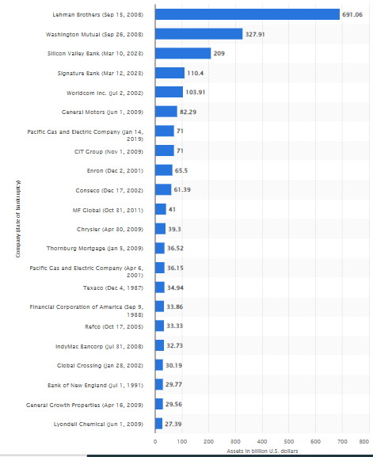

Figure 1: Showing the largest bankruptcies USA
(Source: Statista, 2025)
18926 bankruptcy cases were recorded in the United States in 2023, and the country ranked first in bankruptcies among other countries (Tierney, 2024). As of 2025, Lehman Brothers faced the largest bankruptcy in 2008, and the total amount of bankruptcy was 691 billion U.S dollars (Statista, 2025). The above chart helps in analysing the largest bankruptcies of the financial services companies in the USA. In the modern era, machine learning (ML) algorithms are used to increase the accuracy of the prediction model by leveraging governance and financial-related data (Zhu, 2024). ML algorithms can be implemented here to improve the early warning system by addressing the patterns of the large dataset. Data-driven approaches can be implemented to improve the real-time early warning system and accurately predict the bankruptcy status. Thus, the early warning systems help banks identify issues that can protect the financial losses of the bank. Proactive risk management allows for making lending decisions and improving the economic stability of the financial industry.

1.2 Aim and objectives
Aim
The main aim of the research is to implement machine learning models for predicting the bankruptcy of the company based on the corporate governance indicators and financial ratios to develop an early warning system.
Objectives
- To analyse the early warning system for bankruptcy prediction and address governance and financial-related factors that contribute to the company's bankruptcy
- To implement ML models for predicting bankruptcy, and make a comparison based on the model’s performance metrics
- To address the issues of developing an early warning system for bankruptcy prediction
- To recommend effective strategies for ongoing model validation and monitoring, as well as implementing the ML-based early warning system to improve the risk management system

1.3 Research question
Can Machine learning models accurately predict company bankruptcy based on corporate governance indicators and the financial ratios?

1.4 Research rationale
The main issue is the inability of traditional financial models to timely and accurately predict the company's bankruptcy in high-risk economic and dynamic environments. Linear regression or financial ratio-based models fail to analyse the complex interactions among governance and financial variables, leading to inaccurate or delayed risk assessments. The global markets face rising volatility due to geopolitical tensions, post-pandemic recovery challenges, and economic uncertainty (Di Quirico, 2023). Hence, businesses are vulnerable to regulators, investors, banks, and financial stress, as well as reliable tools are implemented to address the early signs of bankruptcy. The outdated risk models are required to be improved by a data-driven approach and the automation process. In such circumstances, ML models are powerful solutions for exploring the non-linear and complex relationships between governance and financial-related data, as well as improving the accuracy of bankruptcy prediction.

1.5 Research significance
The escalating negative effects and frequency of the corporate bankruptcies, driven by the volatile economic conditions globally, underscore the immediate requirements for an effective and predictive financial intelligence system. The significance of the present study actually lies in its potential of contributing to the field of financial risk management, applied machine learning, and decision support systems substantively. The main aim of the study is to address the financial distress of the company and improve the predictive accuracy of bankruptcy by leveraging ML techniques. An effective early warning can help investors, regulators, and the financial industry take relevant proactive measures to manage, allocate resources, and reduce risks of the business. ML models have higher performance than traditional models, as the models can explore the trends and interactions of bankruptcy based on the large datasets. The findings of the research have the potential to increase the financial stability, as well as support the strategic planning of banks and businesses.

1.6 Hypothesis
Null hypothesis: Machine learning models do not have the ability to predict bankruptcy based on corporate governance indicators and financial ratios and improve the early warning systems.
Alternative hypothesis: Machine learning models can predict bankruptcy based on corporate governance indicators and financial ratios and improve the early warning systems.
Independent variables | Dependent variables
- Profitability ratios  - Liquidity ratios  - Efficiency ratios  - Cashflow indicators  - Corporate governance indicators  - Leverage and solvency ratios | Bankrupt

Table 1: Independent and dependent variables

2: Methodology

2.1 Introduction
The methodology chapter of a research study describes the way specific study design and specific methods and processes were used to conduct the study. The methodology chapter explains how the research was developed and conducted, and it provides justification for the decisions made in regard to data collection, and data analysis (Snyder, 2019). This chapter discusses the methodology used to construct a bankruptcy prediction early warning system using machine learning. The chapter outlines the data source, ethical considerations, data preparation processes, exploratory data analysis, model selection, tuning strategies, and evaluation metrics. The analysis leverages tabular financial data from the Taiwan Economic Journal accessed via Kaggle. A systematic, ethical process has been followed to ensure that the findings present a reliable, accurate and relevant structured outcome. Each decision has practical implementation, and technical rationale described throughout the chapter.

2.2 Research Design
Descriptive research design has been chosen to support the assessment of historical financial data to identify patterns and indicators of bankruptcy. According to Aggarwal and Ranganathan (2020), descriptive design helps in systematic observation, classification and interpretation of the variables in the dataset, including financial ratios and governance indicators, without manipulative behaviours. Such observations provide the opportunity to assess the research goal of bankruptcy prediction based on existing firm characteristics. While exploratory and experimental research designs were less applicable to the use of the historical dataset collected by Taiwanese firms between 1999 to 2009, descriptive research is the most appropriate with historical pre-collected data when the goal is to identify dependence rather than investigate unexplored or open-ended causal relationships. The tabulated nature of the dataset, with the record characteristics and measures maintained since data collection, made it easy to analyse the data descriptively. The study documented diverse machine learning models (XGBoost, Random Forest, Logistic Regression) on a balanced dataset for which it could compile aggregately valid conclusions about predictive factors of bankruptcy with performance metrics and interpretability techniques like SHAP.

2.3 Dataset Description
The study has used a dataset which was obtained through secondary data collection. It was downloaded from Kaggle, created by Deron Liang and Chih-Fong Tsai from the National Central University, Taiwan, and came from the UCI Machine Learning Repository (Kaggle, 2021). Selecting an existing dataset is a viable method for this study owing to high reliability, completeness and ethical integrity of the dataset which makes it possible to present data with some degree of academic accountability. The use of secondary data allows this study to focus more on the model development and evaluation phase of the research rather than the primary data collection process, which is appropriate as the type of model considered requires longitudinal data that is pre-validated.
The dataset comprises bankruptcy records of Taiwanese companies from 1999 to 2009 and includes tabular data. It contains a total of 96 columns, with 95 input features (X1 to X95) and 1 binary target label (Y: 1= Bankrupt, 0= Not Bankrupt). The input features encompass an extensive range of financial ratios, such as profitability, liquidity, leverage, efficiency, and growth measures (Kaggle, 2021). These indicators represent meaningful markers of an organisations' financial health and performance. The bankruptcy target variable simply reflects the bankruptcy status as defined by the Taiwan Stock Exchange (Refer to Table 2).
Variable Name | Description | Type / Category
Y (Target) | Bankruptcy status (1 = Bankrupt, 0 = Not Bankrupt) | Binary Classification Label
X1 | Return on total assets (ROA) (C) before interest and depreciation | Profitability
X4 | Operating Gross Margin (Gross Profit / Net Sales) | Profitability
X6 | Operating Profit Rate (Operating Income / Net Sales) | Profitability
X13 | Cash Flow Rate (Cash Flow from Operations / Current Liabilities) | Liquidity
X33 | Current Ratio (Current Assets / Current Liabilities) | Liquidity
X34 | Quick Ratio (Acid Test) | Liquidity
X36 | Total Debt / Total Net Worth | Leverage
X37 | Debt Ratio (Liabilities / Total Assets) | Leverage
X45 | Total Asset Turnover | Efficiency
X47 | Average Collection Days | Efficiency
X51 | Revenue per Employee | Productivity
X54 | Working Capital to Total Assets | Solvency
X68 | Retained Earnings to Total Assets | Profitability
X86 | Net Income to Total Assets | Profitability
X94 | Net Income Flag (1 = Negative for 2 years) | Profitability Indicator
X95 | Equity to Liability | Capital Structure

Table 2: Dataset variables

2.4 Data Preprocessing
The dataset has been analysed to look for missing values and the integrity of the data prior to fitting any models. There were no null values in the dataset because it had already been cleaned and was complete. All the features were numeric, so there was no categorical encoding required. The dataset exhibited a large amount of class imbalance, with more instances of non-bankrupt than instances of bankrupt. In order to resolve the imbalanced classes, RandomUnderSampler from the imblearn library was used to randomly down-sample the majority class's (non-bankrupt) samples to equal the number of instances of the minority class (bankrupt) so the target distribution was balanced. This was a necessary step to avoid a bias in the modeling of the sample and make the classification results fair and accurate (van Giffen, Herhausen and Fahse, 2022). Feature scaling had no bearing for models based on trees, such as Random Forest or XGBoost, but was applied to Logistic Regression using Standard Scaler to standardise the input ranges.

2.5 Model Selection
Model selection required utilisation of tools and technologies for preprocessing, data training and evaluation of machine-learning models. It used Python programming language and libraries like pandas, numpy, matplotlib and seaborn. Additionally, the study has used ML algorithms like XGBoost classifier, Random Forest, Logistics Regression along with scikit-learn frameworks. Further, Kaggle data source has been used in the research along with visualisation have been executed with Matplotlit and seaborn.
Exploratory data analysis approaches with supervised machine learning models have been adopted for exploring the dataset for prediction of bankruptcy of companies based on corporate governance indicators and financial ratios for development of early warning systems. Therefore the overall purpose of study is to develop an effective machine learning based model with higher accuracy. The study has utilized the XGBoost Classifier algorithm, Random Forest, and Logistics Regression and conducted comparative analysis to identify superior models to eventually identify the best model for prediction of bankruptcy. XGBoost refers to a type of gradient boost that builds an ensemble of decision trees sequentially and pushes the limits of computing power for boosted tree algorithms (Hakkal and Lahcen, 2024). Therefore, it is suited for structured data like the bankruptcy data file.

ML Model | Overview | Rationale for Selection
XGBoost | XGBoost indicates machine learning algorithms that belong to the ensemble learning category, especially with the gradient boosting trees (Mesut, Başkor and Aksu, 2023). | XGBoost offers easier or simple processes that reduce preprocessing requirements especially in terms of working with real-world secondary data.
Random Forest | Random Forest indicates a machine learning model utilized for classification and forecasting (Salman, Kalakech and Steiti, 2024). However, it requires a substantial amount of high-quality data for effective data collection. | RF offers an ensemble of decision trees that reduces risk of overfitting through prediction from multiple trees. It is resistant to noise which is common in secondary datasets.
Logistics Regression | Logistics regression refers to the most commonly used classification algorithms in machine learning that allows for categorization of data into discrete classes (Zaidi and Luhayb, 2023). | LR acts as a benchmark model, offering clear coefficients based on interpretation of feature effects and is well suited for binary classification. It has higher computational efficiency to train, test and is useful for initial comparison in case of limited resources.

Table 3: Machine Learning Models

2.6 Evaluation Metrics
The ML model in the study has been assessed with the help of classification measurements like the precision, recall, F1-score and support along with accuracy, macro avg and weighted avg. These measurements have contributed towards more realistic insights on capabilities of performance of each model for prediction of bankruptcy of the company based on corporate governance indicators and financial ratio for development of early warling systems. Confusion matrix supports evaluation of the performance of the classification model as it summarises incorrect and correct predictions developed by the model (Sathyanarayanan, 2024). Thus, the study has created a confusion matrix for XGBoost classifier, allowing for better visualisation of the performance results. Further, the model has shown the most balanced performance and accuracy level over the assessment measures assigned which are most appropriate for XGBoost, Logistic Regression and Random Forests.

2.7 Ethical Considerations
Ethical considerations are required for a project that utilises secondary quantitative data for avoidance of harm, data protection and issue of return for consent. The study has adhered with the ethical guidelines as it uses publicly available dataset that does not include human identifiers or personal information. Further, ethical guidelines outlined by the University for conducting desk based research have been adhered to in the study. It has provided proper citation for acknowledging authors of original publications for avoiding chances of plagiarism. The UK copyright, design and patients act of 1988 ensure the rights of original work in terms of usage (Government of UK, 1988). Therefore, the study has used several references and ensured that no information has been manipulated or distorted in the study, thereby improving transparency and academic integrity as well.

2.8 Chapter Summary
This chapter has described the research methodology adopted for exploration of the dataset on bankruptcy prediction from Kaggle. The chapter has outlined tools, technology, resources and models deployed in the project. Further, it has outlined key ethical considerations adopted for ensuring academic integrity and improved reliability of findings.

3: Results and Analysis

3.1 Introduction
This chapter has outlined experimental results for implementation of predictive maintenance model on prediction of bankruptcy of the company based on key indicators like the financial ratios and governance indicators. The study has utilized various machine learning algorithms that were applied to analyse the dataset along with application of classification accuracy, prediction, F1-score and recall. These metrics support measurement of high performance models. The results have provided insights and guidelines for data-driven methods for prediction of bankruptcy. Further, the chapter has presented and analysed the results in the context of research aims and assisted the modelling towards effective predictive bankruptcy predictive models.

3.2 Implementation

3.2.1 Dataset loading
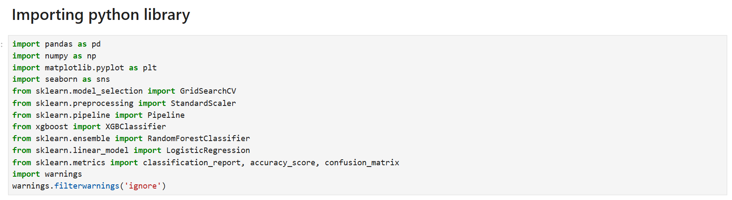

Figure 2: Importing python libraries
The above figure indicates the necessary imports of libraries in the python notebook environment in the initial setup process for effective manipulation, visualisation and creation of a model. Further, Machine learning has been trained, balanced and evaluated based on the use of packages like sklearn, XGBoost, RandomUnderSampler from the imblearn library. These tools have facilitated development of predictive maintenance methodologies as prescribed through data science procedures (Imani, Beikmohammadi and Arabnia, 2025). Further, use of libraries like pandas, numpy, matplotlib and seaborn support effective data visualisation and manipulation.
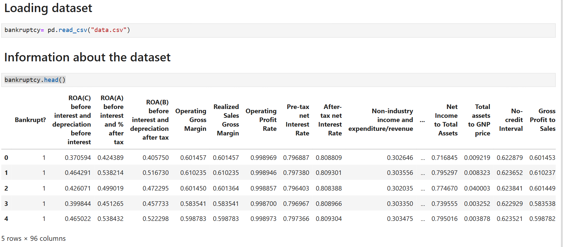

Figure 3: Dataset Loading
Figure 7 shows that 95 financial ratio features and one binary target variable (1 for Bankrupt and 0 for non-Bankrupt) with total number of columns being 96. The first row displayed ratios, such as ROA, gross margin, profit rates and leverage measures. Data has appeared with numeric and well-formatted and with no missing values, suitable for machine learning models.
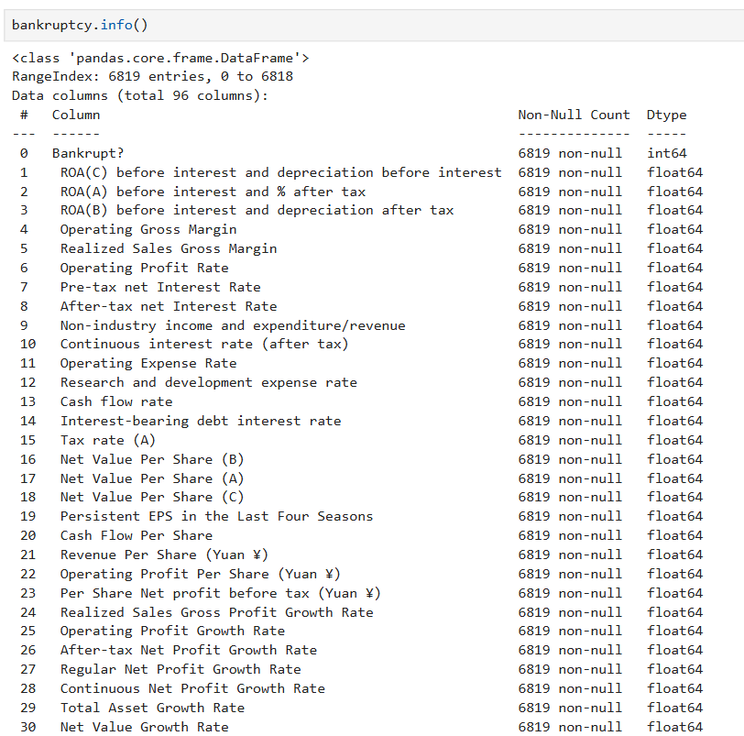

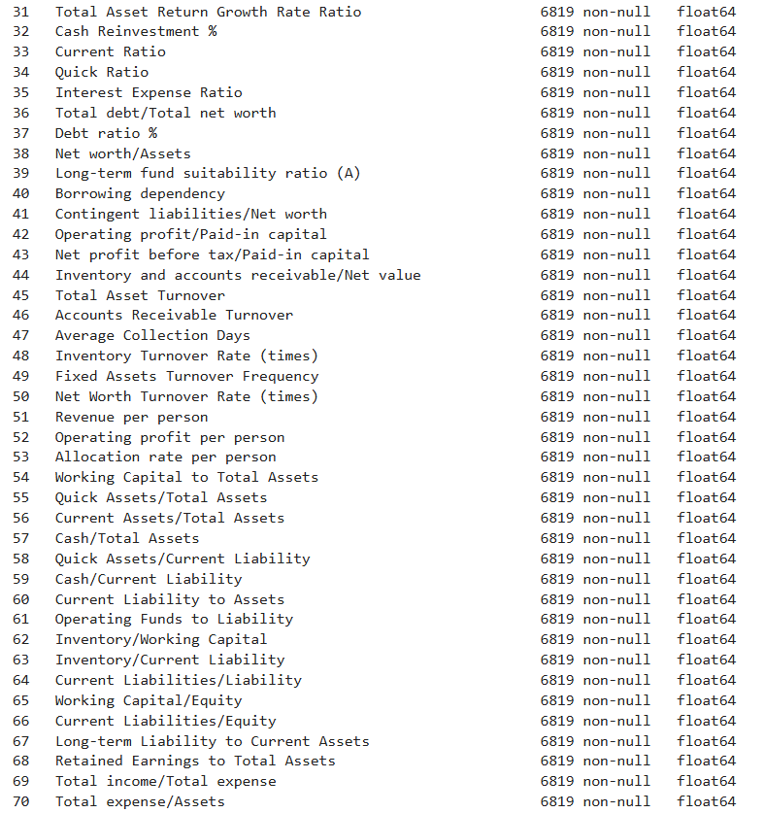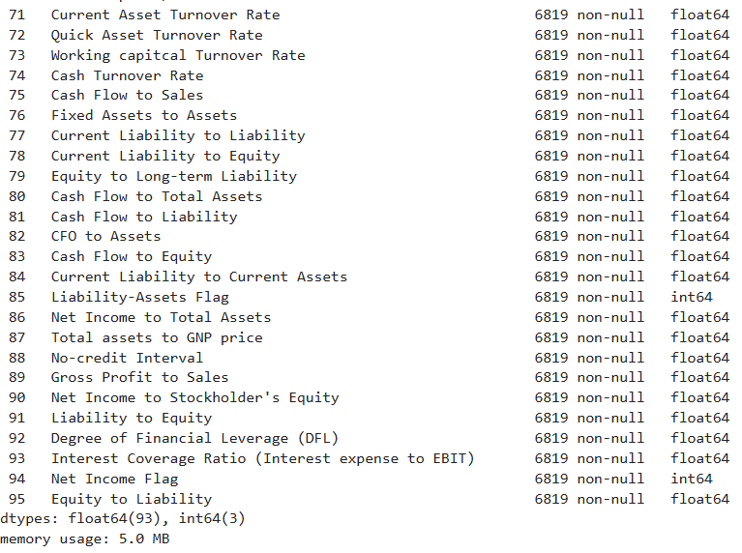Figure 4: Information about the dataset
The dataset includes 6,819 observations on numerous financial indicators such as profitability, liquidity, leverage, efficiency and growth metrics (Refer to Figure 8). The dataset contains only electronic records, all of which are numerical and non-null covering real estate areas through 41 financial indicators that can be used in the bankruptcy prediction.

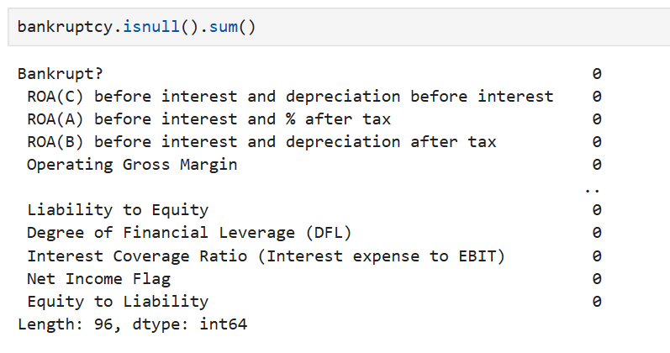Figure 5: Checking null and duplicates values
Based on the above Figure 9, there are also no missing values in any of the 96 columns thus making the data complete and valid. This has prevented the data requiring imputation or data cleaning and makes immediate feature engineering and model training possible, there is no longer any need to worry about missing values or data anomalies.

3.2.2 Data Visualization
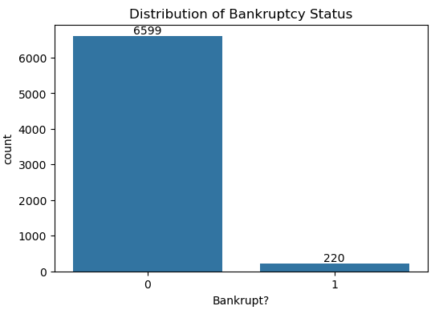

Figure 6: Distribution of Bankruptcy Status
From Figure 10, there was a severe imbalance in the distribution of the bankruptcy status, in that 6,599 are non-bankrupt, and 220 are bankrupt. The imbalance also means that resampling methods, either undersampling or oversampling. This has been required to provide balanced model training and avoid the risk of bias towards the majority non-bankrupt class when making predictive analysis.
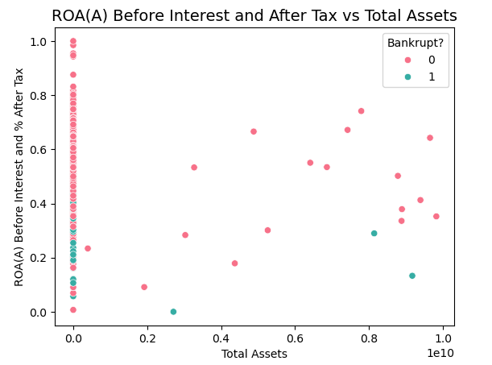

Figure 7: ROA (A) before interest and after tax vs total asset
Relationship between ROA(A) and total assets for both non-bankrupt as well as bankrupt firms shown in Figure 11. The distribution of most bankrupt companies is concentrated around small total assets and low ROA, while non-bankrupt firms are less clustered, which means size and profitability seems to reduce potential bankruptcy.
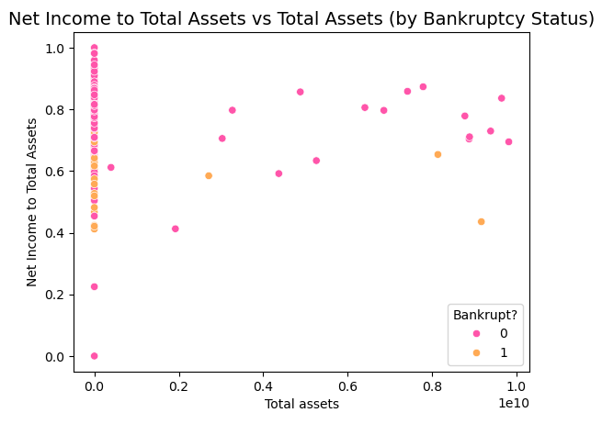

Figure 8: Net income to total asset as per bankruptcy status
Figure 12 illustrates the tendency that companies are less likely to go bankrupt if their net income to total assets ratio is higher, especially near 1.0, where total asset values tend to be lower). This has implied heterogeneity in profitability by bankruptcy status.
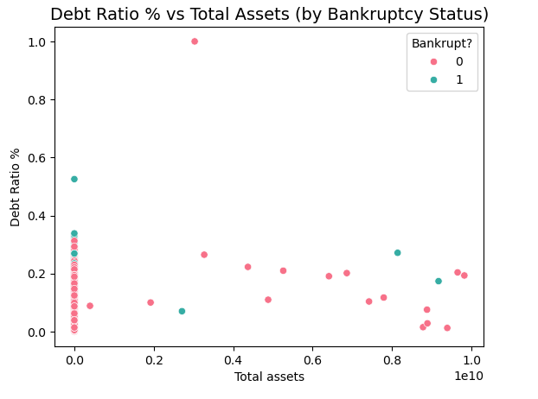

Figure 9: Debt Ratio vs total asset by bankruptcy status
Figure 13 reveals that firms who file bankruptcy (green) exhibit a much higher dispersion of debt ratios across different levels of assets and even some very high values. Non-bankrupt firms (pink) tend to cluster at lower debt ratios, particularly when total assets are small, suggesting a potential link between higher debt levels and bankruptcy risk.
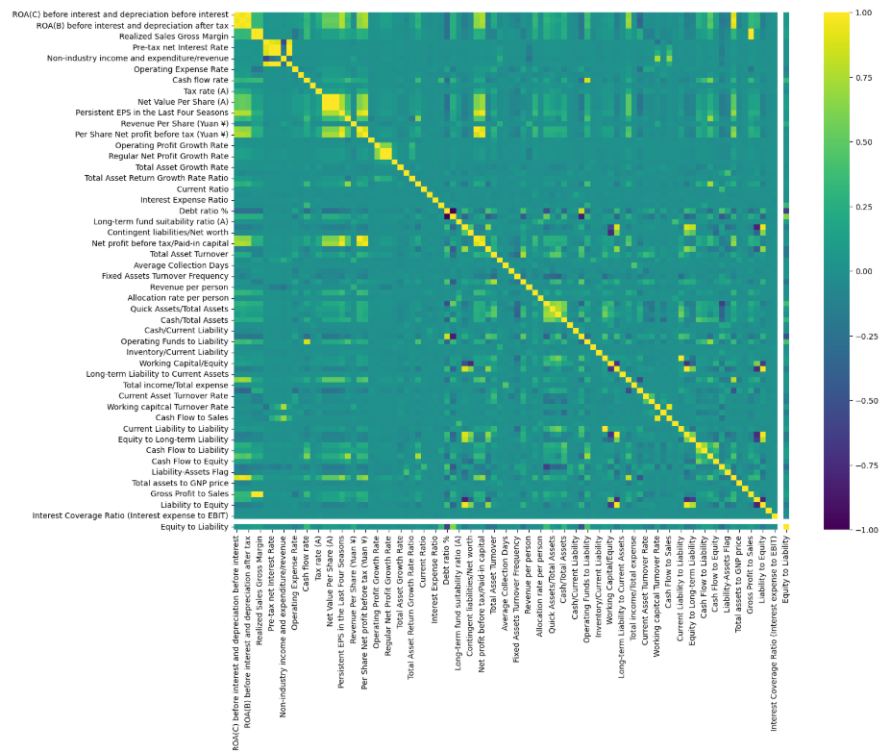

Figure 10: Correlation Map
The correlation map visualises relationships between financial variables, where values near 1 indicate strong positive correlations, and values near -1 show strong negative correlations (Refer to Figure 14). Some of them have strong positive relationships like the relationship between ROA(C) before interest and depreciation, and ROA(B) before interest and after tax while some of them have negative relationships such as current ratio and quick ratio. However, debt ratio was highly negatively correlated with equity-to-liability ratios. These relationships seemed to show common financial details and possible multicollinearity between the key ratios.

3.2.3 Feature Engineering
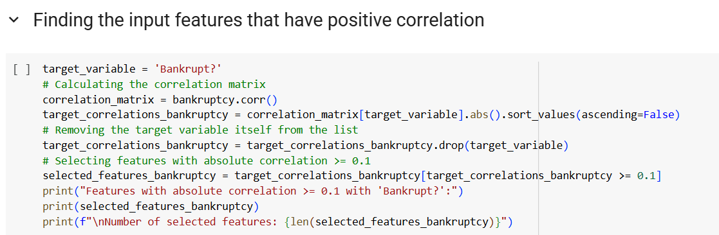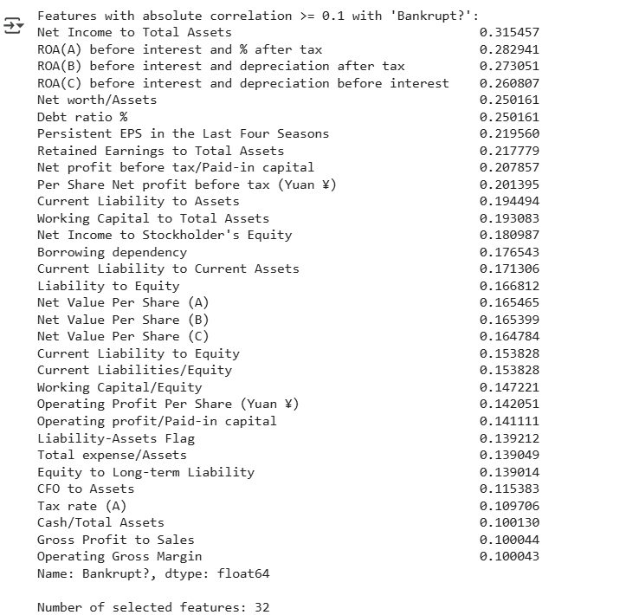

Figure 11: Finding input features
The analysis in Figure 15 recognises 32 features that have an absolute correlation ≥ 0.1 with bankruptcy outcome. The notable predictors are the profitability ratios (e.g., Net Income to Total Assets), return on assets measures, debt ratio, and retained earnings. This implies that both profitability metrics and leverage metrics are predicting bankruptcy probability.
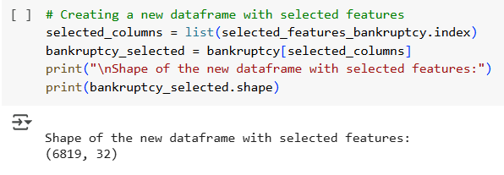

Figure 12: Data frame with input features
The refined dataset is made up of 6,819 records and 32 features, all of which are showing significance with respect to bankruptcy status (Refer to Figure 16). This reduction of the original feature set of variables allows for the financial and governance indicators that are most relevant when training a model, maximising the efficiency of the model as well as retaining the power of prediction for bankruptcy classification.

3.3 Testing
XGBoost
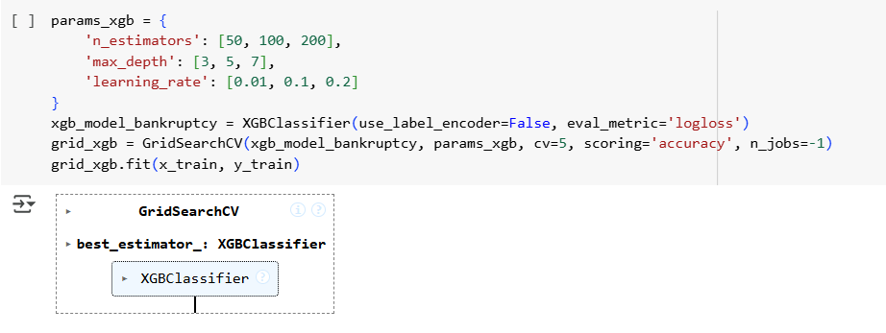
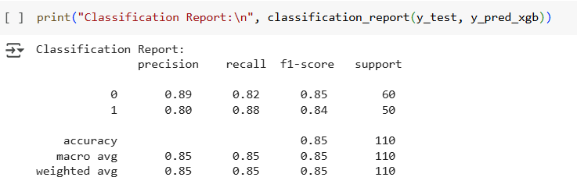
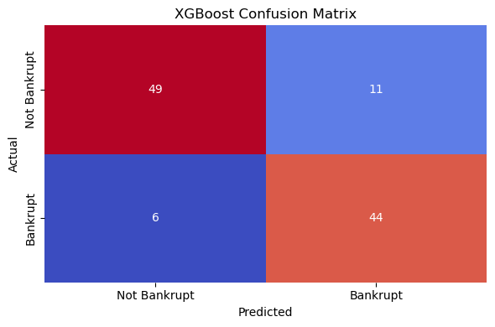

Figure 13: XGBoost development and accuracy
The XGBoost model in Figure 17, optimized with GridSearchCV, was able to predict bankruptcies with an accuracy of 85% with balanced precision and recall (0.85 macro average) resulting in predictions of 49 non-bankrupt and 44 bankrupt firms with 17 mistakes. The recall associated with bankruptcies was high (0.88), which indicates the model was effective at identifying financial distress that is critical data for future warning systems.
Random Forest
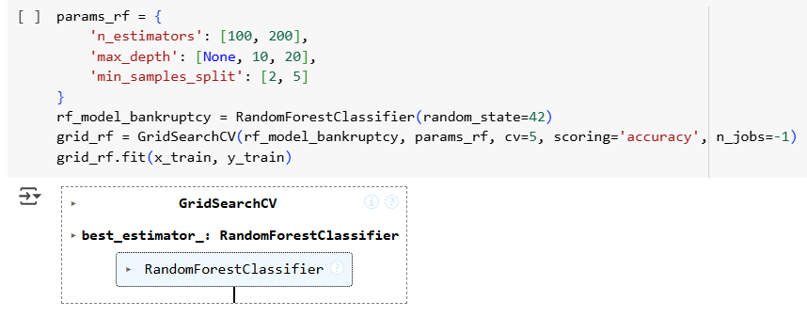
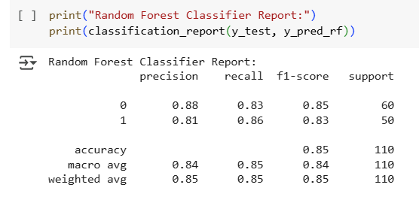
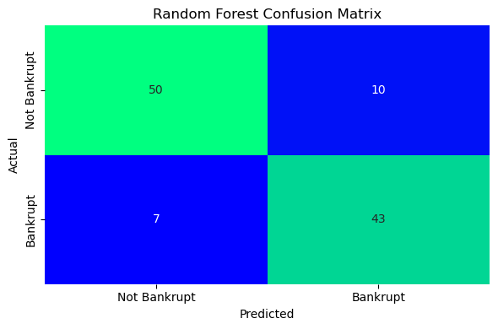

Figure 14: Random Forest model development and accuracy
Random Forest Classifier in Figure 18 has been developed as a solution to predicting bankruptcy using financial data from Taiwanese companies between 1999- 2009. The classifier report outlines a good precision (0.88); recall (0.83); and F1-score (0.85) for the non-bankrupt class, with an overall accuracy of 0.85 across 110 instances. The confusion matrix indicates that there were 50 true negatives, 43 true positives, 10 false positives, and 7 false negatives, thereby also providing a good balance in performance. Furthermore, GridSearchCV has been used to determine the best settings for the model including n_estimators (100,200); and max_depth (None, 10, 20) to demonstrate an improvement in accuracy.

Logistics Regression
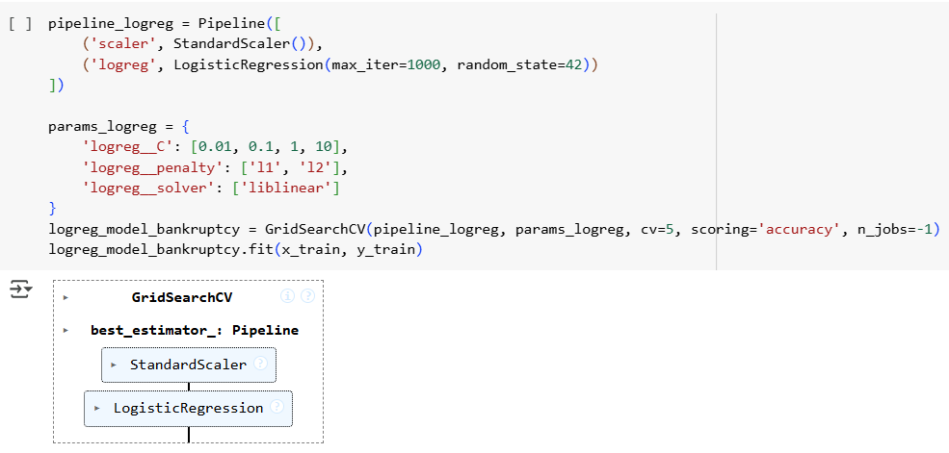
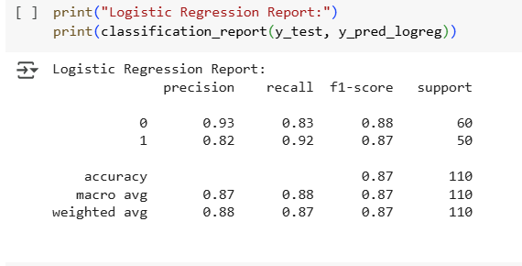
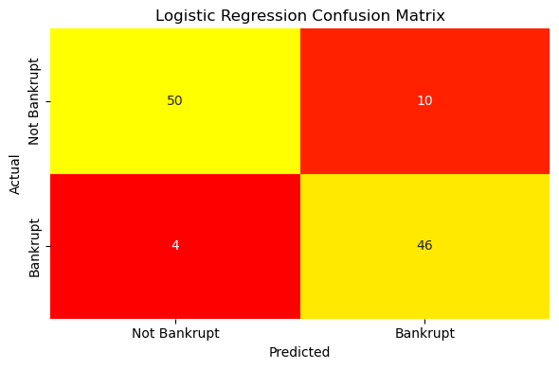

Figure 15: Logistic regression model development and accuracy
Figure 19 outlines a Logistic Regression model for bankruptcy prediction, using financial data from Taiwan from 1999-2009. The model, developed with GridSearchCV and a pipeline that included standardscaler, achieved an accuracy of 0.87. The report also shows the model's precision (0.82-0.93), recall (0.83-0.92), and F1-score (0.87) across 110 total instances, with both macro and weighted averages being fairly balanced. The model had 50 true negatives, 46 true positives, 10 false positives, and only 4 false negatives, indicating a good degree of confidence with application. Several hyperparameters were tuned including the C (0.01-1), and the solver (liblinear) all contributing to the overall reliability of the model for early detection of bankruptcy.
Model Comparison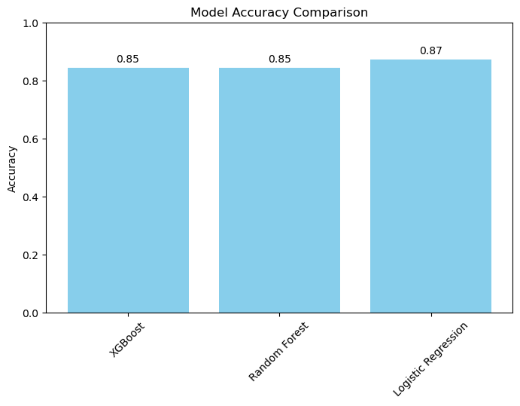

Figure 16: Model accuracy
Figure 20 indicates the performance of XGBoost (0.85), Random Forest (0.85), and Logistic Regression (0.87) in bankruptcy prediction. Logistic Regression is marginally better, reflecting better generalization. The models are all good but data bias or overfitting must be checked.

3.4 Implementation
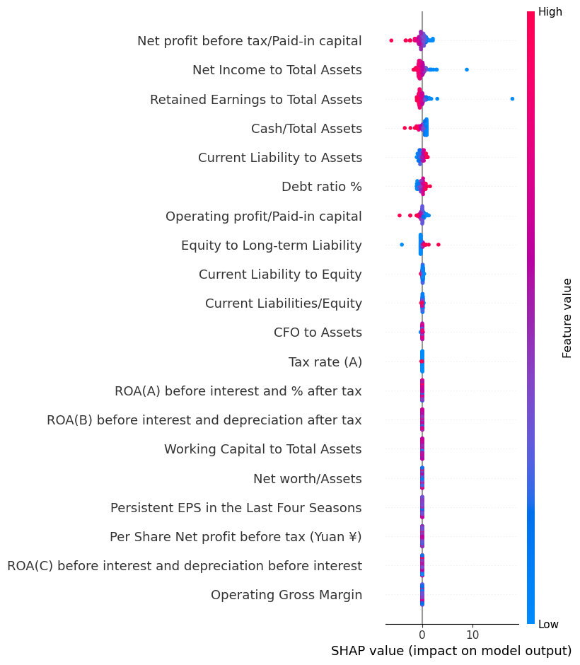

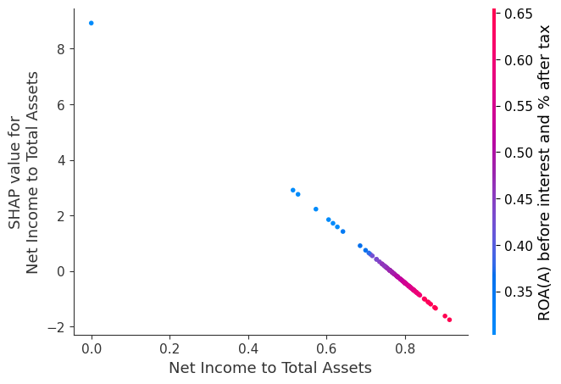

Figure 17: Logistic regression with SHAP
SHAP summary plot in Figure 21 indicates significant features that influence the Logistic Regression model's bankruptcies predictions. The most significant (SHAP values of up to 0.65) are Net Profit before Tax/Paid-in Capital and Net Income to Total Assets, which indicate strong positive correlations with the risk of bankruptcy. Dependence plot indicates that Net Income to Total Assets increases with SHAP values, explaining its predictive strength. Features like Operating Gross Margin have lesser influence, indicating little impact on the model's prediction.

3.5 Key Findings
Based on the above analysis, it has been found that the base characteristics of the system include a detailed set of financial indicators, samples balancing selected to resample had a positive effect on building an effective early bankruptcy prediction system upon using ML algorithms. Structural patterns to detect bankruptcy risk with features mainly related to governance and financial stuff, including debt ratio, ROA and profitability. These functionalities have created a base to implement ML models and then evaluate the results with some performance metrics in order to decide which is the best of all predictive methods. The results suggest that all models, XGBoost, Random Forest, and Logistic Regression, performed well for predicting Bankruptcy with Logistic regression exhibiting a slightly better generalisation. The models successfully maintained a balance between precision and recall ensuring accurate detection of distress. Investigation of the feature importance stats showed that ratios related profitability and capital were most impactful in predictions with some operational metrics having little to no impact. This shows how the most prevailing features into bankruptcy risk could be considered to have a core focus on a firm's financial position.

3.6 Summary
This chapter discussed the development, optimisation and evaluation of three machine learning models that aim to predict bankruptcy. Results demonstrated strong, balanced performance across all models as key profitability and capital ratios predicted bankruptcy, indicating using the model can create value through identifying indications of financial distress at an early stage.

4: Analysis and Discussions

4.1 Introduction
In this chapter, the research findings connect to the research objectives, model performance is evaluated and results compared with existing literature. The purpose of this chapter is to interpret the results of ML models predicting bankruptcy using governance indicators and financial ratios, comparing their performance and effectiveness. Moreover, the study also provided challenges and links findings to the research question, objectives and relevant literature on risk management.

4.2 Discussion

4.2.1 Analysis of early warning systems for bankruptcy prediction and related governance and financial factors
The necessity of early warning systems has played a vital role in identifying potential bankruptcy risks, preventing their further development and financial hardships. According to existing literature, the machine learning methodologies, such as XGBoost and Random Forest, provide a bigger accuracy and flexibility than the conventional models, including Altman Z-score (Rashid, Khan and Qureshi, 2024). Similarly, XGBoost and Random Forest did very well follow by their advancement as powerful, modern ensemble methods which have highly accurate and versatile over a variety of classification and regression problems (Fatima et al., 2023). They have to be interpretable, robust and need to account for complex non-linear relationships so as to be practical predictive models in the real-world. From the results, bankruptcy is one of the stronger indicators since it concerns governance and financial ratios, such as ROA, debt ratio and liquidity. The results illustrate the capabilities of ML-based early warning systems for improving predictive accuracy and so generating practical implications for preemptive financial risk management under discretion in dynamically changing economic environments, thus, objective 1 has been met successfully.

4.2.2 Implementation of ML models and comparative performance evaluation
Building ML model for bankruptcy prediction that used to compare different algorithms for identifying the best model by using performance metric. From the existing literature, ensemble methods, including Random Forest and XGBoost do perform well in financial distress prediction (Papík and Papíková, 2024). From findings, it has been found that logistic regression has the best average stability over all predictors and similarly demands the strong generalisation overall while XGBoost alongside Random Forest have delivered balanced precision and recall that effectively identifies bankrupt firms. Accordingly, the consistency of logistic regression has highlighted the value of combining interpretability with predictive strength in early working systems (Groot et al., 2025). Thus, multiple ML models have produced accurate bankruptcy predictions, logistics regression and ensemble methods being competitive with different characteristics under varying financial environments, therefore objective 2 has been met successfully.

4.2.3 Challenges in developing early warning systems for bankruptcy prediction
In order to create a successful early warning system to predict bankruptcy has faced challenges due to complexities regarding the financial environment as well as the economic and other governance factors all play their part. As per existing literature, AI-based models are becoming problematic because of their issues surrounding explain ability, data precision, and legalistic compliance (Boukherouaa et al., 2021). Consequently, AI-based models have raised regulatory compliance and risk management issues such as explainability, poor data quality, difficulties in integrating financial sector regulations (Akter et al., 2023). Based on the results, the critical imbalance in classes was an initial problem that reduced the attainment of prediction accuracy that needed resampling and the financial indicators had multicollinearity. Models such as Logistic Regression, Random Forest, and XGBoost worked well with balanced precision and recall, but each of them needed some fine-tuning. This imbalance has distorted performance metrics that have given a misleading sense of model reliability. Thus, the challenges have not been handled properly that causes working predictions, late action and bigger financial losses for stakeholders, therefore, objective 3 has been achieved.

4.2.4 Recommendations for model validation, monitoring and integration into risk management
Based on the existing literature, combining interpretable ML approaches, like SHAP values to ensemble models, like XGBoost or Random Forest, significantly enhances accuracy and transparency in the predictive task (Papík and Papíková, 2024). Resulting metrics indicated that the three models tested retained overall balanced precision and recall, with Logistic Regression performing slightly better than other algorithms, thereby most importantly stressing on the need for continuous model performance evaluation. Based on the TAM model, the usefulness and ease of use have encouraged stakeholder adoption, supporting the earlier bankruptcy detection and making financial decision data-driven on time. These practices have aligned with practical applications, enabling timely detection of financial distress and informed decision-making. Thus, continuous monitoring has been imperative to both maintaining model relevance and robustness as well as preserving system effectiveness in a changing market environment.

4.3 Chapter summary
From the above discussion, it has been summarised that bankruptcy prediction accuracy was strong for the ML models, including logistic regression, random forest and XGBoost. Performance was affected by challenges, including class imbalance and multicollinearity. Continuous process of validation, monitoring and stakeholder acceptance was also required to ensure continuous effectiveness of models and ensure financial distress, thereby improving practical risk management in dynamic economic environments.

5: Conclusion

5.1 Conclusion
In the analysis of the early warning system, the governance indicators and financial indicators indicated that profitability ratios (like Net Income to Total Assets) and leverage indicators (like Debt Ratio) are important factors in declaring bankruptcy. The analysis using data visualisation showed that there were strong connections between the financial performance and bankruptcy risk, and using SHAP analysis, the most important features could be defined. This holistic assessment centred on the contribution of such indicators in the financial distress detection. This is how the 1st objective has been addressed, indicating the relevance of targeted indicators in the development of effective early warning systems.
The predictions of bankruptcy by the use of logistic regression, random forest, and XGBoost machine learning models were tested by accuracy, precision, recall and F1 score. Logistic Regression performed slightly better than the rest because it exhibited superior generalisation and all models had balanced predictions. GridSearchCV tuning was used to optimise hyperparameters on better performance and guarantee the general performance of classification. This is how the second objective has been addressed, indicating that ML algorithms are capable of making right and reliable predictions of bankruptcy cases.
In order to handle the issues related to the development of the early warning system, such as the extreme imbalance in the data by the classes, the research used RandomUnderSampler in order to prevent the bias towards the majority class. Data reduction was carried out through feature engineering in order to maintain the predictive value. These measures enhanced model readability and performance that were in the way of practical and procedural challenges. This is how the third objective has been addressed which demonstrates the significance of preprocessing and balancing procedures in delivering fair results in terms of predictions made.
Suggestions are also based on results where even well-functioning models can be biased or over-fit. The interpretability of the SHAP implies transparency to the stakeholders, whereas retraining on new data sets, in case of volatile markets, implies the flexibility of adapting to the dynamics. This is the way that the final objective has been addressed indicating the necessity of sustainable, interpretable, and adaptive ML-based early warning systems in the process of risk management.

5.2 Limitation of the study
The limitations of this study derive from its use of secondary data. The use of secondary data limits the ability to control for the quality of data, definitions of features, and the biases of the original data collection process. The dataset has a limited geographic scope and temporal scope, generalisability is restricted to certain periods and markets. Additionally, this study used RandomUnderSampler in order to balance classes. While this technique removes instances of majority class in the dataset, it does drastically reduce the sample size and also removes some potentially informative majority class instances. Model performance was evaluated on a static dataset and therefore, the adaptability to financial changes in real-time was not tested. Models often differ in interpretability, which may result in less trust from stakeholders despite the inclusion of SHAP analysis.

5.3 Recommendations of the study
In response to the existing limitations in the research, the implication is to rely on multi-country datasets with diverse time periods to allow for generalisability. Augmenting secondary data with primary data collection can offer stronger association relevant attributes and reduce reliance on aprioristic variables. Also, instead of only undersampling, combined hybrid sampling methods (for example, using SMOTE and undersampling) can allow more relevant cases to be retained. In order to be able to adapt to changing economic conditions, ongoing periodic retraining should be mandated with the current datasets. Increasing interpretable models or use explainability tools (like SHAP or LIME) can inspire confidence in stakeholders and thrust the separation of the best predictive outcomes as an assurance, then permitting the assimilation of machine learning based early warning systems in the real world when managing financial risk.

5.4 Future work
Future work could implement macroeconomic and qualitative governance criteria, to incorporate bigger risk factors apart from financial ratios. The possibility of testing models with real time financial data could investigate the versatility in volatile markets. Furthermore, building on this study alongside deep learning architectures would be to determine if improvements can be made over ML algorithms. Other ways of research could also include more advanced ensemble models and cost-sensitive learning that may also improve the accuracy of bankruptcy detection. Incorporating practitioners with live deployment would validate usable outputs and a better fit of the predictive systems within an organisational risk management strategy.

References
Aggarwal, R. and Ranganathan, P. (2020). Study designs: Part 2 – descriptive studies. Perspectives in Clinical Research, [online] 10(1), pp.34–36. doi:https://doi.org/10.4103/picr.PICR_154_18.
Akter, S., Sultana, S., Mariani, M., Wamba, S.F., Spanaki, K. and Dwivedi, Y.K. (2023). Advancing algorithmic bias management capabilities in AI-driven marketing analytics research. Industrial Marketing Management, [online] 114, pp.243–261. doi:https://doi.org/10.1016/j.indmarman.2023.08.013.
Asif, M., Saxena, A., Bhardwaj, S., Tiwari, S. and Chaturvedi, S. (2024) ‘A STUDY OF ALTMAN Z-SCORE BANKRUPTCY MODEL FOR ASSESSING BANKRUPTCY RISK OF NATIONAL STOCK EXCHANGE-LISTED COMPANIES’, Proceedings on Engineering Sciences, 6(2), pp. 789–806. (Available at: https://doi.org/10.24874/PES06.02A.006.)
Billios, D., Seretidou, D. and Stavropoulos, A. (2024). The Power of Numerical Indicators in Predicting Bankruptcy: A Systematic Review. Journal of risk and financial management, [online] 17(10), pp.433–433. doi:https://doi.org/10.3390/jrfm17100433.
Boukherouaa, E.B., AlAjmi, K., Deodoro, J., Farias, A. and Ravikumar, R. (2021). Powering the Digital Economy: Opportunities and Risks of Artificial Intelligence in Finance. Departmental Papers, [online] 2021(024). doi:https://doi.org/10.5089/9781589063952.087.
Bragoli, D., Ferretti, C., Ganugi, P., Marseguerra, G., Mezzogori, D. and Zammori, F. (2021). Machine-learning models for bankruptcy prediction: do industrial variables matter? Spatial Economic Analysis, pp.1–22. doi:https://doi.org/10.1080/17421772.2021.1977377.
Carroll, J.D. (1997). The Nature of Multivariate Data Analysis. Elsevier eBooks, pp.1–25. doi:https://doi.org/10.1016/b978-012160954-2/50002-0.
Chakraborty, A. and Tsokos, C. (2024). A Stock Optimization Problem in Finance: Understanding Financial and Economic Indicators through Analytical Predictive Modeling. Mathematics, [online] 12(15), pp.2407–2407. doi:https://doi.org/10.3390/math12152407.
Das, A., Agarwal, A.K., Jacob, J., Mohapatra, S., Hishikar, S., Bangar, S., Parekh, S., Basu, S. and Sinha, U.K. (2020). Insolvency and Bankruptcy Reforms: The Way Forward. Vikalpa: The Journal for Decision Makers, 45(2), pp.115–131. doi:https://doi.org/10.1177/0256090920953988.
Dasilas, A. and Rigani, A. (2024). Machine learning techniques in bankruptcy prediction: A systematic literature review. Expert Systems with Applications, pp.124761–124761. doi:https://doi.org/10.1016/j.eswa.2024.124761.
Davis, F.D. (1985). A technology acceptance model for empirically testing new end-user information systems : theory and results. Massachusetts Institute Of Technology.
Di Quirico, R. (2023) ‘Uncertainty, Anxiety and the Post-Pandemic Economic Environment’, Clinical Neuropsychiatry, 20(4), p. 227. (Available at: https://doi.org/10.36131/cnfioritieditore20230401.)
Drotár, P., Gazda, M. and Vokorokos, L. (2019). Ensemble feature selection using election methods and ranker clustering. Information Sciences, 480, pp.365–380. doi:https://doi.org/10.1016/j.ins.2018.12.033.
Fatima, S., Hussain, A., Amir, S.B. and Ahmed, S.H. (2023). XGBoost and Random Forest Algorithms: An in Depth Analysis. Pakistan journal of scientific research, [online] 3(1), pp.26–31. doi:https://doi.org/10.57041/pjosr.v3i1.946.

