Front-End Test Automation: Regular Exam

Exam assignment for the "QA Front-End Test Automation" Course @ SoftUni.

Submit your work as a single zip / rar / 7z archive holding your solutions for each problem at SoftUni Website.
Please refer to the end of this document for instructions on how to submit your work.

The "TimeWise" Web Application
"TimeWise" is a web application designed to help users manage their time efficiently. The platform provides functionalities for users to register, log in, edit their profiles, and manage their time, including adding, editing, and deleting tasks. The primary objective of this exam is to ensure the application's functionalities perform as expected through automated UI tests using Selenium IDE and Selenium WebDriver.
Access the "TimeWise" Web App through its dedicated URL:
https://d1dzr3dh7g0qgk.cloudfront.net

Application Functionality
Key Features:

- Landing Page (Unregistered/Non-Logged Users) - The Landing Page is simple and focused on getting visitors to Login or Register. The Landing Page is scrollable and includes the following:
  - Title and Description
  - "Optimize Your Time Now!" Button: Upon clicking the button, it leads to the Register / Login page
  - "10 Time Management Tips to Boost Your Productivity" YouTube Video

    - Register
      - Allows users to register by entering a first name, middle name, last name, username, email, password, and repeat password.
      - Upon successful registration, users are redirected to the login screen.

- Log In
- Enables registered users to log in using their email and password.

- Home Page (Logged Users) - Provides access to functionalities for:
- Viewing and editing profile
- Adding tasks
- Arraging tasks in lists – To-Do (+), In Progress, Done
- Logout functionality

- Profile management
  - Users can edit their profile details, including first name, last name, email, username, and profile
picture (via URL).
NOTE: Since this is an educational app, the edit profile option is not fully implemented, so the new data is not recorded.

  - Add new task
- Logged users can create new tasks with a TaskName, start date, end date and selecting their status To-Do (+), In Progress, Done
- These tasks are then listed on the corresponding list.

  - Task Management
- Includes options to edit and delete, and seт their status To-Do (+), In Progress, Done

IMPORTANT! Locators in TimeWise are intentionally messy: repeated classes, missing IDs, nested elements and clickable links that sometimes appear as spans. This reflects real QA work, where automation often requires finding stable selectors in imperfect HTML. The important lesson is that good locators depend on developers providing clear IDs or data attributes, and QAs must actively request them. For the exam, don’t overthink it: use the simplest selectors that work. Some of the more difficult selectors are shown in this document, but we encourageyou to try finding them on by yourself first.

Selenium IDE
In this section, you will use Selenium IDE to automate and validate core user flows within the "TimeWise" application. This involves recording and running tests to ensure key functionalities are accessible and perform as expected for both unregistered and registered users.

Preparation
Before beginning the automated tests, manually register an account on the "TimeWise" application. Use this account for tasks involving logged-in user actions.

Tests
Use Firefox. Selenium IDE is no longer officially supported in Google Chrome.

1.2.1. Landing Page Navigation Test (Non-Logged User)
- Use Selenium IDE to record a test that navigates to the Landing page as an unregistered or non-logged user.
- Verify that the displayed text is "TIMEWISE".
- Verify the presence of the "ORGANIZE YOUR TIME NOW!" Button.

1.2.2. Log In Test (a tricky one)
- Using Selenium IDE, create a test that logs into the "TimeWise" application with your manually registered account.
- Input your registered email and password into the login form and submit it.
- Verify that the Sidebar includes links to To-Do, In Progress, Done.
- Log out and verify that the "TIMEWISE" text is present on the Landing page, indicating the user is logged out.
Note: You will record the test without problems, but when you try to run it, it will fail, because it can't seem to find and click the "SIGN IN" button.
Selenium IDE will record a WRONG selector: css=.ripple-surface.
This selector appears only during the click animation and will NOT exist when the test runs.
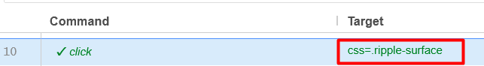
And sometimes we have to do things manually. Replace the Target manually with this stable selector:
xpath=//button[@type='submit']
This one always exists.
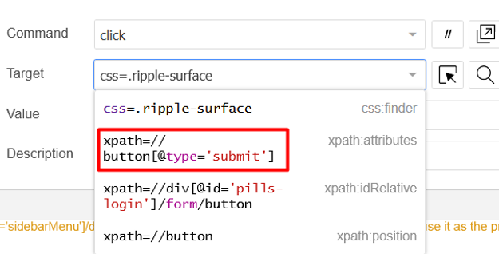
Run the test again.
Get used to explore different targets. It might happen again.

1.2.3. View Profile Test
- Write a Selenium IDE test that logs in with the user's credentials from the manually registered account and views the profile information.
- Use the credentials to log in to the application. (Remember to change the selector for the "SIGN IN" button manually)
- After logging in, navigate to the "" page.
- Click on the "My Profile" button.
- Verify that the "Edit Profile Button" is present.
- Logout and verify redirection to home page by asserting the "ORGANIZE YOUR TIME NOW!" Button is present.

Tests Organization
- Ensure all recorded tests are organized into a test suite.
- Give the test suite a clear and descriptive name that indicates its purpose.
- Name each test appropriately to reflect the specific task or functionality being tested.
- Arrange the tests in a logical sequence within the suite.
- Each test should start in a new browser window to ensure a fresh state.
- Maximize the browser window at the start of each test to ensure all elements are visible and to maintain consistency across different screen resolutions.

Selenium WebDriver
In this section, you will set up and execute automated UI tests for the "TimeWise" application using Selenium WebDriver. The goal is to validate various functionalities of the application, ensuring it behaves as expected under different scenarios. You are free to use the Page Object Model (POM) for better test structure and maintainability, but using POM is not mandatory—you can write your tests without it if you prefer.

Setup and Preparation
Create a New NUnit Project

Install Necessary Packages
- Selenium.WebDriver
- Selenium.Support
- FirefoxDriver or ChromeDriver

Include the relevant namespaces in your test classes by adding using directives
- using OpenQA.Selenium;
Instantiating and managing WebDriver instances, interacting with web elements, and controlling browser actions.
- using OpenQA.Selenium.Chrome;
Launching Chrome, setting Chrome-specific options, and managing ChromeDriver.
- using OpenQA.Selenium.Interactions;
Performing complex user interactions that go beyond simple clicks or text entry.
- using OpenQA.Selenium.Support.UI;
Implementing explicit waits, which are essential for handling dynamic content and synchronizing tests.

Create [OneTimeSetup] or [Setup] method
- Configure Chrome or Firefox options and set preferences.
For example: This block disables Chrome’s built-in password manager so it doesn’t block Selenium from clicking elements, which causes failing tests..
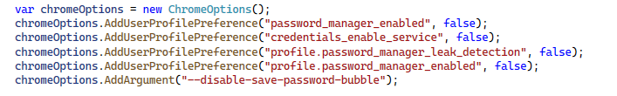
- Initialize the WebDriver.
- Maximize the browser window and set implicit wait times.
- Perform an initial login to the application, ensuring the session is ready for the tests.
Add [OneTimeTearDown] or [TearDown] method
- Close the browser and end the WebDriver session.

Automated Tests
- Tests should follow a logical sequence - Use the [Order] attribute
- Each test should start with a consistent state
- Name your tests descriptively

IMPORTANT! When testing the Time Wise application, it is very important to understand the following points regarding task listings:
The TimeWise application displays tasks in a grid layout:
- Each row contains up to three tasks.
- Each page contains up to two rows, so a maximum of six tasks per page.
- When you add more than six tasks, the application automatically creates a new page and adds pagination links such as:
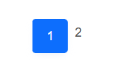
This means:
- Tasks 1–3 appear in row 1
- Tasks 4–6 appear in row 2
- Tasks 7+ appear on a new page
This behavior is normal for the application, but it makes automated tests more complicated because the "last added task" might move to another row or another page.
✔ What you need to do for the exam
To keep the exam simple and focused on your Selenium test logic, you do not need to work with multiple rows or multiple pages unless you really want to.
You are encouraged to keep your setup simple:
✔ ONLY keep 3 tasks (one row) or 6 tasks (two rows) in total.
This way:
- You will never trigger pagination
- The “last added task” will always be on the same row or page
- You can access the last task without handling extra rows or pages
There is no requirement to work with pagination.
There is no requirement to handle more than one row.
✔ What to do if you already added too many tasks
If your TimeWise account already contains many old test tasks:
Go into the application and simply delete the extra tasks manually until you are left with up to 3 tasks, better delete all the tasks and start clean.
Do this once at the beginning of the exam or everytime you have more than 3 tasks and you won’t have to worry about rows and pagination at all.
If you choose to use rows and pages, here is a method that will help you to always find the last task, on the last row of the last page:
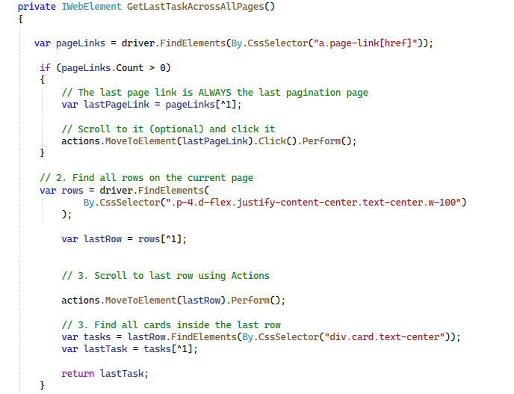
This method will help you:
✅ Navigate to the last page with tasks.
✅ Verify the TaskName of the last task on that page.

Add Task Without Name Test
- Navigate to + TO DO: Direct the browser to /Task/ToDo by clicking the TO DO link.
- Open the Create Task Page: Locate and click the Create Task button to begin adding a new task.
- Enter an Empty TaskName: Leave the Task field blank to simulate invalid input.
- Submit the Form: Find and click the Create button to attempt submitting the task.
- Verify the Result: Ensure that the browser remains on the Task/Create page, confirming that the application does not allow creating a task without a TaskName.

2.2.2. Add Task with Random Name Test
- Navigate to + TO DO: Open the /Task/ToDo page from the navigation menu.
- Open the Create Task Page: Click the Create Task button to start adding a new task.
- Generate Test Data: Create a random TaskName and a random description.
Note: The description must be at least 30 characters long, because the application enforces validation on this field.
- Fill the Form: Enter the generated TaskName, the generated description, start date, end date, and choose Status = To-Do from the dropdown menu.
Note: The Status dropdown has no IDs or classes, so the only reliable locator is select[name='Status'].
To interact with dropdowns in Selenium, you must use the SelectElement class and select options by value or text.
- Submit the Form: Click the Create button to add the task.
- Wait for Redirect: Confirm that the browser returns to the /Task/ToDo page.
- Verify the Created Task: Locate the last task and check that its TaskName matches the generated TaskName.

2.2.3. Edit Last Added Task Test
- Navigate to + TO DO: Open the /Task/ToDo page from the navigation menu.
- Locate the Last Task: Find the last task (the most recently added task).
- Open Edit View: Inside that task, click the Edit button.
- Change the TaskName: Clear the existing TaskName and enter a new one. For example: "Edited: " followed by the original task TaskName stored from the previous test.
- Save the Changes: Click the Edit button to submit the edited task.
- Wait for Redirect: Ensure the browser navigates back to /Task/ToDo.
- Verify the Updated Task: Find the last task again and assert that its TaskName is successfully cganged.

2.2.4. Move Last Added Task Test
- Open the + TO DO Page: Navigate to /Task/ToDo so the list of To-Do tasks is visible.
- Get the Last Task: Locate the last task that you just edited.
- Store Its TaskName: Read and save the task TaskName so you can verify later that it no longer appears in the To-Do section.
- Move the Task: Click the Set to "In Progress" status button inside that task.
- Verify the Task Is Gone from To Do: Assert that the moved task’s TaskName is not present anywhere on the page, ensuring it was successfully moved out of the To-Do list. Feel free to assert this whichever way you like. The easiest way is that its TaskName does not appear anywhere on the page Assert.That(driver.PageSource.Contains(/* the stored TaskName */), Is.False);

2.2.5. Delete Last Added Task Test
- Open the In Progress Page: Navigate to /Task/InProgress to access the tasks waiting to be completed.
- Identify the Last Task: Locate the last task that you moved in the previous test.
- Store Its TaskName: Read and store the TaskName so you know exactly which one should disappear.
- Delete the Task: Click the DELETE button inside the task, then confirm the deletion by clicking Yes on the confirmation screen.
- Wait for the Page to Reload: Make sure the page returns to /Task/InProgress before continuing.
- Verify the Task Is Gone: Assert that the moved task’s TaskName is not present anywhere on the page, ensuring it was successfully moved out of the To-Do list. Feel free to assert this whichever way you like. (similar to previous one)

How to submit your exam
You should attach a single zip / rar / 7z archive containing all of your tasks.
Upload your archive at SoftUni website, into Regular Exam section.
- The Selenium IDE task exported in a single .side file.
- Your Selenium WebDriver project should be in a folder.
At the end, the content of your archive should look similar:
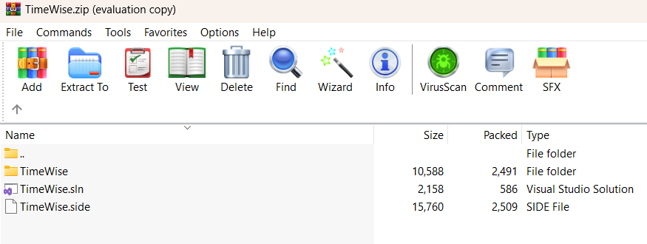
Before archiving, please make sure that you deleted all bin and obj folders from your VS Test project.

