# Solution M1 (@softuni-id)

*Please fill in your* ***SoftUni username*** *above. Name the file* ***M1-Solution****, prepare a compressed archive, and upload it to the* ***SoftUni*** *site*

### Virtual Machine #1

**CHECK:**

*\**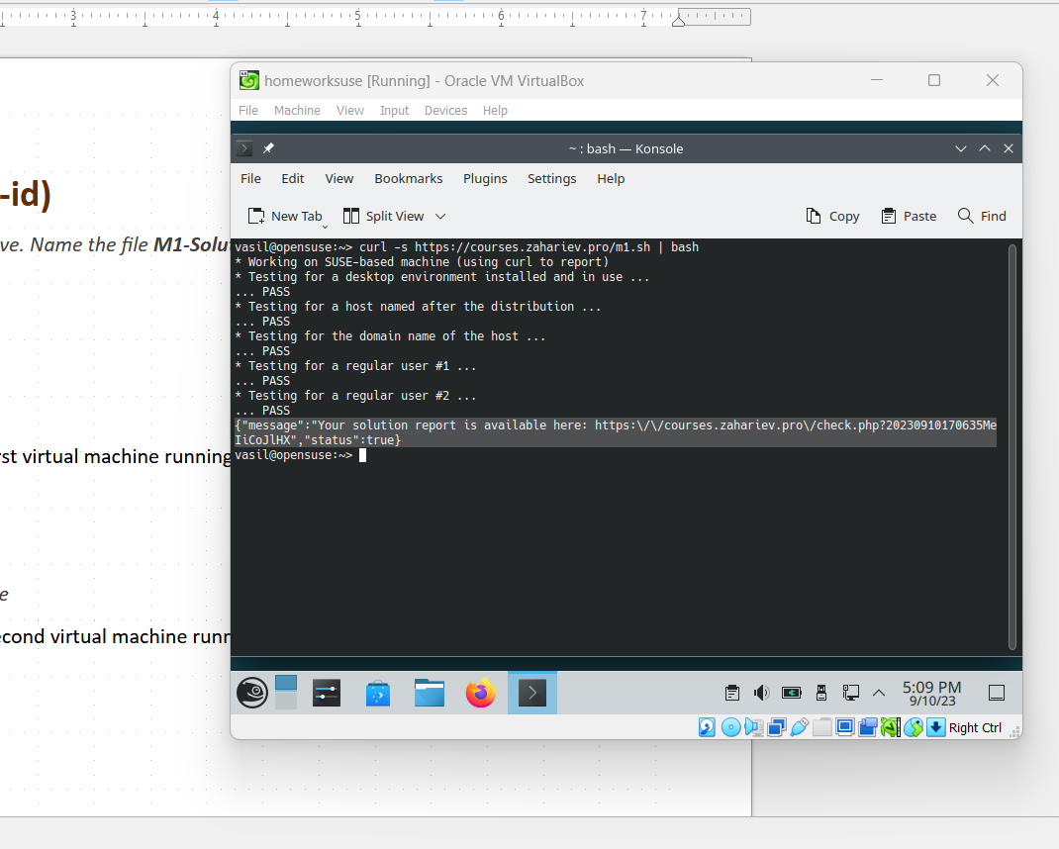 *Working on SUSE-based machine (using curl to report)   
* Testing for a desktop environment installed and in use ...   
... PASS   
* Testing for a host named after the distribution ...   
... PASS   
* Testing for the domain name of the host ...   
... PASS   
* Testing for a regular user #1 ...   
... PASS   
* Testing for a regular user #2 ...   
... PASS   
{"message":"Your solution report is available here: https:\/\/courses.zahariev.pro\/check.php?20230910170635Me  
IiCoJlHX","status":true}*

### Virtual Machine #2

**CHECK:**

*Working on Debian-based machine (using wget to report)*

*\* Testing for a desktop environment installed and in use ...   
... PASS   
* Testing for a host named after the distribution ...   
... PASS   
* Testing for the domain name of the host ...   
... PASS   
* Testing for a regular user #1 ...   
... PASS   
* Testing for a regular user #2 ...   
... PASS   
{"message":"Your solution report is available here: https:\/\/courses.zahariev.pro\/check.php?20230910180901mgozqRjpx7","status":true}*

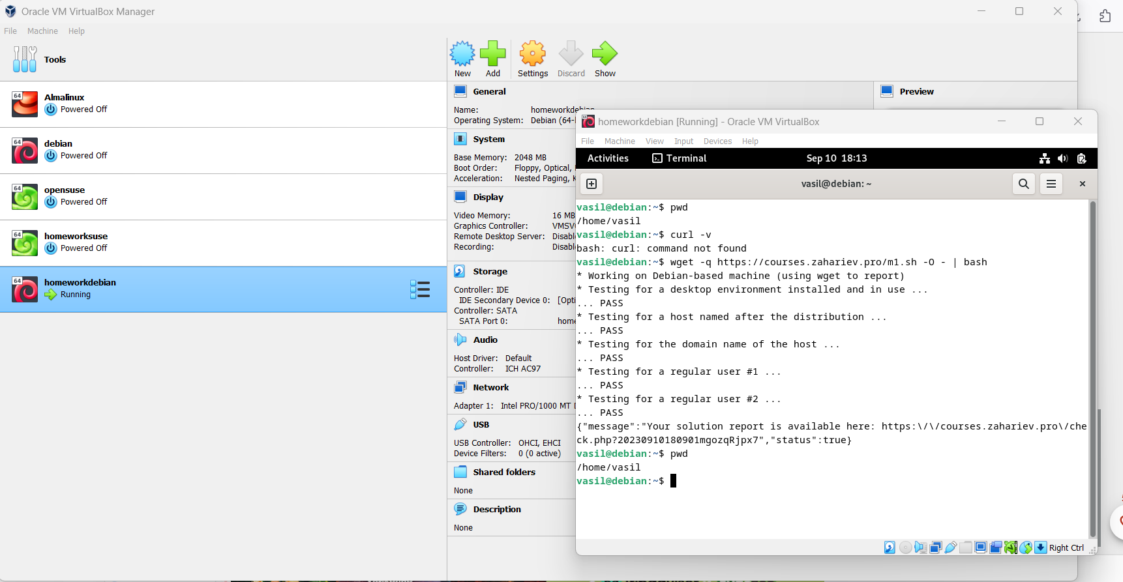

Paste one or more screenshots of the second virtual machine running with a terminal emulator open