# Solution M4 (@vasilmg)

*Please fill in your* ***SoftUni username*** *above. Name the file* ***M4-Solution****, prepare a compressed archive, and upload it to the* ***SoftUni*** *site*

### Solution Details

**CHECK:** *Paste the solution check link here*

Include the commands you used for every step. Also include the output if you like (either as pictures or as text)

VM 1 AlmaLinux Rila:

1.$ sudo ip address add 192.168.148.1/24 dev enp0s8

2.$ sudo dnf install -y dhcp-server

$ sudo vi /etc/dhcp/dhcpd.conf

option domain-name "Rila";

option domain-name-servers 8.8.8.8;

subnet 192.168.148.0 netmask 255.255.255.0 {

range 192.168.148.50 192.168.148.59;

option routers 192.168.148.1;

option broadcast-address 192.168.148.255;

default-lease-time 600;

max-lease-time 7200;

}

$ sudo systemctl start dhcpd

$ sudo systemctl enable dhcpd

3.$ sudo dnf install -y openssh

$ sudo systemctl start sshd

$ sudo systemctl enable sshd

4.$ sudo dnf update

5.$ sudo sysctl -w net.ipv4.ip_forward=1

6.$ sudo dnf config-manager --add-repo https://repos.zahariev.pro/dnf/zahariev-repo.repo

7.$ sudo dnf install --nogpgcheck hello-lsa

sudo firewall-cmd –get-active-zones

sudo nmcli connection modify enp0s3 connection.zone external

sudo nmcli connection modify static-internal connection.zone trusted

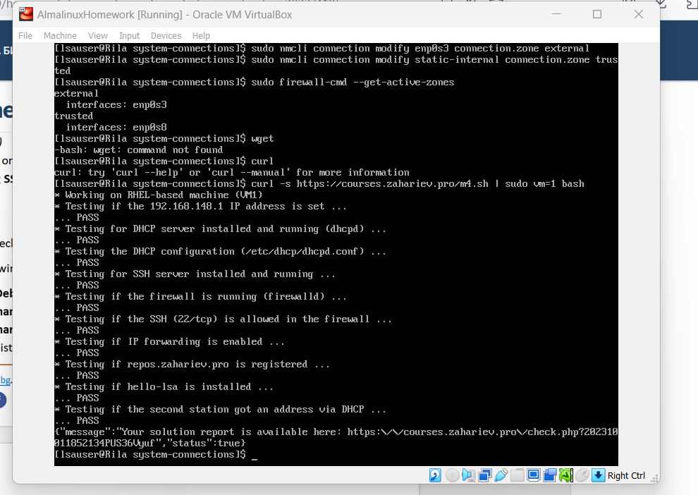

VM 2 Debian Pirin:

1.Get ip address automatically by the server.

2.$ sudo useradd homework

$ sudo passwd homework

$ sudo usermod -a -G sudo homework

3.$ sudo vi /etc/ssh/sshd_config

...

Port 50022

…

$ sudo apt-install ufw

$ sudo ufw allow 50022/tcp

$ sudo ufw enable

