Homework

Task 1

First we need to create the two conf file main and port.

**cat > main.conf << EOF**

**# main.conf**

**name=homework**

**path=/tmp**

**certs=/secret**

**EOF**

**cat > port.conf << EOF**

**8080**

**EOF**

Than we run the following command:

**kubectl create configmap hwcm --from-literal=k8sver=v1.27.5 --from-literal=k8sos=Debian-11 --from-file=main.conf –from-file=port.conf**

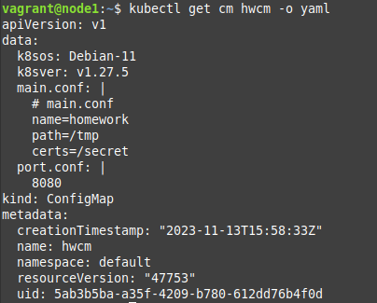

Next step is to generate the **main.key and main.crt** as described in the Homework assignment file.

Now we create the secret **hwsec** from the two files.

**kubectl create secret generic hwsec --from-file=main.key –from-file=main.crt**

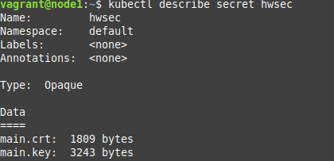

Now lest add all of the above to a pod.

Using the manifest pod-hw.yml:

**apiVersion: v1**

**kind: Pod**

**metadata:**

**name: pod-hw**

**labels:**

**app: environ**

**spec:**

**containers:**

**- image: shekeriev/k8s-environ**

**name: cont-w-env**

**env:**

**- name: HW_k8sver**

**valueFrom:**

**configMapKeyRef:**

**name: hwcm**

**key: k8sver**

**- name: HW_k8sos**

**valueFrom:**

**configMapKeyRef:**

**name: hwcm**

**key: k8sos**

**- name: HW_PORT**

**valueFrom:**

**configMapKeyRef:**

**name: hwcm**

**key: port.conf**

**volumeMounts:**

**- name: config-volume**

**mountPath: /config**

**readOnly: true**

**- name: secret-volume**

**mountPath: /secret**

**readOnly: true**

**volumes:**

**- name: config-volume**

**configMap:**

**name: hwcm**

**items:**

**- key: main.conf**

**path: main.conf**

**- name: secret-volume**

**secret:**

**secretName: hwsec**

Than we run the command :

**kubectl apply -f pod-hw.yml**

Lets not forget to apply the service.yml too.

**kubectl apply -f service.yaml**

And we check the result of http://<node-ip:port>

